Q1 Do you operate a commercial rural and related business entity? Please select from the options below what best describes the nature and scope of your commercial production business/es.
Answered: 499 Skipped: 2
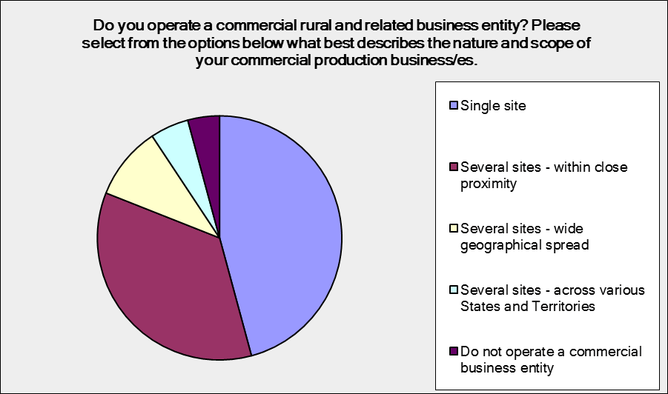

Answer Choices | Responses
Single site | 45.49% | 227
Several sites - within c lose proximity | 35.47% | 177
Several sites - wide geographic al spread | 9.22% | 46
Several sites - ac ross various States and Territories | 5.21% | 26
Do not operate a commercial business entity | 4.61% | 23
Total |  | 499

Q2 In which State/Territory is your principal farm or agricultural business? If you operate farming businesses/entities in more than one State/Territory, please indicate which jurisdictions.
Answered: 497 Skipped: 4
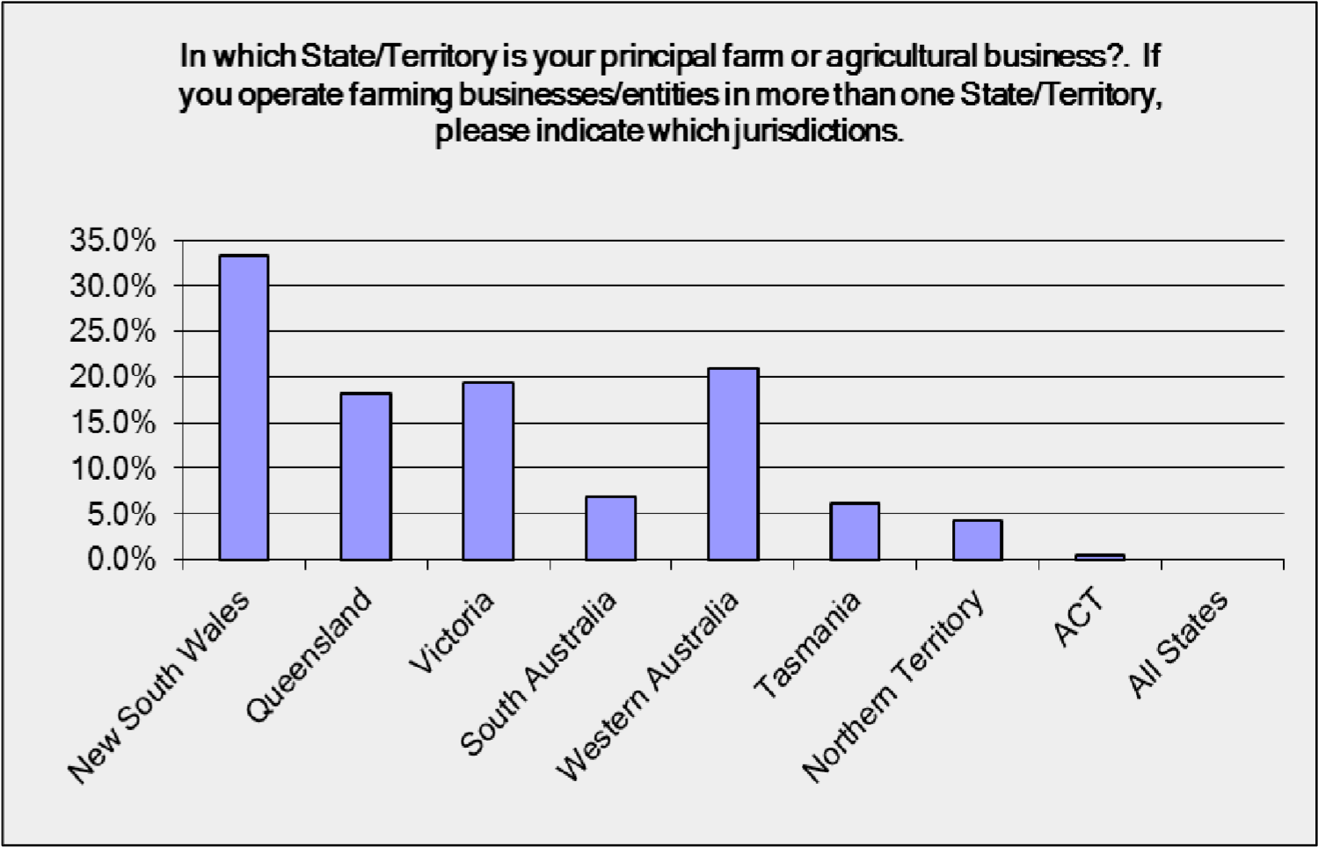

Answer Choices | Responses
New South Wales | 33.20% | 165
Queensland | 18.11% | 90
Victoria | 19.32% | 96
South Australia | 6.84% | 34
Western Australia | 20.93% | 104
Tasmania | 6.24% | 31
Northern Territory | 4.23% | 21
ACT | 0.40% | 2
All States | 0% | 0
Total Respondents: 497

Q3 Describe the nature of your principal farming/agricultural activity.

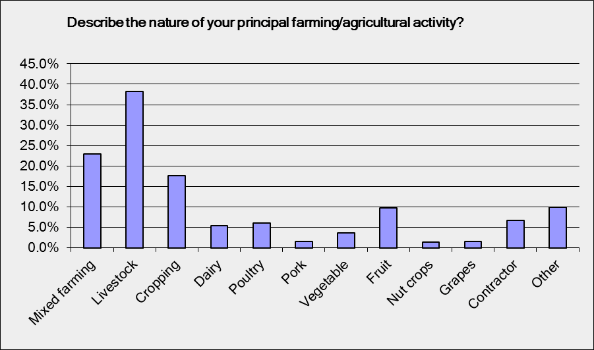
Answer Choices | Responses
Mixed farming | 22.98% | 114
Livestock | 38.31% | 190
Cropping | 17.74% | 88
Dairy | 5.44% | 27
Poultry | 6.05% | 30
Pork | 1.61% | 8
Vegetable | 3.63% | 18
Fruit | 9.68% | 48
Nut crops | 1.41% | 7
Grapes | 1.61% | 8
Contractor | 6.65% | 33
Other | 9.88% | 49
Total Respondents: 496

Q4 What best describes the nature of your enterprise/s?
Answered: 496 Skipped: 5

%
100

%
80

84.27
%

%
60

%
40

%
20

0.81
%

5.65
%
8.47
%
3.63
%

%
0

Owner/operator

including

Cooperative
Corporate
business

20-100

Employees

> 100

Employees
family business (medium) (large)

Answer Choices | Responses
Owner/operator including family business | 84.27% | 418
Cooperative | 0.81% | 4
Corporate business | 5.65% | 28
20-100 Employees (medium) | 8.47% | 42
> 100 Employees (large) | 3.63% | 18
Total Respondents: 496

Q5 Which of the options below best describes the size of your enterprise/s? Please include permanent, casual and part- time employees.
Answered: 496 Skipped: 5

%
100

80
%

%
40

20
%

30.65
%

42.14
%

18.95
%

9.07
%

%
4.03

%
0

Family farm

-
primarily

1-5

Employees

5-20

Employees

20-100

Employees

> 100

Employees
family (small) (small to (medium) (large) members medium)

Answer Choices | Responses
Family farm - primarily family members employed only | 30.65% | 152
1-5 Employees (small) | 42.14% | 209
5-20 Employees (small to medium) | 18.95% | 94
20-100 Employees (medium) | 9.07% | 45
> 100 Employees (large) | 4.03% | 20
Total Respondents: 496

Q6 How many family members or business partners are involved with your enterprise on a full-time and/or part-time basis? Family members can include partners/spouses, parents, sons, daughters, brothers, sisters, aunts, uncles etc
Answered: 447 Skipped: 54

100
%

Number

%
80

60
%

40
%

20
%

0
%

Full-time
Part-time

> 4
1

2

3

4

Number
 | 1 |  | 2 |  | 3 |  |  | 4 |  | > 4 |  | Total
Full-time |  | 35.01% |  | 37.03% |  |  | 14.86% |  | 7.81% |  | 5.29%
 |  | 139 |  | 147 |  |  | 59 |  | 31 |  | 21 |  | 397
Part-time |  | 42.91% |  | 30.18% |  |  | 16% |  | 3.27% |  | 7.64%
 |  | 118 |  | 83 |  |  | 44 |  | 9 |  | 21 |  | 275

Q7 On what basis do you employ staff, if any?

Answered: 475 Skipped: 25

%
100

80
%

60
%

40
%

20
%

0
%

Casual
Part-time
Full-time
Contract
Seasonal

Answer Choices | Responses
Casual | 65.89% | 313
Part-time | 22.95% | 109
Full-time | 52.21% | 248
Contract | 28.21% | 134
Seasonal | 25.26% | 120
Total Respondents: 475

Q8 In the last 12 months have you employed or attempted to employ rural and related workers? If yes, please confirm whether you were successful and the time taken to complete the recruitment process.

Answered: 493 Skipped: 8

%
100

%
80

60
%

40
%

20
%

0
%

Yes
No
month
1
months
2
months
3
Longer

than 3

months

Answer Choices | Responses
Yes | 68.97% | 340
No | 28.40% | 140
1 month | 31.24% | 154
2 months | 12.37% | 61
3 months | 4.87% | 24
Longer than 3 months | 10.75% | 53
Total Respondents: 493

Q9 Please describe the nature of your labour / workforce requirements.

Answered: 441 Skipped: 35

%
100

%
80

%
60

40
%

%
20

%
0

Semi-skilled

workers -

New entrants

Traineeship /

Skilled

workers -

Supervisory

Overseer

Management -

Farm manager

labourers Apprenticeship Farm/Station Leading hand hands

Answer Choices | Responses
Semi-skilled workers - labourers | 56.68% | 263
New entrants - Traineeship/Apprenticeship | 15.09% | 70
Skilled workers - Farm/Station hands | 59.70% | 277
Supervisory - Overseer/Leading hand | 18.97% | 88
Management - Farm manager | 15.52% | 72
Total Respondents: 464

Q10 Have you engaged with or attempted to utilise options available through the Australian Migration system to access employees? If yes, please identify which options from the list below, and confirm whether you were successful or not, or expect to be successful or not, and the number of employees effectively sourced.
Migration...

Visa...

Categories...

Yes
No

100
%

Successful
or not

80
%

60
%

%
40

%
20

%
0

Permanent

Labour

Temporary

Temporary

S
eas
on
a
l

Employer

Agreements

Work

Working

Worker

Answered: 279 Skipped: 222

100
%

Option used, if any

80
%

60
%

40
%

20
%

%
0

Permanent

Employer

Labour

Agreements

Temporary
Work

Temporary

Working

Seasonal
Worker
Sponsored  Migration... |  | (Skilled) Visa... | Holiday Visa Categories... | Program
Sponsored (Skilled) Holiday Visa Program

%
100

No. of employees sourced

80
%

%
60

%
40

%
20

%
0

Permanent

Labour

Temporary

Temporary

S
eas
on
a
l

Employer

Agreements

Work

Working

Worker

Sponsored (Skilled) Holiday Visa Program Migration... Visa... Categories...

5-20 > 20
1

1-5

Option used, if any |  |  |  | Yes |  | No | Total
Permanent Employer Sponsored Migration Program |  |  |  | 24.43% 43 |  | 75.57% 133 | 176
Labour Agreements |  |  |  | 15.58% 24 |  | 84.42% 130 | 154
Temporary Work (Skilled) Visa (subclass 457) - 457 Visa |  |  |  | 34.48% 60 |  | 65.52% 114 | 174
Temporary Working Holiday Visa Categories - Backpackers |  |  |  | 57.69% 135 |  | 42.31% 99 | 234
Seasonal Worker Program |  |  |  | 12.50% 19 |  | 87.50% 133 | 152
Successful or not |  |  |  | Yes |  | No | Total
Permanent Employer Sponsored Migration Program |  |  |  | 54.72% 29 |  | 45.28% 24 | 53
Labour Agreements |  |  |  | 62.96% 17 |  | 37.04% 10 | 27
Temporary Work (Skilled) Visa (subclass 457) - 457 Visa |  |  |  | 74.60% 47 |  | 25.40% 16 | 63
Temporary Working Holiday Visa Categories - Backpackers |  |  |  | 95.45% 126 |  | 4.55%  6 | 132
Seasonal Worker Program |  |  |  | 71.43% 20 |  | 28.57%  8 | 28

No. of employees sourced | 1 |  | 1-5 | 5-20 | > 20 | Total
Permanent Employer Sponsored Migration Program |  | 63.89% 23 | 30.56% 11 | 0%  0 | 5.56%  2 | 36
Labour Agreements |  | 15.79%  3 | 26.32%  5 | 26.32%  5 | 31.58%  6 | 19
Temporary Work (Skilled) Visa (subclass 457) - 457 Visa |  | 44.44% | 38.89% | 7.41% | 9.26%
 |  | 24 | 21 | 4 | 5 | 54
Temporary Working Holiday Visa Categories - Backpackers |  | 12.80% | 41.60% | 26.40% | 19.20%
 |  | 16 | 52 | 33 | 24 | 125
Seasonal Worker Program |  | 16.67% | 38.89% | 22.22% | 22.22%
 |  | 3 | 7 | 4 | 3 | 18

Q11 What approaches/strategies have you used/applied to date to identify, develop and foster skills training and personnel development within your enterprise/s?
Answered: 476 Skipped: 25

%
0.0
5.0
%
10.0
%
15.0
%
20.0
%
25.0
%
%
30.0
35.0
%
40.0
%
45.0
%
50.0
%
Formal
workforce
planning
processes
Use of
agricultural
consultants
Skills and
training
need
analysis
Internal
Human
Resource
Unit
Use of
labour hire
contractors
Have not
used any
What approaches/strategies have you used/applied to date to
identify, develop and foster skills training and personnel
development within your enterprise/s?

Answer Choices | Responses
Formal workforce planning processes | 22.48% | 107
Use of agricultural consultants | 18.28% | 87
Skills and training need analysis | 19.96% | 95
Internal Human Resource Unit | 9.66% | 46
Use of labour hire contractors | 14.71% | 70
Have not used any | 44.54% | 212
Total Respondents: 476

Q12 On what basis would you assess your labour, skills and other workforce development requirements?
Answered: 490 Skipped: 11

%
100

%
80

60
%

40
%

20
%

%
0

Annually
Regularly
As the need

arises

Do not formally

assess these
requirements

Answer Choices | Responses
Annually | 9.59% | 47
Regularly | 26.33% | 129
As the need arises | 48.37% | 237
Do not formally assess these requirements | 15.71% | 77
Total |  | 490

Q13 If you use workforce planning processes, which of the following scenarios best describes your approach?

Answered: 363 Skipped: 138

If you use workforce planning processes, which of

the following scenarios best describes your approach?

Is confined to an on-going
review of skill and labour
requirements
Informal process not
conducted using a template
Involves the use of a purpose
built template, and recorded
written outcomes
Is a formal structured process
conducted with the assistance
of an external Consultant/HR
Specialist
An internal formal process
conducted without external
assistance
Process findings guide and
underpin all recruitment,
training and workforce
development decisions

Answer Choices | Responses
Is confined to an on-going review of skill and labour requirements | 37.47% | 136
Informal process not conducted using a template | 43.80% | 159
Involves the use of a purpose built template, and recorded written outcomes | 5.23% | 19
Is a formal structured process conducted with the assistance of an external Consultant/HR Specialist | 1.93% | 7
An internal formal process conducted without external assistance | 10.47% | 38
Process findings guide and underpin all recruitment, training and workforce development decisions | 1.10% | 4
Total |  | 363

Q14 What do you focus on when reviewing workforce requirements?
Answered: 455 Skipped: 46

What do you focus on when reviewing workforce requirements?

The labour needs of your
business
Skills required as well as
number of employees
needed
Assess the skills
development requirements
of existing workers and
development of individual
training plans
All aspects of workforce
planning labour
requirements, skills needs,
job statements, and existing
workers training and
development

Answer Choices | Responses
The labour needs of your business | 36.48% | 166
Skills required as well as number of employees needed | 39.12% | 178
Assess the skills development requirements of existing workers and development of individual training plans | 5.27% | 24
All aspects of workforce planning labour requirements, skills needs, job statements, and existing workers training and development | 19.12% | 87
Total | 455

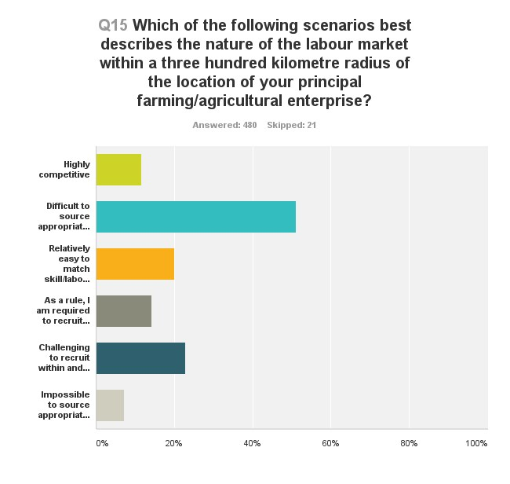
Answer Choices | Responses
Highly competitive | 11.67% | 56
Difficult to source appropriately skilled and trained personnel | 51.04% | 245
Relatively easy to match skill/labour needs within the immediate area | 20% | 96
As a rule, I am required to recruit from outside my local area | 14.17% | 68
Challenging to recruit within and outside my local/regional area | 22.92% | 110
Impossible to source appropriately skilled personnel | 7.29% | 35
Total Respondents: 480

Q16 What methods do you adopt when looking to recruit workers?
Answered: 479 Skipped: 22

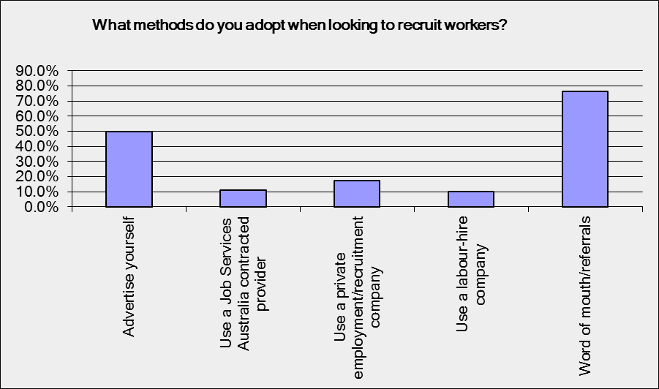

Answer Choices | Responses
Advertise yourself | 49.90% |  | 239
Use a Job Services Australia contracted provider | 10.86% |  | 52
Use a private employment/recruitment company | 17.12% |  | 82
Use a labour-hire company | 10.23% |  | 49
Word of mouth/referrals | 76.41% |  | 366
Total Respondents: 479

Q17 Does your enterprise/s use contractors? If yes, please identify range of services.

Answered: 401 Skipped: 100

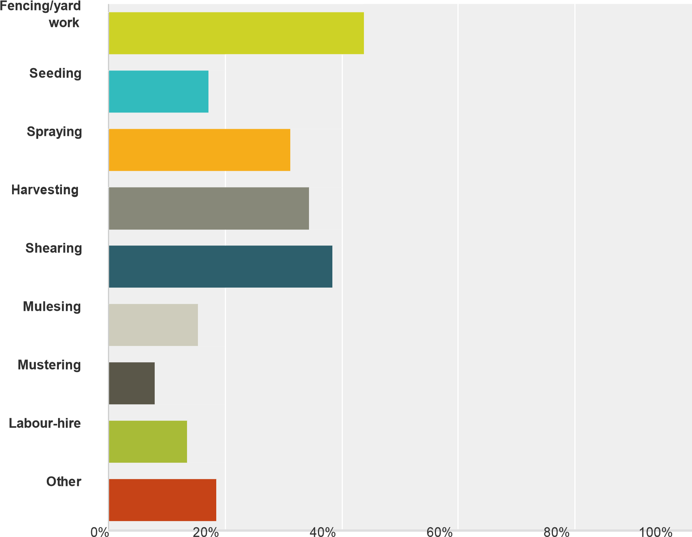

Answer Choices | Responses
Fencing/yard work | 43.89% |  |  | 176
Seeding | 17.21% |  |  | 69
Spraying | 31.17% |  |  | 125
Harvesting | 34.41% |  |  | 138
Shearing | 38.40% |  |  | 154
Mulesing | 15.46% |  |  | 62
Mustering | 7.98% |  |  | 32
Labour-hire | 13.72% |  |  | 55
Other | 18.70% |  |  | 75
Total Respondents: 401

Q18 Is your use of contractors motivated or necessitated by difficulties in recruiting workers? If yes, please explain why?
Answered: 194 Skipped: 307

1 in 5 respondents indicated that their use of contractors is motivated or necessitated by difficulties in recruiting skilled workers.

Q19 Which of the following scenarios best describe your anticipated business performance over the next three to five years? If growth is expected, will it rely on you expanding your workforce?

Answered: 496 Skipped: 5

0
%
20
%
40
%
60
%
80
%
100
%

Improved profitability and growth

Expand into other areas/activities

Maintained at current levels

Likely to contract

May leave the industry

Yes

No

Answer Choices | Responses
Improved profitability and growth | 45.56% | 226
Expand into other areas/activities | 12.70% | 63
Maintained at current levels | 32.06% | 159
Likely to contract | 7.06% | 35
May leave the industry | 13.71% | 68
Yes | 20.56% | 102
No | 16.73% | 83
Total Respondents: 496

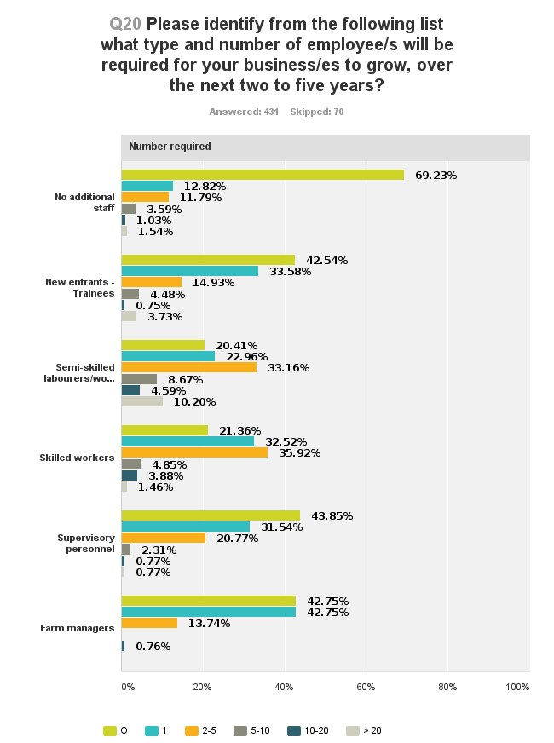

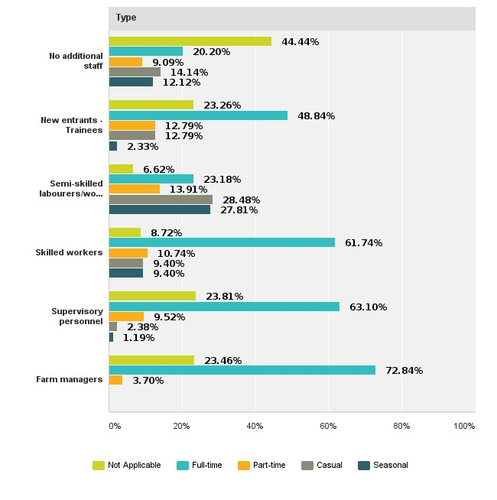

Q21 In the last twelve months, have you or any of your employees undertaken any formal training? If yes, please provide course/skill set or training program name.
Answered: 287 Skipped: 214
40 % of respondents indicated that they or a member of their workforce had undertaken formal training in the last twelve months. 60% of respondents did not.

Q22 In the next six to twelve months, will you or any of your employees commence a course of formal study or look to complete a training program? If yes, please provide course, skill set or training program name/s.
Answered: 232 Skipped: 269
30 % of respondents indicated that they or a member of their workforce would undertake formal training or a training program in the next twelve months. 70% of respondents will not.

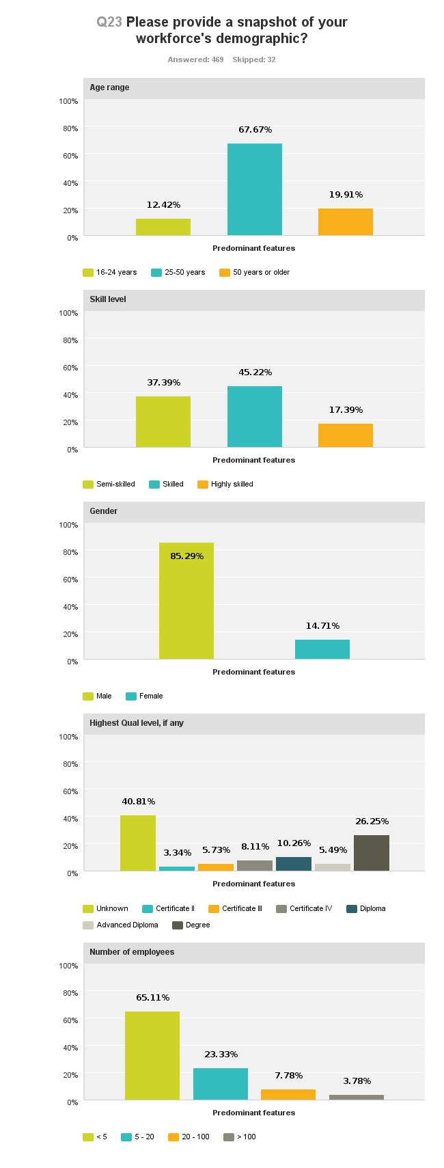
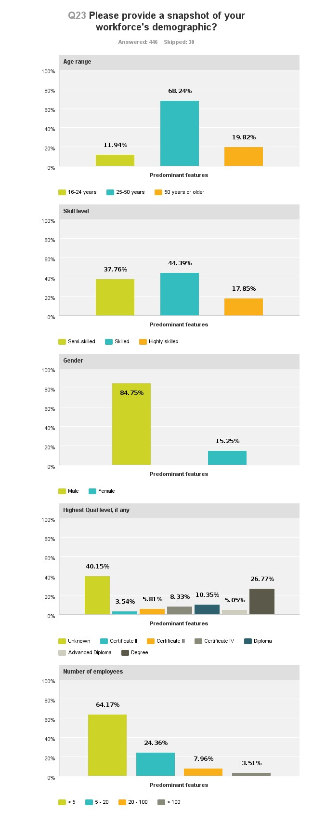

Age range
 |  |  | 16-24 years |  |  |  |  | 25-50 years |  |  |  |  |  | 50 years or older |  |  |  |  |  |  | Total
Predominant features |  |  | 12.42% 58 |  |  |  |  | 67.67% 316 |  |  |  |  |  | 19.91% 93 |  |  |  |  |  |  | 467
Skill lev el
 |  |  |  | Semi-skilled |  |  |  |  |  | Skilled |  |  |  |  | Highly skilled |  |  |  |  | Total
Predominant features |  |  |  | 37.39% 172 |  |  |  |  |  | 45.22% 208 |  |  |  |  | 17.39% 80 |  |  |  |  | 460
Gender
 |  |  |  |  |  | Male |  |  |  |  |  |  | Female |  |  |  |  |  | Total
Predominant features |  |  |  |  |  | 85.29% 348 |  |  |  |  |  |  | 14.71% 60 |  |  |  |  |  | 408
Highest Qual level, if any
 | Unknown | Certificate II |  |  | Certificate III |  |  |  | Certificate IV |  |  | Diploma |  |  |  | Adv anced Diploma |  | Degree |  | Total
Predominant features | 40.81% 171 | 3.34% 14 |  |  | 5.73% 24 |  |  |  | 8.11% 34 |  |  | 10.26% 43 |  |  |  | 5.49% 23 |  | 26.25% 110 |  | 419
Number of employees
 |  |  |  | < 5 |  |  | 5 - 20 |  |  |  | 20 - 100 |  |  |  |  |  | > 100 |  |  | Total
Predominant features |  |  |  | 65.11% 293 |  |  | 23.33% 105 |  |  |  | 7.78% 35 |  |  |  |  |  | 3.78% 17 |  |  | 450

Q24 From your perspective, which of following challenges will have the greatest impact on your enterprise/s in the next three to five years?
Answered: 486 Skipped: 15

Financial viability

65.84
%

Government regulations

Skill and labour shortages

Highly competitive global
markets

42.18
%

36.63
%

6
30.8
%

Threats from mining/CSG
%
14
.40

29.84
%

Climate variability

Other

%
8.85

%
0
%
20
%
40
%
60
%
80
%
100

Answer Choices | Responses
Financial viability | 65.84% |  | 320
Government regulations | 42.18% |  | 205
Skill and labour shortages | 36.63% |  | 178
Highly competitive global markets | 30.86% |  | 150
Threats from mining/CSG | 14.40% |  | 70
Climate variability - including impacts of climate change | 29.84% |  | 145
Other | 8.85% |  | 43
Total Respondents: 486

Q25 What provides the greatest impediment to employing rural and related workers?
Answered: 483 Skipped: 18

 |  |  |  | .76%  50.52 | %
 |  |  | 45
12. | 63%
6.21  %  4.97  % | 22.77%  33 | .54%
Cannot afford to employ additional personnel

Shortage of skilled and committed labour.

Highly competitive labour. markets

Small and inadequate applicant choice.

Government regulations including OHS requirements

Other

No impediments

0% 20% 40% 60% 80% 100%

Answer Choices | Responses
Cannot afford to employ additional personnel | 45.76% | 221
Shortage of skilled and committed labour | 50.52% | 244
Highly competitive labour markets | 12.63% | 61
Small and inadequate applic ant choice | 22.77% | 110
Government regulations including OHS requirements | 33.54% | 162
Other | 6.21% | 30
No impediments | 4.97% | 24
Total Respondents: 483
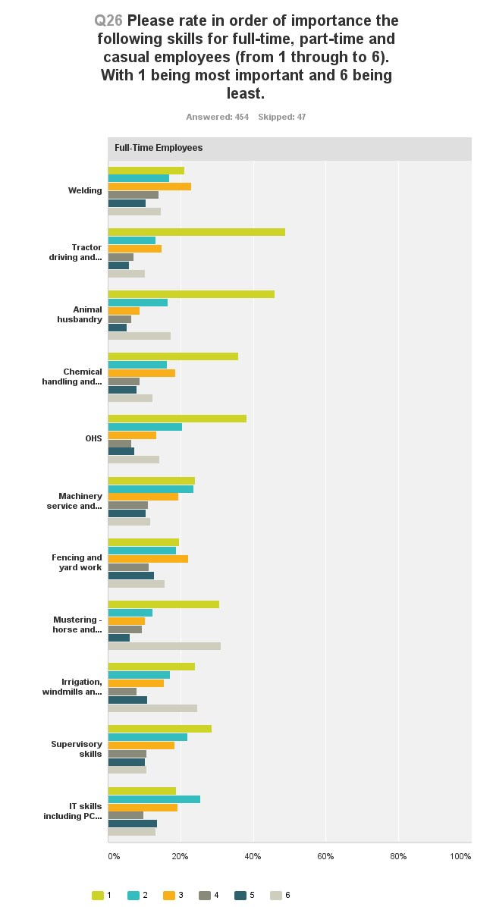
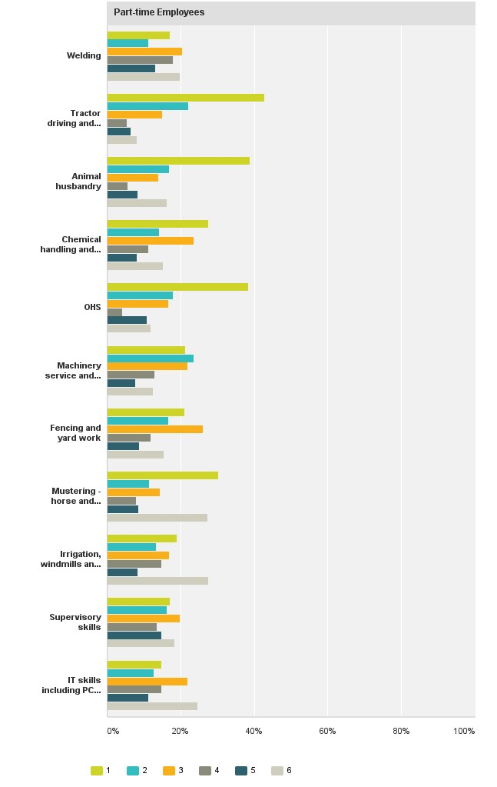
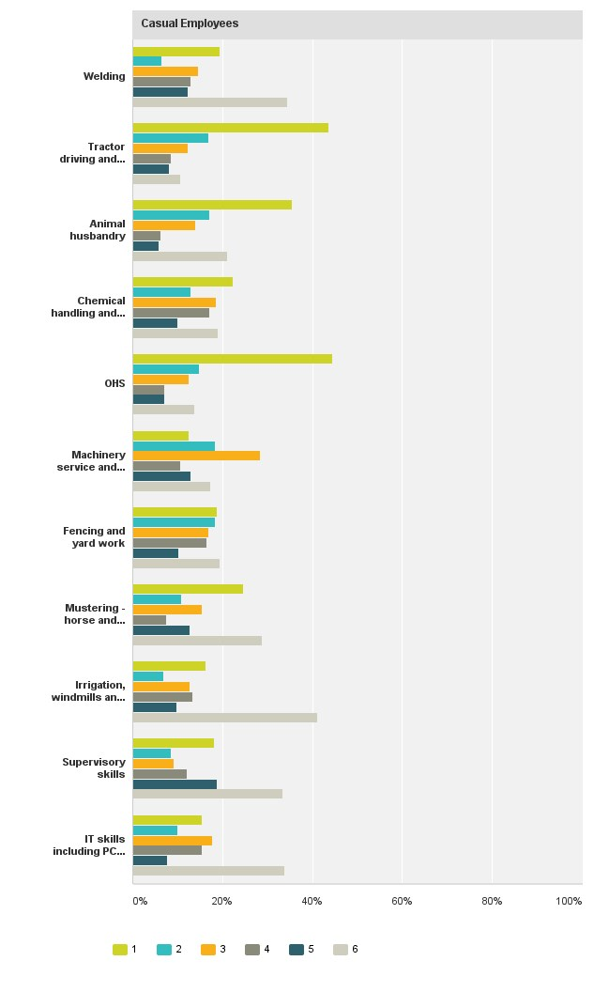
APPENDIX A - Agriculture Workforce - Farm Sector Employer Survey Results

Full-Time Employees
 |  | 1 |  | 2 |  | 3 |  | 4 |  | 5 |  | 6 |  | Total
Welding |  | 21.05% |  | 16.92% |  | 22.93% |  | 13.91% |  | 10.53% |  | 14.66%
 |  | 56 |  | 45 |  | 61 |  | 37 |  | 28 |  | 39 |  | 266
Tractor driving and heavy machinery |  | 48.92% |  | 13.23% |  | 14.77% |  | 7.08% |  | 5.85% |  | 10.15%
 |  | 159 |  | 43 |  | 48 |  | 23 |  | 19 |  | 33 |  | 325
Animal husbandry |  | 45.98% |  | 16.40% |  | 8.68% |  | 6.43% |  | 5.14% |  | 17.36%
 |  | 143 |  | 51 |  | 27 |  | 20 |  | 16 |  | 54 |  | 311
Chemic al handling and application |  | 35.95% |  | 16.34% |  | 18.63% |  | 8.82% |  | 7.84% |  | 12.42%
 |  | 110 |  | 50 |  | 57 |  | 27 |  | 24 |  | 38 |  | 306
OHS |  | 38.26% |  | 20.47% |  | 13.42% |  | 6.38% |  | 7.38% |  | 14.09%
 |  | 114 |  | 61 |  | 40 |  | 19 |  | 22 |  | 42 |  | 298
Machinery service and repairs |  | 23.95% |  | 23.62% |  | 19.42% |  | 11.00% |  | 10.36% |  | 11.65%
 |  | 74 |  | 73 |  | 60 |  | 34 |  | 32 |  | 36 |  | 309
Fencing and yard work |  | 19.57% |  | 18.84% |  | 22.10% |  | 11.23% |  | 12.68% |  | 15.58%
 |  | 54 |  | 52 |  | 61 |  | 31 |  | 35 |  | 43 |  | 276
Mustering - horse and motorbike |  | 30.74% |  | 12.30% |  | 10.25% |  | 9.43% |  | 6.15% |  | 31.15%
 |  | 75 |  | 30 |  | 25 |  | 23 |  | 15 |  | 76 |  | 244
Irrigation, windmills and bores |  | 23.90% |  | 17.13% |  | 15.54% |  | 7.97% |  | 10.76% |  | 24.70%
 |  | 60 |  | 43 |  | 39 |  | 20 |  | 27 |  | 62 |  | 251
Supervisory skills |  | 28.52% |  | 21.83% |  | 18.31% |  | 10.56% |  | 10.21% |  | 10.56%
 |  | 81 |  | 62 |  | 52 |  | 30 |  | 29 |  | 30 |  | 284
IT skills including PCs, GPS, NLIS |  | 18.80% |  | 25.56% |  | 19.17% |  | 9.77% |  | 13.53% |  | 13.16%
 |  | 50 |  | 68 |  | 51 |  | 26 |  | 36 |  | 35 |  | 266
Part-time Employees
 |  | 1 |  | 2 |  | 3 |  | 4 |  | 5 |  | 6 |  | Total
Welding |  | 17.22% |  | 11.26% |  | 20.53% |  | 17.88% |  | 13.25% |  | 19.87%
 |  | 26 |  | 17 |  | 31 |  | 27 |  | 20 |  | 30 |  | 151
Tractor driving and heavy machinery |  | 42.70% |  | 22.16% |  | 15.14% |  | 5.41% |  | 6.49% |  | 8.11%
 |  | 79 |  | 41 |  | 28 |  | 10 |  | 12 |  | 15 |  | 185
Animal husbandry |  | 38.76% |  | 16.85% |  | 14.04% |  | 5.62% |  | 8.43% |  | 16.29%
 |  | 69 |  | 30 |  | 25 |  | 10 |  | 15 |  | 29 |  | 178
Chemic al handling and application |  | 27.65% |  | 14.12% |  | 23.53% |  | 11.18% |  | 8.24% |  | 15.29%
 |  | 47 |  | 24 |  | 40 |  | 19 |  | 14 |  | 26 |  | 170
OHS |  | 38.32% |  | 17.96% |  | 16.77% |  | 4.19% |  | 10.78% |  | 11.98%
 |  | 64 |  | 30 |  | 28 |  | 7 |  | 18 |  | 20 |  | 167
Machinery service and repairs |  | 21.30% |  | 23.67% |  | 21.89% |  | 13.02% |  | 7.69% |  | 12.43%
 |  | 36 |  | 40 |  | 37 |  | 22 |  | 13 |  | 21 |  | 169
 | Fencing and yard work |  | 21.12% |  | 16.77% |  | 26.09% |  | 11.80% |  | 8.70% |  | 15.53%
 |  |  | 34 |  | 27 |  | 42 |  | 19 |  | 14 |  | 25 |  | 161
 | Mustering - horse and motorbike |  | 30.22% |  | 11.51% |  | 14.39% |  | 7.91% |  | 8.63% |  | 27.34%
 |  |  | 42 |  | 16 |  | 20 |  | 11 |  | 12 |  | 38 |  | 139
 | Irrigation, windmills and bores |  | 19.01% |  | 13.38% |  | 16.90% |  | 14.79% |  | 8.45% |  | 27.46%
 |  |  | 27 |  | 19 |  | 24 |  | 21 |  | 12 |  | 39 |  | 142
 | Supervisory skills |  | 17.02% |  | 16.31% |  | 19.86% |  | 13.48% |  | 14.89% |  | 18.44%
 |  |  | 24 |  | 23 |  | 28 |  | 19 |  | 21 |  | 26 |  | 141
 | IT skills including PCs, GPS, NLIS |  | 14.79% |  | 12.68% |  | 21.83% |  | 14.79% |  | 11.27% |  | 24.65%
 |  |  | 21 |  | 18 |  | 31 |  | 21 |  | 16 |  | 35 |  | 142
 | Casual Employees
 |  |  | 1 |  | 2 |  | 3 |  | 4 |  | 5 |  | 6 |  | Total
 | Welding |  | 19.35% |  | 6.45% |  | 14.52% |  | 12.90% |  | 12.37% |  | 34.41%
 |  |  | 36 |  | 12 |  | 27 |  | 24 |  | 23 |  | 64 |  | 186
 | Tractor driving and heavy machinery |  | 43.64% |  | 16.95% |  | 12.29% |  | 8.47% |  | 8.05% |  | 10.59%
 |  |  | 103 |  | 40 |  | 29 |  | 20 |  | 19 |  | 25 |  | 236
 | Animal husbandry |  | 35.59% |  | 17.12% |  | 13.96% |  | 6.31% |  | 5.86% |  | 21.17%
 |  |  | 79 |  | 38 |  | 31 |  | 14 |  | 13 |  | 47 |  | 222
 | Chemic al handling and application |  | 22.38% |  | 12.86% |  | 18.57% |  | 17.14% |  | 10% |  | 19.05%
 |  |  | 47 |  | 27 |  | 39 |  | 36 |  | 21 |  | 40 |  | 210
 | OHS |  | 44.50% |  | 14.83% |  | 12.44% |  | 7.18% |  | 7.18% |  | 13.88%
 |  |  | 93 |  | 31 |  | 26 |  | 15 |  | 15 |  | 29 |  | 209
 | Machinery service and repairs |  | 12.50% |  | 18.27% |  | 28.37% |  | 10.58% |  | 12.98% |  | 17.31%
 |  |  | 26 |  | 38 |  | 59 |  | 22 |  | 27 |  | 36 |  | 208
 | Fencing and yard work |  | 18.84% |  | 18.36% |  | 16.91% |  | 16.43% |  | 10.14% |  | 19.32%
 |  |  | 39 |  | 38 |  | 35 |  | 34 |  | 21 |  | 40 |  | 207
 | Mustering - horse and motorbike |  | 24.71% |  | 10.92% |  | 15.52% |  | 7.47% |  | 12.64% |  | 28.74%
 |  |  | 43 |  | 19 |  | 27 |  | 13 |  | 22 |  | 50 |  | 174
 | Irrigation, windmills and bores |  | 16.18% |  | 6.94% |  | 12.72% |  | 13.29% |  | 9.83% |  | 41.04%
 |  |  | 28 |  | 12 |  | 22 |  | 23 |  | 17 |  | 71 |  | 173
 | Supervisory skills |  | 18.18% |  | 8.48% |  | 9.09% |  | 12.12% |  | 18.79% |  | 33.33%
 |  |  | 30 |  | 14 |  | 15 |  | 20 |  | 31 |  | 55 |  | 165
 | IT skills including PCs, GPS, NLIS |  | 15.38% |  | 10.06% |  | 17.75% |  | 15.38% |  | 7.69% |  | 33.73%
 |  |  | 26 |  | 17 |  | 30 |  | 26 |  | 13 |  | 57 |  | 169

