Migrant Intake Into Australia

Submission to the Productivity Commission Issues Paper

June 2015

Table of Contents

1. rural HEALTH workforce aUSTRALIA 3

2. MIGRANT INTAKE INTO AUSTRALIA 5

2.1 Background -Maldistribution of the healthcare workforce in Australia 5

2.2 The use of migration to address health workforce shortages 6

2.3 The use of migration to address health workforce maldistribution 7

2.4 The need for ongoing health migration 9

2.5 The global health workforce market 10

2.6 Issues relating to the health workforce migrant intake into Australia 11

3. RECOMMENDATIONS 14

- RURAL HEALTH WORKFORCE AUSTRALIA

Rural Health Workforce Australia (RHWA) is the national peak body for Australia’s network of state and territory Rural Workforce Agencies. The independent, not-for-profit RWA Network is comprised of Rural Health Workforce Australia (RHWA) and the seven State and Territory based Rural Workforce Agencies (RWAs):
- Rural Health Workforce Australia
- NSW Rural Doctors Network
- Rural Workforce Agency Victoria
- Health Workforce Queensland
- Rural Doctors Workforce Agency (South Australia)
- Rural Health West (Western Australia)
- Northern Territory Medicare Local
- Health Recruitment Plus – Tasmania

Our Network is committed to making healthcare more accessible for the people of regional, rural and remote Australia by providing a skilled workforce that meets communities’ health care needs. We provide a wide range of services to regional, rural and remote general practices, Aboriginal and Torres Strait Islander health services, dental and primary care services, including:
- attraction, marketing and career advice
- recruitment
- locum support
- training and continuing professional development activities
- ongoing professional and family support services for healthcare professionals
- practice support services
- medical specialist and multidisciplinary outreach health service teams
- community and health service development
- project management
- research and policy advice
- communications and advocacy

This submission addresses issues relating to the role of migration in Australia’s healthcare workforce, particularly in regional, rural and remote communities. For the sake of brevity, data and examples in the submission generally relate to general practitioners, however many of the issues raised apply to the health workforce more broadly (notable exceptions are highlighted where relevant).
This submission addresses skilled healthcare migration undertaken for economic reasons or for positive social benefits to Australia. Migration programs for humanitarian or altruistic benefits are not addressed.

- MIGRANT INTAKE INTO AUSTRALIA

2.1 Background – Maldistribution Of The Healthcare Workforce In Australia
Undersupply and maldistribution of health professionals in rural and remote areas is a persistent global problem. As a geographically large and relatively sparsely populated country, Australia is no exception and gaps in access to health services have been evident for many decades.
Poorer access to quality healthcare providers has been cited as one of the primary causes of health inequity and poorer health outcomes. For example, the life expectancy of Australians living in rural and remote areas is up to 7 years less than that of those in our major cities and cancer survival rates decrease with increased rurality.
Efforts to address inequitable access to healthcare have predominantly focussed on the maldistribution of General Practitioners (GPs) in Australia. Despite significant improvements in recent years, in 2013 there were 988 people living in major cities for every 1 Full-time Working Equivalent, (FWE) GP compared with 1,551 people in rural and remote Australia for every FWE GP.
Figures are similar for most healthcare professionals (nursing being a notable exception). Figure 1 shows that the number of Full-Time Equivalent (FTE) allied health professionals per 100,000 population declines significantly with increasing rurality.

Figure 1:
Selected allied health professionals (Full-Time Equivalent) by Remoteness Area,
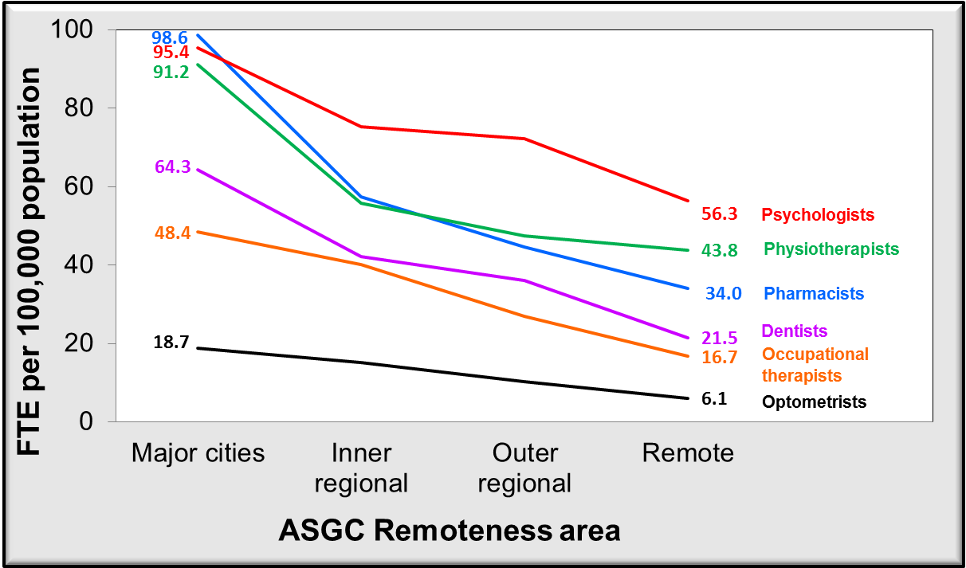

2.2 The Use Of Migration To Address Health Workforce Shortages
Australia has a long history of using migration as a tool to address healthcare workforce shortages, and more recently to address workforce maldistribution issues. The first Overseas Trained Doctors (OTDs) arrived in Australia in the early 1920s and increased significantly following the second World War. Today, OTDs comprise 40% of Australia’s total GP workforce, and over 44% of the GPs outside of major cities. In some states OTDs comprise more than 50% of the GP workforce in regional, rural and remote areas.
Figure 2 highlights the growing importance of migration in Australia’s GP workforce. Some 30 years ago, OTDs comprised approximately 25% of the workforce, growing to 40% today. Australian Trained Doctor (ATD) numbers peaked in 1997 then declined for many years before beginning to rise again in around 2005. It was only in 2012 that the number of ATDs in the GP workforce passed their 1997 peak. Neither Australia’s population nor our demand for GP services declined during that period – quite the opposite, and OTDs filled that workforce gap.
Migration has also been used (and continues to be used) to address shortages in other health professions, notably nursing and dentistry.

Figure 2:
Growth in the GP workforce 1984-2014 – Australian Trained and Overseas Trained Doctors
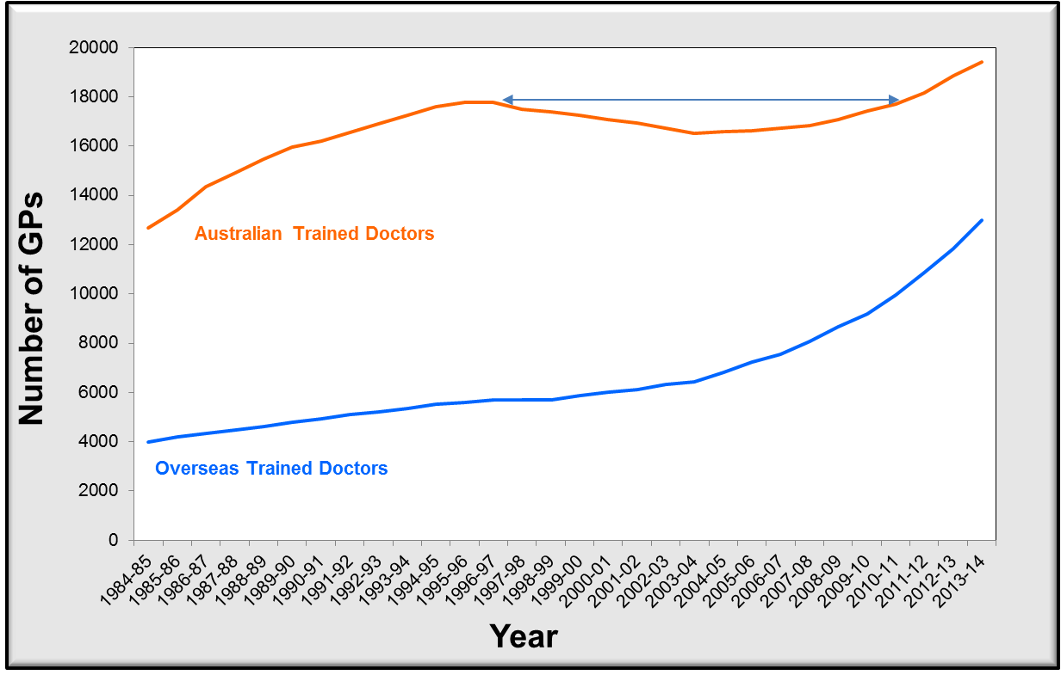

2.3 The Use Of Migration To Address Health Workforce Maldistribution
In addition to shortages, migration is used to address the maldistribution of the GP workforce in Australia. This is achieved through restricting OTDs’ ability to access Medicare unless they work in areas deemed to be Districts of Workforce Shortage (DWS). Under Section 19AB of the Health Insurance Act (1973), OTDs are required to work in a DWS for 10 years from the time of their first Australian medical registration in order to access Medicare benefits arrangements. This is commonly referred to as the “10 year moratorium”. In 2010, ‘scaling’ was introduced offering OTDs the opportunity to reduce the 10 year moratorium restriction period down to five years. Under the scaling program, time reductions are significantly greater for doctors who choose to work in more remote locations. Major cities are now the only locations subject to 10 years return of service by OTDs.
The moratorium was introduced in 1996-97 and its impact is evident in Figure 3 – the growth of OTDs working in major cities was immediately arrested while the growth of OTDs in rural and remote areas accelerated. As the first wave of doctors subject to the moratorium finish their 10 year service (around 2005), the growth of OTDs in major cities begins to grow again.

Figure 3:
Growth in the GP workforce 1984-2014 – Australian Trained and Overseas Trained Doctors
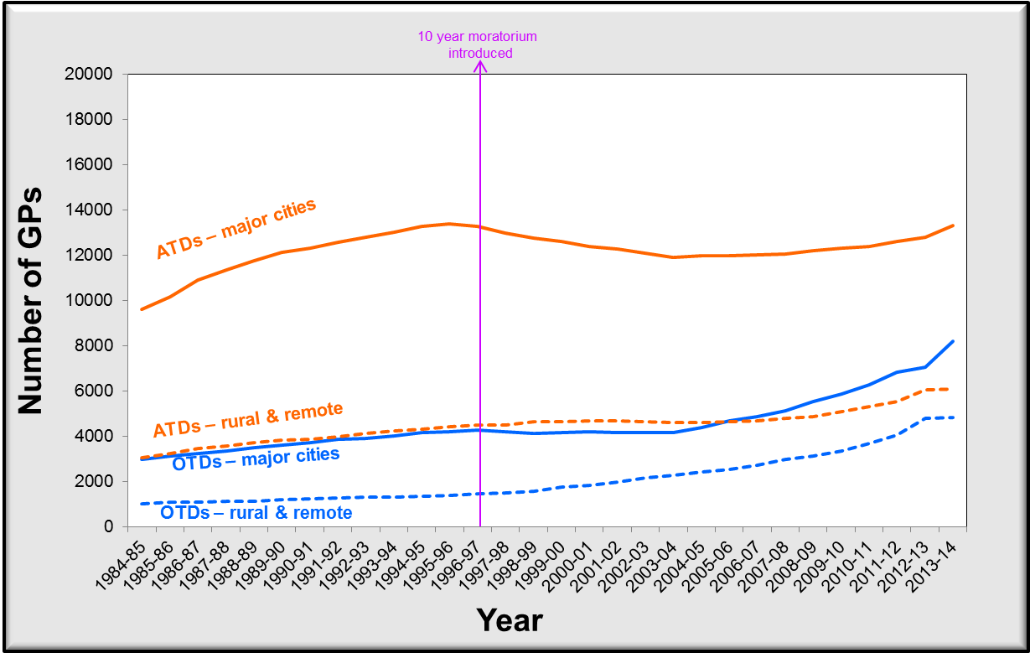

2.4 The Need For Ongoing Health Migration
With a stated aim of ‘self-sufficiency’ in regards to the medical practitioner workforce,, over the past decade the Australian government has made significant investments to address the issue of shortages and maldistribution of Australian trained medical practitioners. Central to this has been a large increase in medical student places from 8,689 domestic students in 2006 to 14,267 in 2013. This strategy is premised on the assumption that if medical school graduate numbers are dramatically increased, the forces of supply and demand will ameliorate geographic maldistribution issues as new graduates move to areas where there are jobs.
However it appears unlikely that enough new medical graduates will enter the specialities where they are needed let alone the geographic areas. For example, the latest data from the Medical Schools Outcome Database longitudinal study of students at Australian medical schools highlights that of graduating students only 13% list general practice as their preferred speciality and less than 5% state an intention to have their future medical practice in smaller towns and communities (defined as a population of less than 25,000).
In 2012 Health Workforce Australia published Australia’s first long-term, national projections for doctors, nurses and midwives. Future workforce modelling suggested that for Australia’s medical workforce to be self-sufficient by 2025 the geographic distribution of doctors would need to improve by 100% compared with 2012. Hence, there was a predicted continued reliance on medical migration to augment workforce supply until at least 2025. The report also forecast highly significant nursing workforce shortages (more than 100,000) by 2025.
Hence, despite continued efforts to train and attract more Australian trained health professionals to work in regional, rural and remote Australia, migration will continue to play a significant role in meeting Australia’s health workforce needs in the foreseeable future (albeit to a potentially reduced extent as more Australian trained professionals enter the workforce).

2.5 The Global Health Workforce Market
Healthcare migration (as with other professions) is becoming increasingly mobile and Australia competes in a global market for a skilled health workforce. Healthcare professionals are highly sought after around the world. For example, over the next 5 years there is predicted to be a shortage of 500,000 nurses in Europe and a need for 8,000 new GPs in England alone.
With respect to medical migration, Australia predominantly competes for doctors with other English-speaking OECD countries – the United Kingdom, Ireland, the United States, Canada and New Zealand. Interest in migration to Australia is a product of various ‘push’ and ‘pull’ factors.
Push factors are issues in the source country that may increase a professional’s desire to emigrate. Recent examples include a down-sizing of the UK’s National Health Service which led to a spike in emigration of experienced and well-trained doctors, nurses and health administrators. Other push factors include economic factors (eg the impact of the Global Financial Crisis in Ireland) and civil war.
Pull factors are those issues that attract a healthcare professional to another country. In Australia’s case, such pull factors may include better living conditions, higher salaries, a warmer climate, political stability, etc. As our reliance on overseas trained doctors (and other health professionals such as nurses) continues, Australia needs to be internationally competitive as an attractive destination for health workforce migration.

2.6 Issues Relating to the Health Workforce Migrant Intake Into Australia
Bureaucracy and red tape
In 2012, a comprehensive report into the registration processes and support for OTDs was undertaken by the House of Representatives Standing Committee on Health and Ageing (the ‘Lost in the Labyrinth’ report). The report found that OTDs and the agencies working with them faced significant bureaucratic complexities and inefficiencies. A total of 45 recommendations were made to address these issues and while some progress has been made, ongoing effort and commitment in this area is required from all stakeholders.
These regulatory barriers and red tape add to the time and costs for doctors choosing to work in Australia, creating disincentives and making it more difficult for Australia to recruit skilled migrants in the global market. The process for an OTD to progress from recruitment to commencing work requires applications and approvals by a variety of agencies at multiple stages including the Australian Medical Council, the Australian Health Practitioner Regulation Agency and specialist training colleges such as the Royal Australian College of General Practitioners. The fees involved can often exceed $10,000 in addition to the cost of visas and the actual relocation (ie airfares and removalists). As such, Australia could be viewed as an expensive and bureaucratically complex country to emigrate to relative to our competitors.
The Productivity Commission Issues Paper asks for examples of policy issues created by the shift from permanent to temporary migration in Australia and this area is highly relevant to illustrating how bureaucratic processes can act as a disincentive and negatively impact on both doctors and the rural and remote communities they serve.

CASE STUDY

Loss of Medicare provider number when an OTD with a temporary visa gains permanent residency or citizenship

The RWA Network administers the Rural Locum Relief Program (RLRP) which is an approved workforce program under Section 3GA of the Health Insurance Act 1973.

The RLRP enables overseas-trained doctors (OTDs) with permanent residency or Australian citizenship to undertake work in rural and remote general practice and access a Medicare provider number while working towards post-graduate general practice qualifications.

OTDs with a temporary visa are not eligible for the RLRP however they can work in rural and remote (or outer metropolitan) general practice in a District of Workforce Shortage with a 19AB exemption.

When an OTD with a temporary visa attains permanent residency or citizenship they then become subject to Section 19AA (which requires vocational or specialist registration, ie Fellowship of a specialist college). If they do not have Fellowship they must apply for the RLRP.

The administrative process and paperwork involved in applying for the RLRP and receiving a new 19AB exemption and Medicare provider number can take from 2 to 6 weeks (and sometimes longer).

During this time, the doctor has no Medicare provider number and is unable to offer any Medicare-rebated services to patients. In the scenario of a solo rural doctor town, the community could effectively lose access to vital general practice services.

Stakeholder engagement and workforce planning
In addition to these bureaucratic issues, Australia’s health migration policy requires continued stakeholder engagement, coordination and workforce planning to ensure that supply closely matches demand. To take one example, Health Workforce Australia modelling of the dental workforce published in 2014 highlighted both a current and forecast mild oversupply of dentists. Despite this, dentists remain on the Skilled Migration List at a time when there is an adequate supply of Australian trained dentists and policy initiatives such as the Dental Relocation and Infrastructure Support Scheme exist to address the dental workforce maldistribution.
With regard to doctors, as more Australian-trained medical graduates enter the workforce and achieve specialist registration there is likely to be a reduced need for migration. Other policy initiatives such as bonded medical places are also likely to impact in the future, again potentially reducing the level of migration necessary to address non-metropolitan workforce needs. The 457 Temporary Migration Visa Program under which most Overseas Trained Doctors enter Australia is uncapped and should, in theory, be responsive to market forces. Doctors coming to Australia on 457 visas are specifically recruited to fill a need in regional, rural or remote Australia or the need for certain specialist skills/ qualifications. If Australian Trained Doctors fill this need, there would be no need for Overseas Trained Doctors on 457 visas (who must have a job offer/ employment contract prior to entry).
As has been noted however, despite increasing numbers of Australian Trained Doctors, significant specialty and geographic maldistribution persists. With the demise of Health Workforce Australia, it is important that ongoing planning and consultation continues to ensure health workforce migration policy settings are appropriate. As a minimum, regular input is required from the Department of Health, Department of Immigration and Border Protection, Department of Education and Training, universities, specialist colleges and training providers, rural workforce agencies and professionals associations.

Unintended consequences of health workforce migration
Health workforce migration is a relatively fast and effective remedy to address workforce shortages and maldistribution (compared with the time taken to train a domestic student). However over time, there can be ‘downstream’ consequences that require holistic monitoring to recognise and address. For example, upon graduation from university, Australian Medical Graduates (AMGs) are required to undertake a minimum of 1 to 2 years’ postgraduate training in clinical hospital rotations. AMGs are essentially guaranteed a hospital placement upon graduation and the recent doubling of medical undergraduates is placing a strain on the hospital system to accommodate these junior doctors.
There is anecdotal evidence emerging that many OTDs who were recruited some years ago to fill shortages of Medical Officers in the hospital system are being displaced to make positions available for AMGs. These OTDs, who may be Permanent Residents or Australian citizens, are often unable to find other work as medical professionals. Again, regular consultation with relevant stakeholders is required so that these issues can be identified early and acted upon.

- RECommendations
To re-cap:
- Australia has an overall shortage of some healthcare professionals;
- all healthcare professionals (with the exception of nurses) are maldistributed, with access declining with increased distance from major cities;
- despite ongoing efforts to train more professionals domestically (along with other policy initiatives such as rural student quotas and financial incentives), in the short to medium term Australia will continue to rely on health workforce migration to meet demand for services, particularly in regional, rural and remote communities; and
- Australia competes in a global market for skilled healthcare professionals, predominantly with English-speaking OECD countries.

As such, Australia’s migration policy with respect to the health workforce needs to ensure that:
- Australia is perceived as an attractive place to work and live;
- Australia’s migration processes and costs are competitive with other OECD countries such as New Zealand, Canada, the UK and the USA;
- the supply of health professionals closely matches need/ workforce gaps;
- the supply of health professionals does not negatively impact on opportunities for Australian trained healthcare workers; and
- policy settings favour the most highly skilled/ best trained healthcare professionals.

RECOMMENDATIONS

Efforts continue to streamline the processes involved in migrating to Australia for healthcare professional.
Migration policies and fees position Australia as an attractive choice relative to other English-speaking OECD countries.
Costs and fees are adjusted such that migration is more attractive for the most skilled and experienced healthcare professionals – for example, fees could be reduced for a doctor with GP training and qualifications and increased for those with little or no general practice experience.
Policy settings are adjusted to ensure a smooth transition to permanent residency or Australian citizenship for healthcare professionals, especially doctors who at present are unable to access a Medicare provider number for a period of time while the appropriate paperwork is completed.
There is regular and ongoing stakeholder liaison and workforce planning to ensure:
- intake levels meet Australia’s needs;
- any unintended consequences are recognised in a timely manner; and
- the Skilled Migration List reflects workforce needs.

World Health Organization 2010. Increasing access to health workers in remote and rural areas through improved retention: global policy recommendations. Geneva: WHO
Duckett S, Breadon P & Ginnivan L 2013. Access all areas: new solutions for GP shortages in rural Australia. Grattan Institute: Melbourne
World Health Organization. 2010. Op cit.
Australian Institute of Health and Welfare 2014. http://www.aihw.gov.au/rural-health-life-expectancy/, accessed 7/4/2014.
Australian Institute of Health and Welfare 2012. Australia’s health 2012. Australia’s health series no 13 Cat. No. AUS 156. Canberra:AIHW.
Australian Bureau of Statistics 2014. Regional population growth, Australia. Cat. No. 3218.0. Canberra: ABS.
FWE is a measure of service provision produced by Medicare taking into account doctors’ varying workloads. FWE is calculated by dividing each doctor’s Medicare billing by the average billing of full-time doctors for the reference period.
Australian Government Department of Health 2014. General Practice Workforce Statistics, http://www.health.gov.au/internet/main/publishing.nsf/Content/General+Practice+Statistics-1, accessed 08/05/2015.
Australian Standard Geographic Classification Remoteness Area (ASGC-RA). ASGC-RA is a geographic classification system that was developed in 2001 by the Australian Bureau of Statistics (ABS), as a statistical geography structure which allows quantitative comparisons between 'city' and 'country' Australia. The RA categories are - RA1: Major Cities of Australia; RA2: Inner Regional Australia; RA3: Outer Regional Australia; RA4: Remote Australia; and RA5: Very Remote Australia.
Australian Institute of Health and Welfare 2014. Dental workforce 2012. National health workforce series No. 7. Cat. No. HWL 53. Canberra: AIHW.
Australian Institute of Health and Welfare 2014. Allied health workforce 2012. National health workforce series No. 5. Cat. No. HWL 51. Canberra: AIHW.
Australian Government Department of Health 2014.Op cit.
Ibid.
A district of workforce shortage is a geographical area in which the local population has less access to Medicare-subsidised medical services when compared to the national average. These areas are identified using Medicare billing statistics and geographic distribution of the Australian medical workforce, and the latest residential population estimates as provided by the Australian Bureau of Statistics.
Australian Government Department of Health 2014.Op cit.
House of Representatives Standing Committee on Health and Ageing 2012. Lost in the labyrinth: report on the inquiry into registration processes and support for overseas trained doctors. Canberra.
National Health Workforce Taskforce 2008. Self-sufficiency and international medical graduates – Australia. Melbourne: NHWT.
Medical Deans Australia and New Zealand 2006. http://www.medicaldeans.org.au/wp-content/uploads/2006-Table-1-Domestic-by-year.pdf, accessed 21/02/2014.
Medical Training Review Panel 2014. Seventeenth report. Canberra: MTRP.
Kaur B, Carberry A, Hogan N, Roberton D & Beilby J 2014. The Medical Schools Outcome Database project: Australian medical student characteristics. BMC Medical Education; 14:180.
Health Workforce Australia was abolished on 8 October 2014 with its functions transferring to the Department of Health.
Health Workforce Australia 2012. Health Workforce 2025 – Doctors, Nurses and Midwives – Volume 1, HWA: Adelaide.
The Guardian 2015. http://www.theguardian.com/society/2015/feb/25/britain-gp-shortages-outside-eu-experts, accessed 4/6/2015.
Royal College of General Practitioners 2015. http://www.rcgp.org.uk/news/2015/february/new-league-table-reveals-gp-shortages-across-england.aspx. Accessed 4/6/2015.
Commonwealth of Australia House of Representatives Standing Committee on Health and Ageing. 2012. Lost in the Labyrinth: report on the inquiry into registration processes and support for overseas trained doctors. Commonwealth of Australia: Canberra.
Health Workforce Australia 2014. Australia’s Future Health Workforce–Oral Health – Overview, Department of Health: Canberra.

