Regulation of Australian Agriculture

Submission by Dr John Cooke DSc(hc), PhD, BSc

Focus for this Submission; Rangeland Management

- The focus of this submission is to address whether there are impediments to the diversification of farming activity, including limits on the type and amount of alternative activities that can occur under pastoral leases.

Background to the submission
- The submission will bring to the attention of the Commission an important source of information that addresses the complexity of rangeland rehabilitation, the high cost of rehabilitation and the long timelines involved.
- The northwest of the state of Victoria extends into the semi-arid zone of Australia. Pastoral grazing commenced in the late 1850s and access licences were issued over much of the area.
- From the 1870’s to the 1930’s grazing licences were resumed over approximately 60 % of the mallee zone. This land was subdivided and sold for the purpose of cropping and grazing. Approximately 40 % of the semi-arid zone of Victoria is retained as public land.
- The Victorian Government released Reviews of the use of public land in the Mallee in 1979 and recommended that those areas of public land under grazing occupation be offered to existing landholders under long-term lease arrangements. These arrangements would require the leaseholders to undertake land protection works as a condition of the leases.
- The government and the potential lease-holders had not reached agreement on the level of protection of the land by 1982. Damage due to excessive grazing by sheep was extensive and serious across much of the grazed landscape during the 1982 drought. It was extreme on some holdings.
- Government responded by revoking grazing licences over much of the area and the land was set aside for conservation purposes. Since then the areas have been managed mostly as National Parks.
Rehabilitation and restoration of a degraded pastoral landscape
- In 1990, the Government set about the task of rehabilitating the recently resumed land. That task was approached under a strategic framework. Rehabilitations actions have continued since that time Sandell (2011).

- The key elements of the strategy are;

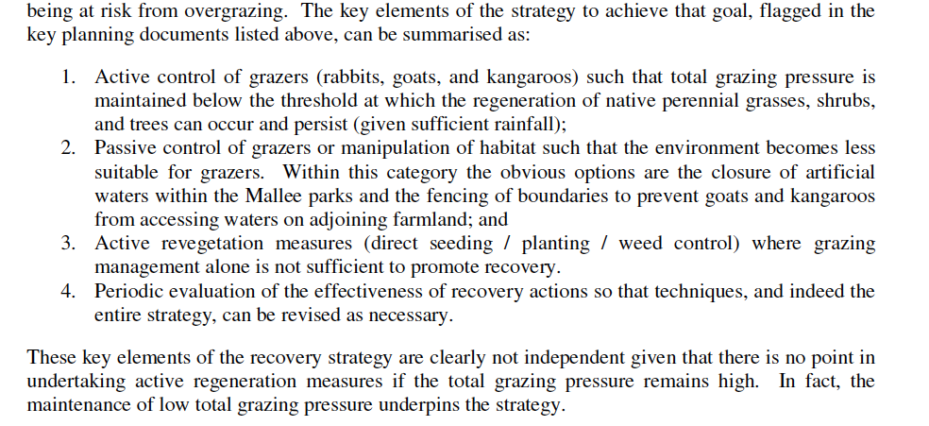
A very important Report on rehabilitation and restoration of a degraded pastoral landscape
- A Report, on the progress made towards the goal of landscape restoration was prepared by the late Peter Sandell in 2011.
- An essential element of the success to-date of the restoration is the strategy that set clear targets for each element of the strategy and to manage towards those targets.
- The monitoring showed that once sheep were removed, rabbit numbers increased, and once rabbit numbers increased kangaroo numbers increased. This clearly demonstrated that controlling just one grazer was not effective. An approach based on total grazing pressure was adopted.
- Whilst the management of total grazing pressure was important, the interaction of the grazer and the nature of the vegetation was also important. Restoration of the original woody landscape requires grazing to be lowered to a point that allows woody vegetation to replace the annual grasses and weeds that colonised the previous over-grazed landscapes.
- The report concludes that total grazing pressure has been significantly reduced since 1990. The removal of sheep, the lowering of kangaroo and rabbit numbers to below target levels has been an essential component of the restoration project.
- Whilst Sandell (2011) does not provide details of the financial cost of the rehabilitation actions detailed in the Report, it does provide sufficient and comprehensive details of the various actions on which costs could be estimated.

- The following can be deduced from the Report;
  - The report clearly demonstrates that overgrazing especially in times of drought leads to land degradation that takes decades and considerable resources to rehabilitate.
  - The reticulation of the supply of water allows for more even grazing across the landscape, but comes at the potential cost of widening the spread of damage caused by overgrazing. Reticulation of stock water supply may extent the area of degradation to previously undisturbed or partially disturbed landscape.
  - That in the semi-arid areas of south-eastern Australia, the cost of rehabilitation most likely outweighs the capital value of the land. In the case of the grazing of the semi-arid woodlands of Victoria the cost of rehabilitation far outweighs the economic benefits derived.
  - The data and details of land rehabilitation in Victoria is highly relevant to similar landscapes in adjoining States. It is also relevant to the discussion around the potential conversion of Pastoral lease to freehold title.
  - It is unlikely that grazing industries on semi-arid lands will generate sufficient income to cover the cost of control of rabbits and other pest animal levels to a density, and for a sufficient period, that allows restoration to occur.
  - It is likely that restoration will only be possible if there is government financial assistance. Even then pest animal management would only be effective if delivered under a strategic and coordinated framework.
  - The need to protect against the loss of carbon and perhaps even build carbon levels may justify Government cost sharing. This investment would be best directed under leasehold rather than freehold tenure.
  - The Commission is therefore urged to have regard to the matters raised in the Sandell (2011) Report in addressing What are the highest priority reforms for improving pastoral lease arrangements?
  - The answer this question lies in the need for reform that protects from further degradation and to commence the long process of restoration of semi-arid rangelands.
End of Submission
Reference
Sandell P (2011) Victoria’s Rangelands: In Recovery or in Transition, Report from a Parks Victoria Sabbatical Project,
http://parkweb.vic.gov.au/__data/assets/pdf_file/0020/521417/Rangeland-master_Final-c2.pdf

