Submission by Dr Laurel Scanlan, A Head Start Children Centre, and Child Essential Learning Systems (CELS).

Our objective is to have the commission fully investigate the cost effectiveness and efficiency of Child Essential Learning Systems (CELS) technology to aid the delivery of high quality outcomes for children 0 to 8 years.

Reasons why online technology should be investigated by the Productivity Commission;

- The efficiencies of this online technology facilitates key decisions to be made to improve early education and care outcomes based on aggregate data that is current, accurate, reliable and instantly accessible. Hence decisions involving public expenditure can be used for grater benefit
NOTE: See excerpts from the report titled “Performance Reporting Systems in Education” by the Victorian Auditor-Generals Office tabled 18th September 2013 in Appendix 1

- This technology allows ECEC information to be monitored continuously to highlight what is working and to reveal trends that equip all stakeholders at all levels, including governments, to make informed decisions

- Access to this online system anytime and anywhere can ensure continuity of training and practice and the integration of support services nationwide including unifying and connecting the Australian and State Governments, Universities and vocational training institutions (RTO’s) and ECEC services to promote high quality teaching and increase workforce capacity and productivity

- This proven online technology is easy to use and reliable and can unify professional learning that prepares and enhances pre-service teachers’ and educators’ competencies and expertise over the course of their study, and this can seamlessly continue when they enter the workforce

- Transitions; all information about each child’s development and learning outcomes is continuously accumulating and instantly available when and where it is needed securely and with privacy e.g. at risk children, support agencies and when transitioning through early education and care and school

- Accuracy; data is of high quality and trusted because the stakeholders creating and monitoring the data can instantly identify errors and quickly resolve these.
- CELS has the National Quality Standard including the EYLF, and the Australian Curriculum inserted.

NOTE: Please refer to Appendix 2 for more in-depth information about the benefits of Child Essential Learning Systems (CELS) for governments.

History of Child Essential Learning Systems (CELS)
  - Child Essential Learning Systems (CELS) is unique patented software that received a COMET Grant (Project No.2009-127) from the Department of Innovation, Industry, Science and Research in 2009. Innovation patent 2012100860 and Innovation patent 2010101352.

  - CELS paperless software has been used exclusively by A Head Start Children’s Centre, Currumbin, Qld since January 2008 and A Head Start Children’s Centre, Burleigh Heads, Qld

since opening in April 2009 to record and monitor the continuous pedagogical documentation and progress of each child’s learning and development.

  - A Head Start Children’s Centre, Currumbin which provides education and care for children 0 to 5 years has 6 years of continuous learning and developmental data completed online for each child (some who have attended for over 4 years). This data includes programs and an array of observations that have been recorded and assessed using the Early Years Learning Framework (EYLF). All stakeholders have been able to easily access and monitor each child’s learning progress anytime online and this data can seamlessly transition onto school with the child.

  - CELS online was examined under the National Childcare Accreditation Council (NCAC) accreditation process twice since January 2008, first at A Head Start Children’s Centre, Currumbin, Queensland, in 2009 and second at A Head Start Children’s Centre, Burleigh Heads, Qld in 2010. Both centres received a high quality rating for all seven quality areas.

  - CELS online has also been through the new National Quality Standard (NQS) assessment process introduced by Australian Children’s Education and Care Quality Authority (ACECQA), specifically;
    - August, 28th 2012 A Head Start Children’s Centre, Currumbin, Qld submitted their Quality Improvement Plan online to the Office of Early Childhood Education and Care (OECEC)
    - October, 24th 2012 A Head Start Children’s Centre, Currumbin, Qld
was assessed against the National Quality Standard (NQS) and was awarded "Exceeding national quality standard” for all seven (7) Quality Areas and also met all 58 Elements of the NQS. Refer to Service Approval Number: QSA-801610 and Assessment and ratings ID: 12/252137.

APPENDICES

Appendix 1: PERFORMANCE REPORTING SYSTEMS IN EDUCATION
Report by the Victorian Auditor-Generals Office tabled on the 18th September 2013 Title of report “Performance Reporting Systems in Education”
Excerpts below from this recent study of the Department of Education and Early Childhood Development (DEECD) Victoria, highlights the need for more efficient and effective performance reporting systems in early education.
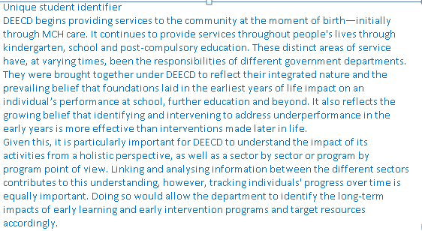
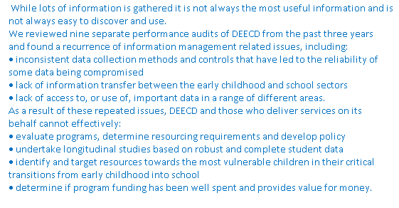

Appendix 2: Benefits of Child Essential Learning Systems (CELS)

  - Monitor the programming master record that instantly displays group and individual programs created for children and instantly flags;
    - Programs that have not been evaluated and if a follow-up program is needed to meet a learning objective
    - Programs that have not been reflected upon for a group and individual children for any date range
  - Can provide helpful online feedback to teachers about particular practices to drive continuous improvement
  - Perform instant online cross checks on each child’s learning outcomes history to identify or flag areas where a child may be at risk or have developmental delay issues to prevent them slipping through the net.
  - Give online access to health professionals, community support services to monitor and provide support for educators and families of children with developmental delay or with special needs in any ECEC service in any location with the parents’ permission
  - Builds respectful and caring relationships between the services personnel, children and families and the service because of the transparency CELS provides for all stakeholders.
  - Provides valuable longitudinal data for researching and health and support services

Benefits of CELS Online: For Governments, and tertiary and vocational training institutions
  - Is proven cloud technology that is secure, easy to install, and to operate and manage
  - Has a powerful search engine to quickly locate specific reports and data for research
  - Creates a more qualified, motivated and productive early childhood workforce.
  - Provides continuous and unified education and assessment systems using any curriculum framework and content for children 0 to 12 years and beyond, for example the EYLF and Australian Curriculum
  - Can connect the Australian and State Governments, Universities and vocational training institutions, and ECEC services to promote integrated high quality teaching to increase workforce capacity and productivity.
  - Reduce costs and increase efficiencies for regulatory authorities because monitoring compliance of the NQF and NQS quality assessment of ECEC services can be viewed online anytime through the CELS NQS reports including the Quality master record, Quality Strengths report and Continuing Improvement Plans.
  - Supports the early childhood workforce, especially in the context of the National Quality Standard and the Early Years Learning Framework.
  - Fosters professional learning that prepares and enhances pre-service teachers’ and educators’ competencies and expertise over the course of their study and can seamlessly continue when they enter the workforce.
  - Is a connected process that is flexible, time saving and effective, and thus reduces stress and burnout in the workplace
  - Promotes high workplace satisfaction, morale and retention of personnel
  - Develops outstanding collaboration, confidence, enthusiasm and extension of knowledge
  - Ability to implement online continuous and ongoing improvement to curriculum and teaching practices
  - Online access to every child’s comprehensive continuum of learning and development in ECEC services and could align this information with the Australian Early Development Index (AEDI).
  - Easy for governments, community and ECEC services to create specific reports and graphs from up to the minute information stored indefinitely in CELS database
  - Provides information for longitudinal studies of the effectiveness of government policy
  - Provides online access to more learning resources and ‘real’ experiences for training institutions
  - Offers online professional support, development and leadership to early childhood teachers and carers in regional, rural and remote communities
  - Connected online channels of communication between universities, pre-service teachers and ECEC services
  - Online access for health professionals, community support services and training institutions can provide instant online support for teachers and carers of special needs children or students working in isolated locations.
  - Provides online NQS quality monitoring reports and support for teachers/educators and management of ECEC services to achieve the highest rating for the National Quality Standard and to provide ongoing feedback for continual improvement.
  - Provides valuable data to help communities and Governments pin point the types of services and support that young children and families need.

