**Productivity Commission Submission – National Water Reform**

**Rainwater Harvesting Association of Australia**

**18 April 2017**

**Michael Smit, Executive Officer**

Dear Madam/Sir,

Thank you for the opportunity to make a submission to the Productivity Commission on these important issues. The terms of reference the Association is responding to are as follows:

*Broader water policy issues and the role of the NWI in improving outcomes, in particular:*

* *the interaction of water policy with other policy areas such as energy, agriculture, planning, urban supply*
* *whole-of-cycle water management*
* *provision to regional, rural and remote communities, and*
* *the economically efficient provision of water infrastructure.*

The Association has four main points. These are summary points based on a long process of research and analysis[1][2][3].

Water Utilities are no longer behaving as Natural Monopolies.

1. Most of the industry believes that water utilities operate as natural monopolies and therefore they provide the most efficient service and competitors are by definition unable to provide a more efficient service. Because water utilities are considered to provide the most efficient service they are relied on to advise on how services should be delivered. However, natural monopolies exist within a range of production. As networks increase in area and reliance on centralised infrastructure is concentrated it is possible for diseconomies of scale to occur. The defining feature of a natural monopoly is declining marginal cost, increasing production reduces the unit cost of additional units.
2. However, Australian water monopolies have experienced increasing marginal costs for a decade and arguably they now exist not by virtue of being more efficient but by virtue of regulations preventing competing services and with all the economic inefficiency implied.
3. This reflects a water planning approach where water supplies, water security and the level of water treatment has increased however the cost of additional units of water far exceeds traditional unit costs for water. Because these services are regulated to prevent competition households and local communities have no option to choose a cheaper competitive service.
4. National increases in household expenditure relative to the volume of water supplied have been used to calculate the average medium run marginal cost for water services as $77/KL and total water services as $174/KL over the period 2003/4-2015/16. Household expenditure on water services in Melbourne has increased by 143% since 2003/4. The amount of water supplied has increased by 2% since 2003/4. [4]

Figure 1 – Household Expenditure on Water Services for Greater Melbourne 2003/4 -2015/16[5]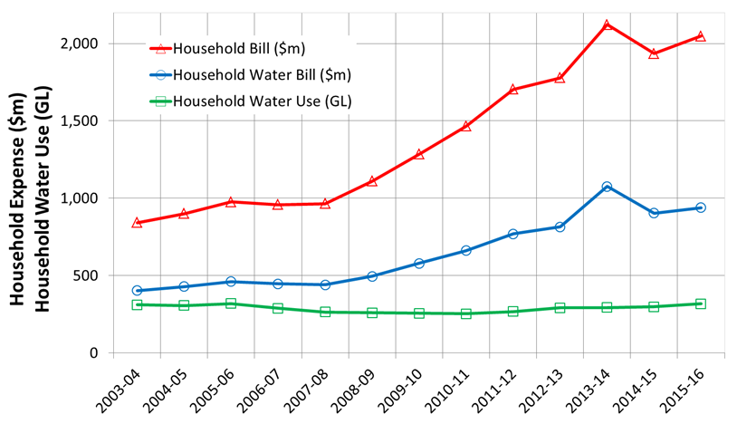

Figure 1 shows that while both water and sewage bills have risen significantly over the last decade water use has been steady. This implies large increases in marginal costs.

1. Household Welfare is key indicator of economic welfare, household expenditure increases of this magnitude have a negative impact across the entire economy. Household welfare is a sensitive issue in the current context of static wage growth and a housing affordability crisis.
2. Research by the recently convened Independent Water Council[6] has shown a pattern of urban fringe housing development is already experiencing competitive water services. Water utilities are declining to service rural fringe hamlets and thousands of dwellings have been constructed with independent water services including rainwater harvesting, groundwater bores and septic tanks. Consultation with these water users indicates a high level of satisfaction with the independent service and a perceived lower cost than water utility services.
3. The Productivity Commission is requested to recommend structural changes to water services in Australia to ensure there is sufficient competition to ensure efficient delivery of water services. Giving permission for competitive water services would provide a useful and practical check on the efficiency of monopoly water services.

## Current Pricing Systems encourage water consumption and discourage alternative water sources

1. The current pricing mechanism for water is complex but can be understood in simple terms. The only factor over which the household has control is the number of kilolitres of water used. By combining all the fixed and variable costs into a single figure and dividing by the kilolitres of water used a rate for water services (both water and sewage) can be derived. Figure 2 shows these rates for one of the major water utilities, however all appear to have a similar pattern.

**Figure 2. Paid price for combined fixed and variable charges for water and sewerage[7]**

1. The important element here is the fixed charges. In this example fixed charges for water services were $500 per year. This charge applies regardless of water use. The average household in this area uses 149KL each year. This equates to water service charges of $1160 of which $500 are fixed costs.
2. There are some far reaching consequences of this pricing structure.
   1. This is a financial penalty applied to competing sources of water that reduce potable water use. Installing a rainwater tank or water efficient appliances reduces the variable charges but not the fixed charges, the homeowner ends up paying a higher rate for less water.
   2. The more water a household uses the less the unit rate for water. The pricing structure has a financial incentive to use more water.
   3. This pricing structure is regressive. Low water users are subsidising higher water users by paying higher unit costs for their water as shown in Figure 3.

**Figure 3 Paid unit rate for low, average and high water users[8]**

1. Figure 3 shows the impact of the pricing structure for homeowners who use less water than the average are paying significantly higher rates ($/KL) than homeowners who use more water than the average. Figure 3 also demonstrates that all homeowners are paying real water rates much higher than the variable charge for water.
2. The Productivity Commission is requested to recommend a pricing structure which does not encourage increased consumption and does not act as a barrier to adopting alternative water sources and water efficient technologies and behaviour.

## The impact of Rainwater Harvesting, alternative water sources and water use behaviour is significantly underestimated

1. The Productivity Commission Issues Report does not acknowledge the existence of rainwater harvesting. Rainwater harvesting provides an estimated 8% of residential demand in Australia, nearly 70% of residential water outside capital cities and 156GL of water worth over $500 million to householders annually. (ABS, 2015). The RHAA considers these to be conservative estimates and that it is unwise to not consider them in a discussion about Australian water. However, this attitude to non traditional water extends to multiple water sources, multiple technologies and multiple behaviours.
2. The following graph shows current actual water use in Melbourne based on a highly detailed assessment of the ABS 2013 surveys.

**Figure 4: Residential water supply in Greater Melbourne for 2016 [9]**



1. Note that behaviour change is derived from shorter showers, less full flushes of toilets and reduced clothes washer loads as defined by the ABS statistics. The quantum of behaviour change has diminished since the 2013 data.
2. Figure 4 demonstrates that while the focus has been on centralised water supplies from water utilities there are actually other important factors at play including distributed supply solutions like rainwater harvesting, greywater reuse and stormwater harvesting and demand side factors including water efficient appliances and water efficient behaviour. Without these factors the mains water demand would be much higher.

**Figure 5 – Annual water savings from Water Efficient Appliances and Rainwater Harvesting[10]**

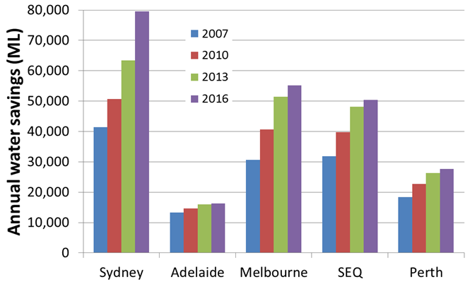Figure 5 demonstrates existing water efficient appliances and rainwater harvesting have made a significant and increasing contribution to water management in Australian capital cities. The Melbourne contribution is nearly 55 GL compared to the utility water supply of 420GL.

1. The Productivity Commission is requested to recommend the scope of water management in Australia be expanded to include rainwater harvesting, recycled water, stormwater harvesting water sources, water efficient technologies and water efficient behaviours.

Sustainable Buildings

1. Water use demand is currently largely driven by households. Integrating water and energy use policies with land use planning and building controls through setting water use performance targets has far reaching impacts through the urban system. Performance based targets allow builders to choose locally efficient water saving options and small but consistent demand reductions have a long term system wide benefit in avoiding and deferring major capital works. Households enjoy more affordable living and urban stormwater systems enjoy reduced stormwater volumes, reduced flooding and improved waterway quality as a result of those households who chose rainwater harvesting. This option has been modelled for a number of Australian capital cities and is verified by an independent analysis of the BASIX program in NSW. This option also responds very favourable to Climate Change scenarios which are now considered to be practical risks rather than conceptual future challenges. This summary represents a major body of work the authors are happy to expand on in a presentation. [11]
2. The Productivity Commission is requested to recommend an independent detailed analysis of the benefits of integrating water cycle and energy management with land use planning and building controls in each capital city in Australia.

1. Peter J Coombes, Michael Smit & Garth MacDonald (2016): *Resolving*

   *boundary conditions in economic analysis of distributed solutions for water cycle*

   *management*, Australian Journal of Water Resources, DOI: 10.1080/13241583.2016.1162762
2. Peter J Coombes, Michael Smit, Josh Byrne, Christopher J Walsh (2016) *Stormwater, waterway benefits and water resources benefits of water conservation measures for Australian cities*, Hydrology and Water Resources Symposium Auckland 2016
3. Peter Coombes, (2017) *Why the water supply needs a splash of competition*, Australian Financial Review January 18, 2017
4. Coombes, Smit 2017
5. Coombes, Smit 2017
6. https://www.independentwatercouncil.org/
7. Coombes, Smit 2017
8. Coombes, Smit 2017
9. Coombes, Smit 2017
10. Coombes, Smit 2017
11. Coombes, Smit 2017