# Productivity Commission

# National Disability Agreement Review

### Submission from the Government of South Australia

### September 2018

### **Introduction**

South Australia welcomes the Productivity Commission’s review into the National Disability Agreement (NDA).

In 2009, the Commonwealth, state and territory governments established the National Disability Agreement (NDA), a high level agreement to work together towards the long-term objective of ensuring:

*“people with disability and their carers have an enhanced quality of life and participate as valued members of the community”.*

Despite national efforts, people with disability and carers continue to face substantial barriers to social and economic participation in society and are among the most disadvantaged in the community[1]. The goals and outcomes agreed by governments a decade ago are still as relevant and important for people with disability and their carers today.

The South Australian Government remains committed to the values underpinning the NDA and is implementing a range of initiatives to work with people with disability, their carers and families to maximise participation, independence, access and inclusion.

However, the NDA itself as a national agreement is no longer up-to-date. As identified by the Productivity Commission, there have been significant changes to the disability policy and service provision landscape.[2] This is particularly the case given the fundamental reforms brought about by the introduction of the *National Disability Strategy 2010-2010* (NDS) and the National Disability Insurance Scheme (NDIS).

The full implementation of the NDIS, including Information, Linkages and Capacity Building in South Australia is not yet complete. In the transition to the NDIS, there are a number of risks which are apparent, including potential service gaps. There is extensive national work underway to determine the detail of how the NDIS will work with mainstream services. The South Australian Government is continuing to progress NDIS implementation issues nationally, with the Commonwealth Government, National Disability Insurance Agency and with other jurisdictions directly and through the Disability Reform Council.

The South Australian Government believes the existing arrangements for the NDIS and NDS are sufficient, and that renewing the NDA will not provide significant benefit for the South Australian community. The existing NDIS Bilateral Agreement and NDS provide sufficient intergovernmental architecture to enable and promote service and community reforms for people with disability.

In addition to existing state-based initiatives, South Australia supports a strengthened and enhanced focus on the NDS (rather than the NDA), to improve the lives of people with disability across a range of areas including inclusive and accessible communities, skills and work, health and wellbeing. This will continue to require the participation of all governments, businesses and the community.

South Australia looks forward to continued participation in the review of the NDS.

**Scope and Purpose of the National Disability Agreement**

The NDA was implemented in 2009, replacing previous iterations of the Commonwealth, State and Territory Disability Agreement.

The focus of the NDA is the provision of disability services, particularly specialist disability services to support people with disability and carers. The NDA also acknowledges that specialist disability services are complemented by mainstream services and income support measures. Mainstream services are services provided to the community as a whole, such as education and health services.

Under the NDA, disability services contribute to the following agreed outcomes:

1. people with disability achieve economic participation and social inclusion
2. people with disability enjoy choice, wellbeing and the opportunity to live as independently as possible
3. families and carers are well supported.

The NDA also includes an extensive framework to measure progress in achieving these outcomes, including benchmarks and performance indicators to aid public accountability.

**Roles and Responsibilities**

The NDA outlines roles and responsibilities of the Commonwealth and states and territories and a unified national disability reform and policy agenda.

South Australia supports the Productivity Commission’s summary of the existing roles and responsibilities under the NDA as reflected in Figure 1.

Under the NDA, the Commonwealth is responsible for providing income support (such as the Disability Support Pension) and employment services.

States and territories are responsible for the provision of specialist disability services (except employment services) and basic community care services (Home and Community Care) for people under 65 years. Under the NDA, in South Australia, as in most jurisdictions, people with psychosocial disability were not eligible for specialist disability services.

In 2011, reforms to the responsibilities for funding aged care and disability services were agreed under the National Partnership for Transitioning Responsibilities for Aged Care and Disability Services (NPA-TRAD).Broadly speaking, the Commonwealth assumed funding and policy responsibility for all aged care and disability services for older people. South Australia became responsible for funding aged care and disability services for people aged less than 65 years (and Indigenous Australians aged less than 50 years). The NDA encompasses these roles.

Shared roles include funding research and provision of data.

| Figure 1 Summary of roles and responsibilities in the current NDA |
| --- |
| | Roles and responsibilities in the NDA either sit with the Commonwealth, the States and Territories or are shared between them. Roles and responsibilities that sit with the Commonwealth include the provision of employment services, incomes support and providing some funds to the States and Territories; funding disability services delivered by the States for the aged; investing in initiatives to support policy priorities; and developing policy and reform directions.   Roles and responsibilities that sit with the States and Territories include the provision of disability services; funding and regulating community care services for people under 65 (50 for Indigenous Australians); funding packaged community and residential aged care delivered under Commonwealth programs to people under the age of 65 (50 for indigenous Australians); and delivering policy and reform directions.   Shared roles and responsibilities include funding and pursuing research; improving continuity of care improving outcomes for Indigenous people with a disability; the provision of data; meeting commitments under  the National Partnership Agreement on Transitioning Responsibilities for Aged Care and Disability Services; and aligning legislation | | --- | |
| a National Partnership Agreement on Transitioning Responsibilities for Aged Care and Disability Services  b Except for Victoria and Western Australia. |
| Source: Productivity Commission (2018) National Disability Agreement Review Issues Paper |

**Funding for Specialist Disability Services**

The NDA does not provide funding for disability services. The Commonwealth has provided funding for specialist disability services to states and territories through national specific purpose payments and various national partnerships.

As shown in Figure 2, the total level of funding for specialist disability services in South Australia increased from $392 million in 2008-09 to $680 million in 2016-17. Over this period, the State Government share of funding for specialist disability services increased from 75% to 85%.

**Figure 2: Total Real Government Expenditure on Specialist Disability Services, South Australia, 2008-09 to 2016-17 (2016-17 Dollars)**

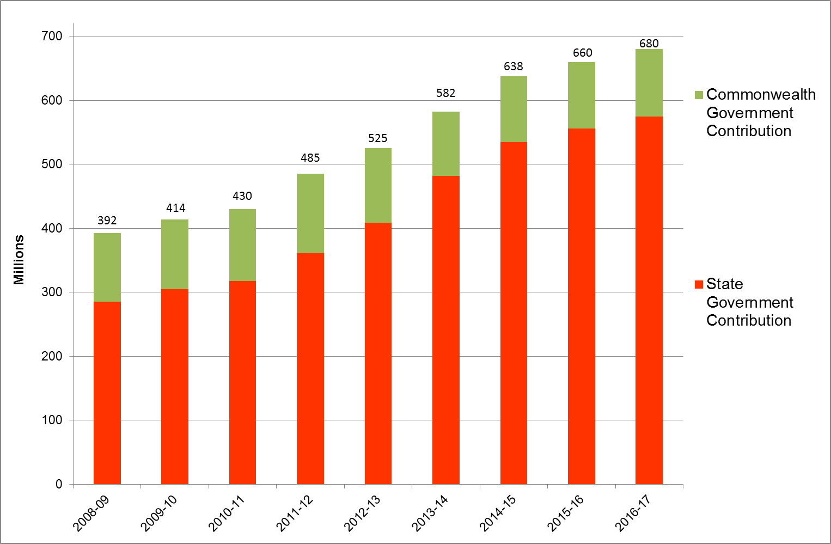

Source: Productivity Commission (2018) *Report on Government Services*, Table 15A.4

**Performance Against the NDA**

**NDA Performance Framework**

South Australia notes that governments have worked together to develop an extensive NDA performance framework, including benchmarks, outcomes, indicators and performance measures.

Benchmarks

Two national benchmarks (targets) were agreed:

1. between 2009 and 2018, there will be a five percentage point national increase in the proportion of people with disability participating in the labour force
2. between 2009 and 2018, there will be a five percentage point national decrease in the proportion of people with disability who report a need for more formal assistance.

Australian Bureau of Statistics *Survey of Disability, Ageing and Carers* data from 2009 to 2015, indicate there has been no significant national change in these proportions over the life of the NDA.[3]

Despite findings of the 2012 review of the NDA, a third national benchmark, with a quantifiable target relating to families and carers, was not developed.

Outcomes

**Outcome 1: People with disability achieve economic participation and social inclusion**

Indicators:

* Proportion of people with disability who receive income support and who also report earnings (for example receiving the Disability Support Pension and working up to 30 hours a week - a measure of economic participation)
* Proportion of people with disability who participate in social and community activities
* Proportion of people with disability in the labour force

**Outcome 2: People with disability enjoy choice, wellbeing and the opportunity to live as independently as possible**

Indicators:

* Proportion of people with disability accessing disability services
* Proportion of younger people entering, living in and exiting permanent residential aged care
* Proportion of people with disability who are satisfied with the range of services available, and with the adequacy and quality of services provided

**Outcome 3: Families and carers are well supported**

Indicators:

* Proportion of carers of people with disability participating in the labour force
* Proportion of carers of people with disability who report their health and wellbeing as positive
* Proportion of primary carers of people with disability who are satisfied with the range of services available and with the adequacy and quality of services provided to the person with disability and to the carer.

Assessment of the NDA Performance Framework

The framework has had the following strengths:

* A strong focus on the outcomes the agreement is seeking to achieve for people with disability, their families and carers (rather than a focus on inputs / funding or outputs / specific services to be delivered)
* Clear expression of the expected relationships between funding for disability services and the associated outputs, desired outcomes and objectives
* A rigorous and transparent approach to articulating performance indicators, their measures / method of computation (numerators and denominators), data sources / providers, baseline data and statements of data quality
* Highlighted data gaps and lags, and provided an impetus for more frequent collection of national data (e.g. Survey of Disability, Ageing and Carers), to support reporting on progress
* Enabled the comparative analysis and independent reporting to track governments’ performance through systemic and regular production and release of performance information, such as occurred via the COAG Reform Council annual reports (up until 2014).

Despite these benefits, it is difficult to determine the precise impact of the NDA performance framework itself in delivering outcomes for people with disability, their families and carers. It is unlikely that the performance framework drove substantive and systemic reform. It is more likely that the performance framework influenced and supported the achievement of existing reform directions and improved outcomes.

An example of success under the NDA has been the reduction of younger people in residential aged care in South Australia, particularly for people aged less than 50 years. This achievement directly relates to the NDA performance indicator ‘*Proportion of younger people entering, living and exiting permanent residential aged care*’, under the outcome area *‘People with disability enjoy choice, wellbeing and the* opportunity *to live as independently as possible’*.

As shown in Table 1, since the NDA was signed in 2008, there has been a gradual, but significant decline in the number of younger people aged under 50 years in residential aged care in SA.

**Table 1: Number of People Aged 0-49 Years in Residential Aged Care, SA, 2008 to 2017[4]**

|  |  |
| --- | --- |
|  | **Number of People Aged 0-49 Years in Residential Aged Care, SA** |
| 2008 | 55 |
| 2009 | 54 |
| 2010 | 53 |
| 2011 | 49 |
| 2012 | 45 |
| 2013 | 43 |
| 2014 | 49 |
| 2015 | 39 |
| 2016 | 41 |
| 2017 | 28 |

*Source:* Productivity Commission *(2018) Report on Government Services 2018,* Table 15A.54 Permanent aged care residents aged under 65 years, 30 June

From the South Australian Government’s perspective, the NDA Performance Framework has served a useful role in tracking progress, but has not enabled this change. Rather, this reflects deliberate long-term reforms, investments and efforts by the South Australian Government to reduce the number of younger people (particularly aged under 50 years) in residential aged care.

There are a number of weaknesses of the performance framework:

* The agreed objective and outcomes are very high level and broad, outside of the control of the South Australian government.

For example, there are a number of complex factors that relate to labour force participation and employment, such as state of the job market, discriminatory attitudes and behaviours during recruitment and difficulties (or perceived difficulties) in ensuring access and flexibility for workers with disability. The provision of specialist disability services is only one lever to improving labour force participation and employment.

* Significant data collection and reporting lags
* Challenges of small sample sizes for some survey data
* Significant data caveats and questionable comparability of some performance data across jurisdictions, leading to a perceived or actual lack of definitive or valuable data
* Overlapping outcomes and reporting between the NDA and NDS, and to a lesser degree the NDIS
* Multiple and sometime overlapping reporting of performance data, for example from the Productivity Commission Report on Government Services, Australian Institute of Health and Welfare, Australian Bureau of Statistics (and previously the COAG Reform Council).
* Lack of performance measures relating to access to, and outcomes for people with disability from mainstream services such as education, health, housing and transport.

Notwithstanding, the South Australian Government acknowledges the important value of transparent and publicly available national data and the role of a coherent national performance reporting system. South Australia also acknowledges gaps in existing mainstream data collections, such as the identification of people with disability.

Given the NDA outcomes sought for people with disability overlap with the NDS, South Australia supports the development of a comprehensive performance reporting system under the NDS framework, which would also include NDIS participants.

Where possible, performance indicators should ideally be disaggregated to support analysis by:

* Disability type or broad categories of impairment (self-care, mobility and communication)
* Gender
* Age (children and older people)
* Indigenous people
* People from culturally and linguistically diverse backgrounds
* People living in rural and remote areas
* Socio-economic status

**NDA Supporting Policy Landscape**

From a South Australian perspective, the South Australian *Disability Inclusion Act* 2018 and *Carer Recognition Act* 2005support the implementation of the NDA.

**South Australian *Disability Inclusion Act 2018***

The *Disability Inclusion Act 2018* (the Act) commenced on 1 July 2018 and provides the legal framework to ensure South Australians with disability have equal access and inclusion in the community. The Act replaces the *Disability Services Act 1993* andaligns with the United Nations Convention on the Rights of Persons with Disabilities and the National Disability Strategy.

The Act requires the State Government to develop a State Disability Inclusion Plan (the Plan). Consultation and engagement will occur with other stakeholders, including people with disability and their carers.

South Australian Disability Inclusion Plan

The South Australian Department of Human Services is currently developing the State Disability Inclusion Plan and will be consulting with people with disability, carers and families and other stakeholders next year before the Plan is finalised. Face-to-face consultation processes are planned across South Australia, including metropolitan and regional centres.

The Plan will set out whole-of-government policies and measures relating to the provision of services and programs delivered by state authorities for people with disability, acknowledging the additional risk and multiple disadvantage faced by women, children, Aboriginal and Torres Strait Islander people and people from culturally and linguistically diverse backgrounds with disability.

To support the operation of the Plan, each State authority is required to develop a Disability Access and Inclusion Plan (DAIP) that includes strategies to facilitate accessibility for people with disability (for example: to built environs; events facilities; information; communication; employment; services; programs; and infrastructure including transport).

The Act imposes obligations on the State government to provide an annual progress report on the Plan, and to review the Plan every four years, to ensure the rights and inclusion of people with disability are being met. State authorities are also obliged to provide an annual progress report and four-yearly review of DAIPs. Annual reports will be presented to both Houses of the South Australian Parliament.

**South Australian *Carer Recognition Act 2005***

The Carer Recognition Act acknowledges the important role of unpaid carers in the South Australian community.

It imposes obligations on government agencies and contracted organisations that provide services to carers and the people in their care in areas such as recognition, consultation and support.

The Act provides a legal framework for South Australian Government departments and government-funded organisations to review and improve how they provide services to carers, and recognise them as employees and partners in the provision of care.

The Act requires State Government agencies to provide services that ensure:

* staff and associates are aware of carers' needs
* carers are consulted in the planning, delivery and review of policies and programs that affect them, including for government and government-funded services that impact on carers
* the relevant principles of the *SA Carers Charter* are followed.

The *SA Carers Charter* is enshrined within the Act and sets out seven principles that guide services for carers:

1. Carers have choices within their caring role.
2. Carers’ health and well-being are critical to the community.
3. Carers play a critical role in maintaining the fabric of society.
4. Service providers work in partnership with carers.
5. Carers in Aboriginal and Torres Strait Islander communities need specific consideration.
6. All children and young people have the right to enjoy life and reach their potential.
7. Resources are available to provide timely, appropriate and adequate assistance to carers.

The South Australian Carers Recognition Act is complemented by the Commonwealth *Carer Recognition Act 2010*.

South Australia supports the key elements of the policy architecture supporting the NDA, as represented by the Productivity Commission in Figure 3.

However, since the introduction of the NDA, there have been a series of fundamental reforms to the disability policy landscape, including the introduction of the United Nations Convention on the Rights of Persons with Disabilities, the National Disability Strategy and the reforms of the NDIS.

**United Nations *Convention on the Rights of Persons with Disabilities***

Whilst it has not been reflected in Figure 3, South Australia particularly notes the importance of the United Nations *Convention on the Rights of Persons with Disabilities* and the broader legislative and policy context.

Australia ratified the UN Convention in July 2008 and as such is obliged to ensure and promote the human rights and dignity of people with disability.

For example, the *National Disability Insurance Scheme Act 2013* was enacted to give effect to Australia’s obligations under the Convention (in conjunction with other laws).

| **Figure 3** **The policy architecture supporting the NDA**  The policy architecture supporting the National Disability Agreement is  provided by the Council of Australian Governments, COAG.  The Council on Federal Financial Relations (CFFR) is one of the eight councils established to support COAG to improve the current and future well-being of all Australians. The CFFR oversees the financial relationship between the Commonwealth and the States and Territories, including the Intergovernmental Agreement on Federal Financial Relations (IGA FFR). The CFFR is comprised of the Commonwealth Treasurer as Chair and the State and Territory Treasurers.  National Agreements define the objectives, outcomes, outputs and performance indicators, and clarify the roles and responsibilities that guide the Commonwealth and the States in the delivery of services in key sectors. There are currently six National Agreements in the health, education, skills and workforce development, disability services, affordable housing and Indigenous reform sectors, and a National Health Reform Agreement:  The National Disability Agreement is associated with a Specific Purpose Payment through which the Commonwealth supports States' efforts in delivering disability services.  The COAG Disability Reform Council oversees the trial and implementation of the NDIS and will make recommendations to COAG on the transition to NDIS full scheme. The Disability Reform Council also ensures a broad range of reforms are implemented through the National Disability Agreement and the National Disability Strategy to support people with disability, their families and carers. The Disability Reform Council is chaired by the Commonwealth Minister responsible for disability and consists of Commonwealth, State and Territory Ministers within disability and treasury portfolios. |
| --- |
| Source: Productivity Commission (2018) National Disability Agreement Review Issues Paper |
|  |

In addition to the NDA, there are now two additional intergovernmental agreements or strategies that exist in the national disability policy landscape.

**National Disability Strategy**

South Australia considers the National Disability Strategy (NDS) to be the preeminent, overarching national strategy, which outlines the shared vision for: *an inclusive Australian society that enables people with disability to fulfil their potential as equal citizens.*

The NDS aims holistically to influence the planning, design and delivery of mainstream policies, programs, services and infrastructure, so that people with disability can participate as equal citizens in all areas of Australian life.

The scope of the NDS includes all people with disability, regardless of the nature or severity of their impairment, whether they have a need for support or are participant or potential participant of the NDIS.

The NDS articulates long-term goals across a number of key policy areas which impact people with disability, their families and carers. These are:

1. Inclusive and accessible communities
2. Rights, protection, justice and legislation
3. Economic security
4. Personal and community support
5. Learning and skills
6. Health and wellbeing

The NDS includes a specific focus on improving community and mainstream services to be available and fully accessible for people with disability.

The NDIS is a significant reform initiative which contributes to the overall implementation of the NDS.

The Commonwealth Department of Social Services is currently conducting a review of the NDS. The objective of the review is to consider the implementation of the Strategy and provide advice on successful implementation processes and measures to inform the development of a new framework for beyond 2020.

South Australia supports a strengthened and enhanced NDS and looks forward to continued participation in the review to ensure government continue to deliver targeted and evidence-based outcomes for people with disability, their families and carers.

**National Disability Insurance Scheme**

In June 2018, the South Australian Government agreed a bilateral agreement with the Commonwealth to implement the full scheme of the NDIS. The Bilateral Agreement outlines the roles and responsibilities of the Commonwealth and South Australia in relation to governance, policy, market development and oversight and funding arrangements for the NDIS.

The Bilateral Agreement is interoperable with the NDIS Act, its associated Rules and the National Disability Strategy.

Under these arrangements, the scope of disability supports under the NDIS is being extended to include people with psychosocial disability.

Funding for the NDIS is shared by the Commonwealth and states and territories. As shown in Figure 4, funding for specialist disability services in South Australia under the NDIS will approximately double to $1.5 billion in 2018-19, compared to funding provided in 2016-17. This includes an agreed South Australian Government contribution of $747.9 million.

**Figure 4: Government Expenditure on Specialist Disability Services, South Australia 2008-09 to 2016-17 and Indicative NDIS Expenditure 2018-19 to 2018-21** [5]

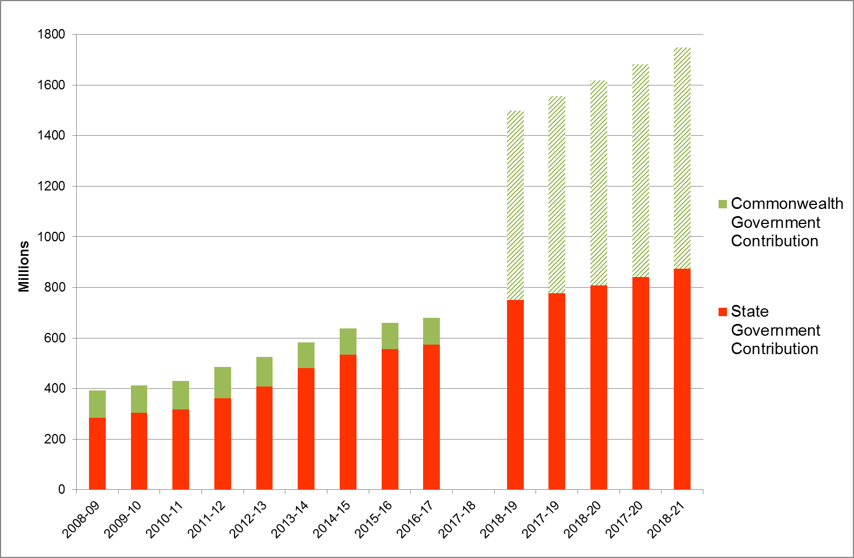

Source: Productivity Commission (2018) *Report on Government Services*, Table 15A.4

The South Australian government has effectively rolled-in existing funding provided for specialist disability services, and is providing additional funding for the NDIS.

The NDIS is rapidly replacing the existing system of disability care and support provided under the NDA framework. In July 2013, the NDIS trial commenced in South Australia. Since that time, a total of 7,777 people receiving specialist disability services have transitioned to receive supports from the NDIS[6]. An additional 10,788 South Australians who were not previously receiving specialist disability services have also become NDIS participants.

In South Australia, approximately 6000 people currently receiving specialist disability services are yet to transition to the NDIS. At the completion of transition, the NDA and its focus on the provision of specialist disability services will no longer be relevant.

Once fully implemented, the NDIS is expected to improve the lives of more than 32,000 South Australians living with disability, their families and carers. This is almost double the number of people receiving specialist disability services in South Australia in 2015-16 (16,932 people).

The NDIS will also create significant employment opportunities for South Australia. It is anticipated the current disability workforce in South Australia will grow from 5,650 – 6,900 current full-time equivalent employees to 10,250 – 12,550 one the Scheme is fully implemented[7].

As identified by the Productivity Commission in Figure 5 below, the NDIS was not envisaged to directly support all Australians with disability. The Scheme funds reasonable and necessary supports, based upon individual needs, for people with permanent and significant disability (individualised supports).

| Figure 5 The NDIS is part of a broader system of supports[8] |
| --- |
| | Figure 1 The NDIS is part of a broader system of supports. This figure is a pyramid that shows that the NDIS targets a subset of people with disability. It shows that there are 23.4 million Australians, all of which receive mainstream services and insurance cover from the NDIS. It shows that 4.3 million Australians have a disability, and in addition to the services received by all Australians, they also receive the services of local area coordination; information, linkages and capacity building; and non-NDIS disability services. And of those with a disability, 475 000 will be NDIS participants receiving NDIS packages, in addition to the services received by all other people with a disability. | | --- | |
| Source: Productivity Commission (2017) NDIS Costs Study Report, p4. |
|  |
|  |

South Australia recognises that there is significant stakeholder concern about what services will be available outside the NDIS and the interfaces of the NDIS with mainstream services. It is important to note that a significantly higher number of South Australians will receive disability support under the NDIS, and the scope of supports has increased.

Under the NDIS Bilateral Agreement, South Australia has agreed to provide continuity of support for people aged under 65 years who were receiving specialist disability services and who may be deemed ineligible for the NDIS. The South Australian Government Department for Human Services Eligibility for Continuity of Support policy and framework defines continuity of support, and provides a consistent and transparent framework for determining eligibility.

Likewise, the Commonwealth Government is providing continuity of support for existing clients of Commonwealth programs. Existing state-administered clients aged 65 years and over who were receiving specialist disability services are now receiving continuity of support through the Commonwealth Continuity of Support Programme.

The National Disability Insurance Agency (NDIA) is continuing to roll-out supports provided under the ILC framework. South Australia recognises the importance of these supports in connecting people with disability, their families and carers with appropriate disability, community and mainstream supports and in promoting community inclusion and participation for all people with disability.

In particular, it is noted that Local Area Coordination has a role in providing short-term assistance to people who do not have an NDIS plan to connect with mainstream services and community activities. South Australia is keen to consider data and evidence regarding the effectiveness and impact of ILC and LAC services, particularly for people with disability who do not have an NDIS plan.

There are a number of risks which are apparent, including potential service gaps in the transition to the NDIS. These can arise when there remains uncertainty or no clear resolution to specialist disability support services traditionally offered by State Governments that the NDIA consider to be out of scope of the what is deemed ‘reasonable and necessary’. Examples of this include:

* Disability supports for non-residents / people who do not meet the NDIS Act residency requirements
* Funded disability supports associated with the care of children in voluntary out of home care (VOOHC) arrangements. There is a risk that the NDIA’s approach to VOOHC may in the future unnecessarily bring children and young people into the child protection system and create budget implications on state/territory governments
* NDIS interfaces with ‘mainstream’ state government services, including public hospitals and correctional facilities. In particular, there are risks to individuals, services and communities where discharge from services is delayed as a result of NDIS planning/plan implementation or appropriate market responses (i.e. housing) to enable people to safely re-enter the community. Any delays to discharge generate additional costs that are borne by State Government services in the context where states and territories have committed significant funds to a national support scheme.

South Australia supports the development of flexible and person-centered engagement, planning and plan implementation processes for vulnerable people and people with exceptional needs or in unique circumstances. This includes for example the in-reach of NDIS services into custodial environments for people with disability requiring NDIS supports, in preparation for their transition from the criminal justice system to the community.

South Australia recognises that significant progress has been made, but that there is still extensive work to be done, in defining the boundaries between mainstream service systems and the NDIS. There is extensive national work underway to determine the detail of how the NDIS will work with mainstream services, including through delineation of the Applied Principles and Tables of Support.

It is not clear that a revised national disability agreement would be able to outline in detail a nationally consistent approach for mainstream services outside of the NDIS, given jurisdictional differences.

The South Australian Government is continuing to progress NDIS implementation issues at a local level, as well as nationally with the Commonwealth Government, NDIA and with other jurisdictions directly and through the Disability Reform Council.

South Australia remains strongly committed to the Scheme and to continued collaboration across governments, the NDIA and sector stakeholders to ensure its successful implementation.

**Framework for assessing the NDA**

The South Australian Government supports the Productivity Commission’s proposed framework and assessment criteria for assessing the NDA, as outlined in Figure 6.

|  |  |  |  |
| --- | --- | --- | --- |
| | Figure 6 A possible framework for assessing the NDA | | --- | | | **The proposed framework for assessing the NDA is shown as a flow diagram with the overall objective of disability policy at the top, followed by the following elements: purpose and scope of the NDA; the NDA objective; outcomes for people with disability (which include participation and social inclusion; choice, wellbeing and independence; and support for families and carers); performance indicators; roles and responsibilities; and policy developments and actions.  It also shows that context is part of a framework and affects all elements of the framework. Context includes other policies and agreements including the NDIS bilateral, the NDS and the IGA FFR. It shows that the assessment lenses of clarity, effectiveness and accountability are used to assess all elements of the framework.** | | --- | | |
| Source: Productivity Commission (2018) National Disability Agreement Review Issues Paper |
|  |
|  |

South Australia supports an explicit focus on the assessment of ‘appropriateness’ as a criterion, particularly whether there is a need for the national agreement to continue or whether there is a need to pursue further reforms. It is acknowledged that the Productivity Commission has addressed this consideration in the NDA review.

In reviewing other national agreements, the South Australian Government supports an explicit focus on efficiency, particularly an assessment of value for money in achieving outputs and outcomes. This focus is less relevant in reviewing the NDA, given there is no funding specifically tied to the national agreement.

### **Conclusion**

The NDA is no longer up to date given the significant changes to the disability policy and service provision landscape, arising from the introduction of the NDS and NDIS.

The NDIS is rapidly replacing the existing system of disability care and support provided under the NDA framework. In 2019, the transition of all existing South Australians receiving specialist disability services is expected to be complete. Once this transition is complete, the NDA and its focus on the provision of specialist disability services will no longer be relevant.

The South Australian Government believes the existing arrangements for the NDIS and NDS are sufficient, and that renewing the NDA will not provide significant benefit for the South Australian community. The existing NDIS Bilateral Agreement and NDS provide sufficient intergovernmental architecture to enable and promote service and community reforms for people with disability.

The NDS is due to expire in 2020 and is currently being reviewed. South Australia looks forward to continued participation in the review.

South Australia supports a strengthened and enhanced focus on the NDS, rather than the NDA, to improve the lives of people with disability across a range of areas including inclusive and accessible communities, skills and work, health and wellbeing. It is also important that the NDA’s focus on improving outcomes for carers, who provide the primary source of support for people with disability, is strengthened in the NDS.

1. Gooding, P., Anderson and McVilly K. (2017) Disability and social inclusion ‘Down Under’: A systemic literature review. *Journal of Social Inclusion*, 8(2). Available at <https://josi.journals.griffith.edu.au/index.php/inclusion/article/download/964/886>.
2. Productivity Commission (2018) *National Disability Agreement Review – Productivity Commission Issues Paper*, Canberra.
3. Productivity Commission (2018) *Report on Government Services 2018,* Services for People with Disability*,* Table 15A.73, Labour force participation rate for people with disability aged 15–64 years, by disability status, by State/Territory ('000) and Table 15A.42 People aged 0–64 years in potential population who need more formal assistance than they are currently receiving, by sex, by State/Territory ('000).
4. Data are for permanent residents in aged care
5. Precise funding levels for 2017-18 have not been finalised, so have been omitted from the graph. Commonwealth NDIS funding contributions are not outlined in the Bilateral Agreement and are therefore indicative, as the Commonwealth is responsible for the balance of all NDIS costs.
6. National Disability Insurance Agency (2018) *COAG Disability Reform Council Quarterly Report 30 June 2018*, p131. State participants are considered as ‘Existing’. Commonwealth, New and ECEI participants are considered as ‘New’ participants.
7. National Disability Insurance Agency (2016) *Market Position Statement, South Australia*
8. Number of Australians and those with disability are based on 2015 data. NDIS participants are the projected number of people eligible in 2020.