21 January 2020

Mental Health Inquiry

Productivity Commission

GPO Box 1428

Canberra City ACT 260

Dear Commissioners,

On behalf of Streamliners NZ (SNZ) I would like to take this opportunity to provide further information about HealthPathways and to introduce ‘Leading Lights’, which we believe will be of interest to the commission.

SNZ are responsible for working with our partners at the Canterbury District Health Board (CDHB) and health and social providers in New Zealand, Australia and the United Kingdom for the provision of the HealthPathways platform, which is specifically mentioned in Volume 1 of your interim report on page 26. I have taken the opportunity to add further context to the role HealthPathways could play in improving the arrangement and coordination of mental health services in Australia.

With various partners in the Canterbury (NZ) region we have also recently launched ‘Leading Lights’, which is based on the HealthPathways platform and the principles that underpin it. We believe this could support some of your early thoughts on matters pertaining to the support required for children and their families.

We hope that our input may assist you in formulating a progressive way forward for improving mental health care in Australia.

We would be happy to provide extra information at any stage to support the work of the commission.

Kind Regards  
  
**Andy Froggatt**

**Streamliners**|*Director Strategic Partnerships*  
  
**tel (UK)**  +44 20 3519 1964 | **tel (Aus)**  +61 7 3067 3665 |  **tel (NZ)**   +64 3 595 0989 |



# Background

SNZ are currently working with 47 health and social care regions across Australia, New Zealand and the United Kingdom to deliver HealthPathways to local regions.

In Australia 31 regions, across all states and territories, have an active HealthPathways programme and localised version of HealthPathways. Only 3 regions do not currently have a version of HealthPathways, with two of those actively engaged in discussions with us now. As HealthPathways has grown across Australia, we have seen increasing interest in how it can be utilised as a key enabler in health and social care systems, both regionally, at state and now at the commonwealth government level.

This has focused particularly on removing variation in care, getting evidence into practice quickly and ensuring that appropriate local variation can then be accommodated and effectively delivered to practitioners via local HealthPathways sites. The partnership between ourselves, the Queensland Department of Health and HealthPathways regions in Queensland has led this work and an early case study looking at this (jointly commissioned by ourselves, Queensland Health and the CDHB) is attached to this submission. Encouragingly, this is now influencing further engagement by governments across Australia.

Essentially HealthPathways provides both a process and a platform for health and social care providers to decide ‘how we do things around here’ and then be able to have one ‘single source of truth’ available at the point of care, that adapts quickly to changing requirements.

‘Leading Lights’ has recently been launched in Canterbury (NZ) and provides guidance for Canterbury teachers, school well-being staff and others to help recognise and respond to the wellbeing needs of individual children and their families in Years 1 to 8 of school.

It contains locally agreed information on prevention, interventions and strategies, as well as when to seek further support, who can provide it, and how to make requests for support.

## Relevance for the Commission

##### HealthPathways:

HealthPathways is already well utilised across Australia, being available in regions covering over 23 million Australians. It is increasingly depended on by practitioners, primary health care teams and health care systems. Diagram A shows the level of interaction across Australia, with 2 million-page views in the past 6 months and high levels of interactions with clinicians in the ongoing development of pathway content.

**Diagram A**

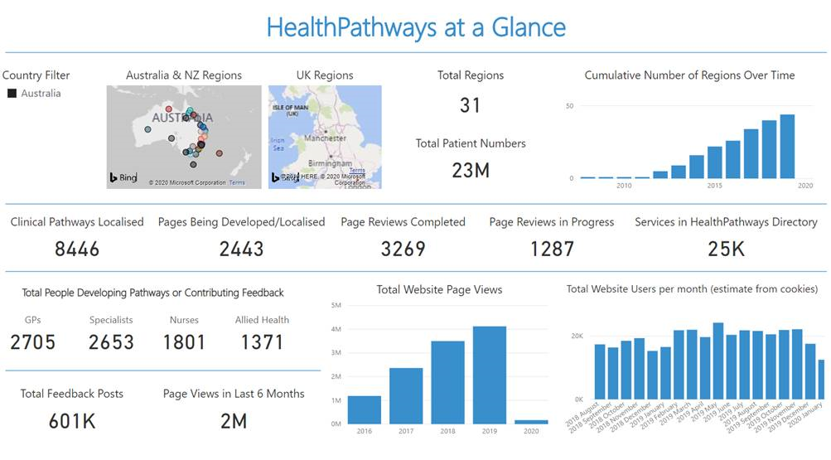

As the commission has recognised, improving mental health care in Australia, is not just about new programmes and resources, but about addressing the fragmented nature of care. In our experience it is common that systems have not had an agreed ‘way of working’ across sectors and certainly have not had a single resource that presented this information to all practitioners in a way that is useful and trusted for use at the point of care.

HealthPathways is assisting to change this across Australia, but there is significant potential to enhance its impact on all health care, including mental health. When we look at utilisation of HealthPathways across Australia, mental health pathways are consistently some of the most frequently utilised.

There are several reasons why we believe that HealthPathways can support the aims of the commission in ensuring that best evidence is put into practice consistently across Australia. The following gives an overview of this.

1/ HealthPathways is more than just a website that people read. It provides a process by which clinicians (and other stakeholders where relevant) from across primary and secondary care make local agreements on ‘how we do things around here’. This covers a number of areas from,

* Relevant assessment in primary care
* Clinical management
* Service and support options available to patients and families across the community
* Referral criteria and advice for both clinical and non-clinical services (NGO’s for example) across the region (public and private)

2/ Once these are agreed, they are documented in the consistent HealthPathways style, to ensure that they meet international standards of how to present information that is easily useable at the point of care.

3/ HealthPathways has developed a ‘pathway sharing’ framework that allows us to develop content with one ‘lead HealthPathways region’ that can then be populated across all other sites, either regionally or nationally. There are many examples of this, including the dissemination of Queensland Health’s ‘Clinical Prioritisation Criteria’ across all Queensland HealthPathways sites. This is an example of HealthPathways being a key enabler in getting policy into practice (in this case ‘equity of access’ for Queenslanders). The attached case study gives more details of this and other initiatives in Queensland.

3/ The ‘pathway sharing’ framework lends itself well to developing a nationally disseminated approach to ‘stepped care’. We have the capability to work with government and HealthPathways regions to develop exemplar ‘stepped care’ pathways that could be created once, disseminated nationally, with only justified local variation to accommodate service structure and service availability. This would assist in addressing the commissions observation of considerable variance in current practice and would require only small investment to add this to the existing Australia wide platform.

4/ HealthPathways is a process and platform that covers all areas of health and social care, with clinicians accessing it all in one place, making access to information simple. It is trusted by clinicians due to the quality of information it provides, curated across the HealthPathways community of 47 like-minded regions, whilst balancing the efficiency of shared content with local clinical engagement and knowledge.

5/ Ongoing poor mental health is also associated with poor morbidity and mortality as physical health issues are often not considered or appropriately addressed. Other submissions to commission will no doubt cover this in detail. The HealthPathways process and platform allows us to ensure that these are consistently addressed in pathways, utilising best practice in exemplar pathways, with links to local resources and services clearly notated in each region.

6/ The HealthPathways platform is proficient at providing information that meets the needs of significantly differing populations and geographies. It ranges from single state iterations such as Western Australia, South Australia and the Northern Territory to multiple sites within larger metro regions such as Sydney and Melbourne. Within these there are specific notations of appropriate care for our ATSI and culturally diverse communities.

7/ HealthPathways is an iterative process and is quickly able to revise pathways based on changing evidence and/or changes in local service capacity and capability.

In summation, with a little additional resourcing and coordination, HealthPathways could provide a single ‘source of truth’ across Australia for how to provide best practice care across our primary and community sector, with appropriate support by and connection to secondary care services.

To view HealthPathways please go to,

http://trial.communityhealthpathways.org   
  
Username: TrialHP Password: joinhp

##### Leading Lights

The commission addresses many aspects of supporting the development of positive wellbeing in young people. It notes the requirement for identifying children at risk, ensuring early help for those at risk and supporting schools to be effective gateways for children and families.

‘Leading Lights’ shares the same platform as HealthPathways but has currently been developed to meet the needs of children in school years 1-8. However, the resource is already being used by early childhood centres and high schools and further development could occur to adapt content tailored for these areas.

We believe that the currently available ‘Leading Lights’ platform in Canterbury (NZ), could be adapted in its current format for Australia to provide information to support schools, families and positions such ‘School Well Being Leaders’. It could also be further developed to support earlier interventions in pre-school and high school children.

The commission can access Canterbury ‘Leading Lights’ (as currently seen by the Canterbury community) at the unique log-in:

[https://canterbury.leadinglights.org.nz/](https://canterbury.leadinglights.org.nz/" \t "_blank)

username: TrialAus

password: W3llbeing

‘Leading Lights’ supports a strengths-based approach to supporting children, with family involvement being of vital importance. It is focused on providing information and connections that support effective early intervention.

Whilst sharing the same platform as HealthPathways, ‘Leading Lights’ has some differences to meet the needs of its current target age group of children in years 1-8 of school. Reviewing the ‘Anxiety’ pathway provides a good overview of its functionality and its structure.

**Section1:** **Recognise:** *Notice, Document, Discuss, Plan*

This gives clear guidance and support on how to safely and effectively recognise anxiety and links to relevant resources and information.

**Section 2: Respond:** *At Once, With the Child, With the Class, With the Family/Whanau, With Support*

This gives information to safely and effectively manage the situation, with links to relevant resources and information and;

Provides information on how to safely and effectively engage with the class in a preventive manner about anxiety and;

How to work with and support the family/whanau, with links to relevant resources and information.

Following are a set of screenshots of the pathway and the direct link is <https://canterbury.leadinglights.org.nz/262.htm> (please use the credentials above)

Please Note: Blue text denotes a dropdown box with further information.

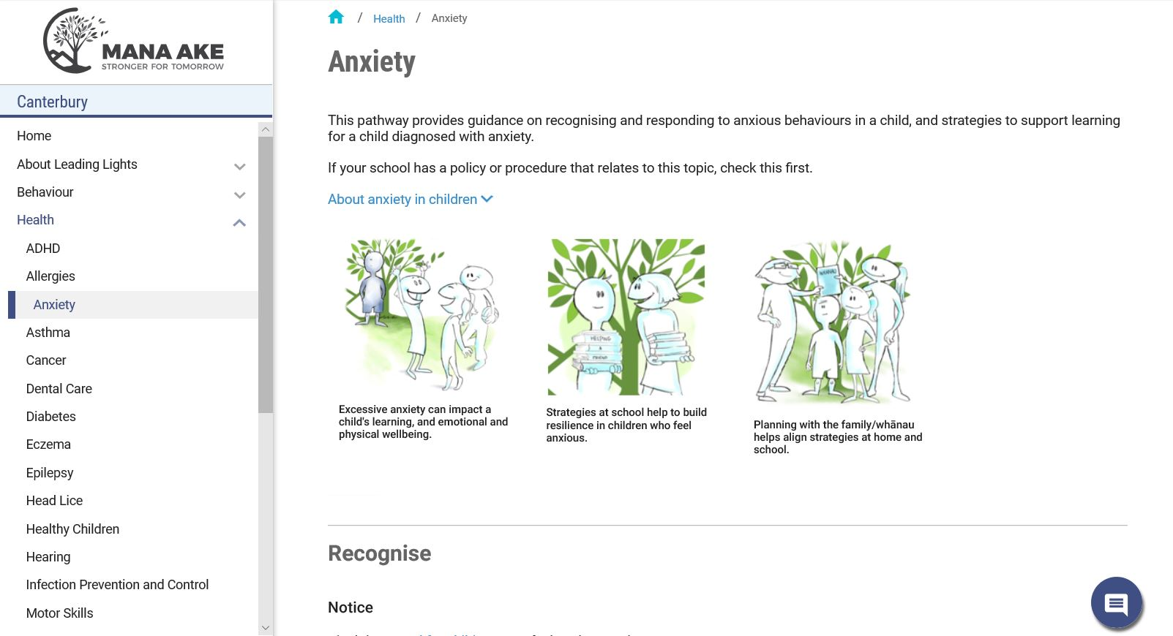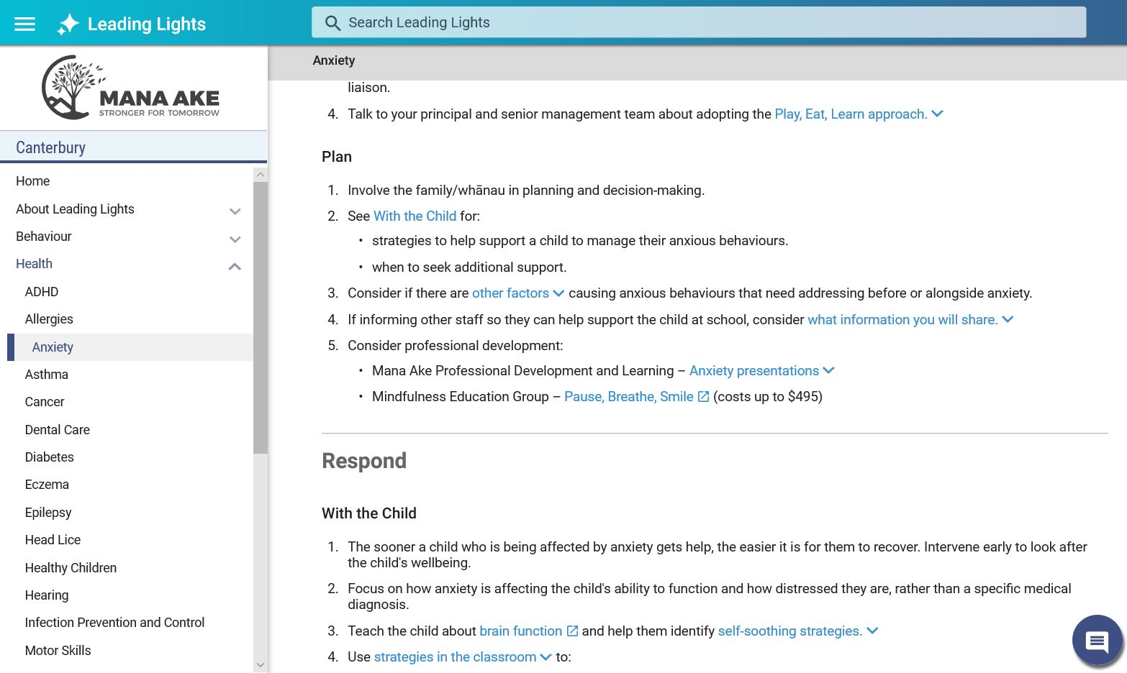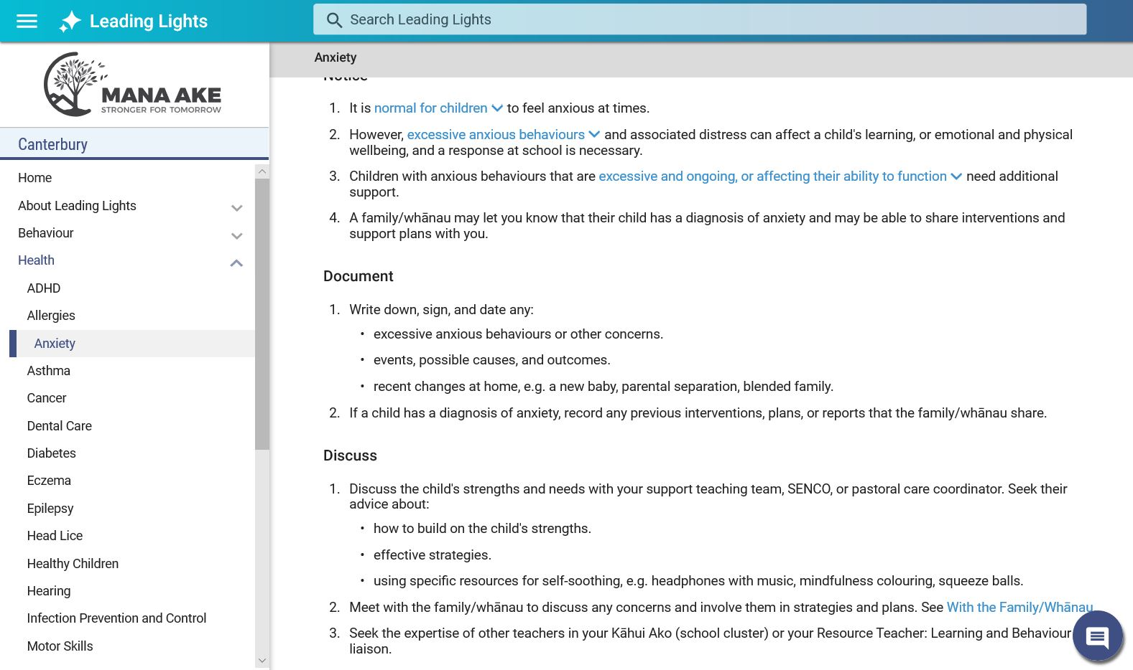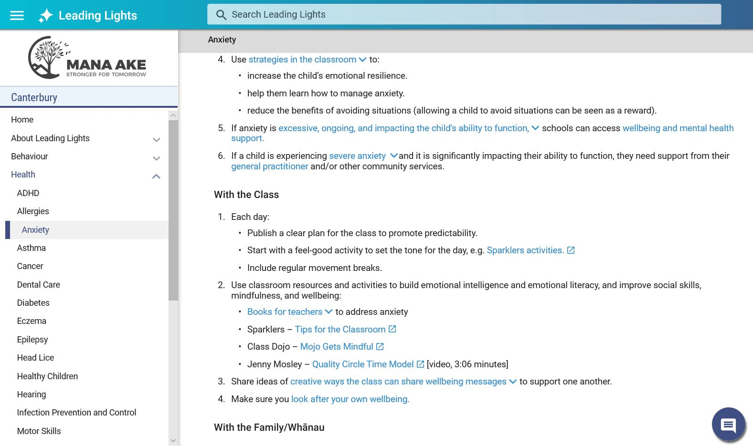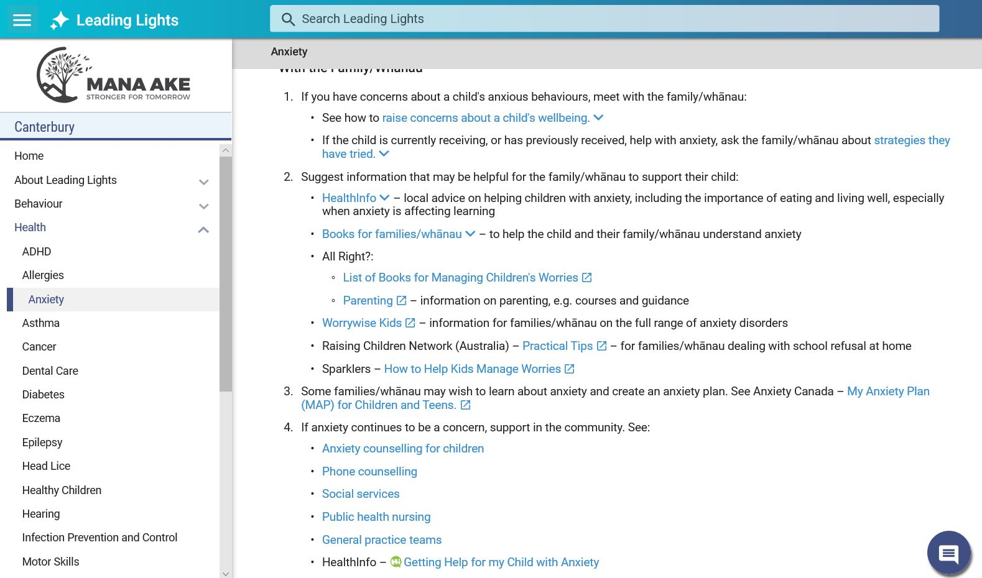

Unlike HealthPathways, as this is a developing initiative, we can’t point to its success yet, but we believe that adapting ‘Leading Lights’ for Australia could provide significant support to the types of resources and programmes that are under consideration by the commission.

Our initial thinking is that ‘Leading Lights’ could be provided at scale across Australia with Australia wide exemplar pathways being developed to support best available evidence. Local regions would have their own ‘Leading Lights’ site populated with the exemplar pathways, with limited local variation being possible to accommodate local structures and resources only.

Like HealthPathways, ‘Leading Lights’ is an iterative process and can quickly adapt to changing evidence, with an ability to make changes to exemplar pathways quickly across Australia, as well as adopting any local service changes quickly.

This would allow us to develop most of the content via one team, with only minimal localisation allowing us to ensure an accessible, evidence-based resource

I hope that this overview of HealthPathways and ‘Leading Lights’ is of interest to the commission and we would be happy to provide any further thoughts or information to the commission at any time.

Kind Regards  
  
**Andy Froggatt**  
**Streamliners**|*Director Strategic Partnerships*  
  
**tel (UK)**  +44 20 3519 1964 | **tel (Aus)**  +61 7 3067 3665 |  **tel (NZ)**   +64 3 595 0989 |

