Australian Government, Productivity Commission
National Water Reform
Productivity Commission Issues Paper, May 2020
Submission to Productivity Commission by Damian Crowe ACA, following submission by Wamba Wamba Aboriginal Land Council and farmer Bob Worrell to the ACCC inquiry into the MDB water markets.
Version 1.0, 2nd September 2020
Submissions: water.reform.2020@pc.gov.au

Introduction

I think it is important to provide some context to this submission: I returned to my home-town in Swan Hill, Victoria in November 2017, after spending 20 years living in London working on a mission that my Grandfather gave me, to find the keys to global food security and then deliver it. My family have been leaders of Victoria’s Irish-Catholic farming community for most of the past 170 years, my Grandfather was a founder-Director of Murray Goulburn. My family have lived in Swan Hill for the past century and before that my Irish-Australian ancestors were founders of the Borough of Koroit, in Victoria’s Western Districts.

Whilst I was in the UK, I established an international reputation as an expert on FinTech and the value of Liquidity + Data. I have permission from a staff member of the US National Security Council to say that I “responded to President Obama” for presenting an idea to rescue the US economy from its 2010 liquidity crisis. The SupplierPay Pledge was announced as US government policy by President Obama in 2014. I then partnered with the UK public sector (Birmingham City Council) to create an upgrade to the Pledge.

Upon my return to Australia I began researching my family history in Australia. I discovered that my ancestors benefited from the dispossession of Australian First Nations from some of their most productive lands. My ancestors were founders of Victoria’s export dairy industry and led Australia’s first fresh produce exports to Asia. My Grandfather’s Uncle Robert Crowe was a Director of the Department of Agriculture in Victoria and in 1898, wrote a booklet called “Modern Dairying” that was distributed throughout the world to modernise dairying. During his tenure, the Victoria’s Department of Agriculture was seen as a world leader. During WW1, Robert Crowe led Victoria’s agriculture industry in sending convoys of ships to deliver food security from Crowe’s Railway Line (today Crowes Railway Line) to the British Armies in Asia and to the British homelands. I discovered that my ancestors may have played a role in the creation of Victoria’s First National Park, a culturally significant site for the Koroit Gundidj. During my research, I discovered a hidden message in a draft of the 1892 bill that created the Tower Hill National Park – that appears to reference a debt owed by Australia’s settlers to Australia’s First Nations “that can never be fully repaid”. I am still trying to fully understand the implications of that message, and I invite debate, but it appears relevant to the question of First Nations’ rights to trade water for capacity building (i.e. to the Terms of Reference for the Productivity Commission Inquiry).

Since my return to Australia, I brought myself up to speed on the issues affecting Australia’s horticulture industry (my community), including growing politically motivated persecution of family owned farms, undocumented workers and Rural Communities, the way Plant Breeders Rights legislation has been implemented without protection for the data rights of Australia’s family owned farms and mistakes by Australian institutions such as the Productivity Commission in its understanding of the importance, including security value and efficiency of small to medium sized businesses, including family owned farms. I created a proposal for an alternative, collaborative digital model that better protects our borders than the current Australian Border Force strategy. My proposed model releases value from digital integration in Australia’s food supply chains, from the bottom (voters, Aussie farmers, etc), upwards.

Shortly after the ACCC announced its inquiry into the Murray Darling Basin water markets, I was introduced to Uncle Col Williams, the Interim CEO of Wamba Wamba Aboriginal Land Council and he began sharing with me his views on the Murray Darling Basin water issues. Uncle Col told me that he would like to make a submission to the ACCC Water Markets inquiry on behalf of Wamba Wamba Aboriginal Land Corp. He believed an Aboriginal voice could add common sense to the management of environmental flows. He decided that it was important to make a joint submission with a farmer living with a family who depends upon the Murray Darling Basin, and so an indigenous Australian team identified farmer Bob Worrell. The joint submission to the ACCC by Wamba Wamba and farmer Bob Worrell was made on 27th November 2019. During the process of preparing the submission, the Wamba Wamba team told me they once ran a successful, small scale hothouse and that that success continues to inspire them. I could see there is already substantial common ground between Wamba Wamba and local horticulture farming families. Uncle Col told me that he was working on something like a business plan for Wamba Wamba. I was already aware that the President of the Swan Hill Summerfruit Development Association believes in the potential of a large greenhouse run on a commercial “for profit” basis. So, I set up some meetings between growers and Wamba Wamba so they could explore their common ground (neighbours / water / horticulture / past experiences working together / capacity building). That led to a non-binding agreement between the Wamba Wamba team and Swan Hill Summerfruit Development Association Board on common ground. That led to a discussion on the potential of a partnership. And that then led to the drafting of a non-binding MOU for a potential partnership. I was then encouraged by several indigenous leaders to make a submission to the ACCC Interim Report into the water markets and to include the draft MOU on the basis that it is an example of an indigenous self-determination and employment project that hits a lot of buttons. I also received various approval to make this submission to the Productivity Commission’s inquiry into water reform.

This submission is made on my own behalf, drawing upon my experiences. It includes a section that responds specifically to the Productivity Commission’s questions I have approvals from indigenous leaders for the sections, quotes, photograph, recollections and the copy of the draft MOU between Wamba Wamba and Swan Hill Summerfruit Development Association. And for the request for funding so that the MOU can be finalised and signed and work begin on raising the funds required to complete a feasibility of the proposed Wamba Wamba / Swan Hill Summerfruit Association Greenhouse Partnership. I have permission to include quotes from Uncle Col and for the use of the photograph. Note however that I do not speak for Wamba Wamba Aboriginal Land Council or any indigenous Australian. The opinions included in this submission are my own.

INFORMATION REQUEST 7
What progress are States and Territories making on including Indigenous cultural values in water plans, and how are they reporting progress?
How could a refreshed NWI help Indigenous Australians realise their aspirations for access to water, including cultural and economic uses?

(PC. NWR, PC Issues Paper, 2020: 119).

Response: Back in the early days of our nation, indigenous peoples were violently displaced from their lands by colonial settlers who needed to produce food, first to deliver food security to the young colonies, and then later to support our allies in the region and the United Kingdom during periods of conflict or political tension. Early Australian settlers attempted to honour the sacrifice of indigenous Australians in a hidden message in a draft of the bill that created Victoria’s First National Park to tell the world “we owe indigenous Australians a debt that we can never fully repay”. Food security has always been a major dimension to the security of our nation.
I do not speak for any First Nations or a Traditional owner group. I supported the Wamba Wamba Aboriginal Land Council together with a farmer representing family owned farms in writing a response to the ACCC Inquiry. I ran several workshops and numerous one on one meetings with indigenous leaders and family farmers from the Swan Hill horticulture region. I also facilitated a site visit to a stonefruit farm and packing shed for an indigenous leader and a joint meeting between representatives of Wamba Wamba and the board of the Swan Hill Summerfruit Development Association. And then several meetings afterwards. I facilitated a meeting between a senior representative of Wamba Wamba and Leader of Victoria’s National Party, Peter Walsh. I also facilitated meetings between senior representatives of Wamba Wamba and councillors and executives from Murray River Shire Council. I facilitated the drafting of requirements for Wamba Wamba and for the Swan Hill Summerfruit Development Association from the water markets inquiry. I also facilitated the drafting of a MOU for a cooperation agreement between First Nations and the local stonefruit growers’ association which has been refined through several one on one face to face meetings and via numerous telephone calls. I also facilitated media interviews for Leena Sweeney and Michael Tripodi. The MOU is incomplete because it has not yet been reviewed, debated and signed off by the Wamba Wamba Aboriginal Land Council Board. However, it is also worth mentioning that Uncle Col Williams (the interim CEO of Wamba Wamba) told me that his objective for the partnership between Wamba Wamba and Swan Hill Summerfruit Development Association was to create a repeatable model partnership between rural indigenous people and rural farming families. If a MOU between family owned farms and indigenous users can be negotiated and projected benefits subsequently delivered (set up for success), then my view is that would be something valuable, including for various dimensions of Security and Trade policy. An opportunity for partnership and Reconciliation on issues that go to the heart of indigenous Australian priorities and their identity. I hereby request that if indigenous leaders and local grower associations see value in partnership that funding be provided so that the MOU can be completed and approvals obtained for moving forward with the project.
In my experience as the facilitator of the negotiation of the MOU, a key barrier faced by First Nations in acquiring permanent and temporary water in Basin water markets is a lack career opportunities that might lead to roles where water can be used for irrigation or environmental purposes. The Murray Darling Basin water markets’ products are inaccessible to indigenous users because of a lack of capacity in terms of career pathways to becoming horticulturalists or professional water management experts. The Murray Darling Basin Plan has not fulfilled its responsibility for an indigenous voice at the table in managing water. Closing the gap targets were imposed from top down. There is now an opportunity for rural indigenous Australians to establish partnerships with family owned farms to achieve their goals in terms of capacity building and employment outcomes.
Based upon my research and what I have observed, the cost of acquiring permanent water entitlements is a barrier to indigenous stakeholders acquiring water entitlements. If local indigenous people could gain access to the permanent water rights that would enable them to trade short-term rights with local farmers in return for education and training in the use of those water rights and employment with businesses in the horticulture supply chain. Eventually that would lead to indigenous water users with the expert experience necessary to run their own horticulture businesses.
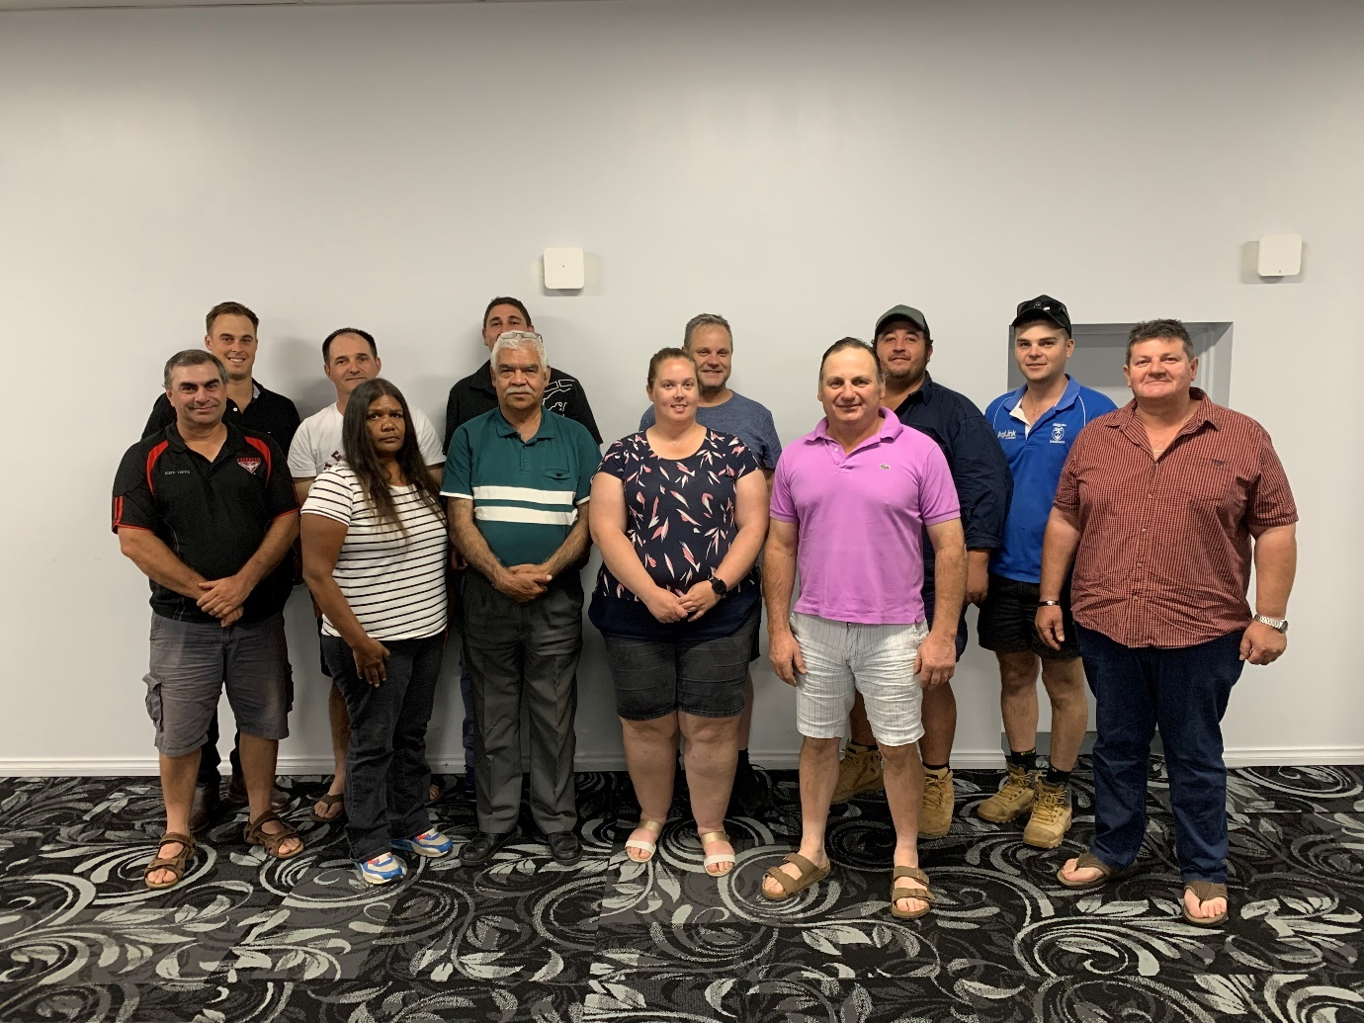
Here is Wamba Wamba Office Manager, Lena Sweeney together with President of the Swan Hill Summerfruit Development Association, Michael Tripodi, talking about their vision for partnership from the use of permanent and temporary water rights.
https://www.abc.net.au/radio/programs/vic-country-hour/victorian-country-hour/12013168 (Lena Sweeney and Michael Tripodi start talking at 13 minutes into this radio segment)
Reconciliation and Truth telling process with Australia’s First Nations that has just begun in some states. It will inevitably include a discussion about indigenous whether indigenous peoples have any sovereign rights to Murray Darling Basin water, including not just for cultural purposes but as part of the career opportunities at all levels that comes from professional and commercial water management. A mechanism to build partnership and teamwork between family owned farms and indigenous water users should be considered a crucial dimension of Australia’s national and regional Security and Trade policies because it will strengthen communities with a role for a Social Contract and a profit motive. It may offer a pathway for indigenous and non-indigenous Australians to genuine Reconciliation.
When I spoke to the interim CEO of Wamba Wamba Aboriginal Land Council about family owned farms, he regularly referred to them as neighbours of local indigenous people. That is both an indigenous perspective and it is also a traditional non-indigenous perspective on the relationship between people and family owned businesses in rural communities. That’s to say, “good neighbours” and “prosperous communities” are values shared by all Australians. And that could be one of the bases for a proper Reconciliation.
On a separate but related matter, all Australians understand the importance to the cultures of indigenous Australians of their traditional responsibilities as owners and custodians of the land and its waters. It is at the very heart of the indigenous identity. So, attempts at Reconciliation that do not deliver exciting career paths for indigenous people with a seat at the table in the management of water would be taking the piss. The context is that right at this moment, leaders all over the world are referring to our Social Contract as the moral and rational basis for necessary actions that are being taken at the moment to defend our communities from the pandemic. It is important that our Social Contract is more than political spin. If careers in water management is what indigenous Australians want then given that is so obviously the right thing to do (to make happen) given our Social Contract, then surely the only question is, how do we make it happen? Clearly, we have an obligation to all Australians to defend food security for our nation and perhaps our neighbours in the region. So, the key is to define and implement a development process that allows for all the most important risks to be systematically identified and mitigated.
References:
Wamba Wamba & farmer Bob Worrell submission to the ACCC Water Markets inquiry dated 27th November 2019.
Wamba Wamba Aboriginal Land Council & Swan Hill Summerfruit Development Association draft MOU dated 20th March 2020 (included with this submission).
Consider the value of this proposed partnership from a better integrated Security and Trade policy perspective – particularly given the call to arms by Prime Minister Scott Morrison at the Aspen Institution on 5th August 2020. Reconciliation and capacity building partnerships between Australian family owned farmers and rural indigenous Australians makes a lot of sense.
See also: https://www.eastasiaforum.org/2020/06/29/supply-chain-management-and-economic-statecraft-a-five-point-agenda/

https://obamawhitehouse.archives.gov/sites/default/files/docs/supplierpay_pledge.pdf
https://trove.nla.gov.au/newspaper/article/242779960
https://www.amazon.com.au/Modern-Dairying-Victoria-Dept-Agriculture/dp/1372136355
https://en.wikipedia.org/wiki/Crowes_railway_line
https://trove.nla.gov.au/newspaper/article/173678236
https://trove.nla.gov.au/newspaper/article/173678236
https://www.pm.gov.au/media/address-aspen-security-forum-tomorrow-indo-pacific

