Right to repair submission
Kath Deighton
1 February 2021

Introduction

My name is Kath Deighton. I am a tertiary Product Design educator and PhD candidate in the field of Product Design education. I am passionate about sustainable Product Design.
This submission will include ideas related to Product Design education, ideas arising from my personal experiences with product reparability, and some of my personal views on the issue of product reparability.

A key aspect of this discussion is the way “benefit” will be measured by the Commission. The Commission’s issues document indicates that changes to legislation or policy will, “need to demonstrate that any potential new regulation delivers net benefits to the community” but it does not indicate how these benefits will be evaluated.
Economic measures such as effects upon GDP could be applied but a burgeoning movement suggests that holistic measures of wellbeing are more appropriate in the 21st century (Drabsch, 2012; European Commission, 2021; OECD, 2021). At the very least, the environment must be considered as a resource whose economic value shall only be exploited at sustainable levels, but ideally, “net benefits to the community” must comprise of economic benefits, social benefits, and environmental benefits, or in other words, be measured against the “the triple bottom line” (Fisk, 2010; Elkington, 2004).

The highest aspiration of sustainable product design is to balance these three priorities so that clients profit, user needs and/or desires are satisfied, and the environment is nurtured (Ellen Macarthur Foundation, 2021). We have not yet reached a stage where product life cycles readily benefit the environment, and we know that the environment is often desecrated in this relationship, but legislation and government advertising campaigns targeting behaviour change can shift the balance towards the environment so that client profit, user satisfaction, minimal environmental harm, (and holistic community wellbeing) are achieved.

Preceding the priorities of client profit, user satisfaction, environmental sustainability, (and designer expression), however, comes education, notably engineering education, repairer education, and Product Design education (also known as Industrial Design education). But generalist education is also needed so that future entrepreneurs, manufacturers, and consumers also understand the life cycle benefits and impacts of the products they design, produce, distribute, consume, and dispose of.

I will now respond to the following questions from the Commission’s issues document.

4g) What policy changes could be introduced if there is a need to increase competition
in repair markets and improve consumer access to, and affordability of, repairs?

5c) Do current IP protections (e.g. intellectual property rights, technological protection
measures, end-user licencing agreements) pose a significant barrier to repair in
Australia?

7e) How can a right to repair policy further reduce the net costs of e-waste in Australia,
and would such an approach be an effective and efficient means of addressing the
costs of e-waste to the community?

I will then make one further comment and finally, I will summarise my contributions.

4g) What policy changes could be introduced if there is a need to increase competition
in repair markets and improve consumer access to, and affordability of, repairs?

After a Covid 19 ravaged 2020, now is the ideal time to implement positive changes, stimulate employment, and take up unexpected opportunities.

One way to do this is for repair industries to be supported through subsidies, reduced fee TAFE courses, and apprenticeship incentives. As an example, consumers may have less money to spend on furniture in coming years due to the effects of the Pandemic but if upholstery services were cheaper (through subsidies) and more upholsterers were in business (through training support), consumers, workers, small business owners, and the environment would all benefit.

The pandemic has also taught us that manufacturing should be further supported to return to Australia. This would reduce the vulnerability of Australia to future possible global disruptions and is becoming more and more feasible with advanced manufacturing developments and the flexibility and customisability that Industry 4.0 brings. Returning more manufacturing to Australia would increase Australia’s ability to “design-in” reparability.
With continued bolstering of manufacturing in Australia, reparability could become a specialisation, an in-demand niche area.
The following link, shows video footage of a robot disassembling iPhones https://www.cnet.com/videos/watch-apples-daisy-robot-rip-apart-old-iphones/ (CNET, 2018). The iPhones in this video are being completely stripped in a safe manner, unlike the dirty and unsafe product stripping that may occur when waste goods are shipped to countries with poor Health and Safety laws. This robot could also just as easily be completing repairs.

Advanced manufacturing innovation and research & development have been identified as sectors where Australia could gain a competitive advantage (Australian Government, 2014, p. 7 & p. 72). Niche industries in de-manufacturing, remanufacturing, and robotic repair could easily become a part of this. Appliances and devices with lower susceptibility to short fashion cycles, such as household appliances and commercially-used machines, could be the first products targeted in de-manufacturing, remanufacturing, and robotic repair industries.

As with most environmental sustainability challenges, however, it is not just scientific, technological, or legislative solutions that are needed to increase reparability. Regular community members need to be motivated to care about it. Currently, many appear to be motivated by advertisers and the imperative to “keep up with the Jones’ ”. Some are addicted to purchasing. Therefore, government sponsored advertising promoting the “coolness” and desirability of owning repaired and updated products and should be disseminated (where this fits within Government advertising guidelines). Designers and others could also act as influencers, and promote the fashionability of repaired or upgraded goods. Such a role could be promoted in secondary and tertiary design courses.

Another approach to reparability and fashion cycles is to view the skin, surface, or interface of a product as a part that can be upgraded independently of the interior of the product. Surface replaceability can be planned-for during product design and should therefore be taught in design and engineering courses.

Further education-related policies that could support reparability include the following:

Education providers should be supported to educate both specialist and generalist students about sustainable product design strategies. This would benefit future manufacturers, entrepreneurs, designers, repairers, and consumers. This already happens to a significant degree but reparability-related knowledge areas may not always be included.

In relation to specialist design students, tertiary providers should be strongly encouraged to ensure they are delivering sound training in the areas of design for disassembly, design for upgradeability, design for reparability, the effects of e waste, modular design, and other relevant areas, rather than just paying lip service to sustainable product design. Senior secondary 3D design students should study these same concepts in less detail.

In relation to specialist design technology training, hands-on Design technology subjects should be actively supported in schools to ensure that students maintain the non-routine manual skills and non-routine digital skills necessary for the repair professions. This would include instituting policy to help schools recruit suitable teaching staff and may include funding of teacher retraining (DATTA, 2019).

For more generalist students in secondary and even primary school, the contents of the Design and technologies learning area in the Australian Curriculum (or relevant state based curricula) should be properly delivered.
The Australian Curriculum indicates that children as young as eight and nine should, “examine social and environmental sustainability implications of existing products”; and “critique and assess suitability, sustainability and enterprise opportunities” (of their designs) (ACARA, 2021). While year 9-10 students must, “Critically analyse factors, including social, ethical and sustainability considerations, that impact on designed solutions” (ACARA, 2021). However, primary teachers and secondary teachers, are seldom Product Design or engineering specialists, so it is likely they would benefit from user friendly support materials and exemplar projects to help them deliver sustainable product design curricula more confidently. Such support materials would help foster key product reparability knowledge in our future manufacturers, entrepreneurs, designers, repairers, and consumers. Government funding for the development of such support material would be beneficial.

There are two final education-related initiatives that the government could instigate in relation to questions asked in the issues paper. Firstly, based on the Commission’s query about the extent of planned obsolescence in present-day Australia, a research grant could be made available for a researcher to answer this question accurately.
Secondly, in relation to the Commission’s query about what a reasonable life time for a given product should be, a research grant should be offered so that a team of researchers can develop a set of product life-length benchmarks for a range of common household and commercial products. This should be done independently of length of product life according to fashion cycles and would need to be updated every few years. This would become a valuable global resource.

5c) Do current IP protections (e.g. intellectual property rights, technological protection
measures, end-user licencing agreements) pose a significant barrier to repair in
Australia?

In response to current IP protections in Australia, I would like to tell the story of my broken oven.
My daughter dropped an electronic tablet onto my open oven door and smashed the internal layer of glass in the oven door, (the tablet was unharmed).
I phoned the oven company and they told me parts were no longer being manufactured for that model. I said, “That’s OK, can you please send me the specifications of the piece of glass that I need replaced so that I can have it made up?” but they refused on the grounds that it was proprietary information.
I believe that sharing the specifications of a single part of a 20 year old oven design would not have harmed their business. Therefore, I suggest that companies be strongly encouraged to make certain part specifications available for a small price. This could even involve companies emailing 3d computer models of parts, along with materials specifications, which could then be produced digitally.

7e) How can a right to repair policy further reduce the net costs of e-waste in
Australia, and would such an approach be an effective and efficient means of
addressing the costs of e-waste to the community?

In order to respond to this question, it should again be emphasised that “costs to the community” should instead be viewed in terms of “net benefits to the community” which must in turn comprise of not just economic benefits, but also social benefits, and environmental benefits. Ideally, this concept should be extended to become “net benefits to the global community”.

As has been mentioned, e waste has usually been first manufactured by robots according to strict design specifications, so there is an emerging opportunity to use those same design specifications to de-manufacture e waste using robots. This would allow access to valuable components and materials and would also allow the extraction of dangerous components and materials. Robotic repair and upgrade stations could also be made available as part of a new niche industry.

As has already been mentioned, machines and devices viewed by consumers as high fashion items could have their surfaces updated without internal components being altered. This is in line with the way many people change their phone covers from time to time and may satisfy the human desire for novelty with a lower environmental impact. Again, this is something that could be encouraged through government sponsored advertising campaigns and by enlisting designers and others as influencers.

Finally, e waste could be reduced by prohibiting contracts or advertising materials that encourage short product replacement cycles. For example, it is currently easy to sign up to be sent a brand new, updated phone model every two or three years, but how much improved functionality does a regular person really need? and how many cameras does one phone really need? Such contracts normalise planned obsolescence with short turnaround cycles in the community and should be eliminated. Definitions of “short replacement cycles” applicable to such prohibition could be obtained from the product life-length benchmarking project suggested above.

Additional comment

The Commission has probably already recognised that it is important for a small-population country like Australia to first take-up reparability schemes already in place in larger-population jurisdictions, while also making intended future changes publicly known. This would mitigate difficulties associated with large overseas manufacturers not bothering to include Australia-specific reparability provisions in their products.

Summary

In summary, the points I have made are as follows.

I am making this submission from the perspective of my Product Design education expertise as well as from my personal perspective.

One of the key considerations behind any recommendations regarding the right to reparability should be that “benefits to the community” be evaluated in line with measures that consider not just economic benefit, but also social benefit, and environmental benefit in much the way the OECD’s Better life index proposes (OECD, 2021) and the way suggested by the European Commission’s Beyond GDP explorations (European Commission, 2021).

Another key consideration in relation to the right to reparability is the appropriate education of future engineers, product designers (also known as industrial designers), repairers, manufacturers, entrepreneurs, and consumers. This should be instituted through formal specialist and generalist education channels and also through government sponsored advertising campaigns.

Post-pandemic Australia is an ideal time and place to implement positive changes, stimulate employment, and take up unexpected opportunities in relation to the right to reparability. This could include support for repair industries through subsidies, reduced fee TAFE courses, and apprenticeship incentives; as well as support for the return of more manufacturing to Australia, especially in the advanced manufacturing and robotics sectors.
I suggest that advanced manufacturing technologies and robotics be used to develop de-manufacturing and repair niche industries.

Appliances and devices with lower susceptibility to short fashion cycles, such as household appliances and commercially-used machines, should be targeted first for reparability initiatives but high fashion products could also be approached with a “shell replacement” strategy.

Government sponsored advertising campaigns that educate the public about the right to reparability should be designed not just from an information perspective but with behaviour change in mind.
Designers and others could also be enlisted as “influencers”, to promote fashionability of owning repaired or upgraded goods.

Specific education-related policy that could support reparability includes the following:

Education providers should be supported to educate both specialist and generalist students about sustainable product design strategies. This already happens to a significant degree but specific reparability-related knowledge areas should be enshrined in relevant courses.

Hands on Design technology subjects should be actively supported in schools so that future repairers are appropriately trained. This would include instituting policy to help schools recruit suitable teaching staff and may include funding of teacher retraining (DATTA, 2019).

In terms of specialist design and engineering students, it should be ensured that tertiary providers and senior secondary courses deliver sound training in the areas of design for disassembly, design for upgradeability, design for reparability, the effects of e waste, modular design, and other relevant areas. (This may need to be articulated as strong encouragement in the self-regulating university sector)

In relation to generalist education, government funding to develop product reparability and sustainable product design support materials and exemplar projects to help non-expert school teachers would be beneficial. This would also benefit our future manufacturers, entrepreneurs, designers, repairers, and consumers.

A research grant supporting a researcher to explore the extent of planned obsolescence in Australia would be the most appropriate way to answer the Commission’s question about planned obsolescence, and a research grant enabling a team to develop an extensive set of benchmarks on reasonable length of life for common household and commercial products would produce a valuable global resource.

In relation to Intellectual Property laws, I suggest that companies be strongly encouraged to make certain part specifications available for a small price. This is especially the case where such part specifications are no longer commercially valuable and pose minimal safety risk.

e waste could be reduced by prohibiting contracts or advertising materials that encourage short product replacement cycles. Such contracts normalise planned obsolescence with short turnaround cycles in the community.

Finally, I suggest that Australia take a strategic approach to gradually implementing laws. The first laws made should in line with similar laws in large-population jurisdictions. This would mitigate difficulties associated with large overseas manufacturers potentially not bothering to include Australia-specific reparability provisions in their products. Australia should, however, make future intended laws known, so as to inspire other jurisdictions.

Waste hierarchy for designers
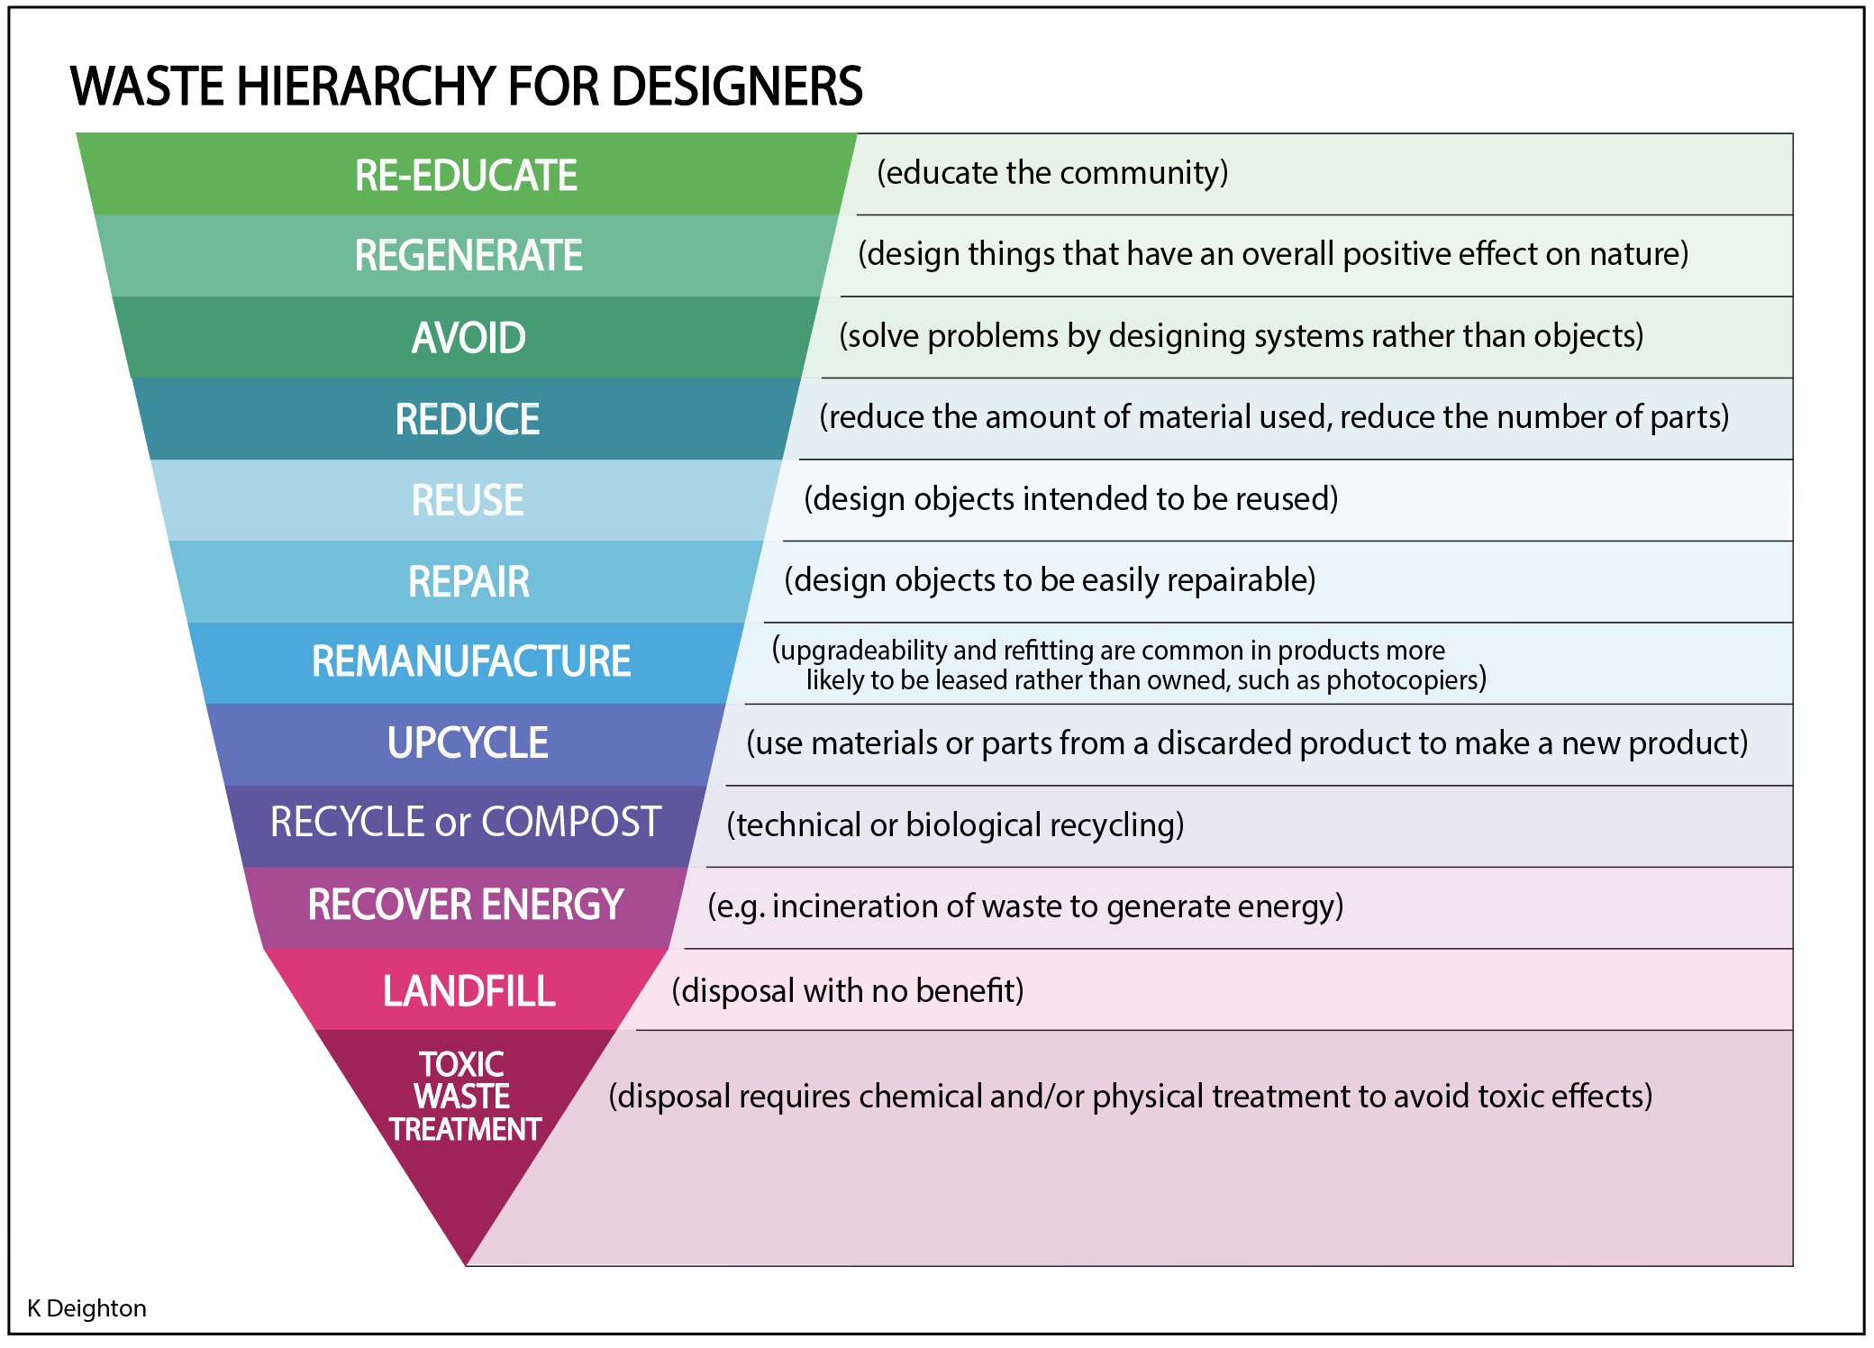
References

ACARA. (2021). Design and technologies. Australian Curriculum, Assessment and Reporting Authority. https://www.australiancurriculum.edu.au/f-10-curriculum/technologies/design-and-technologies/

Australian Government. (2014). Industry Innovation and Competitiveness Agenda: An action plan for a stronger Australia. https://www.pmc.gov.au/sites/default/files/publications/industry_innovation_competitiveness_agenda.pdf

CNET. (2018, April 19). Watch Apple's Daisy robot rip apart old iPhones [Video]. https://www.cnet.com/videos/watch-apples-daisy-robot-rip-apart-old-iphones/

DATTA. (2019). Technologies Teacher Shortage Survey: National Overview 2019. Design and Technology Teachers’ Association of Australia. http://www.dattaaustralia.com/sites/default/files/TECHNOLOGY%20TEACHER%20SHORTAGE%20SURVEY%20REPORT%202019%20DATTA%20AUSTRALIA.pdf

Drabsch, T. (2012). Measuring wellbeing (Briefing paper No 4/2012). NSW Parliamentary Library Research Service. https://www.parliament.nsw.gov.au/researchpapers/Documents/measuring-wellbeing/Wellbeing.pdf

Elkington, J. (2004). Enter the triple bottom line. In A. Henriques, & J. Richardson (Eds.), The triple bottom line, does it all add up? : assessing the sustainability of business and CSR. Earthscan, London.

Ellen Macarthur Foundation. (2021, February 1). What is the circular economy? https://www.ellenmacarthurfoundation.org/circular-economy/what-is-the-circular-economy

European Commission, (2021, February 1). Beyond GDP. https://ec.europa.eu/environment/beyond_gdp/index_en.html

Fisk, P. (2010). People, planet, profit how to embrace sustainability for innovation and business growth. Kogan Page, London.

OECD. (2021, February 1). Better Life Index. http://www.oecdbetterlifeindex.org

