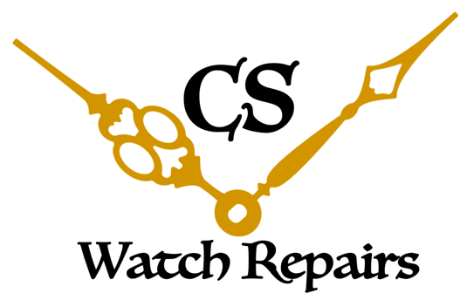

Christopher Soto

Right to Repair: Productivity Commission Submission

Introduction
An independent watchmaker is someone who repairs a wide variety of watch brands and does not belong to a larger corporation or specific brand. As such, he or she is free to assist consumers with a variety of brands to repair and even work on specialised vintage work which is often not repaired by the parent brand. This allows consumers to have a free choice as to where their watch can be repaired which will usually result in a much shorter wait time, competitive price, and no need to send it interstate or overseas for repair.
The work and even existence of the independent watchmaker has been stifled by the inability to obtain spare parts from major watch brands and large corporate groups. This is irrespective of training, experience and equipment. In the odd case where a brand has allowed for the release of some spare parts, they have requested unrealistic and unnecessary tooling, which will cost in the thousands of dollars, procedures regarding stock of spare parts, and rules regarding the pricing of repairs.
This has all led to the slow demise of the independent watchmaker, however it has not addressed the increasing demand for one. The modern watch consumer struggles with the prices, wait times and most importantly, the quality of repairs. Irrespective of the brand or group, it appears that the lack of skilled watchmakers is also causing issues for the consumer with often poorly repaired watches being brought to the independent watchmaker for a re-assessment.
If the restraint of spare parts continues, the independent watchmaker will struggle to the point where they will no longer be able to function and exist. This not only affects the existing watchmakers, but will also kill an entire future industry that has high demand and promising positive contributions for the levels of employment in Australia. Given the rise in young interest for watchmaking and horology, it would certainly go against the core beliefs and foundation of Australia that they should be turned away and denied a future in something they naturally excel at due to a largely preventable and reversable issue.

Personal implications – an ambiguous to non-existent future:
From a personal perspective, I am a 30 year old watchmaker hoping to expand my business and be able to invest in something that I can rely on for years to come. I have been fortunate enough to have trained with some of the most skilled and experienced watchmakers in Sydney, and even completed training with TAFE NSW with their only watchmaking course in Australia.
Even with this training and qualification, my future as an independent watchmaker is completely uncertain. I am not able to consider taking my business further by acquiring a full-time premise to work from, or leave my day job with another watchmaker. The lack of spare parts means that someone such as myself, fully skilled and even with a full functioning workshop, will have little to no chance in trying to set up as an independent. My options are essentially: continue with an established independent until parts run out; join a larger brand and restrict myself to a fine scope of work, essentially rendering my large skill set as redundant; or move industry and re-skill.

Larger, national implications:
Considering only the watchmaking industry, here is a list of issues that could be alleviated if parts were more attainable:
-Unemployment rates: independents would have more work to be able to hire apprentices or qualified watchmakers. This would certainly have an impact on reducing unemployment levels.
-Environmental: people would be willing and able to repair as opposed to replace. With high repair prices and no one to offer competition, people are less willing to repair and more likely to replace an item. This has widespread negative environmental effects which include contributing to the rising issue of landfill space, lack of recyclability, and discarding of pollutants such as plastics and batteries found in watches.
-Economic: it may appear at first that it is more profitable for the nation for consumers to replace rather than repair. However without any watch manufacturing occurring in Australia, profit is sent overseas while nothing is encouraged in Australia. With repair, profit can grow and remain in Australia whilst also building international relations with international watch companies, as they support our watchmakers.
-Availability of a niche trade: watchmaking is unique and appeals to a niche group of people. It involves physical and mental dexterity, knowledge of history, art, and an appreciation for high standards and procedures. Having this available will cater to many who need this type of work and simply cannot fit into other industries. People from all backgrounds have eventually found themselves at a workbench realising this is a trade they can excel and make a difference in.

Hopeful outcomes from the commission:
Brands should not provide parts freely, nor to everyone that asks for them – we are all aware of that. And unfortunately, there are many active watchmakers with no training whatsoever that have previously lost the trust of any brands that were willing to offer parts in the past. This is an issue that independent watchmakers are willing find a solution for in collaboration with big brands.
With that in mind, I hope the commission can find a middle ground for the qualified independent watchmaker and the brands. Training requirements, model restrictions, less restrictive tooling requirements and even parts supply on an exchange basis are reasonable outcomes that we hope to see from this commission. The aim is to allow independents to have work and allow us to repair watches for customers without them having to always face the big brands.
The aim is to also allow the independent watchmakers to have a place in Australia and help tackle the issue of unemployment, job variety, and environmental issues in a different way, while also offering economic benefits. There are so many opportunities in the field of watchmaking that could open up if this collaboration with the larger brands were to occur. I personally, and the independent watchmakers I speak to, welcome this commission and are hopeful for a resolution that can find a balanced ground for everyone.

Thank you for the chance to voice my opinion,
Christopher Soto

