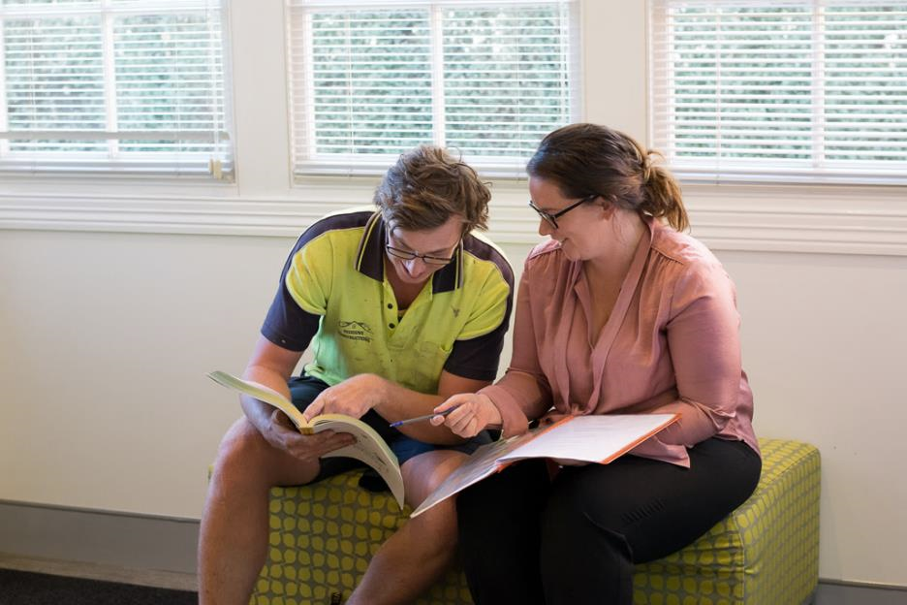




Productivity Commission
21 October 2022

Submission into the 5 Year Productivity Inquiry: From Learning to Growth

Introduction
The Country Universities Centre (CUC) is a not-for-profit organisation which empowers regional, rural and remote communities by increasing access and success in higher education. It is a network of twenty regionally located and community owned tertiary study communities in NSW, Queensland and Victoria equipping students with the technology, facilities, and academic and pastoral support needed for students to thrive and succeed. It operates under the Commonwealth Government’s Regional University Centre Program, and further information can be found at https://www.cuc.edu.au/ .
The success of the CUC in assisting regional students to access, participate and benefit from higher education has been recognised through the support of the Commonwealth Government, NSW Government, local governments of participating communities, cornerstone universities, corporate sponsors and other philanthropists which have all contributed towards expanding the CUC. In return, the CUC has endeavoured to provide higher educational opportunities for regional people without them having to leave their local networks of family, friends and work, to slow the emigration and drain of youth from regional to metropolitan areas, and to provide regional workforces with undergraduate and postgraduate knowledge and qualifications for local future development and challenges.
The evidence is early, but the signals are that the CUC is succeeding in its mission of improving access, participation and success in higher education in regional NSW by training people locally to be the workforce of tomorrow in the location in which they already live. The demographic characteristics of CUC’s students is reflective of the community in which they study, live and work.
The CUC welcomes the opportunity to provide a submission into the Productivity Commission’s 5 Year Inquiry: From Learning to Growth, addressing recommendation directions and information requests of the Commission. If the Commission would like to seek further information of any matter in this submission, please contact Duncan Taylor on .

Recommendation Direction and Information Request 4.4
The Commission is considering recommendations for its final report to support retention where it improves outcomes, while also facilitating exit where it is preferable, and is interested in views about:
• What are the best approaches to supporting student retention, how should these be adapted for different students, and how could the lessons from these approaches be shared across the tertiary sector?
• Should the Higher Education Participation and Partnerships Program extend to support retention beyond equity groups to capture a broader range of students with elevated risk of non-completion (such as part-time, online or low ATAR students)?
• What approaches have been demonstrated to reduce barriers or costs to trying a tertiary pathway and dropping out?
The CUC currently provides face to face human support, learning spaces, connectivity and technology in twenty regional, rural and remote communities in NSW, Queensland and Victoria with populations ranging from 22,000 to 600. The Centres are accessible by any student studying any course at any university, maximising student utilisation of the Centres, and each Centre provides general student assistance based around academic skills, motivation, wellbeing, enrolment advice and administrative support. The CUC does not seek to provide in discipline support as its student base is too fragmented in the courses studied (last semester, 861 different courses were studied through the CUC indicating very significant diversity of regional student study preferences).
The CUC has found that some face to face general academic, wellbeing and motivational support in online education is a major factor in student success, particularly for students with characteristics associated with attrition such as first year of tertiary study, part-time, mature age, regional, indigenous and low socio-economic students. These students are a very significant component of CUC cohorts of students studying online in regional areas.
The CUC finds that the creation of a learning community in regional towns, supported by energetic staff, good connectivity and technology, and a dedicated facility to which students feel they belong is having a major impact on local enthusiasm to skill and reskill. Census data from 2021 indicates NSW communities with a CUC Centre had an increase in university students of 24.7% compared to a non-metropolitan NSW average increase of 5.4%. Further, the one CUC community with a Centre that straddled two census periods (Cooma) had a university student increase of 64.1% compared to a non-metropolitan NSW average growth of 17.5% (See Attachment A).
Recommendation 1: That the Commonwealth continue to expand its Regional University Centre Program in which student support through facilities, staffing and encouragement of a learning community to which the students belong is provided to all students from any university (and particularly those students having characteristics associated with higher attrition rates).
The CUC envisages that these Centres might readily and inexpensively be expanded to provide similar services to vocational students in communities without TAFE campuses, and also distance education school students by using the same infrastructure already made available in these Centres to university students. In towns of low population (say, under 5,000 population) this broadened model will lead to increased utilisation of the Centres and enhanced sustainability, when compared to a dedicated usage of just higher education students. This broadened model of educational support might lead to more sustainable and feasible provision in Centres in low population, more remote communities.
Recommendation 2: That Centres in the Commonwealth Regional University Centre Program be supported to be broadened in low population communities (population under 5000) beyond higher education students to support vocational students in locations where no TAFE facilities exist, as well as potentially supporting distance education school students.

Recommendation Direction and Information Request 4.1
To improve incentives for institutions to invest in teaching quality, the Commission is considering a recommendation in its final report to support students making more informed choices when selecting a tertiary provider, and is interested in views about:
• What mechanisms or channels should be used to provide students with relevant information about higher education course quality when they make their enrolment decisions?
Country Universities Centres are community owned and driven (rather than owned and driven by a particular university) and supported by the Commonwealth to assist all local students regardless of university or course. As a result, the Centres are focussed on the interests and needs of the community rather than on the interests and needs of a particular university. The staff at these Centres are able to provide advice to students which is independent of any particular university or course with regard to enrolment decisions.
Further, these facilities cluster together local students into a tertiary learning community for that location, providing an opportunity for prospective students to conveniently engage with existing students studying at a diversity of universities and non-university providers to assist the prospective students to make informed enrolment decisions as to course and institution of study.
The Centres also become a convenient platform for equity and outreach extension programs and funding of the Commonwealth which is not tied to a particular university or provider. An example of the consequent opportunities and potential of this platform is being realised through the Commonwealth’s Regional Partnership Project Pool Program under which Regional University Centres are now eligible for funding, as well as universities.
Recommendation 3: That the Commonwealth expands opportunities for Regional University Centres to participate in Commonwealth equity and outreach funding and programs for widening participation in regional areas.

Recommendation Direction and Information Request 3.2
Can funding be better allocated in tertiary education to encourage competition across providers? To what extent would this (or other funding approaches) support more efficient or high-quality education, and improve the flexibility of the tertiary system to changing skill needs?
The CUC provides a learning community for all students studying any course at any university. As a result, students can choose any course at any university knowing that levels of support through the CUC model will be similar. This creates a level playing field where students are more likely to choose courses on quality or suitability to a range of personal factors, and not necessarily simply on what university is geographically closest to them.
The CUC is constantly surprised by the diversity in student choice under this model. In Semester One 2022, there were 1462 students studying 861 unique courses at the CUC. These students studied through 39 different Australian Universities, 18 Non-University Higher Education Providers, 48 Registered Training Providers or TAFE’s, 13 Professional Associations and two international universities.
Creating a platform in regional communities through which students are supported to study at any tertiary institution creates competition. The CUC hopes that as more communities adopt this model, tertiary institutions with the highest quality course offerings are rewarded by additional enrolments attracted by their superior product.
The CUC contends this model is superior to universities being supported by government to establish facilities in regional communities where only a small handful of courses are offered by that university, with little incentive for competition to improve course quality and offerings. These small university campus models risk funnelling students into courses that may not be their first study preference, but students compromising their futures due to these courses being the only options locally available in a supported environment.
See Recommendation 1 above.

Recommendation Direction and Information Request 3.1
The Commission is considering a recommendation in its final report to expand the number of places in tertiary education to better support future workforce needs. To inform the development of this recommendation, we are seeking further views and evidence on:
• To what extent is ‘overskilling’ or ‘overeducation’ a problem in Australia, and what should be done to reduce it?

The CUC has done multiple analyses of regional and remote communities, and in the majority of cases finds that vocational training in these regional communities sits at or above national average, but higher education bachelor attainment rates and current higher education participation sits at under half, and sometimes only approximately a third, of national averages.
Whilst regional areas and metropolitan areas both doubtlessly need more vocational training opportunities, the CUC suggests that the biggest gaps in participation in regional areas relate to higher education rather than vocational training. This acute need for higher educational policy encouraging further participation may not be such a priority in some metropolitan areas with already high university participation. Consequently, regional areas may need a different policy response to metropolitan areas exhibiting higher educational access and participation. Conversely, policy responses in vocational training may be more uniformly applied across metropolitan and regional geographic areas as the participation rates are more similar (at least where TAFE campuses are accessible).
Recommendation 4: That the Commonwealth Government recognises the specific and acute need to encourage more higher educational participation in regional areas through policy responses to narrow the gap with metropolitan higher educational participation. In particular, the Commonwealth Government should consider metropolitan and regional areas differently when it comes to any issues of “overeducation” in higher education, which are likely to be metropolitan issues only.

Recommendation Direction and Information Request 2.2
• How can virtual schools be more widely used to ensure that students are able to take a broader range of subjects with appropriately qualified teachers?
• What is the best model for providing access to classes in a virtual setting?
• What are the risks of providing access to virtual schooling? How can they best be addressed?

Where Country Universities Centres have been established, there is an opportunity to potentially create centres of virtual lifelong learning that support distance education/online school students as well as tertiary students, at very little additional marginal expense to operating these Centres dedicated to higher education. The added burdens of having minors in an adult learning space including application of principles of child safety will require some consideration, but this is likely well offset by the ancillary benefits of exposing school students to post-school educational and training pathways being actively studied at the Centres.
It may well be this broadening of the Country Universities Centre model into Virtual Schooling as well as lifelong learning is best adopted in smaller population towns (under 5,000) that will benefit from the extra sustainability and utilisation of being inclusive of school students and other cohorts of learners.
Additionally, the long opening hours of Country Universities Centres (at least 7am to midnight) may provide a better learning environment than some school students may experience at home, with the Centre’s spaces, technology, connectivity and staffing support accessible outside of school hours.
See Recommendation 2 above.

Attachment A
2021 Census Data
Growth in University Students in CUC Locations v Regional NSW Trends
As indicated below, university student numbers in NSW towns with CUC Centres established prior to 2021 grew by 24.7% over the 2016-2021 period, whereas in non-metropolitan NSW (NSW excluding Sydney) university student numbers grew by 5.4%. Further, the significant growth in numbers in towns having a CUC above non-metropolitan NSW trends was repeatable across every CUC Centre community, with growth in student numbers varying from 16 to 34%. That is to say, each and every town with a CUC in NSW established prior to 2021 had a growth in university student numbers threefold to sixfold greater than the non-metropolitan NSW average university student growth.
Only one CUC Centre straddles two census periods being in Cooma, which has had an increase of 64% of current university students over the two census periods 2011-2021, compared to 17.5% for non-metropolitan NSW. That’s close to a fourfold increase in university student numbers when compared to non-metro NSW trends being sustained over that extended period.

Students studying at University in Locality
(ABS 2021 Census Data)
 |  |  | Cohort One CUC Centres
 |  |  |  |  |  | % increase | % increase
 |  | 2011 | 2016 | 2021 |  | 2011-2021 | 2016-21
New South Wales |  | 303070 | 376133 | 375032 |  | 23.7% | -0.3%
Rest of NSW (Sydney Excluded) |  | 73205 | 81648 | 86050 |  | 17.5% | 5.4%
Ave for CUC Centre Locations |  |  |  |  |  | 64.10% | 24.7%
Individual CUC Centre Locations | Year of Opening | 2011 | 2016 | 2021
Cooma | 2013 | 92 | 134 | 151 |  | 64.1%
Broken Hill | 2018 |  | 259 | 318 |  |  | 22.8%
Goulburn | 2018 |  | 495 | 586 |  |  | 18.4%
Grafton | 2019 |  | 167 | 221 |  |  | 32.3%
Griffith and Leeton | 2019 |  | 393 | 526 |  |  | 33.8%
Narrabri and Moree | 2019 |  | 237 | 275 |  |  | 16.0%
Ave for CUC Centre Locations |  |  | 1685 | 2077 |  | 64.10% | 24.7%

