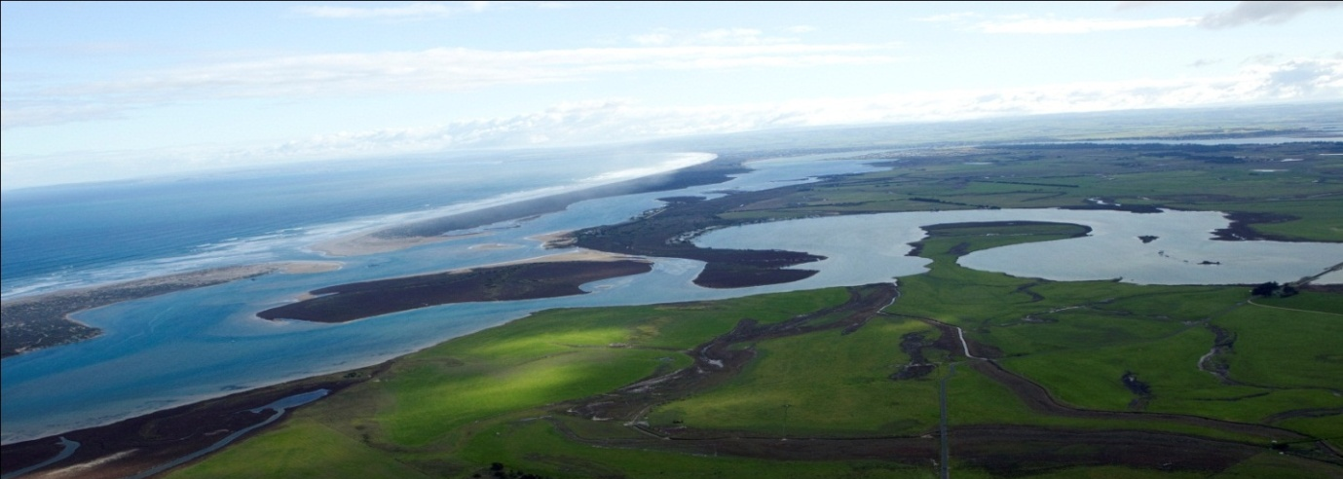
River Lakes and Coorong Action Group Inc
Email: RiverLakesCoorong@gmail.com I ABN 23 590 559 324
Winner 2009 Jill Hudson Environmental Award

Murray -Darling Basin Plan: Implementation review 2023.
Thank you for the opportunity to comment at the Productivity Commission 5 yearly review into the implementation of the Murray Darling Basin Plan.
The River, Lakes and Coorong Action Group is an independent community organisation formed in 2006 with a record of more than 17 years advocacy for the health of the Murray Darling Basin system.
Based at the end of the system we have witnessed, firsthand, the catastrophic devastation, both environmental and socio-economic, caused by over-allocation with the super-imposed millennium drought. We have also noted the positive impact of fresh water on the Southern Lagoon of the Coorong with the recent flood. Everything is connected and rivers die from the mouth up.
Question 1
What issues are important to you in implementing the Basin Plan?
The most important issue is addressing over-allocation and delivering a healthy river, which is the only stated objective of the Water Act 2007.
This means a healthy whole of Murray Darling System from the source to the sea.
A river that sustains life :human, aquatic and riparian, with connectivity throughout.
To achieve this, it is imperative to use the BEST AVAILABLE SCIENCE (as stated in the MDBP). Unfortunately, the MDBP was a compromise from the beginning, with CSIRO recommendations of 4000GL (up to 7,000 GL) required to be returned for a healthy system ignored.
So far the plan has not delivered sufficient water for ecosystem health.
The plan specified end of system flow, with the Murray Mouth to be naturally open 9 years in 10. Unfortunately continuous dredging has been required until the 2022-2023 flood. The dredge has returned to position.
Since 2012, delivery of the agreed 2750GL + 450GL for downstream, has been undermined and under delivered. The actual amount of water delivered by the Commonwealth Environmental Water Holder since 2012 has not exceeded 1700GL in any single year, with an average of 1100GL delivered over 2012-2019. Nature has saved the day with the floods of 2022-2023 but adequate environmental water will be needed when the next drought occurs to prevent the devastation witnessed in the millennium drought.
The impact of Climate Change must be considered and responsibility taken for not including allowances for a possible 30 -40 % reduction in inflows over the Basin in the original plan. The science was well documented then and again, ignored.
It is imperative that we address the issue of delivery of the 450GL. After 10 years, only 4GL has been recovered.
Buybacks from willing sellers have been proven to be the most efficient and cost-effective way of returning real water to the system. Now is the time to act, when there is water in the system. There is no excuse for further delays.
Environmental water can be delivered and is vitally important at this time to follow up the recovery made from the flood.
Care must be taken to firstly buy high security licences and secondly avoid buying “sleeper” licences which would have no impact on returning water to the system.
There needs to be recognition that environmental water, or water for river health, is the most important water, maintaining a sustainable source for every user. Valuing science above vested interests is the only way forward.
It is important to recognise that volumes alone do not dictate a healthy system. While it is agreed that a value of two thirds natural flow left for the river will ensure a healthy system, the current plan falls far short. While increase in volume is related to decrease in salinity a raft of other parameters including pH, nitrogen, phosphorous, heavy metals, pesticides, and ecological parameters need to be measured and anomalies acted upon. In spite of flow in the Darling, major fish kills occurred.
Question 2
What lessons should be learned from programs aimed at helping communities adjust to the Plan?
Recovery of water for the environment has a multifactorial effect on local communities. Previous buybacks were from willing sellers, a majority of whom only sold partial licences and this did not result in a mass exodus from local communities. Regional communities (even those not involved in irrigation) are suffering downturn through the decrease in employment opportunities because of mechanisation and farms becoming larger.It is not only the question of buybacks, but the effects of climate change making some current agricultural endeavours unsustainable. It is essential that funds be invested in regional development, health and education for reasons not limited to the effect of less water for irrigation.
The positive effects on local communities need to be considered also with a healthier river system being better for tourism, health and mental health. Deliberate misinformation about the negative effects of water buybacks needs to be addressed.

Question 3
How well is the Plan addressing the interests of the Aboriginal people?
It appears there is a complete disregard for the different value system of First Nation people, “take what you need” as opposed to “take whatever you can”. We need to celebrate the wisdom of First Nations people in caring for the land and the water for millennia while it has only taken 235 years of settlement to destroy the system.
We need to acknowledge the deep connection of First nations people to the land and to their totems and the intrinsic need to protect them. Particularly distressing is the life expectancy of First nations people, identified in 2015 in Wilcannia as being a mere 37 years for a male.
It is disgraceful that the $ 40 million granted for Indigenous water by Minister Littleproud in 2018 has not yet been delivered. The purchasing power of this money 5 years ago must be acknowledged, and the amount increased to buy an equivalent amount of water now. Water Entitlements held by Aboriginal organisations across the Basin make up a tiny percentage, 0.17%, of the total. Compare this to Foreign entitlements of 11.3%

Question 4
How could Basin Plan water recovery be done better?
Real water needs to be recovered through buybacks. Environmental water is critical to allow ecosystems to survive during drought and to maintain improvements after flood.
Water destined for environmental watering downstream benefits all communities and ecosystems along the length of the river. The notion that environmental water is wasted must be quashed. Environmental water is the most important water. Nobody benefits from a dead river.
So-called efficiency measures are notoriously difficult to quantify water returned to the system. Buybacks are the most efficient and cheapest way to return real water to the system.
Constraints preventing effective delivery of environmental water need to be addressed. After the flood, the Barmah Choke has had more silt deposited. In the mid-Murray reach flows are restricted to less than 15,000 ML/d, whereas 50,000ML/d is needed for improved environmental outcomes.
Environmental watering is just as important in wet times, ensuring resilience in times of drought.
Remove the cap. Organisations, including environmental groups should be able to purchase water entitlements for the environment.
Strengthen the legislation for the Inspector General Compliance to monitor and stop water theft. This is particularly difficult with NSW not having its WRPs accredited, nothing can happen until they are.

Question 5
What needs to change to deliver infrastructure and efficiency projects under the plan?
The aim is for an environmentally healthy river.
Infrastructure and efficiency projects should be a secondary consideration after the legislated, real, measurable water has been returned to the system.
Failed SDLAM projects need to be identified and that amount of water not forthcoming needs to be bought back.

Question 6
How is environmental water improving the health of the Basin?
Environmental water is crucial for a healthy river. All water over the barrages and through the fishways in the few years before the flood was environmental water. Without the Murray Darling Basin Plan environmental water, 2016 water levels in Lake Alexandrina would have been below sea level, similar to the millennium drought.
Small native fish are now recovering. Yarra Pygmy perch were wiped from the Lakes in the drought, re-introduced in 2012 and now surviving around Hindmarsh Island and Mundoo. They have a measurably better outcome when Lake levels are above 0.6 AHD. Being an indicator species, if Yarra Pygmy perch are doing well, other species are also thriving.
Mass germination of Black box following the 2010-2012 floods was sustained by environmental watering. Watered saplings were two to three times taller than non watered in the same location and responded with further rapid growth during the 2022-23 floods.
Environmental watering sustained mature trees, provided refuges for aquatic species and maintained soil moisture. Unfortunately, volumes are not sufficient to create overbank flows, critical for the health of the Lower Murray floodplains.
It is critical to maintain fresh water coverage of acid sulphate type soils exposed during the millennium drought.
The recent floods have seen a resurgence of life in the Southern Lagoon of the Coorong, the food web has been restored, the water is no longer hypersaline and there are aquatic plants and an abundance of fish. We are hopeful of maintaining this improvement with environmental water rather than resort to expensive and unproven engineering solutions.
Question 7
What more could be done to support a healthy working Basin?
The most important thing is to have cooperation between the Basin States with an acknowledgment that it is one river.
Over-allocation must be addressed now and the 450GL obtained through buybacks.
Climate change must be accounted for with flexibility in the volume of environmental water needed to sustain a healthy system. All consumers will have to manage with reduced allocations to maintain river health.
NSW needs to present completed Water Resource Plans and stop issuing new Floodplain harvesting licences.
All Water Resource Plans for sub-catchments must include a minimum end of system flow.
We must acknowledge the economic importance of a healthy river. $11 billion in tourism. Agriculture $ 22 billion.
Acknowledge the cultural importance to First nations and deliver the $40 million for water.
Review water trading, improve transparency, licence water traders, develop code of conduct to be under the watch of Inspector General of Compliance.

Yours sincerely
Janette Brooks
Secretary RLCAG

