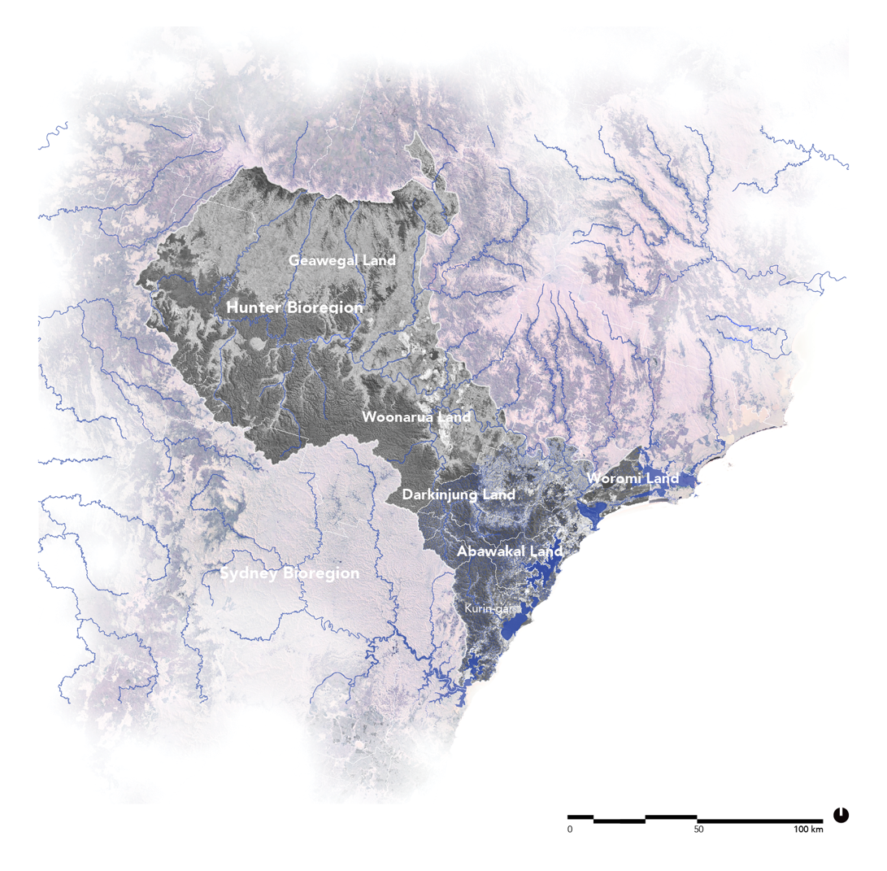
Hydrological, geomorphological, and cultural systems in the Hunter Bioregion, part of the Sydney Bioregion (and Sedimentary Basin). Image: Authors (2022), licensed under CC BY-NC-ND 4.0.

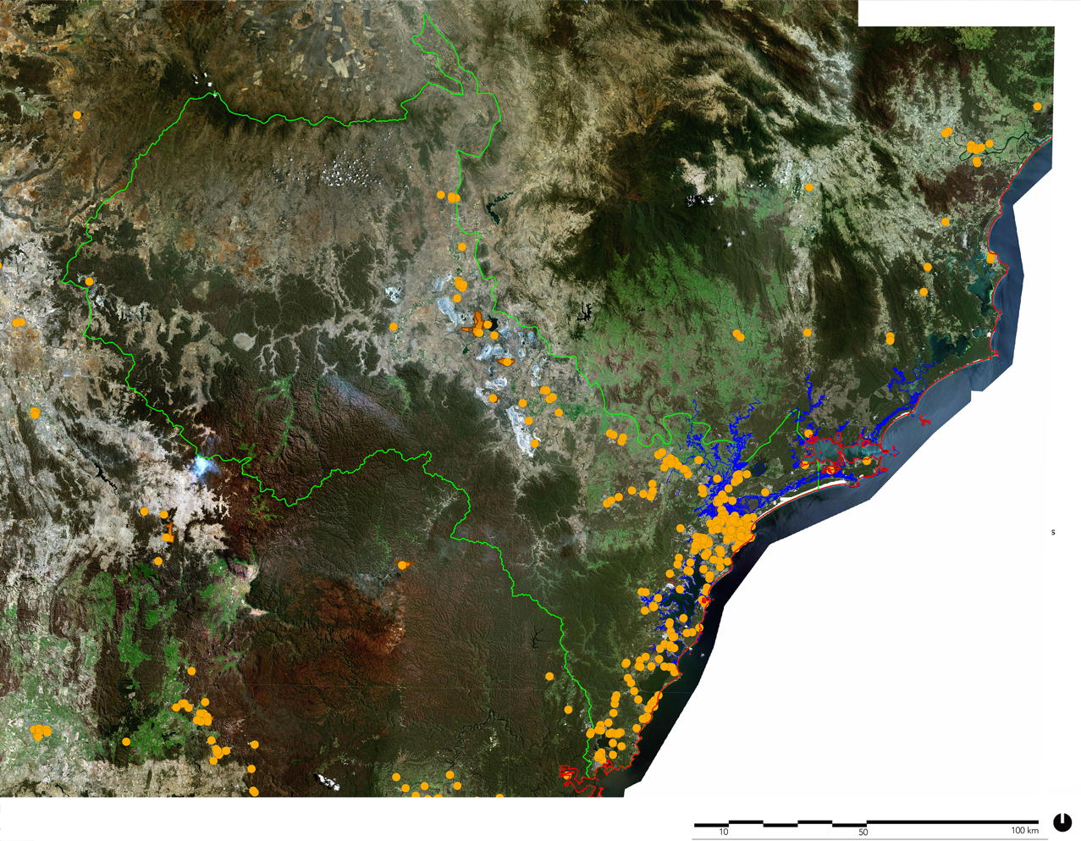
Hunter Bioregion Contaminated sites registered by EPA. Database: Environmental Protection Australia (EPA).

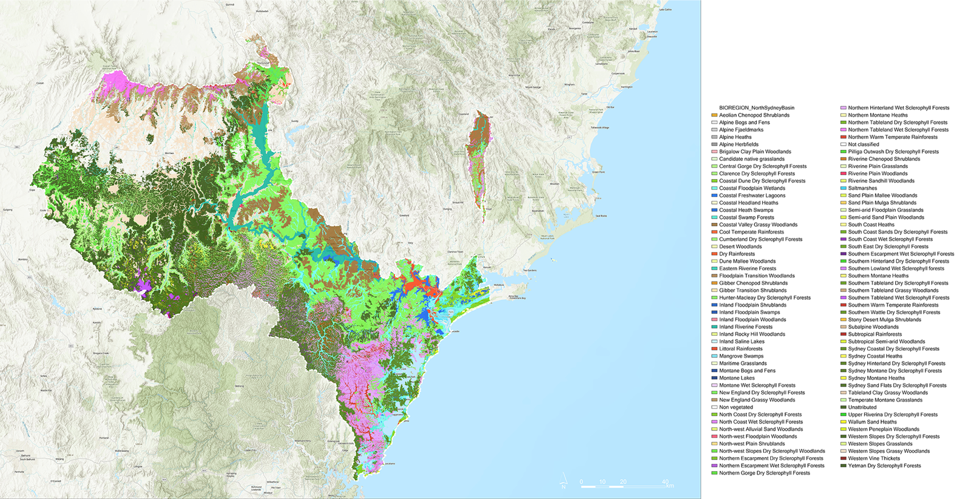

Vegetation Hunter Bioregion - Pre-colonial (pre-1750). Database: © State Government of NSW and NSW Department of Climate Change, Energy, the Environment and Water 2022.

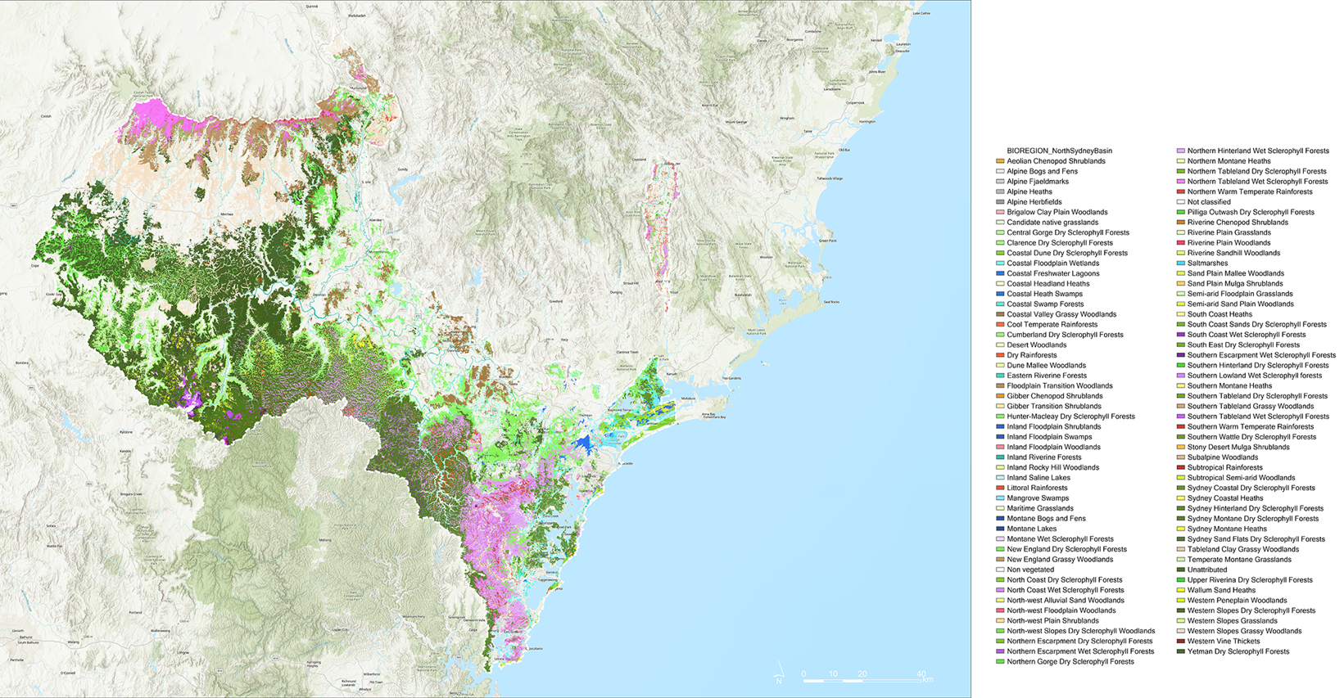
Vegetation Hunter Bioregion - Current State 2024. The legend identified as “Non classified” (in red) areas significantly impacted by clearing. Database: © State Government of NSW and NSW Department of Climate Change, Energy, the Environment and Water 2022.

