Gold Coast Dyslexia
Support Group
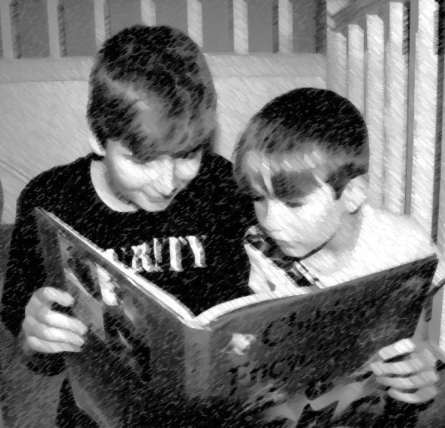

Submission from the Gold Coast Dyslexia Support Group for the
Education Evidence Base Productivity Commission
In today’s education system, the most important aspect of ‘evidence based education’ is also the most overlooked. Currently there is a significant focus on collecting and analysing ‘data’. This ‘data’ is used to inform classroom practice, evaluate school performance and influence education policy. Very few schools and education authorities, seek guidance from the most credible source – EDUCATION RESEARCH.
The research to practice gap in Australian schools is alarming and as a result we are at crisis point.
Research indicates that at the moment, over 40 per cent of our students have inadequate literacy skills, 20 per cent of students have significant reading difficulties and an estimated 3-5 per cent of students will have severe and persistent reading disability. The Australian Bureau of Statistics in 2011 revealed that 46 per cent of 15- to 19-year-olds are functionally illiterate; this means they have inadequate literacy skills to cope with the basic demands of everyday work and life. The Progress in International Reading Literacy Study (PIRLS) in 2011 revealed that many Australian Year 4 students have substantial literacy problems, with around one-quarter of students not meeting the minimal standard of proficiency. In the PIRLS study, Australia was ranked the lowest for literacy out of all English speaking countries. Clearly we have a problem.
John Hattie’s Visible Learning meta-analysis was the largest study ever done in education research. It included 80 million students, 50,000 studies and 800 meta-analyses. The study investigated 138 influences related to learning outcomes and they were ranked from positive to negative effects on student achievement with an average effect size 0.40. The ‘bottom’ effects that have little impact on learning are our most commonly supported practices. Negative influences include class size; ability grouping; homework; inquiry based teaching and whole language. Sadly, the ‘top’ effects that have most impact on student achievement are less common, and sometimes non-existent, in our classrooms. Positive influences include feedback; metacognition; direct instruction; worked examples; peer tutoring and phonics instruction.
Sadly, most educators are unfamiliar with this body of education research.
There are different levels of education research but 'evidence based' is the gold standard. Evidence based pedagogy has a solid research base to demonstrate it has the greatest impact on student results.
- The education research shows that explicit direct instruction with teacher explanation and modelling worked examples using think-aloud; then guided practice with two way feedback; followed by independent practice with scaffolding and support where required. The current practice in most schools is based on constructivist approaches with inquiry based ‘discovery’ learning, or learning by chance.
- The education research supports real-time reciprocal feedback has the greatest impact on both teaching and learning. The current practice in most schools is standardised tests with delayed feedback to correct entrenched student ‘mis-learning’ and inform teaching practice after-the-fact.
- The education research demonstrates that effective learning occurs when students have sufficient time and practice to achieve mastery. The current practice in most schools is the curriculum determines the pace of teaching.
- The education research shows that early intervention of students at risk of learning difficulties is critical. The current practice in most schools is the wait-to-fail model.
- The education research shows that we should differentiate our instruction to scaffold student learning. The current practice in most schools is differentiating the curriculum.
- The education research in the teaching of reading supports the National Inquiry into the Teaching of Literacy (NITL 2005). The current practice in most schools is based on whole language and balanced literacy.
This is just the tip of the iceberg regarding the discrepancies that exist between education research and classroom practice. Education research that focuses on improving student learning is valuable in shaping our classroom practices. We need our teachers to connect with the education research to improve student performance. Data collection of ineffective teaching methods is counter-productive. All the ‘data’ in the world will not improve in our student’s learning until we get our teaching right first!

Written and Approved by Tanya Forbes (on behalf of the Gold Coast Dyslexia Support Group) in the capacity as the founder of the Gold Coast Dyslexia Support group.
Dated: 26 May 2016

