Indigenous Evaluation Strategy
Productivity Commission

To Mr Romlie Mokak and the Productivity Commission,
Re: Indigenous Evaluation Strategy:
Submission from Associate Professor, Clair Andersen, Aboriginal Higher Education Advisor at the University of Tasmania
The following submission is provided in response to the Productivity Commission issues paper relating to the development of the Indigenous Evaluation Strategy. Our goals here at our university are to progress, elevate and secure – past, present and future Aboriginal and Torres Strait Islander knowledges that influence Western academy (universities), to increase the accessibility of higher education for all Indigenous people and communities and to develop and grow scholarship and research for and by Aboriginal and Torres Strait Islander people.
We understand that the Productivity Commission has been tasked to:
- Establish a principles-based framework for the evaluation of policies and programs affecting Indigenous Australians
- Identify priorities for evaluation
- Set out its approach for reviewing agencies’ conduct of evaluations against strategy

This submission provides some general background information and then draws on recent commentary and research from the Indigenous higher education sector to address each of the key focus areas mentioned above.
Background
Within Australia, the Review of Higher Education Access and Outcomes for Aboriginal and Torres Strait Islander People (Behrendt et al 2012) – often referred to as the Behrendt Review - provided a clear blueprint for investing in policies and programs that support Indigenous pathways, transitions, participation and achievement in higher education. Yet, the review also acknowledged that:
While considerable data was available through departmental program-based reporting to monitor progress, there was not always sufficient evidence to assess the overall success or otherwise of specific programs. In some cases, there were no independent evaluations of programs for the Panel to draw on (Behrendt et al., 2012, p. 154)

As part of the review process Moreton-Robinson et al (2011) were commissioned to examine the impact of Indigenous governance and leadership on Aboriginal and Torres Strait Islander participation in higher education. This involved benchmarking all Australian universities against a series of Indigenous-specific measures. The Behrendt Review subsequently recommended that the Australian Government and Universities work together to develop a national Aboriginal and Torres Strait Islander higher education monitoring and evaluation framework (Behrendt et al., 2012).
While there have been multiple investments in Indigenous higher education since the Behrendt Review (2012), action on this recommendation has remained elusive. Similarly, the 2015 recommendation of the Aboriginal and Torres Strait Islander Higher Education Advisory Council to develop a ‘performance framework’ has also been ignored. This has led to recent research on the topic to recommend that:
The Australian higher education sector, NATSIHEC, Universities Australia and the Australian Government prioritise the development of a National Indigenous Higher Education Performance and Evaluation Strategy. This should be Indigenous-led and appropriately resourced.’
‘The Australian Government should include a suite of Indigenous higher education targets, aligned with a National Indigenous Higher Education Performance and Evaluation Strategy, as part of the Closing the Gap refresh.’ (Smith et al. 2018, p7).
Rigney (2017) has offered some initial guidance in relation to what an Indigenous higher education framework can look like. However, in late 2017 NATSIHEC supported a grant proposal to develop a National Indigenous Higher Education Performance and Evaluation Strategy, as recommended above. This was submitted to the Department of Prime Minister and Cabinet through the community-led Indigenous Advancement Strategy application process. This was not funded, and no further feedback was provided by the Department of Prime Minister and Cabinet, despite requests for additional information.
- Establish a principles-based framework for the evaluation of policies and programs affecting Indigenous Australians
We draw attention to recent empirical research undertaken by a team of researchers from the Office of Pro Vice Chancellor – Indigenous Leadership at Charles Darwin University. This research was led by Professor James Smith through a 2017 Equity Fellowship funded by the National Centre for Student Equity in Higher Education (NCSEHE). It was supported by Dr Kellie Pollard, Ms Kim Robertson and Ms Fiona Shalley. The focus of this research was about strengthening evaluation in Indigenous higher education contexts in Australia. It was undertaken in close consultation with NATSIHEC. The report is now freely accessible at:
https://www.ncsehe.edu.au/wp-content/uploads/2018/08/JamesSmith_FellowshipReport_FINAL_Small.pdf

A peer-reviewed article has now also been published on the topic in International Studies in Widening Participation:
https://novaojs.newcastle.edu.au/ceehe/index.php/iswp/article/view/86
This original research contribution represents one of few empirical studies in Australia that has privileged Indigenous voices to highlight issues associated with evaluating Indigenous programs, policies and outcomes. It draws on the perspectives of 24 Indigenous scholars from all states and territories across Australia to:
- Explain that evaluation is defined broadly by key stakeholders – indicating it means different things to different people
- Highlight the importance of qualitative methods in evaluation design
- Show that greater accountability by the Australian Government and Australian Universities (particularly University Executives) is required in relation to evaluating Indigenous higher
education outcomes, with a reciprocal need to show greater accountability towards Indigenous communities
- Identify 14 enablers and drivers for change to strengthen evaluation in Indigenous higher education in Australia. This includes:
- Incentivising cultural competence;
- Growing Indigenous leadership;
- Addressing white privilege and power;
- Valuing Indigenous knowledges and prioritising Indigenous epistemologies;
- Embracing political challenges as opportunities;
- Recognising sovereign rights;
- Increasing funding and resources;
- Leading innovative policy development, implementation and reform;
- Investing in strategy development;
- Investing in cultural transformation, change and quality improvement;
- Improving Indigenous student outcomes;
- Promoting cultural standards and accreditation;
- Reframing curricula to explicitly incorporate Indigenous knowledges and practices; and
- Investing in an Indigenous workforce.
- Present a conceptual model of potential performance parameters to strengthen Indigenous higher education monitoring and evaluation in Australia - spanning students, family and community, schools and other organisations, and universities (see Figure 1 below)
- Outline 17 recommendations for implementation by the Australian Government, Australian Universities and other key stakeholder groups.

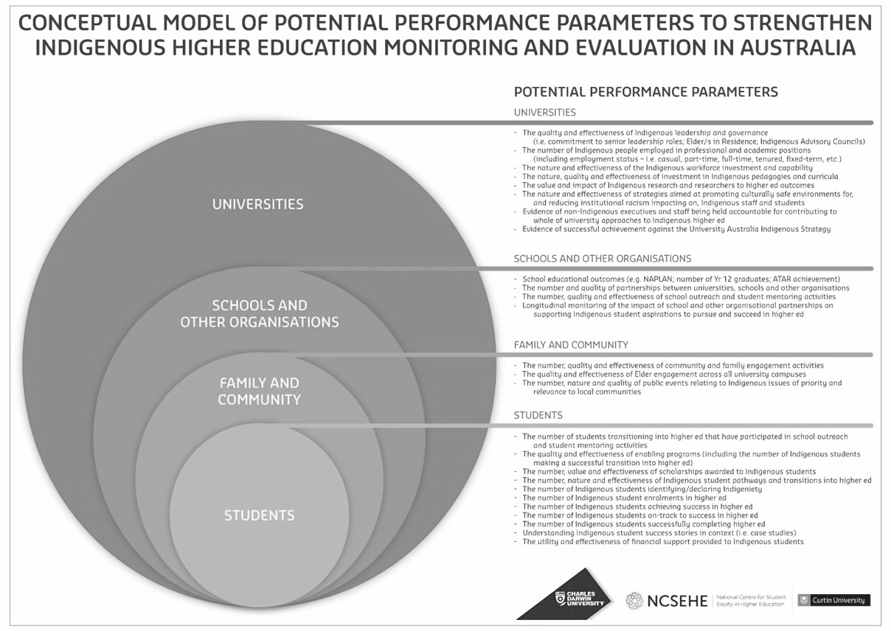
Figure 1: Conceptual model of potential performance parameters to strengthen Indigenous higher education monitoring and evaluation in Australia (Smith et al. 2018)
As a follow-up to recommendations from this research report, a national capacity building and legacy workshop was facilitated by the NCSEHE in April 2018. The focus was on Indigenous data sovereignty within Indigenous higher education evaluation contexts. The workshop included Indigenous representatives from across Australia, including multiple NATSIHEC members. Outcomes from this workshop are documented in the following report:
https://www.ncsehe.edu.au/wp-content/uploads/2018/07/WS3_-CompleteReport_FINAL.pdf
They are also available via this webinar:
https://www.slideshare.net/NCSEHE/ncsehe-webinar-indigenous-perspectives-on-evaluation-in-indigenous-higher-education
Of relevance to the Productivity Commission’s terms of reference is a series of good practice principles that were developed during this workshop (see Figure 2).

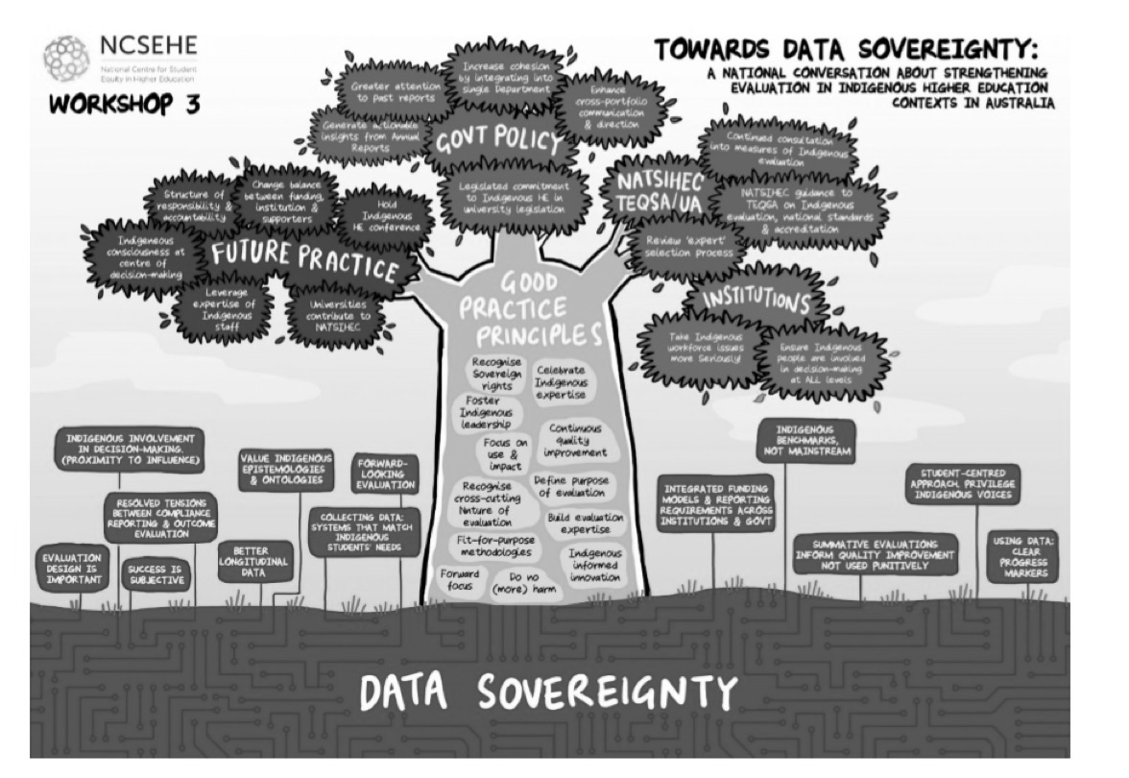
Figure 2: Towards data sovereignty: A national conversation about strengthening evaluation in Indigenous higher contexts in Australia. (NCSEHE, 2018, p. 5)
- Identify priorities for evaluation
We consider that the evaluation of Indigenous higher education programs and policies, and respective educational outcomes, needs to be clearly identified as a key national evaluation priority. There is now sufficient evidence, and a well-articulated roadmap, to warrant this level of investment.
As outlined above, calls for a greater focus on evaluation in Indigenous higher education contexts has been repeatedly highlighted through national reviews, ministerial advisory councils, and empirical research. Yet, minimal tangible action by the Australian Government has occurred. Within an Indigenous higher education context, this has been stifled by a perceived lack of policy and program co-ordination between the Department of Education and Training and Department of Prime Minister and Cabinet in the area of Indigenous higher education (Smith et al 2018, p42).
At a NATSIHEC National Caucus meeting held in Darwin from the 21st-22nd June 2018, it was agreed that Professor Smith’s research and its recommendations were of direct relevance, and it should be used as a tool to advocate and agitate for long overdue changes to the Australian Indigenous higher education sector. The findings of the report touch on a range of important issues of national significance, such as growing Indigenous leadership; increasing university and government accountability; challenging white power and privilege; and prioritising Indigenous data sovereignty. As such we have included the following attachments as part of this submission:

- Smith, J., Pollard, K., Robertson, K. & Trinidad, S. (2017a). What do we know about evaluation in Indigenous higher education context in Australia? International Studies in Widening Participation, 4 (2), 18-31.
- Smith, J., Pollard, K., Robertson, K. & Shalley, F. (2018). Strengthening evaluation in Indigenous higher education contexts in Australia: 2017 Equity Fellowship Report. Perth, National Centre for Student Equity in Higher Education.
- National Centre for Student Equity in Higher Education (NCSEHE) (2018). Building legacy and capacity workshop 3: Indigenous perspectives on evaluation in Indigenous higher education. Perth, National Centre for Student Equity in Higher Education.
- Smith, J. & Robertson, K. (In Press). Evaluating cultural competence in Indigenous higher education contexts in Australia: A challenge for change. Cultural Competence in Higher Education. Springer. Not yet published (provided in-confidence).

- Set out its approach for reviewing agencies’ conduct of evaluations against strategy
The following extract from the Smith et al (2018) report has been reproduced with permission, as it succinctly summarises challenges faced in relation to the two primary Australian Government Departments involved in Indigenous higher education policy and program development in Australia:
‘The Machinery of Government change resulting in the structural separation of Indigenous higher education policy and program responsibilities at the federal level has stifled progress in Indigenous higher education. In turn, this has limited the ability to use evaluation evidence to influence innovative policy and program change, whether through targeted Indigenous education investments or through influencing mainstream strategy development. It appears these changes have been further hampered by a perceived lack of communication between departments, which creates difficulty in navigating pathways between them. For example, a current NATSIHEC executive member commented:
We are often mediating between departments because they’re not actually communicating between each other, and there’s a lack of visibility and transparency around what each other are doing. This is something explicitly between DET and PMC that we’ve brought to their attention on numerous occasions around the competing agendas, and equally the conflict in some of their aspirations. (Cheryl Godwell, Indigenous scholar)
Similarly, another participant claimed:
It’s actually really hard to go between Prime Minister and Cabinet and going back to the Department of Education [and Training], who’s responsible for curriculum, and the national curriculum. So they will say at the federal level, ‘we can’t go do anything until you go back to Prime Minister and Cabinet’ and

vice versa. So to actually try to streamline something within teacher education is almost entirely impossible. (Zac, Indigenous scholar)
When policymakers were queried about communication mechanisms between DET and PMC, there were varied responses. Some considered current communication channels were appropriate, and some considered they could be improved. For example:
We [DET] catch up with people that are working on the Indigenous Advancement Strategy. We have a chat with them every now and then about what's going on and what's been happening. My Director, I think, meets with some of the other departments once a month or every two months or so, where they discuss some of the hot topics that are going on. So there are communications on that level. (John, policymaker)
Another participant reflected:
I think we [DET] work quite well with PMC. I think we could always work closer with them, but there are a lot of legacy program issues that come up that we need to provide advice on and they need to provide advice on. We’ve got contacts there. (Isabelle, policymaker)
Whereas another policymaker commented:
They [PMC] do silly things like not consult properly but they’re also getting the feedback from the universities on what is working and what is not working fairly immediately and they’re making the adjustments there and those adjustments are policy adjustments. So, in that sense, unless we’re in regular contact with them, we’re actually out of touch with the actual policy contexts. (Oliver, policymaker)
Concerns about the split between DET and PMC were also raised by Indigenous scholars in relation to the duplication of reporting processes:
I think when you have two bodies to report to, and there is a difference in the reporting requirements, then you’ve got some duplication. But you’ve also got some loss of data that would be useful to the other. (Cindy, Indigenous scholar)
A similar sentiment, albeit in relation to whole-of-government policy responses, was emphasised by a member of the former First Peoples Education Advisory Group, who commented:
It’s simply ludicrous at the moment that we report on student retention rates and so on, and success and completion rates. None of this data about Aboriginal enrolment in higher education ends up in the housing sections of government services or the accommodation sections or the health sections.

These present Indigenous education with a conundrum that has always been there — that government policy and agency[ies] work in silos. So the challenges of poor health and poor accommodation that a university Aboriginal student presents to an institution is not relayed to other organised areas inside government. (Lester-Irabinna Rigney, Indigenous scholar)
Concern about the way in which data is used (or not used) by governments surfaced frequently. This was particularly pertinent in relation to new reporting measures, such as those being introduced through the Indigenous Student Success Program (ISSP):
I think PMC [Tertiary Education] need some help with setting up their evaluation framework by the looks of it, because they’ve put in these things like employment and the curriculum and all those things. How are they really going to evaluate that it’s working? (Leslie, Indigenous scholar)
Whilst many participants insisted that new and expanded measures were required to increase accountability of both governments and universities, this was mentioned with caution. Participants emphasised it was important for evaluation and reporting measures to have a clear purpose, and for these to be discussed with key stakeholders through co-design processes, well prior to implementation. That is, a clear line of sight about what was being measured, by whom, how, and why.’ (Smith et al, p42-44)
Clearly, urgent work is required to streamline government processes to enable improved evaluation processes in the Indigenous higher education sector in Australia. At UTAS we are keen to be involved and look forward to opportunities to work with the Productivity Commission and the Australian Government to ensure that a National Indigenous Higher Education Performance and Evaluation Strategy is developed and implemented as a matter of priority. An investment of this nature is long overdue.

Yours sincerely,

