Ruah Community Services

Productivity commission

National Housing and Homelessness agreement Review Submission

FEBRUARY 2022

Executive Summary
- Ruah Community Services have been providing mental health, family and domestic violence and housing and homelessness services to people in Western Australia for over 60 years.
- From its leading role in bringing Housing First to Western Australia in 2015 and strong partnerships with industry bodies, Ruah were appointed Housing First System Coordinators as part of the WA government’s Housing First Homelessness Initiative and 10-year homelessness strategy launched in 2020.
- Ruah stands by the Australian Alliance to End Homelessness in a commitment to Housing First, Ending Homelessness and the Advance to Zero methodology. The Housing First Principles are evidenced-based and grounded in international experience that demonstrates the efficacy of this approach as a strategy to ending homelessness. Alongside commissioning of services to reflect a systemic approach, investment in supporting quality data to monitor our progress toward achieving functional zero is also of high importance.
- At the grass roots, our capacity to implement Housing First within WA and across Ruah’s portfolio of services is challenged by the availability of housing stock and diverse approaches to the commissioning of services, which are not always in alignment with commitment to the Housing First principles.
- Ruah believes a national commitment to providing housing for all and a system of homelessness prevention and response services aligned with the principles of Housing First is the best opportunity to fundamentally end rough sleeping across Australia. To do this, Housing First needs to be implemented as a philosophy, integrated system, and program that is aligned to how housing is prioritised.
- Ruah with leading sector stakeholders (including the Centre for Social Impact, the Australian Alliance to End Homelessness and Shelter WA) call for leadership and proactivity at the Australian Government level and a national strategy to end homelessness, including clear targets for housing directly linked to NHHA outcomes.

Ruah community services

about ruah
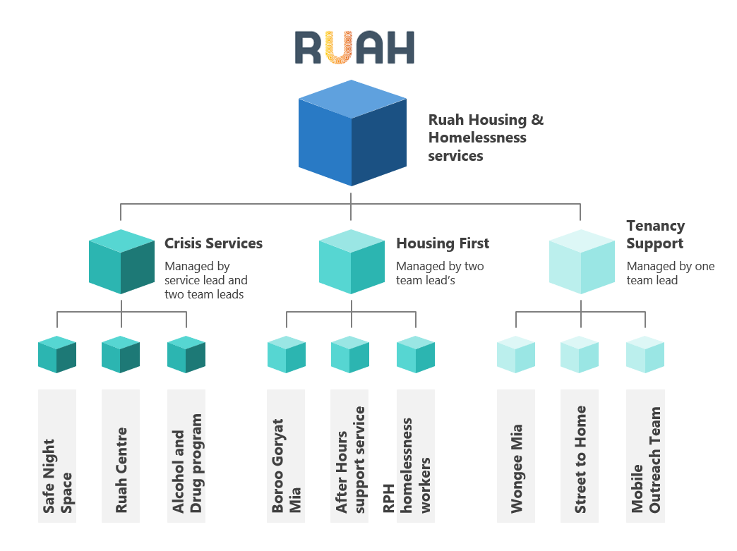
Ruah is an award-winning integrated community services provider based in Perth, Western Australia with over 60 years’ experience supporting vulnerable people in the mental health, family and domestic violence and housing and homelessness sectors. Ruah operates more than 20 different programs that combine to provide wraparound trauma-informed support for our clients. We also provide legal advice, support, and advocacy in the areas of mental health law, care and protection, family and domestic law and homelessness.
Housing and homelessness are one of our three core service areas, supporting a range of programs and services.

Homelessness in WA
Although Western Australians can be keen to boast of the fantastic lifestyle enjoyed in the sunny resource-rich state, some 9,000 of its 2.1m people are presently homeless. As of January 2022, 18,388 households (32,067 people) in WA are on the social housing waitlist; with 3,762 applications (7,603 people) on the priority waitlist. The average wait-time for public housing is over 100 weeks, and in the WA outback (North), the rate of people accessing specialist homelessness services in 2020 was the highest in the nation. At Ruah however, we know that many rough sleepers do not have active housing applications or access to government funded services, and that many more people could be added to the totals reflected in these official data sources.
Additionally, the steady rise in residential property value and rents that has occurred over the last 12 months has put severe strain on the private rental market, reducing opportunities for those seeking a way out of homelessness. A reopening of borders in WA in 2022 is also likely to put further pressure on the housing market as residents and international students return, immigration recommences, and the building industry struggles to catchup from a slowdown through labour and materials shortages because of COVID-19.

Policy Environment

background
A call for a greater degree of national leadership and whole of government approach to ending homelessness is not new. Public response to the May 2008 Green Paper on homelessness, Which Way Home? A New Approach to Homelessness, attracted almost 600 written submissions that delivered this goal as a primary recommendation. A subsequent white paper The Road Home: A National Approach to Reducing Homelessness, set ambitious targets and proposed frameworks to address homelessness by 2020. Different methodologies were trialed nationally during the period 2008-2013, creating a shift within practice and policy development, instilling a belief that homelessness could be not just be reduced, but ended. But as leading researchers in the field, the Centre for Social Impact have observed, although federal endeavors to make this goal a reality have petered out; it has been individual homelessness organisations and state and territory housing and homelessness strategies and responses that stepped up to fill the void.

Housing First in australia
Support for a Housing First/Advance to Zero approach, with origins overseas and data-driven, grew in Australia in the decade 2010-2020. Place-based community success right across the nation in this period has now delivered a new rich dataset on Australian homelessness - The Australian Advance to Zero database. This enables deep-dive local, state, and national understanding through individual experiences and pathways into, and out of homelessness; and is a valuable addition to existing Census and Specialist Homelessness Services Collection (SHSC) data sources. A baseline of people experiencing homelessness in communities allows for the ability to improve measurement of the effectiveness of interventions and the way homelessness is influencing communities across the country. Understanding healthcare and welfare demands for example, which have significant impact on national spending and investment, can be greatly assisted with access to this data.
While the Western Australian government has listened to the voices of the sector organisations and put Housing First at the centre of the state’s housing and homelessness strategy; at a national policy level, this narrative is now noticeably absent.

Sector-Led State Strategy
In Western Australia the housing and homelessness services sector has been at the forefront of driving policy direction. Frustrated with the continued lack of solution-based strategy in WA, in 2015 a major Housing First project, the ‘50 Lives 50 Homes’ project (50 Lives) was launched, a three-year collaborative impact response supporting Perth’s most vulnerable rough sleepers to access housing and wrap-around support. Ruah were the lead agency and provided the ‘backbone support’ to this project: facilitating sector collaboration through working groups, information sharing, measurement, and access to an After-Hours Support Service. The community services sector in WA embraced 50 Lives, with 27 organisations participating in the initiative and evaluation published by the Centre for Social Impact (CSI) at the University of Western Australia. By 2019 not 50, but 341 people who engaged with the project had been housed, with a retention rate of 81% after one year of operation.
In 2018, the local branch of the Alliance to End Homelessness (WAAEH) made up of a wide group of stakeholders launched the Western Australian Strategy to End Homelessness, a ten-year collaborative blueprint advocating for more desperately needed housing and sector coordination. A year later in 2019 the Western Australian government launched All Paths Lead to a Home: Western Australia’s 10-Year Strategy on Homelessness 2020–2030, building on this strategy and formally expressing commitment to a Housing First approach. Alongside the launch of the state strategy, funding of $34.5 million was announced for delivery of the Housing First Homelessness Initiative (HFHI), to provide accommodation and wrap-around support to people sleeping rough. At this time the Zero Project WA, led by Ruah was awarded the Housing First System Coordinator role, building on its learning from the previous four years.
The sector has welcomed the announcement of a $875 million boost for social housing in the 2021-22 State Budget, but with a dire shortage of housing, model fidelity and ultimately the effective implementation of Housing First is hamstrung. Indeed, an independent evaluation of how well the Homelessness Service System is aligning to the Strategy published in 2021 found a lack of clarity of how Housing First should be embedded, a commitment no doubt difficult to meet and hindered by the drastic shortage of housing stock. Such reflection highlights the deep frustrations felt by the sector attempting to deliver on a model that core funding and commitment at state level has been unable to service.
Under the current WA Department of Communities Housing Allocations policy, only 50% of public housing allocations and Non-Growth Community Housing Organisations, and 35% of Growth Community Housing Organisation allocations are allocated to people on the Priority Housing Wait List. Furthermore, the Priority Housing Wait List does not prioritise those most in need but is based on wait turn. These factors limit the number of properties allocated to people who are rough sleeping and chronically homeless and is also at odds with the Advance to Zero methodology which seeks to prioritise the most vulnerable people. Housing First needs to be implemented as a philosophy, integrated system, and program.

call for a unified approach
Ruah supports calls for a more systematic approach to housing policy and a national housing strategy, one that reflects the advances made by the WA services sector and government through a Housing First approach to ending homelessness. This shift is key to meeting the objective of the National Housing and Homelessness Agreement (NHHA) to “prevent and address homelessness, and to support social and economic participation” (p.3); and that the depth of data and understanding delivered by the approach will directly contribute to the shared responsibilities in the NHHA around data collection, use and improvement (pp. 5-6).
Future leadership at the federal level and a commitment to Housing First will be essential to ending homelessness in Australia. This is a view now shared by our key local stakeholders as follows:

Shelter WA
Shelter WA advocate for a national housing and homelessness strategy that is led/overseen by a dedicated agency with clear targets for housing and directly linked to the outcomes defined by the NHHA. Ruah endorses the views expressed in the forthcoming submission from Shelter WA, including direct response to issues raised in the National Housing and Homelessness Agreement Review Issues Paper (not addressed in detail in this submission).

Centre for Social Impact
Most recently, the CSI’s 2021 analysis of the national Advance to Zero Database has identified five key action recommendations, the first of these being a “call for leadership and proactivity at the Australian Government level and a national end homelessness strategy applying across the states and territories”.

West Australian Alliance to End Homelessness
The WAAEH Western Australian Strategy to End Homelessness (2018) provides calls for action which require broader leadership by the Federal Government to ensure implementation. These include:
- independent review of Commonwealth Rent Assistance (CRA) rates
- indexation and interaction with other payments
- evaluations of Australian Government sponsored social housing projects
- conditional waivers of historical state and territory government housing debts.
Uniting federal and state governments to co-commit to adequate investment to meet projected social housing demand right across Australia could be instrumental to ensure that the current crisis in housing stock in WA will become a discreet episode in our history. The collaboration required to action these recommendations will represent a shift in the dynamic between state and territory governments and the Federal Government implied in the NHHA; whilst acknowledging that state and territory governments are best placed to identify the projects and services that are necessary to meet local needs.

Parliament of Western Australia, Parliamentary Debates, Legislative Council, 15 February 2022. https://www.parliament.wa.gov.au/Hansard/hansard.nsf/0/788D9075B822295C482587EB0019A32A/$File/C41%20S1%2020220215%20All.pdf.
Australian Insitute of Health and Welfare (2020). Specialist homelessness services annual report. Cat. no. HOU 322. Canberra: Australian Institute of Health and Welfare.
Flatau, P., Lester, L., Seivwright, A., Teal, R., Dobrovic, J., Vallesi, S., Hartley, C. and Callis, Z. (2021). Ending homelessness in Australia: An evidence and policy deep dive. Centre for Social Impact, The University of Western Australia and the University of New South Wales. DOI: 10.25916/ntba-f006.
International examples include Community Solutions in the United States (https://community.solutions/built-for-zero/); Homeless Hub in Canada (https://www.homelesshub.ca/about-homelessness/homelessness-101/housing-first); Housing First Europe Hub in Finland (https://housingfirsteurope.eu/countries/finland/).
Vallesi, S., Wood, L., Gazey, A., Cumming, C., Zaretzky, K., and Irwin, E. (2020) 50 Lives 50 Homes: A Housing First Response to Ending Homelessness in Perth. Third Evaluation Report. Centre for Social Impact and the School of Population and Global Health: University of Western Australia, Perth, Western Australia.
Zanella, D., Flatau, P., Hunt, A., Glasson, M., Berger, J., Gregory, K., Knoght, S., Rooney, S., Morrison, D., & Stubley, K. (2018). The Western Australian strategy to end homelessness. Western Australian Alliance to End Homelessness. https://www.csi.edu.au/media/Version_1.0_WA_Strategy_to_End_Homelessness.pdf, accessed 15 February 2022.
Collective IQ (2021) Homeless Service System Alignment Analysis and Roadmap. https://www.wa.gov.au/system/files/2021-10/Homelessness-Roadmap.pdf, accessed 15 February 2022.
Department of Housing Western Australia (2009). Community Housing Allocations Policy (CHAP). Policy Number CH/2007/32194-02, revised October 2010. Available: https://www.housing.wa.gov.au/HousingDocuments/Community_Housing_Allocations_Policy.PDF.
Flatau et al., 2021, p.160.

