Submission to the Productivity Commission Inquiry into Early Childhood Education and Care
17 May 2023

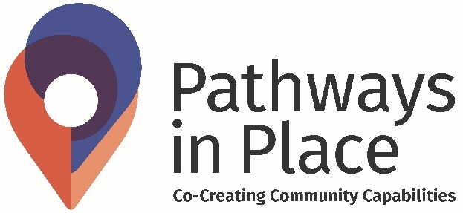

A partnership between

Funded by
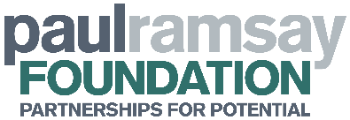

© Pathways in Place: Co-Creating Community Capabilities, 2023
This work is licensed under a Creative Commons Attribution-NonCommercial-NoDerivatives 4.0 International License. To view a copy of this license, visit http://creativecommons.org/licenses/by-
nc-nd/4.0/
For enquiries regarding this publication:
contact: pathwaysinplace@griffith.edu.au
Disclaimer:
Any opinions, findings, or conclusions expressed in this submission are those of the author(s) and do not necessarily reflect the views of the Paul Ramsay Foundation or of Griffith University.

Table of contents

Introduction 4

Relevant background 4

Logan: A brief overview 5

Key report findings 5

Conclusion 6

Reference List 7

Appendix 1 8

Introduction
The Pathways in Place: Co-Creating Community Capabilities (PiP) program at Griffith University welcomes the opportunity to make a submission as part of the public consultation process for the Early Childhood Education and Care inquiry.
PIP is an innovative program of research and action that supports the flourishing of children and young people. This program is jointly delivered by Victoria University and Griffith University with funding generously provided by the Paul Ramsay Foundation through a five year funding partnership.
The Griffith University program works with communities in Logan, Queensland and focuses on early learning and development pathways, children and youth 0-15 years in the Logan, Queensland area. The program uses a place-based approach designed to strengthen community capacity and agency in Logan. PiP understands and prioritises early childhood education and care (ECEC), as a critical stage of the life cycle.
We note that the inquiry encourages submissions to present research, reports and/or case studies. Attached as Appendix 1 to this submission is a report entitled; Building the Foundation for Lifelong Learning: An analysis of early learning service provision in Logan (Report).

Relevant background
Over the course of 2021, PiP Griffith researchers undertook extensive community consultation in Logan focusing on health, education, and community services sectors. Part of the consultation around education involved the Report focused on early childhood education resources in Logan. This Report involved a systematic desktop data collection of the services, programs and interventions that make up Logan’s child and youth development system for children aged 0-5 (Zanus, 2022). The Report examined a subset of 1450 assets. The overarching focus of the Report was whether children in Logan have access to high quality learning opportunities to build solid early learning foundations.
By way of overview, the Report found service provision gaps in early childhood education contributing to school readiness and also found that the current service response does not adequately reflect or support the diversity of Logan's children and families (Zanus, 2022).

Logan: A brief overview
Logan is an extremely diverse area with a majority young population that is growing. The City of Logan is home to 327,000 people from over 217 different cultures, including an above average Indigenous population and the highest proportion of Māori and Pasifika people in Australia (7.75% per cent as at 2021 census) (Australian Bureau of Statistics, 2021).

Within Logan, there are approximately 28,000 children under the age of five (Zanus, 2022). Of this group, 53% live in SA2’s which are classified as the most disadvantaged areas (Zanus, 2022). In 2021, the Australian Early Development Census showed that 73.3% of children in Logan started school developmentally on track in terms of physical health and wellbeing, 5.1% below their national peers (Zanus, 2022).
Participation in quality early childhood education and care benefits all children. Early childcare services have the potential to ensure children enter school on a more equal developmental footing. However, the benefits of early childcare services are especially important for children from vulnerable or disadvantaged backgrounds (Zanus, 2022; Melhuish, 2015). As a place where diversity and disadvantage intersect, Logan represents an important opportunity to examine childcare issues.

Key report findings
A full copy of the Report is provided as Appendix 1 to this submission.
By way of summary, the key findings of the Report that relate to the Productivity Commission’s scope are:
- There are limited services to cater for culturally and linguistically diverse families.

- There are limited childcare options for parents seeking access to childcare outside of non-standard work hours. In Logan, the small number of family day care centres identified in the Report were generally not open outside of non-standard work hours.

- There are limited casual childcare options that provide short periods of care.

- There has been no significant increase in number of children enrolled in a kindergarten program in Logan despite increased state and local efforts to increase awareness of the benefits of Kindy.

- The number of childcare services, in the most disadvantaged areas of Logan, that are exceeding the National Quality Standards should be increased.The proportion of children starting school developmentally on track according to the Australian Early Development Census categories has increased in Queensland and Logan since 2009. However, further work is required as children in Logan are still presenting with higher levels of developmental vulnerability than the national average.
- Further research is required to understand whether the current number of childcare places in Logan is sufficient to accommodate all children under school age.

Conclusion
We thank the Commission for the opportunity to contribute to the Inquiry and we look forward to future opportunities to participate. If you wish to discuss the issues raised in more detail, please contact the Pathways in Place team at pathwaysinplace@griffith.edu.au.

Reference List
Australian Bureau of Statistics. (2021). Census. https://www.abs.gov.au/census
Melhuish E, Ereky-Stevens K, Petrogiannis K, Vaharis Penderi E, Rentzou K, Tawell A, Broekhuizen M and Leseman P (2015) A review of research on the effects of early childhood education and care (ECEC) upon child development. CARE project: Curriculum Quality Analysis and Impact Review of European Early Childhood Education and Care (ECEC).
Zanus, S. (2022). Building the foundation for lifelong learning: An analysis of early childhood service provision and quality in Logan. Pathways in Place, Griffith University, Logan, Australia.

Appendix 1

Building the foundation for lifelong learning
An analysis of early learning service provision in Logan

July 2022

Sherena Zanus

A partnership between

Funded by
This research was funded by the Paul Ramsay Foundation (grant number: 681). Any opinions, findings, or conclusions expressed in this report are those of the author(s) and do not necessarily reflect the views of the Foundation.
Please cite as
Zanus, S. (2022). Building the foundation for lifelong learning: An analysis of early childhood service provision and quality in Logan. Pathways in Place, Griffith University, Logan, Australia.
Acknowledgement
The author would like to acknowledge the work of S.Ramsay, who played a significant role in collecting the raw data for the Pathways in Place Logan Community Asset Mapping project. This report uses a subset of the Community Asset Mapping data.
© Pathways in Place: Co-Creating Community Capabilities, 2022
This work is licensed under a Creative Commons Attribution-NonCommercial-NoDerivatives 4.0 International License. To view a copy of this license, visit http://creativecommons.org/licenses/by-nc-nd/4.0/
For enquiries regarding this publication
Contact pathwaysinplace@griffith.edu.au
Contents

Table index 1

Figure index 2

Summary 6

Key findings 6

Introduction 10

Background 10

Context and rationale 10

Aim and structure 11

Method and approach 12

A positive start to school 15

School readiness and the ready child equation 15

School-ready children: how are Logan’s kids faring? 16

Performance against the AEDC domains 24

Ready families: How are parent-child relationships supported in Logan? 32

Parenting programs 32

Supported early learning 35

Family support 35

Family relationships 36

Linking services 36

Distribution of services 36

Ready communities: Are there community-based opportunities for Logan kids to learn and play? 40

Family centres 40

Junior sport 41

Parent support groups 43

Playgroups 44

Transition to kindy 44

Wellbeing 45

Distribution of services 45

Ready early childhood education and care: What is the state of early years care services in Logan? 49

Availability 50

Affordability 60

Quality 62

Conclusion 3

References 4

Table index
Table 1. Summary Index of disadvantage in Logan by SA2 for all children aged 0–5 and vulnerable populations (Aboriginal and Torres Strait Islander children and children who speak a language other than English in the home). Highlighted SA2s experience multilayered disadvantage i.e.eight or more indicators are in the top 5% of most disadvantaged locations in Queensland. (Source: ‘Dropping off the Edge’ report; ABS census 2016). 22
Table 2. SA3 and SA2 distribution of all children in Logan aged 0–5 and vulnerable groups, 2016 (Highlighted SA2s are from bands 1 and 2 of the summary index). 26
Table 3. The type and number of services and support in Logan contributing to 'ready families' and the level of support provided, categorised by SA3. 33
Table 4. The type and number of services and support in Logan contributing to 'ready communities’ and the level of support provided, categorised by SA3. 42

Figure index
Figure 1. Flow diagram of asset inclusion screening and coding against the revised 'school-ready child' equation (based on Kagen and Rigbys' ‘ready child’ equation). 13

Figure 2. Change in the percentage of children starting school developmentally on track in all five AEDC domains, 2009 vs 21. This graph also shows the percentage increase of children starting school developmentally on track in Logan and Queensland needed to close the gap on national benchmarks, 2021 (Source: AEDC). 17

Figure 3. The proportion of Aboriginal and Torres Strait Islander children starting school developmentally vulnerable on one or more AEDC domains compared with their peers, Australia, Queensland and Logan, 2018 (Source: AEDC). 18

Figure 4. Shows the distribution of children aged 0–5 experiencing the most disadvantage and advantage in Logan and Queensland. Where band 1=most disadvantaged and band 5=least disadvantaged. For Logan, the percentage of Aboriginal and Torres Strait Islander and culturally and linguistically diverse children aged 0-5 has been included, as these children are at increased risk of developmental vulnerability, 2021 (Source: ‘Dropping off the Edge’ report). 20

Figure 5. Map showing the geographical distribution of socioeconomic advantage and disadvantage by SA2, with legend. Band 1=most disadvantaged and band=5 least disadvantaged (Source: ‘Dropping off the Edge’ report). 21

Figure 6. Percentage of children starting school developmentally on track in each AEDC domain, Logan, Qld and Australia, 2021. This graph also illustrates the percentage needed to close the gap for each AEDC domain for Logan compared with state and national scores in 2021. n=4,839 Logan children with a valid score (Source: AEDC). 24

Figure 7. Percentage of Aboriginal and Torres Strait Islander children starting school developmentally on track in each AEDC domain, Logan, Australia, 2018. This graph also illustrates the percentage needed to close the gap for each AEDC domain for Aboriginal and Torres Strait Islander children in Logan compared with their peers in Logan and Australia. n=337 Aboriginal and Torres Strait Islander children in Logan (6.9% of children in Logan with a valid score) (Source; AEDC). 25

Figure 8. Percentage of children in the Springwood-Kingston SA3, n=1,109 (23% of Logan children with a valid score) starting school developmentally on track in each AEDC domain, 2021. This graph also shows the percentage needed to close the gap for each AEDC domain for Logan compared with state and national scores (Source: AEDC). 28

Figure 9. Percentage of children in the Browns Plains SA3, n=1,438 (30% of Logan children with a valid score) starting school developmentally on track in each AEDC domain, 2021. This graph also illustrates the percentage needed to close the gap for each AEDC domain for Logan compared with state and national scores (Source: AEDC). 28

Figure 10. Percentage of children in the Beenleigh SA3, n=588 (12% of children in Logan with a valid score) starting school developmentally on track in each AEDC domain, 2021. This graph also shows the percentage needed to close the gap for each AEDC domain for Logan compared with state and national scores (Source: AEDC). 29

Figure 11. Percentage of children in the Loganlea-Carbrook SA3 starting school developmentally on track in each AEDC domain, 2021, n=782 (16% of Logan children with a valid score). This graph also shows the percentage needed to close the gap for each AEDC domain for Logan compared with state and national scores (Source: AEDC). 29

Figure 12. Percentage of children in the Jimboomba SA3 starting school developmentally on track in each AEDC domain, 2021, n=922 (19% of Logan children with a valid score). This graph also shows the percentage needed to close the gap for each AEDC domain for Logan compared with state and national scores (Source: AEDC). 30

Figure 13. The cycle of disadvantage (Source: The Smith Family, 2010) 31

Figure 14. The number of services (n=28) by type that aim to enhance the quality of the parent-child relationship through individualised support or independent skill development, contributing to ‘ready families' in Logan. 37

Figure 15. The geographical distribution and balance of universal and targeted services (n=28) that aim to enhance the quality of the parent-child relationship through individualised support or independent skill development, contributing to ‘ready families' in Logan. 38

Figure 16. Map showing geographical distribution of services (n=28) by type contributing to 'ready families' in Logan (Note: Where there is more than one type of service listing in the icon key, for example, parenting, family support and early learning, this represents more than one service type provided from the one location) 39

Figure 17. The number of services (n=45) by type providing group, community-based early learning experiences contributing to the physical, social, emotional, cognitive and language development of children aged 0-5 in Logan. 46

Figure 18. The geographical distribution and balance of universal preventative and targeted services (n=45) providing group, community-based early learning experiences contributing to the physical, social, emotional, cognitive and language development of children aged 0-5 in Logan. 47

Figure 19. Map showing the geographical distribution of services (n=45) by type contributing to ‘ready communities’ in Logan. (Note: Where there is more than one type of service listing in the icon key – for example, family centre and playgroup – this represents more than one service type provided from the one location). 48

Figure 20. Shows the proportion and number of ECEC services (n=174) in Logan, by type, SA3 (Sources: ACEQUA; ECEC National Quality Standard Register). 51

Figure 21. Shows the number of approved long day care places (n=11,869) compared to the number of children under school age (n=27,760) by SA3 (Sources: ACEQUA; ECEC National Quality Standard Register; ABS census 2016). 53

Figure 22. Shows the ratio of approved long day care places to the number of children aged 0-5 and 0-3 in Logan, SA3 (Sources: ACEQUA; ECEC National Quality Standard Register; ABS census 2016) 54

Figure 23. Shows the ratio of approved family day care services n=16 (unable to source the number of family day care places) to the number of children aged 0-5 (n=27,760) and 0-3 (n=18,292) in Logan, SA3 (Sources: ACEQUA; ECEC National Quality Standard Register; ABS census 2016) 55

Figure 24. Shows the number of children enrolled in government-approved kindergarten programs in 2016, 2019 and 2020, by SA3 compared with the total number of kindy aged children in Logan (Source: Department of Education). 57

Figure 25. Average cost per day (in AUD) for childcare in Logan, SA3 (Source: Care for Kids, childcare calculator) 61

Figure 26. Shows the overall quality ratings of early childhood education and care services in Logan by SA3 (Sources: ACEQUA; ECEC National Quality Standard Register) 63
Figure 27. Map showing geographical distribution of services in Logan contributing to ‘ready early childhood education and care’ (Services have been colour coded according to the National Quality Standard quality rating). 64

Summary
Every child has the right to realise their full potential. Early foundational learning opportunities are key to this: they provide the basis for the social, emotional, developmental, and cognitive progression that can enable children to thrive and adapt later in life.
This report examines whether children in Logan have access to high-quality early learning opportunities necessary for acquiring solid early learning foundations. It describes the methods and results of a systematic desktop data collection to identify the assets (services, programs, and interventions) that make up Logan’s child and youth development system, specifically for children aged zero–five. The findings are presented using the ecological framework and an adaptation of the ready child equation where: ready families + ready communities + ready early childhood education and care services = school-ready children.
The unparalleled cultural diversity and the population growth experienced and projected in Logan provide unique opportunities and challenges for health, education and community service providers. Furthermore, the celebrated diversity that exists in Logan has the potential to create rich learning experiences for all children, developing competencies, attitudes and values that enable children to interact with society as they acknowledge their own culture and explore the culture of others.
This report finds service provision gaps in early childhood education contributing to school readiness and a broader sense that the current service response does not reflect or support the diversity of Logan's children and families well enough.
This analysis provides a template for further enquiry and presents a unique opportunity to take collaborative action toward an improved future state, responsive to the needs of children and families and celebrates and supports cultural diversity.

Key findings
The ‘school-ready’ child equation conceptualises school readiness as three connected and essential components.
- Ready families: support provided to families designed to enhance family functioning and the quality of parent-child relationships in the home.
- Ready communities: group and community-based early learning experiences.
- Ready early childhood education and care: centre-based, fee-for-service childcare and early learning.
The following findings have been structured according to the ‘school-ready’ child equation and reflect unique opportunities for further enquiry and analysis to optimise Logan's early learning development system.

Ready families
- Geography and diversity impact access to services
A disproportionate number of services contributing to ‘ready families’ are located in the Springwood-Kingston SA3 (statistical area level 3), reflecting this area's disadvantage and cultural diversity. Overall, services in this category typically have an extensive geographical reach and offer in-home and virtual support. In theory, this should reduce barriers to access for individuals living outside of the Springwood-Kingston SA3; however, in practice, limited capacity of these services, inadequate transport options, and an individual’s proximity to services may pose significant challenges for families seeking support.
Furthermore, services and support tailored to culturally and linguistically diverse families were not identified. This gap raises the question of the current engagement and experience of culturally and linguistically diverse families with services and support in Logan.
- Parenting programs dominate the services and support contributing to ‘ready families’
Parenting programs promoted in Logan focus predominately on managing behaviour and developing positive parent-child interactions. Furthermore, support for parents seeking guidance on early child development milestones and parent-child attachment is insufficient.
- Home-based supported early learning opportunities are lacking
Opportunities for families to provide supported home-based early learning experiences aligned to school readiness appear to be lacking in Logan. This has considerable implications for children transitioning to school whose parents are unable or unwilling to engage in kindergarten or early childhood education and care.
- Family support is not widely available
Family support type services are targeted towards a relatively small percentage of families requiring more intensive support with family functioning and wellbeing. These services typically have strict eligibility criteria that inevitably make many families ineligible for support. A related problem is the difficulty in providing adequate coverage for the population of focus and ensuring that eligible families have easy access to them.

Parents/carers seeking everyday ad hoc practical family support rely on the strength of their community connections.

Ready communities
- Location and operating hours impact availability
Much like the geographical distribution of services contributing to ‘ready families’, most interventions contributing to ‘ready communities’ are located in the Springwood-Kingston SA3. However, unlike ‘ready families’, all interventions in this component are centre-based and require the participant to travel to the place of service delivery, which poses an inherent barrier to access. In addition, all services identified operate between 9 am and 5 pm, Monday to Friday, posing an additional barrier for parents, particularly working parents.
- One-stop-shop family centres may be difficult to access
The model of Early Years Places, part of the Queensland Government’s Early Years Plan, aims to provide a host of services in one welcoming location. While certain benefits exist, this model creates a potential barrier to access for families living outside the immediate area.
- Parent support groups are limited
Groups that provide support for parents are predominately tailored to specific individuals, for example, young parents and parents with children born prematurely. Consequently, parents who do not meet the eligibility criteria may struggle to find appropriate support within close geographical reach. Consistent with previous observations, our search failed to identify parent support groups tailored to the specific needs of culturally and linguistically diverse children and families. Furthermore, all services identified operate between 9 am and 5 pm, Monday to Friday, creating inherent barriers to access – particularly for working parents.
While services identified were not explicitly directed toward mothers, it is frequently inferred in the program description and imagery that mothers will be the primary parent to attend with children.

Ready early childhood education and care
- Flexible child care options are lacking

Child care options for parents seeking access to child care outside of non-standard work hours are significantly lacking, negatively impacting parents who are required to work evenings and weekends.

Family day care has the option to offer flexible child care, including overnight stays and weekends. However, in Logan, the small number of family day care centres identified were typically not operational outside non-standard work hours.

Furthermore, child care solutions providing short periods of care that families can access on a casual basis are further limited.

School-ready children
- Queensland and Logan have made positive gains, but more needs to be done
The proportion of children starting school developmentally on track in all five Australian Early Development Census (AEDC) domains has significantly increased in Queensland and Logan since the commencement of the AEDC in 2009. Logan has made substantial progress toward closing the gap on the national benchmark.
Children living in the Springwood-Kingston and Browns Plains SA3 experience the highest rates of developmental vulnerability, and the distribution of this is reflected in the level and distribution of disadvantage and diversity in these locations.
Aboriginal and Torres Strait Islander children start school significantly more developmentally vulnerable than their peers

Introduction

Background
Pathways in Place is an innovative program of research and action that aims to help children, young people, and families flourish. Funded by the Paul Ramsay Foundation, the Program is a collaboration between Griffith University and Victoria University, whose staff work respectively with communities in Logan, Queensland, and Brimbank, Victoria. Our place-based approach is explicitly designed to strengthen local communities' capacity and agency and address local needs. We work across the life cycle from antenatal through infancy and early education, the school years, and into early adulthood to strengthen the capacity of the education, health, and community organisations to support children, young people, and families.
Griffith University and Victoria University are each leading complementary program streams, focusing on two key life phases: early learning and developmental pathways; and pathways through education to employment. In Logan, we have initially focused on the analysis of antenatal and early childhood support, understanding the centrality of this stage to subsequent health and education outcomes for young people. Our approach involves extending the evidence base, developing tools and guidance, and supporting people and organisations working in place.
Through consultation with service providers spanning the health, education and community services sectors, it became evident that efforts made by service providers to advocate on behalf of the community, integrate service responses at the local level, and provide appropriate referral pathways have been hindered in the absence of a shared understanding of the service system. Therefore, as part of our commitment to extending the evidence base for early learning and developmental pathways, we undertook an extensive review to identify the community assets (services, programs, interventions) that comprise the service system for children zero to fifteen and their parents/carers in Logan. As a result, 1,405 assets spanning the health, education and community services sectors were identified.
This report examines a subset of the 1,405 assets and primarily focuses on children aged zero to five, a critical time in a child's development. Specifically, this report examines whether children in Logan have access to the high-quality early learning opportunities necessary for acquiring solid early learning foundations.

Context and rationale
Childhood is an important time for development and learning, as it establishes the foundation for adulthood. This means it is also a time of vulnerability: if a child lacks opportunities for healthy development and inclusive learning early on, it can adversely effect their future wellbeing, security, and economic development – as well as, in the long term, that of their communities (and therefore future generations) (1).
Numerous studies confirm that children can achieve better education, health, and social outcomes through early intervention and investment. Moreover, as renowned economist Professor James Heckman argues, such early action can reduce the need for costly social spending on issues as they present by addressing the underlying causes. In particular, Heckman found that strong families and quality early education, health, and nutrition are the foundation for children's success (2).
Logan is a young, vibrant and fast-growing city, home to more than 327,000 people from over 217 different cultures. Approximately 50 per cent of residents are aged 30 and under, with a burgeoning population of children anticipated in the coming decades. The population growth experienced and projected in Logan provides unique social infrastructure challenges, increasing the demand for services and support necessary for children and families to thrive. Furthermore, Logan's extraordinary unparalleled cultural diversity offers unique opportunities and challenges for health, education and community service providers.
The recent Australian Early Development Census (AEDC) results show that whilst progress has been made, children in Logan start school more developmentally vulnerable than their peers. This raises the question of whether children in Logan can acquire the early learning foundation needed to reach their full potential as lifelong learners.

Aim and structure
This report aims to examine whether children in Logan have access to the high-quality early learning opportunities necessary for acquiring solid early learning foundations. It reviews the availability of and access to services and support that provide early learning experiences and enhance the quality of the parent-child relationship and is structured according to two models: the ecological framework, which examines individual relationships within communities and the wider society; and the 'ready child' equation, which considers the many areas of child growth and development and represents all stakeholders that impact those development areas in the years before school. These models reflect the fact that families, communities, and early childhood education and care (ECEC) services provide the environment and experiences necessary to support young children's physical, social, emotional, language, communication, and cognitive development (3) – and therefore build the foundations for lifelong learning.
Logan covers a large geographical area. Therefore, the analysis and findings in this report are structured according to statistical area level 3 (SA3), of which there are five in Logan: Beenleigh; Browns Plains; Loganlea-Carbrook; Jimboomba; and Springwood-Kingston. Where possible, it also examines the quality of services provided using national indicators.
A second aim of this report is to identify apparent gaps in service provision and make recommendations for further enquiry and analysis. Overall, our aim is for this report to provide the health, education, and community service sectors in Logan with 1) a shared understanding of the current early learning service response; 2) an identification of implications for children and their ability to thrive; and 3) opportunities to explore, co-create, and take action towards an improved future state.
Limitations in data prevent us from determining whether the supply of services is sufficient to meet actual demand or assess the efficacy and effectiveness of services and support. Furthermore, defining and measuring quality outside of ECEC services, which operate under the National Quality Standard, presents many challenges that this study cannot address. Therefore we have not made observations regarding the quality of services delivered outside of formal ECEC.

Method and approach
In late 2021, Pathways in Place completed a systematic desktop review to identify the assets (services, programs, and interventions) that make up the service system response in Logan for children and families. The review identified 1,405 assets spanning health, education, and community services. This report takes a subset of those 1,405 assets to focus on the early learning experiences of children aged 0–5. We used content analysis to screen the qualitative description and aim of all 1,405 assets for the presence of words and themes related to early learning and parent-child attachment. Furthermore, the eligibility criteria of each asset were screened to include assets only available to children aged 0–5 and their parents/carers.
In this report, the term 'early learning' is an umbrella term used to describe all services, programs, and interventions for children under school age that contribute to a child's social, emotional, cognitive, and physical skill development. This includes early learning opportunities provided in the home and community, as well as centre-based ECEC. While we recognise that health plays a critical role in early child development, the scope of this report is limited to early learning experiences.
We use the terms ‘services and support’, programs and interventions interchangeably to refer to a discreet set of activities that:
- Are designed specifically to benefit children from birth to age five in Logan
- Provide experiences to enhance child development and early learning
- Strengthen the quality of the parent-child relationship, where parents can develop the skills and confidence to promote child development and early learning
- Are offered by a formal service provider.
A total of 246 assets were considered in scope. Using content analysis, we coded the 246 assets against the 'ready child' equation (heavily influenced by Bronfenbrenner's ecological theory) and the type and level of intervention (described below).

Ecological theory and the 'ready child' equation
Bronfenbrenner's ecological theory views child development as a complex system of relationships affected by multiple levels of the surrounding environment. The theory reflects the role of families, communities, and ECEC services in building the foundations for lifelong learning (4). Further, the ecological perspective has contributed to a revised view of 'school readiness' known as the 'ready child' equation. Developed by Kagen and Rigby, the ‘ready child’ equation conceptualises school readiness as four connected and essential components: ready families + ready communities + ready early childhood education and care services + ready schools = ready children.
While we recognise that 'ready schools' provide children with opportunities to enhance and build confidence in their knowledge, skills and abilities, this report focuses on early learning experiences in the years before school; therefore, schools are considered out of scope. Therefore, for the purpose of this report, we have adapted the Kagen and Rigby 'ready child' equation to reflect the exclusion of 'ready schools'. Accordingly, assets were coded against a revised 'school-ready child' equation – ready families + ready communities + ready early childhood education and care services = school-ready children – where:
- Ready families refers to support provided to families designed to enhance family functioning and the quality of parent-child relationships in the home;
- Ready communities refers to group, community-based early learning experiences;
- Ready early childhood education and care refers to centre-based, fee-for-service childcare and early learning.
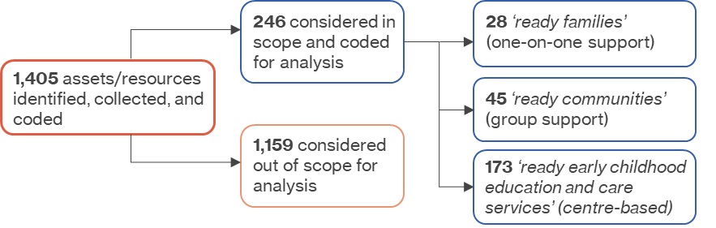
Figure 1. Flow diagram of asset inclusion screening and coding against the revised 'school-ready child' equation (based on Kagen and Rigbys' ‘ready child’ equation).

Type and level of intervention
Not all young children and their families experience the same level of need for support. Consequently, the service system aims to provide effective and efficient interventions for the whole population, as well as more targeted, intensive support for individuals and families who need it.
No standard set of criteria is used in Queensland across the health, education, and community service sectors to describe the level of support provided. In lieu of this, we borrowed from the work of the Early Intervention Foundation, UK, which offers the following categories to describe the type and level of support provided:
- Universal preventative: interventions available to all children and families;
- Targeted selective: services that target or 'select' families with characteristics that place them at greater risk of experiencing problems, including economic hardship, single parenthood, young parents, and/or ethnic minorities;
- Targeted indicated: services provided to a smaller percentage of families with a child or parent who has a pre-identified issue or diagnosed problem and requires more intensive support;
- Specialist: interventions for high-need families with ongoing problems (e.g. illness; special needs) or severe child protection concerns (5).
In addition to coding assets against the ‘school-ready child’ equation, assets were further coded against the type and level of intervention described above. This report’s scope is limited to universal, targeted selective, and targeted indicated services. Specialist programmes were explicitly excluded. Therefore, support for children and families with a diagnosed disability was considered out of scope.

A positive start to school
Starting school is an important time for young children and their families. The transition to school requires adjustment from home learning environments, early childhood education programs or kindergarten to a more formal educational school-based setting.
How well children are prepared for and adjust to school can impact their long-term educational outcomes. Research has found that a successful transition to school concerns more than the individual characteristics and readiness of the child and what a school does to orient the child and family into the school community. In fact, it's a process that begins years before children commence school and continues well after they have started (6).
In the early years of life, a child's immediate environment has the most influence on his/her development. As a result, all children start primary school with the knowledge and experiences gained from growing up in the family home, neighbourhood and broader community. These include the family and home environment and the child's experience of early childhood education and care outside of the home.

School readiness and the ready child equation
The ecological model of development has contributed to a revised view of 'school readiness', where readiness does not reside solely with the child but reflects the environments in which they find themselves. The ready child equation developed by Kagen and Rigby conceptualises school readiness as four connected and essential components: ready families + ready communities + ready early childhood education and care services + ready schools = ready children. The equation reframes the question of whether children are ready for school and instead recognises the importance of relationships and resources in early child development. Where families, schools, and communities provide the environment and experiences necessary to support young children's physical, social, emotional, language, communication, and cognitive development (3).
This report is structured against a revised version of Kagen and Rigbys' ready child' equation, where ready families + ready communities + ready early childhood education and care services = ‘school ready’ children—reflecting the scope of this report.
Before we examine whether children in Logan have equitable access to high quality early learning opportunities in the family home and community, it is first helpful to frame this question with an exploration of how children in Logan are faring once they start school.

School-ready children: how are Logan’s kids faring?
The Australian Early Development Census (AEDC) is a nationally recognised and endorsed measure of early childhood development and school readiness. It is conducted every three years and collected in the first year of primary school. All children included in the AEDC are scored on five domains of development that are associated with predictors of good social, health, and educational outcomes into adulthood: 1) physical health and wellbeing; 2) social competence; 3) emotional maturity; 4) language and cognitive skills, and 5) communication skills and general knowledge (7).
AEDC results are presented as the number and percentage of children who are:
- Developmentally on track: children who scored above the 25th percentile (in the top 75 per cent) of the national population;
- Developmentally at risk: children who scored between the 10th and 25th percentile of the national population;
- Developmentally vulnerable: children who scored below the 10th percentile (in the lowest 10%) of the national population.
How children score on each of the domains provides valuable information on how well early child development is supported across the country and indicates the effectiveness of current policies and programs in improving school readiness and child outcomes. Since its introduction in 2009, the AEDC has shown that, on average, children in Logan consistently start school more developmentally vulnerable than their peers at the state at national levels. Broad local, state, and federal efforts to improve these outcomes over many years appear to be having a positive effect. Illustrated in Figure 2, Logan (and Queensland) have made significant positive gains, progressively closing the gap on the national benchmark. Despite this good news, in 2021, 29% of children in Logan started school developmentally vulnerable, highlighting that a great deal remains to be done.
Logan is a large city, home to approximately 28,000 children under five. Therefore, before we examine the availability of services and support contributing to ‘school-ready’ children, it is first helpful to identify the children and families who would benefit the most from preventative or targeted support.
The proportion of developmentally vulnerable children is not the same for all groups. In its report, Australia’s Children, the Australian Institute of Health and Welfare found that children who spoke a language other than English at home start school more developmentally vulnerable, specifically in terms of communication skills and general knowledge. Differences were also evident between Indigenous and non-Indigenous children, notably in language and cognitive skills, where Indigenous children are more likely to experience developmental vulnerability. Furthermore, children living in socioeconomically disadvantaged communities experience a higher rate of developmental vulnerability than their peers living in more advantaged communities. In particular, children living in the most disadvantaged communities experience language and cognitive skill development delays (1).
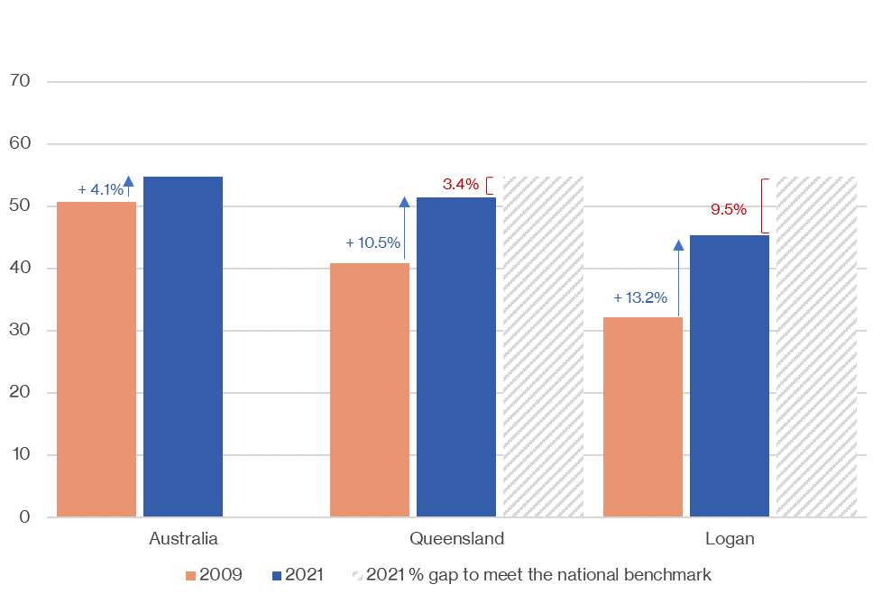
Figure 2. Change in the percentage of children starting school developmentally on track in all five AEDC domains, 2009 vs 21. This graph also shows the percentage increase of children starting school developmentally on track in Logan and Queensland needed to close the gap on national benchmarks, 2021 (Source: AEDC).

Aboriginal and Torres Strait Islander
Nationally, Aboriginal and Torres Strait Islander children are twice as likely as other children to start school developmentally vulnerable (8). Logan is no exception: in 2018, 45.1% of Aboriginal and Torres Strait Islander children started school developmentally vulnerable on one or more domains (Figure 3). This percentage equates to 152 Logan children, 10% of children developmentally vulnerable, and 3% of all children starting school in Logan in 2018.
Unfortunately, we could not access 2021 data for Aboriginal and Torres Strait Islander children or the 2018 breakdown of children starting school developmentally on track and at risk. However, data is available for 2018 on Aboriginal and Torres Strait Islander performance against each AEDC domain (see Figure 7). Consequently, the data presented focuses on developmental vulnerability rather than our preferred approach, developmentally on track.
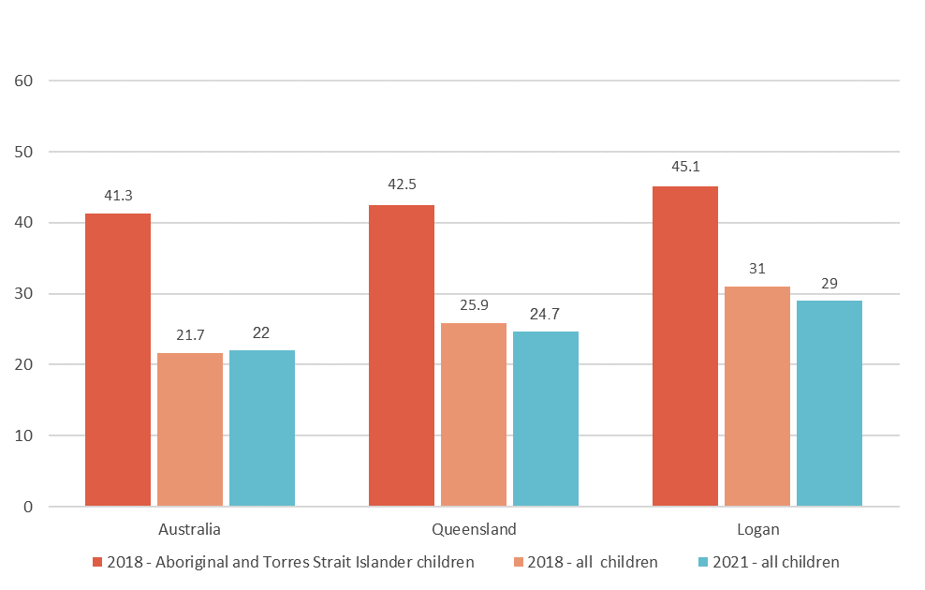
Figure 3. The proportion of Aboriginal and Torres Strait Islander children starting school developmentally vulnerable on one or more AEDC domains compared with their peers, Australia, Queensland and Logan, 2018 (Source: AEDC).

Culturally and linguistically diverse
Despite increasing cultural diversity in Australia, children from culturally and linguistically diverse (CALD) backgrounds remain more developmentally vulnerable than their peers (9). Children who speak a language other than English in the home are more likely to experience delayed early language development, negatively impacting cognitive development and school readiness. These children are also less likely to attend some early years services, such as maternal and child health and ECEC, meaning early childhood development vulnerabilities are less likely to be picked up (10).
Logan is a diverse community and is home to people from more than 200 different nationalities and cultures. Unfortunately, we could not access AEDC data for children who spoke a language other than English in the home. The most recent census data is yet to be released; however, we were able to identify that in 2016 almost 16% of children age five in Logan spoke a language other than English in the home.

Socioeconomic disadvantage
Logan is a vibrant young city with many strengths, but the city has often been synonymous with high and often persistent rates of intergenerational disadvantage, low household income, youth unemployment, and low-skilled occupations, all of which contribute to housing stress, high rates of public housing, and poor health. Poverty during early childhood can negatively affect children's health and development. Children growing up in communities with high poverty rates are more likely to attend low-performing and low-resourced schools and have less access to playgrounds, parks and libraries, and high-quality early education experiences and programs (11).
While some suburbs in Logan City experience high and persistent rates of disadvantage, this does not apply to all suburbs. Logan is divided by the Pacific Highway, which runs through the LGA from north to south, creating an east-west divide. On the eastern side of the highway are the relatively affluent suburbs of Daisy Hill, Springwood and Shailer Park. Therefore, reference to Logan as a place of disadvantage typically applies to the western suburbs of Logan Central, Woodridge, Kingston, Slacks Creek, Loganlea, Eagleby, Beenleigh, Crestmead, Marsden and Waterford West.
Traditionally, levels of advantage and disadvantage have been equated with economic factors such as income and employment. In his 2007 report, ‘Dropping off the Edge: Distribution of Disadvantage in Australia’, Professor Tony Vinson introduced a multi-dimensional measure of community disadvantage. The measure incorporated indicators across five domains of disadvantage, recognising that disadvantage refers to a range of difficulties families might face, limiting their capacity to have a happy and healthy life. Individual indicators within each domain – social distress, health, community safety, economic, and education – allow for a detailed analysis of the underlying cause of disadvantage. In addition, Vinson developed a summary index of disadvantage that captures what the indicators have in common, revealing areas of disadvantage and allowing for comparisons within each state and territory (12).
Table 1 ranks all statistical areas level 2 (SA2s) in Logan, of which there are 30, against the Dropping off the Edge 2021 summary index of disadvantage, where band 1 is the most disadvantaged and band 5 is the least disadvantaged. SA2s in Logan are listed alphabetically within each band rather than in order of disadvantage. The table also shows the number and percentage of children aged 0–5 who speak a language other than English and children who identify as Aboriginal and Torres Strait Islander. This table highlights areas within Logan where children are at increased risk of starting school developmentally vulnerable. Figure 5 shows the distribution of advantage and disadvantage across Logan. Logan Central, Kingston, Woodridge, and Eagleby appear in the list of 40 most disadvantaged locations in Queensland, making a case for localised responses within Logan.
Concerningly, 53% of Logan's children aged 0–5 live in the SA2s identified as the most disadvantaged (i.e. bands 1 and 2). Furthermore, children in these bands have a higher proportion of Aboriginal and Torres Strait Islander (62.5%) and CALD (66%) children living in Logan. Furthermore, Figure 4 illustrates the stark contrast between Logan and Queensland's distribution of disadvantage and advantage and shows Logan's children experience higher rates of disadvantage than their Queensland peers.
We draw on the data and findings from this section of the report as we examine the distribution of services and support in ready families, ready communities and ready early childhood education and care services.
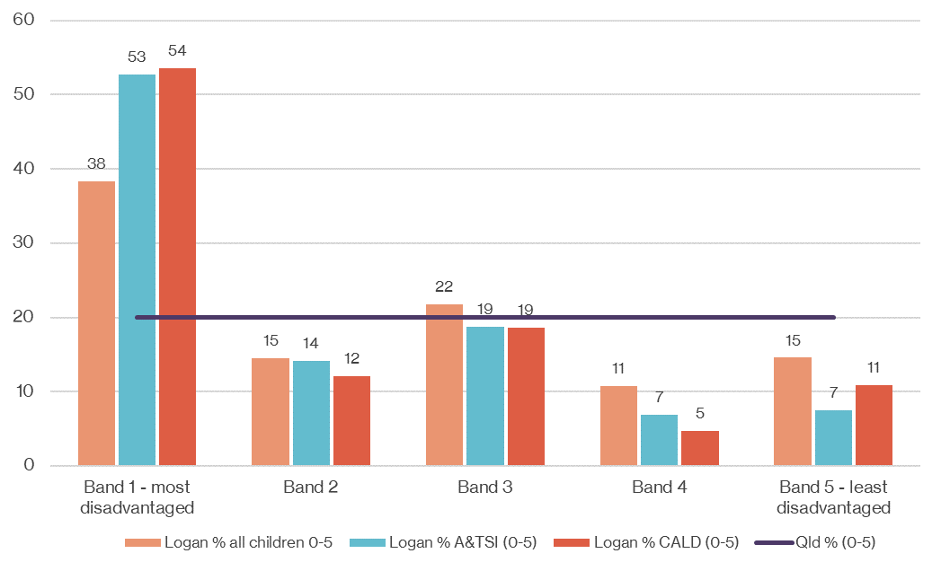
Figure 4. Shows the distribution of children aged 0–5 experiencing the most disadvantage and advantage in Logan and Queensland. Where band 1=most disadvantaged and band 5=least disadvantaged. For Logan, the percentage of Aboriginal and Torres Strait Islander and culturally and linguistically diverse children aged 0-5 has been included, as these children are at increased risk of developmental vulnerability, 2021 (Source: ‘Dropping off the Edge’ report).

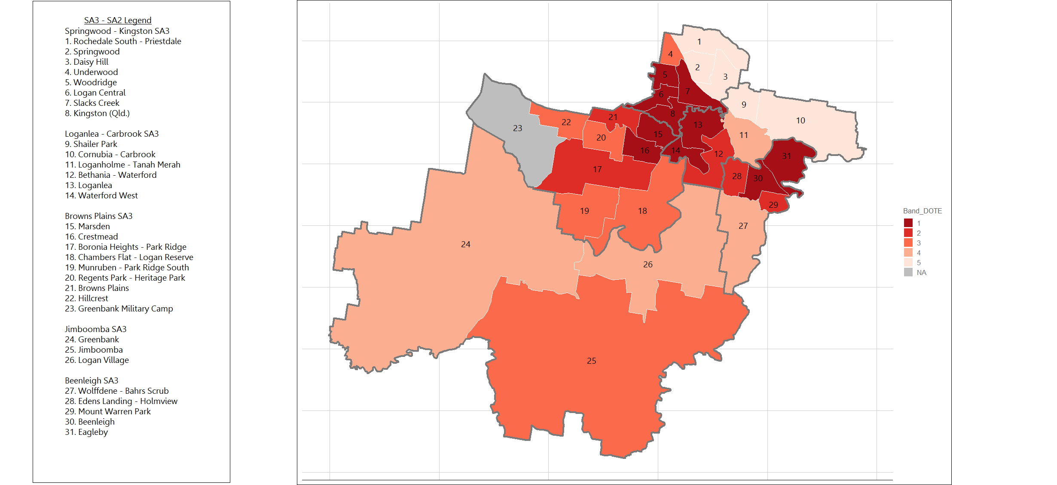
Figure 5. Map showing the geographical distribution of socioeconomic advantage and disadvantage by SA2, with legend. Band 1=most disadvantaged and band=5 least disadvantaged (Source: ‘Dropping off the Edge’ report).
Map provided by the Relational Insights Data Lab, Griffith University

Table 1. Summary Index of disadvantage in Logan by SA2 for all children aged 0–5 and vulnerable populations (Aboriginal and Torres Strait Islander children and children who speak a language other than English in the home). Highlighted SA2s experience multilayered disadvantage i.e. eight or more indicators are in the top 5% of most disadvantaged locations in Queensland. (Source: ‘Dropping off the Edge’ report; ABS census 2016).
(Band 1: most disadvantaged - band 5: least disadvantaged)
Summary index of disadvantage | SA2 name | Children aged 0–5 in Logan (n=27,752) |  | Aboriginal ad Torres Strait Islander Children aged 0–5 (n=1,603) |  | Children aged 0–5 who speak a language other than English (n=3,852)
Band |  | # | % of 0–5 | # | % of 0–5 in SA2 | # | % of 0-5 in SA2
1 | Beenleigh | 1,827 | 2.4 | 83 | 12.5 | 41 | 6.2
 | Crestmead | 1,139 | 5.0 | 102 | 7.3 | 178 | 12.7
 | Eagleby | 1,604 | 4.7 | 92 | 7.1 | 127 | 9.8
 | Kingston | 665 | 3.5 | 88 | 9.1 | 214 | 22.2
 | Logan Central | 529 | 2.2 | 31 | 5.0 | 226 | 36.6
 | Loganlea | 804 | 3.6 | 76 | 7.6 | 184 | 18.4
 | Marsden | 1,207 | 6.2 | 94 | 5.4 | 334 | 19.3
 | Slacks Creek | 657 | 3.5 | 89 | 9.2 | 201 | 20.8
 | Waterford West | 684 | 2.5 | 41 | 5.9 | 99 | 14.2
 | Woodridge | 561 | 4.7 | 103 | 7.9 | 461 | 35.3
2 | Bethania-Waterford | 1,019 | 3.7 | 59 | 5.8 | 102 | 10.0
 | Boronia Heights – Park Ridge | 993 | 3.6 | 44 | 4.4 | 139 | 14.0
 | Browns Plains | 757 | 2.7 | 42 | 5.5 | 153 | 20.2
 | Eden’s Landing-Holmview | 807 | 2.9 | 38 | 4.7 | 55 | 6.8
 | Mount Warren Park | 463 | 1.7 | 20 | 4.3 | 18 | 3.9
3 | Chambers Flat-Logan Reserve | 381 | 1.4 | 20 | 5.2 | 57 | 15.0
 | Hillcrest | 688 | 2.5 | 45 | 6.5 | 87 | 12.6
 | Jimboomba | 2,497 | 9.0 | 153 | 6.1 | 77 | 3.1
 | Munruben-Park Ridge South | 274 | 1.0 | 15 | 5.5 | 21 | 7.7
 | Regents Park-Heritage Park | 1,524 | 5.5 | 59 | 3.9 | 220 | 14.4
 | Underwood | 678 | 2.4 | 21 | 3.1 | 255 | 37.6
4 | Greenbank | 984 | 3.5 | 43 | 4.4 | 75 | 7.6
 | Logan Village | 477 | 1.7 | 13 | 2.7 | 10 | 2.1
 | Loganholme-Tanah Merah | 1,039 | 3.7 | 29 | 2.8 | 78 | 7.5
 | Wolffedene-Bahrs Scrub | 486 | 1.8 | 17 | 3.5 | 19 | 3.9
5 | Cornubia-Carbrook | 537 | 1.9 | 13 | 2.4 | 13 | 2.4
 | Daisy Hill | 517 | 1.9 | 9 | 1.7 | 69 | 13.3
 | Rochedale South-Priestdale | 1,397 | 5.0 | 25 | 1.8 | 157 | 11.2
 | Shailer Park | 878 | 3.2 | 15 | 1.7 | 72 | 8.2
 | Springwood | 713 | 2.6 | 17 | 2.4 | 110 | 15.4

Performance against the AEDC domains
Examining the data for each of the five AEDC domains provides valuable information on how children in Logan are faring against crucial early childhood development measures. Illustrated in Figure 6, Logan follows the national and state trend, with more children experiencing developmental vulnerability in emotional maturity and social competence. Children with low levels of emotional maturity experience challenges related to emotional regulation, including managing aggression, becoming easily distracted, and being prone to disobedience (14). Delays associated with social competence result in children struggling with the routine and structure of school, not adjusting well to change and having difficulty getting along with others. There is a significant body of literature that shows the association between adult outcomes and childhood social and emotional skill development, in particular, between self-regulation and self-control in childhood and domains of adult life such as mental health, income and labour market outcomes, crime, and physical health and overall wellbeing (14).
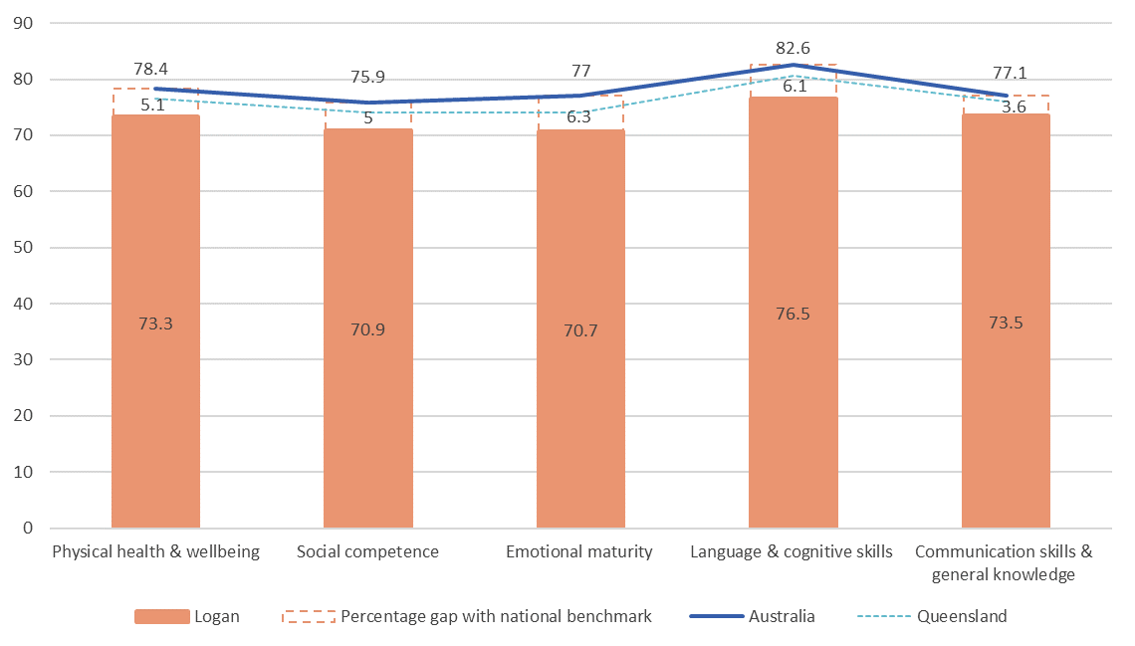
Figure 6. Percentage of children starting school developmentally on track in each AEDC domain, Logan, Qld and Australia, 2021. This graph also illustrates the percentage needed to close the gap for each AEDC domain for Logan compared with state and national scores in 2021. n=4,839 Logan children with a valid score (Source: AEDC).
Conversely, Logan's Aboriginal and Torres Strait Islander children do not follow the national and state trend. While remaining significantly more developmentally vulnerable than their peers, Aboriginal and Torres Strait Islander children in Logan scored higher in emotional maturity than in other domains (Figure 7).
On the other hand, Aboriginal and Torres Strait Islander children scored less favourably on physical health and wellbeing – 17.4% below their Logan peers. Children developmentally vulnerable in physical health and wellbeing experience many challenges that interfere with their ability to cope with the school day, such as frequently arriving late for school, being dressed inappropriately, and feeling hungry or tired (15).
Data were not available on children who spoke a language other than English.
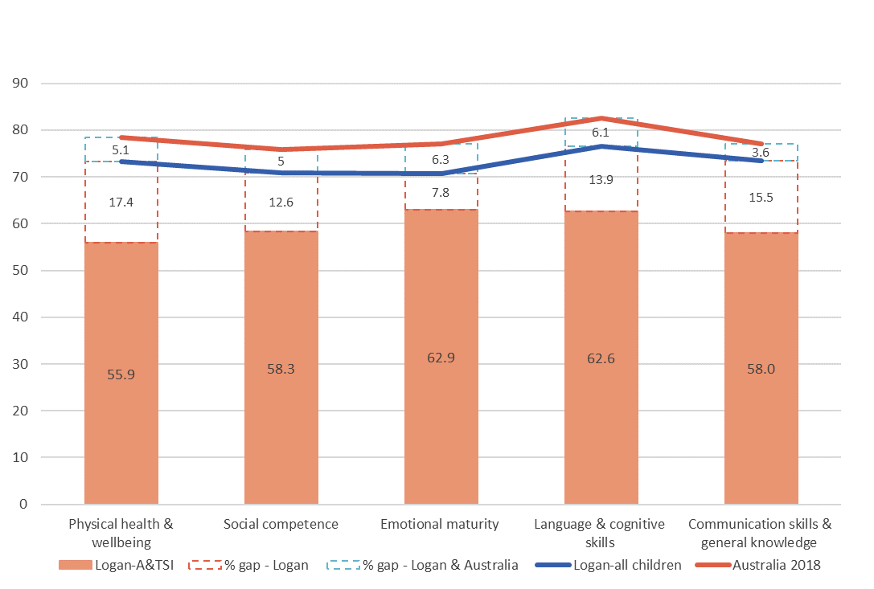
Figure 7. Percentage of Aboriginal and Torres Strait Islander children starting school developmentally on track in each AEDC domain, Logan, Australia, 2018. This graph also illustrates the percentage needed to close the gap for each AEDC domain for Aboriginal and Torres Strait Islander children in Logan compared with their peers in Logan and Australia. n=337 Aboriginal and Torres Strait Islander children in Logan (6.9% of children in Logan with a valid score) (Source; AEDC).
Logan covers a large geographical area that has pockets of concentrated disadvantage. Analysing SA3 data provides a manageable aggregation for examining developmental vulnerability across Logan. Table 2 lists the five SA3s and their corresponding SA2s in Logan, the numbers of children aged 0–5 in each, and the specific groups more likely to experience developmental vulnerability, including Aboriginal and Torres Strait Islander children, CALD children and children living in the most disadvantaged areas of Logan. This table shows that the highest proportion of children aged 0–5 (54%) live in two SA3s, Browns Plains and Springwood-Kingston. Furthermore, 48% of children in the Browns Plains and Springwood-Kingston SA3s live in Logan's most disadvantaged areas (SA2s).
Springwood-Kingston, divided by the Pacific Highway, incorporates some of Logan's most affluent and least affluent SA2s, making it an anomaly. Therefore, care should be taken when interpreting the data. For example, Kingston, Logan Central, Woodridge, and Slacks Creek, located east of the highway, experience significant disadvantage and cultural diversity. In stark contrast, neighbouring Daisy Hill, Springwood and Rochedale South-Preistdale – all to the west of the highway – experience the least disadvantage.
Table 2. SA3 and SA2 distribution of all children in Logan aged 0–5 and vulnerable groups, 2016 (Highlighted SA2s are from bands 1 and 2 of the summary index).
(Source: ABS census 2016 and Dropping off the Edge)

SA3 | SA2 | Number of children aged 0–5 in Logan
 |  | Total  (n=27,752) | Most disadvantaged  Bands 1&2 (n=3,671) | Aboriginal and Torres Strait Islander (n=1,603) | CALD  (n=3,852)
Beenleigh | Beenleigh  Eagleby  Edens Landing-Holmview  Mount Warren Park  Wolffedene-Bahrs Scrub | 3,719 (13.4%) | 3,233 (87%) | 264 | 260
Browns Plains | Browns Plains  Boronia Heights-Park Ridge  Chambers Flat-Logan Reserve  Crestmead  Hillcrest  Marsden  Munbruben-Park Ridge South  Regents Park-Heritage Park | 7,746m (28%) | 4,879 (63%) | 447 | 1,189
Jimboomba | Greenbank  Logan Village  Jimboomba | 3,958 (14.2%) | NA | 206 | 162
Loganlea-Carbrook | Bethania-Waterford  Cornubia-Carbrook  Loganlea  Loganholme-Tanah Merah  Shailer Park  Waterford West | 5,168 (18.6%) | 2,714 (52.5%) | 274 | 548
Springwood-Kingston | Daisy Hill  Kingston  Logan Central  Rochedale South-Priestdale  Slacks Creek  Springwood  Underwood  Woodridge | 7,161 (25.8%) | 3,856 (54%) | 412 | 1,693
Yarrabilba and Flagstone, located in SA3 Jimboomba, are among Queensland's fastest-growing population corridors and have expanded significantly since the 2016 census. Therefore, Tables 1 and 2, populated with 2016 census data, may not adequately reflect the number of children, diversity and the level of advantage experienced by children and families residing in the Jimboomba SA3.
The most populated SA3s in Logan are Springwood-Kingston and Browns Plains, home to 54% of children under five and the most culturally diverse. Unsurprisingly, these communities also experience high rates of disadvantage. Beenleigh SA3, while not as populated or diverse, has the highest proportion of disadvantage, with 87% of residents living in bands 1 and 2.
Unsurprisingly, the level and distribution of disadvantage and diversity in Logan are reflected in the distribution of children starting school developmentally vulnerable, evidenced in Figures 8–12. Notably, Figures 8 and 9 show that children in Browns Plains and Springwood-Kingston start school more developmentally vulnerable than their peers in Logan and Australia, reflecting the diversity and high rates of disadvantage in these communities highlighted in table 1 and 2 above.
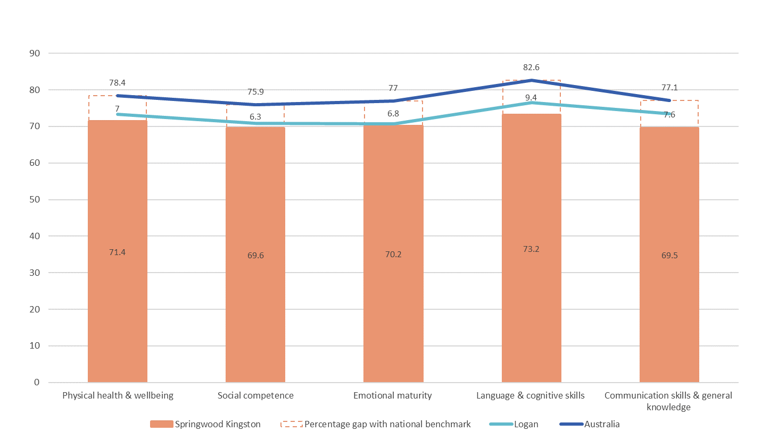

Figure 8. Percentage of children in the Springwood-Kingston SA3, n=1,109 (23% of Logan children with a valid score) starting school developmentally on track in each AEDC domain, 2021. This graph also shows the percentage needed to close the gap for each AEDC domain for Logan compared with state and national scores (Source: AEDC).
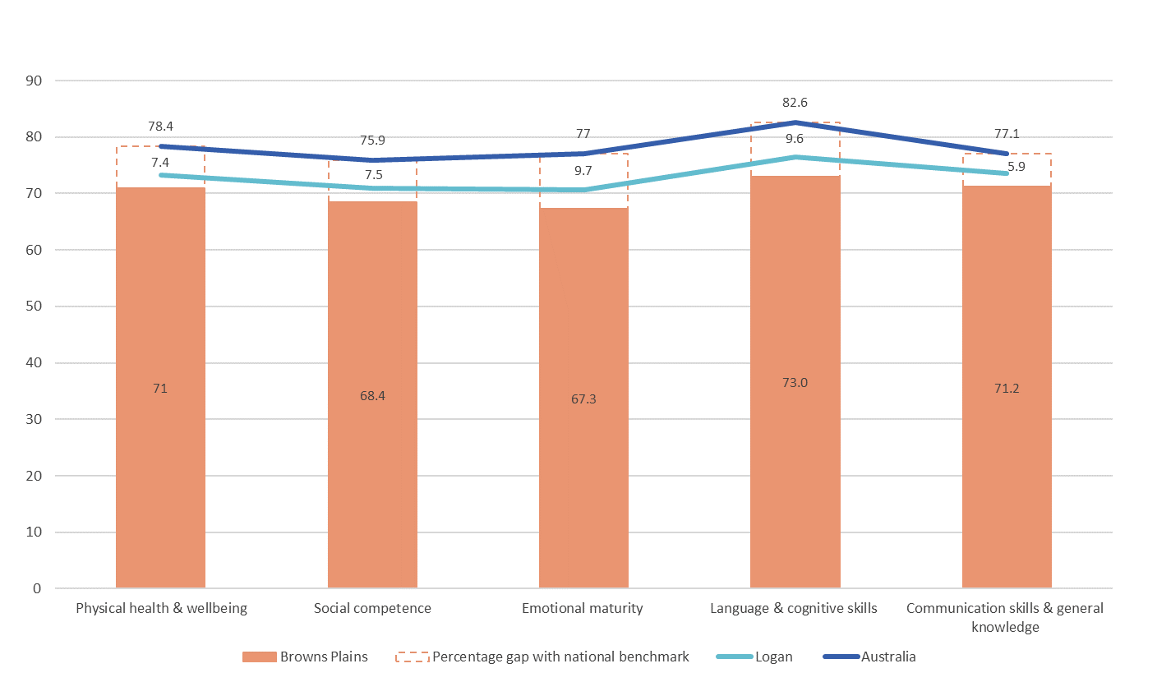
Figure 9. Percentage of children in the Browns Plains SA3, n=1,438 (30% of Logan children with a valid score) starting school developmentally on track in each AEDC domain, 2021. This graph also illustrates the percentage needed to close the gap for each AEDC domain for Logan compared with state and national scores (Source: AEDC).

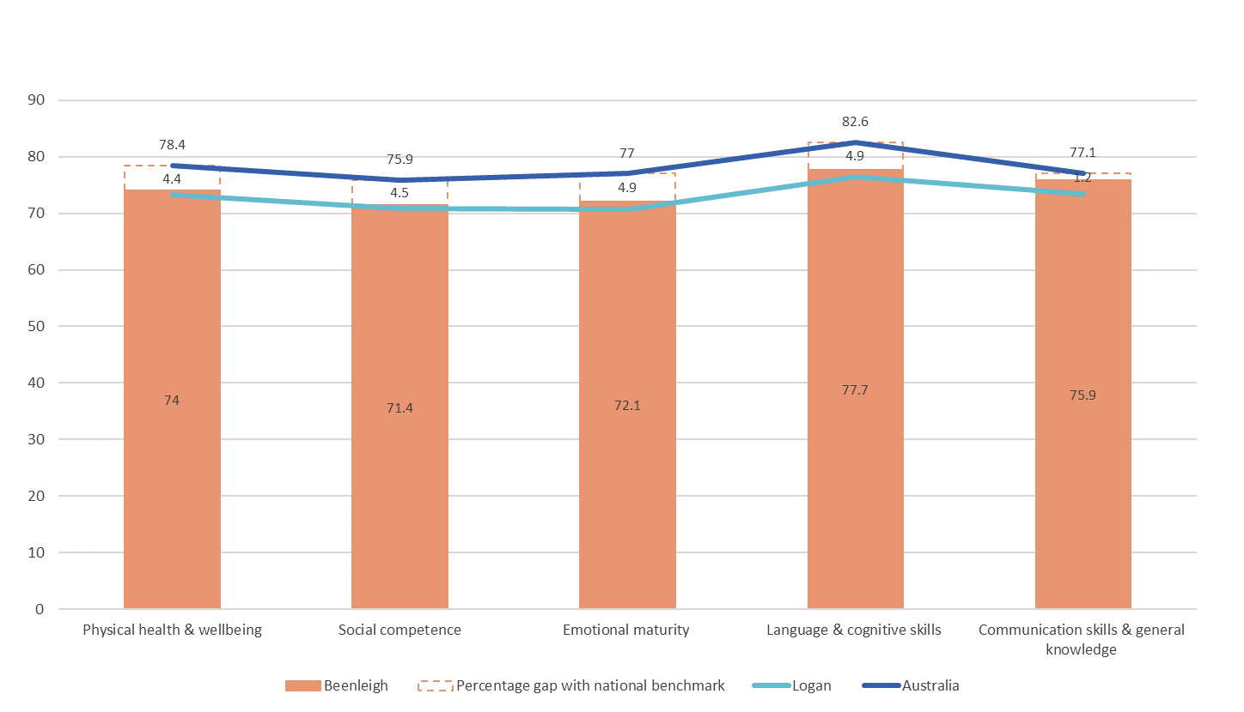
Figure 10. Percentage of children in the Beenleigh SA3, n=588 (12% of children in Logan with a valid score) starting school developmentally on track in each AEDC domain, 2021. This graph also shows the percentage needed to close the gap for each AEDC domain for Logan compared with state and national scores (Source: AEDC).

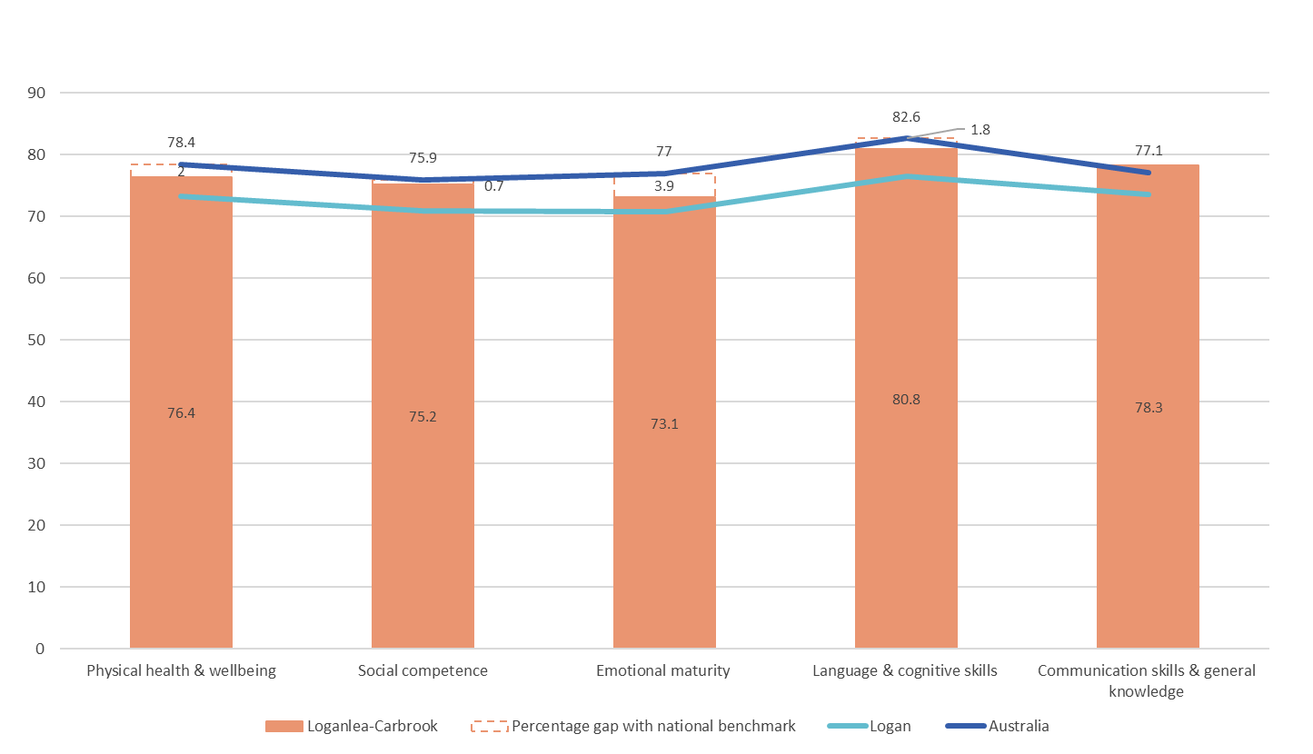
Figure 11. Percentage of children in the Loganlea-Carbrook SA3 starting school developmentally on track in each AEDC domain, 2021, n=782 (16% of Logan children with a valid score). This graph also shows the percentage needed to close the gap for each AEDC domain for Logan compared with state and national scores (Source: AEDC).

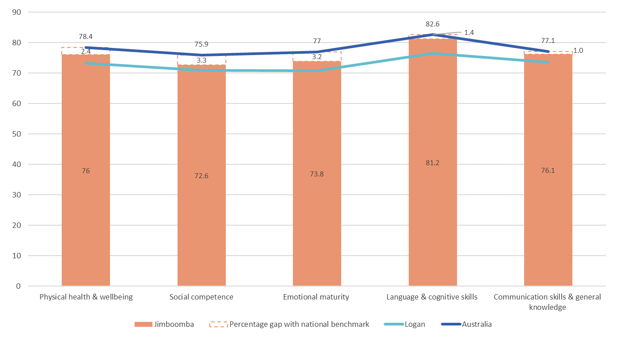
Figure 12. Percentage of children in the Jimboomba SA3 starting school developmentally on track in each AEDC domain, 2021, n=922 (19% of Logan children with a valid score). This graph also shows the percentage needed to close the gap for each AEDC domain for Logan compared with state and national scores (Source: AEDC).
The cycle of disadvantage developed by the Smith Family (Figure 13) shows that challenges faced by children early in their lives are likely to lead to multiple negative consequences later in life, such as the lack of motivation or skills to learn and poor employability. Moreover, without appropriate and timely support, children and young people are unlikely to have the necessary foundations to increase their earning and learning potential, reinforcing intergenerational disadvantage (16).
Breaking the cycle of disadvantage requires preventative rather than remedial support across the life course to stop risk factors from accumulating. Both parents and children require different types of support at various points, likely in different settings such as the home, school, and community (16). In their case for high-quality early learning for all children, the Front Project reports that not getting the best start and starting school behind can be tough to overcome. Moreover, the effects of developmental vulnerability at school entry can persist for life, impacting children's ability to succeed and thrive throughout their lives (17). They state that 'increasing the number of children who start school on track is one of our best strategies to boost educational achievement and change a child's life trajectory. Reducing inequality in the early years and at school entry is likely to be one of the most effective ways to create a more equitable, cohesive, and productive society for the future (35 p6)'.
If we are to close the gap, more work needs to be done to support early child development and school readiness in Logan.
Researchers, practitioners, service providers, families, and communities can use a greater understanding of the service sector and policy influences to start thinking about how they may manipulate the service sector to encourage better developmental outcomes for children.
Figure 13. The cycle of disadvantage (Source: The Smith Family, 2010)
Child
Cycle of disadvantage
Adult

Ready families: How are parent-child relationships supported in Logan?
In this report, the term 'ready families' refers to the services and support that aim to enhance the quality of the parent–child relationship by helping parents develop the skills and confidence needed to promote child development and improve child outcomes. Services and support are considered in scope if the operating model primarily focuses on individualised support with the parent – i.e. family support or independent skill development through a parenting program. Group skill development is captured in 'ready communities'.
As we’ve discussed, the first five years of a child’s life are significant in human development. It is a time of dramatic transformation where the foundations for lifelong learning, health, and behaviour are laid down. The quality of a young child’s environment, such as diet, a safe and stable home, and unconditional love and affection, heavily influence early child development outcomes. Most parents are highly motivated to provide a positive environment for their children. Through advice and support from family, friends, services, and the community, parents gain the confidence to know what to provide and that they can provide it (9).
Our study identified 28 services contributing to ‘ready families’ in Logan, comprising 11% of the total subset of Logan social infrastructure assets in scope for this report. We categorised these 28 services into five service and support themes, reflecting each service's description and aim. The themes explored below are parenting programs, early learning, family support, family relationships, and linking services (i.e. services designed to connect families with the right service at the right time). Table 3 lists all 28 services categorised by service and support theme and identifies the level of support provided.

Parenting programs
Formal parenting support can come from various sources, including online forums, telephone advice lines, and parent education programs. Effective parenting support can assist in the development of healthy, positive parent–child interactions, which are the foundation for positive child outcomes (18). Parenting programs dominate the services and support contributing to 'ready families'. Specifically, we identified three well-known relationship-based early intervention programs: Triple P Positive Parenting Program, 123 Magic, and Circle of Security.
The Triple P Parenting Program, funded by the Queensland Government, is backed by more than 35 years of research and claims to be one of the world's most effective evidence-based parenting programs. We identified eight no-cost Triple P programs delivered across Logan, all offering a choice of delivery methods from personal consultation to in-person and online courses and seminars delivered in group settings. Triple P consists of 17 parenting strategies focused on preventing and addressing behavioural and emotional problems in children and developing positive relationships, attitudes, and conduct. Its multi-level system offers a suite of programs catering to different levels of family needs, from light-touch parenting tips to highly targeted interventions for at-risk families. Triple P is available to parents of children up to 12 years old, with Teen Triple P for parents of 12–16 year olds.
Table 3. The type and number of services and support in Logan contributing to 'ready families' and the level of support provided, categorised by SA3.
SA3 | Theme | Service name | # | Level of support
Beenleigh
Browns Plains | Parenting program | Triple P Positive Parenting Program | 2 | Universal preventative
 |  | 123 Magic | 1 | Universal preventative
 | Linking service | Family and Child Connect | 1 | Universal preventative
Loganlea-Carbrook | Parenting program | Indigenous Triple P Positive Parenting Program* | 1 | Targeted selective
 | Family support | Family and parenting support* | 1 | Targeted selective
 | Linking service | Family and Child Connect | 1 | Universal preventative
Jimboomba | Parenting program | Triple P Positive Parenting Program | 1 | Universal preventative
 |  | Circle of Security Parenting Program | 1 | Universal preventative
Springwood-Kingston | Parenting program | Stepping stones Triple P Positive Parenting | 1 | Targeted selective
 |  | Triple P Positive Parenting Program | 3 | Universal preventative
 |  | Circle of Security Parenting Program | 1 | Universal preventative
 |  | Magic 123 and Emotion Coaching | 1 | Universal preventative
 | Early learning | Home Interaction Program for Parents and Youngsters (HIPPY) | 1 | Universal preventative
 | Family support | Solid and deadly families* | 1 | Targeted indicated
 |  | Step by step, young families∆ | 1 | Targeted indicated
 |  | Family support program | 1 | Targeted selective
 |  | Intensive family support | 1 | Targeted indicated
 | Family relationships | Mediation service | 3 | Targeted indicated
 |  | Children's Contact Services | 1 | Targeted indicated
 |  | Parenting order program and post-separation co-operative parenting | 1 | Targeted indicated
 |  | Logan family relationship centre | 1 | Targeted indicated
 |  | Functional family therapy | 1 | Targeted indicated
 | Linking service | Family and Child Connect | 1 | Universal preventative
Total |  |  | 28
* Aboriginal and Torres Strait Islander service
∆ Aboriginal and Torres Strait Islander – priority group
Specialist Triple P programs tailored to specific groups include:
- Stepping Stones Triple P: for parents of pre-adolescent children with an intellectual or physical disability
- Family transitions: individual or group sessions for parents where separation or divorce is complicating parenting
- Lifestyle Triple P: for parents of overweight children aged 5–10 years
- Indigenous Triple P: allows providers to tailor their delivery of the programs to suit Indigenous families (19).
Our study identified two specialist Triple P programs: Indigenous Triple P in Waterford West and Stepping Stones in Springwood.
The 123 Magic parenting program developed by American Psychologist Dr Tom Phelan claims to offer a gentle but firm approach to managing the behaviour of children aged 2–12, regardless of the child's individual needs. Similarly, Magic 123 & Emotion Coaching, developed in Australia by child psychologist Michael Hawton, aims to equip parents and carers with the skills to manage challenging behaviours and build positive relationships. However, unlike Triple P, service delivery is limited to in-person attendance, and no evidence of specialist/tailored approaches for specific groups was found. Both services were available at no cost to participants.
Unlike the parenting programs mentioned above, Circle of Security focuses on parent–child attachment rather than behavioural modification. The program is intended to help caregivers increase their awareness of their children's needs and whether their responses meet those needs. With increased awareness, the program aims to expand the moment-to-moment parenting choices that lead to secure attachment relationships, setting the foundation for a lifetime of learning, health, and wellbeing.
Except for Circle of Security, the parenting programs promoted in Logan focus predominately on managing behaviour and developing positive relationships, and we are unable to say if these programs provide guidance on early childhood developmental milestones.
While there is evidence of a specialist parenting program for Aboriginal and Torres Strait Islander families in Logan, we could not identify services explicitly tailored for culturally and linguistically diverse families. This gap raises the question of the current engagement and experience of CALD families with parenting programs.

Supported early learning
The Home Interaction Parenting Program (HIPPY) is a two-year, home-based early learning and parenting program for families with young children. There is only one HIPPY program operating in Logan, which is delivered by the Kingston East Neighborhood Centre. The HIPPY program license in Australia is held by the Brotherhood of St Laurence and it is funded by the Department of Social Services. With support from a local tutor, parents are supported to work through weekly or fortnightly packs of play-based educational activities with their child. Activities and storybooks are designed to be fun and to align with the early years National Quality Standard.
Parents receive guidance on early child development milestones and transition to school support throughout the program. The HIPPY program provides an alternative early learning development opportunity for families preferencing in-home learning rather than formal ECEC. Other than HIPPY, opportunities for families to provide supported home-based early learning experiences aligned to school readiness appear to be lacking in Logan.
In an effort to increase the number of children starting school developmentally on track, the Australian and Queensland governments have focused on increasing the number of children engaged in government-approved kindergarten programs and, more broadly, in ECEC. These formal programs are heavily promoted and subsidised; however, not all families are willing or able to have their children attend.
This observation leads us to ask, what are the implications for children transitioning to school whose parents are unable or unwilling to engage in kindergarten or early childhood education and care? Is there a demand for supported home-based early learning experiences that prepare children for school?

Family support
Our study identified five services that aim to strengthen the capacity of families to foster positive relationships, improve communication, enhance practical skills, and build confidence and parenting skills. Support is provided through a case management plan designed to address challenges specific to each family, such as housing, budgeting, and parenting. The majority of family support type services are targeted towards a smaller percentage of the population of families requiring more intensive support, for example, Step by Step for young parents and the Aboriginal and Torres Strait Islander Solid and Deadly families service (Table 3).
Most families experience challenges and need a little support from time to time. However, our search failed to identify universal-preventative practical family support for those not considered high risk or vulnerable. Support is currently limited to information and advice provided by parenting programs and Family and Child Connect (FACC) (a linking service). This finding presents an opportunity to determine whether there is a need for early universal access to services providing brief periods of practical support, helping families to navigate challenges before they become detrimental to family functioning.

Family relationships
Parents separating is often problematic and can result in high conflict and communication breakdown. Counselling and family mediation is available to help people during separation to manage the emotional impact, resolve disputes, and make arrangements for children and financial matters without going to family court. However, these services usually attract a significant fee, which can present barriers for individuals. In Logan, we identified mediation and post-separation services offering no-cost or low-cost counselling and mediation support, all of which were located in the Springwood-Kingston SA3. All services identified provided targeted support to assist parents during and after separation to improve communication and reduce conflict.

Linking services
Navigating the health, education, and social service system is challenging. Family and Child Connect (FACC), funded by the Queensland Government, is an early intervention service providing free, unlimited, confidential advice to connect families with timely and appropriate information, advice, and referrals. FACC assesses a family's needs and assists them in linking to local services. The operating model allows for some flexibility, providing outreach support to families in their homes or at a place the family believes is safe to talk. Our study identified three FACC services, all operating during standard work hours. Support outside of hours is available via a central phone number. Access to interpreters is available upon request. All parents or carers with children 0–18 years are eligible to receive support from this service

Distribution of services
Figure 14 shows that a relatively disproportionate number of services contributing to 'ready families' is located in the SA3 Springwood-Kingston. The family support, family relationship, and linking type services typically have an extensive geographical reach and offer in-home and virtual support. Therefore, in theory, the location of services should not be a barrier to access. However, in practice, limited service capacity, inadequate transport options, and poor proximity to services may pose significant barriers for families seeking support. This is particularly concerning in SA3 Beenleigh, where no services were identified.
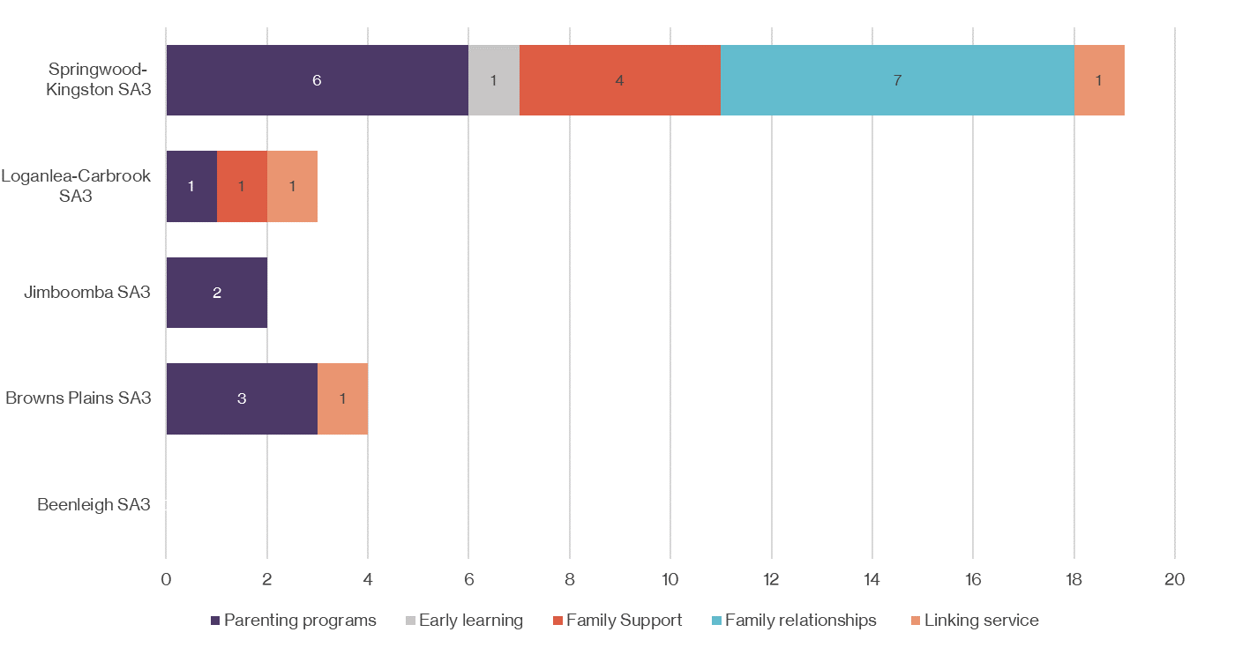
Figure 14. The number of services (n=28) by type that aim to enhance the quality of the parent-child relationship through individualised support or independent skill development, contributing to ‘ready families' in Logan.
Our study found that 50% of services contributing to 'ready families' were targeted towards a select group of families with characteristics that place them at greater risk of experiencing problems or where there is a pre-identified issue or diagnosed problem. These targeted selective services have the capacity to provide intervention for vulnerable groups before symptoms present or are well established. For example, the Family and Parent Support program for Indigenous families provides in-home parenting support and resources.
As shown in Figure 15, targeted support is heavily skewed toward services addressing complex issues (targeted indicated) rather than early intervention. Targeted solutions with strict eligibility criteria inevitably make many families ineligible for support. A related problem is the difficulty in providing adequate coverage for the population of focus and ensuring that eligible families have easy access to them. Data on caseloads, participants, waitlists, and service demand were unavailable.

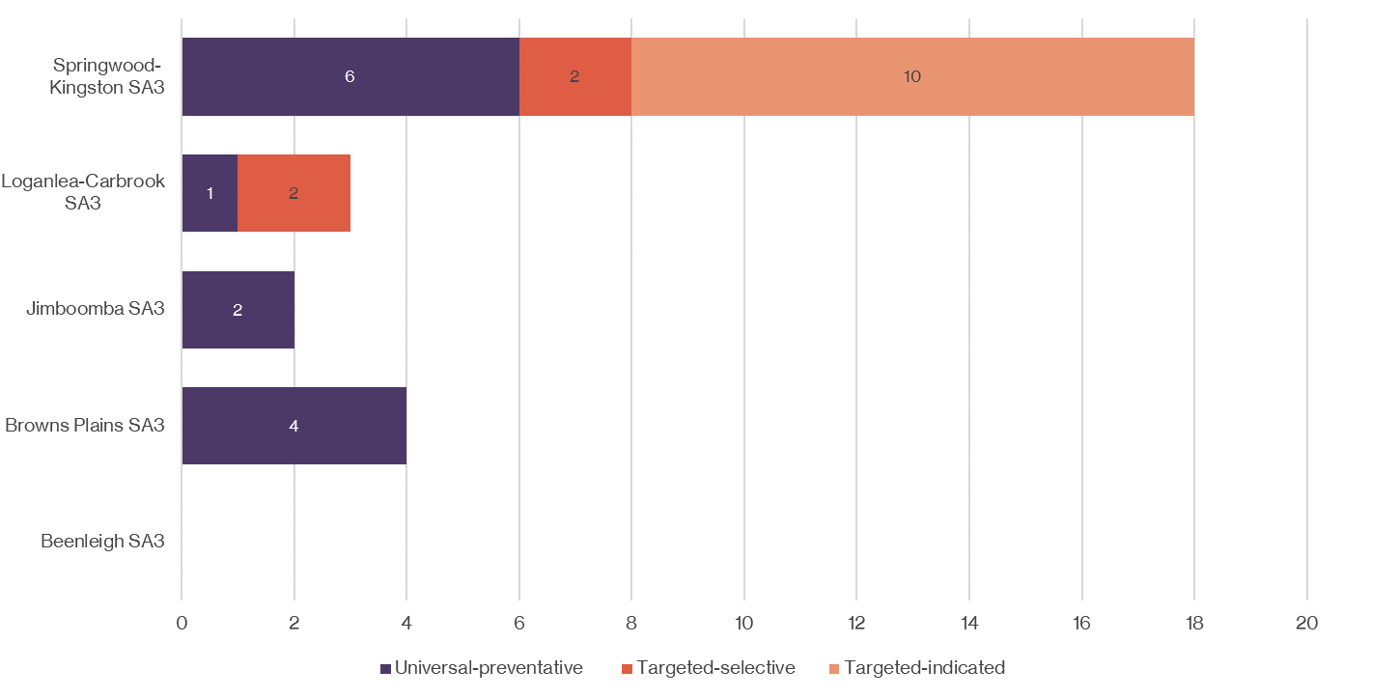

Figure 15. The geographical distribution and balance of universal and targeted services (n=28) that aim to enhance the quality of the parent-child relationship through individualised support or independent skill development, contributing to ‘ready families' in Logan.
While it is positive that 50% of services are available to all families and children (i.e., universal preventative), the scope is limited to parenting programs and information and advice. In addition, there are challenges associated with implementing an effective universal approach. Challenges include, but are not limited to, matching services to the individual needs of families and ensuring services are genuinely inclusive, can meet the needs of all children and families, and are accessible and of high quality.
Our search failed to identify any services contributing to 'ready families' that work specifically with CALD families and children. This may have been due to the search strategy's limitations, but it raises the question of whether services are responsive to families and children with cultural and language backgrounds.
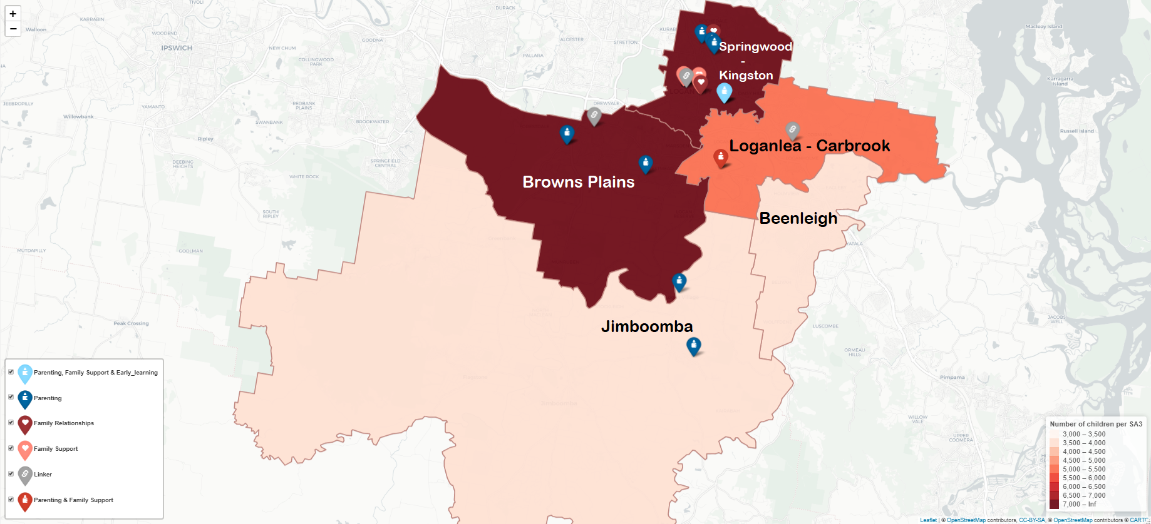
Figure 16. Map showing geographical distribution of services (n=28) by type contributing to 'ready families' in Logan (Note: Where there is more than one type of service listing in the icon key, for example, parenting, family support and early learning, this represents more than one service type provided from the one location)
Map provided by the Relational Insights Data Lab, Griffith University

Ready communities: Are there community-based opportunities for Logan kids to learn and play?
Right from birth, children learn by playing and exploring in safe and stimulating environments. Active play such as running, climbing, jumping, and dancing are essential for physical development, supporting muscle development and physical growth. Imaginative play provides opportunities for children to build confidence, play with others, become more independent, and learn to manage emotions, contributing to overall social and emotional development. Through play, children also develop their thinking, problem-solving (cognitive), language, and communication skills (20).
Community-based early learning experiences allow children to play, expand their relationships, and provide opportunities for parents/carers to share experiences and ideas. Our study identified 45 services contributing to 'ready communities' in Logan, comprising 18% of the total subset of Logan social infrastructure assets in scope for this report. We categorised the 45 services into six service and support themes, reflecting the description and aim of each asset. The themes identified and explored below are; family centres, junior sports, parent support groups, playgroups, transition to kindy, and wellbeing. Table 4 lists all 45 services categorised by service and support theme and level of support provided.

Family centres
The Early Years Plan developed by the Queensland Government aims to support all children to have a confident start in life. The whole-of-government plan sets out actions to support all children to reach their full potential with support from families, service providers, and the broader community. Early Years Places implemented under the Early Years Plan aim to make it easy for vulnerable families with children aged 0-8 living in areas of most need to access a range of early childhood activities and support from one location. Activities and programs may include playgroups, maternal health services, family and parenting support, and ECEC.
Our search identified two Early Years Places: the Browns Plains Early Years Centre and the Child and Family Centre. The 'one-stop shop' model of Early Years Places aim to provide a different mix of services under one roof, including playgroup, early childhood education and care, health services and family and parenting support. While there are obvious benefits to this in terms of holistic care, such centralisation will likely create a barrier to access for families living outside the immediate area. We could not determine if either of the Early Years Places in Logan provided satellite or outreach services to families outside the Browns Plains or Loganlea-Carbrook SA3s. The Browns Plains Early Years Place is the only centre available to all children and families and indicates insufficient supply. In addition, we could not find evidence of service activity specifically tailored to meet the needs of children and families from culturally and linguistically diverse backgrounds. The absence of CALD-focused services does not mean that activities run by these centres aren't tailored to ensure they are sensitive to cultural factors and accessible to CALD children and families.
While not an Early Years Place, the family and community place in Yarrabilba has a similar purpose in that it aims to support the growth and development of children and thriving families, it operates as a community hub and is open to anyone in the community to use. However, unlike Early Years Places, its services and programs are tailored to children 0–12 years.

Junior sport
Toddlers and preschoolers naturally tend to be physically active and become increasingly independent as they develop and master their fine and gross motor skills through movement. Physical health and wellbeing is one of the five important areas of early child development and is underpinned by good nutrition, physical activity, personal safety, and rest. During structured physical activity, children are introduced to new ideas and opportunities, enhancing their development and learning abilities and setting the foundations for learning to focus, pay attention, take turns, and follow instructions (21).
We identified two activities in Logan aimed at developing gross motor skills, such as running and throwing for children under five. Both activities are pre-cursors to formal gymnastic lessons and attract a fee, posing a barrier to access.
In 2021, 73.3% of children in Logan started school developmentally on track in terms of physical health and wellbeing, 5.1% below their national peers. According to 2018 data, this proportion is much lower for Aboriginal and Torres Strait Islander children, with only 55.9% of children starting school developmentally on track in this domain, 17.4% behind their peers in Logan (Figure 7). This raises the question, what more needs to be done in physical health and wellbeing to better support Aboriginal and Torres Strait Islander children and their families?

Table 4. The type and number of services and support in Logan contributing to 'ready communities’ and the level of support provided, categorised by SA3.
SA3 | Service Type | Service name |  | # | Level of support
Beenleigh | Junior sport | Kinder Gym |  | 1 | Universal preventative
 | Playgroup | Baby time group |  | 1 | Universal preventative
 |  | Multicultural playgroup |  | 1 | Targeted selective
Browns Plains | Junior sport | Tiny tots |  | 1 | Universal preventative
 | Family centre | Early Years Centre |  | 1 | Universal preventative
 | Parent support group | Jarjums Thonar*∆ |  | 1 | Targeted selective
 |  | Expectant parents group∆ |  | 1 | Universal preventative
 |  | Young parents group∆ |  | 1 | Targeted selective
 |  | Premies play and learn∆ |  | 1 | Targeted selective
 |  | Baby and me∆ |  | 1 | Universal preventative
 | Playgroup | Wriggle and Rhyme |  | 2 | Universal preventative
 |  | Babytime group |  | 1 | Universal preventative
 |  | Toddler play and learn |  | 1 | Universal preventative
 | Transition to kindy | KindyLinq∆ |  | 1 | Universal preventative
 |  | Connect 2 Kindy∆ |  | 1 | Universal preventative
Loganlea-Carbrook | Family centre | Child and family centre* |  | 1 | Targeted selective
 | Playgroup | Jarjums at play*◊ |  | 1 | Targeted selective
 |  | Baby jarjums at play*◊ |  | 1 | Targeted selective
 |  | Babytime group |  | 1 | Universal preventative
 | Wellbeing | Prenatal and postnatal yoga mum and baby |  | 1 | Universal preventative
Jimboomba | Family centre | The family and community place |  | 1 | Universal preventative
 | Playgroup | Toddler time^{Ω} |  | 1 | Universal preventative
 |  | Babytime group^{Ω} |  | 1 | Universal preventative
 |  | Wriggle and Rhyme |  | 1 | Universal preventative
 |  | KP Kids Playgroup |  | 1 | Universal preventative
 | Transition to kindy | KindyLinq Ω |  | 1 | Universal preventative
Springwood-Kingston | Parent support group | Bringing up great kids – childhood development |  | 1 | Universal preventative
 |  | What were we thinking? First baby program |  | 1 | Universal preventative
 |  | Parents and pram group |  | 1 | Universal preventative
 |  | Butterfly wing's early years |  | 1 | Universal preventative
 | Playgroup | Wriggle and Rhyme |  | 2 | Universal preventative
 |  | Babytime group |  | 2 | Universal preventative
 |  | Mainly music |  | 1 | Universal preventative
 |  | Logan East littlies |  | 1 | Universal preventative
 |  | KP Kids Playgroup |  | 1 | Universal preventative
 |  | Woodridge playgroup |  | 1 | Universal preventative
 |  | Hello baby, music and sensory play |  | 1 | Universal preventative
 |  | Playgroup and kids club |  | 1 | Universal preventative
 |  | Wilbert worm literacy program |  | 1 | Universal preventative
 | Transition to kindy | KindyLinq |  | 1 | Universal preventative
 | Wellbeing | Sewing group with childcare |  | 1 | Universal preventative
 |  | Occasional childcare |  | 1 | Universal preventative
Total |  |  |  | 45
*Aboriginal and Torres Strait Islander service  ◊ delivered from the Child and Family Centre |  |  | ∆ delivered from the Early Years Centre  ^{Ω} delivered from the Family and Community Place

Parent support groups
Every stage of child development for many families raises several questions and choices. Parent support groups are intentional groups that provide opportunities for parents to connect with other parents and discuss topics such as growth and development, self-care, attachment, and bonding. Our search identified nine parent support groups, five of which are delivered at the Browns Plains Early Years Centre. Groups identified are tailored for specific groups, namely; Aboriginal and Torres Strait Islander families, expectant parents, young parents, babies, and children born prematurely.
As illustrated in Figure 17, the availability of parent support groups is limited to the Browns Plains (Early Years Centre) and Springwood-Kingston SA3. Kingston East Neighbourhood Centre, based in the Springwood-Kingston SA3, operates two of the nine parent support groups. The parent support groups are predominately tailored to specific groups, for example, young parents, and all are delivered from just three venues at specified times during the working week. As a result, parents may struggle to find an appropriate support group tailored to their circumstances within close geographical reach and available at the hours that work for them and their family circumstances. As per previous observations, we did not identify any parent support groups tailored to the specific needs of CALD children and families.

Playgroups
Playgroups have supported families and children for decades, becoming a staple component of the early year's service system. Playgroups provide opportunities for parents and children to meet informally with a regular group of other parents and children in a relaxed and friendly environment. Specifically, playgroups provide an opportunity for children to engage in regular play with children their own age. For parents, playgroup provides an opportunity to strengthen social connections, build their skills, and gain knowledge of their child's development while fostering linkages with the broader community (22). Given this, it is unsurprising that more than 50% of services contributing to ‘ready communities’ in Logan were playgroups. Working with the State Library of Queensland, Logan City Council significantly contributes to the number of playgroups, running regular sessions of Babytime and Wriggle and Rhyme through their ten libraries.
The Child and Family Centre (an Aboriginal and Torres Strait Islander Early Years Place) offers two playgroups specifically for babies and toddlers. The delivery venue and playgroup description indicate that these groups may be more intentional in their delivery, akin to a parent support group. In addition, we identified a single multicultural playgroup dedicated to working with CALD families in the underresourced SA3 Beenleigh.
There are likely many more playgroups in Logan that have not been identified in this study. Playgroups are a low-cost early years service; consequently, the number and type of playgroups available evolve much faster than the more expensive and highly regulated early years services.

Transition to kindy
Under the Queensland Government’s Early Years Plan, the KindyLinq program is being piloted in several priority locations across the state. Based on a facilitated playgroup model, KindyLinq is a play-based program for children aged three, where families can stay with their children and participate in fun early learning experiences that provide a pathway to kindergarten. Guidance, support, and resources are also offered to facilitate in-home learning and development in preparation for kindergarten and the transition to school (23). In addition to the three KindyLinq programs, our study identified Connect 2 Kindy, run by the Browns Plains Early Years Centre, which also supports children to develop the skills to transition smoothly from home into an approved kindergarten program.
The transition to kindy programs are available to all children within the desired age bracket (age 3). However, we were unable to determine if the KindyLinq or Connect 2 Kindy programs are responsive and culturally sensitive to Aboriginal and Torres Strait Islander and CALD families and children.

Wellbeing
During our analysis, we identified three services directed at enhancing parent wellbeing by providing childcare that allows parents to take a small break from their children. However, except for the occasional childcare service (discussed in the ‘Ready early childhood education and care’ section of this report), this break was contingent on participating in an organised, creative activity such as sewing.

Distribution of services
Figures 17–19 show the geographical distribution of services across Logan for community-based services providing early learning experiences contributing to the physical, social, emotional, and cognitive development of children aged 0–5 (i.e. to ‘ready communities’). Much like the geographical distribution of services contributing to ‘ready families’, most interventions are in the Springwood-Kingston SA3. However, unlike ‘ready families’, all interventions contributing to ‘ready communities’ are centre-based and require the participant to travel to the place of service delivery.
All services identified are provided from 9am to 5pm, Monday to Friday, creating inherent barriers for parents – particularly working parents. While services identified were not explicitly directed toward mothers, it is frequently inferred in the program description and imagery used that mothers will be the primary parent to attend with children. The absence of groups or support for fathers leads us to ask, is there a demand for services that promote positive parenting for fathers and provide support and connection for new dads?
The Early Years Places offer various services and activities promoting early child development. However, access is highly dependent on availability and geographical reach. As ‘one-stop shops’, they theoretically provide a step in the right direction toward improving child development outcomes. However, the number of children set to benefit depends on the current capacity of the centres to respond to the identified need. If this proves to be an effective model, what would need to be done to ensure all children can access an early year's service?
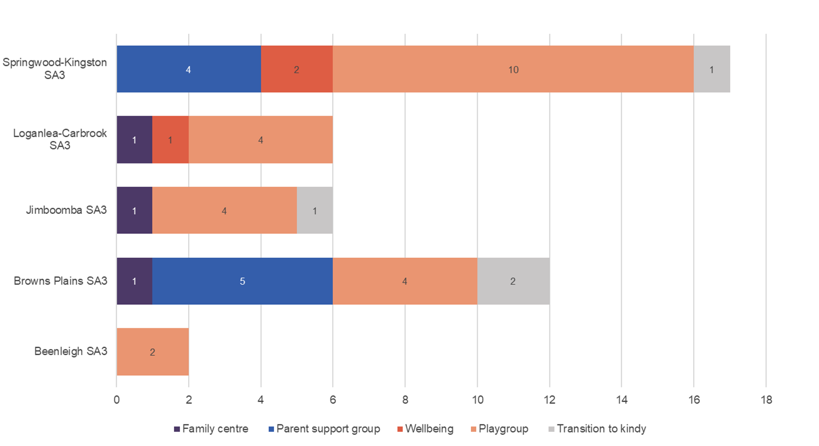
Figure 17. The number of services (n=45) by type providing group, community-based early learning experiences contributing to the physical, social, emotional, cognitive and language development of children aged 0-5 in Logan.
The majority of services contributing to ‘ready communities’ focus on universal preventative support and provide play-based learning, skill development, and social connection opportunities. Service providers create intentional spaces for learning and skill development, timely advice, and referral by offering services in a welcoming, relaxed environment.
With the exception of one multicultural playgroup, there is no evidence to suggest that services are responsive to families and children with cultural and language backgrounds.
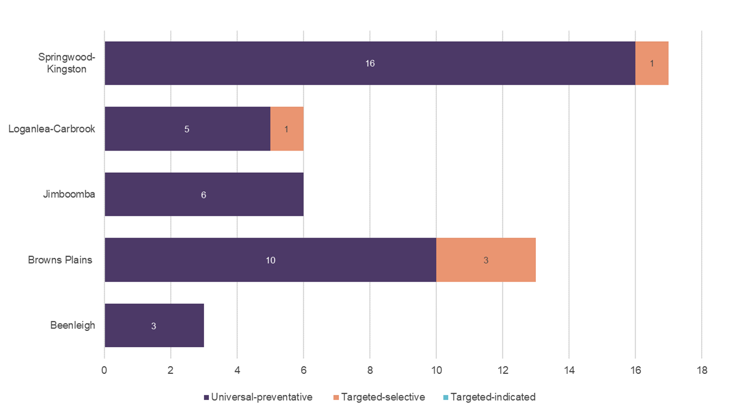
Figure 18. The geographical distribution and balance of universal preventative and targeted services (n=45) providing group, community-based early learning experiences contributing to the physical, social, emotional, cognitive and language development of children aged 0-5 in Logan.

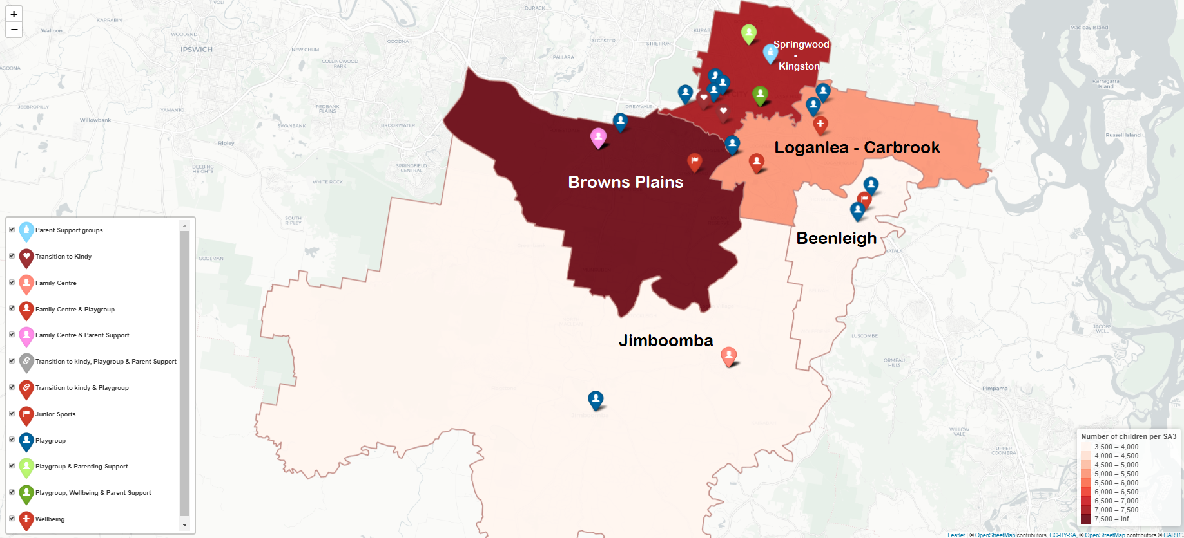
Figure 19. Map showing the geographical distribution of services (n=45) by type contributing to ‘ready communities’ in Logan. (Note: Where there is more than one type of service listing in the icon key – for example, family centre and playgroup – this represents more than one service type provided from the one location).
Map provided by the Relational Insights Data Lab, Griffith University

Ready early childhood education and care: What is the state of early years care services in Logan?
In Australia, the term early childhood education and care (ECEC) is used to describe childcare services, including centre-based care (i.e. long day care, kindergarten (preschool), outside school hours care (OSHC)) and family day care. Through its many forms, early childhood education aims to develop a child’s social, emotional, cognitive, and physical skills, building a stable foundation for lifelong learning and overall well-being. Participation in quality early childhood education and care benefits all children. However, those benefits are especially important for children from vulnerable or disadvantaged backgrounds.
ECEC services have the potential to ensure children enter school on a more equal developmental footing and, all other things being equal, can have effects on child wellbeing that last into adulthood (24). With the prospect of lifelong benefits, it is not surprising that governments have increased public investment in ECEC services, particularly kindergarten.
Early childhood education is not compulsory in Australia. According to the Front Line Project, which seeks to understand how Australian families experience early childhood education and care, the decision to seek ECEC most typically occurs at one of two turning points: the first is around the end of parental leave (typically around one year of age) and then at around three years of age when the perceived need for school readiness increases. Numerous factors impact a parent's decision to seek early childhood education and care. Considerations include family income and the need/desire to return to work; personal beliefs and values; the child's individual needs; and the availability of family members who can provide care and age-appropriate activities to support development. In addition, parents may experience external influences from family, friends, and employers (25).
Parents will typically identify the types of ECEC available that are best suited to the needs of the family and the child. The education and care options available for children younger than school age include:
- Long day care: centre-based childcare operating at least 8 hours a day, typically Monday to Friday
- Family day care: home-based learning in small groups for children from birth to 12 years, which can offer more flexibility with opening hours, including evenings and weekends
- Kindergarten: a school readiness program, operating as a standalone service or part of another service, for children meeting the kindergarten age requirement (age four by 30 June in the year they are enrolled), provided for 15 hours a week.

According to the Front Line Project, the following factors influence decision-making when selecting an ECEC provider.
- Availability of care and alignment to work schedule
- Proximity to home and work
- Cost and likely childcare subsidy
- Perceived quality
- Perception in the community. (25)
The following sections will examine the availability, affordability, and quality of ECEC services for Logan's children younger than school age. This approach reflects the factors influencing the decision-making process for families described above. Unfortunately, the data available do not allow for the inclusion of perceptions held in the community regarding ECEC services.

Availability
We use the term availability to refer to Logan's reported quantity of ECEC services. Figure 20 shows Logan's distribution and proportion of ECEC services (long day care, kindy and family day care). Long day care services dominate the ECEC sector in Logan, providing 77.5% of all childcare services.
Long day care is often a popular option for working parents, providing licensed, centre-based care for children aged six weeks to six years. Many centres are open for 10 to 12 hours a day, Monday to Friday, 48 weeks a year and must meet minimum staffing requirements, including minimum educator to child ratios, which vary according to the child's age. The centres are run by qualified educators, and children are grouped by age and provided with age-appropriate activities, equipment, and toys tailored to their developmental phases.
In contrast, we identified just 16 family day care centres, just 9% of all ECEC services. The balance of ECEC in favour of long day care services is not unique to Logan; this disparity also occurs at the state and national level. While long day care is the preferred option for many parents, family day care may offer the flexibility of operating hours needed to accommodate non-standard working hours such as weekends and evenings. In addition, some children will struggle to integrate and thrive in a centre-based environment, making family day care a favourable option.
All family day care services are subject to national regulations and monitored and supported by a family day care scheme coordination unit. Opening hours can include overnight stays and weekends, making this option appealing for parents/carers who work unsociable hours.
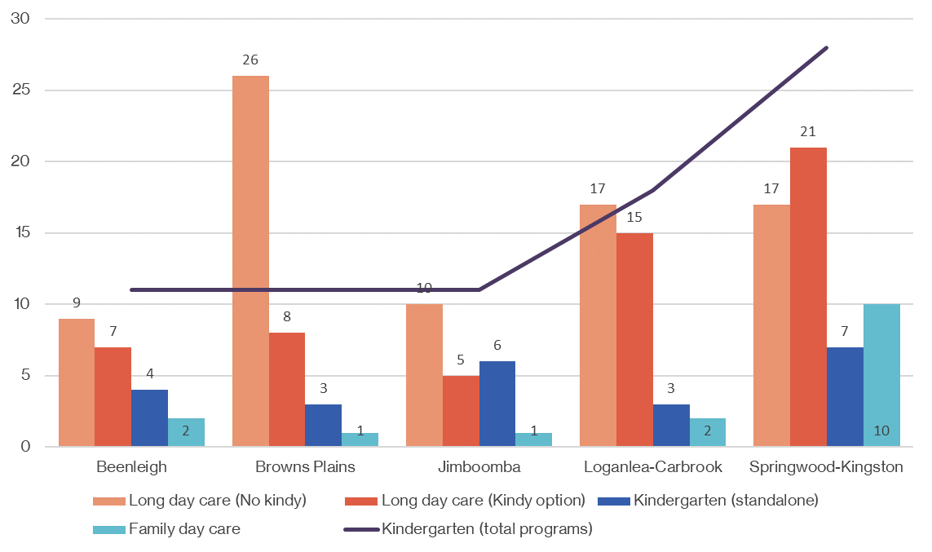
Figure 20. Shows the proportion and number of ECEC services (n=174) in Logan, by type, SA3 (Sources: ACEQUA; ECEC National Quality Standard Register).

Given the limited availability of family day care in Logan, parents preferencing care in a family-like environment may find it challenging to find services that align with this. Furthermore, most family day care services (62.5%) are located in the Springwood-Kingston SA3. As a result, families looking for family day care outside the Springwood-Kingston area are even more likely to experience barriers to access and limited ECEC options. Therefore, the choice offered to parents of long day care vs family day care in determining the best fit for the family appears redundant in Logan. Raising the question, what is the impact on families preferencing family day care over long day care?
Approved kindergarten programs aim to ensure that children can participate in a quality early learning program in the year before starting school. Although kindergarten is optional, international studies show that attending a quality kindergarten program improves child outcomes. Kindergarten programs are delivered for 15 hours a week, either as standalone services or programs offered as part of long day care. Due to the nature of service delivery (combined ages), family day care services do not offer kindergarten programs. While it is heavily promoted as beneficial for all children in the year before school, attending kindergarten attracts a fee. Reforms set to commence in early 2023 aim to make kindergarten more affordable through reduced fees and increased numbers of free kindergarten places.

Culturally inclusive early childhood education and care
During analysis, we identified two culturally inclusive kindergarten programs tailored to Aboriginal and Torres Strait Islander children. The Deadly Kindy program is part of the Queensland Government's strategy to increase the number of Aboriginal and Torres Strait Islander children participating in kindergarten. The program is funded by the state government and, importantly, run and delivered by ATSICHS, a not-for-profit Aboriginal community-controlled organisation.
Beyond the Deadly Kindy program, guidance on culturally inclusive practice and how to promote respect for diversity is available under the Early Years Learning Framework (EYLF), which aims to ensure that all Aboriginal and Torres Strait Islander children have a strong sense of identity and belonging.
All services are assessed against the National Quality Standard, receiving a rating against each of seven quality standard areas and an overall rating. Quality areas 5 and 6 focus on respectful relationships with children and building collaborative partnerships with families and communities. However, it is unknown whether early childhood educators are sufficiently supported to ensure their practice is culturally inclusive and respectful without further data collection.

Proximity to home
This section looks specifically at the geographical location of ECEC services and their proximity to where children live.
The total number of ECEC services (Figure 20) can be misleading because, depending on the size of the service, the total number of approved places can vary considerably. Therefore, the following will examine the geographical distribution of approved childcare places for long day care, family day care, and kindergarten programs (occurring in standalone services and long day care centres). We have assumed that all services operate at capacity. While it is helpful to examine the ratio of children for every approved ECEC place, we could not obtain data on the breakdown of approved ECEC places by age. For example, babies and toddlers require different levels of care and child-to-educator ratios. Without further data collection, we cannot be sure that the current geographical distribution of approved childcare places is sufficient to accommodate children of all ages under school age.

Long day care
In addition to long day care, some centres deliver kindergarten programs as part of their service offering, benefiting children of kindy age while providing additional hours of care to meet the needs of parents. Therefore, some of the approved child care places for centres offering kindergarten programs can only be allocated to children meeting the kindergarten age requirement (age four by 30 June in the year they are enrolled). Unfortunately, it was not possible to determine the number of kindergarten places held by long day care centres. Consequently, the long day care numbers depicted in Figure 21 are believed to be slightly lower, and kindergarten places slightly higher.

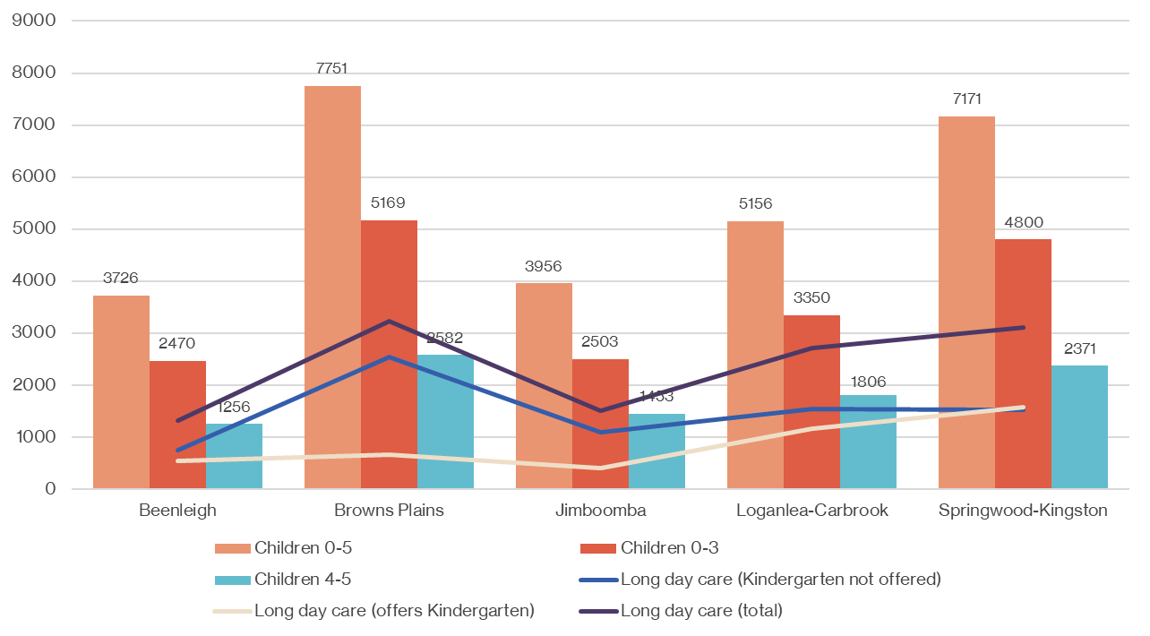
Figure 21. Shows the number of approved long day care places (n=11,869) compared to the number of children under school age (n=27,760) by SA3 (Sources: ACEQUA; ECEC National Quality Standard Register; ABS census 2016).
Figure 21 shows the distribution of approved childcare places for long day care against the total number of children by age residing in each SA3. At the time of writing, census data from 2020 was unavailable. Therefore, 2016 census data is used to determine the age breakdown of children living in Logan. Although birth rates between 2016 and 2019 remained stable (indicating that the 2016 census data reflect the current population), the data doesn’t allow for migration.
The distribution of long day care places appears to align with the number of children in each SA3, indicating that services are located where there is likely demand. However, this finding assumes that children will access care within the SA3 they live. In addition, figure 21 fails to illustrate one important issue: Greater Flagstone and Yarrabilba, located in the Jimboomba SA3, have been identified as expansion areas accommodating an additional 272,200 people and 89,000 homes by 2041. Therefore, the number of children currently residing in the Jimboomba SA3 is likely greater than that identified in the 2016 census.
Figure 22 shows the ratio of children to the number of approved long day care places. Based on 2016 population figures and assuming that not all parents will desire to engage with ECEC services and, more specifically, long day care. It appears that the number of places is sufficient to meet demand; however, the predicted increase of children living in the Jimboomba SA3 suggests that the current ratio of childcare places is likely insufficient in the future.

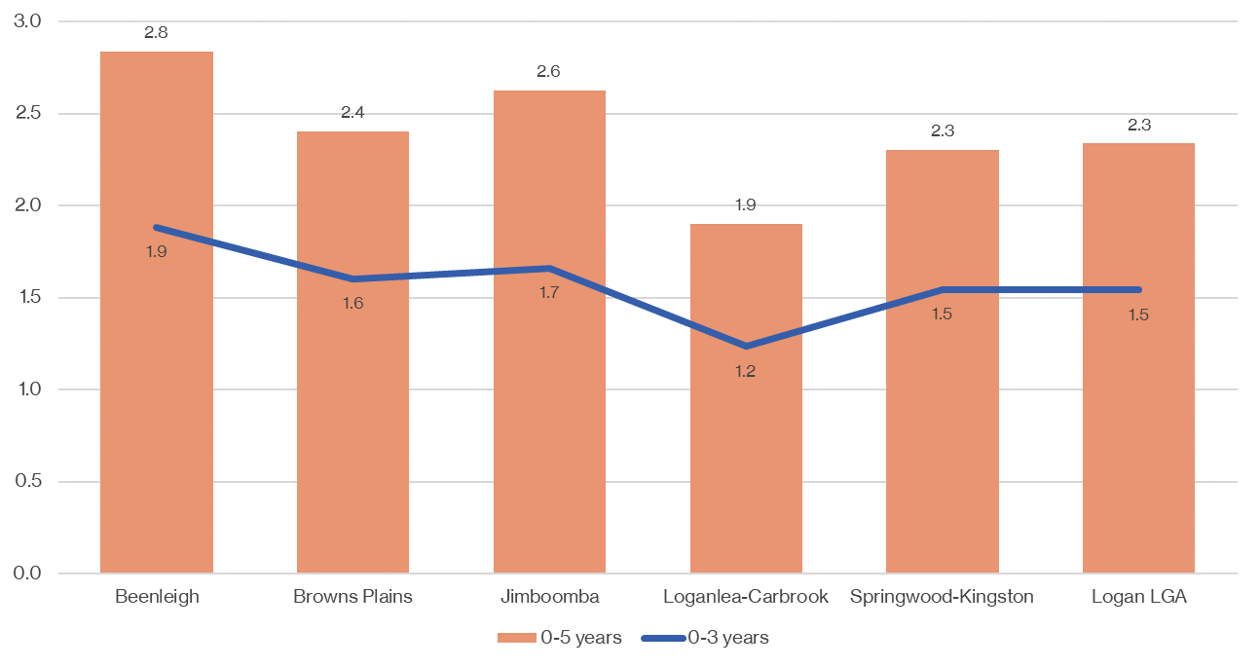
Figure 22. Shows the ratio of approved long day care places to the number of children aged 0-5 and 0-3 in Logan, SA3 (Sources: ACEQUA; ECEC National Quality Standard Register; ABS census 2016)

Family day care
In 2019, Family Day Care Australia surveyed more than 2,000 Australian families using family day care to assess their perceptions of the services. It found that ‘families chose family day care for its unique natural home environment and small group settings (26)’. In addition, the survey found that parents accessing family day care services reported the following benefits:
- They provide early education and care in a nurturing environment, which is natural and flexible, like a home environment
- They provide opportunities for children to bond with their educators and form long-lasting relationships
- Some services offer care during non-standard work hours, such as evenings, before and after school, school holidays, and weekends
- Every child receives tailored, individualised learning programs
- They can provide care for babies and children up to 13 years of age, offering the opportunity for siblings to attend the same location
- They provide experiences that reflect the diversity of the community (26).
The limited availability of family day care in Logan, evidenced in Figure 23, significantly restricts the ECEC choices available to parents. Unfortunately, data are not available on the number of approved places for each family day care service, making it impossible to determine the child-to-place ratio. However, family day care services operate with small groups of children (up to 7, including 4 children not yet in school).
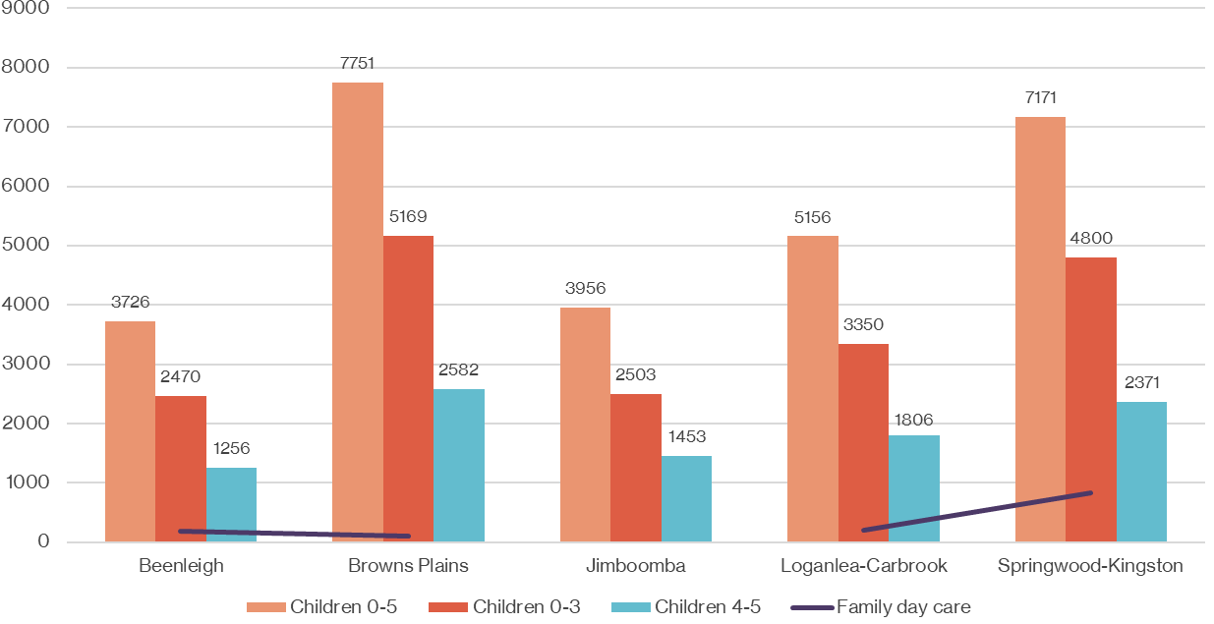
Figure 23. Shows the ratio of approved family day care services n=16 (unable to source the number of family day care places) to the number of children aged 0-5 (n=27,760) and 0-3 (n=18,292) in Logan, SA3 (Sources: ACEQUA; ECEC National Quality Standard Register; ABS census 2016)

While long day care is the preferred option for many parents, family day care operating hours can include overnight stays and weekends, making this option appealing for parents/carers who work unsociable hours. In addition, family day care may provide a more affordable option for parents. According to Care for Kids, the average hourly cost of family day care in Queensland is $10.15 (27) compared with between $10 and $18.80 for long day care.
Further investigation is required to determine the actual demand for family day care, the barriers to access, and the impact on parents preferring family day care. Furthermore, the limited availability of family day care leads us to ask, are there barriers to opening and operating a family day care service? For example, legislation and regulations, qualifications, profitability, etc.

Kindergarten (standalone)
Approved kindergarten providers must offer a learning program that is delivered by a qualified early childhood educator in the year before prep for at least 600 hours, or at least 15 hours a week for 40 weeks. In addition, the curriculum must be based on the Queensland Kindergarten Learning Guideline (QKLG), a set of five learning and development areas that align with the five broad learning outcomes identified in the EYLF.
In December 2021, the Australian and Queensland governments signed the Preschool Reform Funding Agreement, confirming up to $360 million of Commonwealth funding that will benefit more than 250,000 Queensland children in the year before school over the next four years. The Agreement aims to ‘facilitate children's early learning and development and transition to school by: ‘Maintaining universal access to affordable, quality preschool programs for all children improving participation in preschool programs, maximising the benefit of the preschool year by improving outcomes for children’ (28). It makes funding contingent on state and territory governments agreeing to a robust reform timeline to increase children's kindergarten attendance and school readiness.
From 2024, funding will be tied to kindergarten attendance targets, and an outcomes measure to be developed and trialled for introduction in 2025. As a result, there will likely be an increased push to actively promote and enable access to approved kindergarten programs in the coming months and years. In addition, there is an ongoing commitment to removing the barriers for Aboriginal and Torres Strait Islander children and children from disadvantaged families and communities to access and benefit from an approved kindergarten program, lowering overall rates of developmental vulnerability and improving academic performance.
The Queensland Government launched a kindy counts campaign in December 2021. The campaign focuses on raising the awareness of the lifelong benefits of attending kindy and encourages families to enrol their child in a Queensland Government approved kindergarten program. Campaign material includes short videos, a social media presence (Facebook and Instagram) and posters. The posters show a variety of voices from children, parents/carers and early childhood educators. Individuals are encouraged to use the posters that best resonate with their community (29).
At a local level, Logan Together, through their community-facing branding and website ‘The Early Years’ (30), has co-designed a range of resources to increase kindy awareness and enrollment with the community. The resources include:
- What is kindy? a practical guide for parents on the benefits of kindy
- Videos for parents to experience kindy in Logan
- Guidance on how to find a government approved kindergarten
- Information on the cost of kindy and available subsidies
- Details on the Logan Together Kindy Scholarship Program (see affordability below)
- Information on playgroup, a fun, informal step into early learning
- A kindy champion contact number for those with more questions.
In addition, the ‘going to kindy’ project led by Logan Together looks to reduce and resolve the range of barriers that may prevent parents from sending their children to a good quality kindergarten. Barriers identified include awareness, transport, cost and cultural norms.
Data from the Department of Education on the number of children enrolled in a kindergarten program in 2016, 2019, and 2020 (Figure 24) shows no significant increase in the number of children enrolled in an approved kindergarten program. This indicates that state and local efforts to increase awareness of the benefits of kindergarten are yet to translate into increased kindergarten enrolments in Logan.
The specific barriers parents face to enrolling their children in kindergarten are unknown. However, it is likely that the socio-economic disadvantage experienced by many families and the high levels of cultural diversity and subsequent variation of cultural norms regarding early childhood are significant contributors. In addition, recent efforts by the Queensland Government and Logan Together to increase awareness of kindy and its benefits suggest a lack of understanding among parents on the benefits of kindy and how to access it, which will further impact enrolments. Additionally, the number of enrolments does not reflect attendance, which may mean that actual engagement with kindergartens is lower than shown in Figure 24.
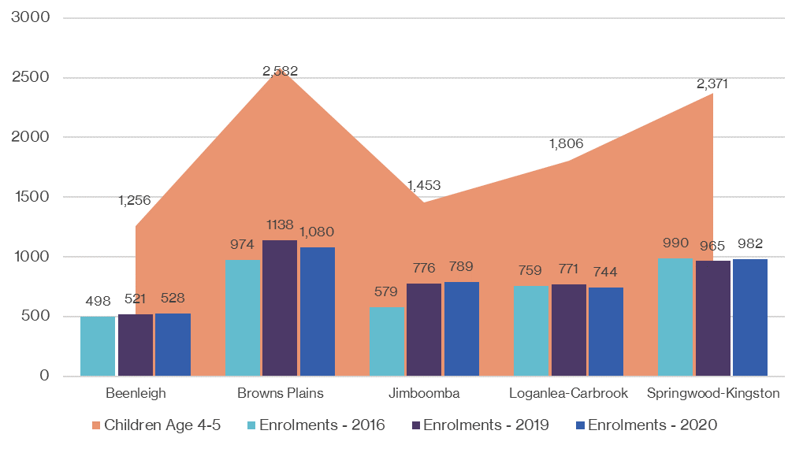
Figure 24. Shows the number of children enrolled in government-approved kindergarten programs in 2016, 2019 and 2020, by SA3 compared with the total number of kindy aged children in Logan (Source: Department of Education).
Kindergarten programs are delivered in some long day care centres as well as standalone kindergarten services. Unfortunately, data on the number of approved kindergarten places in long day care centres are not available. In Logan, 37% of long day care providers have a kindergarten program complemented by supplementary education and care. Assuming parents are aware and desire to engage with kindergarten programs, those with work commitments are more likely to access kindergarten via long day care than standalone kindergarten, where additional care can be provided around the 15 hours of programming provided.

Operating hours
Child care is an essential factor in enabling parents to engage in paid work. The standard working week in Australia is usually Monday to Friday, and, according to Fair Work Australia, ordinary work hours are between 7am and 7pm. Parents who work non-standard hours may require access to ECEC services offering flexible child care solutions. It is difficult to ascertain the demand for flexible child care. Not all parents working outside ordinary hours require access to flexible childcare: parents may find alternative solutions, such as choosing to manage work schedules around the availability of formal child care or using informal care provided by family or friends (31).
The Australian Institute of Family Studies (AIFS) commissioned a report on flexible child care, examining the key findings from the AIFS evaluation of the child care flexibility trials, a project conducted by the Australian Government in 2013 and 2014 (31). Different approaches to flexible child care were trialled across Australia, including:
- Flexible care provided through family day care
- Extended hours of operation in long day care
- Weekend care in centre-based settings.
The evaluation found that the needs and preferences of parents for child care were diverse and consequently required a range of easily accessible solutions. Families with less flexibility around family support or local solutions (i.e. single-parent families in regional areas or children with special needs) were identified as needing more or different childcare options. While parents working non-standard hours agreed that more flexible child care options were required, no one clear solution emerged. Overall, the data found preferences for more occasional care and increased in-home support (31).
Long day care services provide most of the formal childcare in Logan (87%). Long day care typically operates from Monday to Friday, 10–12 hours a day, 48 weeks a year, with 94% of services opening their doors between 6 am and 7 pm. This provides some flexibility in child care options outside of ordinary work hours; however, only one service provides care beyond 6.30pm, operating between 6 am and 9 pm in the suburb of Eagleby (in the Beenleigh SA3). In contrast, family day care providers offer child care between 8 am and 5 pm, likely making this option impractical for parents trying to accommodate work hours. AIFS found that collecting children by closing time was especially difficult for those with no flexibility in working hours or those subject to unexpected overtime. In addition, parents with children in long day care reported incurring a financial penalty if they were late (31).
In addition, some parents are likely to require child care solutions at the weekend to accommodate work hours. We found only five service providers in Logan offering formal childcare at the weekend. These were all family day care services, and care was limited to four hours on Saturdays, except for one provider who only offered five hours of care on Sundays.
According to the AIFS evaluation of child care, service providers in flexibility trials ‘had difficulties finding financially viable ways to accommodate parents who had rotating and variable rosters that did not compromise the well-being of the individual educators and their families. This was especially the case for the provision of the most flexible care for families with variable care needs’ (31).
Professional in-home child care provided by nannies may be an option for parents working variable or non-standard work hours. In-home care (IHC) is part of the childcare subsidy package, an approved government subsidy designed to provide a high quality, flexible early childhood education and care option to families in their own home. The IHC is delivered through a network of IHC support agencies to help families find the care that best meets their needs. It aims to support workforce participation and early childhood education and care requirements where other approved child care options (centre-based ECEC and family day care) are not available or appropriate. Parents may be eligible for this child care subsidy payment if they work non-standard or variable hours, are geographically isolated, or have families with challenging or complex needs. Professional in-home child care may be an appropriate and viable solution for parents working variable or non-standard work hours currently not accommodated in mainstream ECEC services (32). While nannies are considered out of scope for this report, it is important to mention that they offer an alternative professional child care option for parents. Child care provided in the family home can save money if there is more than one child, reduce the stress when leaving for work, and better support children with specific needs who may not cope well with transitions to new environments.
We could not ascertain the cost of formal childcare operating during non-ordinary work hours. Consequently, consideration must be given to the possibility of formal child care operating in non-ordinary hours, attracting higher fees. This has an implication on affordability and, if available, the ability of families to engage in these formal child care solutions.

Occasional care
Accessing ECEC services requires parents to make permanent and regular bookings. Posing significant issues for parents who work rotating rosters or shifts, as is the case for many emergency services and health care workers. Securing permanent regular bookings that cover every eventuality may be required to meet possible work commitments. However, this approach to meeting childcare needs attracts unnecessary costs and may add additional financial pressure on parents and take childcare places other parents may need. During the analysis, we also looked for incidences of occasional childcare that offered short sessions of casual care.
Access to occasional childcare may assist parents to; attend appointments, spend time with a new baby or school-aged child, provide opportunities for their child to socialise, or allow parents to have some time to themselves. Unsurprisingly, no evidence of formal ECEC services offering occasional childcare solutions was found. However, a not-for-profit organisation located in Kingston provides limited hours of childcare, offering an educational program delivered by early childhood staff. Childcare bookings for a minimum of 2 hours can be made between 8:30 am and 1 pm, Tuesdays-Fridays. The occasional childcare service provided by the Kingston East Neighbourhood Centre appears to be a rare exception to the childcare offering in Logan. Specialised early childhood staff provide an educational program for a small fee while parents attend to other commitments or simply take a break.
These findings lead us to the question, are current ECEC options sufficient for parents who desire to further their career in their chosen path? If not, does this limit the ability of parents to lift their socioeconomic status and that of their children and communities?

Affordability
Early childhood education and care in Australia is a private market. Daily fees, before government subsidies, vary across the country for long day care ($70 to $188) and preschool (i.e. kindergarten; $45 to $80) (33). While some families are fortunate to secure high-quality ECEC close to home and can meet the cost of care, many families experience multiple barriers in finding close, available, quality, affordable services.
The average cost of child care in Logan is $92.50 a day. Springwood-Kingston SA3 has a much lower average daily rate of $86.50, reflecting the distribution of disadvantage and socioeconomic means of families. However, the Beenleigh and Browns Plains SA3s attract significantly higher daily fees (Figure 25), which may pose a considerable barrier for families. Children most likely to benefit from exposure to ECEC are those from socially disadvantaged backgrounds. These benefits accrue in the form of short-term developmental improvements as well as longer-term gains (34).
The Australian Government is the primary source of funding for child care services, which is delivered through fee subsidies paid directly to approved child care providers. The national Child Care Subsidy (CCS) aims to make access to high-quality child care more affordable for eligible families. The amount of CCS parents are entitled to will depend on individual circumstances such as family income, the type of child care, and activity level.
The Department of Social Services does not release data at the LGA, SA3 or SA2 level on the number and value of CCS payments made. Therefore, we were unable to determine the average out-of-pocket gap fee and possible implications for parents in Logan. Families residing in areas of most disadvantage will likely be eligible to receive the CCS; however, consideration must be given to individual earnings, skill level, market opportunities, and whether a return to work is financially viable. This may be particularly true for lower-income single-parent mothers.
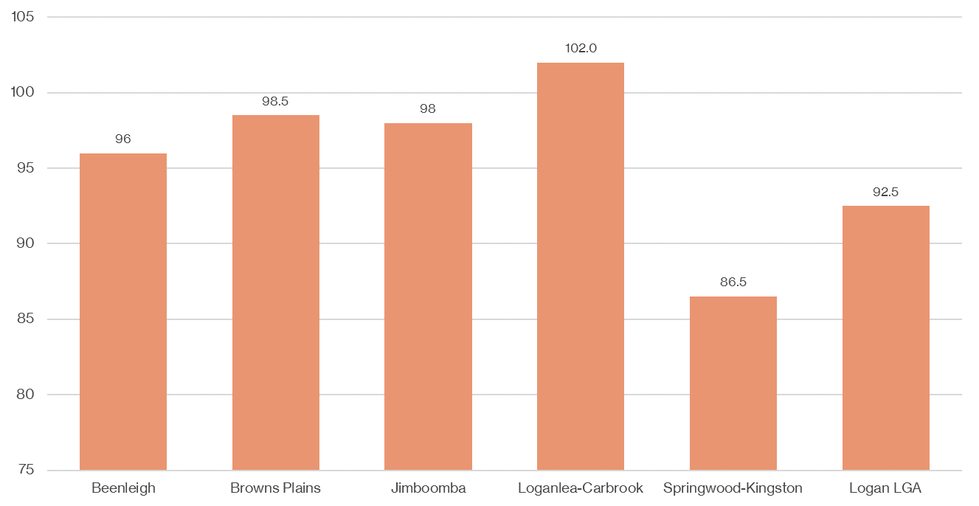
Figure 25. Average cost per day (in AUD) for childcare in Logan, SA3 (Source: Care for Kids, childcare calculator)
In addition to CCS, state and local efforts to remove the financial barriers for disadvantaged and vulnerable children to attend kindergarten have been implemented. The Queensland Kindergarten Funding Scheme (QKFS) is designed to assist kindergarten providers with the cost of implementing and delivering an approved kindergarten program. In addition, services in remote and very remote areas may be eligible to receive additional funding to attract and retain qualified early childhood teachers(35).
Under the QKFS, there are subsidies for eligible families (paid directly to the service) to reduce or remove the financial barriers for families when accessing kindergarten. The low-socio-economic subsidy reduces costs for parents who access a kindergarten service located in the most disadvantaged areas.
The QKFS Plus Kindy Support Subsidy aims to reduce fees or remove them for eligible families. Eligible families must demonstrate one of the following criteria:
- A current Australian Government Health Care Card (HCC)
- A current Australian Government Pensioner Concession Card (automatic HCC entitlements)
- Department of Veterans Affairs Gold Card or White Card
- Identify as Aboriginal and/or Torres Strait Islander
- Three or more children of the same age enrolled in the same year (35).
At a local level, Logan Together has started the Logan Together Kindergarten Scholarship Program. In partnership with the Logan Community Bank Branches of Bendigo Bank and individual donors, eligible children will receive 100% of kindy costs. The scholarship program aims to address the significant barriers to accessing kindergarten in Logan, particularly for Aboriginal and Torres Strait Islander children and children from disadvantaged families.
State and local efforts to remove financial barriers are limited to increasing access to government approved kindergarten programs in preparation for formal schooling. Consequently, where the CCS is insufficient to meet the cost of early childhood education and care, financial barriers may prevent access and impact education and employment opportunities.

Quality
Attending child care and kindergarten programs has been associated with children's learning and developmental outcomes. However, successful developmental outcomes depend not only on the availability but also on the quality of early childhood services (36).

National Quality Framework
The National Quality Framework (NQF) was introduced in 2012 to improve the quality of education and care in long day care, family day care, kindergarten, and outside-school-hours services. The framework provides a national approach to regulation, assessment, and quality improvement and includes legislation, regulation, and an assessment and quality rating process (the National Quality Standard and the Early Years Learning Framework). The Australian Children’s Education and Care Authority (ACECQA) is the independent national authority that assists governments in administering the NQF (37).

National Quality Standard
All ECEC and outside-school-hours care services are assessed and rated against the National Quality Standard by the relevant state or territory regulating authority, receiving a rating against each of seven quality standard areas, as well as an overall rating. The quality areas are; educational program and practice, children's health and safety, physical environment, staffing arrangements, relationships with children, collaborative partnerships with families and communities, and governance and leadership. The rating scale has five categories: significant improvement required, working towards NQS, meeting NQS, exceeding NQS, and excellent.
The least disadvantaged and diverse SA3s of Jimboomba and Loganlea-Carbrook have a significantly higher proportion of ECEC services that exceed the National Quality Standard (Figure 26). Conversely, in the most disadvantaged areas of Browns Plains, Beenleigh, and Springwood-Kingston a high proportion of services are working towards the National Quality Standard, which means that there are one or more quality areas identified for improvement.
According to the Australian Children's Education and Care Authority report on quality ratings by socio-economic status of areas, ‘services in the most disadvantaged areas typically find Quality Area 1 (Educational program and practice) and Quality Area 4 (Staffing arrangements), and Quality Area 7 (Governance and leadership) more challenging' (34).
Due to the increased benefit of high-quality education and care for children from disadvantaged backgrounds, the goal should not only be to eliminate the difference between working towards and meeting the National Quality Standard, but also to increase the number of services exceeding the NQS.
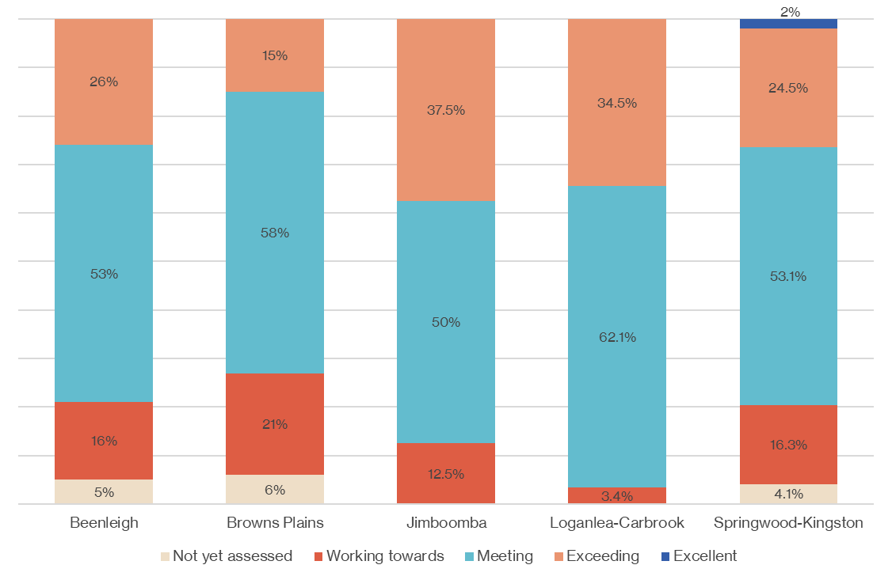
Figure 26. Shows the overall quality ratings of early childhood education and care services in Logan by SA3 (Sources: ACEQUA; ECEC National Quality Standard Register)

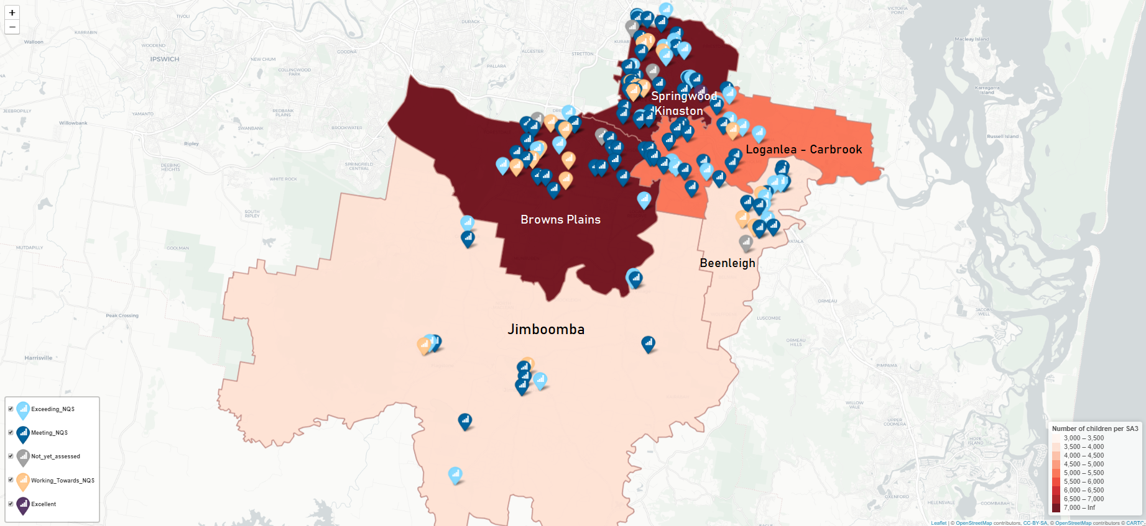
Figure 27. Map showing geographical distribution of services in Logan contributing to ‘ready early childhood education and care’ (Services have been colour coded according to the National Quality Standard quality rating).
Map provided by the Relational Insights Data Lab, Griffith University

Conclusion
The Logan community is committed to working together toward a shared vision of improving early child development outcomes. Stakeholders across the community, government, service providers, and universities are taking a place-based approach to address service fragmentation, siloing, duplication, and the lack of coordinated responses which make up the service system for children and families.
The systemic change needed to reform the service system requires the sharing and pooling of skills and resources across sectors and identifying ways to improve the service system to become more supportive and integrated, better responding to the needs of children and families.
This study was undertaken as the first step toward building a shared understanding of the services and support contributing to Logan's early learning development system. Specifically, the report highlights key findings and opportunities for further enquiry and analysis regarding the availability and distribution of services and support and the implications for access.
Although small in scale, the key findings in this report present a unique opportunity to optimise collaboration, providing a shared understanding of the current early learning service response in Logan, and opportunities to explore, co-create and take action towards an improved future state.

References
1. Australian Institute of Health and Welfare. Australia’s Children. Canberra: AIHW; 2020. Report No.: Cat no.CWS 69.
2. Heckman JJ. There’s more to gain by taking a comprehensive approach to early childhood development. 2016;
3. Rhode Islands Kids Count. Getting ready: Findings from the National State Readiness Indicators Initiative, 17 State Partnership. 2005.
4. Bronfenbrenner,U. The ecology of human development: experiments by nature and design. Harvard University Press; 1979.
5. The Early Intervention Foundation [Internet]. Available from: https://www.eif.org.uk/home/
6. Sayers, M., West, S., Lorains, J., Laidlaw, B., Moore, T. G., & Robinson, R. Starting school: A pivotal life transition for children and their families. 2012.
7. Australian Government. Australian Early Development Census. 2022.
8. SNAICC - National Voice for our Children. Early Childhood [Internet]. SNAICC. Available from: https://www.snaicc.org.au/policy-and-research/early-childhood/
9. Asmussen,K.,Feinstein, L.,Martin,J.,Chowdry,H. Early Intervention Foundation. Foundations for life: What works to support parent child interaction in the early years. 2016.
10. Centre for Community Child Health. Exploring the impacts of community hubs on school readiness. 2017.
11. Logan Together. The State of Logan’s Children summary report. 2018.
12. Tanton R, Dare L, Miranti R, Vidyattama Y, McCabe M. Dropping off the Edge Report: Persistent and multilayered disadvantage in Australia. Melbourne: Jesuit Social Services; 2021.
13. Edwards B, Baxter J, Smart D, Sanson A, Hayes A. Financial disadvantage and children’s school readiness.
14. Early Intervention Foundation. Social and Emotional Skills and their Long Term Effects on Adult Life. 2015.
15. Australian Early Development Census, Domains [Internet]. Available from: https://www.aedc.gov.au/about-the-aedc/about-the-aedc-domains
16. The Smith Family. Breaking the cycle of disadvantage: Submission to the Australian Government Social Inclusion Board [Internet]. 2010. Available from: https://www.thesmithfamily.com.au/-/media/files/research/policy-submissions/social-inclusion-board-july2010.pdf
17. The Front Project. The case for high-quality early learning for all children.
18. Parker R, McDonald M. Assessing and responding to parenting support needs in disadvantaged families.
19. Triple P Positive Parenting Program [Internet]. Available from: https://www.triplep.net/glo-en/the-triple-p-system-at-work/the-system-explained/specialist-programs/
20. Starting Blocks. The importance of play in children’s learning and development [Internet]. 2019. Available from: https://www.startingblocks.gov.au/other-resources/factsheets/the-importance-of-play-in-children-s-learning-and-development
21. Playgroup SA. Structured vs Unstructured Play [Internet]. 2017. Available from: https://www.playgroupsa.com.au/publications-blog/structured-vs-unstructured-play-226.html
22. Sincovich,A.,Harman-Smith,Y.,Brinkman,S. The reach of playgroups and their benefit for childrens development across Australia: A comparison of 2012,2015, and 2018 AEDC data. 2019;
23. Early Years Plan - A Great Start for all Queensland Children [Internet]. [cited 2022 Feb 23]. Available from: https://qed.qld.gov.au/programsinitiatives/education/Documents/early-years-plan.pdf
24. Reynolds AJ, Englund M, Ou SR, Schweinhart L, Campbell FA. Paths of effects of preschool participation to educational attainment at age 21: A three-study analysis. Child Programs Pract First Decade Life Hum Cap Integr. 2010;
25. Heartward Strategic. Work and play: Understanding how Australian families experience early childhood education and care. 2021;
26. Family Day Care, Australia. Benefits of Family Day Care [Internet]. [cited 2022 Feb 8]. Available from: https://www.familydaycare.com.au/about/benefits
27. Care for Kids. Family Day Care, average cost, Queensland [Internet]. [cited 2022 Jan 17]. Available from: https://www.careforkids.com.au/family-day-care/qld
28. Department of Education, Skills and Employment. Preschool Reform Funding Agreement. Department of Education, Skills and Employment.
29. Queensland Government. Kindy counts campaign material. Early Childhood Education and Care. 2021.
30. The Early Years [Internet]. [cited 2022 Feb 10]. Available from: https://theearlyyears.com.au/
31. Baxter J, Hand K. Flexible child care: key findings from AIFS Evaluation of the Child Care Flexibility Trials. Melbourne: Australian Institute of Family Studies; 2016.
32. Department of Education, Skills and Employment. In Home Care (IHC), Australian Government subsidy [Internet]. Department of Education, Skills and Employment. [cited 2022 Feb 9]. Available from: https://www.dese.gov.au/child-care-subsidy/child-care-service-types/home-care
33. Care for Kids. Cost of childcare [Internet]. [cited 2022 Jan 17]. Available from: https://www.careforkids.com.au/child-care-articles/article/77/how-much-does-child-care-cost
34. Australian Institute of Health and Welfare. Literature review of the impact of early childhood education and care on learning and development: working paper. Canberra, ACT: Australian Institute of Health and Welfare; 2015.
35. Department of Education. Queensland Kindergarten Funding Scheme – Eligibility and subsidies.
36. Barnett WS, Ackerman DJ. Costs, Benefits, and Long-Term Effects of Early Care and Education Programs: Recommendations and Cautions for Community Developers. Community Dev. 2006;
37. Australian Children’s Education and Care Authority. National Quality Framework [Internet]. [cited 2022 Jan 11]. Available from: https://www.acecqa.gov.au/nqf/about

Geographical areas built from whole statistical areas level 2 (SA2), representing a population of between 30,000 and 130,000 persons.
2021 data just released, the data for Aboriginal and Torres Strait Islander children was not available at the time of writing
Data were only available for each AEDC domain on the percentage of Aboriginal and Torres Strait Islander children developmentally on track in the Logan LGA (Figure 7).
SA2s are medium-sized general purpose areas built up from whole statistical areas level 1, representing without overlap or gaps 3,000-25,000 persons.
Grey borders show SA3 boundaries
Data in this column from the 2021 ‘Dropping off the Edge’ report
Targeted selective: services that target or 'select' families with characteristics that place them at greater risk of experiencing problems, including economic hardship, single parenthood, young parents, and/or ethnic minorities.
Targeted-Indicated: services provided to a smaller percentage of families with a child or parent who has a pre-identified issue or diagnosed problem and requires more intensive support
Universal preventative: interventions available to all children and families.

