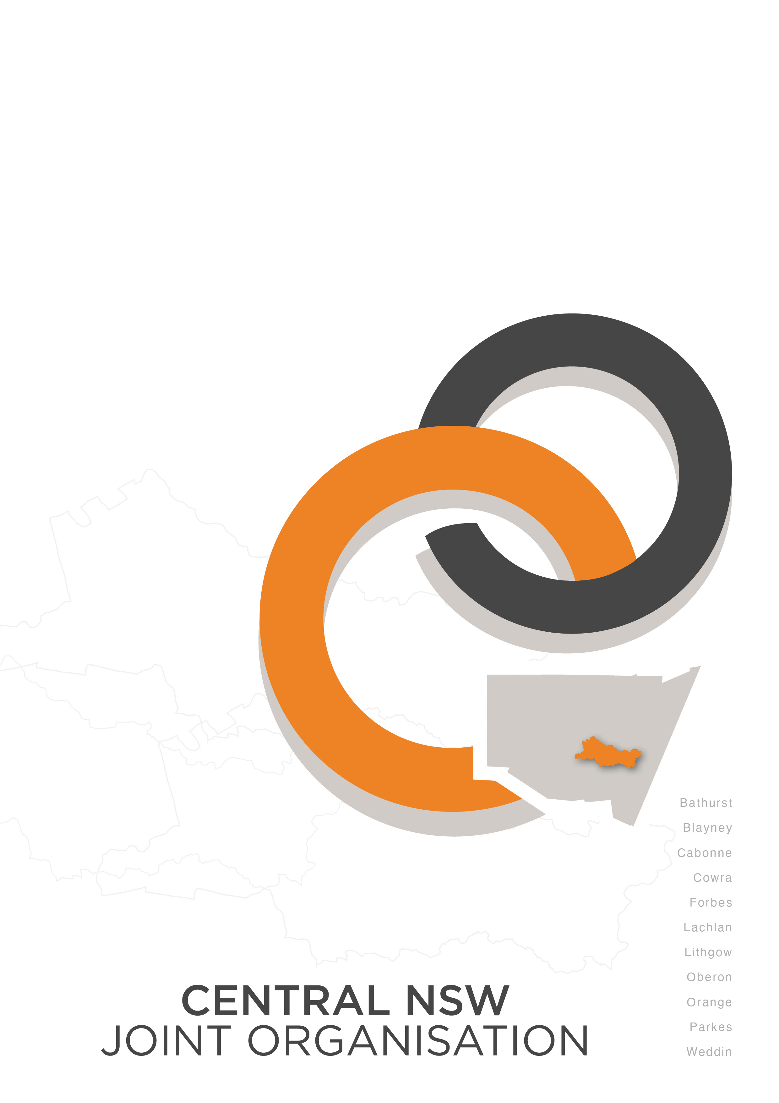
PRODUCTIVITY COMMISSION
NATIONAL WATER REFORM 2024
THIRD INQUIRY

31 January 2024 Reference: jb:mm 240131
Enquiries: Ms J Bennett:

National Water Reform 2024
Productivity Commission
GPO Box 1428
Canberra City ACT 2601

Email: water.reform.2024@pc.gov.au

Dear Commissioner,

Re: National Water Reform 2024- third inquiry

Joint Organisations (JOs) were proclaimed in May 2018 under the NSW Local Government Act 1993. The Central NSW Joint Organisation (CNSWJO) represents over 177,000 people covering an area of more than 51,000sq kms comprising the eleven Local Government Areas of Bathurst, Blayney, Cabonne, Cowra, Forbes, Lachlan, Lithgow, Oberon, Orange, Parkes and Weddin.

Tasked with intergovernmental cooperation, leadership and prioritisation, JOs have consulted with their stakeholders to identify key strategic regional priorities. The CNSWJO Strategic Plan can be found here: Strategic Plan & Regional Priorities - Central Joint Organisation (nsw.gov.au)

Firstly, we thank you for the opportunity to provide input to this inquiry into whether the intended objectives and outcomes of the National Water Initiative (NWI) have been achieved.

Access to quality, secure, affordable water for Central NSW communities is critical for the growth and prosperity of our towns, for productive use and to sustain the environment and is of the highest priority for the CNSWJO Board.

This response is informed by policy developed in region and endorsed by the CNSWJO Board. It provides overarching feedback on progress in achieving the objectives of the NWI as they relate to communities in Central NSW with commentary on key issues related to the elements for reform to deliver the outcomes of the NWI (Box 2) including:

- The Framework for water resource management
- Water entitlements and planning
- Pricing and institutional arrangements
- Urban water services
- Infrastructure development
- Community engagement, and adjustment.

Progress on achieving the objectives of the National Water Initiative

Regarding progress on the objectives of the NWI, specifically to optimise economic and social outcomes for regional communities, there is still a long way to go.

Recognition of the productive value of town water in the strategic planning and infrastructure funding framework

What has been found through strategic work by the CNSWJO in the water management framework since completion of its 2009 National award winning Centroc Water Security Study is that the relatively small amount of water needed for urban communities and its productive value is still not well considered or recognised. This includes in the current Murray Darling Basin (MDB) Plan.

This has been supported by Infrastructure Australia in 2019 where it found that:

The true value of water is poorly understood by users and many in the sector. Unreliable and incomplete evidence undermines the effectiveness of decisions, and community confidence in water managers. Overcoming the challenges faced by the water sector and preparing for the future will require a shift in planning and decision making to ensure the long-term interests of a range of stakeholders are protected.

It has been widely recognised, including by the Independent Panel that undertook the Independent assessment of the social and economic conditions in the Basin (April 2020) that town water security is the fundamental building block of socio-economic outcomes in the Basin.

Most Central NSW towns have been subject to severe town water restrictions with long periods of little or no general security, agricultural water availability and restricted high security water. The millennium drought, but in particular, the 2017 to 2020 drought, saw the regional centres of Orange and Bathurst come precariously close to running out of water. Towns in the Lachlan Valley were similarly impacted.

In Orange, storage levels dropped to well below 25% and the city faced the real threat of complete failure of its drinking water supply. Level 5 water restrictions were imposed during both droughts affecting both residents and businesses. The introduction of Level 6 water restrictions was a real possibility. Meanwhile water continued to be released to the environment.

Modelling undertaken through the 2009 Centroc Water Security Study and more recently by the NSW Government as part of the Macquarie-Castlereagh and Lachlan Regional Water Strategies demonstrates that not only the Orange water supply system, but other supplies across the CNSWJO region are at some risk under future climate conditions. This paleoclimate modelling shows that Orange, for example has an 11.8% (1 in 8 years) probability of experiencing water supply “failure” under a dry future climate change scenario while Bathurst has a 6.3% (1 in 16 years) probability.

Despite fervent activity by Councils, not enough has been done since the last drought to ensure adequate security is in place for towns. Failure of urban water supplies is socially unacceptable and the avoided costs of communities running out of water worth hundreds of billions of dollars to the economy.
Significantly more effort is needed to understand and recognise the social and economic value of town water in the strategic and funding framework.
An example is in the Lachlan Valley where the Business Case for raising the wall at Wyangala Dam developed by the NSW Government assumed that during times of water shortfall towns ‘never run out of water.’ This advice is at odds with the lived experience of the millennial drought where both Forbes and Cowra were given day zero advice on cease to flow. This means the benefit of avoiding the costs of closing towns was not included in the cost benefit analysis. We know this benefit changed the Benefit Cost Ratio significantly when modelled in Bathurst (available on request) – this is extremely unfortunate and something that must be overcome in any strategic work going forward.

For the NWI objectives to optimise economic and social outcomes for regional communities
there needs to be more storage and a change in how the Murray Darling Basin Plan is administered to sustain growth, particularly in the context of drought for inland communities.
There needs to be better evidence-based decision making with transparency around the inputs to business cases including the methodology used to determine the costs, benefits, avoided costs and biodiversity offsets.
Further, significantly more effort is needed to demonstrate the social and economic benefits of additional water for the environment to give communities confidence that the costs incurred from reducing the consumptive pool are worthwhile. This is particularly the case when through the 2017-2020 drought the timing of environmental flows seemed incongruous when towns were facing day-zero scenarios.

Progress on reforms to deliver the outcomes of the NWI

Water entitlements and planning

Enablement of water for critical human need under the Water Act 2007

Consistent with the Productivity Commission findings, we need to be clearer about critical human water needs in Water Resource Plans during extreme events, and how the MDBA will assess the adequacy of critical human water needs during extreme events.

There remains a need for better policy and protocols to underpin the NSW Water Management Act 2000 in a new climate future to ensure water for critical human needs are met as the highest priority.
Despite the NSW Government’s Town Water Risk Reduction Program implemented to address the findings of the NSW Auditor General in a report on Support by DPIE Water for regional town water infrastructure (September 2020), our members continue to report challenges in navigating the NSW Government bureaucracy to implement projects needed to meet critical human needs and the NSW Health Guidelines for the supply of safe and quality drinking water. The real-life impact of this is that Orange and Bathurst, among others, are unable to progress the water security projects needed to better prepare their communities for the next drought.

The Framework for water resource management

The strategic framework

This region has collaborated with the NSW Department of Planning and Environment – Water for over four years now to influence the Regional Water Strategies. While we have come a long way towards seeing town water challenges integrated into the State Government strategic planning framework for water, as outlined above, we continue to see assumptions made about the value of town water and its security that are frankly wrong. The idea that ‘no town will run out of water’ that we again saw in the Final Business Case for the Wyangala Dam wall raising project has no basis in the real-world scenarios that this region saw play out in 2020.
Community engagement and adjustment

Better inter-governmental collaboration on strategic water planning and management

Advice is provided elsewhere on progress in enshrining in legislation LG ownership and management of regional LWUs in NSW. It is suggested that while this is a priority, the question that should be asked is not about the institutional or structural arrangements but rather how water is managed strategically between the State, Federal and Local Government. This is where the greatest gains can be made in the delivery of regional LWU services.

This region continues to advocate for what it refers to as the ‘missing piece’ being effective inter-governmental collaboration at the regional level in strategic water planning and management.

In line with the findings of the Productivity Commission and NSW Auditor General (report Sept 2020) future reform should ensure effective collaboration on water management at the regional level between multiple government agencies, Councils and Joint Organisations, Local Water Utilities and local and regional stakeholders, including in water reliant industries.

The development of Regional Water Strategies and the State Water Strategy by the NSW Government is the ideal time to seek to have governance arrangements in place for both the implementation of these plans, but to deliver a range of significant benefits afforded by intergovernmental collaboration through a new approach leveraging the Joint Organisations.

Whether this be through the formation of Strategic Regional Water Committees or some other protocol, the opportunity exists to codesign a fit-for-purpose arrangement that will see an improved means of managing water for critical human need, particularly in times of shortages and for flood management. With predictions of a future with more frequent climate extremes, the sharing of data, the management of water quality issues, improved water efficiencies and the initiation of forums for better communication and collaboration, the better prepared we will be for managing the challenges ahead for regional communities.

We see mutually beneficial outcomes for all levels of government but most importantly the people of regional NSW from a more collaborative working partnership.

It is critical that the need for the ‘missing piece’ is addressed. This was no more clearly seen than through the last drought, where LG LWUs in regional NSW saw the need for a Critical Water Supply Act to be enacted and the redeployment of the Cross Border Commissioner to the role of Town Water Supply Coordinator. This served to highlight just how poorly neglected the concept of water for critical human need has been in regional NSW.

The CNSWJO Board have advocated consistently for the missing piece throughout the development of the Regional Water Strategies in the form of a Governance and Implementation Plan to deliver on the water security options identified in these 20-year strategies. Where we have made some headway in acknowledgement of this need - we’re not there yet.

Infrastructure development

Our members are anxious that despite their best efforts many continue to be stymied by bureaucracy or lack of funding and resources to implement the infrastructure projects they know from managing their towns through two previous droughts are needed to address town water security challenges. Some of these projects cross Local Government boundaries while others require a simple change of protocol or policy or even just agreement between different government agencies (sometimes even the same agency) to enable.

It is generally agreed that the Central NSW region needs a multi-faceted approach to protect against uncertainties and balance the competing needs of our environment, towns, and farmers. This was identified in the 2009 Centroc Water Security Study. However, 15 years on we are no closer to seeing the infrastructure recommendations from this award-winning strategy any closer to fruition.

Written off the back of the millennium drought, it is particularly frustrating for our communities that having endured an even worse drought in 2017-2020, the current draft of the Lachlan Regional Water Strategy and the Macquarie-Castlereagh Regional Water Strategy are plans for yet more strategies, studies and investigations.

The CNSWJO Board supports the need for water security projects to be grounded in solid evidence and state-of-the-art climate modelling, but this process is taking too long and the assumptions that underpin decision making is not transparent or based in real world experience.

Urban Water Services

Alternate funding models

Currently the rating of water utilities is on an either 75:25 or 60:40 basis where the larger number is based on consumption. This is a very challenging constraint on LWUs trying to sort financial sustainability.

LWU self-funding is augmented by State funding through a competitive framework and torturous processes. This process is such a significant disincentive that LWUs particularly the least resourced do not pursue funding in a timely manner. There is a significant backlog of infrastructure needing funding and significant infrastructure maintenance challenges for regional LWU’s. The trend will be for increased asset development to address water security, water safety, environmental performance and integrated water management. When combined with the cost of borrowings and increasing operational cost this will create issues with financial sustainability.
An explicit Community Service Obligation (CSO) should be developed as recommended by the Productivity Commission. Whilst capital subsidy would be almost impossible to remove entirely, funding could also be directed to capability development of LWUs which includes professional development, certification of operator training and further development of water utility business management systems. The CSO could also be extended to address infrastructure backlogs for LWUs.

The provision of water for the communities of NSW should adopt a Community Service Obligation framework that considers:
- Community needing to have control over its water supply.
- Economies of scale (or lack thereof).
- Remoteness.
- Population size.
- Secure water supply sources.
- Community ability to pay; and
- Levels of service considerations and obligations including regulation under health and the EPA.

The development of a CSO framework should include significant work with LWUs where the approach should be codesign – not bureaucrat’s assumptions about LWUs and ultimately creating a framework that runs the risk of not being fit for purpose. Any number of examples can be provided of assumptions that have led to unfortunate outcomes for regional communities.
The CNSWJO Board welcomes announcement by the NSW Minister for Water, Rose Jackson of the NSW Productivity Commissioner’s inquiry into alternate funding models. Particularly welcome has been early engagement by the Commissioner with the network of Joint Organisations across regional NSW in the development of the issues paper and stakeholder engagement plan for consultation on this critical issue. This follows consideration of alternate funding model by the Joint Select Committee inquiring into the protection of LWUs from privatisation.

Progress on this is urgently needed.

Local Government ownership of regional water utilities

The CNSWJO Board support institutional arrangements that maintain local government responsibility for the operation and management of water supply and sewerage services and infrastructure in regional NSW. It opposes the transfer of council provided water supply and sewerage services to state owned water corporations or their privatisation.

In summary, councils in regional NSW are best placed to ensure an integrated and locally appropriate approach to water supply and sewerage management and optimal whole-of-community outcomes for their communities. There are no compelling arguments that support privatisation, amalgamation or any sell-off of LWU assets, particularly where the private sector needs to make a profit.

The CNSWJO has welcomed the NSW Government’s current Joint Select Committee inquiry on protecting Local Water Utilities from privatisation, in particular, examination of how LWUs and their assets can be best protected against privatisation, forced amalgamations and sell-offs. It is hoped that the Committee’s response will be to support legislation that enshrines this protection providing there are no perverse consequences with outsourcing to the private sector and that any legislative change will be done in a true co-design manner with the sector to ensure a fit-for-purpose outcome.

Having said this, the question that really needs to be asked is not about structural arrangements but rather how LG LWUs can be supported and enabled to deliver local services and respond to the ever-increasing risks to their communities.

In summary

Water security is linked to climate change but also population growth. As more and more people move to regional areas and new industries are established, we will need secure water supplies to ensure economic and social growth. While some inroads have been made in the NSW context there continues to be a lack of focus on urban water security in most strategies. The challenge remains to ensure the true social and economic value of town water is recognised. Until this and the primacy of options for water for critical human need are addressed the NWI will struggle to meet its objectives of optimising social and economic water outcomes for communities.

There is a need for greater recognition of the socio-economic needs of regional communities in the context of the Murray Darling Basin Plan. The review of the Plan and work underway to develop MDB Plan 2 presents an opportunity to ensure that the relatively small amount of water needed for urban communities and productive use and the socio-economic impact of the Plan is considered.

Where water for critical human need must be the highest priority in times of shortages, there needs to be discussion within regions about achieving the balance that is needed for all stakeholders’ areas of interest across the catchment in a new climate future. This includes for cultural needs, urban communities, agriculture, industry and the environment. It is in our communities’ interests to ensure that the right balance is struck in water management across all these areas with better inter-governmental collaboration and frameworks to support coordination and decision-making around the planning and management of water resources.

If there are no changes to infrastructure, policy, or demand management practices, future droughts could have severe consequences for cities and towns in the region.

If you require further information or clarification on comments in this submission, please do not hesitate to contact Jenny Bennett

Yours sincerely,

Jenny Bennett
Executive Officer
Central NSW Joint Organisation (CNSWJO)

https://www.centraljo.nsw.gov.au/content/uploads/2.centroc-water-security-study-component-2-options-paper-rev-1-291009.pdf
https://www.infrastructureaustralia.gov.au/australian-infrastructure-audit-2019-water
Centroc Water Security Study
https://water.dpie.nsw.gov.au/__data/assets/pdf_file/0009/586818/macquarie-castlereagh-rws-final.pdf page 38
https://water.dpie.nsw.gov.au/__data/assets/pdf_file/0006/578481/wyangala-damn-wall-raising-final-business-case.pdf page 251
https://www.dcceew.gov.au/water/policy/mdb/policy/independent-assessment-social-economic-conditions-basin- page 72
National Water Reform 2020: Findings, recommendations and renewal advice, 2021)
https://water.dpie.nsw.gov.au/__data/assets/pdf_file/0009/586818/macquarie-castlereagh-rws-final.pdf page 36

