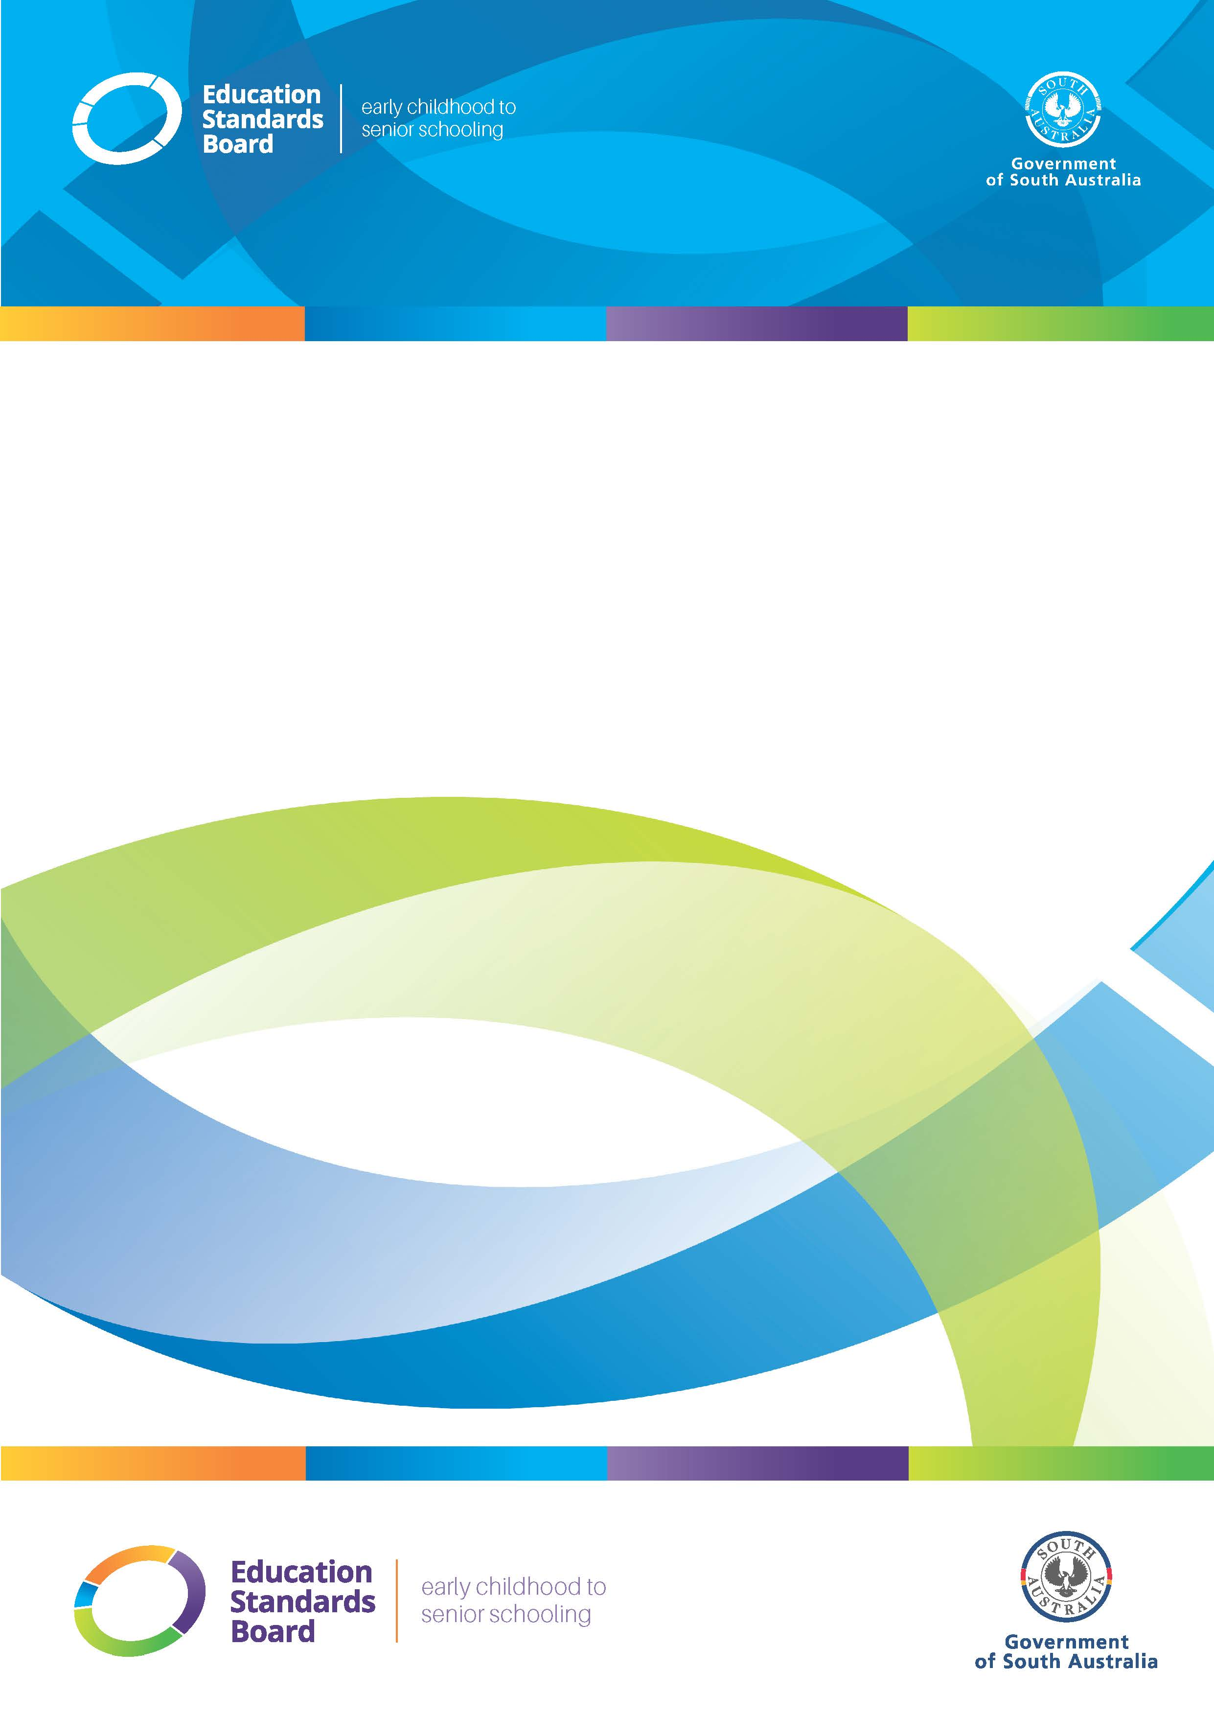
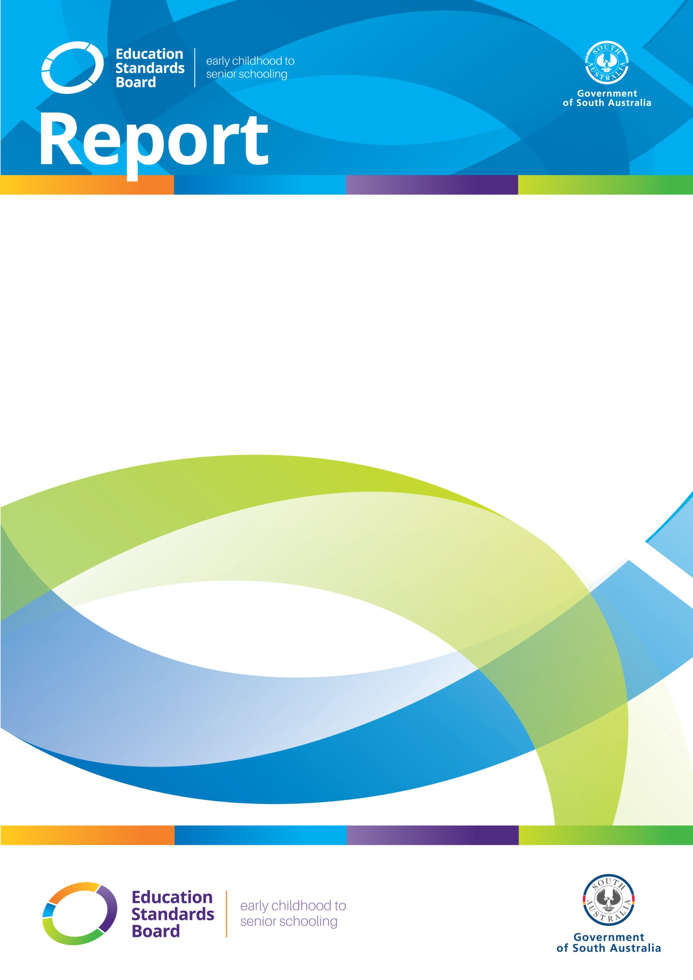

OFFICIAL

Submission
to the
Productivity Commission Draft Report
on its
Inquiry Into Early Childhood Education and Care

8 March 2024

Contents

Executive summary 4
Response to information requests 5
2.1: Suitability of the National Quality Framework for Outside School Hours Care 5
8.1: Provision of service ratings information for families 7
8.2: Regulatory actions against serial underperformers 10
8.3: Support for services to meet the NQS 15
9.2: An Early Childhood Education and Care Commission 16
The Role of the Education Standards Board 18
References 19

Executive summary

The Education Standards Board of South Australia (the ESB) welcomes the opportunity to provide a submission to the Productivity Commission regarding its draft report – A path to universal early childhood education and care (the Draft Report) as part of its inquiry into Early Childhood Education and Care (ECEC) in Australia.

The ESB agrees with the Productivity Commission’s statement that participation in quality ECEC has important developmental, social, and educational benefits and can provide a foundation for our children’s future wellbeing and success.

For the purposes of this submission, the ESB has focussed on the areas and recommendations of the Draft Report that fall within the legislative and regulatory ambits of the organisation. As such, the submission will respond to the following information requests:
- 2.1: suitability of the National Quality Framework for Outside School Hours Care
- 8.1: provision of service ratings information for families
- 8.2: regulatory actions against serial underperformers
- 8.3: support for services to meet the National Quality Standards and
- 9.2: an ECEC Commission.

This submission also provides commentary on the following draft recommendations:
- 2.1: ensure appropriate quality regulation for services outside the scope of the National Quality Framework
- 8.1: state and territory regulatory authorities should improve their performance reporting
- 8.2: a new review of the National Quality Framework
- 8.3: ensure regulatory authorities are adequately resourced
- 8.4: incentivise quality provision in new ECEC services
- 9.1: improve policy coordination and implementation and
- 9.2: establish an ECEC Commission

The ESB fully endorses draft recommendations 2.1, 8.1, 8.3, 9.1, and 9.2, recognising their value in enhancing the effectiveness and quality of ECEC services. Draft recommendations 8.2 and 8.4, while the ESB acknowledges their merits and intent, it does so with some considerations, notations, and observations.

The ESB looks forward to continuing the constructive collaboration with the Productivity Commission on this important matter and awaits the release of the Final Report.

Kerry Leaver
Chief Executive and Registrar

Response to information requests

2.1: Suitability of the National Quality Framework for Outside School Hours Care

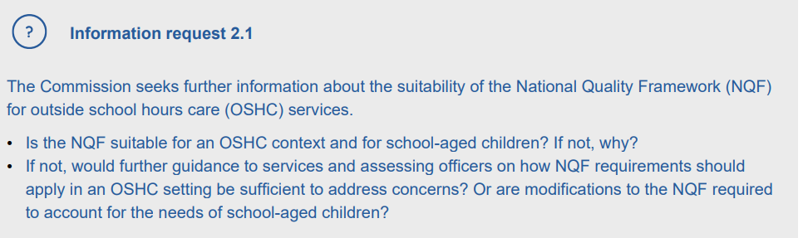
Information request 2.1 of the Productivity Commission’s Draft Report following its Inquiry into Early Childhood Education and Care

Of particular significance to this inquiry, especially regarding information request 2.1, is the most recent National Quality Framework (NQF) Review and the 2023 Royal Commission Inquiry into Early Childhood Education and Care in South Australia (the Royal Commission).

Initiated in 2019 and concluded in 2022, the NQF Review aimed to assess the effectiveness and sustainability of the NQF, evaluating its alignment with contemporary best practices in regulation. One aspect of the review was to examine the effectiveness of the assessment and rating process, particularly concerning Outside School Hours Care (OSHC) services.

The Royal Commission echoed the findings of the NQF Review, identifying shortcomings in the process and identifying that progress on reviewing the assessment and rating process for OSHC had been lacking, as detailed in recommendation 27.

The review emphasised the unique characteristics of OSHC facilities compared to ECEC providers and recommended a series of legislative and policy adjustments:

- Effective from 1 July 2023, OSHC services in the States of South Australia, Tasmania, Western Australia, and Victoria underwent a significant shift in documentation requirements. Specifically, these services no longer maintain individual children's developmental records and instead document the educational program's development. The changes now align with previous amendments made in most other jurisdictions.

- From February 2024, OSHC services are assessed against the revised Approved Learning Framework for school age children, My Time Our Place: Framework for School Age Care (v2.0), released in December 2023.

- Minimum OSHC qualification requirements are being pursued through the National Children’s Education and Care Workforce Strategy and the South Australian Government accepted recommendation 35 of the Royal Commission to modernise OSHC qualifications in SA.

The ESB supports an evaluation of the impact of recent policy and practice changes, a review of current guidance material for Authorised Officers and the sector and a comparative jurisdictional analysis of current assessment methodology for the OSHC service type.

Any review of the NQF applying to OSHC should be informed by a broad base of evidence that reflects contemporary research and expert views.

With reference to draft recommendation 8.2, proposing a new review of the NQF, the ESB acknowledges the importance of periodically evaluating regulatory frameworks, and the current five-yearly review cycle is in place.

The ESB recognises that the pace of change within the early ECEC sector demands a more dynamic approach to reviewing the NQF, that is resourced appropriately.
Aspects of the NQF are reviewed outside of the established cycle as the need arises, as evidenced by the 2023 review into child safety arrangements under the NQF.

While this demonstrates that the system responds to changing circumstances and emerging risks, the ESB considers it is challenging to mobilise resources to meet this demand in the current model.

8.1: Provision of service ratings information for families

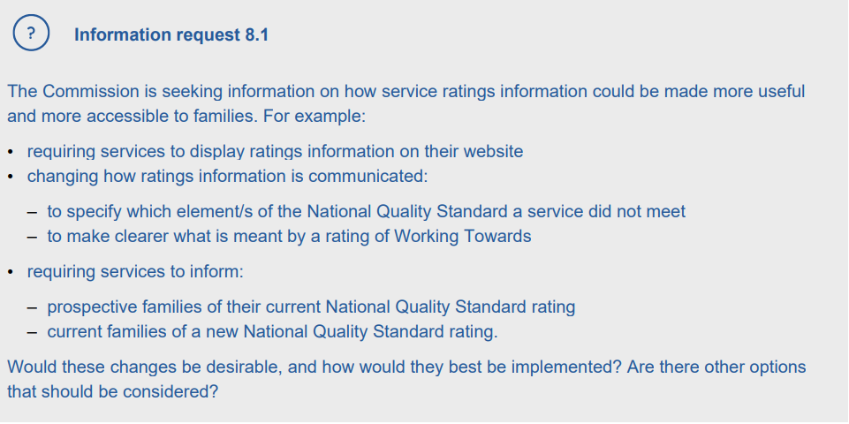
Information request 8.1 of the Productivity Commission’s Draft Report following its Inquiry into Early Childhood Education and Care

Published service ratings aim to inform families about the quality of the service they choose for their children. The ESB supports increased awareness of the NQF as it strengthens the regulatory framework by promoting transparency, accountability, trust, and regulatory compliance. Further information is provided below.
- Transparency and informed decision-making:
  - increased awareness of the NQF and service ratings empowers parents with valuable information to make informed decisions about their child's early education and care. By readily accessing the NQF rating of a service, parents can evaluate its quality, safety, and suitability, to support their decision making process when choosing the best possible care for their child.

- Accountability and quality improvement:
  - public visibility of NQF ratings holds service providers accountable for the quality of care they deliver. When parents are aware of the NQF and service ratings, providers are motivated to maintain high standards and continuously improve their practices to meet or exceed the NQS. This fosters a culture of accountability and quality improvement within the ECEC sector.

- Community engagement and trust:
  - publishing NQF ratings fosters transparency and builds trust within the community. Parents feel reassured knowing that service providers are transparent about their performance and are committed to delivering high-quality care. This increased trust leads to stronger partnerships between parents and service providers, ultimately benefiting the wellbeing and development of children.

- Regulatory compliance:
  - enhanced awareness of the NQF and service ratings encourages service providers to comply with regulatory requirements and serves as an external driver for them to strive for excellence in service delivery. It also serves as a regulatory lever to drive voluntary compliance. The public visibility of ratings serves as a reminder to providers of their obligation to adhere to the NQF and comply with regulatory standards, promoting a culture of compliance and regulatory oversight.

The ESB acknowledges the conclusions outlined in draft finding 8.2 of the Draft Report, which highlights that families often lack awareness of or do not value ratings against the National Quality Standard (NQS) when selecting ECEC services, instead opting to use alternative indicators of quality. The report underscores the necessity for families to have access to more detailed and easily accessible information regarding service ratings.

Furthermore, the ESB notes a similar observation reported by the Australian Children's Education & Care Quality Authority (ACECQA) in its 2023 biennial survey, which aimed to understand the factors influencing families' decisions when selecting an ECEC service, as well as what resources families used in the decision-making process. The 2023 NQF Annual Performance Report states that:
“The fourth wave of our biennial families’ survey found little change in the level of awareness of the quality rating system, suggesting more work needs to be done to communicate the benefits of the NQF and the value of NQS ratings. To this end, we will continue to develop and enhance StartingBlocks.gov.au, our national family-focused website.”

To ACECQA's credit, StartingBlocks.gov.au serves as a vital component of its communication strategy aimed at raising awareness of the NQF and enhancing public understanding regarding the importance of early childhood development.

Through public access platforms such as Facebook, Instagram, and Twitter, as well as digital marketing campaigns, ACECQA actively engages with families and communities, directing attention to the StartingBlocks.gov.au website. Moreover, ACECQA participates in various sector conferences and speaking engagements to promote the NQF, fostering knowledge building and continuous quality improvement across the sector.

However, despite these concerted efforts, there persists a notable stagnation in the level of awareness surrounding the NQS and the NQF amongst families. Consequently, there is a need to explore alternative approaches to advocacy and awareness.

The ESB considers that one potential avenue involves requiring services to self-declare their NQF ratings to both current and prospective parents, by mandating the publication of ratings on ECEC service marketing materials or communication and media channels, including websites. The ESB notes that implementing such measures could pose regulatory challenges, particularly in ensuring compliance and monitoring adherence. There is also a risk that services would express objections to such requirements and view it as administratively burdensome.

Another avenue may be to contemplate alternative means of communicating beyond StartingBlocks.gov.au. This could entail exploring avenues for rebranding or identifying supplementary channels for disseminating information, such as Apps, collaboration with healthcare professionals or partnering with local councils.

Information about what to consider when choosing an early childhood service could also be included in SA’s ‘blue book’ for parents with new babies. This ‘book’ is also used in other jurisdictions.
In conclusion, it is evident that empowering parents with comprehensive information and nurturing a culture of continuous quality improvement are pivotal steps towards enhancing the effectiveness of ECEC services and regulation. However, the crux of the matter lies in determining the most optimal approach to achieve these objectives.

While the ESB has put forward some preliminary ideas, it emphasises the necessity of market research and thoroughly assessing any ideas for their feasibility, efficacy, and cost-effectiveness as a precursor to validating those ideas.

8.2: Regulatory actions against serial underperformers

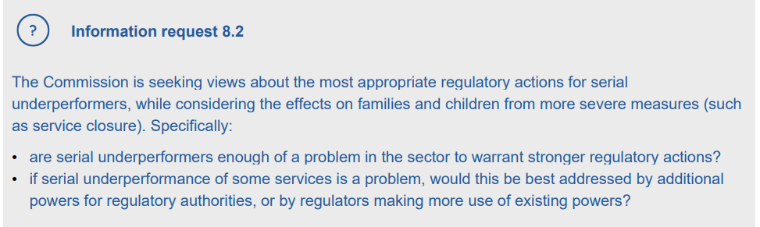
Information request 8.2 of the Productivity Commission’s Draft Report following its Inquiry into Early Childhood Education and Care

What constitutes ‘underperformance’?
In the context of the NQF, defining performance, and by extension, underperformance requires a flexible and individualised approach to quality assessment and compliance.

The contextual nature of underperformance within the ECEC sector is underscored by Section 9 of the South Australian Education and Early Childhood Services (Registration and Standards) Act 2011 (State Act) which provides for proportionality and responsiveness to the specific circumstances of each service provider when responding to non-compliance.

Essentially Section 9 of the State Act grants the ESB discretion and flexibility to assess underperformance on a case-by-case basis with recognition that underperformance can manifest differently across diverse service contexts, and regulatory responses must be tailored accordingly.

So, while the NQF does not include an explicit definition or threshold for what constitutes ‘underperformance’, regulators agree that underperformance occurs when a service provider continually fails to meet the required standards set forth in the NQS and associated regulations. It can manifest in various ways, some of which are listed below:
- Consistent ratings of Working Towards (‘WT’) or below:
  - services that repeatedly receive ‘WT’ ratings may be considered underperforming, indicating a failure to achieve satisfactory outcomes for children's learning and development.

- Non-compliance with regulatory requirements:
  - underperformance may also encompass breaches of regulatory obligations, such as failure to maintain appropriate staff-to-child ratios, adhere to health and safety regulations, or fulfil administrative requirements. This can manifest at the service type, provider, or service level.

- Inadequate response to feedback and improvement efforts:
  - providers that demonstrate a lack of responsiveness or effort in addressing identified areas for improvement, despite receiving support and guidance from regulatory authorities, may be considered underperforming.

Underperformance in South Australia: does it exist?
As depicted below, South Australia currently has 1,245 ECEC approved services with a quality rating. Among these, 16% percent hold a rating of ‘WT’, while the remaining 84% currently hold either a 'Meeting' or 'Exceeding' rating.

Rating | Number Rated Services
Significant Improvement Required | 0 (0%)
Working Towards | 201 (16%)
Meeting | 590 (47.5%)
Exceeding | 454 (36.5%)
Excellent | 0 (0%)
Total | 1,245 (100%)

Regarding the 16% of services rated as 'WT', it's noteworthy that approximately one-third of them have consistently received 'WT' ratings for three consecutive assessments. This represents five percent of services in South Australia, totalling 60 out of 1,245.

An analysis of the data presented in the table below indicates that nearly 80% of the services with three consecutive 'WT' ratings belong to the OSHC category. This subset constitutes four percent of services in South Australia.

Breakdown of Service by Type | Services with 3 consecutive WT ratings
Family Day Care | 1 (2%)
Long Day Care | 11 (18%)
OSHC | 47 (78%)
Pre School/Kindergarten | 1 (2%)
Total | 60 (100%)

In January 2023, through incident monitoring, the ESB identified a worrying trend in the number of incidents being reported of children being missing or unaccounted for in an OSHC setting. The ESB communicated the risk to the relevant providers and provided guidance and direction about adequate supervision.

The ESB also commissioned training in adequate supervision, risk management and the role of the nominated supervisor for 200 OSHC educators that took place in September 2023.

Since then, there has been a significant decrease in the number of incidents relating to children reported as ‘missing or unaccounted for’ in South Australia with the quarterly average dropping from 14 incidents per month in Quarter 3 of 2023, to just 5 per month in Quarter 4.

This case study underscores the necessity for a contextual interpretation of ratings to proportionately and fairly assess the service, provider, and sector performance to determine the appropriate regulatory response that will achieve the desired behavioural change.

While a ‘WT’ rating for a service can result from a single quality area assessed as 'not met’, without indicating any immediate concerns regarding child safety, health, or wellbeing, persistent ‘WT’ ratings across multiple quality areas, spanning multiple reassessments, likely signal service challenges in achieving educational and developmental outcomes for children under the service's care.

Increasing the assessment and rating cycle in South Australia is a key focus for our agency, aligning to Recommendation 7 of the Royal Commission’s Final Report.

In response to this recommendation, the ESB received $7 million over two years to ensure that all childhood education and care services in South Australia can be assessed and rated at least once every three years. This funding increase is of paramount significance to the ESB as it enhances our operational capacity, extends regulatory reach, and enables us to better identify and effectively manage underperformance within the sector.

The Education and Care Services National Law 2010 (National Law) has very strong investigation and evidence gathering powers and these powers are critical in the context of protecting such a vulnerable cohort of our community. The quality of the evidence gathering, and investigative activities are fundamental to successfully exercising regulatory powers in response to serious and systemic non-compliance and must withstand judicial scrutiny. Regulatory authorities need funding that is commensurate with attracting and retaining qualified, specialist compliance and investigations professionals who can exercise such strong powers with appropriate skill and knowledge.

Currently, regulatory authorities are engaged in responding to an unprecedented number of very important and impactful national and state-based reviews to reduce risks of harm to children and improve educational outcomes. The ESB acknowledges regulatory performance evaluation is critical to ensure a regulatory framework remains fit for purpose.

In this context, the ESB fully supports Recommendation 8.3 of the Draft Report, advocating for regulatory authorities to be adequately resourced to achieve these expectations in a timely and effective manner.

How is underperformance measured: do regulators have enough power?
The NQF provides the ESB with a range of specific and targeted regulatory compliance tools and interventions to address underperformance within the ECEC sector. These mechanisms include:
- caution letters, emergency action notices and compliance directions
- enforceable undertakings, prohibition notices and prosecutions
- monitoring practices, such as announced or unannounced visits
- targeted campaigns
- data intelligence
- serious incident self-reporting and
- suspension or cancellation of educators, services, or providers.

In our assessment, the existing regulatory powers at our disposal are robust and comprehensive. We possess a range of tools and interventions, as highlighted above, which enable us to address instances of underperformance swiftly and decisively. These powers are designed to promote accountability among service providers and facilitate ongoing quality enhancement within the ECEC sector.
One area for enhancement is intelligence-led regulatory approaches that make increased use of the data recorded in the National IT system. National consistency in its use, and recordkeeping business rules need to be improved to support this.

By maximizing the use of existing regulatory tools and levers in conjunction with an enhanced proactive, more consistent, data-driven approach, we can more effectively identify, assess, and remediate instances of underperformance, thereby safeguarding the wellbeing and development of children in ECEC settings.

The Regulatory Practice Committee, which comprises all Regulatory Authorities, is working on a Focussed Deterrence Project to improve the effectiveness of regulatory responses to provider-level risk at a system level and achieve greater national consistency in use of high-volume compliance tools.

The project was initiated in response to the increasing number of large, approved providers that operate across multiple jurisdictions, and the growing business model of related providers opening services under multiple provider approvals. Each related provider has overlapping persons with management or control but, with our current systems, the relatedness of providers is not identifiable.

The National Law allows for enforcement action to be taken at the provider approval level but does not envisage a scenario where related providers organise themselves across multiple provider approvals.

Challenges in regulating related providers manifest when, for example, there is consistently poor performance or a pattern of compliance breaches across services that may have a systemic cause. The issue also presents when expansion attempts are made, against the backdrop of poor compliance history across the related providers. The system is also not designed to support risk profiling on related providers to allow compliance performance to be monitored or analysed across multiple related providers.

Creating mechanisms, including examining the need for legislative change, to identify and effectively regulate related providers would significantly bolster our regulatory efforts to address serial underperformance.

8.3: Support for services to meet the NQS

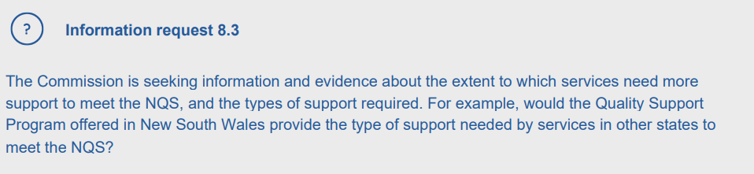
Information request 8.3 of the Productivity Commission’s Draft Report following its Inquiry into Early Childhood Education and Care

It is widely recognised that state and territory regulatory authorities, alongside ACECQA, play a pivotal role in educating and guiding ECEC service providers to uphold the NQS and deliver high-quality care.

The ESB is actively reforming its regulatory approach to deliver risk-based and intelligence-led monitoring and education activities, including the assessment and review process.

Timely and effective monitoring, communication and education programs are essential to support services to voluntarily comply with the NQF.

The ESB is also working closely with the newly established Office for Early Childhood Development (OECD) to implement a recommendation from the Royal Commission to embed a quality support program in South Australia for ECEC services that provide preschool programs and are rated as Working Towards.

The success of programs like the New South Wales Quality Support Program shows there is merit in more tailored support mechanisms in some circumstances.

The ESB notes however, that any support mechanism must be assessed against the affordability and scalability of such initiatives within the local context and must also be tailored to the specific sector needs and challenges of a jurisdiction.

While it is essential for regulators to develop a robust education strategy and allocate sufficient resources to support ECEC services effectively, the ESB is of the view that any quality support program should be funded independent of the regulator to maintain impartiality and avoid potential conflicts of interest.

The ESB also emphasises the need for clear, targeted criteria to participate in a program of this nature, for example, prioritising supporting rural and single service providers.

Furthermore, it is recommended that a mechanism for escalated regulatory response if a service fails to improve after receiving support, thereby ensuring accountability, and maintaining and improving quality in the ECEC sector.

9.2: An Early Childhood Education and Care Commission

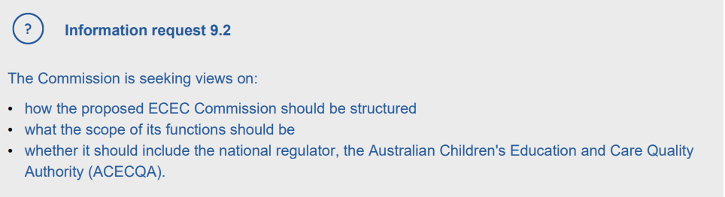
Information request 9.2 of the Productivity Commission’s Draft Report following its Inquiry into Early Childhood Education and Care

The ESB supports the concept of a national system stewardship approach. Recognising its potential benefits, the ESB acknowledges a system steward could centralise oversight, enhance collaboration, streamline processes, improve policy coordination and implementation, and foster continuous improvement and innovation within the sector from a national perspective.

However, the ESB emphasises the need for careful planning, coordination, and systematic consideration of challenges including potential duplication or overlap of functions at the jurisdictional level. For example, South Australia has recently established the South Australian Office for Early Childhood Development (OECD) as the jurisdictional system steward.

Formed earlier this year following the recommendations of Royal Commission, the OECD assumes the role of steward for the early childhood development system in SA. Its primary function is to coordinate the implementation of the Royal Commission's recommendations, thereby ensuring effective governance and oversight within the sector.

On the question of whether to include ACECQA in the proposed ECEC Commission, the ESB is of the view that any decision should be based on a thorough assessment of the potential benefits and risks. Stakeholder consultation, rigorous analysis of governance structures, budgetary and resourcing requirements, and consideration of the impact on regulatory effectiveness and sector accountability should inform the decision-making process.

The ESB underscores the importance of maintaining regulatory independence, regardless of the structure adopted.

Risks and challenges associated with ACECQA being absorbed into the proposed new body may include:

- Loss of autonomy:
  - may diminish ACECQA’s autonomy and independence, potentially compromising its ability to fulfil its regulatory functions impartially.

- Complexity of integration:
  - the process of merging ACECQA into a new body would require careful planning, resource allocation, and organisational restructuring, which could be challenging and resource intensive.

- Potential conflicts of interest:
  - combining regulatory and policy functions within the same body could create conflicts of interest in decision-making processes, particularly if regulatory priorities conflict with broader sector objectives.

The Role of the Education Standards Board

The Early Childhood Services (Registration and Standards) Board of South Australia, otherwise known as the ESB, was established on 1 January 2012 under section 21 of the South Australian Education and Early Childhood Services (Registration and Standards) Act 2011 (State Act).

The ESB is an independent statutory authority responsible for the registration and regulation of early childhood services and registration of schools for domestic and overseas students in South Australia.

This work is carried out to ensure high-quality education services and high standards of competence and conduct by providers.

The ESB’s priority is to minimise any risks to the safety, health, and wellbeing of children.

Under the State Act, the Chief Executive of the ESB is the ‘Early Childhood Services Registrar’.

Under the National Law, the ESB’s functions as the Regulatory Authority in South Australia are:
  - to administer the NQF
  - to assess approved education and care services against the NQS and the national regulations and determine the ratings of those services
  - to monitor and enforce compliance with the National Law
  - to receive and investigate complaints arising under the National Law
  - in conjunction with the National Authority and the relevant Commonwealth Department, to educate and inform education and care services and the community in relation to the NQF
  - to work in collaboration with the National Authority to support and promote continuous quality improvements in education and care services
  - to undertake information collection, review, and reporting for the purposes of:
      - the regulation of education and care services
      - reporting on the administration of the NQF
      - the sharing of information under the National Law; and
  - any other functions conferred on the Regulatory Authority under National Law.

References

- Productivity Commission Inquiry into Early Childhood Education and Care, Draft Report, November 2023
Full draft report - A path to universal early childhood education and care (pc.gov.au)

- SA Royal Commission into Early Childhood Care and Education in South Australia, Final Report, August 2023
Royal Commission into Early Childhood Care and Education in South Australia

- The Australian Children’s Education and Care Quality Authority
ACECQA

- The Australian Children’s Education and Care Quality Authority, National Quality Framework Annual Performance Report, November 2023
2023-NQF-Annual-Performance-Report-FINAL_0.pdf (acecqa.gov.au)

- The 2019 National Quality Framework Review, Issues Paper, April 2019
NQF_Review_Issues_Paper.pdf (acecqa.gov.au)

- The 2019 National Quality Framework Review, Decision Regulation Impact Statement
Explore the DRIS | National Quality Framework Review (nqfreview.com.au)

- The Education Standards Board
Homepage | Education Standards Board SA (esb.sa.gov.au)

- The South Australian Office of Early Childhood Development
Early Childhood Education and Care - OECD

Productivity Commission, Draft report, A path to universal early childhood education and care, November 2023, page 146
National Quality Framework Review, 2019
Royal Commission into Early Childhood Care and Education in South Australia, August 2023
National Quality Framework Review, Decision Regulation Impact Statement, 2019 , page 43
Royal Commission into Early Childhood Care and Education in South Australia, August 2023, page 26
ACECQA website
Productivity Commission, Draft report, A path to universal early childhood education and care, November 2023, page 475
Productivity Commission, Draft report, A path to universal early childhood education and care, November 2023, page 83
ACECQA, National Quality Framework Annual Performance Report, November 2023, page 3
Productivity Commission’s Draft Report on Early Childhood Education and Care, November 2023, page 478
Royal Commission into Early Childhood Care and Education in South Australia, August 2023, page 9
Department of Premier and Cabinet, South Australia, Media Release “State Government acts immediately on nation-leading Royal Commission report, 27 August 2023
Productivity Commission’s Draft Report on Early Childhood Education and Care, November 2023, Page 479
Royal Commission into Early Childhood Care and Education in South Australia, August 2023, page 23
NSW Department of Education and ACECQA, Quality Support Program, Dual Pathways Program, End of Stage Five Progress Report, November 2023, page 6
Productivity Commission’s Draft Report on Early Childhood Education and Care, November 2023, page 517
Royal Commission into Early Childhood Care and Education in South Australia, August 2023, page 5
Section 21(2), State Act.
Sections 3(1) and 27(1), State Act.
The National Authority under the National Law is the Australian Children’s Education and Care Quality Authority (ACECQA) established under sections 224 and 230 of the National Law.

