Submission to the Australian Productivity Commission's Report “Copy (Not) Right”

I'm an illustrator credited with nearly forty titles of children's books and graphic novels. The changes to Australia's copyright laws and restrictions of parallel importation as outlined in the Productivity Commission's draft report would have a grave effect on Australian publishing and the already tenuous ability I and others have to make a living from our craft.

When reading the responses to this report one is struck by the solidarity and a deep sense of déjà vu. There is a unity of opposition to these proposals and we've all stated them before. Every author and illustrator may as well copy and paste their responses from the 2009 inquiry's similarly ill-conceived proposals. Removing parallel importation was, and remains, a bad idea with unproven, or at best short-term, benefits to readers and proven examples of harm to local publishing and its ancillary industries (Canada and New Zealand are often cited as examples.)

Coupled with the proposed implementation of “Fair Use” and reducing the longevity of copyright to hardly more then the life of a house-pet, the economic viability of the art and industry of book publishing in Australia, not to mention a number of other creative endeavours, becomes highly doubtful.

In an environment where the output of Australian creativity is neither respected or defended, there's likely to be little productivity.

-Greg Holfeld
Adelaide, South Australia

Submission to the Australian Productivity Commission's Report “Copy (Not) Right”

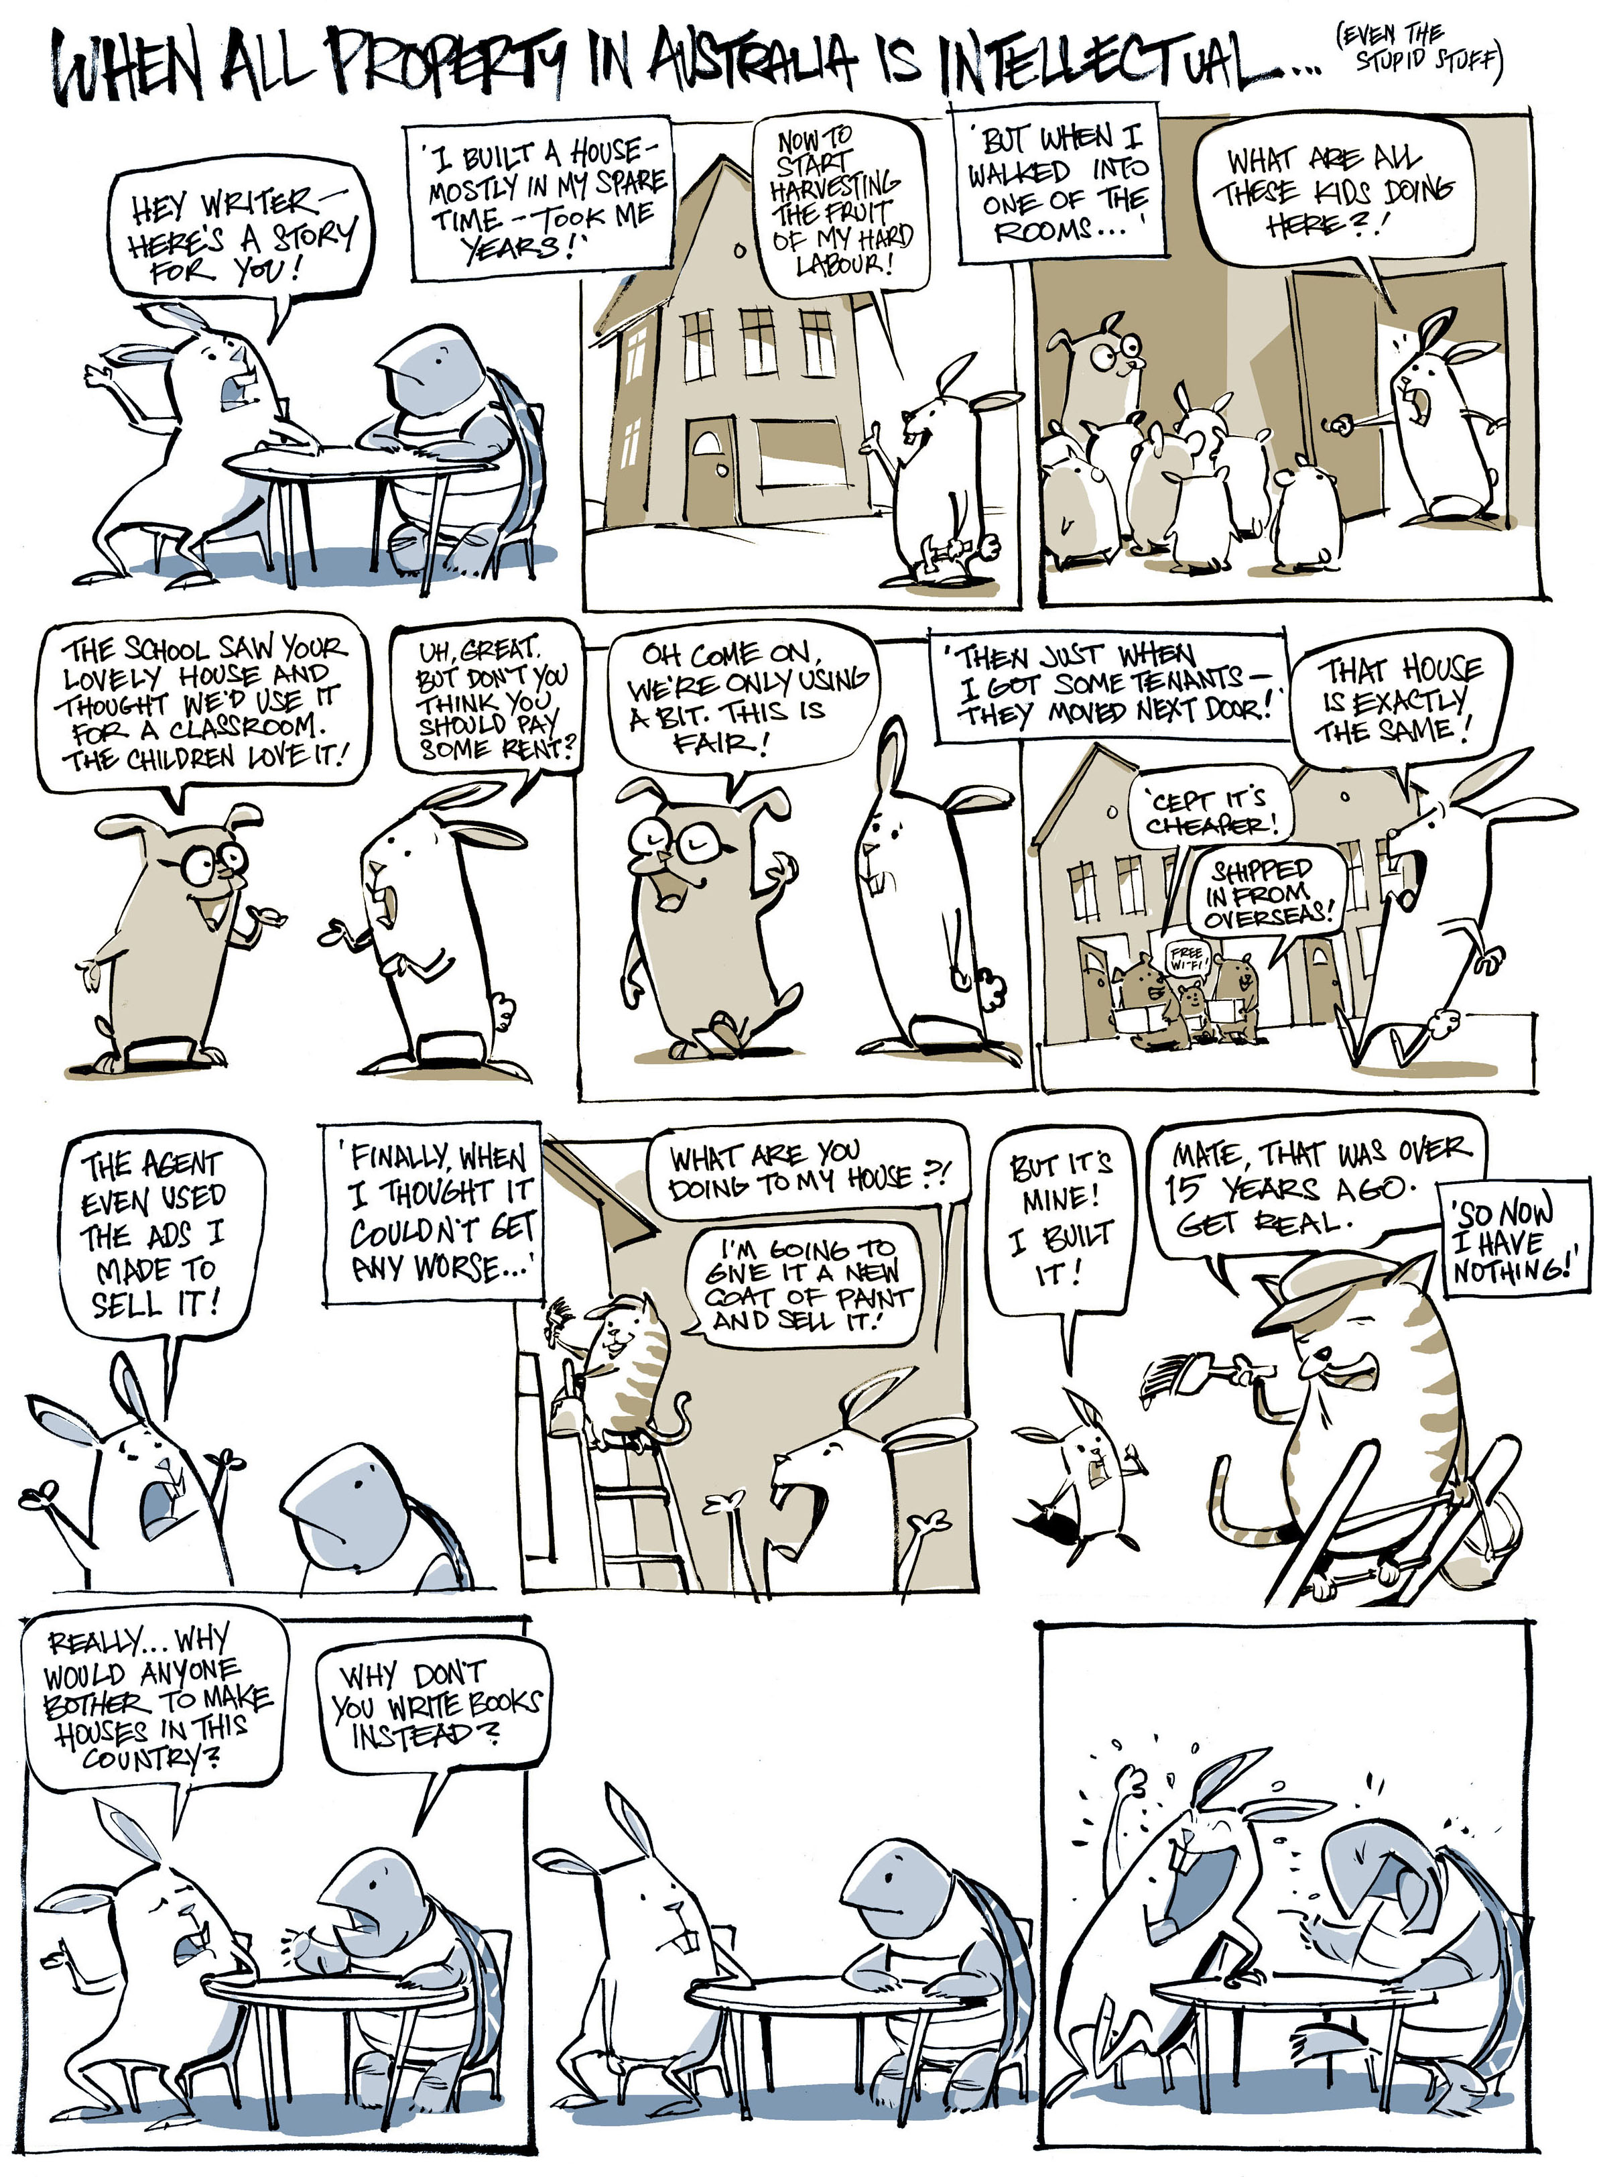
- Greg Holfeld

