University of Melbourne
University of Melbourne
Submission 83 - University of Melbourne - National Water Reform - Public inquiry

National Water Reform: Issues Paper

Key recommendation
The key recommendation of this submission is that the cost of maintaining reliability in a water supply system needs to be made explicit for Australia’s urban centres. Doing so will help ensure the community desires, and is willing to pay for, existing reliability standards. It also makes it possible to operate a portfolio of water supply sources, such as ones comprising traditional rain fed gravity storages and desalination plants. It is important to quantify the costs associated with maintaining a level of reliability before introducing greater use of price to ration water supply as, otherwise, it will encourage shifting the costs of risk to public purse.

Introduction
The Productivity Commission’s Issues paper (2017) identified the important role that economic reforms have played in improving the economic efficiency with which the water supply sector operates. It reiterated that Australia’s gross domestic product was raised by 0.35 per cent due to improved efficiency in urban water services (Commission 2005) and, if these gains were continued, Australia’s economy would be $5 billion larger. This submission would argue that, without appropriate changes to the regulatory framework governing urban water supplies, increasing the use of price to ration water will exacerbate structural resource allocation issues for the sector. The result would be reforms designed to improve efficiencies would result in increased risks of reservoir failure, and associated costs, being transferred to the public.
The Issues Paper raised a range of issues for consideration. Of those issues, this submission will address:
- What policy and institutional arrangements are needed in the urban water sector to improve the efficiency of service provision?
- What approach should be taken to price regulation in the urban water sector? Is there a need for greater consistency in price setting approaches across different jurisdictions? Do current pricing practices promote investor confidence?
- How can the level of competition in the provision of urban water services be increased?
- How can demand management approaches such as water restrictions and water-use efficiency measures best contribute to the efficiency of urban water services?
At their heart, economic criticism of existing urban water supply system operations is that they do not appreciate the responsiveness of demand to price and its effectiveness as a means of rationing available water. However, the failure of economic remedies is in not adequately addressing the hydrological risk to which urban water supplies are subject.
Economists have a long history of encouraging the use of marginal pricing to ration water stocks. However, the urban water sector prefers to the rely on quantity controls, imposing homogenous restrictions in times of anticipated shortfalls in supply. Rather than price to ration water availability they tend to use inclining block tariffs to signal scarcity. (Hewitt 2000) observes that ‘‘utilities are more likely to voluntarily adopt . . . [IBT] if they are located in climates characterized by some combination of hot, dry, sunny, and lengthy growing season,’’ such as in Europe’s Mediterranean countries of Portugal, Spain, Italy, Greece, and Turkey. (Monteiro and Roseta‐Palma 2011) find that IBTs may reflect consumer preferences reflecting the fact that IBTs are concentrated in jurisdictions with hotter and drier climates. This finding is confirmed by several recent Organisation for Economic Co-operation and Development (OECD) publications (OECD 2003, OECD 2006, OECD 2009).This may explain why IBTs are a feature of mainland Australia but are not used in Tasmania.
The Productivity Commission’s review of the urban water sector (Productivity Commission 2011), along with other economists (Grafton 2008, ), estimated that water restrictions costs about $150 above the cost of achieving the same level of water use with higher water charges and undermine the capacity of urban water utilities to investment efficiently.
However, this submission argues that the way water scarcity has been defined has misrepresented and oversimplified hydrological risk. Consequentially, economic reform has the potential for being a cure worse than the disease unless it successfully incorporates the uncertainty that underpins the urban water supply sector. The focus of economic reform should be on quantifying the costs associated with Australia’s urban water sectors regulatory framework. In particular, ensuring that it incorporates the costs associated with catastrophic reservoir failure, and defining the opportunity cost of water in storage given the existence of climate independent water supply sources.

Key points
This submission makes a number of key points relating to the questions raised by the Issues Paper. They are:
- Water supply systems are regulated based on a socially acceptable level of risk;
- The socially acceptable level of risk is met by a combination of infrastructure and water available;
- Not incorporating the risks associated with reservoir failure within the regulatory framework results in this risk being socialised. It also results in inevitable political interference when the risk of failure rises to unacceptable levels, as happened during the Millennial drought;
- Economic reforms that do not quantify and adequately reflect the hydrological risks to which a water supply system is subject will worsen resource allocation decisions of reservoir operators;
- Introducing greater competition into the urban water supply sector, without quantifying the costs associated with reservoir failure, will result in risk shifting to the public; and
- The cost of maintaining reliability can be quantified and used as the basis for operation decisions and future augmentations.
  - It would also serve the basis for comparing alternative water supply sources, such as rainwater tanks of stormwater harvesting, on a comparable basis.
  - It could serve to encourage greater competition in the urban water supply sector as alternative means on the basis of how they reduce the overall costs of maintaining a socially desired level of reliability.
  - It would also allow for more considered consideration of the what a socially appropriate level of risk should be.

Scarcity pricing
Economics suggests that the marginal cost of water for use today should represent the full cost of water, a price which includes the cost of operations, capital replacement, augmentation and the opportunity cost of storing water for use in the future (Zetland and Gasson 2013). By ignoring all of the opportunity costs of a resource, it is undervalued and consequentially overused. (Hotelling 1931) was the first to suggest the application of marginal pricing to ration available water. However, the application of marginal cost pricing was first examined by (Dupuit 1844) and elaborated on by (Coase 1946), while the treatment of capacity constraints and peak load pricing was examined by (Boiteux 1960). The key challenges for marginal cost pricing in the water sector relate to the seasonal and stochastic variability of the hydrological resource and that the good it delivers to urban consumers is essential for the quality of their life (Monteiro and Roseta‐Palma 2011). This creates unique challenges associated with defining capacity constraints.
According to (Mann 1980), if capacity is less than fully utilised, the costs attributable to additional usage are additional operating costs, or short-run marginal costs. Long run marginal costs refer to the sum of short run marginal costs and the capital costs of a marginal expansion of capacity, the latter being defined as the cost of extending capacity to accommodate an additional unit of consumption. Long run marginal cost (LRMC) calculations implicitly are based on long term hydrological expectations and demand, see (Griffin 2002), (Turvey 1976 ) or (Saunders 1976) for examples. As (Grafton, Chu et al. 2014) observes, there is no optimal investment as it depends on current conditions.
The water industry regulators prefer pricing with reference to LRMC since water and wastewater sectors are generally highly capital intensive and characterised by 'lumpy' investment in new capacity (NERA 2012). At any one time, most water and/or wastewater systems operate with some spare capacity such that the system is capable of serving additional demand at relatively low or zero cost. Given this, marginal costs are generally measured on the basis of the change in the per unit costs of supply associated with permanent step changes in forecast demand that require some level of additional capital investment.
Numerous economists have criticised this approach and recommended a more responsive use of pricing to ration available water resources (see (Ng, 1987 #76), (Grafton, Chu et al. 2014), (Griffin 2002), (Productivity Commission 2011)). However, reflecting the early tendency to expand water supply networks in the face of constraints during the ‘age of expansion’, which was defined by (Randall 1981) as lasting until the 1970s, the issue of scarcity pricing has been less explored in the literature. The majority of academic work examining scarcity pricing in the water supply sector has focused on capacity expansion and associated optimal investment strategies. This is despite the fact that developed countries can store between 70 and 90 per cent of their renewable surface water, and remaining potential dams are generally either not economically viable and/or socially acceptable (UN 2011).
Deterministic models have focused on the relationship between long term expectations and capacity expansion (Ng 1987) (Griffin 2002), (Elnaboulsi 2001) and have not explicitly incorporated the costs of failure in their pricing models. For instance, Ng implicitly assumes the long run average water supply can be rationed via price despite it following a stochastic process and reservoirs having limited storage capacity. In addition, deterministic models, such as those of (Griffin 2002) or (Elnaboulsi 2001) fail to value reserve capacity (Zhao and Zhao 2014) as they implicitly assume all available water is allocated.
Stochastic models have addressed reservoir failure either through loss functions (Hughes, Hafi et al. 2009), (Productivity Commission 2011) or through the use of backstop technologies (Grafton, Chu et al. 2014, Grafton, Chu et al. 2015). A loss function, if appropriately sized with regards to demand, can generate a level of reliability for a given hydrological expectation. However, it misrepresents the resources required to generate this reliability explicitly and so cannot adequately resolve the trade-offs between reserving water in storage or augmenting the water supply system to avoid reservoir failure. The alternative approach, of a backstop technology, when applied with zero time for deployment is effectively the same as a loss function. Both options fundamentally misrepresent the trade-offs confronting a reservoir operator.
It is critically important to adequately represent the risk confronting a water supply system as the variability of hydrological systems that exhibit cyclical behaviour that can stretch from short term to multi-decade (Hurst 1951). For instance, in south-east Australia rainfall is influenced by uncertain climate patterns that can range from five to seven years, in the case of the El Nino influence, and the multi decade Pacific Oscillation which can last for 20 or 30 years (Kiem and Franks 2004). In addition to the stochasticity of hydrological inflows, it is difficult to define periods of shortfall. Drought is a “creeping phenomenon” (Gillette 1950.), making an accurate prediction of either its onset or end a difficult and contested task. Current measures of short run marginal cost do not “ration the resource” as there are considerable uncertainties about the resource that requires rationing. According to (Tannehill 1971), “The first rainless day in a spell of fine weather contributes as much to the drought as the last, but no one knows how serious it will be until the last dry day is gone and the rains have come again . . . we are not sure about it until the crops have withered and died.”

The hydrological risk
Regulators typically use long term expectations of reliability to inform the design criteria, or service level obligations, that are established from stead state analysis of system performance. These service level obligations are broadly similar to the safety criteria used in structural engineering in that they reflect minimum service levels that the infrastructure is expected to deliver. For example, the service level obligations for three major urban centres in Australia are (Department of energy and water supply 2013):
- Melbourne: 95 per cent reliability of supply with no longer than 12 consecutive months of water restrictions that are no more severe than stage three;
- Canberra: restrictions should not occur more than one year in 20, with a severe water restrictions target of 150 litres per person per day (which is about a 45 per cent reduction in summer water demand); and
- Sydney: reliability comprises security (defined as water storage not falling below 5 per cent of water storage capacity more often than 0.001% of the time), robustness (restrictions occur no more than once every 10 years on average) and reliability (restrictions have limited duration) measures.
It should be noted that these definitions of risk fail to explicitly account for reservoir failure. Consequentially, they disenfranchise water utilities from taking actions to address these risks. The result is that, when these water supply systems are stressed, decisions about operating and augmenting the water supply system become highly political. In addition, failing to quantify the cost of reservoir failure would mean that any reforms aimed at using price to ration water would encourage risk shifting towards the public.
The most commonly used modern method of establishing a reservoir’s reliability is behaviour analysis (McMahon and Mein 1986). This approach determines the minimum reservoir storage capacity required for delivery of a specified yield with a given reliability. The storage is determined by trial and error. While generally accurate, it requires streamflow sequences of at least 1,000 years to provide a stable steady state solution (Pretto, Chiew et al. 1997).
Economic reforms aimed at improving the way in which the urban water supply sector uses water resources, and invests in future water supply source, implicitly and explicitly relate to the reliability of supply. Unless the costs associated with this reserve capacity are quantified and related to its risks, then attempts to improve the economic efficiency of reservoir operation are likely to increase the risk of failure. This is because these risks are socialised and can be transferred to the public purse.
(Hu, Zhang et al. 2016) noted that drought is difficult to predict, let alone forecast with confidence. As such, when the risk of failure has not been privatised, it can be difficult to use price to ration the available water.
With climatic variability, even highly reliable reservoirs, with significant “excess” storage capacity, can require augmentations during periods of prolonged low inflow. During the unprecedented Millennium Drought in southeast Australia (2001-2009) the water supply system supplying the city of Melbourne experienced severe stress. In 2007 an assessment of the reserve capacity of the water supply system suggesting the city required 240 gigalitres in augmentations by 2012, including the construction of a 150 gigalitre desalination plant. However, pervious assessments in 2004 and 2005 suggested that no significant infrastructure investment would be required until 2025 at the earliest, even incorporating the influence of climate change.

Potential remedy
The capacity to source water from climate independent sources in time frames significantly shorter than the system memory essentially acts as an upper bound on social losses associated with reservoir failure. It allows for the use of a risk management strategy based on augmentation with a climate independent water supply source. To inform such a strategy it is necessary to quantify the costs associated with maintaining a given reliability level. In addition, these climate independent sources, such as recycling or desalination plants, have distinctly higher operating costs than the traditional gravity fed reservoirs. This creates an opportunity cost associated with water in storage – the capacity to avoid accessing an existing climate independent water supply source or to pre-emptively or unnecessarily augment a water supply system.
Since a water supply source, such as a desalination plant, can be built with a defined number of years and to a fixed reliable quantity, the cost of maintaining a given level of reliabiltiy can be quantified. This means that long term performance metrics used to regulate urban water supplies can be costed. The technical paper, presented at the OzWater 2017 conference, on The cost of reliability set out a methodology to do this (Taylor 2017).
Consider the following conceptual two-period model where a reservoir operate is required to maxmise total utility while maintaining a minimum level of water delivery, and with a range of augmention options $\left(S_{i}^{a}\right)$ available to ensure that this minimum can be met. This situation can be described as:
$\max{U}={TB}_{1}+{TB}_{2}-{Cost}_{i}\left(S_{i}^{a}\right)$ Equation 1
$s.t.$
${TB}_{j}=f_{j}(Q_{j})$ Equation 2
$Q_{1}+Q_{2}=S+S_{i}^{a}$ Equation 3
$Q_{j}≥D^{m}$ Equation 4

Where U is utility, and ${TB}_{j}$ is the total benefits of water released in period j. Costs i are the costs associated with augmentation i and there are 1, 2,…n possible augmentations that can be commissioned in the first period and be ready for use in the second period to produce quantity $S_{i}^{a}$, and $D^{m}$ is the minimum level of demand that must be met. It should be noted that this model allocates available water between demand in period one and period two. As such, the derived decision rules and outcomes will be functions of the predetermined initial stock, inflows and required final stock.
The Lagrangian for this program is:
$$L\left(Q_{1}, Q_{2},S_{i}^{a},n,λ_{1},λ_{2}\right)=-f_{1}\left(Q_{1}\right)-f_{2}\left(Q_{2}\right)+cost(S_{i}^{a})-n\left(Q_{1}+Q_{2}-S-S_{i}^{a}\right)+λ_{1}^{ }(D^{m}-Q_{1})+λ_{2}^{ }(D^{m}-Q_{2})$$
Applying the Karush–Kuhn–Tucker conditions under two scenarios shows that optimality is achieved when:

- Scenario 1: Plentiful water

$n^{*}=\frac{∂f\left(Q_{1}\right)}{∂Q_{1}}=\frac{∂f\left(Q_{2}\right)}{∂Q_{2}}$ Equation 5
This suggests that total benefits are optimised when marginal benefits today are equivalent to marginal benefits tomorrow when constraint (4) is not binding.

- Scenario 2: Scarce water in period II

$n^{*}=\frac{∂f\left(Q_{1}\right)}{∂Q_{1}}=\frac{∂cost(S_{i}^{a})}{∂S_{i}^{a}}$ Equation 6

Which suggests optimality is achieved when water is scarce in period two by charging the marginal cost of the augmentation in period 1. If a desalination plant has already been built, than the marginal cost of the agumentation operating cost; if plant to be built, then the marginal cost is the operating cost plus annual fixed cost for depreciation and interest.
It should also be noted that manufactured water supply sources require a lead time to develop. As a consequence, it is necessary to evaluate the decision over two periods of a length associated with the construction time. For instance, a desalination plant may take four years to plan and construct, or approximately two years to construct it if planning has already been complete. This augmentation timeframe establishes the length of the two periods and is a critical factor in establishing the cost of reliability for a water supply system.
The program presented set out a deterministic way for attributing the cost of reliability. An alternative method, more applicable to real world scenarios, is to quantify the cost of reliability regulations via simulation.
The conference paper by Taylor, et al, 2017 takes the deterministic based reliability constraint, from Equation 4, and converts it to a probabilistic one reflecting a stylised service level obligation equivalent to those in place for Australia’s mainland urban water authorities. The methodology is demonstrated through an application to a single reservoir system that can be augmented with a desalination plant of scalable but unknown size. This system is sized to be a reasonable representation of a major metropolitan water supply and we use an aggregation of the inflows to the four main reservoirs constituting the urban water supply of Melbourne: the Thomson, Upper Yarra, O’Shannassy and Maroondah reservoirs. Data were available to form a single 97-year (1913-2010) reconstructed streamflow data series. An annual lag one autoregressive AR(1) model with parameter uncertainty was fitted using the Stochastic Climate Library (Srikanthan 2007) and 200,000 synthetic 50 year hydrological realisations were produced.
This water supply system examined the probability of failure at a range of initial storage increments. This is described in Figure 1.
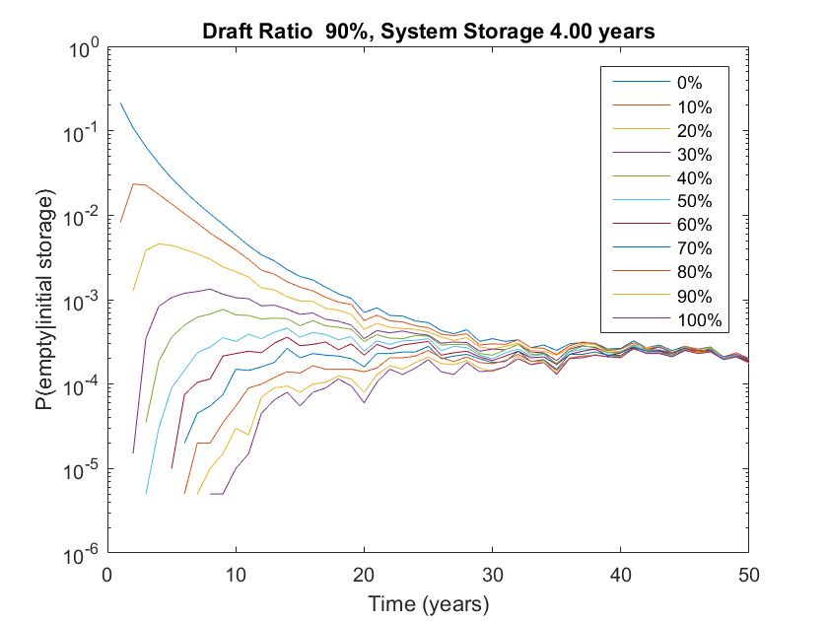
Figure 1: Probability of failure for each initial storage increment
To identify the level of storage at which the constraint of Equation 4 violated the reliability requirements of the service level obligations requires defining the timeframe in which an augmentation can take place. Based on an assumed two-year lead time, the cost of maintaining the reliability standards can be shown in Figure 2.
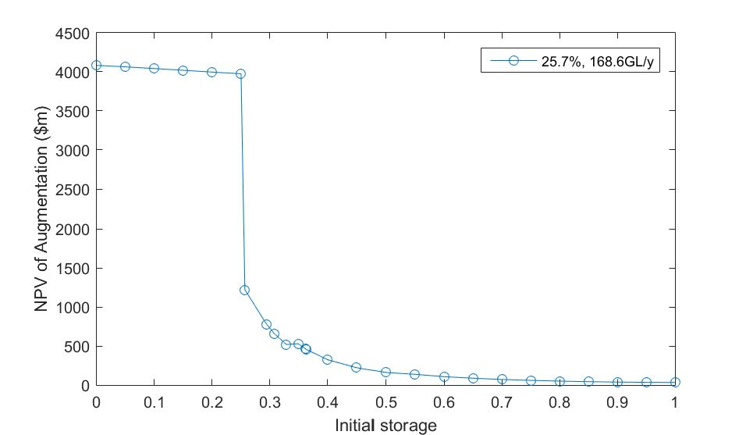
Figure 2: The cost of maintaining a reliability standard
The paper made a range of simplifying assumptions and then subjected a number of them to a stress test. It did so by examining the consequences of changing:
- The amount of water deemed necessary for life;
- The acceptable probability of failure; and
- The augmentation timeframe.
The result was very significant differences in the costs of maintaining reliability.
It should be noted that the cost of maintaining a given level of reliability is not currently incorporated in the regulatory frameworks governing urban water supply systems. While these regulations discuss concepts such as reliability and security, they do not posit a means of quantifying them. Nor do they describe how actions by urban water providers influence these regulatory costs.

Conclusion
The storage-yield-performance relationship described by hydrologists attempts to quantify the relationship between an uncertain naturally occurring hydrological resource and the yield produced by reservoirs. Economic reforms to the urban water sector have to be based on the long-term performance metrics of hydrologists to adequately reflect the risks to the water supply system.
The University of Melbourne is undertaking a project, The economic value of water in storage, sponsored by the Department of Land, Water and Planning, Melbourne Water, Yarra Valley Water, City West Water, and South East Water. The project team of Nathan Taylor, Professor Andrew Western, Professor John Langford, and Dr Mohammad Azmi is applying a modified approach to that presented in this report to quantify the costs of maintaining reliability for Melbourne’s water supply system. The project will examine how the existing regulatory structure creates a cost associated with maintaining reliability and then how this changes as operational decisions are altered. This represents a significant step towards quantifying the hydrological risk of a water supply system in an economic context that enables alternative policy choices to be examined.
Quantifying the costs associated with maintaining a standard of reliability is the first step in evaluating alternative water supply sources. This is because it establishes a consistent hydrological basis for comparing highly diverse water supply sources. It is also the basis for determining how to evaluate a portfolio of options.

Bibliography
Boiteux, M. (1960). "Peak-load Pricing." Journal of Business 33: 157–179.
Coase, R. H. (1946). "The marginal cost controversy." Economica 13 (51): 169–182.
Commission, P. (2005). "Review of National Competition Policy reforms."
Department of energy and water supply (2013). Water security for South East Queensland - discussion paper on the review of the level of service objectives. Q. Government. Brisbane, Department of energy and water supply.
Dupuit, J. (1844). "De la mesure de l’utilité des travaux publics." Annales des Ponts et Chaussées Memoirs et Documents: 332–375.
Elnaboulsi, J. C. (2001). "Nonlinear pricing and capacity planning for water and wastewater services." Water Resources Management 15(1): 55-69.
Gillette, H. P. (1950.). " A creeping drought under way. ." Water and Sewage Works,: p. 104-105, .
Grafton, R. Q., L. Chu and T. Kompas (2015). "Optimal water tariffs and supply augmentation for cost-of-service regulated water utilities." Utilities Policy 34: 54-62.
Grafton, R. Q., L. Chu, T. Kompas and M. Ward (2014). "Volumetric water pricing, social surplus and supply augmentation." Water Resources and Economics 6: 74-87.
Grafton, R. Q. a. W., M. B. (2008, ). "‘Prices versus rationing: Marshallian surplus and mandatory water restrictions’." Economic Record Vol. 84(Special Issue ): pp. S57–65.
Griffin, R. C. (2002). "EFFECTIVE WATER PRICING ' undertake conservation where more valuable ties , and any peripheral properties not currently." October 37: 1335-1347.
Hewitt, J. A. (2000). An investigation into the reasons why water utilities choose particular residential rate structures. The Political Economy of Water Pricing Reforms. A. Dinar. New York., Oxford Univ. Press,: 259–277.
Hotelling, H. (1931). "The economics of exhaustible resources." Journal. Polit. Econ. 39(2): 137–175.
Hu, T., X.-Z. Zhang, X. Zeng and J. Wang (2016). "A Two-Step Approach for Analytical Optimal Hedging with Two Triggers." Water 8(2): 52.
Hughes, N., A. Hafi and T. Goesch (2009). "Urban water management: optimal price and investment policy under climate variability." Australian Journal of Agricultural and Resource Economics 53(2): 175-192.
Hurst, H. E. (1951). "Long-term storage capacity of reservoirs. ." Transactions of the American Society of Civil Engineers, Volume 116,: Pages 770--799.
Kiem, A. S. and S. W. Franks (2004). "Multi-decadal variability of drought risk, eastern Australia." Hydrological Processes 18(11): 2039-2050.
Mann, P. C., Robert J. Saunders, and Jeremy J. Warford (1980). "A Note on Capital Indivisibility and the Definition of Marginal Cost." Water Resources Research 16: 602-604.
McMahon, T. A. and R. G. Mein (1986). River and reservoir yield, Water Resources Publications Fort Collins, CO.
Monteiro, H. and C. Roseta‐Palma (2011). "Pricing for scarcity? An efficiency analysis of increasing block tariffs." Water Resources Research 47(6).
NERA, E. C. (2012). An Economic Framework for Estimating Long Run Marginal Costs in the Victorian Water Industry. S. W. Fund. Sydney.
Ng, Y.-K. (1987). "Equity, Efficiency and Financial Viability: Public-Utility Pricing with Special Reference to Water Supply." Australian Economic Review 20(3): 21-35.
OECD, O. f. E. C.-o. a. D. (2003). Social Issues in the Provision and Pricing of Water Services. Paris.
OECD, O. f. E. C.-o. a. D. (2006). Water: The Experience in OECD Countries Environmental Performance Reviews. Paris.
OECD, O. f. E. C.-o. a. D. (2009). Managing Water for All: An OECD Perspective on Pricing and Financing. Paris.
Pretto, P. B., F. H. S. Chiew, T. A. McMahon, R. M. Vogel and J. R. Stedinger (1997). "The (mis)behavior of behavior analysis storage estimates." Water Resources Research 33(4): 703-709.
Productivity Commission (2011). "Australia’s urban water sector." Inquiry report(55).
Randall, A. (1981). "Property Entitlements and Pricing Policies for a Maturing
Water Economy." Aust. J. Agric. Econ. 25: 195–212.
Saunders, R. J., and J. J. Warford (1976). Village Water Supply: Economics and Policy in the Developing World. Baltimore, Md., Johns Hopkins University Press.
Srikanthan, S., Chiew, F., and Frost, A., (2007). Stochastic Climate Library toolkit, Stochastic Climate Library.
Tannehill, I. R. (1971). Drought: Its Causes and Effects.
Taylor, N. M., Western, A., Langford, K.J. and Freebairn, J. (2017). The cost of reliability. OzWater 2017. Sydney.
Turvey, R. (1976 ). "Analyzing the Marginal Cost of Water Supply " Land Economics 52: 158-168.
UN, T. F. a. A. O. o. t. U. N. (2011). THE STATE OF THE WORLD’S LAND AND WATER RESOURCES FOR FOOD AND AGRICULTURE: Managing systems at risk. 2 Park Sq. Milton Park, Abingdon, Earthscan.
Zetland, D. and C. Gasson (2013). "A global survey of urban water tariffs: are they sustainable, efficient and fair?" International Journal of Water Resources Development 29(3): 327-342.
Zhao, T. and J. Zhao (2014). "Optimizing operation of water supply reservoir: The role of constraints." Mathematical Problems in Engineering 2014.

