Murray Darling Basin Plan
Inquiry: Five-year assessment
Submission

Accounting of water
I believe that the accounting for water in the system is simply not through enough and with current technology it is possible to establish a central data base that can monitor the volume of water in the basin on a live basis.

All water should be accounted for that is present between the ridge lines of each valley.

That water should include all flows including, overland flows, subsurface flows as well as main channel flows, as in the end they are all interconnected.

I therefore believe that;
- A central data base be established for all AUSTRALIAN rivers. (It would not be hard to set up a code to identify where the water originates and where it is extracted)
  - That data base record
    - All flows in those rivers
    - All extractions
    - All licences
    - Have trading facilities so that registered persons/entities are able to trade licences electronically (like share trading)
  - All streams should have monitors at regular intervals
  - All pumps should have meters and those meters should be at source of extraction; i.e. on the river.
  - All sensors should take readings at 15-minute intervals
  - All readings should be transmitted to the central data base.
  - All interested parties to have access to all offers to buy and sell.
- The data base to be monitored for;
  - Actual Readings (when a reading is not received on time an immediate notice (electronically) be sent to the extractor and the local authority demanding that the problem be fixed immediately.
- Local water authorities e.g. Lower Murray Water.
  - Not be involved in recording,
  - Their customers to be connected direct to central data base.
  - Water authorities to have access to data for their districts.
  - Water authorities and extractor to be advised (electronically) when an irrigator exceeds their licence volume.

Inflows into the Murray-Graphs showing moving averages

The data used was supplied by MDBA, these graphs show a serious shortfall in recent years which should give people plenty of worry about the future and the ability of the river to provide all the water people are expecting under current plans.
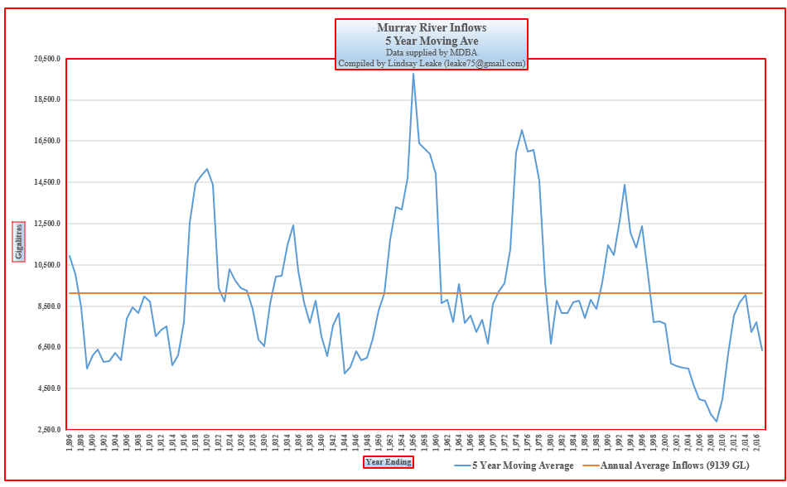
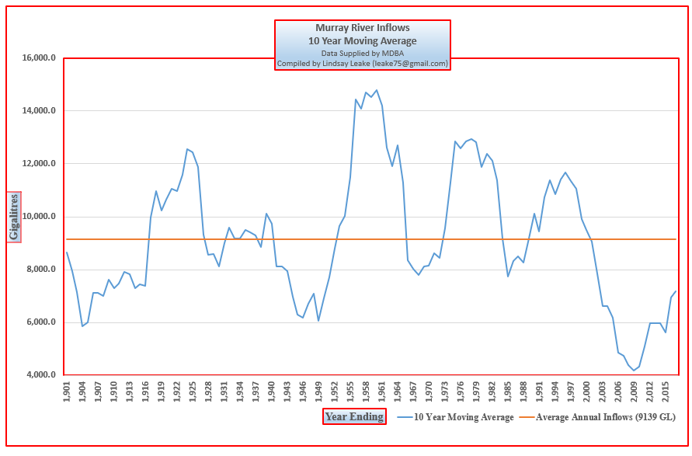
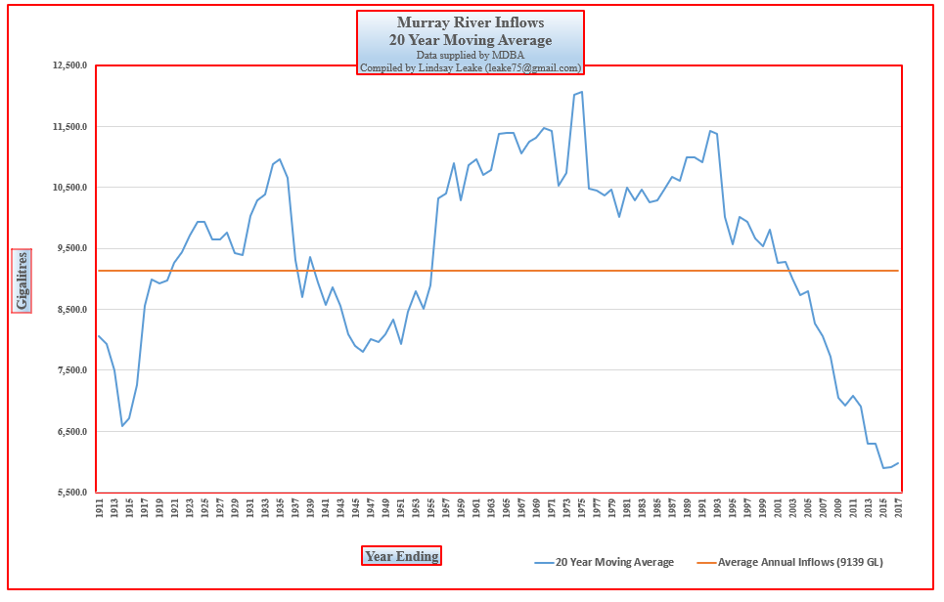
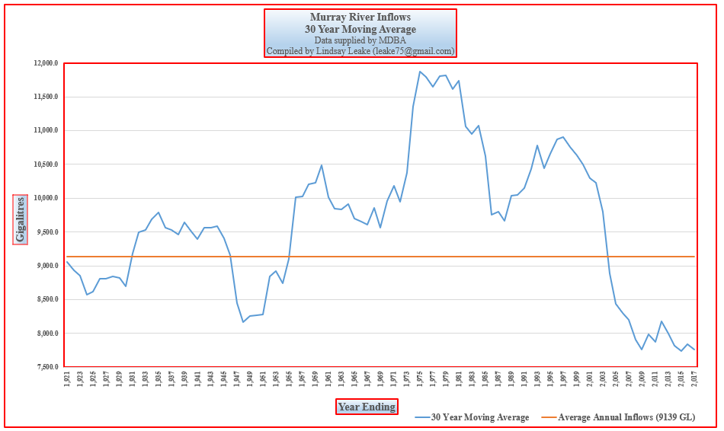
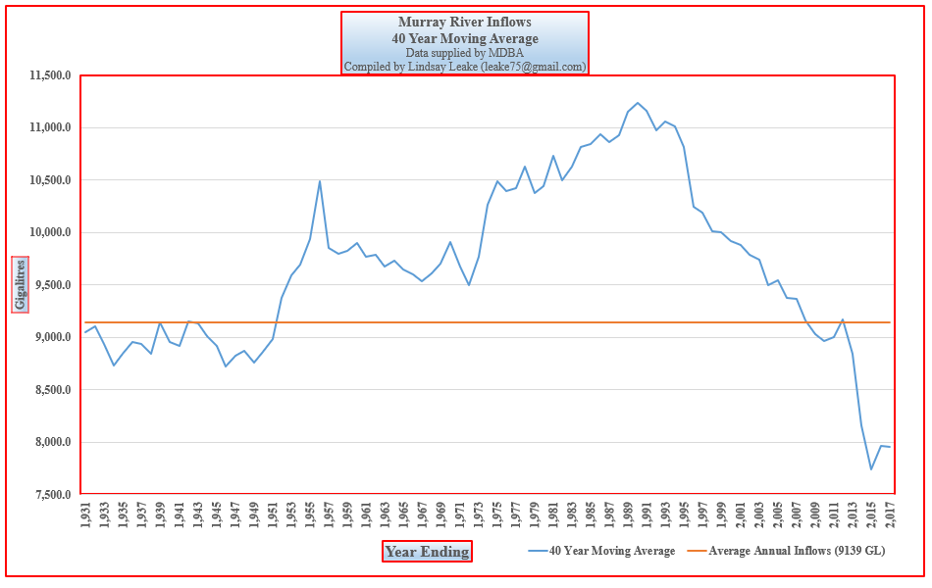

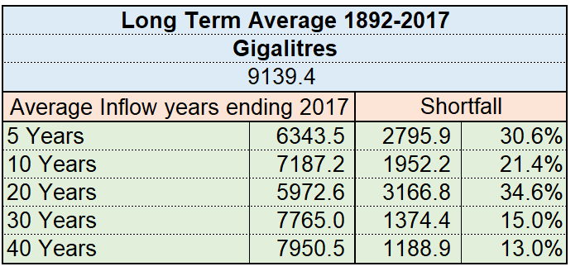

Lindsay Leake

