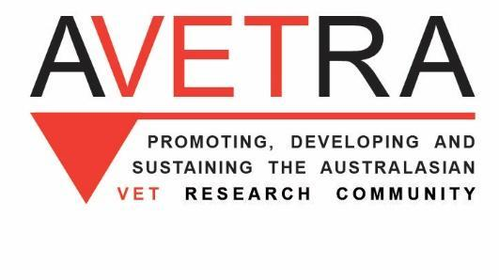
6 December 2019

Dear Commissioner

The Australasian Vocational Education and Training Research Association (AVETRA) would like to accept the Productivity Commission’s invitation to both register its interest and provide some first comments on your study into the National Agreement for Skills and Workforce Development (NASWD).
AVETRA is the pre-eminent voluntary research association for VET in Australia. It brings together researchers and practitioners from universities, VET institutions in both the public and private sectors, think thanks like the Grattan Institute, NGOs like the Brotherhood of St Laurence, and government supported bodies like the National Centre for Vocational Education Research (NCVER). It sponsors several publications as well as holding conferences and colloquia which bring together researchers from Australasia and beyond. Its members include senior academics, policy makers and operational directors who often represent Australia at international bodies such as the OECD and the Asian Development Bank Skills Forums. It aims to support all VET researchers and promote good VET research.
AVETRA believes research enhances policy. Good policy is founded on good and comprehensive research. In the past, we believe, that research has been under weighted and underutilised in the development of plans such as the NASWD. We recognise that the NASWD is inevitably, in part, the result of political, inter government processes. Outcomes can be influenced by political compromises. Ideology has sometimes in the recent past seemed to inform policy more than research. The recent VET FEE-HELP problems, for example, were partially caused by a lack of attention to the risks of marketisation involving government funds in this area of the VET system. VET researchers have long pointed to the dangers of market mechanisms without appropriate regulation, reporting on earlier experiments in Australian and overseas. Greater attention to existing research, and involving research experts in relevant consultations, would be helpful.
AVETRA would therefore like to see more direct and overt use of research in the formation of these agreements. This may include commissioning new pieces of research to inform the NASWD development process.

The AVETRA Executive would be happy to discuss these points further either by a face to face consultation or though the exchange of correspondence

Yours
Robin Shreeve
Adjunct Professor
President AVETRA

