Productivity Commission Review of the National Agreement for Skills and Workforce Development

**December 2019**



Working for business.

Working for Australia

Telephone 02 6270 8000

Email [info@australianchamber.com.au](mailto:info@australianchamber.com.au)

Website [www.australianchamber.com.au](http://www.australianchamber.com.au/)

Canberra Office

Commerce House

Level 3, 24 Brisbane Avenue

Barton ACT 2600 PO BOX 6005

Kingston ACT 2604

Melbourne Office

Level 2, 150 Collins Street

Melbourne VIC 3000

Sydney Office

Level 15, 140 Arthur Street

North Sydney NSW 2060

Locked Bag 938

North Sydney NSW 2059

ABN 85 008 391 795  
© Australian Chamber of Commerce and Industry 2019

This work is copyright. No part of this publication may be reproduced or used in any way without acknowledgement to the Australian Chamber of Commerce and Industry.

**Disclaimers & Acknowledgements**   
The Australian Chamber of Commerce and Industry has taken reasonable care in publishing the information contained in this publication but does not guarantee that the information is complete, accurate or current. In particular, the Australian Chamber is not responsible for the accuracy of information that has been provided by other parties. The information in this publication is not intended to be used as the basis for making any investment decision and must not be relied upon as investment advice. To the maximum extent permitted by law, the Australian Chamber disclaims all liability (including liability in negligence) to any person arising out of use or reliance on the information contained in this publication including for loss or damage which you or anyone else might suffer as a result of that use or reliance.

Executive Summary

The Productivity Commission’s review of the National Agreement for Skills and Workforce Development is an opportunity to focus on the most important weakness of the vocational education and training (VET) system. Funding.

Funding of VET has been inconsistent across all Governments and within each jurisdiction. The total number of VET students publicly funded has, over the last three decades, risen, fallen, risen and fallen again. Funding of VET qualifications, as the recent Joyce Review of VET identified, is also inconsistent across jurisdictions, as well as being inequitable across industries and student disciplines.

This situation has developed as a result of a lack of clear delineation of roles and responsibilities between the Commonwealth and State/Territory Governments, with the shared responsibility in a federated environment leading to a lack of accountability for the objectives, KPIs and targets that are contained within the NASWD.

There is a strong case for change. Growth in the publicly funded VET system has fallen well behind growth in the labour market, and with predictions in the future of work even more strongly emphasising the need for skilled workers, this situation is unacceptable. With labour productivity at worryingly low levels, an increased investment in skills, both full qualifications and skillsets, is essential.

This requires an investment of governments, industry and individuals. The NASWD focuses on the commitment of governments. This submission strongly recommends that a new agreement focuses on funding commitments and measurements. The objectives of the agreement should be broader, to encompass the vision of the VET that both government and industry agree is necessary, but the bottom line needs to be about providing stability and consistency in funding.

A new national agreement on skills should include:

* Clear objectives that embrace the key elements of the VET system
* Commitment to funding growth within and across jurisdictions that matches the growth in the workforce with financial penalties for failure to achieve funding growth.
* Commitment to provide more certainty through base funding for qualifications that are job facing delivered by approved providers, and additional funding that reflects skill priorities
* Targets that focus primarily on funding and that jurisdictions have clear responsibility for and influence over.
* A process that highlights both subsidy and price differences across jurisdictions.
* A pathway to achieve a clearer delineation of roles and responsibilities in the medium to long term.
* A recognition that productivity outcomes from developing skills can be delivered across all industries serviced by VET equally embracing training for occupations that require VET qualifications alongside those that would benefit from a well trained workforce.

Table of Contents

1 Introduction 5

2 Approach to the Review 5

2.1 Overall Funding Envelope 6

2.2 Funding of Qualifications 10

2.2.1 Greater Transparency 10

2.2.2 VET compared to higher education funding 10

2.2.3 A better funding approach for VET should be possible 11

3 NASWD Objectives 12

3.1 Have the objectives been met? 12

3.2 Are the objectives suitable for the future? 15

4 Outcomes, Performance Indicators & Targets 17

4.1 Skilling Australians Fund example 19

4.2 Shortcomings of targets 20

5 Roles & Responsibilities 21

6 Other Issues 21

7 Conclusion 22

8 About the Australian Chamber 23

1 Introduction – Review of the NSNL 24

2 Role and importance of incentives 24

2.1 Rationale for incentives 24

2.2 Reflections on incentive structure 26

2.3 Certainty in base incentives is necessary 26

2.4 Effectiveness of Incentives 26

3 Role of the NSNL in apprenticeships 27

4 Single coherent approach to skills shortage analysis 28

4.1 National Skills Shortage Research Reports and Ratings Summary 29

4.2 Internet Vacancy Index 29

4.3 Skills Shortage Lists for Migration 30

4.4 Need for a Single Approach 31

5 Methodology for determining skills shortages 32

5.1 Forward Looking 32

5.2 ANZSCO 35

6 Conclusion 36

# Introduction

Lack of certainty and funding consistency is the greatest weakness of the Vocational Education and Training (VET) system. The National Agreement for Skills and Workforce Development (NASWD), which underpins the funding arrangements between Australian Governments in the area of skills and workforce development with a focus on VET, has been unsuccessful in addressing this weakness. This is despite it explicitly including in its objectives the need for a sustainable national training system with a stable funding base.

The performance indicators and targets of the NASWD have also generally not been achieved. Given the actual performance, it is hard to see that the policies of Governments in the 10 years since NASWD was initially signed (and updated in 2012) have been driven by the achievement of these targets. Also, the two partnership agreements signed during the term of the NASWD have fallen short of achieving their objectives.

There are many areas of VET that need to be addressed, and the actions taken in response to the Joyce Review will progress some of these in a positive way. However, neither the Joyce review nor the shared vision statement released by the Council of Australian Governments (COAG) in August 2019 sufficiently address the overall funding weakness. We strongly recommend that this review by the Productivity Commission (PC) of the NASWD goes to the heart of the funding weakness in VET.

The inability for the COAG arrangements to address funding uncertainty and inconsistency has led to a loss of faith in the national agreement and partnership agreements to deliver long term funding growth. The Australian Chamber of Commerce and Industry (ACCI) encourages the Productivity Commission to look at alternative options and lay down some funding principles that should guide VET investment for all Governments.

# Approach to the Review

The terms of reference (TOR) focus on the achievements of the NASWD and funding arrangements. Specifically, the TOR include: funding of and between governments, government support for VET, funding and pricing arrangements, consistency of funding and loan arrangements between VET and higher education, return on investment in VET and the potential to further target funding. This is a welcome focus.

The assessment approach set out on page 2 of the issues paper is appropriate to the task in the following significant respects:

* When taking into account the recommendations of other reviews, it is planned that the focus of the PC remains on funding issues
* Understanding that skills are not just delivered through the VET system, even though the terms are often used interchangeably. This is important in the context of the NASWD review as there is frequent reference in the agreement that implies that the VET system can solve the skills needs for “all working age Australians”, increase workforce participation and to meet the needs of a changing economy. A number of the Performance Indicators and Targets are measures that cannot only be achieved by VET. For example, qualifications above Certificate III include higher education, and foundation skills are delivered in a range of learning environments.

Even though the key task of the PC is a review of the NASWD itself, there is a risk that stakeholders will seek to broaden the PC review to the performance of VET generally, which will lead to a replication of the recently completed Joyce Review process. The Commission is urged to stay focused on funding, and the role and performance of the NASWD as the underpinning agreement for the way VET is funded.

Reflecting our overriding argument about the need to focus on funding, we will make some important observations about overall funding and VET training qualifications funding before addressing the relevant information requests made in the Issues paper.

## Overall Funding Envelope

In this context, funding is not just about the “complexity and variation in the funding and pricing of courses” (which is the funding issue identified by the Joyce Review), it is the inconsistency and uncertainty in the overall funding envelope, both within each jurisdiction as well as the total investment made by all governments.

There has been a decline in overall public funding over the last decade, at a time when public investment in all other education sectors has risen significantly, and at a time when the economy’s need for skilled workers has increased.

**Figure 1: Government Funded VET Students, Australia 1988-2018[1].**

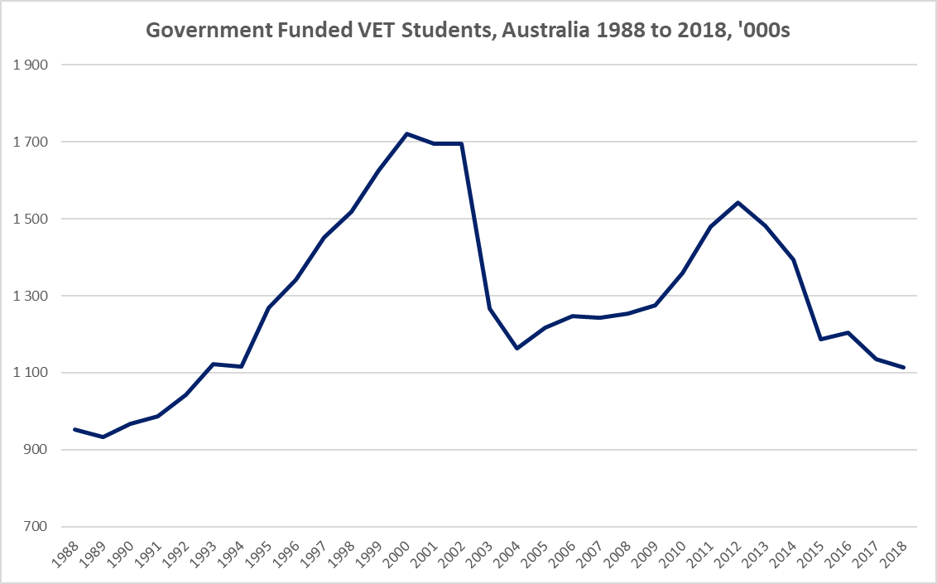

As Figure 1 shows, the number of VET students funded by governments over the last decade has fallen, and over the last 3 decades has risen, fallen, risen and then fallen again.

As mentioned, funding consistency is not just about consistency between jurisdictions, although that is highly important. It is also about consistency and reliability of funding and policy **within** each jurisdiction. Figures 2 and 3 demonstrate this very clearly, with only ACT and to some extent WA demonstrating at least some consistency, although even in those states there has been a decline (and then some recovery in the case of ACT) in the last few years.

**Figure 2: Government Funded VET students in NSW, Victoria, Queensland, SA and WA 1988-2018 [2]**

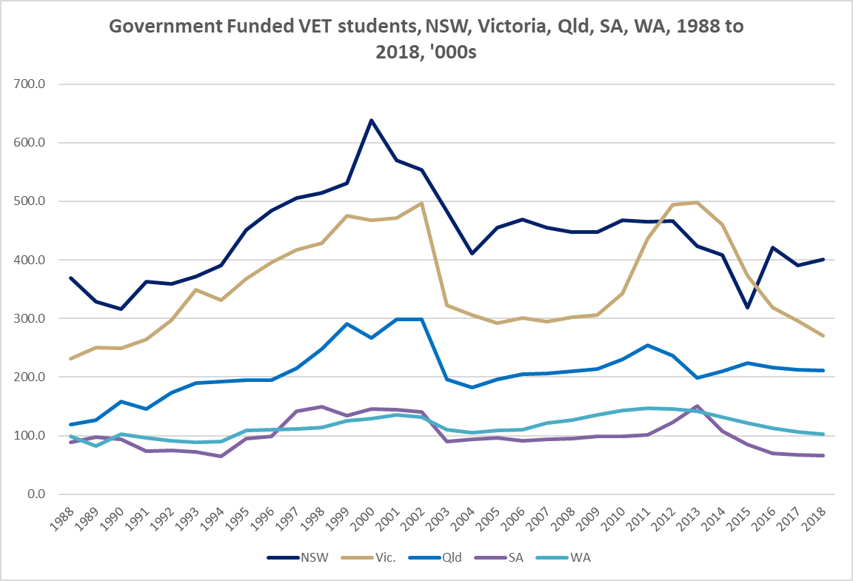

The extent to which there are similarities across State and Territory jurisdictions reflects that Commonwealth funding, including the arrangements in national agreements, flow through the system. The trend variances reflect differences in jurisdictional decisions, most strikingly reflected in the difference between NSW and Victoria in the last ten years.

**Figure 3: Government Funded VET Students – ACT, NT and Tasmania 1988 – 2018[3]**

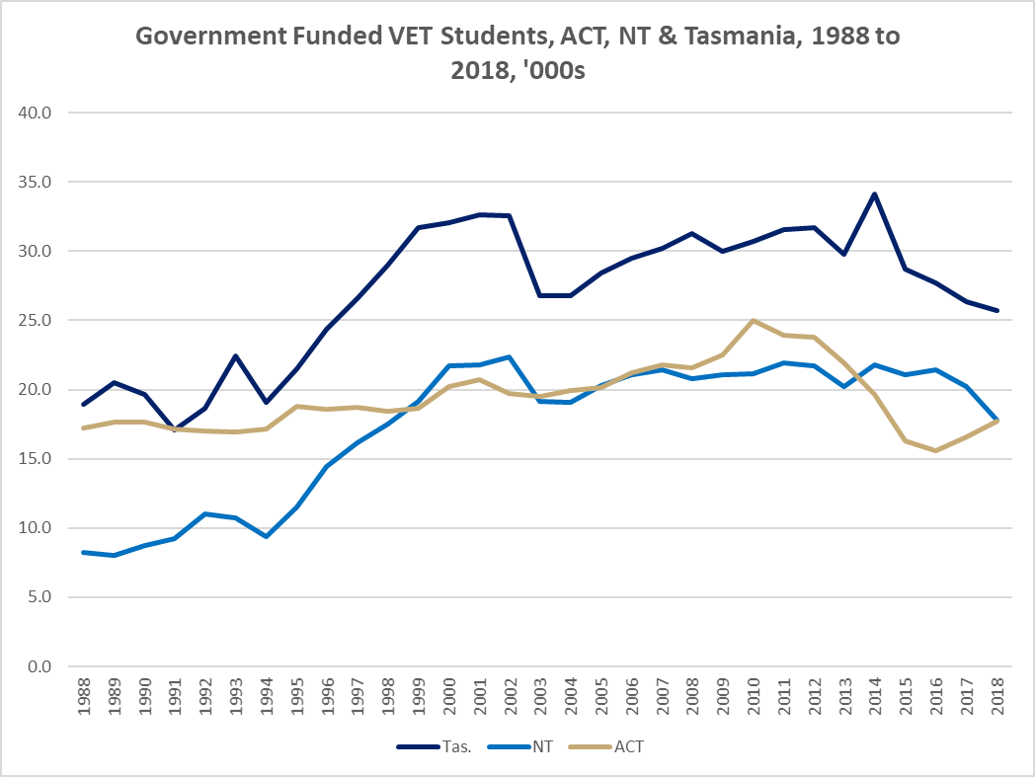

Uncertainty and inconsistency within jurisdictions is also reflected in decisions (often politically driven) to shift the funding depending on the type of provider. Figure 4 demonstrates how these shifts vary in each jurisdiction. Only ACT and NSW increased the number of students they funded from 2015 to 2018. Victoria increased its funding for public providers, but the significant decrease in funding of private providers meant that the overall investment was over 25% down overall. That said, the significant increases in VET funding in the period to 2012 were substantially driven by major increases in Victoria, again illustrating the significant rises and falls in funding.

These significant fluctuations within State and Territory VET budgets occur even though a substantial amount of their funding comes from a certain flow of funds for VET from the Commonwealth via the Specific Purpose Payment (SPP). In 2018-19 the total payment via the National Skills and Workforce Development SPP to all State and Territory governments was $1.516 billion, and this is projected to rise to $1.616 billion by 2022-23.

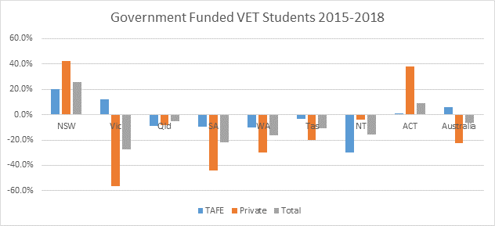**Figure 4. Percentage growth/decline in government funded VET students from 2015 to 2018**

A useful comparison to government funded students in VET is higher education funding under the Commonwealth Grant Scheme (CGS). Although funding to higher education comes from a range of sources, the CGS is the most important of these and directly reflects the number of government funded students in higher education. As figure 5 indicates, apart from a single budget drop in 2013-14, the scheme has shown a consistent increase, rising rapidly in 2008-2012 with the introduction of the uncapped demand driven system. The Federal Budget 2019-20 shows that this funding is projected to rise to $7.6 billion by 2022-23.

**Figure 5. Commonwealth Grant Scheme funding.** *Source: Federal portfolio budget statements*

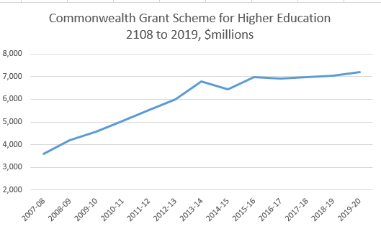

In summary, overall funding for VET is the missing objective in the national agreement, the language surrounding the agreed COAG vision released in August 2019 and the VET reform priorities arising from the Joyce Review. This PC review provides the opportunity to highlight the deficiencies in overall investment, and the extent to which COAG arrangements contribute to this.

## Funding of Qualifications

The identification of options for nationally-consistent funding and pricing arrangements of VET qualifications is the focus of the PC Review TOR (b).

The Joyce Review and the initial tasking for the Interim National Skills Commissioner has focused on the funding of individual VET qualifications, with the objective of determining a national funding model. The expectation is not that there would be one national price, but that the model would allow for loadings for location, learner disadvantage or regional or skills prioritisation.

The development of a national subsidy and pricing model for VET is an ambitious ask, not just in the complexity of the task, but even more so, in the expectation that all of the State and Territory Governments would accept that a national model is an appropriate way forward. Experience in the last decade with the negotiations between governments around VET funding do not lead to optimism that the State and Territory Governments would support a single model.

### Greater Transparency

Instead of or until a national funding model, ACCI recommends that much could be achieved through greater transparency. Awareness of the major disparities in subsidy and student fee will bring stakeholder and community pressure to bear in a way that should correct any outliers, and potentially achieve a more consistent outcome. Thus transparency and publication of the differentials would be a great first step. We have recommended that the publication of subsidy, loan and price arrangements in all jurisdictions for the top 50 VET qualifications would have a major impact on funding consistency without the need to force jurisdictions to adopt a national model.

Incentives could be built into the agreement to encourage States and Territories to adopt the national training model, or at least agree to shift to a model that is more transparent and consistent.

### VET compared to higher education funding

Another important early consideration in any assessment of the “options for a nationally-consistent funding and pricing arrangement” is the relationship between TOR (b) and the TOR (c), which looks at “promoting consistency in funding and loan arrangements between VET and higher education”.

VET funding arrangements of the State and Territory Governments have been heavily influenced by assessment of skill needs and shortages. This is not the case with higher education where qualifications that attract CGS (largely in public universities) are regulated both in terms of subsidy and price, with the subsidy reflecting the cost of delivery. Courses such as law, accounting and business are in lower clusters that attract much lower subsidy than high cost delivery clusters such as for medicine and veterinary science.

In the higher education funding scheme, the subsidy and price does not vary according to any assessment of skill needs. This means, for example, even when the evidence indicates that higher education is producing too many communications or creative arts graduates compared to labour market need, the subsidy remains the same for those students who are offered places in these courses. Although ACCI has long argued that this decision should be strongly influenced by more evidence presented to intending students about their choices, and to providers about their offerings, there has not been a strong push to shift higher education funding to a funding model that fluctuates according to labour market analysis. But yet we have accepted this model for VET for decades, and have witnessed how this approach creates uncertainty and inconsistency across jurisdictions, and even within jurisdictions, as well as inconsistency and inequity across qualifications and industries.

Skills analysis and forecasting should inform policy, not direct or dictate it as there is a real danger that skill needs will be left unsatisfied if investment is too targeted, or changes too frequently as this creates uncertainty and system disengagement. As the Issues Paper points out (p19) different jurisdictions use different approaches, and this adds to the inconsistency and complexity.

It is important to acknowledge that there are structural differences in higher education compared with VET, including a much larger number of providers in VET, multiple funders, a greater role of private including industry and enterprise providers, and an incomplete national regulatory system. These structural features of VET make funding more challenging. We have learnt through the budget difficulties created through the implementation of national entitlement, and then VET FEE HELP, that providing funding to providers on the basis of their accredited status as RTOs was not sufficient to regulate funding, and that additional contractual requirements were necessary to regulate the market.

Funding differences, including access to loans, between VET and Higher Education does not just impact student choices. It also impacts providers. Increasingly VET providers with higher VET qualifications on scope are seeking to be higher education providers in order to access greater funding certainty.

### A better funding approach for VET should be possible

With this experience, it should be possible to design a funded market that provides a much more certain base level of funding to job-facing qualifications across the economy. This proposal of looking at funding options which provide base-line certainty is consistent with the submission we made on the review of the national skills needs list. We have attached that submission to reinforce this key message.

# NASWD Objectives

The issues paper poses the question of whether the existing objectives of the NASWD have been met and whether they are appropriate for future agreements.

As an initial comment, the issues paper implies that that NASWD clearly sets out its objectives, but in reality the wording of the agreement lacks clarity in this area. The overall objective on the front page of the agreement is worded differently than that contained in para 18, and the list on page 6 of the PC issues paper is a construct based on the commitment to reform in para 10 of the agreement. This leads to a straight forward recommendation that should there be another national agreement, the objectives of the agreement need to be clearer.

## Have the objectives been met?

Many of the objectives are very difficult to measure, and some can only be assessed subjectively. Comments on key elements within the objectives are as follows:

* *Meets industry needs* – as the graphs on government funded students demonstrates, the public funding of VET has not kept pace with economic growth. This is also reflected in the NCVER data on total VET activity (publicly and privately funded), which shows a reduction in the number of students completing training package qualifications. There has been an increase in VET delivery in stand-alone subject enrolments which are not part of a nationally recognised program. Although the increase in subject delivery will be delivering skills of economic benefit, the nationally recognised programs are designed to deliver a higher productivity benefit as well as portability for the individual.

**Figure 6: Total VET activity 2015-2018** (Source NCVER)

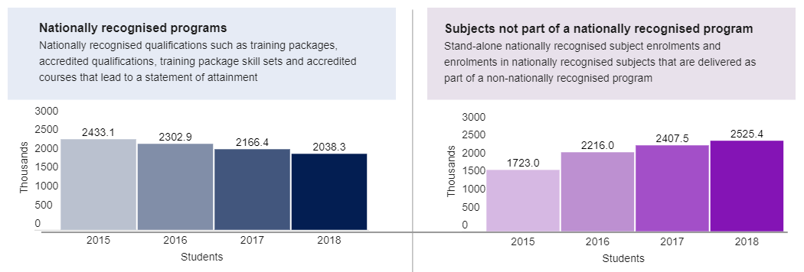

* *Accessible to all working-age Australians* – although sounding fairly broad, this objective was strongly linked to the concept of “national entitlement” where at least one VET qualification should be available at no cost to learners in order that there be no barrier to training based on the capacity to pay. In the years following the signing of the national agreement, State and Territory Governments implemented this entitlement to varying extents, with Victoria and South Australia two jurisdictions that arguably went the “furthest” but then had to significantly change their approach when the amount of money spent far exceeded the budgetary forecasts.
* *Works with business to provide Australians with the opportunity to develop and use their skills* – this objective is so broad as to be virtually impossible to assess its success. The general comment would be that Governments approach industry consultation in varying ways. The opportunity for Australians to develop their skills has a specific implication to the workforce development co-contribution government-industry funds that existed in some States during the period of the agreement, and federally from 2011 to 2015 under various program fund names (eg. National Workforce Development Fund). These funds did achieve some success, although the design was critically important, but it is a reflection on the nature of VET funding that such programs come, change and go rather than offering a consistent approach.

There is evidence that employer engagement has fallen. The NCVER *Employers’ use and views of the VET system survey results for 2019* showedthat only 50.9 percent of employers used the VET system, down 3.5 percentage points (pp) from 2017. 19.9 percent of employers used nationally recognised training (that was not part of an apprenticeship or traineeship), down 2.5 pp from 2017. Every state and territory saw a drop in employer engagement between 2017 and 2019. Small, medium and large businesses also recorded lesser employer engagement in 2019, compared to 2017.

* *Accessible and meeting to the needs of disadvantaged Australians* – VET is an important option as a pathway to employment for disadvantaged groups. Performance of this objective for young people has been less successful, if you look at the drop in the number of apprenticeship and traineeship opportunities. That said, the performance of the system when there are opportunities available is good. The NCVER Apprentice and Trainee experience and destinations 2019 report[4] shows that nearly nine out of ten (87.7%) apprentices and trainees who complete training are employed afterwards, with those who secure full-time work earning a median annual income of $59,600. For those that are employed full-time after their training, the median annual income was $12,700 more than those students who did not complete their training which reinforces the value of completing an apprenticeship or traineeship. The report highlights the positive outcomes for trade apprentice graduates, with 91.5% in employment including 84.2% in full time work after training and earning a median annual income of $62 800, which is an increase of $17 000 since 2018. Non-trade apprenticeships also did well, with 85% employed after training, 59.9% in full time work and a median income of $54,700.
* *Quality teaching and learning outcomes* – Quality is a key focus for VET performance, particularly in the wake of the VET FEE HELP saga that highlighted the negative impact on quality and reputation that a few “rogue” providers can have. More generally, employers satisfaction with VET delivery has fallen, but still stays overwhelmingly positive. The results of Australia’s largest survey of VET students recently released by the NCVER in December 2019 also indicates that student satisfaction remains high, with 88.1% of graduates and 91.4% of subject completers satisfied with the overall quality of their training. The survey also indicated that
  + 83.9% achieved their main reason for training, with 85.1% training for employment-related reasons, 11.3% for personal development reasons and 3.6% for further study.
  + Employment outcomes for graduates were also good, with 65.8% having an improved employment status after training, and 46.8% of those who were not employed before training in employment after.

Overall, the issue of quality presents a mixed picture, although it is any area where there has been undeniably a focus of governments and stakeholders.

* *Access to information* – performance over the course of the agreement in this area has also been mixed. The NCVER continues to provide highly credible and useful research, but it is more stakeholder facing than informing choices of students. Although there has not been significant progress over the course of the agreement, recent initiatives are likely to deliver on this objective. Work is currently underway to better embed student outcomes data into myskills.gov.au. The federal government, through the establishment of the National Careers Institute, has also made a recent commitment to improving information and better integrating the various job and student seeker websites. This is long overdue, but welcome.
* *Pathways* – it is not clear if there has been any significant improvement in pathways between schools and VET, higher education and employment. To a great extent these existed before the agreement and now, with not much improvement in addressing barriers such as VET qualifications at school which in some occupations create barriers to accessing apprenticeship pathways due to competency wage progression. School systems need to be more open to industry’s views about the appropriateness of VET delivered at school.
* *Stable Funding Base* – This has not been achieved (see 2.1).
* *Promoting Opportunities for shared investment* – Overall, the growth in private activity in VET demonstrates that the conditions for both students and employers investing in skills exists. The lack of ongoing commitment and imperfect program design to national workforce development funds has been lost opportunity to encourage greater investment by employers.
* *Efficient, in that government responds to areas of future jobs growth* – as previously stated, most of the jurisdictions allocate funding according to an analysis of skill needs, but it is less clear that efficiency is an outcome of this allocation. This approach to funding implies that skill needs and shortages can always be correctly identified, and also that constant shifting funding according to this approach delivers uncertainty, inconsistency and inequity.

Overall, it is a mixed report card. If the overriding objective is to ensure that the governments’ commitment to VET matched labour market skill needs, then Figure 7 demonstrates the shortfall in a simple way, overlaying the number of publicly funded students with workforce growth. Although there are a range of models used by Governments and industry to forecast the skills needs within the workforce, these will not determine what is the optimum number of publicly funded students as a proportion of the workforce. However, given that our labour productivity is falling, it is unlikely that we have been achieving the optimum number, although clearly other factors come into play, not the least of which is the role of student and employer funded training as well higher education’s contribution to labour productivity. Interestingly, the average percentage of publicly funded students to the workforce in the last 30 years is 13 percent. Current performance is 9 percent.

**Figure 7: Government Funded Students and Workforce** Source NCVER and ABS

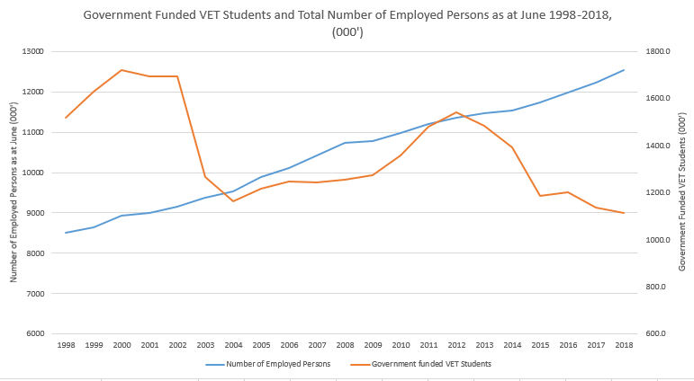

## Are the objectives suitable for the future?

At the beginning of this year, with the federal election looming, ACCI undertook extensive discussions with our member organisations and also our business leaders’ council affiliates on what the principles should be that underpin tertiary education reform, and also what would be some of the key measures of success. These would be a useful basis for identifying objectives:

**Principles that should underpin tertiary education policy**

1. A holistic approach to tertiary education – a policy and funding framework that aims to deliver consistency across the system and values VET and Higher Education equally.
2. A clear articulation of roles and responsibilities of governments and stakeholders (avoiding duplication and cost shifting) working to a shared vision and within an agreed governance framework.
3. Well-informed careers and student market providing effective and efficient approaches to careers information based on strong labour market analysis and forecasts with input from industry.
4. Capacity of the education and training system to respond to the pace of change in the labour market and skill needs.
5. Equitable access, stronger pathways, improved articulation and greater choice in education including the recognition of the contribution of quality private as well as public provision.
6. Strong industry role across the system, in the governance of VET, in setting VET competency standards, and informing delivery in higher education.
7. Policy and funding decisions should be evidence-based.
8. Delivered through high quality providers working within a well-regulated system.
9. Funding transparency.
10. Funding contributions from government, students and employers that reflect public and private benefit.
11. Funding for tertiary education which reflects labour market skills needs, but works within an overall Budget constraint of affordability and funding efficiency.

**What would success in tertiary education reform look like?**

These are some suggested measures for assessing the success of tertiary education:

* Labour market skills needs met.
* Return to growth in the number of funded VET students.
* Real funding increases for both VET and Higher Education.
* Shared vision for future of VET – set through government and industry consultation – funding and governance and an agreed transition process to achieve it.
* Improved student employment outcomes for both VET and higher education.
* Industry more strongly embedded in the advisory and governance arrangements.
* VET and Higher Education equally valued.

In addition to these issues, ACCI agrees that there will be an increasing need for skillsets and micro-credentials, reflecting the need for skills over a whole qualification if time and resources are short. It is also a reflection of the lifelong approach to learning and upskilling that a range of research reports indicate is reflective of the future.

ACCI also agrees that the defining feature of VET is “its focus on employment-related training”. Fundamentally, VET is a competency-based system built on occupational skill standards developed by industry to meet job requirements. The system has been directly linked into industrial awards, and career paths within industries where VET has a major role. Although training packages have become more complex than the original concept of occupational skill standards, this fundamental process of industry identifying the jobs and career paths in their industry, identifying the skills needed to perform those roles, and packaging those skill standards into qualifications is at the core of the system.

The PC issues paper identifies that some stakeholders including the BCA have put forward the concept of a lifelong ‘learner account’ across all tertiary education. This concept has some similarity to policies that have been implemented in the past such as the national entitlement.

While the principle of lifelong learning and the ambition of equitable access is to be commended, the introduction of a learner account should not be considered at this time for the following reasons:

* The most important first step is to achieve clarity around division of funding and policy responsibility and bed down a new agreement within COAG that commits to objectives that deliver real progress in improvement in the VET system and funding.
* A learner account will be difficult to implement unless there is a single national tertiary system, otherwise cost shifting and unintended consequences would be hard to avoid.
* If we cannot achieve consensus amongst all jurisdictions about VET and a national pricing model, then we should not bring higher education into a “chaotic” system.
* To ensure funding is managed within a budget envelope.
* To avoid learners becoming targets for providers pushing courses that are unsuitable.
* With apprenticeships and higher education largely uncapped and demand driven, a large part of the delivery of accessible education is accommodated.
* To avoid the management of a contingent liability of a learner account which may exist on paper but not be used in practice.
* A one-size-fits-all amount in a learner account is not compatible with occupations that have different qualification and skill requirements.

The commitment made by COAG to develop a roadmap for reform for VET and the sign off on a new vision is likely to result in a new national agreement, and we would support putting a new agreement in place. It is essential that this new agreement contains objectives which ensure that VET operates within a funding environment that is certain, growing, and consistent. This should be the number one focus, and supported by objectives reflected in the eleven principles listed earlier.

Overall, VET funding growth should be closely aligned to overall employment growth. This simple mechanism reflects the evidence that the jobs outlook reflects a continued strong demand for skills that are delivered by VET.

VET qualifications funding should be informed by skill needs, particularly for loadings and to address areas of priority, but skill needs should not be the only factor that dictates funding. Base funding should be more certain so that industries can rely on a skills pipeline. Qualifications that are job facing in all industries (not just those industries that require qualifications) should be eligible for government subsidy if delivered by providers, both public and private, that have met the contractual standards of the jurisdictions.

# Outcomes, Performance Indicators & Targets

The principle of embedding specific outcomes and targets into COAG agreements is hard to argue against. However, it is clear that in this agreement and others such as the Skilling Australians fund (SAF) partnership agreement, that a shift to an outcomes based approach has not delivered the hoped for dividends in terms of agreement performance.

The two graphs on page 10 of the issues paper and reproduced here as Figure 8 are useful illustration of the shortcomings. The first concerns the target of halving the proportion of Australians without Certificate III qualifications. The graph shows that we were in line with target only until 2012 and then on have well fallen short. Up until 2012, there were a range of federal apprenticeship incentives in place and also the introduction of entitlement particularly in Victoria that kept this target on track. However, jurisdictions were not willing to maintain the level of investment that was needed to maintain the trend.

**Figure 8: Performance against two NASWD targets** Source *PC Issues Paper Nov 19*

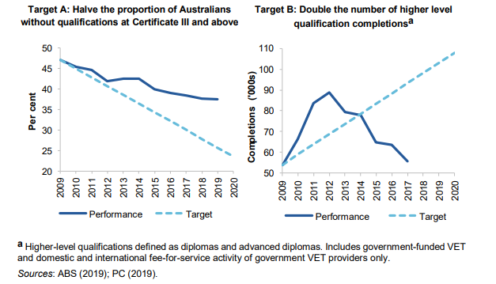

It is also important to note that the VET system and its Skills Ministers and jurisdictions are not solely responsible for the achievement of this target. Schools (all sectors), higher education, employment services and employers, amongst others, would also have a role to play, with the target not just young people, but the upskilling of existing workers without qualifications.

The second graph is far more specific to VET, with governments having a much greater control over its achievement, either through subsidising this training or through the settings for income contingent loans. Ironically, the very scheme that is so derided now, being the VET FEE HELP scheme significantly raised the number of diploma level qualifications completed until 2014. It also provided a basis for a number of jurisdictions to decrease their level of subsidy support which has affected outcomes in the longer term. The corrective action on VET FEE HELP and the introduction of VET Student Loans clearly demonstrated that this target did not influence the policy response by the Commonwealth. As the graph demonstrates the number of higher VET qualifications completed, far from double, is only around the same level as it was ten years ago.

## Skilling Australians Fund example

TOR (a) of the current inquiry calls for an investigation of options for coordinating and streamlining governments’ support for the VET system. On the face of it, the partnership agreements entered into by governments under the NASWD umbrella aim to coordinate and direct the investment in VET on particular activities.

The most recent partnership agreement announced in May 2017, the $1.47 billion Skilling Australians Fund (SAF), focuses on apprenticeships and comes after the previous national partnership of $1.75 billion on skills that expired in 2016. This new agreement was also meant to be outcomes driven, with a target of 300,000 new apprenticeship commencements. The SAF agreement, instead of it all being funded out of consolidated revenue as was the previous agreement, was linked to a new migration levy which was to raise $1.2 billion. This source of income immediately created issues in the negotiation of the agreement as it introduced funding uncertainty as the Commonwealth initially did not guarantee any of the income for SAF apart from the first year.

In the protracted negotiations, the jurisdictions also argued over the calculation of the target including what was the base for the calculation of additional commencements.

With all of this complexity, the SAF took a long time to come to fruition, and Victoria and Queensland did not sign up at all, forfeiting access to the matched funding on apprenticeships in all but the first year, where $250 m was divided amongst the states merely on the basis of an exchange of letters where investment on apprenticeships could be demonstrated, and an extra $50 million sign on bonus.

Figure 9 shows that the SAF has had no impact in arresting the slide in the number of commencements, despite the Commonwealth investing $300 m in 2017-18 and $293.4 million in 2018-19. In 2018-19, this investment was to be matched by the State and Territory governments. This is almost $900 m with no material impact on commencements.

**Figure 9: Apprenticeship commencements** (Source NCVER)

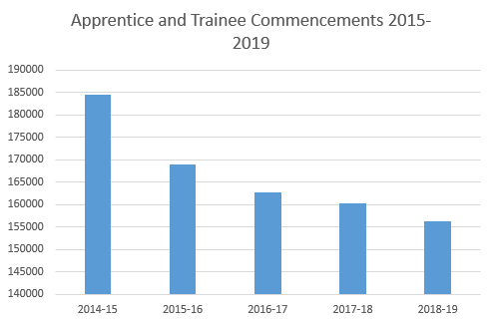

## Shortcomings of targets

These three examples illustrate the shortcomings in setting targets when there insufficient direct accountability. They are either not able to be delivered by changes to VET policy and funding alone, or even when they are, the evidence indicates that jurisdictions do not place a high enough value on them to sufficiently change policy direction to ensure they are met. It is symptomatic of targets when there are multiple parties to the agreement. No one entity takes responsibility, and blame shifting is common.

So is there any way that targets can work? In the context of our main premise in this submission that funding should be the focus, then the targets could be very specific about a demonstration of funding spent by both the Commonwealth and the states and territories. Even in this, experience has shown us that agreeing on the baseline is usually a stumbling block. There are a number of options which we would encourage the PC to investigate including:

* Measuring the outcome by total number of publicly funded students as well as VET finance data. By measuring using both variables, there will be a reduced ability to shift funding to the cheaper qualifications in order to increase the number of students for the same investment. The agreement needs to incentivise investment across the AQF levels.
* Using 2019/20 as the base year, but overlay the investment as it relates to the proportion of the workforce so that States/Territories who are investing at a higher level compared to their workforce are only required to maintain rather than increase their investment. This overcomes the often used argument that the base year can unfairly penalise those who have made the effort to invest more.
* Both the Commonwealth and the State/Territory governments are held to account

This recommendation goes to the public investment in VET, which represents two thirds of the total investment in VET (*PC Issues Paper*, p 24). This does not mean that the 3 million VET students funded privately or by industry are not important to skills development which is why broader objectives beyond public funding are important. However, the targets should be focused on those things that the jurisdictions are completely responsible for – how much they fund the system. An active and growing public investment will deliver certainty and encourage greater engagement. This will provide a good basis for increasing private investment. Also, as we saw in Figure 6, that part of VET is growing strongly anyway through market forces.

In the run up to the federal election we put this approach to targets into practice. In ACCI’s federal election campaign, *Small Business is a Big Deal*, we identified three priority areas for small business, one of which was stopping the “collapse in skills”. We pointed out that there were 300,000 less students funded to do VET than five years ago, including 140,000 less apprentices. We suggested the target should be 350,000 more students being funded in VET. Using the SAF experience, we avoided commencements as a measurement.

# Roles & Responsibilities

It is critically important in VET that the roles and responsibilities in the system are clear. They need to relate to the objectives and also to any targets set. It is telling, that no role was allocated to any jurisdiction for growing the VET system in line with labour market needs.

There are a number of options to better dividing the roles and responsibilities, ranging from the Commonwealth taking over the system, through to complete responsibility residing with the State and Territory Governments. Around three decades ago when the higher education system was reformed there was a proposal for the Commonwealth to take over TAFE (given that VET was largely delivered through public institutions then). This was not proceeded with and the jurisdictions, particularly the States and Territories have shown little appetite for this radical reform since.

ACCI and its members have discussed other options for more clearly dividing the funding and responsibilities in VET, including shifting more of the workplace-facing VET (including apprenticeships and traineeships as well as workforce development/upskilling) to the Commonwealth, and leaving the independent student to be funded by the State and Territory Governments. There are pros and cons of this approach, but it is illustrative of what options could be considered.

The need for options is also a reflection of the lack of faith in the current national training and partnership agreements to deliver on their promises. As the cliché says, if you make everyone responsible then no one is.

# Other Issues

There are many other issues that are mentioned in the paper that ACCI has developed policy and made submissions, including:

* Evidence of apprenticeship incentives impacting on the number of apprentices and trainees
* Recommendations to improve the approach to VET in schools and apprenticeships
* Strengths and recommendations for improvement in training package development
* The importance of provider choice
* Improving information into the careers marketplace to ensure students and job seekers make informed choices.
* Role of industry and governance of VET
* Improving quality through validation of assessment

In the interests of focusing on funding, we have not included all of these issues in this submission. We are available for further consultation as required.

# Conclusion

The number one weakness in VET is lack of consistency and certainty in funding, across the system as well as in each jurisdiction. The NASWD has not been effective in addressing this issue, and indeed does not include funding growth as one of its KPIs or targets. As part of the roadmap to reform that COAG aims to sign off on in 2020, there should be a commitment to enter into a new agreement. That agreement should include:

* Clear objectives that embrace the key elements of the system
* Commitment to funding growth within and across jurisdictions that matches the growth in the workforce with financial penalties for failure to achieve funding growth. The commitment needs to be not just from the State and Territory Governments, but also the Commonwealth, both in direct funding including growth in apprenticeship incentives, increase in the SPP and growth in loans as a result of ensuring that the VET student loans scheme is focused on workforce development, not just managing integrity.
* Commitment to provide more certainty through base funding for qualifications that are job facing delivered by approved providers, and additional funding that reflects skill priorities
* Targets that focus primarily on funding and that jurisdictions have clear responsibility for and influence over.
* A process that highlights both subsidy and price differences across jurisdictions.
* A pathway to achieve a clearer delineation of roles and responsibilities in the medium to long term.
* A recognition that productivity outcomes from developing skills can be delivered across all industries serviced by VET equally embracing training for occupations that require VET qualifications alongside those that would benefit from a well trained workforce.

Until the overall funding approach improves, and growth in VET matches the growth in the labour market, it is hard to see that progress can be made through partnership agreements under a national agreement framework. The focus should instead be on identifying options and implementing a clearer division of funding responsibilities against which each jurisdiction can be held accountable.

# About the Australian Chamber

The Australian Chamber represents hundreds of thousands of businesses in every state and territory and across all industries. Ranging from small and medium enterprises to the largest companies, our network employs millions of people.

The Australian Chamber strives to make Australia the best place in the world to do business – so that Australians have the jobs, living standards and opportunities to which they aspire.

We seek to create an environment in which businesspeople, employees and independent contractors can achieve their potential as part of a dynamic private sector. We encourage entrepreneurship and innovation to achieve prosperity, economic growth and jobs.

We focus on issues that impact on business, including economics, trade, workplace relations, work health and safety, and employment, education and training.

We advocate for Australian business in public debate and to policy decision-makers, including ministers, shadow ministers, other members of parliament, ministerial policy advisors, public servants, regulators and other national agencies. We represent Australian business in international forums.

We represent the broad interests of the private sector rather than individual clients or a narrow sectional interest.

**Appendix A to PC Review of NASWD**:

Review of the Australian Apprenticeships National Skills Needs List – ACCI submission - Sep 19

# Introduction – Review of the NSNL

The Australian Chamber of Commerce and Industry (Australian Chamber) welcomes the opportunity to make a submission in response to the issues paper on the Review of the Australian Apprenticeships National Skills Needs List (NSNL). Apprenticeship incentives play a critically important role in the system, and the purpose of incentives needs to be clearly understood. The NSNL review provides an opportunity for clarity and also to examine the relationship between skills shortages and apprenticeship incentives.

This submission establishes a clear position that an assessment of skills in shortage should have no role in influencing the base apprenticeship incentives, as there are other more purposeful rationales for public investment in base apprenticeship incentives. Skills shortage analysis does have a place in considering incentives, but its relevance should be confined to some additional or top-up incentives which are designed for a particular purpose.

A single coherent approach to skills shortage analysis is supported as part of improving the understanding of labour market needs and to support decisions taken in policy areas such as top up incentives and migration. In that context, it is recommended that the NSNL be incorporated into a single approach to skill shortage lists.

# Role and importance of incentives

## Rationale for incentives

Apprenticeship incentives play an important role in encouraging employers to consider a work integrated learning model to skills development. In the case where apprenticeships are the only pathway to an occupation, incentives help to ensure that there is a sustainable skills pipeline.

The issues paper (page 4) identifies two key rationales for government intervention in the form of apprenticeship incentives:

* Expand the available training pathways and/or employment opportunities for young people, disadvantaged groups and mature people needing to retrain; and
* Encourage participation in occupations that are in, or expected to be in, skills shortage particularly those that are a critical part of the supply chain for sectors of the economy.

Although there may be some useful discussion about the wording of these rationales, the intent is supported. In addition, we would add an even more important rationale, being:

* Encourage employers to enter into a work integrated learning, training and employment arrangement to develop skills with a high productivity value across the economy.

This third rationale is as true for occupations that require apprenticeship qualifications as the only pathway as it is for those that do not. In trades that require an apprenticeship pathway, those occupations and industries have long accepted that an apprenticeship model delivers the combination of structured, nationally-recognised training and work experience needed to produce highly productive workers. These benefits of an apprenticeship or traineeship are just as true for occupations that allow a variety of pathways to acquire the skills. Highly skilled, nationally accredited workers are the result of putting in place the right conditions for employers to agree to take on an apprentice or trainee, and apprenticeship incentives play an important role in enhancing the business case for them to do so.

The economic and public-benefit arguments in support of this third rationale are very strong and include:

* Work integrated learning models deliver significant productivity benefits and are a proven model for high quality skills outcomes.
* Apprenticeships and traineeships have the highest graduate employment outcomes across all VET qualification options and most higher education qualification options. This delivers a long term economic dividend for both the community and the individual.
* Apprenticeships and traineeships offer suitable pathways for school to work transition, combining a continuation of structured learning alongside work experience within a model where the student receives remuneration, and the employer has access to pay rates that reflect the work/training nature of the employment relationship.
* Apprenticeships and traineeships deliver a nationally recognised qualification.
* There is no more efficient or effective model for combining structured training with work experience than an apprenticeship. The Joyce Review highlighted the importance of work experience in VET qualifications. This is in-built in apprenticeships. With institutional delivery of VET, the organisation of work experience usually adds to training delivery costs as well as often being difficult to find host businesses willing to offer the experience.

These economic benefits are the most important justification for public investment in apprenticeship incentives. Given that the current structure of apprenticeship incentives includes both base incentives and additional incentives, it follows that there are two rationales for the base incentive which need to be clearly recognised as being:

* an inducement for employers to expand the available training and employment pathways for particularly young people (as mentioned in the issues paper),and
* for employers to offer an apprenticeship or traineeship that delivers strong economic and public benefit through the delivery of quality skills within a work integrate learning model (as described above).

Therefore, there is no need to link the base incentive, which is currently set at $1500 on commencement and $2500 on completion, to any skills shortage analysis, as the purpose of the incentive does not relate to the skills shortages rationale for incentives. The rationale for the base incentive is sufficiently strong in its own right.

This clarity around the role of incentives is not well reflected in the issues paper which, although initially identifying the important pathway role for apprenticeships, proceeds to frame incentives only in relation to skill shortages.

Given that vocational training is a shared responsibility between the Commonwealth and the States, the Commonwealth’s commitment to incentivise an apprenticeship contract is very relevant given that it is an employment as well as a skills outcome. Apprenticeships are also highly relevant to the Commonwealth’s long standing policy and funding interest in the economic outcomes for individuals on leaving school by encouraging a successful transition from school to work, as well as the productivity and economic dividend that comes from skills developed of high value.

## Reflections on incentive structure

Although the NSNL review does not seek comment on the structure of the incentives, we take the opportunity to welcome the reinstatement next year of incentives for part time and diploma level traineeships.

## Certainty in base incentives is necessary

One of the questions raised in the issues paper (page 16) is whether volatility of incentives would impede their uptake. The short answer is yes, but the question needs to be reframed to distinguish between the base incentive and additional incentives. Base incentives should not constantly fluctuate – they need to provide consistency and certainty. Top ups such as additional incentives can be short term or adjusted based on identified need provided that if it is based around skills shortages then the methodology has to be sound and consistent.

Additional incentives provide the opportunity for a more targeted approach, including support in areas of significant skill shortage, or in the case of disadvantaged groups and adult apprentices.

## Effectiveness of Incentives

We note that an assessment of the effectiveness of incentives in achieving behavioural change in employers is beyond the scope of this review. However, it is important to make the comment that for those people that believe that incentives are not effective in being able to induce an employer to employ an apprentice when they otherwise would not have, then it is not clear why applying an incentive only to an occupation in shortage will make a difference to their view, or indeed why they would think this would assist in helping to address skill shortages.

Of course, it is our view that incentives are effective. The base incentive is all about improving the business case for entering into a training/employment contract. Additional incentives further improve the business case and hopefully induce even more employers to take on an apprentice. If incentives are removed from occupations deemed not to be in shortage, the apprenticeship system will be decimated and the economies of scale in having an “apprenticeship system” will be reduced so substantially that even those occupations where incentives may still apply will be negatively impacted by the reduction in the overall system.

# Role of the NSNL in apprenticeships

As a matter of clear principle, the need of the employer for a particular skill is demonstrated by the commitment to take on the apprentice/trainee. A skill need is local; a skill shortage as generally understood is not.

No national skill shortage analysis is sufficiently sophisticated to determine the need that, an individual employer has at a particular point in time in a particular location for a worker who they are willing to train to become skilled. Skill needs exist across all industries and are not confined to trades.

The fact that the NSNL has not been updated for many years reflects that its role as (basically) a list of trade apprenticeships has been uncontroversial. It could have usefully been updated to include more recent trade apprenticeships.

The NSNL’s impact on the base apprenticeship incentive at present is confined to allowing existing workers in NSNL occupation to be eligible for employer incentives. The impact of the NSNL is greater in additional incentives where it affects eligibility for programs such as trade support loans and adult apprentice incentives.

There is a strong argument that the existing function of the NSNL in relation to apprenticeship incentives would be better dealt with by using the term trade apprenticeships rather than reference to the NSNL [ie. NSNL = trade apprenticeships]. A consequence of this would be that additional incentives such as for adult apprentices and trade support loans would apply to all trades, including those that have been recognised since the NSNL was last updated. According to the issues paper there are around 15% of trade apprenticeships that are not on the current NSNL. We would envisage this would be a percentage of qualifications not covered rather than apprentice numbers so the expansion of incentive coverage would be relatively modest. The current NSNL includes the vast majority of high volume trade apprenticeships.

There is a logic in relating the additional incentives that are impacted by the operation of the NSNL [such as access to trade support loans and extra support for adult apprentices] to trade apprenticeship, not because they are more valuable, or more in “need”, but because they are longer and the commitment to be made by employers in taking on a trade apprenticeship is more costly over the period of the qualification. In the case of trade support loans, the apprentice stays on apprenticeship wage rates for longer, so again there is some logic in the direct linkage to trade apprenticeships. If the NSNL became a different list – a mixture of trades and non-trades for example – then this relationship would not follow as logically in relation to the existing additional incentives. In all cases, incentives play a role in improving the business case, and when additional incentives are applied, they are targeted to address particular shortfalls in the business case, or particular needs. Skills shortages is only one such need.

The proposition of using trades apprenticeships as the substitute for the current role that the NSNL plays does not imply there is no role for skills shortage analysis in apprenticeship incentives, but we see that role confined to the additional incentives used to target particular areas of need. Further comments on the methodology for skills shortage analysis and lists is explored below.

A further benefit of replacing the current role of the NSNL with the simpler language of trade apprenticeships is that it is well understood and will reduce the complexity of lists. The change would also be dynamic, meaning that it will reflect decisions taken from time to time to add or remove trade qualifications from the system, rather than a static list that would need to be updated.

A potential disadvantage of the replacement of the NSNL in its current role would arise in situations where other jurisdictions are using the list for their own apprenticeship measures. We have been made aware that in Victoria the list is directly linked to state funding so these linkages would need to be taken into account in any final position on the NSNL. This may in the short term be dealt with by using both terms as equivalents, ie. NSNL = trade apprenticeships. In the longer term, it would be more efficient in the term NSNL was replaced by trade apprenticeships wherever it appears.

In summary, we would be very concerned at expanding the role of the NSNL to impact base incentives by relying on skills shortage analysis. Such an expansion would provide a potential vehicle for further cuts in incentives based on only one of the rationales for incentives (skills shortages) rather than taking into account other rationales. That said, there is a need to improve our approach to skills shortage analysis and for it be applied to relevant decisions taken on additional incentives. This approach will be explored in the sections below.

Finally for completeness we note that the AAIP four priority occupations – aged, child and disability care and nursing is untouched by any recommendations we have made in relation to the NSNL which is in line with the comment in the issues paper that it is out of scope.

# Single coherent approach to skills shortage analysis

Skills shortage refers to a labour market condition in which demand for a particular skill exceeds its supply at the prevailing market wage rate[5]. There a number of methods to assess skills shortages and the Department in its various branches has employed a combination of different methodologies to compile various skills shortages lists and research. A single coherent approach to the identification of occupational skills shortages is strongly supported (design principle one). The Australian Chamber has advocated the need for better workforce planning and labour market analysis to the various branches within the Department. This review of NSNL is an opportunity to consolidate these different methodologies and approaches within the new portfolio of the Department of Employment and Skills. The labour market research functions listed below are all undertaken by the Department, but in different silos.

## National Skills Shortage Research Reports and Ratings Summary

A common method to assess skill shortages is to survey employers about their hiring difficulties, as done by the Department in the Survey of Employers’ Recruitment Experiences (SERA)[6]. This exercise produces the ratings summary and national skills shortages reports for occupations[7].

A key element of the skill shortage research is the SERA. The SERA collects two kinds of information about employers’ experiences recruiting skilled workers.

* The first is qualitative information from discussions with employers and recruitment professionals, which enables the identification of key labour market issues for each occupation.
* The second is quantifiable data about employers’ recruitment experiences, including the proportion of vacancies filled and the number of applicants, qualified applicants and suitable applicants. This provides the basis for historical comparisons and analysis across states/territories and occupations[8].

The research focuses on relatively large occupations (national employment of at least 1500 as at the 2011 Census) which are skilled (generally require at least three years of post-school education and training). Most are professions (ANZSCO Major Group 2) and technicians and trades (ANZSCO Major Group 3), although a small number of other occupations are also included. The research comprises of around 80 occupations which have been assessed annually in recent years[9].

Therefore, this summary is not a comprehensive skills shortage report of all the skilled occupations in the economy and is also subjective to the questions phrased and the number of employers surveyed across the market.

## Internet Vacancy Index

The Department publishes monthly job vacancy reports and the Internet Vacancy Index on its Labour Market Information Portal (LMIP). The Internet Vacancy Index is based on a count of online job advertisements newly lodged on SEEK, CareerOne and Australian JobSearch during the month.

Long vacancy periods may signal a skills shortage or that there are hiring difficulties[10]. This method is also not representative of the entire labour market due to other job advertisements platforms such as LinkedIn, word of mouth, employer job boards and websites not being included.

## Skills Shortage Lists for Migration

The Department also assesses skills shortages in the economy to inform Australia’s migration system. This exercise uses a different methodology to assess occupations/skills in shortage in the economy and determines the three skills shortages lists – the Short Term Skilled Occupation List (STSOL), the Medium and Long-term Strategic Skills List (MLTSSL) and the Regional Occupations List (ROL)[11].

For the Migration lists, the below datasets used in the current methodology are classified into primary and secondary factors, with a points system applied to the factors[12]:

* Skilled Migrant Employment Outcomes—Department of Home Affairs’ Continuous Survey of Australia’s Migrants
* Reliance on Temporary Visa Holders—Australian Bureau of Statistics (ABS) Census, Department of Employment Occupation Trend Data, Home Affairs Visa Grant and Visa Stock Data
* Graduate Outcomes—Graduate Careers Australia: Graduate Outcomes Data and Field of Education Occupation Destination data
* Apprenticeship Outcomes—VOCSTATS on the number of apprentice and trainee completions in each occupation (indicator of labour supply)
* Skill Level versus Education Attainment—ABS Survey of Education and Work: Educational Attainment by Occupation data
* Employment Growth Projections—Department of Employment Occupational Projections: Five Years to May 2022 (based on ABS data)
* Vacancies—Department of Employment Internet Vacancies Index for occupations by skill level, as well for all states/territories.
* Australian (National) Skill Shortages—Department of Employment: Skill Shortage Analysis
* ANZSCO Not Elsewhere Classified occupations—ABS Census, Department of Employment Occupation Trend Data
* Age Profile—ABS Labour Force Survey: Employed Persons Median Age by Occupation, and Home Affairs Subclass 457 Visa Grant Data
* Salary—ABS salary data and Subclass 457 Visa Grant Base Nominated Salary Data (not published).

This methodology allows for new evidence to be incorporated into the analysis through regular stakeholder and industry consultations. It also takes into account a wider range of data, including the ones discussed under 4.1 and 4.2 to arrive at a list of skills shortages.

It reflects a dysfunctional loop when some of the same datasets are used but different skills shortages lists produced, due to differing methodologies.

## Need for a Single Approach

The Australian Chamber recommends the consolidation of labour market analysis and the determination of skills shortages on a single consistent basis across the Department. The National Skills Commission, a major recommendation of the Joyce VET Review and an early reform adopted by the Federal Government in the 2019-20 Federal Budget is given responsibility for this function. However, in the context of the NSNL Review, it is important to highlight that before the National Skills Commission is fully operational, any decisions made regarding labour market analysis and skills shortages needs to follow some basic principles.

The Australian Chamber recommends:

* A single robust evidence based methodology to determine skills shortages across the economy. This methodology for skills shortages should underpin all decisions made regarding workforce planning such as migration and additional support in the form of incentives. It could culminate into a single skills shortage list (in detail below) eliminating the need for multiple lists that need to be reviewed periodically and could be undertaken by the National Skills Commission.
* Extensive industry consultation through leveraging available industry insights and surveys to ensure the research results and skills shortage lists accurately reflect the prevailing labour market.
* Consolidation of industry consultation and collection of industry evidence including submissions, forums, one to one meetings.
* There are other labour market research activities undertaken by the Department that will benefit from consistency and rationalisation of methodology such as the publication of Job Outlook and careers information on the Department’s website.

Single Skills Shortage List: Based on a consistent, robust, evidence based methodology, the Australian Chamber recommends a single skills shortage list that could be known as the **Consolidated Skills Shortages List**. This list will replace the various skills shortages lists and include all of the occupations that are currently sitting on the various lists such as the SERA list, MLTSSL, STSOL and the NSNL. This newly created list can underpin the migration system as well as the additional top-up incentives and any other labour market workforce planning activities. This will reduce the complexity of the various lists and the resources needed to maintain and review the lists on a periodic basis.

In viewing skills shortages for the purposes of permanent migration, a separate list that looks at **significant skills shortages** (reminiscent of the MLTSSL and a subset of the Consolidated Skills Shortages List) can underpin independent skilled migration since there needs to be evidence that an independent migrant who arrives in Australia is able to secure a job in the prevailing market conditions. Employer Sponsored Migration should be underpinned by the Consolidated Skills Shortages List since there is a guaranteed job waiting for the migrant based on the employer’s need of labour and skills. In addition, the willingness of the employer to go through the significant regulatory barriers and substantial cost is sufficient to demonstrate that they are in need of that skilled worker and hence do not need an underpinning skills shortages list to determine the occupation’s eligibility. For the purposes of temporary migration, a short term skills list could exist but with a pathway to permanency.

# Methodology for determining skills shortages

In relation to the proposed six design principles for determining skills shortages, subject to the comments below, we have no major concerns with principles 1 through 5.

Design principle 6 does not belong in the methodology for identifying potential skill shortages as it relates more to how the skills shortage information is used and to much broader areas of public policy. As a principle that relates to the investment of public money, a criteria of delivering the greatest social and economic benefit is a sound one. As we have demonstrated in the comments above, the rationale for public investment in apprenticeship incentives is strong without reference to an assessment of skills shortage.

Key underpinnings in any skills shortage research are the accuracy of the forecasts and labour market classifications. We will make detailed representations on both aspects at the methodology discussion paper stage in the next round of submissions and consultations, but felt it was appropriate to flag these issues at this early stage.

## Forward Looking

The Australian Chamber supports a forward-looking skills shortage methodology (design principle 2) but cautions that forecasts are not always accurate. The Department of Employment, Skills, Small and Family Business produces employment projections by industry, occupation, skill level and region for the following five-year period. These employment projections are designed to provide a guide to the future direction of the labour market. However, like all such exercises, they are subject to an inherent degree of uncertainty[13].

An analysis by the Australian Chamber comparing actual labour market employment outcomes to these forecasts published in Australian Jobs highlight the usefulness and limitations of labour forecasts and projections [14]. The analysis evaluates the accuracy of the predictions made in 2013 for five years’ time, against actual employment in 2018.

Figure 1: Project Employment Outcomes versus Actual Employment Outcomes for 2018 by Industry ('000)[15]

As seen in figure 1, the industries where the predictions were well under the actual included have been in Health Care and Social Assistance, Professional, Scientific and Technical Services and Construction and Accommodation and Food Services. The forecast for the size of growth in these industries was not accurate. Other industries that experienced relatively significant growth that was not anticipated were: Information Media and Telecommunications; Manufacturing; Public Admin and Safety and Transport and Postal and Warehousing. On the other hand, two industries that did not grow as predicted were Retail Trade and Wholesale Trade.

Figure 2: Projected Employment in 2018 as a % of the Total Workforce by Occupation (projections made in 2013)



Figure 2 reflects the projected/forecasted proportion of employment in 2018 by ANZSCO’s eight major occupation groups, with figure 3 reflecting the actual proportion of employment in 2018. The 2013 5-year forecasts were more closely matched to the actual breakdown by occupation with a slight over projection in community and personal services and under for labourers.

Figure 3: Actual Employment in 2018 as a % of the Total Workforce

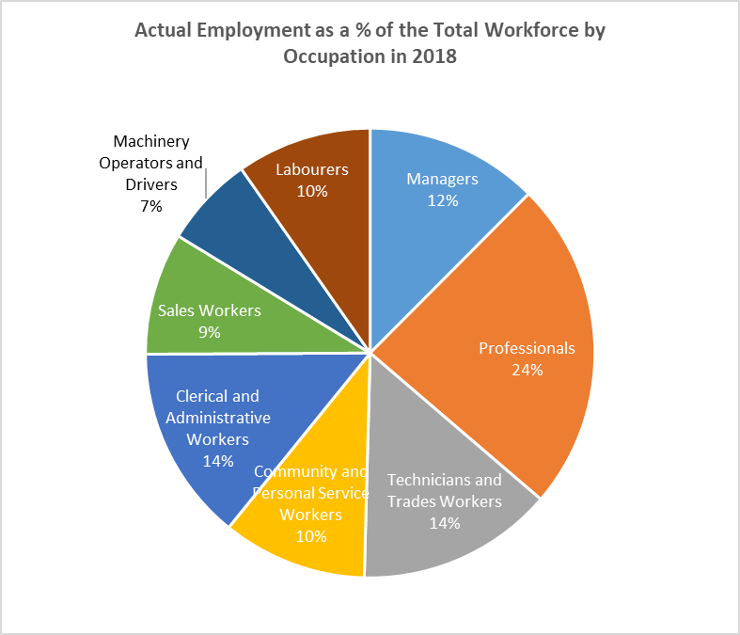

This analysis highlights that although forecasts can be a very useful tool, overly relying on projections, forecasts and modelling to identify skills shortages or needs in economy is not without challenges. This means that caution is needed in relying on forecasts to direct funding in ways that may be counterproductive to actual outcomes, and reinforces the main argument of this submission that skills shortages should not be the sole determinant of apprenticeship incentives. Skill needs, even skill shortages, can occur in any skilled occupation at any time in any location. A national analysis of skills shortages is important – but it has its limitations.

## ANZSCO

No discussion on labour market analysis should be complete without, yet again, expressing concern about the need to urgently commence a review of Australian and New Zealand Standard Classification of Occupations (ANZSCO). Although the ANZSCO is outside the scope of this round of submissions, the Australian Chamber takes the opportunity to highlight its importance in the context of workforce planning and will make detailed representations and recommendations at the methodology discussion stage.

One of the pillars of labour market statistical infrastructure is ANZSCO. This infrastructure maintained by the Australian Bureau of Statistics (ABS) includes information from the Census and underpins a wide range of labour market data such as job outlook information and occupation lists that determine migration eligibility.

Despite major changes to the economy and jobs, including new jobs driven by technology as well as changes to the level of skill needed in certain jobs, ANZSCO has only been reviewed and revised twice (2009 and 2013) since its introduction in 2006 (having transitioned from the previous ASCO codes). Canada, which has a similar classification of occupations, has had regular revisions with a structural review scheduled every ten years (2001, 2006, 2011, and 2016). A major review of ANZSCO is long overdue. Occupations in ANZSCO are out of date in that skill levels are not reflective of the current work performed and for many industries it is woefully inadequate in assessing the skill needs in the context of new occupations. However, the Australian Bureau of Statistics (ABS), custodians of the statistical product are unable to commence a review due to labour and resource constraints and competing priorities. Regular review of major statistical infrastructure such as the ANZSCO needs to be built into the normal operating budget of the ABS. The ABS has not even committed to a review in the future, only that it will be considered post the 2021 Census process.

All occupations are experiencing technological progress and the nature of work and job roles are constantly changing. ANZSCO not only identifies new jobs, but it also appraises the duties within their job and assigns an appropriate skill level. A large number of stakeholders across the economy share our concerns, including colleagues from Business NZ. The 2018 OECD Report on Getting Skills Right in Australia also highlighted the need to update the ANZSCO since emerging occupations such as cyber security, artificial intelligence experts and others were not included in the current classification. According to the ABS Forward Work Program released October 2018, the resource required to fully implement the review is $4 million. An immediate review of ANZSCO is needed in the context of workforce planning.

# Conclusion

The policy and fiscal rationale for the base apprenticeship incentive is the economic and public benefit of improving the business case for an employer to take on an apprentice or trainee in a highly productive, work integrated learning training/employment contract. In relation to the current role that the NSNL plays in incentives, it should be seen as equivalent to the term trade apprenticeships (ie. NSNL = trade apprenticeships], and these terms should be substituted once there are no consequences arising from NSNL being used in other situations.

Skill needs exist across the economy, and government policy needs to reflect that growth and skills gaps can occur across a range of industries. It is also important that policy design reflects that a skill need can be localised to a region, or even a particular employer.

That said, skills shortage analysis is a valuable undertaking for a range of purposes, and is specifically relevant to apprenticeship incentives due to the need, at times, to target additional incentives. A single approach to the analysis of skills shortages within the Department is strongly supported, and the Australian Chamber looks forward to discussing methodology to most effectively undertake this analysis during the course of this review.

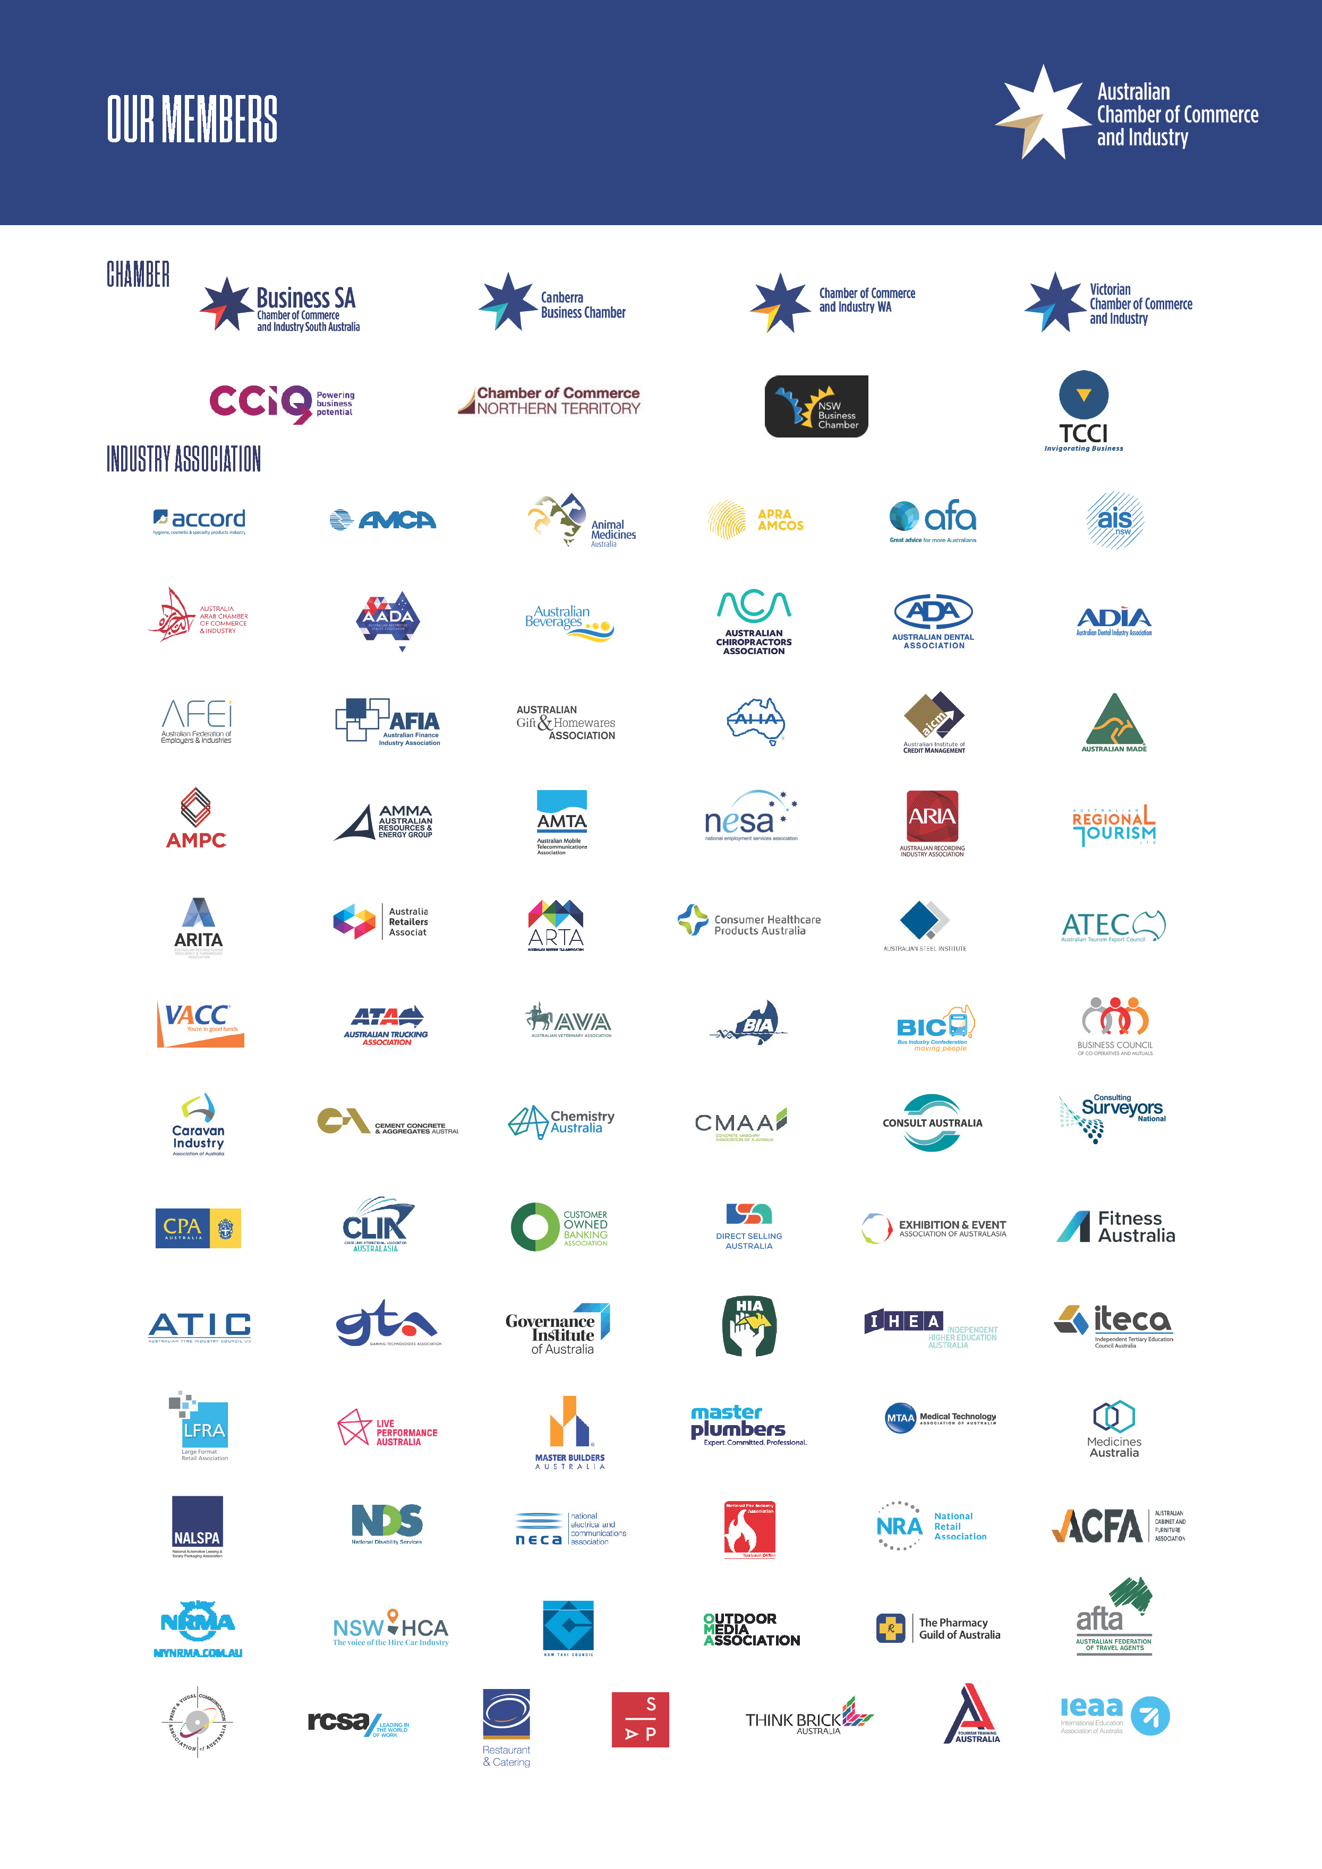

1. NCVER 2019, Government-funded VET students and courses 2018 - Historical time series of government-funded vocational education and training in Australia, from 1981
2. Ibid
3. ibid
4. <https://www.ncver.edu.au/research-and-statistics/publications/all-publications/apprentice-and-trainee-experience-and-destinations-2019>
5. OECD 2018, Getting Skills Right: Australia
6. Department of Employment, Skills, Small and Family Business 2019, Skills Shortages Research Methodology, < <https://docs.employment.gov.au/system/files/doc/other/ss_methodology_0.pdf>>.
7. Department of Employment, Skills, Small and Family Business 2018, Ratings Summary – Labour Market Analysis of Skilled Occupations, < <https://docs.employment.gov.au/system/files/doc/other/ratingssummary.pdf>>.
8. Department of Employment, Skills, Small and Family Business 2019, Skills Shortages Research Methodology, < <https://docs.employment.gov.au/system/files/doc/other/ss_methodology_0.pdf>>.
9. Department of Employment, Skills, Small and Family Business 2019, Skills Shortages Research Methodology, < <https://docs.employment.gov.au/system/files/doc/other/ss_methodology_0.pdf>>.
10. OECD 2018, Getting Skills Right: Australia
11. Department of Employment, Skills, Small and Family Business 2019, Migration Occupation Lists – Update and Methodology, < <https://docs.employment.gov.au/system/files/doc/other/1710_methodology_approach_final.pdf>>.
12. ibid
13. Labour Market Information Portal 2019, 2018 Employment Projections – for the five years to May 2023, <<http://lmip.gov.au/default.aspx?LMIP/GainInsights/EmploymentProjections>>.
14. Department of Employment, Skills, Small and Family Business 2019, Australian Jobs 2019, <<https://docs.employment.gov.au/system/files/doc/other/australianjobs2019.pdf>>.
15. Data sourced from aggregate employment numbers (000’) Australian Jobs 2014 and 2019