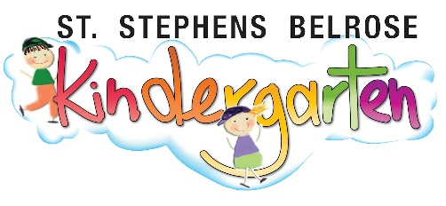

To Whom it may concern,
Regarding: Productivity Commission report on early education, draft recommendation for outside preschool hours ECEC.

I am writing this submission in support of the draft recommendations for outside preschool hours ECEC. We are a community based not for profit preschool, funded by NSW Government, that has been offering extended hours to our families since at least 2016. We have families who rely on this extended care to enable the parents to attend work. Since we first began offering the extended hours program, we have been running it at loss. It operates whether we have one child attending or many children attending. It allows families the option of care between 7am and 6pm every day. Our core preschool program runs from 8:30am-4pm each day. Any access we can receive to the CCS for our extended hours program would be gratefully received and allow us to continue to offer the service to our families.

Yours sincerely,

Ann O’Hare
Director
St Stephens Belrose Kindergarten
12 Lockwood Avenue Belrose 2086

