Policy Positions
of the
Australian Restructuring Insolvency and Turnaround Association

as at February 2015
Policy 15-01: ARITA law reform objectives (corporate)
We believe that the Australian corporate restructuring, insolvency and turnaround regime should:
- support the preservation of viable organisations that have otherwise found themselves in, or heading towards, financial distress, provided they:
  - have good financial systems and controls
  - are tax compliant
  - are compliant with other regulatory obligations (e.g. corporate, WHS, environmental, product safety, etc.), and
  - demonstrate good corporate governance
- recognise the value to the economy of sustaining continuous employment for employees involved in viable organisations facing financial distress
- recognise as a micro-economic principle that capital should be recycled from non-performing businesses to performing businesses and that some element of business failure is a necessary and appropriate mechanism in ensuring an efficient and productive economy
- encourage directors, management, and independent and qualified financial and insolvency advisers to assist organisations operating viable businesses to recover from financial distress and provide a restructuring moratorium (safe harbour) from potential later claims, subject to certain requirements
- otherwise support the preservation of a viable business as a going-concern, including to allow the business to continue to have the benefit of existing contracts and leases
- require the interests of existing and new creditors to be taken into account, but at the same time recognise their responsibilities to attend to their own interests and to do so at a cost in proportion to the value and potential of the business
- allow the resolution of a company’s financial distress to be dealt with as quickly as possible, consistently with the interests of creditors and of the company
- provide for the prompt assessment and orderly disposal of a failed business, recognising that there is a cost to delivering this service
- acknowledge that different sized companies may require different approaches to dealing with financial distress
- have regard to international precedents and best practice in the UK, US, New Zealand, Canada and elsewhere, and
- provide proper remuneration for its practitioners, and not require them to do work or incur expenses in assetless administrations without recompense.

Explanatory notes:
The distinction between high performing and distressed companies and the impact on asset values over the viability spectrum is depicted below.
Value vs. viability
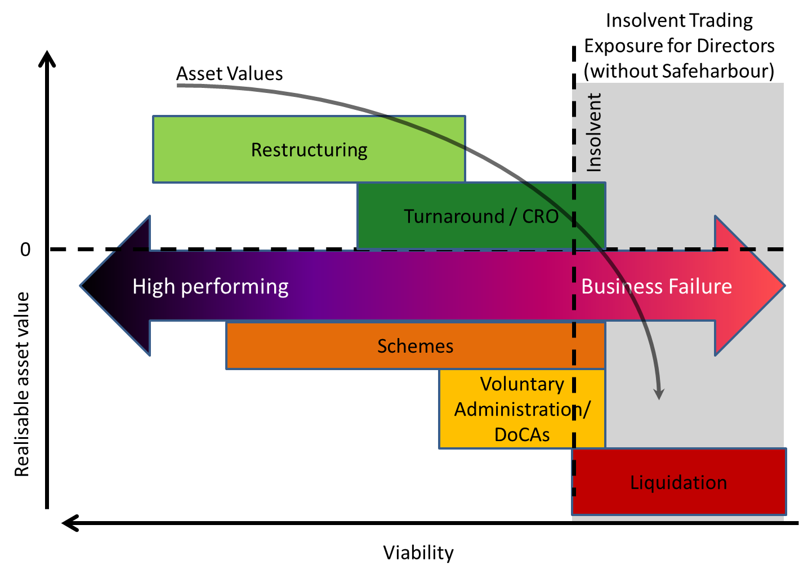
A foundation of our thinking is that a “one size fits all” approach to dealing with companies in financial distress is flawed. For example, such an approach does not take into account the scale of societal impacts of insolvencies in large enterprise collapses compared to small. Nor does it take into account the differences in governance between large and small entities.
To that end, we conceive that there are three framework approaches required:
- large enterprises
- small-to-medium enterprises (SMEs)
- micro companies (provable liabilities less than $250,000).
The following flowchart provides a summary of the proposed reform concepts developed by ARITA based on the three approaches detailed above and the belief that size distinctions are required to better achieve the aims of Australian insolvency law.
Reformed insolvency regime
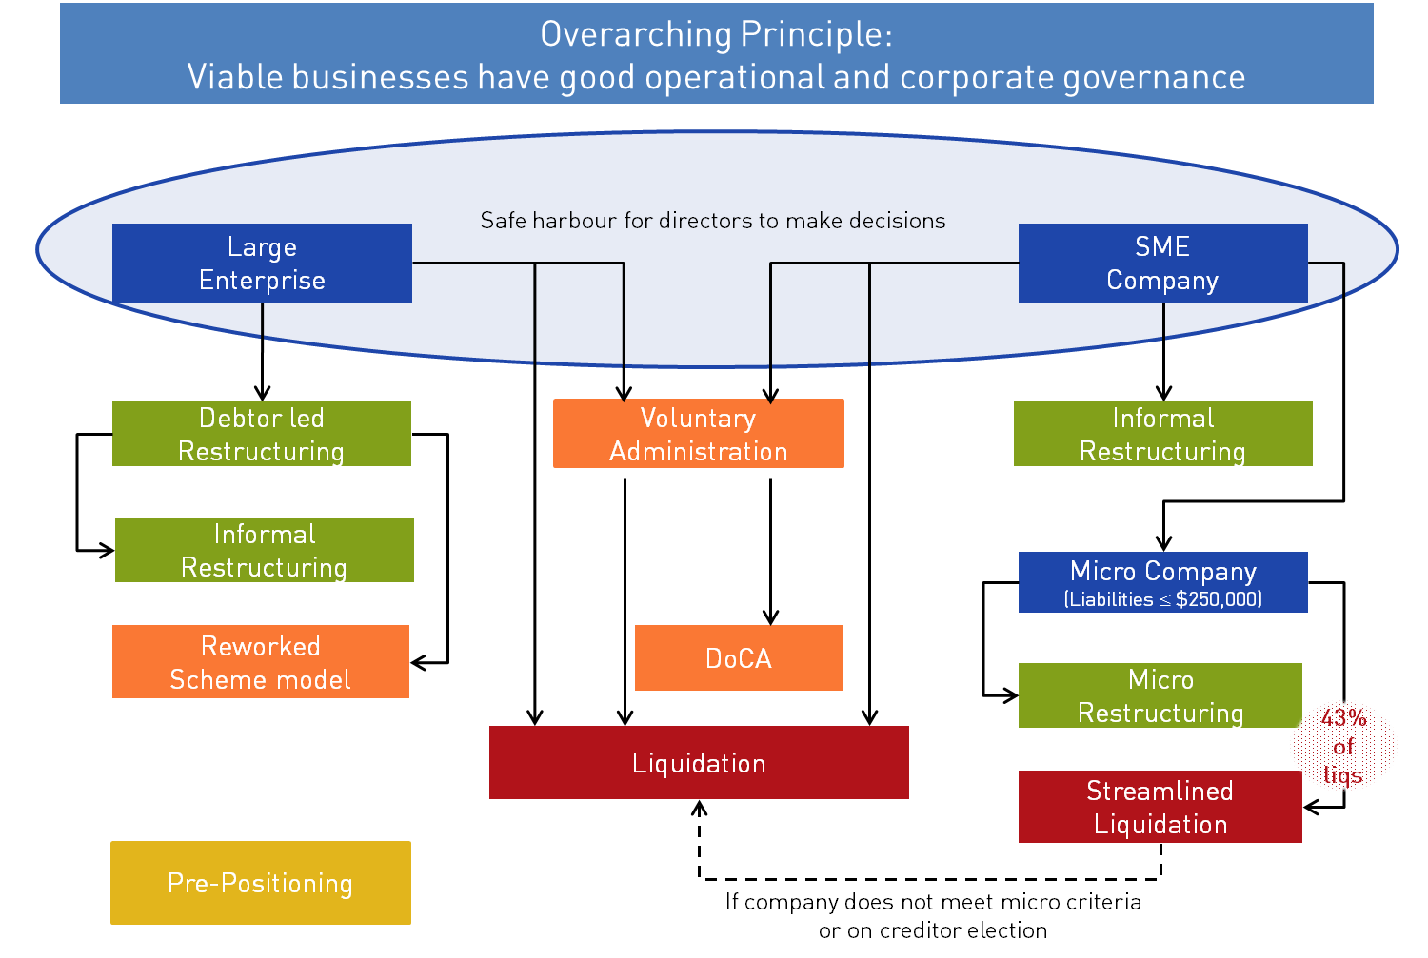

Policy 15-02: Aims of insolvency law
We believe that the fundamental principles of and aims of insolvency law are to:
- provide an equitable, fair and orderly procedure for handling the affairs of insolvent debtors to ensure that claims of priority creditors are appropriately recognised and other creditors receive an equitable distribution of the debtor’s remaining assets: the pari passu (equal sharing) principle
- provide procedures and processes for dealing with an insolvency with the greatest efficiency and as little expense as possible
- ensure that administrations are conducted in an independent, competent and efficient manner
- provide mechanisms that allow for rehabilitation of the affairs of insolvents before their position becomes hopeless
- provide procedures which enable both debtors and creditors to have a voice in the resolution of the reality of the insolvency
- ascertain the reasons for the insolvency and to provide powers and mechanisms which allow for the examination of the conduct of insolvents, their associates and the officers of corporate insolvents, and
- enable identification of any offences have been committed by insolvents or their associates with a view to those offences being prosecuted.

Policy 15-03: Current Australian corporate restructuring, insolvency and turnaround regime and the need for change
It is ARITA’s position that our current corporate insolvency regime has served, and continues to serve, Australia well. In particular, it has sustained economic value through a number of downturns and market shocks and major corporate failures.
Importantly, during the 2008 global financial crisis the Australian economy fared better than other comparable economies. It is reasonable to claim that our robust insolvency regime played a part in that – especially from credit provision and market confidence perspectives.
At the same time, we do believe that fundamental changes are needed, in particular in relation to government involvement in the regime, and the need for greater emphasis on enabling restructuring outcomes.

Explanatory notes:
Australians tend to hold an idealised view of how other markets operate: we see the successes but gloss over some of the failings.
ARITA believes we should carefully and systematically analyse recovery and insolvency regimes elsewhere to see what approaches we may employ here to improve our regime. However, the notion that we can simply transplant other systems here fails to acknowledge our own unique circumstances and ethos.
ARITA’s view is that change and reform is needed for the regime to improve its social and economic outcomes. We necessarily accept some of the current legal and practice structures in place in Australia and do not wish to suggest the impossible or impractical; for example, we are content to maintain the separate laws for personal and corporate insolvency.
The current Australian regime could be described as having a strong bias towards preserving creditors’ rights. Other jurisdictions are more biased towards preserving the troubled company as a going concern. There are significant arguments around where the balance is appropriately set between these two approaches, and the balance point advocated may alter depending on where an economy’s performance is trending.
Policy 15-04: Creation of a restructuring moratorium
ARITA supports a business judgement rule with the following elements, that directors:
- make a business judgement in good faith for proper purpose
- after informing themselves about the subject matter of the judgement to the extent they reasonably believe to be appropriate
- rationally believe that the judgement was in the best interests of the company (and its shareholders)
- the director has taken all proper steps to ensure that the financial information of the company necessary for the provision of restructuring advice is accurate, or is ensuring that all resources necessary in the circumstances to remedy any material deficiencies in that information are being diligently deployed
- the director was informed with restructuring advice from an appropriately experienced and qualified professional engaged or employed by the company, with access to all pertinent financial information, as to the feasibility of and means for ensuring that the company remains solvent, or that it is returned to a state of solvency within a reasonable period of time
- it was the director’s business judgement that the interests of the company’s body of creditors as a whole, as well as members, were best served by pursuing restructuring, and
- the director took all reasonable steps to ensure that the company diligently pursued the restructuring.
A restructuring moratorium (safe harbour) that provides a defence to insolvent trading liability is required as:
- the existing law, without any restructuring moratorium, can impede or prevent proper attempts at informal workouts
- the adverse effect of the existing laws on honest, capable directors, particularly non-executive directors
- the focus of directors of a financially troubled company should primarily be (as it is in many other comparable jurisdictions) on the interests of creditors
- the existing insolvent trading laws limit the options available to deal with financial distress, and
- a restructuring moratorium would promote the critically important policy objective of obliging directors to obtain early restructuring advice.
We note that directors should not be permitted to view the restructuring moratorium provisions as a relaxation of their responsibilities. If anything, their responsibilities should be seen as being heightened during this period by the business judgement rule requiring positive and beneficial governance thresholds to be met before the rule can be used.
In situations where the obligations for the protections are not met, the insolvent trading rules should actually be easier for a liquidator to prove in order to be able to obtain compensation for the affected creditors.

Policy 15-05: Stronger regulation of directors and creation of a director identification number
The strengthening of insolvent trading rules should be supported by stronger regulation of directors. Consideration should be given to the implementation of a unique “director identity number” (DIN) in order to more readily identify and monitor a director’s involvement in companies.

Explanatory notes:
Presently there is no requirement to provide proof of identity when updating the corporate register maintained by the Australian Securities & Investments Commission (ASIC) of a director appointment. Safeguards, such as proof of identity requirements, could be put in place at the time of obtaining a DIN to mitigate the chance of inconsistent, misleading or false information being included on the corporate register.
The skills and abilities of directors cover a wide spectrum. There is a need to ensure that all directors adequately understand the duties and responsibilities of their position, and the good corporate and financial judgment requirements that underpin our proposal for the creation of a restructuring moratorium. We recommend that the successful completion of a suitably structured “new director” course be required as a pre-requisite to the issuing of a DIN. This could be endorsed by ASIC and offered as an online course.
Policy 15-06: Advocate for informal restructuring
Restructuring moratorium proposals are intended to provide an environment whereby, in appropriate circumstances, companies and their directors can undertake informal restructuring initiatives without the threat of incurring liability from insolvent trading. It is reiterated that eligibility for this protection is dependent on meeting specific criteria.
Furthermore, the protections will mean that appropriately qualified and experienced professionals can be engaged in roles such as a chief restructuring officer (CRO) without facing the potential risk of incurring an insolvent trading liability as a shadow director. This would allow greater scope in a CRO role than is currently possible due to the risks imposed under current legislation.
To The protection provided by the safe harbour of a restructuring moratorium would also deliver time to explore informal restructuring options where the solvency of a company may be in doubt.

Explanatory notes:
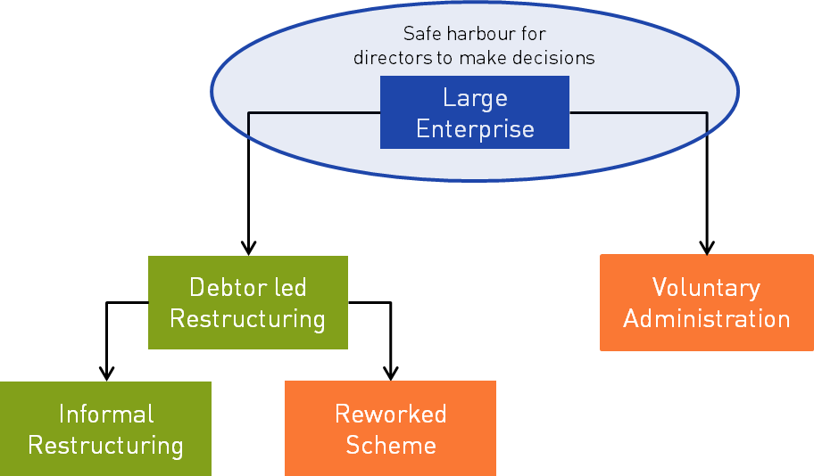

Policy 15-07: Reworked Schemes/Voluntary Administration to aid in the rehabilitation of large enterprises in financial distress
ARITA recommends that the following enhancements be made to the current Scheme of Arrangement provisions (and in some instances, to the Voluntary Administration/Deed of Company Arrangement provisions in Part 5.3A of the Corporations Act 2001) to further foster restructuring in Australia via statutory insolvency administration:
- implement ARITA’s restructuring moratorium (safe harbour) proposal to remove the current necessity for a precursor administration in Schemes of Arrangements
- enact a specific provision enabling a Scheme of Arrangement, subject to court approval, to have a standalone moratorium, including a restriction on the exercising of ipso facto clauses
- extend the voluntary administration moratorium to ipso facto clauses (refer policy 15-08 below)
- legislate to enable recovery of director related antecedent transactions in Schemes of Arrangement and Deeds of Company Arrangement to reduce their misuse by directors to protect their own interests
  - directors to have the ability to contract out of this liability with the Administrator in both Schemes and Deeds
- implement statutory provision for the obtaining of financing via a Scheme of Arrangement (or Voluntary Administration/Deed of Company Arrangement)
- remove related party voting in a Scheme of Arrangement and Voluntary Administration/Deed of Company Arrangement and reduction of voting requirements to a majority threshold in line with those in a Voluntary Administration/Deed of Company Arrangement, and
- limit voting using purchased debts to the value of consideration paid, consistent with the current requirements in the Bankruptcy Act 1966.
In addition to the above, ARITA believes that consideration should be given to the implementation of a “Schemes Panel” to replace the Court’s oversight of Schemes of Arrangement. It is envisaged that this panel would operate in a similar manner to the Takeovers Panel and be a government regulated peer review panel.

Policy 15-08: Extension of moratorium to ipso facto clauses
It is ARITA’s view that successful restructuring through voluntary administrations is hampered because the moratorium in a voluntary administration does not extend to clauses that allow the termination of contracts simply because of the insolvency event (ipso facto clauses).
Extending the moratorium to cover such clauses will ensure that important contracts of the business are maintained so that goodwill is preserved while the company is under administration. This serves to maximise the potential of the company and its business continuing as a going concern or otherwise maintaining its value to third parties. Currently the experience of our members is that where the business is reliant on maintenance of contracts, voluntary administration sees the swift demise of the business due to automatic termination of these contracts – the rights of contractual counterparties are escalated above the rights and interests of creditors as a whole.
Voluntary administration already provides a limited and temporary moratorium against ipso facto clauses in some types of contracts. The law restricts the rights of landlords, secured creditors, and others during the voluntary administration process, but not contracts generally. We see the need for a restriction on the right to enforce all ipso facto clauses at least for the period of the administration, which is generally some few weeks. Leave of the court could be available to challenge the moratorium.

Explanatory notes:
An ipso facto contractual clause allows one party to terminate a contract by reason only of the fact (ipso facto) of the insolvency of the other party. These clauses are found in the majority of critical supplier contracts, franchise and license agreements as well as leases for land and equipment.
Under s 301 of the Bankruptcy Act 1966, ipso facto clauses are rendered void if the relevant obligor becomes bankrupt. However, there is no such prohibition in relation to corporate insolvency, and more particularly voluntary administration, under the Corporations Act 2001.
As a result, if a financially distressed but viable business that is reliant on essential contracts continuing enters into voluntary administration, it is likely that:
- contracts will immediately be terminated
- there will no longer be any business to restructure, and
- there will no longer be any going concern value for creditors.
In some cases, directors may in fact be reluctant to place their companies into voluntary administration because of concern that this may result in creditors exercising their right to terminate under an ipso facto clause and in effect terminate the company’s business. This delay may weaken the company’s chance of financial recovery.
Policy 15-09: Streamlined liquidation for micro companies
Given the inherent lack of funding available for a formal insolvency process in financially distressed SMEs. ARITA believes that a reduced process liquidation option should be made available in certain circumstances for those companies at the small end of the SME spectrum, “the “micro companies”.
For companies where the micro criteria is not met, or creditors elect for a creditors voluntary liquidation in order to ensure investigation processes are undertaken, ready access for practitioners to an enhanced Assetless Administration Fund-style arrangement is necessary.
The current requirements of Australia’s liquidation processes impose a number of statutory reporting and process obligations on liquidators, which have the effect of increasing the costs of the liquidation and reducing, or eliminating, the return to creditors
We propose that to maximise the return to creditors, where companies with minimal liabilities fail, and they meet the micro company criteria (i.e. liabilities to unrelated entities less than $250,000), a new streamlined liquidation process automatically apply.
A new streamlined liquidation process would differ from the current liquidation requirement as follows:
- no requirement to call meetings, report to creditors, undertake investigations into the company and officers’ conduct and complete statutory reporting (e.g. s 533 report)
- expedited dividend process:
  - streamlined proofs of debt dealing process for debts under $10,000
  - no tax clearance required from the Australian Taxation Office where the dividend is less than $25,000 (10% of maximum liability amount) or 10 cents in the dollar, and
  - streamlined advertising and notice requirements for dividends less than $25,000 (10% of maximum liability amount) or 10 cents in the dollar, and
- fixed fee set by government for this type of liquidation, no remuneration accounting or approval.

In order to protect the rights of creditors and the integrity of the regime, the streamlined liquidation process would incorporate provisions whereby:
- the liquidator would report to creditors on appointment and gives them the option of converting the streamlined liquidation into a full creditors’ voluntary liquidation (i.e. where normal investigating and reporting obligations apply and remuneration of liquidator is given priority in the normal way)
- if a majority of creditors (excluding related party creditors) vote for this to occur then it converts and the liquidator does not have the power to convert to a full liquidation without this consent
- if the liquidator subsequently becomes aware of a matter which may warrant investigation, they can again seek creditor directions (including resolution by circulation, if appropriate) as to whether the liquidation should convert to a full liquidation, and
- if provable liabilities at any time in the process exceed $250,000 to unrelated entities the streamlined liquidation process would no longer be available and the existing creditors’ voluntary liquidation requirements would apply.

Policy 15-10: Micro Restructuring
Section 185C of the Bankruptcy Act 1966 provides a mechanism for individual debtors who meet specific eligibility criteria to enter a binding agreement with their creditors to accept a sum of money that the debtor can afford, more commonly referred to as a Part IX Debt Agreement.
Maximising the prospects of continuing the operations of financially distressed but viable small companies, we propose that a similar mechanism be implemented to deal with micro companies. It is envisaged that this process would be more streamlined and cost effective to implement than the compromise alternatives that are available under the existing Voluntary Administration/Deed of Company Arrangement provisions of the Corporations Act 2001.
To be eligible to undertake a micro restructuring agreement the company must:
- meet the definition requirements of a micro company
- be insolvent, and
- not have, or have directors who have, previously done a micro restructuring agreement. Such protection would be available under our restructuring moratorium proposals in Policy 15-04.
We would recommend that any micro restructuring mechanism would require:
- The company to prepare a Report as to Affairs (RATA) to be provided with the proposal.
- A Registered Liquidator to oversee the development and implementation of the proposal, possibly referred to as a Restructuring Monitor:
  - who examines and approves the proposal
  - issues the proposal to creditors, and
  - may set fixed or other fee basis for creditor consideration and approval at same time as proposal.
- Creditors vote to accept or to put the company into liquidation:
  - no need for physical meeting, with the resolution able to be considered by circulation
  - if creditors vote for liquidation then the company proceeds to liquidation immediately
  - related parties cannot vote, and
  - if debt is purchased then purchaser only entitled to vote for amount for which debt purchased.
- An accepted proposal would be put into effect by the Liquidator/Restructuring Monitor and would be subject to the following provisions:
  - no requirement to call or hold further meetings
  - if provable debts to unrelated entities exceed $250,000 then appointment would automatically convert to a Voluntary Administration with full investigation and reporting requirements (if directors wish to continue to put a Deed of Company Arrangement proposal to creditors), or creditors voluntary liquidation (if there is no Deed of Company Arrangement proposal)
  - streamlined proofs of debt process for debts under $10,000
  - no tax clearance from Australian Taxation Office required where dividend is less than $25,000 (10% of maximum liability amount) or 10 cents in the dollar, and
  - a default longer than six months automatically results in the company being placed into liquidation.
- Creditors may apply set aside the proposal if there is a lack of full disclosure in the proposal or injustice provisions, similar to the current requirements in a Part IX Debt Agreement.

Policy 15-11: Pre-positioned sales
ARITA supports a “pre-positioning” arrangement in situations of corporate financial distress, to enable viable businesses to continue and maximise return for creditors via a sale of business negotiated prior to an insolvency appointment.
Pre-positioning is work done prior to a statutory insolvency appointment. Directors take advantage of the proposed restructuring moratorium protections, subject to meeting the criteria for eligibility, to undertake an orderly wind down of the company’s operations – that is a well-managed process where assets may be realised for market value in a non-distressed sale – prior to making a formal insolvency appointment. Directors may obtain the assistance of advisors, including insolvency practitioners, during this process.
ARITA’s proposed pre-positioning framework would require that:
- Any advisor retained by the directors in the pre-positioning phase could not subsequently be appointed in any formal insolvency administration. This is consistent with the current and appropriate independence requirements for insolvency practitioners in Australia.
- Any sales that occur in the pre-positioning phase must be for value and would be subject to review in any subsequent statutory insolvency administration.
- Any sale of assets undertaken during the statutory insolvency administration, where the terms of sale were negotiated in the pre-positioning phase, would be subject to review by the external administrator prior to being effectuated and the external administrator would be subject to the currently existing statutory and professional requirements regarding the sale of assets.
It is ARITA’s view that consideration should be given to restricting the sale of company assets/business to related entities during this pre-positioning phase. Rather, where the sale of a business or the assets to a related entity is contemplated, and the company is insolvent, that sale must be undertaken under the control of an independent insolvency practitioner through a statutory insolvency regime; either a Voluntary Administration (subject to ARITA’s recommendations for improvements), a micro restructuring (refer Policy 15-10) or liquidation.
For a number of reasons (including independence, whether the sale is for value and the lack of creditor involvement) we do not consider that a UK-style pre-pack process would be suitable for Australia.

The list is adapted from the Harmer Report ([33]) and the Cork Report ([198]). See also the 2004 Parliamentary Joint Committee Report, Appendix 4.
Taken directly from the ARITA (then IPA), Law Council of Australia and the Turnaround Management Association Australia joint submission dated 2 March 2010 in response to the discussion paper Insolvent Trading: A Safe Harbour for Reorganisation Attempts Outside of External Administration
Noting that other statutory duties may still apply to these types of roles

