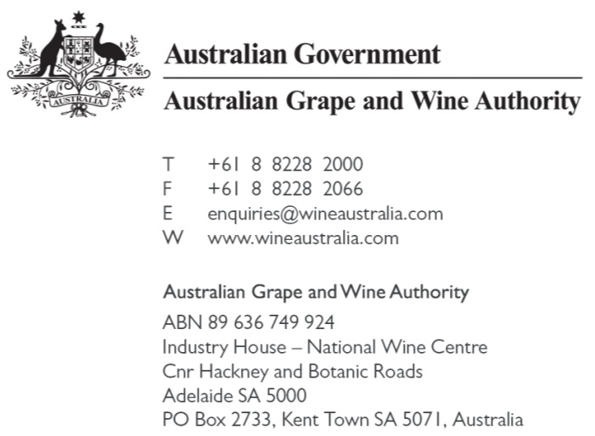
30 November 2015

Intellectual Property Arrangements
Productivity Commission
GPO Box 1428
Canberra City ACT 2601
intellectual.property@pc.gov.au

BY EMAIL

Dear Sir/Madam
Initial submission in relation to the inquiry into Australia’s intellectual property arrangements
The Australian Grape and Wine Authority (AGWA) welcomes the opportunity to make this initial submission to the Productivity Commission in relation to its inquiry into Australia’s intellectual property arrangements. In particular, we note that, in its Issues Paper, the Commission welcomes submissions on:
- how effective and efficient Geographical Indications (GIs) are in terms of protecting IP, including on a firm’s branding and reputation; and
- how GIs may help or hinder competition and consumer outcomes.

- Geographical Indications Framework – overview
AGWA is established under section 6 of the Australian Grape and Wine Authority Act 2013 (AGWA Act). Part VIB of the AGWA Act is devoted to the protection of geographical indications and other terms. The AGWA Act establishes a Geographical Indications Committee (GIC) who receive and assess applications for the determination of new GIs, having regard to the criteria for determining GIs and the requisite features of GI ‘regions’ and ‘subregions’ set out in the Australian Grape and Wine Authority Regulations 1981 (Cth) (AGWA Regulations). The process mandates a period during which the public can object to a proposed determination which occurs via the Registrar of Trade marks. It is an offence under the AGWA Act to import, sell or export a wine with an incorrect GI. A maximum penalty of 2 years imprisonment applies.
In determining Geographical Indications, the GIC must have regard to the criteria set out in Part 5 of the AGWA Regulations.
The system satisfies Australia’s obligations under the EU-Australia Wine Trade Agreement (Wine Agreement). These obligations include:
- the protection of protected terms (geographical indications, traditional expressions and quality terms)—through preventing:
  - the use of geographical indications on all wines not originating from the geographical indication in question (article 13);^{[1]}
  - the use of traditional expressions to describe wine not entitled to those traditional expressions (Article 16);^{[2]}
  - the registration of trademarks which contain or consist of a geographical indication or traditional expression (Articles 13 and 16);^{[3]}
- ensuring wines are not labelled with a term which is false or misleading about the character, composition, quality or origin of a wine (Article 19); ^{[4]} and
- undertake the necessary administrative measures or legal proceedings to ensure compliance with the Agreement (Article 25). ^{[5]}
Any changes to the current system would need to consider Australia’s obligations under the Wine Agreement.
- Strategic objectives – importance of geographic indications framework
Through developing our recent five-year Strategic Plan, we addressed two clear challenges to the prosperity of the Australian grape and wine sector.
Our first challenge: the general global perception of the quality and provenance of our wines is – in our view – less than the reality, and this translates into lower prices for our wine than are warranted. While this challenge affects the whole sector, its impact is greatest on the fine wine segment.
Our second challenge: we need to more profitably compete in a fiercely contested global marketplace. We must continue to improve the competitiveness of our wine offering through productivity gains, innovation, differentiation and meeting market demand.
These challenges were identified following extensive consultation with our levy payers – grape growers, winemakers and wine exporters, who echo our summation that increasing the perception of quality and provenance of Australian wine is paramount to increasing profitability of the sector and encouraging competition, trade and investment.
We submit that maintaining wine regionality is vital in ensuring successful promotion of Australian wine, and increasing the perception of quality and provenance claims for Australian wine. At a high level, we consider it essential in building Australian grape and wine excellence – which is pivotal to us achieving our strategic priority of increasing the demand and the premium paid for all Australian wine. GIs provide a framework which fosters positive consumer perception of quality and provenance of Australian wine which ultimately helps competition and consumer outcomes.
In addition, official recognition of geographical indications ensures that any private investment undertaken at a regional level is protected from claims of unfair competition, ensures that consumers are not mislead by unlawful statements relating to claims of origin, and enables protection of geographical indications to be advanced across governments through means such as the EU-Australia Wine Trade Agreement. A framework whereby certification trade marks were established to regulate claims of origin would not be as robust as the current system and would raise issues of ownership. We submit that the current regime is effective and efficient in protecting geographical indications, including our levy payers’ branding and reputation.
- Areas of possible reform
Process for omitting a GI
Under the current regulatory framework, it is impossible, in practice, to have a GI omitted from the Register of Protected Names and Other Terms (Register), or to have the boundaries amended.
The Geographical Indications Committee has no discretion over whether to omit a GI from the Register if there are any objections to such an application by any of the following:
- the Winemakers’ Federation of Australia (WFA), the Wine Grape Growers Association (WGGA), or any State representative bodies;
- the members of WFA, WGGA, any State representative bodies;
- any winemakers who make wine in the GI;
- any grower of grapes who grows grapes in the GI;
- any person who owns or lease land of five hectares or more in size in the GI; and
- any person with a commercial interest over a vineyard or property used in the production of wine within the GI (assuming the person with whom the agreement to create the commercial interest is forged with one of the persons listed above).
We would support a proposal whereby discretion were vested in the GIC to amend or omit a GI from the Register.

‘Nesting’
Regulation 21 of the AGWA Regulations provides that, if a single GI designation is to be made on a label, 85% of the grapes used to make that wine must have been sourced from that GI. The Regulation also allows multiple GIs to be displayed on wine labels. If multiple GIs are displayed on a label, the GIs must be displayed in descending order, and 95% of the blend must be from the GIs listed.
This causes the potential for consumers to be misled where a small amount of the blend is from a sub-region (which is listed), and the remainder of the blend is from the wider region within which that sub-region sits. For example, ‘Barossa Valley’, ‘South Australia’ and ‘Australia’ all appear on the Register. Accordingly, if 35% of the grapes used to make a blend are derived from the Barossa Valley, 33% is from ‘South Australia’ and the remainder of the blend is from the greater ‘Australia’ GI, a producer may label ‘Barossa Valley, South Australia, Australia’, suggesting that the wine is entirely from the Barossa Valley, when in fact only 35% of the wine is from that region.
We would welcome debate over whether the legislation should be amended to provide that only multiple distinct (rather than overlapping) GIs should be allowed to be displayed on wine labels.
AGWA welcomes further engagement with the Productivity Commission in relation the review of the current GI framework in Australia.
Yours sincerely,

Rachel Triggs
Legal Counsel (and Registrar of Geographical Indications and Other Terms)
Australian Grape and Wine Authority

AGWA Regulations 24 and 25.
[1] Effected under Part VIB of the AGWA Act.
[2] Protected under Part VIB of the AGWA Act.
[3] Effected under the Trade Marks Act 1995.
[4] Effected under Part VIB and section 44 of the AGWA Act, the Australian Consumer Law.
[5] Effected under the export licensing function set out under the AGWA Regulations, section 44 of the AGWA Act, the Label Integrity Program established under Division VIA of the AGWA Act, and the offence provisions set out in Divisions VIA and VII of the AGWA Act.
Kept under section 40ZC of the Australian Grape and Wine Authority Act 2013.

