**Assumptions about Manager Performance**

**Implications for Superannuation Policy**

A submission by Peterson Research Institute to the Productivity Commission in respect of the Draft Report on ‘How to Assess the Competitiveness and Efficiency of the Superannuation System’.

September 2016

**Assumptions about Manager Performance**

**Implications for Superannuation Policy**

Assumptions about the ability of Investment Managers to add value in investment portfolios have considerable significance in finance and investment. In particular, they have an **important bearing on decisions relating to portfolio construction** and the relative attractiveness of active and indexed approaches to investing.

There are three requirements for active investment management to add value in superannuation fund investment portfolios, specifically:

1. That some investment manager’s perform consistently;
2. That superannuation funds have strategies and procedures which allow them to identify and select those investment managers; and
3. That the additional returns earned by those investment managers exceed the fees charged.

The principal underlying requirement for active investment managers to be able to ‘add value’, over ‘index’ or ‘passive’ investment approaches in superannuation fund investment portfolios relates to the consistency (or persistence) of manger performance. Figure 1, sets out the logical arguments related to portfolio construction and manager selection which follow from managers exhibiting, or not exhibiting, consistent investment performance.

**Figure 1**

|  |
| --- |
| **If Investment Managers do not perform consistently, then**: |
| * It is not possible for Investors to select Managers that will consistently add value. |
| * Investors will get random Manager performance |
| * Investors will get Average Manager returns |
| The Average Manager underperforms the Market, therefore:   * Invest primarily in market beta asset classes. * Invest in Index funds |
| * Avoid costs from manager fees and transaction costs |

The assumptions made by the Cooper and Murray Committees of Inquiry about the ability, or otherwise, of investment managers to contribute positively to superannuation investment returns, are not explicitly stated. However, the recommendations of both Committees, and their implementation in Legislation and the Policies of both ASIC and AHPRA, effectively demonstrate that active investment management is viewed primarily as a cost. For example:

* RG 97.42 notes that issuers of a PDS must, “take into account **the costs** of making direct investments, as well as the costs of investing in entities that fall within the definition of ‘interposed vehicles’ …. These costs include, but are not limited to, **management fees based on the value of assets and fees based on the return paid** from the interposed vehicle”.
* RG 97.43 defines ‘indirect costs’ for superannuation products and managed investment products, to include, “**amounts that reduce the amount or value of income or property attributable to an investor’s investment**”.
* SIS Act 1993 s 29V(3) addresses Investment Fees as they relate to reporting in product dashboards for MySuper and qualifying choice investment options.

**This implicit treatment of active investment management as a cost** – and hence something to be minimized – rather than a source of investment risk and return, **is having a very significant influence on the portfolio construction and manager selection policies adopted by many Australian superannuation funds**. That this assertion reflects reality is supported by a number of senior superannuation and investment industry practitioners, including:

1. David Hartley (Retired Chief Investment Officer of Sunsuper: Hartley, 2016), who notes that, “Current fee disclosure in the Australian superannuation industry is not transparent”, which thereby creates, “**compromised fiduciary duty**” (emphasis added), on the part of RSE’s.

Furthermore, Mr Hartley notes that the current fee disclosure regime, “is **also encouraging investment strategies that will become increasingly concentrated in a narrow range of strategies**, such as passive investment in a narrow range of publicly traded securities. The **concentration of strategies** introduces systemic risks to the economy. At the same time, **other investment opportunities that could enhance the broader economy will remain starved of capital**”, (emphasis added).

1. Russell Clarke (Chair of the global investment committee for Mercer’s US$130 billion implemented investment portfolio: Clarke 2016) states that the, “**pressure to lower management fees** across all asset classes in Australia had become extreme in the past three years and was **threatening to negatively impact net-of-fee returns because [superannuation] funds were altering asset mixes** away from more expensive, potentially higher returning, asset classes” (emphasis added).
2. Greg Bright (Managing Director and Publisher, Investor Strategy News: Bright 2016) notes that, “A major looming problem for super funds is that **the very best managers in the world are not going to bother offering their services to Australian funds**. Anecdotally, some have already started to ignore Australia in their asset-gathering activities. They are reserving precious capacity for other investors” (emphasis added).
3. Personally, I have observed a significant increase in allocations by superannuation funds to more passive investment strategies in traditional investment markets such as domestic and international equities – including indexed and enhanced index, and factor/beta strategies. I have also received considerable anecdotal evidence that investment decisions driven by fee pressures are common in the alternative asset classes, including observations by industry colleagues that they are only permitted to make new investments that reduce the superannuation fund’s MER. I have also observed a significant increase in allocations to co-investments in alternative assets, which by their nature leave superannuation funds with more concentrated exposures to larger transactions in private equity, infrastructure, etc., than would be the case if investments were made in the more ‘optimally’ constructed funds offered by managers.

This is not to imply that investment management fee negotiations that reflect the scale and bargaining power of superannuation fund investors is not completely appropriate. This aspect of fee negotiation is also noted in the press (Gordon 2016; Patrick 2016). I fully support, and have personally conducted, such negotiations which, in a competitive and transparent investment industry should clearly benefit investors.

However, **there is considerable evidence that investment decisions are being influenced by a desire to minimise reported Management Expense Ratios** – in order to meet the requirements of regulators and gatekeepers - **rather than to meet an objective of maximising net returns to investors**. This represents a potentially considerable **misallocation of investment resources – and hence allocation inefficiency - to the ultimate detriment of superannuation investors and the functioning of the wider economy**.

**Prescriptive Regulation**

To a significant degree the Cooper Committee’s recommendation for the establishment of the MySuper product, with its explicit focus on fees and costs rather than net investment returns, represents a significant backwards step towards the prescriptive regime of superannuation regulation that existed prior to the Campbell Committee of Inquiry in 1981.

(Note: The Treasury’s public position on MySuper on its website begins with the statement that, “MySuper is a new, simple and **cost-effective** superannuation product” (emphasis added). At no point is explicit reference made to MySuper products having a high(er) return objective, however there does appear to be an implicit assumption that lower cost and fees (including investment management fees), directly corresponds to higher fund returns. This cost-effective / low-cost philosophy has been perpetuated, with the inclusion of investment management fees in fee and cost ratios in both legislation and regulation.)

Thus, while the MySuper regime does not explicitly call for a reduced allocation to active management investments – and hence lower levels of manager skill in superannuation fund portfolios – the affect of the regime, as currently implemented, has **this prescriptive outcome**.

A major concern with prescriptive regulation, particularly on the area of investments, is **the high likelihood of unanticipated and undesirable outcomes being produced**.

**It is my contention that the current regulatory regime under which superannuation funds operate is producing considerable inefficiencies in investment strategy and allocation, with large negative outcomes for investors and the broader community**. This contention is based on two premises:

1. The significant difference between the revealed preference of investors – in particular the trustee directors of superannuation funds – and the actual investment decisions made under the current regulatory regime; and
2. The basing of current prescriptive legislation and regulation on ‘analysis’ of markets and manger performance that is fundamentally flawed.

**Revealed Preference**

First, it can be readily observed that, prior to the introduction of the Cooper/MySuper regulatory regime, those superannuation funds with fewer investment constraints – notably industry and government funds – displayed a markedly greater tendency to allocate to assets with higher manager fee structures. These investments include Infrastructure, Private Equity and Hedge Funds, among others.

It would be difficult to argue that these investment decisions by the Trustee/Directors of these superannuation funds reflected compromised fiduciary duty. Instead, I would argue that the revealed preference of the least constrained superannuation investors expressed a preference for investment strategies with higher investment manager fees because they believed that higher net investment returns would be achieved for fund members. It is also notable that this preference evolved over, and was sustained for, many years.

That the effect of current superannuation regulation is to prescribe an approach to superannuation investment that is diametrically opposed to this revealed preference should, at a minimum, raise significant questions as to whether an optimal and efficient outcome will be achieved.

It is also worth noting that the only Australian investment fund with comparable size, investment objectives and time horizon to institutional superannuation funds – the Future Fund – has adopted an investment strategy with a relatively high emphasis on manager skill in its portfolio. (The investment approach of the Future Fund was analysed in the research paper titled ‘Investment Risk and Portfolio Risk’ (PRI, 2013: Attached). While there are obvious differences in the clientele of the Future Fund and large Superannuation funds, from an investment perspective the objectives and strategies should be broadly similar. The differences in investment strategy reflect, and I believe can be significantly attributed to, the effects of the regulatory stance regarding investment management fees and cost applied to superannuation funds.

**Analysis of Investment Performance**

Second, it should be noted that the current regulatory structure did not simply appear as the result of a whim by the members of the Cooper and Murray Committees. Their recommendations, and the subsequent formulation of legislation and policies to give them effect, were based on judgements concerning the best ‘evidence’ available to them**. Unfortunately, the vast majority of the ‘evidence’ concerning superannuation fund investments, and hence the conclusions based on it, are incorrect**.

I will ask the Commission’s forbearance as I explain. Unfortunately, the journey involves a number of steps, and for those trained in ‘classical’ finance, a certain degree of recasting of accepted wisdom.

Recall from the initial pages of this submission, that the foundation of any consideration of the attractiveness, or otherwise, of active investment management (i.e., Manager Skill) in superannuation investment portfolios is the **consistency of manager performance**. If manager performance is not consistent, then it is difficult to select managers who will add value in the future, and active management is unlikely to increase investment returns. The corollary is that if manager performance is consistent, then the use of active management may lead to increased returns after fees, and hence would be worthwhile.

**Modern Portfolio Theory and the Source of Investment Returns**

The starting point in any discussion on manager performance must be to develop a common understanding around the sources of returns in investment portfolios.

First, there are three fundamental principles that underlie the theoretical edifice that we know as Modern Portfolio Theory (MPT).

1. Investors are **rewarded for taking** **Investment Risks**;
2. **Returns are additive**; and
3. **Risks diversify in portfolios** (and therefore Portfolio Risk is less than the weighted summation of individual Investment Risks).

All other components that we associate with the ‘Classical Implementation’ of MPT, such as the CAPM, Efficient Frontiers, Sharpe ratios, etc. are based on these underlying principles.

(Note that this implies that Investment Risks, which are related to individual investments, and Portfolio Risks are distinctly different. It is easy to, but important not to, confuse them).

Second, there are **only three sources of investment returns** in a superannuation investment portfolio:

1. Placing the money into superannuation in the first place (which at a minimum will earn the cash rate of return with no Investment Risk);
2. Allocating some (up to 100%) to assets that have Market Risk (or volatility), and should earn Market Risk Premia; and
3. Allocating some (up to 100%) to assets with Manager Risk (or volatility), and which should earn a Manager Skill Premia (commonly described as Alpha).

**Market and Manager Risks are Investment Risks. Superannuation funds should be rewarded – by earning additional returns – for taking market and manger risks.**

In a portfolio of investments, **Market and Manager Risks should diversify**, leaving an overall Portfolio Risk. **Superannuation funds do not earn additional returns for taking Portfolio Risks**.

These sources of Investment Risk are illustrated in Figure 2. Note that it is possible to sum the Investment Risks associated with each investment – whether Market or Manager – to give the Total Investment Risk in a portfolio.

**Figure 2**

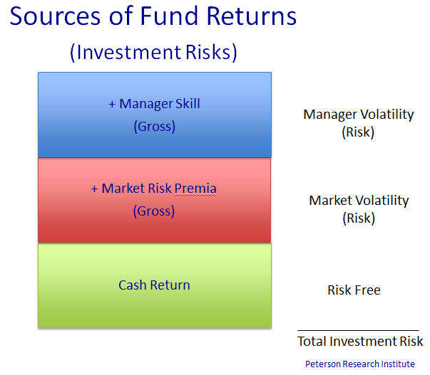

**Consistency**

It is generally accepted that consistent and persistent performance is a necessary condition for investment returns to be repeatable and predictable.

**Assessment of Consistency**

The typical approach to the analysis of the consistency of manager performance is to assess whether investment managers who perform well in one period – as instanced by top-quartile or some other measure of investment returns - repeat that performance in a subsequent period (Carhart (1997); Fortin & Michelson (2010); Juru & Johnson (2015); Pfeiffer & Evensky (2012); Soe (2016)). This is also an implicit assumption underlying statistical measures such as the Sharpe Ratio (returns over cash divided by volatility), as only managers who achieve high returns in both periods will have a high Sharpe Ratio over the full period.

Assessment of the relative rankings of manager performance over two periods involves the managers or funds being grouped into categories of relative performance in a contingency table.

If there is no consistency of performance (i.e. if performance is random across the two periods), then it would be expected that an equal number of investment funds / managers would be found in each cell of the contingency table. Where performance is ranked in quartiles the resulting 4 x 4 contingency table for 160 managers without consistent performance would look like this:

**Figure 3**

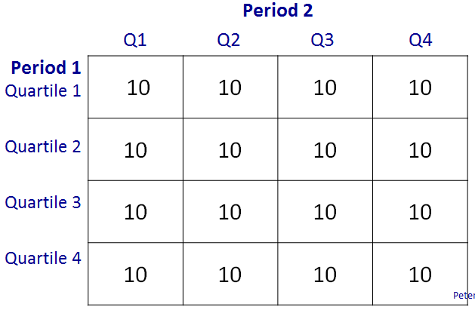

**Consistency in Market Behaviour**

It is proposed that the variability of market returns is greater than the variability of manager returns. Correspondingly, it is to be expected that market returns will exhibit less consistency, than manager returns.

This is demonstrated in the following tables of market and manager investment returns and volatilities. Market Neutral Hedge Funds provide the best available estimates of the volatility of manager risks that arise from the application of manager skill, as ideally, market risks are hedged out. These are relatively low, and stable.

Market volatilities also tend to be relatively stable, as seen for US and Australian Equities, and also for the ‘Size Factor’ (calculated from the differences in monthly returns between the ASX/S&P 300 and Small Caps Indexes). The market volatilities are substantially greater than the volatility of manager returns.

**Table 1**

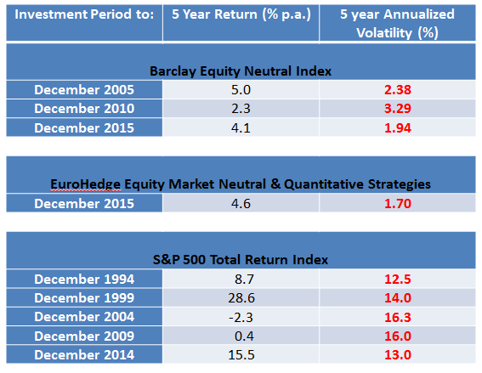

**Table 2**

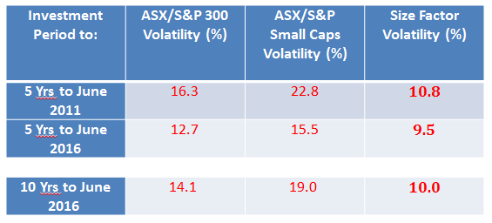

It can also be expected that among investment managers in a particular market or sector there will be a continuum from those managers with a greater proportion of the investment risk in their portfolios derived from exposures to market factors – as a result, for example, of larger and/or more consistently held factor/style tilts - through to those with a higher proportion of investment risks derived from manager risks.

**Patterns of Performance**

There is a general consensus that the behaviour of investments and markets in the actual economy does not conform to some of the underlying assumption of modern finance and portfolio theories. Specifically, the return pattern of investments, and hence of investment managers, is neither Static/Repeating (Static) nor Random/Efficient (Random). Unfortunately, virtually all economic and finance theory, and hence research into market and manger behaviour, is based on the assumption that the economy and markets conform to one or both of these definitions – and sometimes to both simultaneously.

In the remainder of this paper the expected return pattern of manager returns under conditions of uncertainty (Complex markets) are described. The ‘real world’ – including economies that exhibit characteristics described in Behavioural Finance – fall into this broad category. (Note, that in both Static and Random markets, it is not possible to influence market behaviours or outcomes. Thus, creating regulations, conducting Inquiries and establishing Productivity Commissions are implicitly recognising that the actual financial system is Complex.)

**Each of the three market types implies a unique and significantly different pattern of performance from active investment management when assessed across multiple investment periods.**

**Static Markets**

In Static Markets the absolute and relative performance of an investment manager in one period (Period 1) must simply be repeated in the subsequent period (Period 2), as the investment conditions experienced are the same in both periods.

Thus a manager who is first (top) quartile in Period 1 would be expected to also be first quartile in Period 2. Similarly a manager with second quartile performance in Period 1 would be expected to also be second quartile in Period 2, and so on. We could represent this expected Pattern of Performance for investment managers under Static Market conditions diagrammatically in the 4x4 contingency table in Figure 4.

**Figure 4**



Where, Dark / Green represents a more frequent outcome (greater than random probability, > 6.25%), and Light / Pink a less frequent outcome (< 6.25%). An outcome of exactly 6.25% would be represented by a white cell.

**Random Markets**

In Random Markets the performance of an investment manager in one period will be completely unrelated to its performance in the next period, as there is no opportunity for the manager to predict or respond to changes in investment conditions. A market that is ‘efficient’ also provides no opportunity for a manager to develop and apply insights about the performance of the market or its constituent securities, and so may also be classified as random. In Random Markets the relative performance of a manger in both periods is determined solely by luck.

A manager who is top quartile in Period 1 would be expected to randomly fall into any quartile in Period 2. We could represent this diagrammatically as in Figure 5.

**Figure 5**



**Complex Markets**

Complex Markets encompass all other forms of market behaviour - including those corresponding to real world conditions. Complex Markets are characterized by real uncertainty and are represented in economic and financial theories and models that incorporate uncertainty, time and market inefficiencies.

In Complex Markets it is possible for investment managers to acquire insight into the future behaviour of the economy and markets – although because of the complexity, perfect knowledge, and thus complete certainty, can never exist.

The performance of an investment manager in Complex Markets will be determined by a combination of Investment Skills and Market Factors - including those arising from value, growth or other persistent style or factor tilts.

(Note that the reality is far more ‘grey’ than the usual ‘black and white’ differentiation assumed to exist between ‘style’ and ‘skill’. For example, an active investment position (Manager Risk), if held for long enough, becomes indistinguishable from a market factor ‘style’ tilt (Market Risk).)

It can be expected that, for investment managers with a relatively greater proportion of exposure to Market Risks than Manager Risks, market related factors would be relatively more important than manager skill in determining investment performance. As Market Risks are typically larger (i.e., more volatile), and also less consistent, than Manager Risks, these managers’ funds are more likely to have extremes of performance. Their funds’ will therefore be found more frequently in either the first (lucky) or fourth (unlucky) quartiles of performance in any given period, depending on how markets behave.

Also, due to effects such as mean reversal, these managers’ funds are more likely to have extreme results - either first or fourth quartile – in subsequent periods. Thus, managers who’s Market Risks is relatively greater then Manager Skill can be expected to have less consistent relative performance. These can therefore be described as ‘Inconsistent Managers’.

Alternatively, for other managers, Manager Skill will be proportionately greater than exposure to market factors. These managers’ funds will be less likely to experience extreme investment outcomes and will therefore be found more frequently in the second or third quartiles of performance. Moreover, these less extreme managers’ funds are likely to have less extreme results (second or third quartile) in subsequent periods. The pattern of their investment returns can be expected to be more consistent relative to a market reference or to manager peers. For this reason we can appropriately call these ‘Consistent Managers’.

If active managers are not consistently exhibiting skill, then the distribution of their relative performance will be random. Therefore, when active investment mangers perform consistently, this will be represented in an analysis by the occurrence of a higher than random frequency of second and third quartile returns in both periods.

Combining the expected two period outcome patterns for Inconsistent and Consistent Managers, the overall Consistent Pattern of Performance (CPP) expected when active investment managers are performing consistently is given in Figure 6.

**Figure 6**



It follows therefore that in Complex Markets, such as occur in real financial markets**, it is necessary to take into account and analyse the full pattern of investment returns,** rather than the performance of individual managers, or of a sub-set (e.g., top quartile) of managers. (This is a basic characteristic of complex systems in general, where the overall pattern of outcomes can be difficult, or impossible, to identify from the analysis of only a small part of the whole.)

**TESTING THE CONSISTENCY OF MANAGER PERFORMANCE**

To test for the existence of consistency of manager performance two aspects of the sample Pattern of Performance need to be assessed:

* First, whether the pattern of performance of the sample conforms to the Consistent Pattern of Performance; and
* Second, whether the sample’s pattern of performance is significantly different from a random allocation.

**Each of these aspects can be assessed statistically.**

A comparison of the actual pattern of performance of managers in the sample to the Consistent Pattern of Performance can be made on a cell by cell basis, with each cell either matching – i.e. both having more or less managers than expected from a random allocation - or not matching.

This comparison can be analysed as a binomial distribution where n=16. If there were no constraints on the distribution of outcomes making up the pattern of performance there would be 216 = 65,536 possible combinations of matches. However, not all combinations are allowed, as in each row it is not possible for all cells to be greater or less than the expected values. That is, at least one cell must be greater than the expected value if another cell(s) is less than the expected value. Allowing for this restriction, there are 38,416 possible combinations of matches between the sample pattern of performance and the Consistent Pattern of Performance.

For example, the probability of all 16 cells in the sample exactly matching the Consistent Pattern of Performance is 1 in 38,416, or 0.000026, whereas the cumulative probability of only 8 cells matching – which would be expected from a random allocation in the sample set, would be 0.5909.

The cumulative probability is the probability (p) in a statistical test of accepting the hypothesis that the sample pattern of performance is the same as the Consistent Pattern of Performance when it is not (i.e., of making a Type-1 error). (Note, our hypothesis test (H0) is therefore that the sample pattern of performance is not the same as the Consistent Pattern of Performance, not that the sample pattern of performance is random.)

While the sample pattern of performance may be found to be not significantly different from (i.e., statistically the same as) the Consistent Pattern of Performance, this finding would not be meaningful if the sample pattern itself was essentially a random allocation. This can be assessed using the non-parametric Chi-squared statistic, which measures the probability that the allocation is random.

For example, while the pattern of performance of the 160 funds presented in Figure 7, exactly matches the Consistent Pattern of Performance, the values (number of funds) are not sufficiently different from the mean of 10 per cell to be statistically different from a random allocation (χ2 = 0.996).

**Figure 7**

|  |  |  |  |  |  |
| --- | --- | --- | --- | --- | --- |
|  |  | Period 2 | | | |
|  |  | Q1 | Q2 | Q3 | A4 |
| Period 1 | Q1 | 11 | 9 | 9 | 11 |
| Q2 | 9 | 11 | 11 | 9 |
| Q3 | 9 | 11 | 11 | 9 |
| Q4 | 11 | 9 | 9 | 11 |

Therefore we can now:

* **Identify** the overall ‘**Consistent** **Pattern of Performance**’ that will occur in the ‘**real world**’ if **Investment Managers are performing consistently**.
* **Measure** the likelihood that a particular sample Pattern of Performance is random, or is a pattern that indicates the existence of Consistent Performance.
* **Assess** whether a sample Pattern of Performance is significantly different from a random (or expected value) pattern.

**ANALYSIS OF THE CONSISTENCY OF MANAGER PERFORMANCE**

The virtually universal ‘test’ of the ‘consistency of manager performance’ that we see in industry and academic research is based on analysing whether ‘top quartile’ performance in Period 1 is repeated in Period 2 (Bender, Hammond & Mok, 2014; Carhart [1997]; Fortin & Michelson [2010]; Juru & Johnson [2015]; Soe, [2016]; Vidal-Garcia [2013]).

However, the only market condition under which managers can be expected to be consistently in the top quartile across multiple periods is Static Markets (as seen in Figure 3).

Therefore, **testing for repeated top quartile performance across periods is actually testing whether markets are Static.**

The failure to find repeated top quartile performance in these ‘tests of manager consistency’ simply reflects the reality that markets are not Static, and **says nothing about the existence, or otherwise, of manager consistency**.

This observation applies to every piece of analysis of investment manager performance considered by the Cooper and Murray Committees.

**Evidence from Investment Funds available to Australian Investors**

**1. The Vanguard Study**

Juru and Johnson (2015) of Vanguard Investments Australia published a study of Australian Investment Manager performance titled ‘The difficulties picking fund manager winners’, (the ‘Vanguard Study’). (I note that a 2015 paper by Vanguard titled “The Case for Index Fund Investing in Australia”, referred to in the Draft Report is also authored by Johnson and Juru.)

In the Vanguard Study the performance of 663 actively managed funds, across multiple asset classes, was analysed. Funds were initially ranked, ‘in terms of excess return versus their stated benchmarks over the five years ended 2009’. The funds were then divided ‘into quintiles, separating out the top 20% of funds, the next-best-performing 20% of funds, and so on’. The Study then tracked the funds’, ‘excess returns over the following five years (through December 2014) **to check their performance consistency**’ (Emphasis added).

Consistent with other studies, the Vanguard Study focused on the performance of the highest quintile performing funds in Period 1, and their subsequent performance in Period 2. The Study proposed as its research question that, ‘**a significant majority**’ of funds with top quintile performance in Period 1 **should** repeat that performance in Period 2.

The conclusion of the Vanguard Study was that, ‘**the results for Australian funds do not appear to be significantly different from random**’. Consistent with the argument set out in Figure 1, the implication drawn was that, as managers did not exhibit performance consistency, then it is not possible to identify in advance those managers who will outperform in the future.

As noted above, the analysis used in **the Vanguard Study was actually testing for the existence of Static Markets** and, like most comparable studies, found that, in the real world, markets are not Static. **Unfortunately, it is not possible to draw any conclusions about manager consistency** from the narrow subset of components of the study actually assessed (Period 2 relative performance given first quintile Period 1 performance).

To be consistent with the analysis in this submission, the results of the Vanguard Study have been recast into quartiles. (There are certain statistical reasons why quartiles are to be preferred to quintiles, and no identifiable theoretical reasons for such a preference.) These recast results are presented in Figure 8.

**Figure 8. Quartile Ranking of Actively Managed Australian Funds**

**Quartile Ranking in Period 2**

**(5 years to June 2014)**

**Quartile Ranking**

**in Period 1**

**(5 years to**

**June 2009)**

As can be seen, the Pattern of Performance of excess manager returns in the Vanguard Study is, with the exception of the Q1/Q4 and Q3/Q4 outcomes, identical to the pattern expected when active Managers, operating in Complex Markets are performing consistently over time. Fourteen of the sixteen cells in the sample pattern of performance match the Consistent Pattern of Performance.

The results of applying the statistical analysis developed previously, found that the distribution of manager outcomes in the sample pattern of performance in not random (χ2 = .0000), and is not statistically different from the Consistent Pattern of Performance (p = .0004).

I would also note that in the 2016 version of Vanguard’s publication, “The Case for Low-Cost Index-Fund Investing”, (Harbron, Roberts & Johnson, 2106), the same analysis is reported for funds available to Australian investors for periods ending 31 December 2010 (first period) and 2015 (second period) with similar conclusions reached.

*“we concluded that consistent outperformance is very difficult to achieve. This is not to say that there are not periods when active management outperforms, or that no active managers do so regularly. Only that, on average and over time, active managers as a group fail to outperform; and even though some individual managers may be able to generate consistent outperformance, those active managers are extremely rare”.*

In reality**, the actual finding in this study by Vanguard is, again, that markets are not Static**. When analysed correctly it was found that 14 of 16 cells in the sample pattern of performance matched the Consistent Pattern of Performance. This finding means that **there is a 99.96% probability that the actual performance of managers was consistent over these periods**. (The statistical analysis also found that the sample pattern of performance had only a 0.04% probability of being random.)

*Thus, the Vanguard Studies actually provide* ***very strong evidence*** *(virtually proof) that* ***Managers available to Australian Investors******do have consistent performance****.*

**2. Australian and Global Equities**

Data was obtained from Morningstar Australia on the performance of actively managed investment funds available to Australian Investors. The funds were analysed in the two groupings of Australian Equity investments and Global Equity investments. Australian based investment managers managed the majority of Australian Equity investments, while managers based in Europe and the United States managed the majority of the Global Equity Investments.

The consistency of returns were analysed in two studies. Each study covered the two, 5-year periods ending June 2009 and June 2014. (For consistency, these are the same time periods as used in the Vanguard Study.)

The pattern of performance for each group of funds are presented in Figure 9:

**Figure 9**

|  |  |
| --- | --- |
| **Fund Group** | **Sample Pattern of Performance** |
| Australian Equity Funds | Second Period    First  Period |
| Global Equity Funds | Second Period  First  Period |

The statistical results are presented in Figure 10.

**Figure 10**

|  |  |  |
| --- | --- | --- |
|  | Australian Equity Funds | Global Equity Funds |
| Number of Funds | 177 | 96 |
| Number of cells matching the Consistent Pattern of Performance | 14 | 11 |
| Hypothesis Test  H1: The sample pattern of performance is the same as the Consistent Pattern of Performance.  H0: The sample pattern of performance is random (i.e. not the same as the Consistent Pattern of Performance). | *p*=.0004 | *p*=.0497 |
| Significance Test  H1: The sample distribution of managers is not random.  H0: The sample distribution of managers is random. | χ2 = .0001 | χ2 = .0378 |

For both Australian and Global Equity Funds the analysis rejects the Null Hypotheses (H0) that the sample pattern of performance is not the same as the Consistent Pattern of Performance and that the sample distribution of managers is random, at the 5% level of significance.

These results also strongly support the existence of consistency in manager performance.

**Implications**

Across the studies analysed, it was found that there is very strong evidence that investment managers available to Australian superannuation funds do perform consistently.

This finding has profound implications for the question of the most efficient and productive way in which to investing superannuation fund assets. These implications – which are the corollary to the logic in Figure 1 – are set out in Figure 11:

**Figure 11**

|  |
| --- |
| **If Investment Managers do perform consistently, then**: |
| * It is possible to select Managers that will consistently add value. |
| * Investors will not invest with the Average Manager. |
| * Investors will not get Average Manager returns. |
| It does not matter whether the Average Manager underperforms the Market, as Investors do not invest with the Average Manager, therefore:   * Invest in ‘skill rich’ strategies and asset classes. * Invest with Active Managers |
| * There are cost, due to lower returns and higher risks, from investing in Index funds |

It follows therefore that as active investment managers do perform consistently then **there is scope for Australian Superannuation Funds to select active investment managers who will consistently add value after fees**. This finding is of itself sufficient to show that **the measurement and reporting of investment management fees**, as opposed to allowing them to be ‘reported’ in net investment returns, **will generate signals from regulators and other gatekeepers to superannuation fund trustee/directors that will have the effect of distorting investment allocations away from optimal**. As noted previously, this is clearly the case in the Australian superannuation system, with many investment decisions being significantly influenced or constrained by concerns around gross management fee levels, rather than being focused on net investment returns.

Evidence of the likely and actual effects of this distortion can be identified in actual superannuation fund returns.

**The Zero Sum Game**

While not directly applicable to the considerations of the Commission’s Draft Report, it is worthwhile also discussing the concept of the “Zero Sum Game” which is commonly put forward as a further reason why investment managers ‘must’ underperform, for example by Harbron, Roberts & Johnson, (2106).

The essence of the Zero Sum Game Theory is the argument, as for example stated by Harbron, Roberts & Johnson, (2106) that, “for each position that outperforms the market, there must be a position that underperforms the market by the same amount, such that, in aggregate, the **excess return of all invested assets equals zero**” (emphasis added). It follows therefore that any fees charged for active investment must reduce returns to investors in aggregate by that amount.

The **fallacy in this argument again lies in the assumptions made about markets** (in my experience these assumptions are never spelled out). Most importantly**, the Zero Sum Game argument assumes that Markets are Static** – something which Vanguard’s own analysis proves is not the case.

If markets are Static, then, the excess return of all invested assets will in fact equal zero. **There is no growth, and no opportunity for the financial system to reallocate assets to improve the efficiency of production and outputs**. (There would also be no need for a Productivity Commission as nothing could be done to improve productivity and efficiency.)

In reality, most people accept that markets are not Static. It follows therefore that the actions of active investment managers in, for example, moving asset prices closer towards fair value, can improve allocative efficiency and create value. This implies therefore that markets and investment are not a zero sum game, and nullifies the Zero Sum Game argument that investment managers ‘must’ underperform

**Active Investment Management in Australian Superannuation Funds: Evidence**

As noted at the start of this submission, there are three requirements for active investment management to add value in superannuation fund investment portfolios, specifically:

1. That some investment manager’s perform consistently;
2. That superannuation funds have strategies and procedures which allow them to identify and select those investment managers; and
3. That the additional returns earned by those investment managers exceed the fees charged.

The preceding analysis has established that there is considerable evidence of consistent investment manager performance in Australia (Requirement 1).

The further question is whether Australian superannuation funds are in fact able to select investment managers who will add value after fees (Requirements 2 & 3). This section considers evidence related to this question.

First, consider the case where either **superannuation funds are not able to select managers who will perform consistentl**y, or the additional returns generated by managers **does not exceed their fees**. In this instance the relationship between the net investment return earned by superannuation funds and their level of exposure to investment manager skill, **MUST be inverse**, (i.e., higher levels of manager skill must be associated with lower net investment returns) as indicated in Figure 12.

**Figure 12**

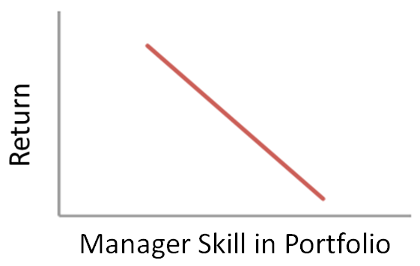

Alternatively, if :

* Some managers consistently add value; and
* Super funds are able to select those Consistent Managers; and
* Those Consistent Managers earn returns that exceed their fees

Then an increased exposure to manager skill in a portfolio **WILL** lead to higher net investment returns – i.e., an upward sloping relationship.

The evidence presented below is based on the following:

1. Australian ‘Growth’ style superannuation fund products (This represents the vast majority of institutionally managed superannuation fund assets over this period.);
2. These funds’ investment allocations as at 30 June 2009;
3. 10 year net investment returns to investors for the period from June 2003 to June 2013;

In the following chart (Figure 13), the annualised net return to investors for the 10 years to June 2013 is plotted on the vertical (left) axis. The percentage of each fund’s Investment Risk contributed by active Manager Skill is plotted on the horizontal axis. (If you refer to Figure 2, this percentage is calculated by dividing the Manager Volatility amount by the Total Investment Risk. Figure 13, and subsequent charts are derived from the Peterson Research Global Investment Analysis system (GIA: www.prigia.com)).

**Figure 13**

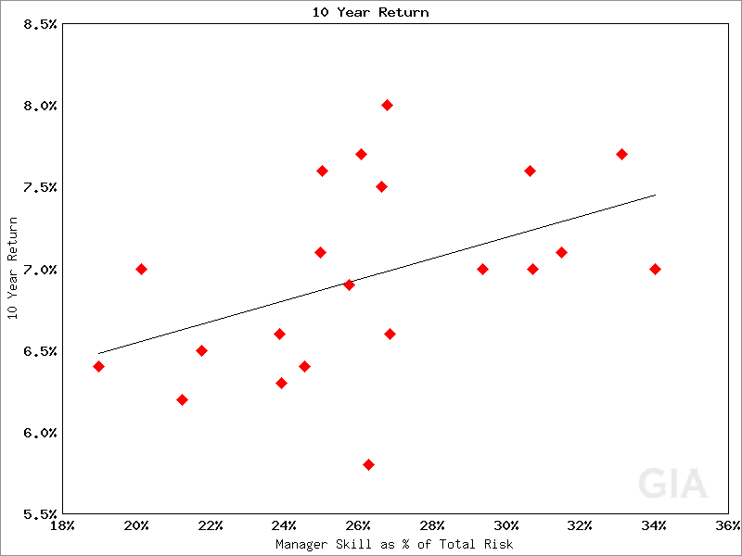

For example, the REST Superannuation Core Strategy was the highest returning fund over the 10 years to June 2013, with a return of just over 8.0% p.a. Approximately 26.5% of the Core Strategy’s, Total Investment Risk came from active Manager Skill, based on its investment allocation as at 30 June 2009 (approximately the middle of the period).

It is worth noting that for ‘Growth’ style Australian superannuation funds, active Manager Skill made up between one-fifth (20%) and one-third (33%) of the Total Investment Risk in their investment portfolios as of June 2009. **This source of Investment Risk and Return is generally ignored** in the analysis of superannuation fund performance, and is completely ignored in Modern Portfolio Theory.

What is most striking about Figure 11 is that **the relationship between Return and exposure to Manager Skill is actually upward sloping in the real world.**

**This implies that Australian Institutional Superannuation Funds have been able to identify and select investment managers who add value after fees.**

Note that this finding **means that**, manager performance must be consistent, superannuation funds must be able to select consistent managers, and managers’ fees must be less than the value added by their active skill.

It is important to note that **this relationship is completely consistent with the principles of Modern Portfolio Theory,** in the situation where manager skill is viewed as an investment and hence a source of Investment Risk and Return**.** Thus, this analysis is simply **a more general implementation of Modern Portfolio Theory** than that contained in ‘classical’ finance, in that markets are not restricted to being only static or random, and Manager Skill is treated as an investment rather than being ignored.

If we consider the vast majority of Australian Institutional Superannuation Fund investments represented in Figure 13:

* All funds have similar allocations to Market Risks (e.g. 60-80% growth) and hence have similar levels of market related Investment Risk
* Those funds with greater allocations to Manager Risk - and hence a higher proportion of Investment Risk derived from Manager Skill - therefore have higher levels of Total Investment Risk, and commensurately have higher returns
* Manager Risk is diversifying, **therefore funds with greater Manager Risk should be more diversified and have lower Portfolio Risk**

This third relationship, which is predicted by theory, is in fact found in actual superannuation fund performance. In Figure 14, the same 10-year fund returns as in Figure 13 are plotted against the 5-year (to June 2013) volatility of returns of each superannuation fund. (Only 5-year data was available to me, however as volatility tends to be relatively stable, the 5-year figure is a good proxy to 10-year volatility.)

**Figure 14**

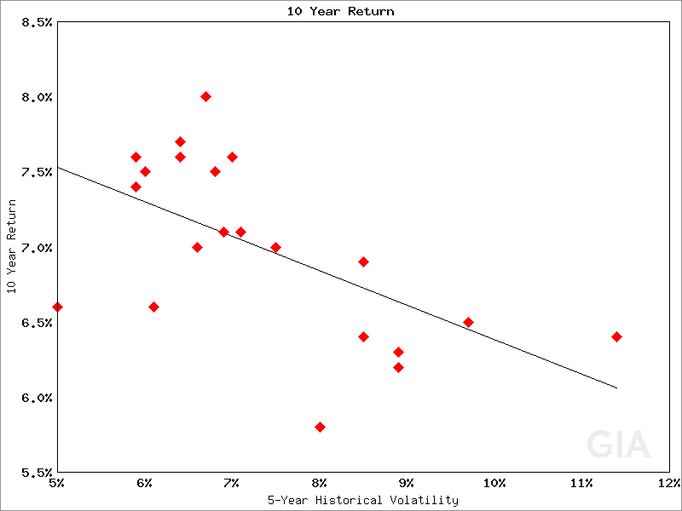

It is clear that the highest returning superannuation funds – those with the highest allocations to Manager Skill – also had the lowest level of Portfolio Risk (volatility). The implication of this result is that, as Manager Skill, as applied by Australian Superannuation Funds, actually reduces Portfolio Risk, then **not using Manager Skill – i.e., investing through index funds – actually increases Portfolio Risk**.

(Alert observers would note that this actual risk/return outcome for Australian superannuation funds runs counter to that expected from ‘classical’ finance theory, which postulates an upward sloping ‘risk-reward trade-off’. This actual outcome is completely consistent with portfolio theory, in that there is a positive risk/return trade-off between Investment Risk and Returns, with higher levels of Investment Risk being rewarded with higher levels of investment return. This risk/return trade-off is postulated to also apply in respect of Portfolio Risk in the ‘classical’ application of portfolio theory, which ignores Manager Skill - and as noted above Manage Skill constitutes approximately 25% of a normal Australian superannuation fund’s Total Investment Risk. In the real world this postulated relationship is not the case.

Note also that this has significant implications for ‘efficient frontier’ analysis and ‘portfolio optimisation’ – implications that are beyond the scope of this submission.)

I would point out that **the proposals to use an ‘efficient frontier’ of fund returns as a measure of fund performance (as set out on pages 117 - 118 of the Draft Report) is almost certainly very deeply flawed.**

Some may wish to assert that the risk/return result in Figure 14 represents a ‘special case’. Figure 15, shows the risk/return relationship for US Foundations over the 10 years to December 2015. The actual risk/return trade-off is the same as in Figure 14.

**Figure 15**

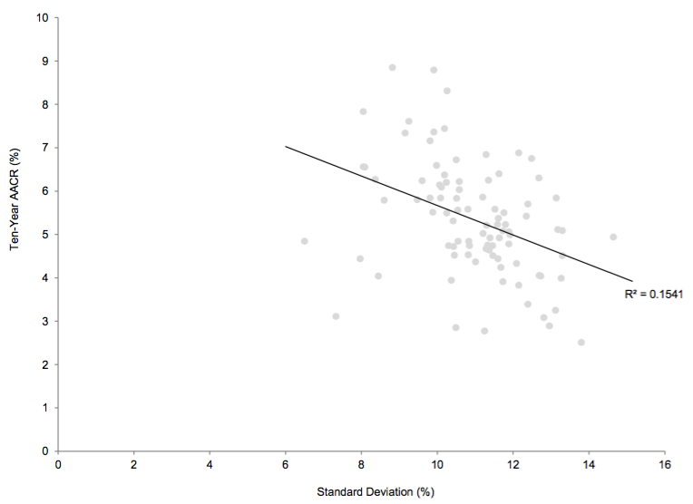

Source: Cambridge Associates

**Efficiency Costs**

The costs to superannuation fund investors and society of the distortions to superannuation fund investment arising the misguided policies and regulations – principally relating to investment management fees - currently applied to superannuation funds is high.

Based on superannuation funds’ actual investment returns over the 10-year period to June 2013, a reduction in allocations to active Manager Skill by 20% (say from 25% to 20% of Total Investment Risk), would be expected to have a net cost (after fees ) of 0.5% per year in reduced superannuation fund returns. (My experience suggests that the actual reduction is significantly greater than 20%, and, as the pressure to reduce investment manager fees remains intense due to the continuing prescriptive regulatory policy, the size of the distortion of actual investment allocations away from the optimal allocations to Manager Skill (as shown by trustee/directors revealed preferences) is likely to increase.)

Thus, on Australia’s $2 Trillion pool of superannuation fund assets, the reduction in returns to superannuation investors would be of the order of **$10 Billion per year** - and

Portfolio Risks are being **increased.**

Finally, I refer again to the Research Paper ‘Investment Risk and Portfolio Risk’ (PRI, 2013). Chart 1 in that paper – which was written in March 2013 – indicated that, as a result of its higher allocation to Manager Skill and resulting higher level of Total Investment Risk, the Future Fund would be expected to outperform the average Growth style superannuation fund by approximately 1.5% per annum.

Table 3 shows the actual performance of the Future Fund and the Median Growth Superannuation Fund for periods to June 2016. (Note that while the Future Fund nominally has a 10 year performance history, its returns in the early years were distorted by its large holding of Telstra shares and large cash positions. The return for the last 7 years, and certainly the last 5 years, are more reasonable representations of the results of the Future Fund’s actual investment strategy.)

Table 3: Returns to June 2016

|  |  |  |  |
| --- | --- | --- | --- |
| Period | Future Fund (%) | Median Super Fund (%) | Difference (%) |
| 3 Years | 11.4 | 8.9 | 2.5 |
| 5 Years | 10.2 | 8.4 | 1.8 |
| 7 Years | 10.7 | 8.9 | 1.8 |

The results are telling. Even if we make an adjustment for the lower administration and operating costs of the Future Fund, the performance differential between the Future Fund and the Median Growth Superannuation Fund, has been consistently greater than 1% p.a. As shown in Chart 3 of the Research Paper, the Future Fund has the same exposure to Market Risks as the average Growth superannuation fund. **Thus, all of the Future Fund’s outperformance can be attributed to the net of fees value added by active manager skill**. Clearly, the Future Fund has also been able to identify active investment managers who will add value after fees.

It is sobering to note that, based on the Future Fund’s **actual performance** relative to superannuation funds, the actual cost of the misguided policies relating to investment management fees may actually be twice the level indicated above – i.e., an actual opportunity cost of lost returns to superannuation investors of $20 Billion per year over the last 3 years.

**CONCLUSIONS**

The principle purpose of this submission has been to establish that, as a result of looking through the distorted prism of classical Finance Theory, the legislation and regulations currently imposed on the investment aspects of superannuation investments are misguided. As a result superannuation fund’s investment strategies are being significantly distorted away from those that would be adopted under optimal conditions.

The key point of distortion relates to the implicit policy position that the investment management fees associated with active Manager Skill, are costs to be reduced, rather than an integral part of the implementation of those investment strategies. The effect, whether intended or otherwise, has been to reintroduce a prescriptive policy in respect of superannuation investment strategies that has not been seen since the abolition of the 30/20 Rule in the 1980’s.

The costs to investors in superannuation, and the economy as a whole, of this misguided policy stance is large. A conservative estimate is that $10 Billion per year is being lost to investors as a result of these policies. These are opportunity costs, so not directly measured – in say the same way as, for example, ‘reduced investment fees’ can be measured and reported – and so are not recognised. Unfortunately, this tends to be the case with efficiency costs and productivity losses, and I would hope that in this case, the Productivity Commission, with its greater understanding of the long-term costs arising from policy induced distortions, would see its way to highlight and attempt to remedy this situation.

In respect of a specific course of action to rectify the policy induced distortions, I would concur with the recommendation in the submission by David Hartley that investment management related fees to unrelated third-parties be measured and reported separately from those fees and costs associated with the funds’ Registrable Superannuation Entities (RSE’s).

Specifically, I would recommend that investment management fees earned by, or paid to, unrelated third-parties should not be reported at all, but simply be ‘reported’ as part of the net investment return generated by that manager.

I recognise that the content of this submission relates, both directly and indirectly, to a number of components of the Draft Report. I would be happy to assist the Commission to further explore and improve its understanding of these issues.

John Peterson

Director

Peterson Research Institute

September 2016

**References**

Arnott. R.D. & Bernstein, P.L. “What Risk Premium Is ‘Normal’?” *Financial Analyst*

*Journal*, (April 2002), pp. 64-85.

Bender, J., Hammond, P.B., & Mok, W. “Can alpha be captured by risk premia?”

*Journal of Portfolio Management*. 40 (2014), pp. 18-29.

Bright, G. “The ramifications of a ‘relentless focus on costs and fees’”. *Investor Strategy*

*News*, (7 August 20916), www.ioandc.com/the-ramifications-of-a-relentless-focus-on-costs-and-fees/

Busse, J.A., Goyal, A. & Wahal, S. “Performance and Persistence in Institutional

Investment Management.” *The Journal of Finance*. 55 (2010), pp. 765-89.

Carhart, M.M. “On persistence in mutual fund performance.” *The Journal of Finance*.

52 (1997), pp. 57-82.

Clarke, R. “Mercer gets behind concerns over fee pressure”. *Investor Strategy News*,

(17 July 2016). www.ioandc.com/mercer-gets-behind-concerns-over-fee-pressure/

Fama, E. & French, K. “Luck Versus Skill in the Cross Section of Mutual Fund

Returns.” *Journal of Finance*,65 (2010), pp. 1915-47.

Fortin, R. & Michelson, S. “Mutual fund performance persistence: still true?”

*Academy of Accounting & Financial Studies Journal*, 14 (2010), pp. 29-41.

Gordon, M. “The fees conundrum: fund managers need to get used to it.” *Investor*

*Strategy News*, (4 September 2016), www.ioandc.com/the-fees-conundrum-

fund-managers-need-to-get-used-to-it/

Harbron, G.L., Roberts, D.R. & Johnson, J.A. “*The case for low-cost index-fund*

*investing*”, Vanguard, July 2016.

Hartley, D. “*Individual Submission to Australian Government Productivity*

*Commission*”, (20 April 2016)

Juru, S.G. & Johnson, J. “The difficulties picking fund manager winners.” *Cufflinks,*

(September 10, 2015).

www.cuffelinks.com.au/difficulties-picking-fund-manager-winners/

Mercer. A review of the equity risk premium, Mercer, 2013.

Patrick, A. “Super’s war on private equity”. *Australian Financial Review*, (19 August

2016)

Peterson, J. “*Investment Risk and Portfolio Risk: for Superannuation Directors and*

*Trustees*”, Peterson research Institute, 2013.

Pfeiffer, S.A. & Evensky, H.R. Modern fool’s gold: Alpha in recessions. *Journal of*

*Investing*. 21 (2012), pp. 60-68.

QCA. Cost of capital: market parameters. Queensland Competition Authority, 2014.

Soe, A.M. “Does Past Performance Matter? The Persistence Scorecard.” Research,

S&P Dow Jones Indices, (January 2016).

Villaverde, M. “Measuring investment performance consistency.” *Quantitative*

*Finance*, 10 (2010), pp. 565–74.