|  |
| --- |
| Ms Karen Chester and Ms Angela MacRae  Productivity Commission  530 Collins Street  Melbourne Vic 3000 |

22 August 2018

Subject: Productivity Commission Draft Report into Superannuation

Dear Karen and Angela

Mercer is delighted to be able to make a submission in response to the Productivity Commission’s Draft Report into Superannuation: Assessing Efficiency and Competitiveness dated April 2018.

Our submission contains the following attachments with each attachment addressing a particular topic discussed in the Draft Report:

|  |  |  |  |
| --- | --- | --- | --- |
| **Attachment** | **Topic** | **Matters covered** | **Pages** |
| 1 | General comments and areas of agreement | Draft recommendations 4, 5, 7, 8, 9, 10, 11, 13, 17, 18 and 19 | 4-5 |
| 2 | Default funds | Draft recommendations 1, 2 and 3 | 6-11 |
| 3 | Benchmark portfolio and Investment performance | Information Requests 2.1 and 2.2 | 12-14 |
| 4 | The difficulty of comparing fees internationally | Draft Finding 3.2 | 15-19 |
| 5 | Life cycle funds | Information Request 4.1 | 20-32 |
| 6 | Comprehensive Income Products for Retirement | Draft Finding 4.4 | 33-36 |
| 7 | Product Dashboards | Draft Recommendation 10 | 37 |
| 8 | Mergers | Draft Recommendation 6 and Information Request 7.1 | 38 |
| 9 | Benefits from economies of scale | Information Request 7.2 | 39-40 |
| 10 | Insurance | Draft Recommendations 14, 15, 16, 17, 18 and 19 | 41-43 |
| 11 | Regulation of trustees | Draft Findings 9.1, 9.2 and 9.3 and Draft Recommendation 5 | 44-45 |
| 12 | Regulation and compliance | Information Request 10.1 and Draft Recommendations 20 and 21 | 46-51 |

**Who is Mercer?**

Mercer is one of the world’s leading firms for superannuation, investments, health and human resources consulting and products. Across the Pacific, leading organisations look to Mercer for global insights, thought leadership and product innovation to help transform and grow their businesses. Supported by our global team of 22,000, we help our clients challenge conventional thinking to create solutions that drive business results and make a difference in the lives of millions of people every day.

Mercer Australia provides customised administration, technology and total benefits outsourcing solutions to a large number of employer clients and superannuation funds (including industry funds, master trusts and employer sponsored superannuation funds). We have over $150 billion in funds under administration locally and provide services to over 2.4 million superannuation members and 15,000 private clients. Our own master trust in Australia, the Mercer Super Trust, has around 230 participating employers, 239,000 members and more than $23 billion in assets under management.

In addition, Mercer has a national team of 55 financial advisers, servicing 13,000 clients with over $3 billion of funds under advice. Mercer is also the only current provider of a group self annuitisation product within Australia with our Mercer LifetimePlus product.

We would be delighted to meet with you and your team to discuss our submission and related matters or provide additional insights into the Australian superannuation system. In particular we would welcome the opportunity to brief you and your team on Mercer’s approach to life cycle investing through a workshop in our Melbourne offices. Please contact me by email if you would like to arrange a discussion or a workshop.

Yours sincerely,

**Dr David Knox**

**Senior Partner**

**Attachment 1: General comments and areas of agreement**

We recognise that the Productivity Commission has been given a very difficult task – to assess the efficiency and competiveness of the Australian superannuation system. Given the history, size and diversity within the system, together with its many players, this is no easy task. Indeed, we are not aware of such a broad assignment being tackled anywhere else in the world.

Initially, therefore we wish to thank the Commission for its work and for shining the light on areas where improvement or change are needed. The Draft Report lists 22 Draft Recommendations and makes 41 Draft Findings. In many cases, we agree with these findings and draft recommendations. However, and perhaps understandably, we will spend more time in this response on the Draft Findings and Recommendations where Mercer has concerns or disagreement. These are discussed in the following Attachments.

The Draft Report identifies that Australia’s super system has two structural flaws; namely unintended multiple accounts and entrenched underperformers[1]. We agree that these flaws exist and need to be addressed. However, as discussed in Attachment 2, we do not agree with the Draft Recommendations relating to these matters.

However we fully support the following Draft Recommendations:

* Draft Recommendation 5 – Strengthening the regulation of trustee boards
* Draft Recommendation 7 – Introducing permanent capital gains tax relief for mergers
* Draft Recommendation 8 – Cleaning up lost accounts
* Draft Recommendation 11 – Providing additional guidance to pre-retirees
* Draft Recommendation 13 – Disclosure of trailing commissions
* Draft Recommendation 17 – Adoption of the Insurance Code
* Draft Recommendation 18 – Insurance Code Task Force

We also support the direction of the following Draft Recommendations although the details, implementation and/or practicalities of these recommendations need further work:

* Draft Recommendation 4 – Strengthening the MySuper authorisation rules
* Draft Recommendations 9 and 10 – Improving dashboards
* Draft Recommendations 19 – A future review of insurance in super

We also comment on Draft Recommendations 14-19 relating to insurance in Attachment 9 as these have, in effect, been superseded by the recent Federal budget. A similar comment applies to Draft Recommendation 12.

**Attachment 2: Default funds**

**Comments on Draft Recommendations 1, 2 and 3**

Draft Recommendations 1, 2 and 3 – if implemented – would represent the most profound changes to the Australian super system ever seen. In effect, they suggest a revolution of a system that is currently delivering solid returns to most MySuper members (as is acknowledged in the Draft Report[2]) and does not represent an orderly evolution that, we believe, can lead to better outcomes for most members.

These three Draft Recommendations would:

* Provide a default super product for individuals once only during their career (ie for those new to the workforce) meaning that most members are likely to stay with their initial fund throughout most of their career due to inertia and limited member engagement.
* Develop a short list of up to 10 MySuper products for those individuals to choose from, if they need a default fund at the outset of their working career.
* Review this list of up to 10 My Super products every four years through an independent expert panel.

## Our concerns

We acknowledge that this process is likely to remove from the Australian superannuation system the two major flaws that were identified in the draft Report; namely unintended multiple accounts and chronic underperformers. However this new process would generate a range of other issues such that many members would be disadvantaged which runs counter to the Commission’s desire to improve member outcomes. Here are some examples of disadvantage:

Insurance needs: The first super fund for many Australians is likely to be a default fund with reasonably standard insurance arrangements. However many individuals will then transfer to an industry with higher risks such as mining, construction or emergency services. Currently these industry specific funds provide better and more targeted insurance cover than would normally be available from the initial fund.

Of course, it could be argued that the individual will have the right to choose the new fund with the better insurance arrangements when entering the new industry. However, in practice, this often does not occur as most members (particularly younger ones) have no interest in, or understanding of, superannuation.

Orphan funds: Inevitably, the selected funds will advertise accordingly and highlight the fact that they have been selected by a Government appointed committee as one of the best funds in the country. This outcome is natural and would be expected to occur in a competitive world. There will be several consequences including:

* A flow of money from other funds (ie those not selected) to those in the top tier. This is natural as individuals believe that the selected funds would be better for them.
* As money flows from these non-selected funds, liquidity issues are likely to arise so that these funds will be less able to invest in longer term investments and will need to maintain a higher cash (or liquidity) component. Naturally, such an outcome will affect their investment returns.
* That is, the members remaining in these non-selected funds are likely to be disadvantaged due to lower returns as well as higher costs (due to declining membership).
* This effect is likely to be regressive as the members who are most likely to move will be the better informed and/or the more highly educated.

The long term impact is likely to be significant and the effect is likely to be most pronounced on the lower income members of our society. This is an undesirable outcome for these members.

Criteria for selection: The criteria for selecting the best funds represent a fundamental part of the recommended process. The Draft Report notes that “the fund’s investment strategy, fees and likelihood of producing long term net returns for members should be given high weights”[3] whilst acknowledging that the panel “should also give heed to the fund’s intra-fund advice offering, governance, and track record on innovation and identifying and meeting member needs”.[4]

This universal set of criteria applied to the whole industry is likely to lead to the selected funds having similar benefit designs and features which provide sound benefits to the mass market. After all, each fund has been selected on the same set of criteria.

However, such an approach misses the opportunity to allow for particular needs within a particular industry or a community. For example, there would be no allowance for a cohort of members such as those in the mining or agricultural industries where there are many members outside the major cities who may need specialised services. Such individuals are likely to be disadvantaged under the proposed approach.

Behaviour by funds: It is almost inevitable that, once selected, these funds will adopt similar behaviour to reduce the probability that they will be removed at the next selection panel decision. That is, each fund is likely to have a similar investment strategy, similar fees and a similar product range. In brief, they will not want to be significantly different from the other selected funds. This sameness is likely to lead to less innovation and a reduced willingness to be different which, in the longer term, will disadvantage members.

On the other hand, there is a distinct risk that funds that are just outside the top tier (at least from their perspective) may behave in a manner that is detrimental to their current members. For example, they may limit services or innovation to reduce fees or adopt a higher risk strategy in respect of their investments to increase the probability of being selected in the next round. Such behaviour may not be in the best interest of their existing members.

MySuper only: The selection process will be for default products only. While the insurance offering could be part of the selection criteria, it appears likely the retirement and choice offerings will not be part of the criteria. That is, the selection process will concentrate on the benefits provided to a particular group of members within the overall fund but ignore all other members.

Of course, it could be argued that the choice members have made a deliberate decision to move away from the MySuper product and therefore the ultimate outcome is their responsibility. However this argument does not apply to the retirement benefits. The major purpose of superannuation should be to provide a retirement income to the member and their household. As the size of balances increase, the retirement phase of superannuation is becoming increasingly important. We know that many members stay with the fund as they move into retirement. Yet, if the selection criteria ignore the quality of the retirement offerings, it is possible that the retirees could receive a retirement benefit that is sub-standard. Hence, we would argue that any criteria should allow for a broad range of benefits and not be restricted to the My Super product only, which is limited to the accumulation years only.

New entrants: The selection of up to ten funds on a certain set of criteria, including past investment performance, may make it very difficult for new super funds to enter the industry. It has been argued that these potential funds could develop a track record though the offering of choice products or from overseas experience. However the offering of a default product within the Australian market is not the same as either of the above alternatives and is likely to require different services, including communication to members. Hence, we believe it is very likely that the selection of a top tier will virtually preclude the inclusion of a new fund in the future. In turn, this is likely to limit innovation within the industry and reduce the possibility of the presence of a disruptor in the broader market.

Public sector funds: The Draft Report appears to give no consideration to the special features of public sector funds although on page 17 it is observed that the majority of them are performing well. The following highlights some of the special characteristics of these funds:

* The South Australian and Western Australian funds (namely Super SA and GESB) are constitutionally protected and are therefore re subject to different taxation treatment which represents an advantage for most members. The inclusion of these individuals into the suggested default arrangements would represent a material disadvantage for them.
* Some individuals employed in the public sector are subject to additional risks and therefore have benefits that may not be available through the private sector. Examples would include military personnel through ADF Super and emergency services personnel in Victoria through their open DB fund (namely ESSSuper). Again, the application of the recommendations to these individuals could lead to a material disadvantage.
* All State Governments have, at various times, expressed a strong interest in the superannuation provisions for their employees. A recent example is Tasmania where two funds (namely RBF representing the public sector and Quadrant representing local government) merged into Tasplan which is now the default fund for the majority of Tasmanian employees. One of the State Government’s motives was to establish a strong fund within Tasmania which provided a full suite of services as well as providing employment opportunities in that State. Without commenting on the merits or otherwise of Tasplan, it is feasible that the Draft Recommendations could lead to having no default fund based in one or more States.

Of course, the Final Report could ignore the application of the recommendations to public sector employees as the Draft Report appears to have done. However such an outcome would heighten the differences between the private and public sectors and could lead to the perception that the public sector is being treated differently. We believe this would be an unfortunate result.

## There is a better way

## As mentioned above, we agree that the two structural flaws identified in the Draft Report – namely unintended multiple accounts and entrenched underperformers exist in the industry. However there are already several steps now being undertaken to address both these issues.

## We believe that the following steps will significantly reduce the number of unintended multiple accounts:

* The recently announced budget measure to transfer all inactive accounts to the ATO where the balances are below $6,000. For many funds, this will reduce their number of member accounts by 30 per cent and in some cases we believe it is as high as 50 per cent.
* The ATO will then seek to consolidate these accounts with a member’s active account, where possible.
* The ongoing development of Single Touch Payroll and the myGov infrastructure and, in particular, the introduction of a list showing each of the individual’s current superannuation accounts (and before the default fund is mentioned) when an individual changes jobs and selects a fund to receive their future SG contributions.

We believe these developments will significantly reduce the number of unintended multiple accounts and also encourage the consolidation of superannuation into a single account for each individual. Hence, although we do not agree with the first sentence in Draft Recommendation 1, we support the second paragraph recommending that the current work for centralised online services relating to Single Touch Payroll and myGov continue as a priority.

In respect of entrenched underperformers within the industry, we agree with Draft Finding 10.1 and, in particular, that “the proposed MySuper outcomes test should enable APRA to de-authorise poorly performing products and better promote fund consolidation.”[5] An elevated MySuper requirement arising from this outcomes test, as discussed in Draft Recommendation 4 should also be part of the process. As Karen Chester said on 20 June 2018 at the public hearings: “Our thinking is the elevated outcomes test should knock off a large part of the tail of woe.”[6] We agree. Ongoing assessment by APRA based on member outcomes should also ensure that a tail of underperformance will not re-emerge.

In addition, we expect APRA’s proposed prudential standard SPS 225 Outcomes Assessment will have a direct impact on the operations of many funds and encourage them to consolidate with other funds. In short, we expect APRA to bring significant pressure on poorly performing funds to merge or to generate greater economies through the provision of outsourced services.

## Our Conclusion

## Although we acknowledge the structural flaws in the superannuation system identified in the Draft Report, we believe that existing developments from the Government and APRA will significantly reduce the number of unintended multiple accounts and encourage consolidation of underperforming funds. We expect that the outcomes in each case will deliver benefits to members without causing the major disruption that would occur under Draft Recommendations 2 and 3 and which would lead to poorer outcomes for many members.

It is also worth noting that the number of public offer MySuper products is now fewer than 60. The current developments mentioned above will encourage further mergers of funds so that we suggest there will be fewer than 40 My Super products within 5 years. We believe that such a number will be competitive whilst also offering a range of services that are not clones of each other. It’s also worth noting that on a per capita basis this will mean that Australia will have fewer MySupers than New Zealand will have in respect of KiwiSavers.

**Attachment 3: Benchmark portfolio and Investment performance**

**Comments on Information Requests 2.1 and 2.2**

## Information Request 2.1

Superannuation funds asset allocations vary significantly and therefore it’s difficult to compare them against a single strategic benchmark. In addition not all funds define growth and defensive assets in the same manner – making comparisons based on headline ‘growth/defensive’ exposure fraught with danger.

A thorough understanding of how each fund defines ‘growth’ and ‘defensive’ assets is required before making ‘apples with apples’ comparisons between fund investment performance. For example, using the definition of defensive assets that the Productivity Commission refers to on page 20 of Technical Supplement 4 – ie ‘asset classes which are considered defensive are cash and fixed interest – all other asset classes are considered to be growth’ - a number of the better performing funds have had growth asset exposures in the 85-95% range – far higher than typical retail funds that have maintained a more traditional 70/30 growth/defensive split.

As well as this, for lifecycle funds, each will de-risk in a slightly different fashion which again makes comparisons difficult, not only against traditional funds but also against each other. Given the strong market returns we’ve experienced throughout the benchmark period, you’d expect any fund with a lower allocation to growth assets to underperform the benchmark. To give a better indication of fund performance, funds should be compared on a risk adjusted basis at different points along the glide path (where a lifecycle approach is utilised). This approach is used by Morningstar in the US for the target date fund universe.

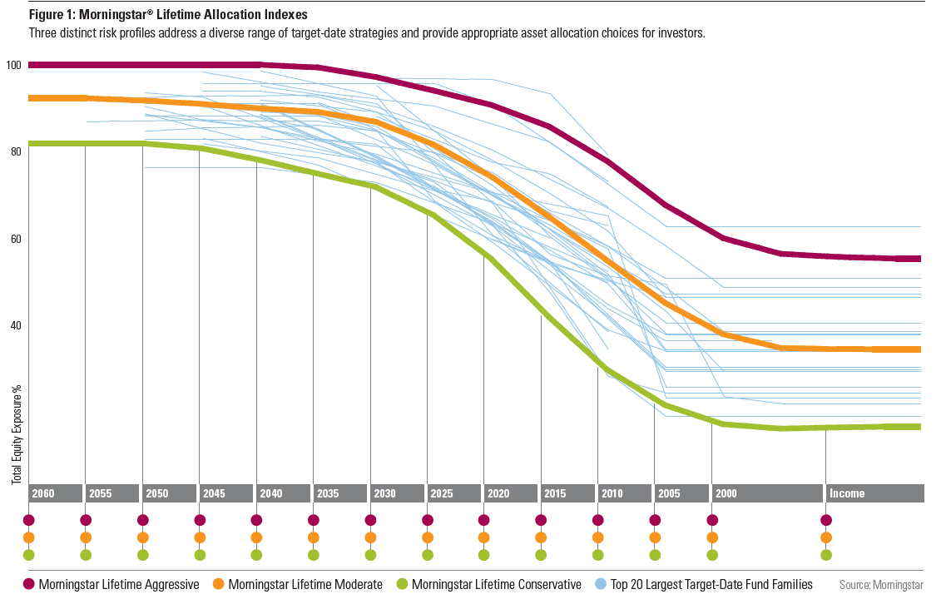

## *Note: Image from 2010*

## Information Request 2.2

There are a significant number of factors that impact performance and so we are not surprised that there is a big variation between different funds particularly as superannuation funds have a high allocation to both active funds and alternatives. For example, if you consider some of the largest unlisted property funds, there is a significant dispersion of returns over the last 10 years.

*Source: Mercer Data. X-axis – randomised unlisted property managers*

If one considers unlisted infrastructure, the spreads are even more significant. This chart looks at the internal rate of return of 14 unlisted infrastructure funds with a 2008 vintage year (i.e. the year in which the first influx of investment capital is delivered to a project or company).

*Source: Mercer Data. X-axis – randomised unlisted infrastructure managers*

**Attachment 4: The difficulty of comparing fees internationally**

**Comments on Draft Finding 3.2**

The Draft Report states that “the costs incurred by Australian superannuation funds are some of the highest in the OECD”[7] and concluded in the Overview that “Reported fees in Australia are higher than in many OECD countries.”[8] These conclusions are misleading for the following reasons:

* The OECD data, upon which these conclusions are based, do not compare national systems on a similar or comparable basis; and
* There are several reasons why we would expect the Australian system to have higher costs than many other systems.

Let us now explore these two topics in more detail.

## The OECD data

The OECD data referred to in the Draft Report is taken from Figure 8.9 in the OECD Report *Pensions at a Glance 2017.* However we have several concerns with this data, including:

* As shown in the OECD’s graph, the data for many countries do not show both administrative costs and investment expenses. For example, the Czech Republic, the Slovak Republic, Poland, Israel and Chile show investment expenses only whereas Estonia, New Zealand, Canada, the United States and Portugal show administrative expenses only.
* The data used from the OECD only applies to autonomous pension funds; it does not apply to the total pension system. When one looks at the data for the total system (including insurance contracts, book reserves and investment countries), the figures for 2016 are only available for 11 countries (including Australia) which considerably limits the value of the comparison.
* The OECD recognises that the data used depends on the data provided by each country[9]. As the Productivity Commission discovered in respect of the Australian data, the data provided to the OECD is incomplete and inconsistent. Hence valid comparisons are very difficult, if not impossible. The following two examples highlight the inconsistency:
  + The Canadian cost figure is shown as 0.4% of the pension funds’ assets. However these figures only apply to trustee operated pension funds and do not include mutual funds, which have much higher costs. On the other hand, the Australian figures from APRA include both retail and not-for-profit funds. In short, we are comparing apples with a fruit salad.
  + The Dutch figures in the OECD graph show a cost of 0.1% of pension funds’ assets. Yet it was recently reported[10] that the Netherlands’ largest pension scheme (ABP) had asset management costs in 2017 of 64.5 basis points (ie 0.645%) which is completely at odds with the OECD number.
* The reporting of costs in pension systems is fraught with difficulties. For example, the traditional pension scheme was an employer-sponsored defined benefit pension scheme. Administration was often carried out in-house by the employer. In other words, there were no separate costs borne by the pension fund. Rather, they were picked up by the employer. Hence, we would expect countries where there continues to be a strong representation of employer-sponsored plans to have lower costs as many of the costs would not be reported. Examples could include Canada, the United Kingdom and the United States to mention a few.
* The OECD data expresses the costs as a percentage of the total investments (or assets). This approach assumes a fully funded system; that is, where assets bear some resemblance to the liabilities. However many countries have components of their system that are unfunded or only partly funded. For example, most of the public sector defined benefit funds in Australia are only partly funded and the shortfall is at least $200 billion. Yet the full costs of operating these funds are included in the data which leads to a higher cost, when expressed as a percentage of assets.

## The Australian situation

There are several reasons why the operating costs of the Australian superannuation system are likely to be higher than for the systems in many other countries. These include:

* There are relatively higher administration costs in the accumulation phase compared to the pension phase. The reason is simple. During the accumulation years, the system is dealing with a range of transactions (including a range of contribution types and changing employers) and member balances can be relatively low compared to the pension phase when balances are higher and the administration is much simpler (ie a pension is being paid). Hence, where the system is still maturing (as in Australia), the relative costs (when expressed as a percentage of assets) would be expected to be higher. In addition, the investment costs tend to be lower in the pension phase due to more conservative investments.
* Broadly speaking, superannuation funds can be either defined benefit (DB) or defined contribution (DC) arrangements. Generally speaking, DC arrangements are more costly due to individual accounts and greater member choice. By contrast, DB funds normally have a single pool of assets, limited individual records and almost no member choice. Australia, with its predominantly DC system, would therefore be expected to have a higher level of costs than a predominantly DB system as occurs in many European countries and Canada. However it should also be recognised that in many of these countries there is now a clear trend towards a DC environment due to a number of factors including the changing labour force and accounting standards. Therefore we would expect the overall costs in these countries to gradually rise.
* The presence of Self-Managed Superannuation Funds in Australia[11] inevitably affects the structure and costs of the Australian superannuation industry. This occurs in several ways including:
  + The transfer of members with significant accounts to the SMSF sector reduces the average size of member accounts within the APRA-regulated fund sector and therefore increases the costs for these funds.
  + The need for funds to compete directly with the SMSF sector through the provision of additional services (eg member directed share portfolios and additional information) increases costs.
  + The continuation of small accounts within the APRA-regulated fund sector where individuals continue to hold member accounts to obtain cheaper insurance whilst transferring most assets to their SMSF.
* As noted on page 145 in the Draft Report, investment strategies will have implications for underlying investment costs. When compared to many pension systems around the world[12], the Australian system has a much higher exposure to equities, property, infrastructure and unlisted assets. Such assets have a greater cost than investments in fixed interest and cash but normally deliver better returns over the longer term.
* The taxation of superannuation in Australia includes taxation on contributions, investment income and some benefits. This means that superannuation funds are required to administer the complexity of the taxation rules with different rules applying to different types of contributions; different rates applying to investment income in the accumulation and pension phases; and different rules applying to different types of benefits. In short, it is extraordinarily complex and costly to administer. On the other hand, many countries adopt an EET system of pension taxation where the contributions and investment income are exempt from taxation whilst the benefits are taxed when received by the individual. There is no doubt that this extra administration relating to taxation adds significant costs to industry.
* With compulsory superannuation, Australia has a strong regulatory environment for good reason. However the existence of strong regulators adds additional costs to the system through both the levies paid to meet the regulators’ costs as well as the significant compliance costs that occur when there are strong and active regulators. The combination of these costs is much higher than in many countries[13].
* The compulsory requirement to provide death and disablement benefits in all MySuper products means there are additional administration costs incurred by superannuation funds as they design an appropriate insurance design, negotiate with the insurer, communicate with members and manage a range of claims from members. It should be noted that many other systems have no insurance requirements.
* The existence of considerable choice within the Australian system ranging from investment and insurance choice to fund choice and a range of available benefits at retirement. Whilst such choice provides greater flexibility to the individual members and can therefore provide more appropriate benefits, it must be recognised that it adds considerable costs to the system when compared a system where there is no choice during the accumulation and/or retirement phases.

## Our Conclusion

Hence, even if the OECD figures were accurate and comparing like with like, it would be expected that the operating expenses of the Australian superannuation system would be higher than for most other countries for the reasons set out above. This is not to say that fees cannot come down as the system continues to develop. Rather, it needs to be recognised there are unique features within the Australian superannuation system (many of which come from legislation) that lead to additional costs.

**Attachment 5: Life cycle funds**

**Comments on Information Request 4.1**

## Should life-cycle products continue to be allowed as part of MySuper?

Yes. We believe a properly designed and managed lifecycle fund is the most appropriate default strategy for the majority of the Australian population who do not actively engage with their superannuation. We agree with the findings of the draft report that lifecycle designs and performance vary significantly and therefore we do not suggest that all existing lifecycle strategies are suitable default funds for MySuper. However, our analysis shows that a well-designed lifecycle fund can:

* Generate returns consistent with (or better than) balanced ‘static’ funds over the long term
* Substantially reduce sequencing risk for members approaching retirement compared to balanced funds

## The following graph shows the glide path for 16 Australian lifecycle funds. It is apparent that there is great diversity in allocation to growth assets in the early years as well as how and when the different funds de-risk.

**Mercer’s Review of the Productivity Commissions’ Lifecycle Modelling**

In the initial phase of our analysis, we replicated the Productivity Commissions’ comparison of a balanced portfolio with a lifecycle strategy (termed ‘Safe Lifecycle’) utilising Mercer’s proprietary stochastic projection model to identify any discrepancies[14]. The lifecycle strategy used by the Productivity Commission maintains a growth allocation consistent with the balanced portfolio up to 5 years before retirement and then moves to a 100% cash allocation in a single step as shown by the dotted red line in the asset allocation graph below.

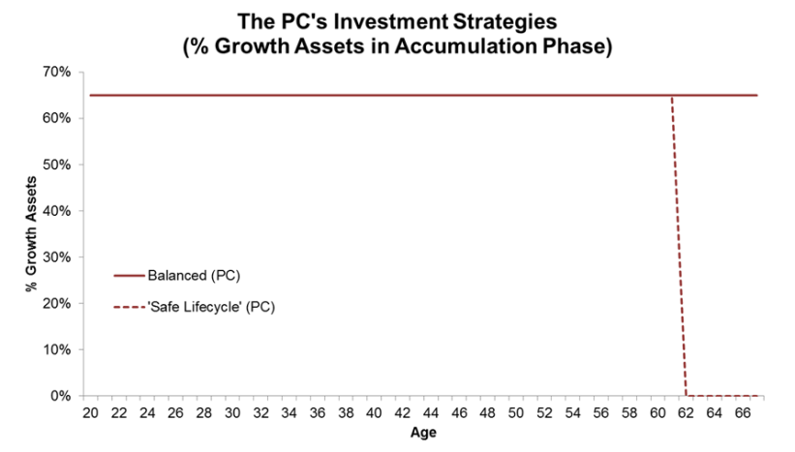

Consistent with the Productivity Commission, our modelling projections resulted in the same relative outcomes between the two investment strategies. We note there were discrepancies in absolute terms, however these are likely due to the Productivity Commission’s adoption of the bootstrap method which extrapolates returns based on historical data and return distributions whereas we have utilised a set of forward-looking capital market return assumptions. Both sets of charts show members will experience reduced returns and therefore lower balances at retirement in the Productivity Commission’s “safe” lifecycle strategy compared to its balanced portfolio.

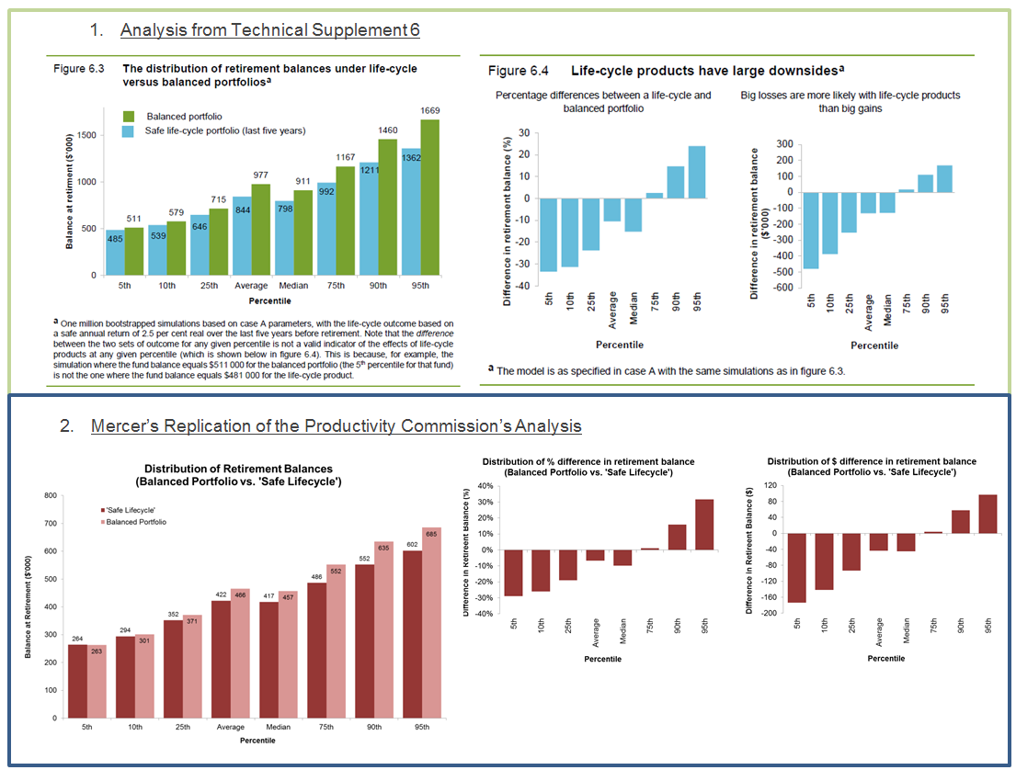

This portfolio the Productivity Commission has used is conservative in that the lifecycle fund and the balanced fund have the same allocation to growth assets up until the point the lifecycle fund de-risks. We would also note that this lifecycle de-risks to 0% in growth assets in one step at age 62. These features do not reflect lifecycle funds in Australia (see the glide path chart for 16 Australian lifecycle funds earlier in this section) which tend to take on more risk in the growth phase and de-risk in a linear fashion to an asset allocation with a meaningful allocation to growth assets at retirement.

**Mercer’s Approach to Life Cycle**

Critical to a good lifecycle fund is good design and ongoing management.

In Mercer’s SmartPath lifecycle strategy, members are invested in a strategy that has a far higher allocation to growth assets than a traditional growth fund for some 30 years of their working life. It then de-risks from age 47 through to retirement age with 50% in growth assets. This is a crucial design element that enables a lifecycle fund to generate wealth for members consistent with (or better than) balanced funds in the long term.

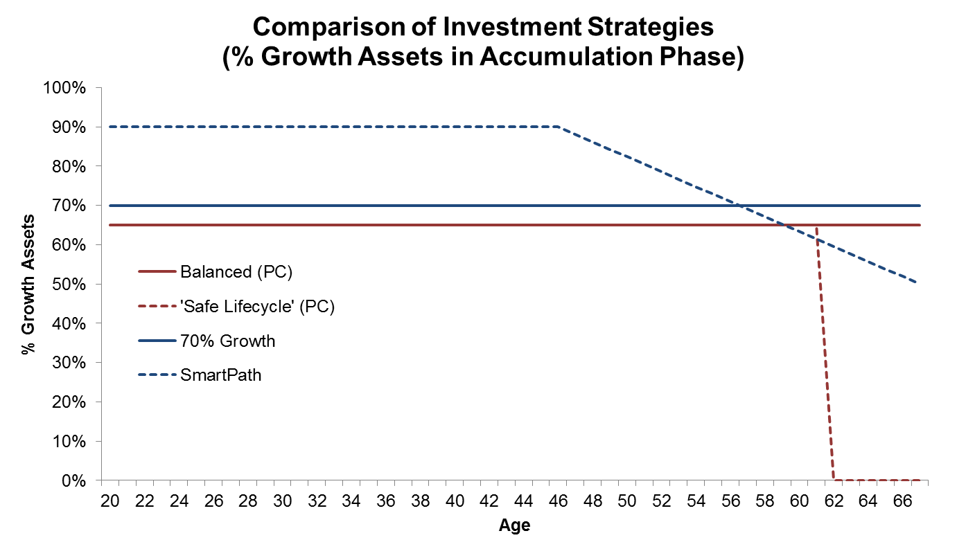In the second phase of analysis we used our projection model to compare Mercer SmartPath with a balanced portfolio that has a slightly higher growth allocation of 70%[15] - this growth level broadly aligns with the average growth/defensive split in the universe of MySuper options. The chart below highlights the differences in growth allocations of these investment strategies alongside those funds used in the Productivity Commission’s Draft Report.

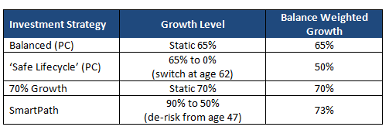Our modelling indicates that investing in a well-designed lifecycle strategy can achieve higher balances for members at retirement compared to a balanced portfolio[16].

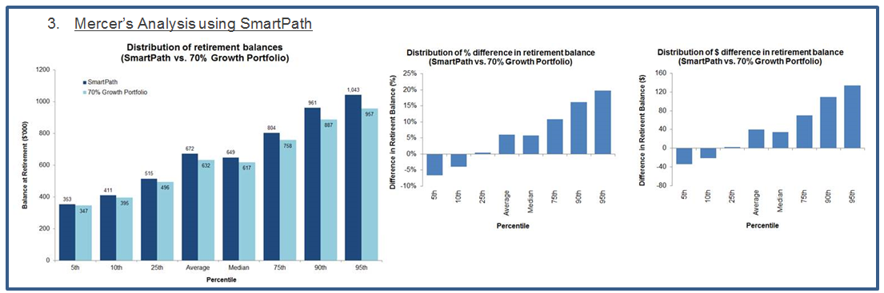

We then proceeded to complete further analysis using the two investment strategies to understand the implications for members joining the fund at different points in their life.

**Key Results from the Modelling Exercise**

**Increased Returns** - For an investor that saves from age 20 to 67, our model[17] shows that members should experience better returns with the median investor forecast to receive over $30,000 more by investing in the lifecycle version.

**Reduced Sequencing Risk** - It is also important to note that by de-risking the fund ahead of retirement, the investors also experience better downside protection and therefore reduced

sequencing risk. This becomes most prominent when you simulate a market crash*[18]* leading up to retirement (see the chart in the red box below – assuming market crash 5 years before retirement). In this scenario, the median investor would be $60,000 better off by investing in the lifecycle version of the fund.

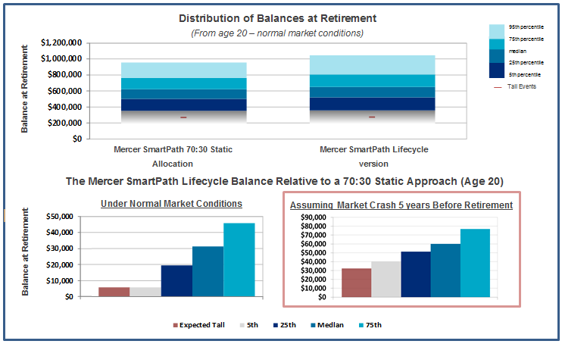

When you consider investors that join the fund at age 45, which for Mercer’s SmartPath is 2 years before the fund begins to de-risk, the investor begins to experience more significant downside protection under normal conditions whilst maintaining better returns on average. This additional downside protection has the effect of narrowing the range outcomes for members and therefore reducing sequencing risk. This downside protection is more prominent if you simulate a market crash 5 years before retirement (see the red box below – assuming market crash 5 years before retirement).

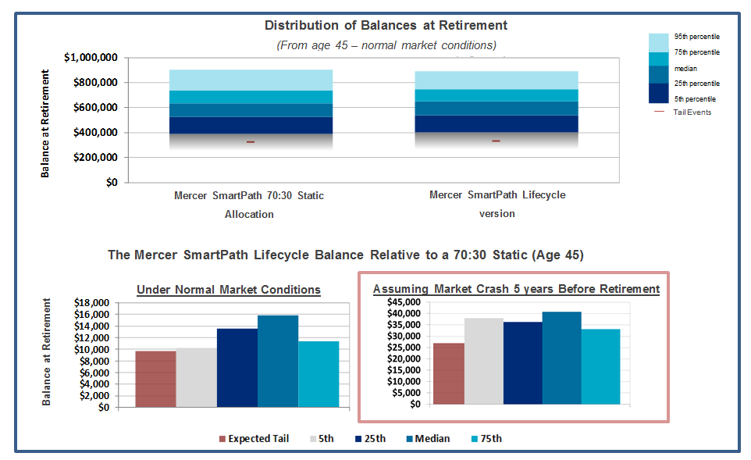

It’s only when we look at an investor that joins the fund at age 55, which is almost half way through the de-risking phase of the glide path, that you see some reduction in the upside by investing in the lifecycle version of the fund under normal market conditions. However, investors would be more protected against downside and therefore sequencing risk. As with the other examples, this protection is amplified if you model a market crash 5 years before retirement.

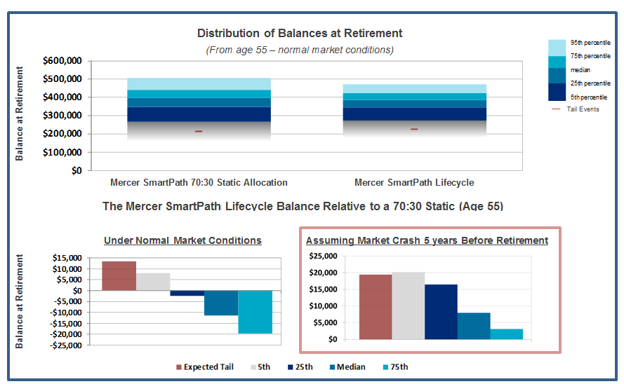

**Other Important Considerations**

It is also important to consider the following when designing a default fund for MySuper:

1. **Sequencing Risk**

In the text above we discuss sequencing risk as it related to the investment strategy however it is also important to consider how it is impacted by member activity. In terms of member activity, sequencing risk crystallises when a member chooses to dis-invest part or all of their savings. If a member disinvests after a period of negative returns, their balance will be less than if they had experienced similar negative returns when they were younger but had had more positive returns recently. As members with lower balances are more likely to disinvest larger portions to pay off mortgages or use elsewhere in order to maximise their age based pension, they are most at risk of poor outcomes related to sequencing risk.

Switching will also crystallise sequencing risk and because members are not rational investors, they are more likely to switch their balance into safer investment options if they see it losing value[19]. As members generally become more engaged with their balance as they approach retirement, this is the most important time to protect their assets from losses.

1. **Administrative Ease**

To be a successful default, Mercer believes the solution must be administratively easy for the member and intuitive to understand at the Trustee level.

Lifecycle funds can achieve both of these objectives. In SmartPath, members are placed in 5 year cohorts according to their age and are automatically ‘de-risked’ as they approach retirement. This means a member doesn’t need to ‘do anything’ to achieve the required reduction in risk. We have also found that the lifecycle approach has resonated well with Trustees or those tasked with talking to members about superannuation.

Lifecycle funds are also more advanced in their transition to the retirement phase. When the member reaches retirement age, funds can be seamlessly transitioned to tax-free post-retirement funds which replicate the retirement point of the lifecycle. This is an asset allocation that has been specifically designed for retirees.

1. **Peoples’ Risk Tolerance Reduces with Age**

Numerous surveys of retirees highlight their increased conservatism with age. In particular, the Retirement Income Survey completed by Investment Trends Pty Ltd in 2013 found that outliving their savings and falls in investment markets were amongst the top three worries for retirees – the third was having enough money left for aged care costs.

These factors suggest that it is not appropriate for someone who is nearing retirement to be invested in a fund with the same level of risk as someone who has just started saving for retirement. Indeed it is Mercer’s observation that de-risking portfolio’s prior to major events such as retirement is a logical and considered action to take.

We would note that we agree with the Draft Report findings that 30 years old is far too young to start de-risking within a lifecycle strategy, and that most other lifecycle strategies in the Australian market do not begin de-risking as early as this. We would also note that we believe it is important to maintain adequate exposure to growth assets in retirement to help mitigate longevity risk.

1. **International experience**

As a final point, we would like to highlight that Australia is not unique in taking a lifecycle approach to DC investing. This approach is becoming globally recognised as the most appropriate strategy for DC members. For example, both the UK and the US utilise this type of strategy for DC investing. In the UK c. 90% of DC members are invested in default funds[20] which are predominantly lifecycle funds. This includes the Government run pension scheme the National Employees Savings Trust (NEST) which has over 4.5 million members. NEST believes that investment risk should be taken in varying amounts throughout a member’s lifetime and has adopted a series of target date funds called the ‘NEST Retirement Date Funds’ to deliver its default lifecycle investment strategy. Each NEST Retirement Date Fund has an asset allocation that is consistent with the expected amount of risk that is appropriate for the age of a member and/or their expected retirement date. In the US, take up of the lifecycle approach has been growing fast. Vanguard reported that 72% of the 4.6 million people invested in their funds and participating in company-sponsored DC plans invest in lifecycle funds. This percentage has tripled over the past decade.

## If so, do they require re-design to better cater for the varying circumstances of members nearing retirement, and how should this be achieved?

Some life cycle strategies are not currently optimal and therefore require redesign. We believe the best default funds have been designed with a deep understanding of members and are considered on a whole of life basis rather than just as an accumulation vehicle.

In order for a scheme to build an optimal solution we believe they need to understand as much of the following as possible:

* Member numbers, by age cohorts, gender cohorts, super account balance, retention rates around retirement age, risk tolerance profile
* Household characteristics; single, couple, dependents etc.
* Other income sources, i.e. aged pension participation, Defined Benefit participation, other social security participation
* Debt levels e.g. home ownership
* Bequest intentions
* Member engagement levels, literacy levels
* Member health, life expectancy

At Mercer, we have completed detailed analysis of the members in SmartParth and have used this to review the asset allocations and shape of the glide path. Mercer Edge is an in-house tool which splits members into ‘geoTribes’. The geoTribes model consists of 15 geodemographic segments and provides insights into each segment’s lifestyle characteristics including inherent values, their approach to finances as well as their personal, social and family lives. The diagram below gives an overview of the different geoTribes in SmartPath.

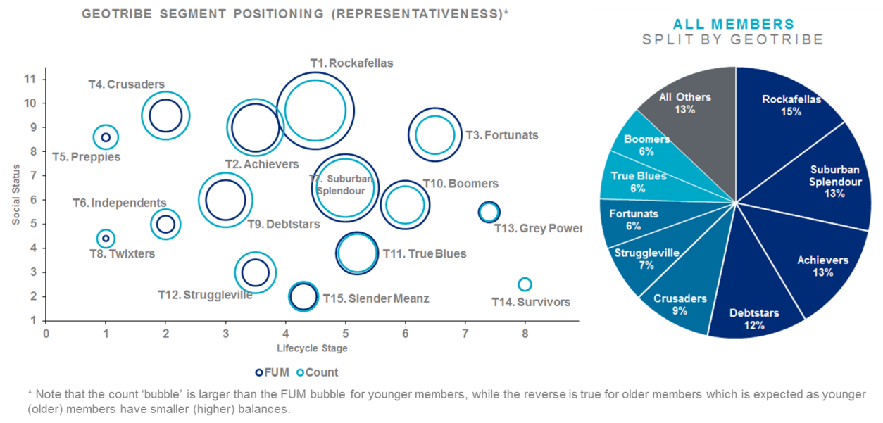

We believe members should have strategies that align to their unique circumstances at retirement and we are currently investigating the impact of having different lifecycle funds as well as how robust the one-size-fits-all lifecycle structure is to variations in the membership.

For this individualisation to be successful the industry would need support from the regulator and members would need to be engaged and provide the necessary data. Mercer hopes to be able to create bespoke lifecycles for members in the future.

## What information is needed on members to develop a product better suited to managing sequencing risk?

Lifecycle funds are specifically designed to manage sequencing risk by de-risking portfolios prior to retirement. The key objective in the design of MySuper funds should be to get the balance right, i.e. not de-risk too early or to a strategy that is too defensive. We believe that if schemes take the above approach in designing their MySuper fund, they will successfully manage sequencing risk and provide better outcomes for members.

## Our Conclusion

Mercer believes that lifecycle funds are the most appropriate default strategy for the majority of the Australian population and should not be restricted to being a choice fund. The Productivity Commission is correct to point out that poorly designed lifecycle products can result in poor outcomes for members and Mercer would therefore encourage superannuation funds to review their MySuper default options to ensure that they are designed with a deep understanding of their members and are considered on a whole of life basis.

Mercer has a strong belief that well-structured and managed lifecycle funds have the potential to offer disengaged members a better superannuation outcome than static balanced funds because they:

* can achieve a return equal to or higher than a balanced fund
* can reduce sequencing risk
* do not require members to make their own de-risking decisions
* are easy to administer and communicate to members
* align with members’ behavioural biases

**Attachment 6: Comprehensive Income Products for Retirement**

**Comments on Draft Finding 4.4**

As discussed in the Draft Report, it is evident that the financial decisions facing retirees are complex and need to take account a number of important factors including:

* Their level of financial assets, both within and beyond superannuation
* Whether they own their home
* The presence or absence of a partner
* The age of the retiree and the age of any partner
* The health of the retiree and any partner, which is likely to affect their longevity
* Their preferences in terms of their future lifestyle, both in the short and longer terms
* The period of planning, which may be 30 or more years
* The availability of any part-time work
* Their access to a full- or part-rate age pension, both immediately and in future years
* The level of risk they are willing to take in respect of any investments
* The need to pay off any debt, such as a credit card or a mortgage
* The need for any significant purchases during the retirement years, such as a car
* Any desire to leave a bequest, particularly from their financial assets

Hence, we agree with the draft report that it is not possible to design “a ‘one-size-fits-all’ default retirement product” that is suitable for all retirees[21]. Indeed, the retirement phase of the superannuation system is much more complex than the accumulation phase.

However, recognising this complexity as well as the heterogeneity of the financial situations of individuals does not necessarily lead to the conclusion in Default Finding 4.4 that “A MyRetirement default is not warranted.”[22]

We recognise that the Draft Report was probably finalised before the release in May 2018 of Treasury’s Position Paper on the Retirement Income Covenant. We believe this Paper has considerably progressed the concept and understanding of Comprehensive Income Products for Retirement (CIPRs). In particular:

* CIPRs will be designed to provide
  + Broadly constant income, in expectation, which represents the most important matter for retirees, as noted in the Draft Report on page 197
  + Longevity risk management
  + Some access to capital
* Superannuation funds will be able to offer up to three CIPRs, thereby not providing all members with the same product
* No member will be defaulted into a CIPR; member consent will be required
* CIPRs will not be required to be offered to retirees with small balances. The Position Paper suggested a limit of $50,000 although Mercer has recommended this should be increased to $100,000
* Trustees will not be required to offer a CIPR to an individual with a life-threatening or terminal illness

We believe that the introduction of CIPRs will significantly broaden the range of retirement products available to retirees. An important reason for this development will be the new means tests rules for longevity products that are planned to apply from 1 July 2019. Previous experience clearly suggests that the means test rules for the age pension affect the behaviour of many retirees as well as the advice provided by financial advisors. In other words, the relative attractiveness of longevity products is expected to increase with these new rules.

Our experience with Mercer LifetimePlus (the only group self-annuity product available in the Australian market) is that the absence of any means test rules for such products considerably inhibits the acceptance of this product in the marketplace. We expect the above change from July next year to considerably enhance the attractiveness of this and similar products. We also expect deferred lifetime annuities to be considered now that the means test rules have been announced.

We do not accept the statement on page 199 of the Draft Report that “there is little evidence that the product range is deficient per se.” The range of retirement products currently available in the Australian market is considerably less than available in markets such as the UK and the USA. Examples from these markets include impaired annuities, deferred lifetime annuities and variable annuities.

Recent changes and Government announcements relating to taxation and the means tests are likely to broaden the range of products available to retirees, which is the Government’s intention.

However the real issue is whether the overall outcomes from the superannuation system are as efficient as they could be. The Financial System Inquiry clearly thought there was scope for improvement. In particular, the increased presence of longevity pooling could provide increased certainty of retirement income for a longer period and therefore a higher standard of living during the retirement years.

Of course, as with any pooling of risk, there will be “winners” and “losers”. However insurance already exists within the superannuation industry through group life insurance. Hence the concept of pooling is not unusual within the industry. Furthermore, longevity pooling occurs in most developed pension systems around the world ranging from Europe to Singapore.

As noted in the Draft Report, most retirees do not voluntarily purchase any longevity protection due a variety of possible reasons relating to the “annuity puzzle”. This outcome has led to many countries requiring an annuity to be purchased at retirement. However, this is not the current suggestion relating to CIPRs. Indeed, it will not be an opt-out default. Instead it is anticipated that it will be a nudge, with trustees highlighting the benefits of a CIPR but providing members with information, including highlighting circumstances or conditions where such a decision would not be appropriate. Such information is also likely to indicate to retirees the availability of financial advice through a range of services ranging from fintech to face-to-face advice.

Of course, the inclusion of a longevity protection component within a CIPR raises the further issue:

* Are retirees willing to reduce the level of their bequest should they die early?

Two comments are worth making.

First, while many retirees wish to leave a bequest from their financial assets as indicated by your Figure 4.9, this is the least important of the nine things that matter most for retirees. This is confirmed in a recent study by Alonso-Garcia et al[23] which compared the saving motives in retirement in Australia and the Netherlands. In reviewing ten saving motives, the least important motive in both countries was intended bequests, as distinct from intra-household bequests. The most important saving motives in Australia were self-gratification, autonomy, security and precautionary saving for future health costs. In other words, many retires have a relatively short term focus on themselves. In such an environment, it is not surprising that longevity protection products are not popular. Retirees tend not to look that far out.

Second, the inclusion of a longevity component within a CIPR does not significantly reduce the flexibility or availability of capital to most retirees. That is because it is expected that the longevity investment in most CIPRs will be in the range of 15-25 per cent of their total benefit. In other words, 75-85 per cent will be invested in an account-based pension giving retirees full control and flexibility of this component. It should also be noted that under the Capital Access Schedule (which we expect most longevity products to follow), there remains some access to the capital until member’s life expectancy is reached. The full investment is also repaid if the member dies in the first half of the period until their life expectancy, which will normally be about 10 years from the date of purchase.

## Our Conclusion

We do not believe it is correct to state that “A MyRetirement default is not warranted.” Treasury’s recent Position Paper has broadened the concept of a CIPR and they can now be designed with members’ circumstances taken into account. Furthermore, no retiree will be invested in such a product without their consent.

In addition, the greater use of longevity pooling will lead to a more efficient superannuation system that provides increased income support for those who live longer. This outcome will be similar, but not identical, to the outcomes from the traditional defined benefit pension schemes. It also appears that many retires are happy with such an outcome even if means their bequests are slightly reduced.

**Attachment 7: Product Dashboards**

**Comments on Draft Recommendation 10**

We note that, in order for the ATO to present the correct dashboard, it would need to have more information about the member’s account than it collects at present – in particular, details of the investment product/s the account is invested in. This would require a significant enhancement to account information that funds are required to report to the ATO, with associated build costs and lead times. The level of additional detail would also have an impact on the implementation program and cost - for example, is the Commission proposing that funds be required to report the account balance split by investment option (however many apply)?

Of course, where a member’s account is invested in more than one investment option (product), there would not be a single dashboard that reflects the overall investment mix, returns and fees applicable to their account. Rather several dashboards would be required which are likely to be confusing to the member.

**Attachment 8: Mergers**

**Comments on Draft Recommendation 6 and Information Request 7.1**

We agree with Draft Recommendation 6 but suggest that it should be extended to cover mergers that do proceed. In other words, the boards of the merging funds should be required to disclose to APRA the reasons why the merger did proceed and the members’ best interest assessment that informed the decision.

Of course, it should be recognised that mergers are expensive and that the costs need to be taken into account in determining the best interests test. For example, the merger of two small funds would not necessarily generate any scale efficiencies and the cost of merging could well outweigh the benefits.

There are many and varied reasons why some proposed mergers do not proceed. In some cases, these relate to the lack of agreement at the Board level. However, often these types of conflict are symptomatic of a major difference in culture which can be important in the consideration of a merger. In the corporate sector it is acknowledged that most mergers fail to deliver value to the merged organisation if there is a cultural mismatch which can, in fact, detract value. The same principle should apply with mergers of two superannuation funds. In reality, funds have options as to which partner would be a best fit and it would be wrong for both funds considering a merger to proceed if there isn’t a good cultural fit.

**Attachment 9: Benefits from economies of scale**

**Comments on Information Request 7.2**

In order to better analyse investment fees (and investment performance) against peers as well as other countries, it is important to consider the asset allocations and investment style of the different funds.

For example, in the US, DC investments are predominantly passive which significantly reduces average fees. As the Australian DC market is predominantly active, you cannot fairly compare average US fees to average Australian fees. If you just compare the active market, fees are a lot more comparable.

As well as management style, is also important to consider asset allocations as different asset classes have different costs. Going back to the US example, active DC funds don’t tend to have allocations to unlisted asset classes which are usually the most expensive asset classes. If you remove the allocation to unlisted alternatives in Australian funds, average fees will reduce. By making this adjustment, it is expected that Australian fees would move closer to the average US active fees, if not below.

The ideal way to compare investment costs would be to do a comparison at the asset class level, taking into consideration management style, as well as ensuring costs are split into direct and indirect fees. If this data cannot be made available, the Productivity Commission should make some allowances for the significant differences in investment style between different regions.

We would also note that whilst the level of investment fee does impact overall return, it is important to consider the relationship between investment fees and expected returns net of fees. We have done some forward looking analysis[24] of investment fees and returns of four commercial Master Trusts and four Industry funds. The chart below shows the results.

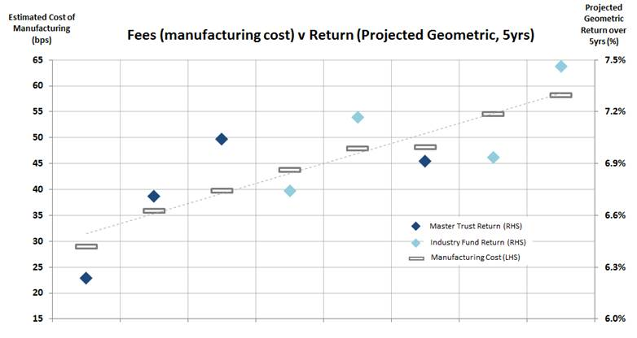

This analysis shows there is a positive relationship between higher investment fees and higher expected returns net of fees (because active management is expected, on average, to add value after fees, and because the capture of alternative risk premia and illiquidity premia is more expensive, but is also expected to result in positive expected returns after costs).

We have examined a number of other funds as well as Master trust and Industry Funds averages and active and passive strategies.  We concluded that the same positive relationship holds across the Funds: the more you can afford, the wider the opportunity set and the higher the risk-adjusted returns that can be achieved, all else being equal.

In conclusion, we believe that fees should not be considered in isolation as there can be net of fee return benefits to higher investment fees. We therefore recommend that the Productivity Commission not only compare fees at an asset class level but it also considers whether the additional fees are having a positive impact on return. By considering these together, we suggest the Productivity Commission would find that the Australian superannuation market is one of the most competitive DC markets in the world.

**Attachment 10: Insurance**

**Comments on Draft Recommendations 14 to 19**

## Draft Recommendations 14 and 15

In respect of these two Draft Recommendations 14 and 15, we note that Mercer has undertaken to adopt the Insurance in Superannuation Voluntary Code of Practice (the Code) and is therefore supportive of much of the direction of these recommendations. Mercer would be in favour of the greater flexibility that the Code provides – for example allowing trustees to provide opt-out cover for members under age 25 in circumstances where they reasonably consider this is the best interests of those members as a whole. However, we acknowledge that both Commission’s recommendations and Mercer’s views have largely been overtaken by the Government’s Protecting Your Super changes to insurance, which go further than both the Commission’s recommendations and Mercer’s preferred policy.

## Draft Recommendation 16

The recommended additional disclosures in this Draft Recommendation are very similar to some of the disclosure requirements of the Code. However, we disagree with the ‘immediately’ timeframe, which is unworkable in the current circumstances where all funds need to review their default insurance arrangements in light of the Protecting Your Super changes. We also note that these changes are expected to have significant consequences for the level of premium rates. These reviews will also need to take into account the requirements of the Code (even for those funds who don’t intend to adopt it) and the recent and ongoing re-framing (via the Code and the Protecting Your Super changes, for example) of views about the level of insurance cover/premium that is affordable and does not result in unnecessary erosion.

Therefore, while we support the additional disclosures, they should be implemented within the transitional timetable provided for under the Code, not immediately.

This Draft Recommendation also suggests that trustees should be required to provide on their websites a simple calculator that members can use to estimate how insurance premiums impact their balances at retirement. We agree that is may be helpful for members to be able to access this information. However we believe that this information would need to be balanced with information assisting members to understand the risk of not taking out insurance value of insurance. In other words, there needs to be a valid comparison of the costs and benefits of insurance.

Further, we recommend that robust consumer testing should be undertaken to assess the ability of members to understand the meaning and relativity of an accumulated impact at retirement versus the annual costs and benefits of insurance. Our concern is that, if presented with a large accumulated cost of a working lifetime of insurance premiums, members who really need insurance will be inclined to ‘roll the dice’ rather than to make a prudent decision to protect themselves and/or their dependants in the event of death or disability.

We also note that it would be far from simple to build a calculator to cater for every member of a corporate master trust. Corporate master trusts facilitate the offering of superannuation arrangements tailored to the needs of an individual employer’s workforce, with pricing often negotiated via competitive tender. These employer-based plans allow the insurance arrangements (types of cover, cover design and pricing) to be tailored to the needs of the employer’s workforce, either as a whole or within different categories. A key advantage is that insurance can be based on each employee’s salary, which will generally result in the level of cover being more appropriate to the employee’s needs, as compared with the same dollar level of cover for every employee regardless of salary level.

However one of the consequences of arrangements varying between employer plans is that it is not possible to produce a single generic insurance calculator that will be applicable to all of the employer sub-plans. For example, the Mercer Super Trust has 230 employer sub-plans, many of which have a number of benefit classes with different insurance designs, resulting in more than 800 different insurance arrangements overall.

It would be a major and costly project to create a calculator - which projects and accumulates insurance costs through to retirement - for every one of these insurance designs.

## Recommendation 17

We support the recommendation that adoption of the *Insurance in Superannuation Voluntary Code of Practice* should be a mandatory requirement of funds to obtain or retain MySuper authorisation.

## Recommendation 18

We support the recommendation that the Government should establish a joint regulator taskforce to advance the *Insurance in Superannuation Voluntary Code of Practice* and maximise the benefits of the code in improving member outcomes.

This will assist community confidence in the value of the Code and provide an avenue to assist in determining the provisions of the Code where there is disagreement within the industry.

## Recommendation 19

We support the direction of this recommendation; namely that the Government should commission a formal independent review of insurance in superannuation.

However, rather than the timing being within four years from the completion of the inquiry report, we recommend that the review be initiated four years after the implementation date of the Government’s Protecting Your Super insurance changes. This will provide a reasonable period for the impact of these changes on insurance offerings, insurance premiums and coverage to emerge and be taken into account by the review.

**Attachment 11: Regulation of trustees**

**Comments on Draft Findings 9.1, 9.2 and 9.3 and Draft Recommendation 5**

## Draft Finding 9.1

Mercer agrees with this Draft Finding. Mercer has undertaken board performance reviews and skills assessments for many superannuation trustee boards. Whilst governance tools used to undertake board assessment (such as a skills matrix) are important, it is far more critical to ensure that third party providers used to conduct such reviews have appropriate expertise. In our experience, such providers should not only have good corporate governance knowledge and experience but also have strong understanding of superannuation obligations applying to superannuation trustee boards.

The role and function of a superannuation board is highly regulated. There are numerous statutory requirements and regulatory guidelines impacting the board’s composition as well as how the board should perform its duties. For example, a skills matrix should take into account the minimum fit and proper requirements in SPS520, APRA guidelines in SPG520 regarding minimum skills for individual directors and the “collective” skills requirements for directors and management under SPS 510. Similarly, when evaluating board performance, it would be important to take into account SIS covenants, such as those requiring the trustee to act in members’ best interests, avoid or manage conflicts of interests and to exercise the standard of care and diligence of a professional superannuation trustee.

Accordingly, we believe it is important that third party providers undertaking skills assessment and board performance reviews understand the relevant superannuation requirements to ensure that their assessments (and any resulting recommendations) are consistent with superannuation law.

## Draft Finding 9.2

Mercer agrees with this Draft Finding. Mandating a number of independent directors should enhance impartiality and objectivity. However, structural independence requirements alone will not ensure good decision-making in the best interests of members. It is therefore important to focus on securing the right competencies for the board.

## Draft Finding 9.3

Mercer undertakes many board performance evaluations for superannuation trustee boards and we observe that, increasingly, more boards are using external providers to do this. Based on our experience, it is important that board evaluations are undertaken by third parties that have strong knowledge and understanding of the regulatory obligations impacting the board’s functions, as mentioned above.

## Recommendation 5

As noted previously, we generally support this recommendation.

In our experience it would also be beneficial to use formal letters of appointment when appointing directors to the board. Whilst many trustees use such letters, our observation is that such practice is not uniform across the industry. This approach is useful in clarifying at the outset the expectations and requirements of directors and is also helpful when undertaking individual director assessments. Letters of appointment typically cover items such as roles and responsibilities of the Directors, time commitment expectations, remuneration arrangements, obligations regarding conflict of interests, director appraisals and training expectations.

We agree that trustee boards should maintain a skills matrix and annually publish a consolidated summary, although we do not agree with publishing the skills of each trustee director. We suggest a better approach would be to follow the approach in the ASX Corporate Governance Principles and Recommendations (Recommendation 2) where disclosure is made collectively across the board as a whole, without identifying the presence or absence of particular skills by a particular director. It is also worth noting that evaluating the capability of individual directors is not an exact science and there are no objective benchmarks for some of the ‘softer skills’ that contribute to a well-functioning board.

An additional observation (related to the first and third recommendations) is that, while superannuation funds currently have set strategic objectives for the fund, many funds have either no or fairly rudimentary objectives for the board itself. For this recommendation to have any meaningful impact, superannuation trustee boards would need to set concrete performance objectives for the board, which would then be measured and tested as part of any external review.

**Attachment 12: Regulation and compliance**

**Comments on Information Request 10.1 and Draft Recommendations 20 and 21**

## Information request 10.1

We believe that the division of responsibilities between APRA and ASIC for superannuation is currently clear:

* APRA is responsible for prudential regulation of superannuation funds and for the supervision of trustee (and director) conduct, which is governed by the covenants in sections 52 and 52A of the *Superannuation (Industry) Supervision Act 1993* (Cth) (**SIS Act**) and by the obligations under a trustee’s RSE licence. A trustee’s RSE licence conditions include compliance with APRA’s Prudential Standards (which APRA has power to make as binding legislative instruments under section 34C of the SIS Act).[25] APRA’s Prudential Standards impose numerous conduct requirements on trustees and, in many cases, their boards.
* ASIC is responsible for:
* superannuation disclosure (under both the SIS Act and the Corporations Act),
* supervision of any financial services provided by a trustee (generally the issuing and disposal of the superannuation product and financial product advice) through AFS licensing under the Corporations Act; and
* limited conduct (such as dispute resolution, employer inducements, charging for intra fund advice, minute keeping and retention of reports and issuing and redemption of public offer interests) under the SIS Act.[26]

APRA is therefore clearly responsible for the regulation and supervision of trustee (and director) strategic conduct, including compliance with:

* their duties of care skill and diligence in relation to all matters affecting the fund,[27]
* their duties to exercise all powers and duties in the best interests of fund members;[28] and
* their duties to give priority to the interests of fund members in the event of a conflict of interest.[29]

This means that, if trustee boards are behaving badly (e.g. by preferring their own interests to those of the fund members in the event of a fund merger proposal), APRA is the regulator that should be taking action. In fact, ASIC’s role as the corporate regulator is displaced in this regard, because section 52(4) of the SIS Act makes it clear that the SIS Act obligations to give priority to member interests in relation to any conflict of interest in a superannuation context overrides any conflicting obligation under Part 2D.1 of the Corporations Act.

In addition, the standards imposed on trustees (and their directors) under the SIS covenants are higher than for corporate directors in a number of ways:

* The SIS covenants impose a professional standard of care and diligence.[30]
* The SIS covenants impose an entirely objective standard of care and diligence because there is no reference to acting in the particular circumstances of the fund or in the particular position of the director.[31]
* There is no ‘business judgment rule’ for superannuation trustee directors, which in a corporate context would provide a defence if a director (who does not have a material personal interest in the subject matter) makes a decision to take or not take action in respect of the business operations of the company
  + in good faith and for a proper purpose,
  + having informed him or herself about the subject matter to the extent he or she reasonably believes to be appropriate, and
  + with a rational belief that the decision is in the best interests of the company.[32]

The exposure of superannuation trustee directors to liability is also greater than corporate directors because the SIS covenants are accompanied by a statutory right for fund members to sue for losses arising from a breach of a covenant.[33]

APRA has extensive powers of investigation under Part 25 of the SIS Act and, under section 298, can commence a civil proceeding in a member’s name for breach of a covenant if it appears to be in the public interest to do so. In addition, the Government has proposed making the SIS covenants into civil penalty provisions,[34] which would then allow APRA to apply to a court for a civil penalty order under section 197 of the SIS Act if there is a contravention.

APRA also has powers to impose conditions on a trustee’s RSE licence and to give a direction for a trustee to comply with those conditions under Part 2A of the SIS Act. Under section 133, APRA may remove a trustee if it breaches any of the conditions of its RSE licence and appoint an acting trustee under section 134.

It is therefore clear that APRA has significant tools that would enable it to regulate the strategic conduct of superannuation trustees (and directors) if they were considered not to be acting in accordance with their professional fiduciary standard of care skill and diligence, in the best interests of members or in their own interests. However, to the best of our knowledge, APRA has rarely used these powers. Its style of prudential regulation is to closely supervise, engage and work with superannuation trustees and directors and to use its regulatory powers only as a last resort. To the best of our knowledge, APRA has never been called to account as to why it has not used its powers in the case of funds that are clearly underperforming.

ASIC exercises its regulatory functions through surveillance and random ‘audit’. It does not seek to have an ongoing ‘relationship’ with its regulated population. ASIC is also more accustomed to using enforcement tools to regulate conduct. It regularly brings proceedings against directors for breach of their corporate duty of care and diligence[35] and, in the case of managed investment schemes, breach of their statutory duties as officers of a responsible entity.[36] It might therefore be thought that ASIC is better equipped to regulate director ‘conduct’ than APRA. However, in cases brought by ASIC, there is typically quantifiable and significant financial loss to investors arising from the alleged breaches of director duty, often accompanied by disclosure breaches on the part of the company itself. In the case of underperforming superannuation funds, it would not be so simple to quantify an exact amount of immediate loss arising from a particular breach of duty (which may also be why there have been no cases to date where members have sued a superannuation trustee for breach of a covenant).

We believe APRA’s approach of working with superannuation trustees and directors to either improve performance or exit the industry is preferable in the context of superannuation funds, which are long term investments with a mandatory component. As mentioned above, APRA also has the tools to compel exit, should persuasion be unsuccessful. In a particularly egregious case, APRA could apply to the court for a disqualification order on the basis that an individual director is not fit and proper[37] or bring civil proceedings in a member’s name against an individual director for contravention of the conflicts covenant, in the event that loss by reason of the breach could be demonstrated. Further, if the Government’s proposed legislation is passed, APRA could apply to the court for a civil penalty order. If granted, this would then have the automatic effect of disqualifying the person from being a director of a superannuation trustee in the future.[38]

In any event, we consider that APRA, as a prudential regulator, is best placed to make ‘enforcement’ decisions because it is likely, through it close supervisory approach, to be able to assess the impact of any contraventions on the fund (and its members) as a whole and on the industry. Further, as a prudential regulator, it is understood that APRA takes care to ensure that its regulatory activity does not create the risk of a ‘run’ on the fund, whereas, as a conduct regulator, ASIC favours greater transparency as a public deterrent.

That said, it may be appropriate to require greater accountability from APRA about the use of its regulatory tools and the exits (including fund mergers) it has been able to bring about, particularly once it has its proposed Member Outcomes Prudential Standard SPS 225 in place. This could be through reporting to the Council of Financial Regulators in line with Draft Recommendation 20.

In relation to product suitability, while there is proposed legislation to give ASIC oversight over a targeted and principles-based product design and distribution regime,[39] the draft legislation proposes to ‘carve out’ MySuper products. Mercer has previously submitted that the legislation should carve out all superannuation products, on the basis that APRA, with its in depth knowledge and experience of the superannuation sector, should supervise the design of superannuation products, using its Member Outcomes Prudential Standard SPS 225.

## Draft Recommendation 20

We do not disagree with the general direction of these recommendations, but make the following observations relating to the implementation and associated costs:

* in relation to formal due diligence of outsourcing arrangements,
  + we observe that there may be sound non-financial reasons for using a related party service provider, such that ‘value for money’ ought not be the sole determinant. For example, we are aware that many funds use a related party service arrangement because it provides closer ‘control’ over governance of the arrangement and closer scrutiny of compliance. It may also allow for greater alignment of cultural values and risk appetite. These are intangible benefits to which it may be difficult to attach a monetary value.
  + we also note the existing requirements from APRA under SPS231 relating to outsourcing arrangements.
  + such reporting may prevent the negotiation of longer term arrangements with service providers which are beneficial to members (for example, with the provider able to spread installation costs over more than three years). Those arrangements can have mechanisms to renegotiate fees under certain conditions, and the focus could instead be on requiring these on a suitably pragmatic basis.
* in relation to fund mergers we note that it won’t always be possible to say that a fund merger was related to the MySuper scale or outcomes tests. There are many factors that can lead to a merger. The purpose of this recommendation is also unclear.
* in relation to the rationalisation of legacy products, we observe that the test for member transfers is imposed by legislation[40] (as an ‘equivalent rights’ test) so it would not be possible for APRA dilute this test without a legislative change. Even APRA’s power to make binding Prudential Standards is subject to an overarching requirement for any prudential standard not to conflict with the SIS Act or SIS Regulations.[41]
* in relation to product-level reporting, we observe that the concept of ‘product’ should be clarified. On one reading, each investment option could be regarded as a ‘Choice product’, while on another reading a product relates to a class of beneficiaries,[42] such as MySuper members, Personal Members (independent of any contributing employer) or Pension members.[43]

## Draft Recommendation 21

We observe that, unlike APRA, ASIC does not have power to make binding standards. It would therefore be impossible for ASIC to ‘set standards’ that could be enforced. Under the Corporations Act, ASIC can make instruments to modify some existing legislative requirements,[44] but not in a way that would allow an entirely new disclosure requirement to be imposed. That said, we agree that members would benefit from a simple disclosure format that allows them to ‘see at a glance’ three key comparators for superannuation products: return, risk and cost. This is what the product dashboard aims to achieve.

Similarly, it would not be legally possible for ASIC to require all superannuation funds to publicly disclose the proportion of costs paid to service providers. This requirement would need to be imposed by legislation, perhaps as an addition to the current content requirement for annual reports.

In relation to the investigation of questionable cases of failed mergers, we observe that this might be a more appropriate task for APRA, given its primary responsibility for the conduct of superannuation trustees and directors.

1. Draft Report, page 2.
2. Ibid, p10.
3. Ibid, p461.
4. Ibid, p461.
5. Ibid, p 391.
6. Productivity Commission, Public Hearings, Sydney, 20 June 2018, p 136.
7. Op cit, p131
8. Ibid, p17
9. This recognition occurred at an ICPM conference in Boston in June 2017.
10. Investment and Pensions Europe (2018), June, p7.
11. It should be noted that no other country (as far as we know) has the equivalent of SMSFs where each member of the fund is also a trustee.
12. OECD (2017), Pension Funds in Figures, Figure 2.
13. An example of this stronger regulation and compliance costs is the introduction of operational risk reserves by APRA, where these reserve funds represented additional costs from member accounts.
14. We have referred to Technical Supplement 6: Analysis of members’ needs for the analysis completed by the Productivity Commission.
15. The balanced portfolio has the same asset allocation as the current 54-58 cohort from Smart Path which is a diversified fund with a 70% allocation to growth assets
16. Projected balances for the 70% growth portfolio used in Mercer’s analysis are higher than the balanced portfolio used by the PC, effectively ‘raising the bar’ in our comparative analysis.
17. Model is based on 2000 trials and utilises Mercer’s March 2018 Market Aware capital market assumptions. The model is net of fee and taxes, assumes average weekly ordinary time earnings (AWOTE) and a conservative level of alpha. In the different charts, data is from the year the member enters the fund to the year they retire (Age 67) and assumes the member enters with the following salary and balance shown in the table below. The salary and balance figures are reflective of the membership and demographic characteristics of the Mercer Super Trust.

    |  |  |  |
    | --- | --- | --- |
    | Age | Salary | Balance |
    | 20 | $40,000 | $0 |
    | 45 | $100,000 | $200,000 |
    | 55 | $100,000 | $200,000 |

   
18. For the market crash, we used simulations that experienced an equity market crisis in any one of the 5 years leading up to retirement age. For the analysis, average equity returns in a crisis year were -35%. This was approximately the return of equities over the Global Financial Crises. Note that non-equity asset classes are also impacted during this period at varying degrees based on movements in underlying economic variables.
19. We have completed member cashflow analysis for the Mercer Super Trust and whilst most members do not switch investments, we have found that those that do can make poorly timed changes e.g. transferring into cash after the Global Financial Crisis
20. The Pensions Regulator
21. Ibid, p204.
22. Ibid, p204.
23. Alonso-Garcia J, Bateman H, Bonekamp J, van Soest A and Stevens R (2017), Saving preferences in retirement: the impact of mandatory annuitisation, flexibility and health status, August 15.¶
24. Based on Mercer data, we have applied our forward-looking assumptions in the forecast (asset class returns, expected net-of-fee alpha by asset class based on assumed common scale of FUM, and various risk premia particularly related to unlisted assets such as infrastructure and property).  In this example there are no life cycle products and none of the funds are purely passive.
25. SIS Act, s 29E(1)(a) – the prudential standards form part of RSE licensee law.
26. SIS Act, s 6(1)
27. SIS Act, ss 52(2)(b) and 52A(2)(b)
28. SIS Act, ss 52(2)(c) and 52A(2)(c)
29. SIS Act, ss 52(2)(d) and 52A(2)(d)
30. They require the standard of care skill and diligence of a ‘superannuation trustee’ and a ‘superannuation entity director’ respectively. A’ superannuation trustee’ is defined as one whose *profession, business or employment* includes acting as trustee of a superannuation entity and investing money on behalf of the beneficiaries: s 52(3) and a ‘superannuation entity director’ is defined as a person whose *profession, business or employment* includes acting as director of a corporate trustee of a superannuation entity and investing money on behalf of the beneficiaries: s 29VO(3).
31. Cf Corporations Act s 180(1)
32. Corporations Act s 180(2)
33. SIS Act, s 55(3) - in the case of superannuation trustee directors, this right is subject to meeting a relatively low threshold test – essentially the claimant need only show that he or she is acting in good faith and that there is a serious question to be tried: ss 55(4A) and 55(4C)
34. See *Treasury Laws Amendment (Improving Accountability and Member Outcomes in Superannuation Measures No 1) Bill 2017* 
35. E.g. the James Hardie and Centro cases
36. E.g. the Prime Trust case
37. SIS Act, s 126H
38. SIS Act, s 126(1)(a)
39. Exposure Draft, *Treasury Laws Amendment (Design and Distribution Obligations and Product Intervention Powers) Bill 2018*, December 2017
40. SIS Regulation 6.29, with the definition of ‘successor fund transfer’ in reg. 1.03(1)
41. SIS Act, s 34D(2)
42. See, eg, definitions of ‘choice product’ and ‘MySuper product’ in SIS Act, s. 10(1), which refer to a class of beneficial interest
43. Going forward, there may even be different ‘classes’ of Pension Members such as account based pensions, lifetime pensions and CIPRs.
44. For example, ASIC used its powers to modify fee disclosure requirements for managed investments and superannuation, but arguably only to provide clarity around the intent of the legislated fee disclosure regime.