Submission to the Productivity Commission regarding the inquiry

Superannuation: Assessing Efficiency and Competitiveness

and the related document

Supplementary Paper – Investment performance: Supplementary analysis

Submitted by: Class Limited, ABN 70 116 802 058
Date: 9 November 2018
Contact: Adam Solomon, Head of Analytics
Phone: 1300 851 057
About Class
Class Limited is the largest cloud-based software provider used by accountants and specialist administrators to administer SMSFs. Over 160,000 SMSFs, about 27% of all SMSFs, are managed on Class Super, which was launched in 2009.
Class software is used to prepare all the financial statements, member reporting and to submit tax returns and regulatory reporting for these funds.
As part of its services, Class performs data analysis of these funds, and publishes the results on a quarterly basis as the Class SMSF Benchmark report.
1. About this Submission
Class read with interest the Productivity Commission’s Supplementary Paper – Investment performance: Supplementary analysis, dated October 2018, which was published in respect of Superannuation: Assessing Efficiency and Competitiveness, Draft Report, dated April 2018.
The Supplementary Paper made progress in exploring the differences between the ATO’s ROA formula and the APRA’s ROR formula, and noted findings showing that returns are understated when the ROA formula is used in comparison to the ROR formula.
However, Class has the following concerns with the Supplementary Paper:
- The analysis of SMSFs by size bracket, which is used to draw conclusions regarding the efficiency of “small” SMSFs:
  - Still uses the ROA formula which understates performance to the greatest extent in the smaller size brackets
  - Utilises an inappropriate measure of “Expenses” which does not provide an accurate indication of the efficiency with which SMSFs are administered, and is not aligned with the APRA measurement of expenses
- There has not been any consideration of “the other side of the coin” – namely that there is a level of superannuation net assets where it becomes more cost-effective for funds to be held in SMSFs compared with APRA funds.

2. Understated returns and overstated expenses

Following feedback relating to the Draft Report, the Productivity Commission has stated in the Supplementary Paper that “ROA will tend to be lower than ROR” (p 59) and “to the extent that contributions tax and insurance flows are relatively larger for smaller SMSFs, the difference between the ROA and ROR measures is likely to be greatest for smaller SMSFs” (p 60).
Notwithstanding the above, the following figure based on the problematic ROA measure was included in the Supplementary Paper:
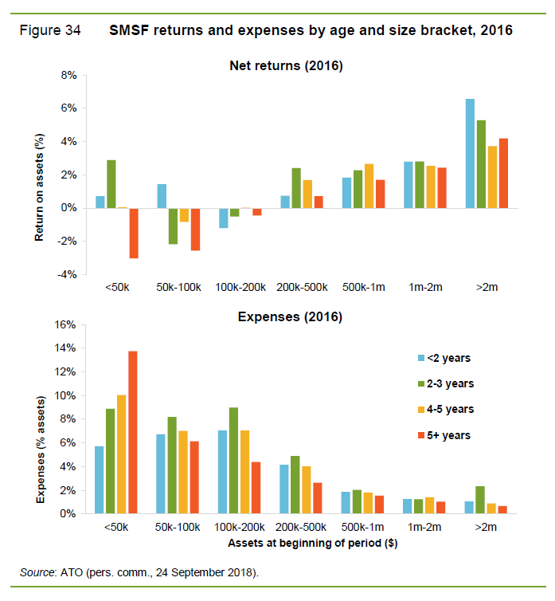
It is therefore important to provide further details on the flawed nature of the ROA as a measure for performance.

2.1 Correcting misperceptions about the ROA

2.1.1 The ROA denominator effect
The Productivity Commission notes (Supplementary Paper, p. 59) the following:

“One key difference is the denominator used in each of the two measures — the ROA measure simply uses the average value of net assets over the period (calculated by taking the value of assets at the beginning and end of the period), whereas the ROR measure takes the beginning value and adds adjustments for net member flows and net insurance flows. The effect is that the ROA denominator is influenced by net earnings during the period, while the ROR denominator is not. In years with positive returns, the ROA will be lower than the ROR.” (Emphasis added by Class)

Firstly, it should be noted that the ROA will also be systematically lower than the ROR due to the denominator effect in years with negative returns (i.e. not only in years with positive returns).

The Productivity Commission’s Supplementary Paper also includes the following figure:

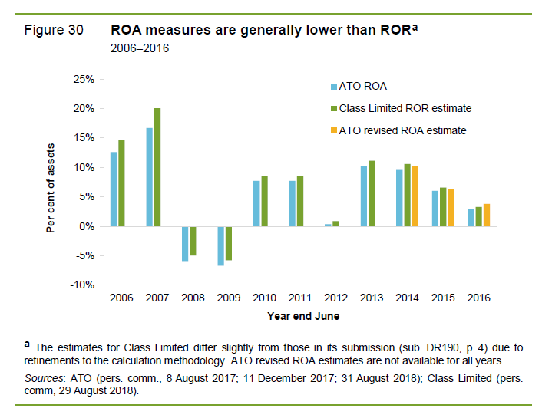
The Productivity Commission states (Supplementary Paper, p. 59) the following:

“Class Limited estimates suggest that the standard ROA measure is, on average, about
1 percentage point below ROR, with the difference greatest in the earlier years of the sample
(the ATO estimates suggest a smaller margin).” (Emphasis added by Class)

The difference between ROA and ROR is indeed greatest in the earlier years of the sample – this is because the magnitude of the difference is greatest when the absolute value of returns is greatest, and this occurred in the earliest years of the sample.

2.1.2 The ROA contributions tax and insurance effects
With regard to Figure 30 above and the ATO revised ROA estimate, the Productivity Commission states (Supplementary Paper, p. 59) the following:
“Class Limited provided ROR estimates (based on publicly available data) that adjust for the time period in the denominator, as well as the effect of contributions tax and insurance flows.”
“The ATO provided ROA estimates that only adjust for the time period in the denominator.”
The Productivity Commission also noted (Supplementary Paper, p. 60) that:
“to the extent that contributions tax and insurance flows are relatively larger for smaller SMSFs, the difference between the ROA and ROR measures is likely to be greatest for smaller SMSFs.”
Class has calculated the difference between the ROR and ROA measures for different fund size groups based on a sample of over 84,000 SMSFs for FY2016:
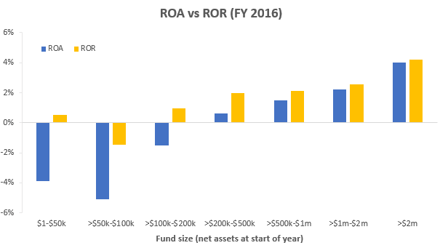
The basis is slightly different to the Productivity Commission chart in that extreme outliers, as well as SMSFs which were only active for part of the year, have been excluded from the sample. Nonetheless we can see that the >$200k-$500k, >$500k-$1m and >$1m-$2m fund size categories are not markedly different from each other in terms of performance measured using the more appropriate ROR measure.
2.2 What is an appropriate measure of “expenses”?
The Productivity Commission asserts the following (Supplementary Paper, p. 2):
“A quarter of SMSFs established in 2012 with under $500 000 grew to exceed this size within five years. However, 42 per cent of established SMSFs (some 200 000 SMSFs that were older than 2 years in 2016) have under $500 000 in assets, facing high costs and low returns on average.”
The ROA vs ROR comparison debunks the returns furphy for SMSFs in the >$200k-$500k range. But what about the expenses of running the funds?
The ATO definition of SMSF “expenses”, which may be valid for its purpose of determining the appropriate level of taxation for a fund, contains many items which are irrelevant when attempting to measure the efficiency with which a SMSF is run from a financial perspective (and its potential flow-on effect to net returns).
Furthermore, there are numerous “expenses” which are being counted for SMSFs that are excluded when measuring the “expense ratio” for APRA funds. We will see below that the inclusion of these amounts as expenses generally have a disproportionate impact on the smaller sized SMSFs.
2.2.1 Insurance
Insurance is not counted as an expense for the purpose of measuring the costs of APRA funds; however, it has inexplicably been included as a cost of SMSFs.
The decision to purchase insurance through a superannuation fund should not have any relevance when measuring the efficiency with which a fund is operated.
A similar insurance premium equates to a larger percentage of net assets in smaller funds than in larger funds, and this is reflected in the following chart:
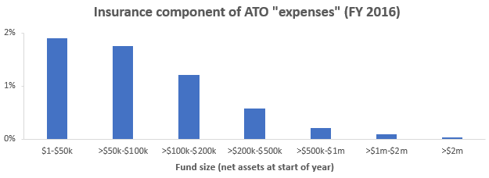
Class recommends that insurance should be removed when measuring the operating and investment expenses of SMSFs, in the same way that it is excluded for APRA funds.

2.2.2 Interest
Interest expense differs from insurance in that it is valid to include it as a decrement when measuring fund performance via net returns. However, it is inappropriate to include interest in an expense ratio when attempting to measure the operating and financial efficiency with which a SMSF is run. Borrowing money to fund additional investments is instead an investment strategy, which pays off if the investment generates a higher level of return than the interest on the borrowings (and loses money in the opposite case).
This can be illustrated via a simplified example: suppose that “SMSF A” on the first day of the financial year has $200,000 in cash, which it uses to invest in an asset that produces a return of 10% for the year, and the fund has $2,000 in operating expenses. The net return for SMSF A for the financial year would be 9% and the expense would be 1%.
Now take “SMSF B” which also has $200,000 in cash at the start of the financial year, but borrows an additional $200,000 at 5% interest and invests the total of $400,000 it now has available in an asset that produces a return of 10% for the year, and the fund has $2,000 in operating expenses.
The net return for SMSF B is 14% (better than SMSF A) and the operating expenses were $2,000 (the same amount as for SMSF A); however, the “expenses” as measured by the ATO would be 6% (i.e. six times the level of SMSF A).
SMSF B is clearly not six times less efficient than SMSF A; indeed, SMSF B had a significantly higher net performance (14% vs 9%). The difference between SMSF B and SMSF A was the investment strategy, and this is not something which any relevance when measuring the operational or financial efficiency with which the SMSFs were run.
Once again, it is the smaller SMSFs where the “expenses” are inflated the most by the inclusion of interest, as larger SMSFs often will have made progress in repaying any borrowings and/or not have required them to the same extent to fund investments:
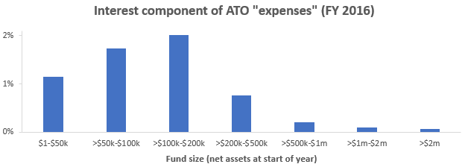
Class recommends that interest should be removed when measuring the operating and investment expenses of SMSFs.

2.2.3 Capital works and depreciation
Capital works expenditure and decline in value of depreciating assets are incurred primarily when real estate assets are directly owned by a superannuation fund. Like interest, it is valid to include capital works and depreciation expenses when measuring the investment performance of the fund, as these are directly related to the underlying investments. However, capital works and depreciation expenses (for example, purchasing a new oven for an investment property) have little to do with the efficiency of the SMSF that happens to own the asset; these are merely a function of owning particular types of assets.
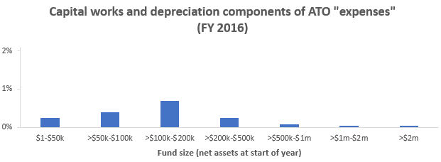
Class recommends that capital works and depreciation expenses should be removed (if this has not been done already) when measuring the operating and investment expenses of SMSFs, in the same way that it is excluded for APRA funds.
2.2.4 ATO “Other amounts”
There is a whole raft of miscellaneous amounts which appear to be lumped into the ATO “expenses” measure – the following is a list obtained from the ATO website:
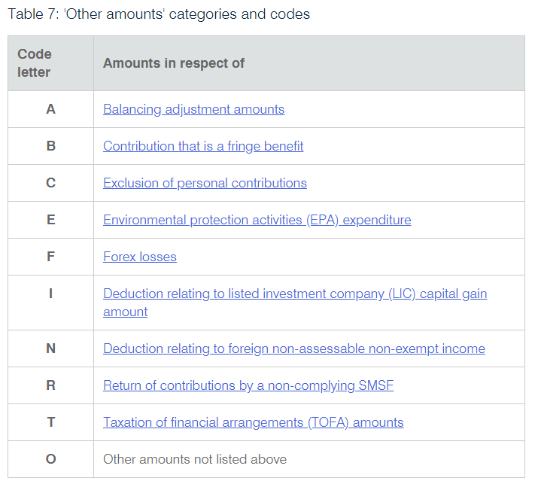
These appear to have little to do with the efficiency of the SMSF and are likely to have been excluded when measuring expenses of APRA funds; Class therefore recommends that the ATO “Other amounts” should be removed when measuring the operating and investment expenses of SMSFs.
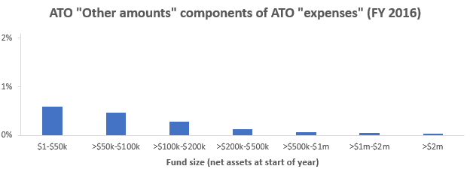
2.3 An adjusted expenses measure which reflects fund efficiency
After removing the components of the ATO “expenses” which are unrelated to the operating and financial efficiency of the underlying SMSF, it is possible to obtain an adjusted expenses measure which is more reflective of fund efficiency:
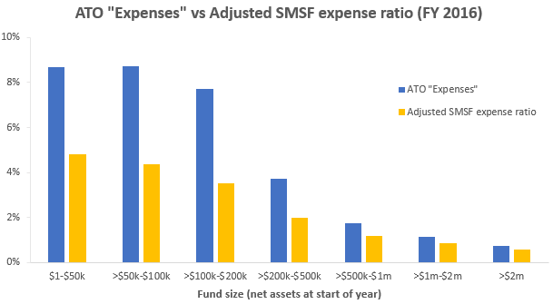
When interpreting the chart above, it is worth noting the following:
- The “adjusted expenses” measure still includes a substantial component of financial advice fees for SMSFs (which are not included to a similar extent when measuring APRA fund expenses); however, the data required to remove financial advice fees from SMSF expenses was not available
  - Consequently, when measured on a like-for-like basis with APRA funds, even the “adjusted expenses” measure may be overstating SMSF expenses
- Each size category includes a wide range of fund sizes (the average start-of-year net assets in each category was slightly less than the category midpoints for $200k-$2m funds and slightly more than the category midpoints for <$200k funds) and therefore statistics which apply at the lower end of the category are often less applicable at the upper end of the category
  - For example, the average start-of-year net assets in the >$200k-$500k category was approximately $339,000 based on the Class dataset
- At the higher asset levels, it becomes increasingly likely that SMSFs would constitute a more cost-effective vehicle for holding superannuation funds than a member account in an APRA fund
3. Conclusion
- The data does not show that $200k-$500k SMSFs experience underperformance or excessive fees relative to APRA funds
  - This is consistent with the median and average levels of SMSFs established in 2016 being firmly within that range
  - This is also consistent with Rice Warner’s comprehensive report compiled for ASIC examining costs associated with SMSFs
  - It may be reasonable to establish an SMSF at a lower size if it were to grow in the near to medium term
- In the interests of determining the most efficient structure for holding superannuation at varying member balances, the Productivity Commission should consider establishing a maximum level of net assets after which it is recommended that SMSFs be explored from a cost efficiency perspective

In a year with negative returns, the ROA and ROR numerators will be negative and the ROA denominator will be lower than the ROR denominator (thereby making the ROA lower, that is, more heavily negative, than the ROR).
In a year with high positive returns, the ROA and ROR numerators will be relatively large and the ROA denominator will be more heavily influenced upwards by the earnings during the period (compared with a year with moderate positive returns); both of these factors will cause the difference between ROR and ROA to be larger. In a year with large negative returns, the ROA and ROR numerators will be relatively large negative numbers and the ROA denominator will be more heavily influenced downwards (whilst still staying positive) by the negative earnings during the period (compared with a year with moderate negative returns); again, both of these factors will cause the difference between ROR and ROA to be larger.
n = 84,962 (extreme outliers excluded); the same data set has been used in the remainder of the Class charts in this submission.
Based on ROR (the most appropriate return calculation): (10%*$200,000 - $2,000)/$200,000 = 9%
$2,000/$200,000 = 1%
(10%*$400,000 – 5%*$200,000 - $2,000)/$200,000 = 14%
(5%*$200,000 + $2,000)/$200,000 = 6%
Self-managed superannuation funds: A statistical overview 2015-2016 (ATO)
Costs of Operating SMSFs (Rice Warner, 2013) – minor adjustments for inflation may be required to adjust to an estimate for 2016 results

