Good governance should include a “WorkCover” system which is fair, reasonable and timely to an injured worker, be that injury, psychological and/or physical.
The fundamental flaw within any current system is that the insurance agency acts on behalf of both parties-the worker and the employer.
Given that “the Commission should: draw on domestic and international policies and experience, where appropriate;” I implore you please to read the FULL ombudsman report into WorkSafe Victoria practices.
https://www.ombudsman.vic.gov.au/getattachment/0eb3f52a-6488-46f5-beb0-5cf051db359d/publications/parliamentary-reports/investigation-into-the-management-of-complex-worke.aspx
Workers reveal difficulties in getting, not only compensation but adequate and timely treatment. Please read even just some of the instances.
Following the announcement that the Victorian Ombudsman will conduct another review in the VIC WorkCover system, comes the recent announcement from The NSW Business Chamber calling on the NSW Treasurer to commission an urgent review of the NSW Workers Compensation system. This gives the other side of the picture-dissatisfaction on both sides!
https://www.nswbusinesschamber.com.au/Media-Centre/Latest-News/December-2018/URGENT-REVIEW-NEEDED-OF-WORKERS-COMPENSATION-IN-NS
“L. S., a personal injuries principal and partner at Maurice Blackburn, said Ms H concerns mirrored the experiences of many other injured workers the law firm represented.
“Their experiences are not isolated, unfortunately. People who’ve been injured at work are incredibly vulnerable and going through some of the most difficult times of their lives, yet they have to fight every step of the way for their legal entitlements,” she said.
“A growing number of our clients are also developing secondary psychological conditions due to stress and anxiety of the WorkCover process.”
Another website which gives insight into the workings of the WorkCover in any state is http://www.aworkcovervictimsdiary.com
Workers reveal difficulties in getting, not only compensation but adequate and timely treatment. Please read even just some of the instances
A key objective of the WIRC Act is
Ensuring that appropriate compensation is paid to injured workers in the most socially and economically appropriate manner and as expeditiously as possible.

Yet injured workers are exposed to a protracted dispute process, often to the detriment of their health and recovery. In my daughter’s case (one of bullying-depression and anxiety) it took two years before the insurer asked to settle and by then my daughter’s meagre savings had been used up.
Economically, she suffered from going through the Workers’ Cover compensation process.

Worse was yet to come however. My daughter was ruled out of employment because she had a claim for Worker’s Compensation for a workplace injury. The employer used the line that it was in her best interests, and in line with work, health and safety legislation. No adjustments were ever offered to her. The IME (independent medical examination) ignored salient facts to support the hospital’ claim
She applied to the major teaching hospital for a casual position as an R.N.
She was not offered a position. The letter saying it was due to an adverse referee report.
She rang the convenor to get feedback to be told at this point she had lied at interview. There are now two different reasons the hospital refused employment

She said she had not. A GIPA (Government information Public Access) application some years later revealed she had not lied and had said at interview she had an ongoing Workers’ compensation case.
The convenor after further discussion then asked my daughter to complete another pre-employment health assessment form. This was passed on up the managerial chain.
The above GIPA application revealed that at this time this hospital had a draft “internal only” Pre -employment Health risk Assessment policy. I believe it is specific to that local health district, and not part of State employment policy, to which I had access.
The health check list is completely different to the one my daughter had signed prior to interview in which she also stated her mental health condition did not prevent her from meeting the inherent requirements of the position for which she had applied-that of a casual nurse. Her treating psychiatrist asked later for the job demands checklist and stated that in his opinion she was able to meet these.
The form appears to be for those with physical injury only as it specifies clothing for exercise and to be cleared to ride a stationary pushbike. This I believe places those with a physical injury at an advantage over those with a psychological injury. The former have physical evidence of injury X-rays for example. As you will see those with a mental health issue face a solitary IME or independent medical examiner. There is no appeal or consultation with their treating specialist.
The background to implementing this policy was because some employees after a few months of employment had suffered injuries because they had pre-existing medical conditions.
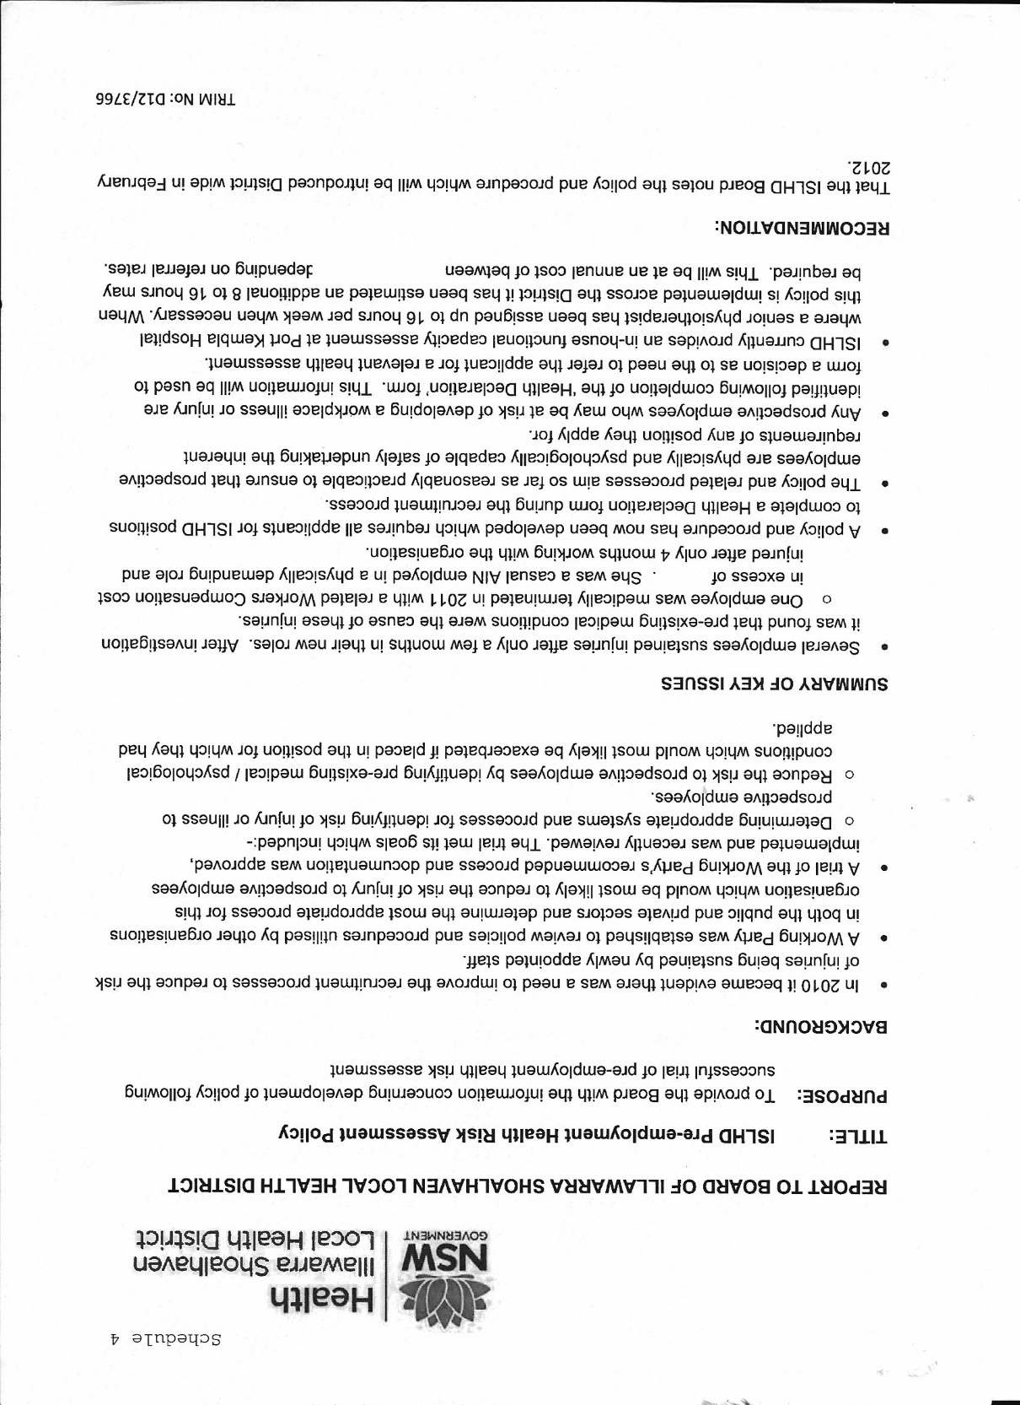
Given the following:-
- Two very different reasons given, with the third only being applied once it was decided to apply the new draft internal policy to the situation.
- Informing the IME that she had ongoing Workers’ compensation claim, I know he was involved in other WorkCover cases.
- The reasons given to have the Pre –Employment functional Capacity Assessment being specifically introduced to protect/minimise the hospital against Workers’ Compensation claims. Australian Human Rights Commission suggests this can be managed through appropriate management of such employees/applicants.
https://www.humanrights.gov.au/publications/2010-workers-mental-illness-practical-guide-managers/3-managing-mental-illness

- I then as now, am convinced that on the balance of probabilities, fighting for Workers Compensation ruled my daughter from ever being able to apply for a position at that hospital. It has never clarified what workplace issues and who determines this.
All the hospital responses to my letters insist that refusing her a position as a casual nurse was in line with its duty of care for her and the safety of others.
Employers use this argument, but it is simply a statement which can neither be shown to be true or false. In my daughter’s case it meant no lawyer, or government agency could validly challenge that process until she had the GIPA review, Then it was too late.
It explains the reluctance by such injured workers to reveal this fact. It is well known you don’t get the position once you do. If you don’t, then it can be an excuse to dismiss you if that is discovered later, or used to deny any further Workers’ compensation claim.
The two different reasons for refusing employment then the final reason as her being “the one to cause the issues creating adverse situations with other staff which then cause her to claim Workers’ Compensation” rang alarm bells for me.
I complained but I was following the standard publicly available flow chart which refers to adjustments required to enable applicant to meet inherent requirements of the position. These were never offered.

At no time when I /my daughter complained about the employment process were we informed about the above alternate process.

Under either format she is sent to a hospital appointed psychiatrist for assessment.
She received the following redacted letter. I have underlined the salient parts. What is not mentioned is that her treating doctor had cleared her to work casually.
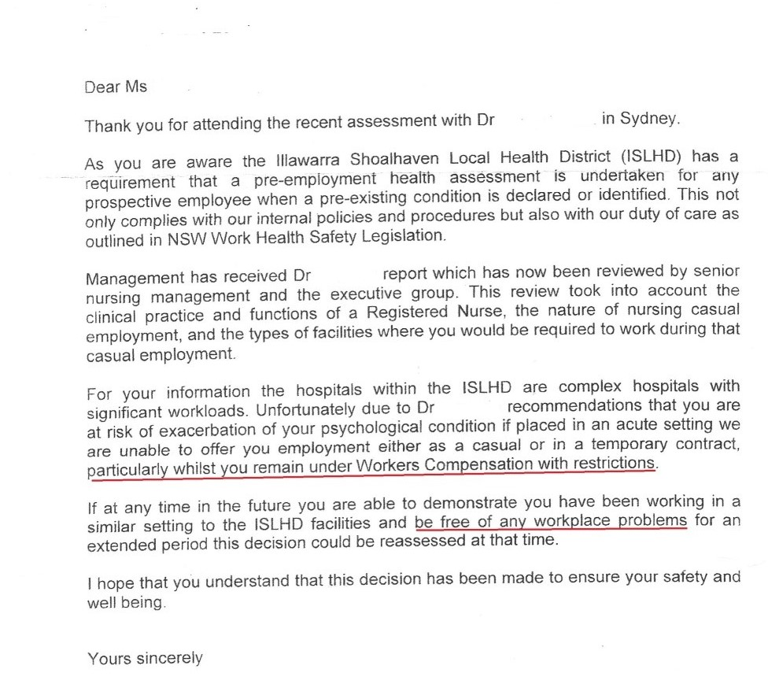
She is devastated. She is ruled unsafe to work in any capacity in any workplace ever (as she could not show herself “to be free of workplace problems” (the nature of which we were never told) in the whole of the Local Health District.
She had operated safely UNMEDICATED in a complex ward with significant workloads. NOW medicated, she is deemed unsafe. Nor was she applying for any other position than the casual pool. This was to give her some control over where and when she worked
Some months later we are able to obtain a copy of the report. It is 21 pages long and contains errors of fact upon which form the basis of some of his conclusions!
He refers to the fact she has an ongoing Workers’ Compensation case. The hospital makes this an issue in its questions it posed to him.
Workers’ Compensation is not part of meeting the inherent requirements of the position.
He never regarded her as being subject to bullying. Instead the situations are of her own making! Bullied people do not want to create such situations.
He states that work as an R.N. in a nursing home is less stressful than that of the complex hospitals with significant workloads.
A nurse’s training does not differentiate between the two situations.
He gave her as the cause of her inability to work in such complex hospitals another metal disorder unnamed because had he done, under the code independent medical examiners operate supposedly, so she would have become a patient, for whom he would be responsible.
It provided him with the means whereby he could alternate between that unnamed disorder and her OCD condition as if they were the same illness. As follows:-
Anankastic (obsessive-compulsive) personality disorder
Opinions on lifestyle issues, such as ethics, morals and religion may be rigid, and delegating tasks to others can be difficult.
Unlike those with obsessive-compulsive disorder (OCD), individuals with obsessive-compulsive personality disorder believe their behaviour is normal and will resist attempts at changing it.
All this after only one hour of assessment!!!
Deeply concerned about this I asked her treating psychiatrist if indeed she had such a personality disorder.
“NO!” He replied.
At no time in this process was he, or her psychologist, ever consulted.
Her passion as a nurse was to be a safe nurse. To be ruled as unsafe was devastating.
Her training was no matter with whom you were working, if it was wrong, it needed to be corrected. This is her duty of care and was what she was drilled to do.
The assessing psychiatrist suggests such perfectionism “is a problem to others”! Dispensing S8 drugs safely and within prescribed rules is a fundamental inherent requirement of the nursing role.
On complaining to an officer in the DDA, he said such assessing medical officers can write what they like and there is absolutely nothing anyone can do about it!
I believe that such Independent Medical experts [IME], when assessing an applicant for their ability to fulfil the inherent job demands, should not be the sole arbiter in this matter.
The importance of work in some capacity, especially paid work, in the lives of Australians injured or not, is too important to leave to the whim of [in this case] a fuddy duddy old guy with no understanding either about bullying or about the training of nurses in giving medication safely!
To leave such a decision with such monumental an impact in people’s lives to one person to assess in one hour is unbelievable.
- My daughter then dropped out of the midwifery course; yet another expense] as it was pointless to continue.
- She opted to do a Masters of Podiatry.
- The university in Sydney decided that, given the above ruling, her placement could not be in the Illawarra.
- She incurred additional costs because of this in travel and accommodation.
- She is now struggling financially. She says “I have two degrees and make less than those on the dole.”
- She lost her savings with the Workers’ Compensation case. Then, because after breaking her leg, she could not at the time of returning to work “meet the job demands of her previous podiatric employment.”
- She had to start all over again as an independent contractor.
- She is struggling psychologically as well and has had to go back on medication to cope with being a failure financially.
She also feels so deeply ashamed and embarrassed to have anxiety, and depression. This adds to the anxiety and depression. You have made the distinction: - mental illness and mental health problem.
Mental illness covers such a broad spectrum of behaviours. It is diagnosed according to standardised criteria. There is a stigma attached to mental health illness deeply felt, by those who suffer it.
She struggles to get out of bed. The anxiety, depression and the medication all make her just so tired. Her health has suffered significantly.
In summary;
- The adversarial nature of Workers Compensation process and unnecessary delays
- The employment process or how can an employer an injured worker safely, and protect himself and have a safe workplace, yet have the worker still protected by Workers’ compensation. After all accidents do happen, and not necessarily because an injury has occurred before. The use of IME’s only without including the treating psychiatrist/psychologist and/or client’s medical doctor.
- The right to appeal if factual errors occur, impacting on the IME’s assessment.
- Medication and the nature of the illness itself being so debilitating.
- The stigma attached to mental illness.
- Bullying -both school and workplace.
These all play a role in placing many of those suffering mental illness at the lower end of the socio-economic spectrum and certainly many fail to reach their potential and fully contribute to the CommonWEALTH ! The associated poor health of so many is a further cost.

My daughter still finds it depressing to deal with this even now, but I have her consent to present it to you.
Thank you in anticipation for taking the time to read this submission.

Yours sincerely, [Name withheld]

