Indigenous Evaluation Strategy – Productivity Commission Issues Paper
Submission from the Institute for Urban Indigenous Health (IUIH) Ltd, August 2019

1. ABOUT THE INSTITUTE FOR URBAN INDIGENOUS HEALTH
The Institute for Urban Indigenous Health (IUIH) was established in 2009 as a strategic response to the significant growth and geographic dispersal of Indigenous people within the South East Queensland (SEQ) region – where 38 percent of the State’s and 11 percent of the nation’s Indigenous population live.

Recent ABS Estimates and Projections of Indigenous population growth 2016 to 2031 (ABS 2019) have confirmed that IUIH’s service footprint of SEQ will continue to be one of the fastest-growing regions in Australia, with SEQ growing from Australia’s second-largest Indigenous population in 2016 (84,454) to Australia’s largest Indigenous population region by 2031 (129,835).

As the peak body of a regional network of member Aboriginal and Torres Strait Islander Community Controlled Health Services (ACCHSs) in SEQ, IUIH was created to drive the development and implementation of transformational change to the way health care services were delivered for urban Indigenous Australians in the region.

IUIH is now the largest ACCHS in Australia, operating an annual budget of $93 million in 2019-2020 with over 620 staff. The combined IUIH Network, including its member ACCHSs, has a combined annual budget of over $120 million and more than 1,170 staff, including 620 Indigenous employees. IUIH Network employs more Aboriginal and Torres Strait Islander people than any other employer within SEQ.

IUIH Network encompasses 20 primary health clinics operated by the following ACCHSs:
- Aboriginal and Torres Strait Islander Community Health Service Brisbane (Network member)
- Kambu Aboriginal and Torres Strait Islander Corporation for Health (Network member)
- Yulu Burri Ba Aboriginal Corporation for Community Health (Network member)
- Kalwun Development Corporation (Network member)
- Moreton Aboriginal and Torres Strait Islander Community Health Service (directly operated by IUIH).

Additional information on IUIH is included at Attachment 1.

2. EXECUTIVE SUMMARY
IUIH appreciates the opportunity to comment on the Indigenous Evaluation Strategy Issues Paper. The document provides a comprehensive insight into the objectives of the Strategy, including the concepts and practices to consider when designing and evaluating government policies and programs affecting Aboriginal and Torres Strait Islander people. There is an imperative to improve these practices to ensure that they are more attuned to delivering better outcomes for Aboriginal and Torres Strait Islander people. IUIH welcomes further opportunities to contribute to this outcome.

The COAG Closing the Gap Refresh strategy, including through the new Partnership Agreement on Closing the Gap 2019-29, situates the Indigenous Evaluation Strategy within the broader context of renewed efforts to privilege Indigenous leadership in policy and program design, build the evidence base about ‘what works’, and to ensure value for money in delivering programs for Indigenous Australians – principles which are underscored in the Productivity Commission’s Indigenous Evaluation Strategy (the Strategy) Issues Paper.

As also highlighted in the Issues Paper, the United Nations Declaration on the Rights of Indigenous Peoples (UNDRIP) constitutes the minimum standards for the survival, dignity, security and well-being of Indigenous peoples, including foundational rights to self-determination, self-governance, participation in the life of the State and national, individual and collective access to human rights, and equality and freedom from discrimination. It also outlines rights to land and resources, education and information, cultural and spiritual identity and indigenous-owned institutions. In this regard, the UNDRIP provides a critical reference point to shape the development and implementation of the Strategy.

The Australian Government’s Letter of Direction indicates that the overarching objective of the Strategy is to improve outcomes for Aboriginal and Torres Strait Islander people and that to support this objective the Productivity Commission should:
- establish a principles-based framework for the evaluation of policies and programs affecting Indigenous Australians
- identify priorities for evaluation
- set out its approach for reviewing agencies’ conduct of evaluations against the strategy.

IUIH’s submission has been prepared from the above frame of reference, including to advocate that the voice and experience of ACCHSs are paramount in shaping the future design and evaluation of the policies and programs affecting Aboriginal and Torres Strait Islander people.

In this context, key recommendations include:
- adopting a policy and evaluation framework which assigns ACCHSs as ‘First Choice’ providers of all Commonwealth-funded health services for Indigenous people, including under Indigenous commissioning arrangements, unless it can be clearly shown that alternative arrangements can produce better outcomes in quality and access to services
- establishing funding criteria for mainstream services which require:
- a recalibration of focus to recognise the centrality of culture as best practice in mainstream programs, including to affirm a systems-level approach to building cultural competency which does not rely solely on cultural training but aims to embed culture in all aspects of mainstream organisations’ governance, community engagement, CQI and service planning domains
- an accountability architecture for mainstream programs which is commensurate with performance reporting requirements of ACCHSs
- demonstration by mainstream providers
- the setting of targets and monitoring mechanisms to ensure equitable access by Indigenous clients to all mainstream programs which is consistent with Indigenous population levels and need.

The Discussion section below provides further detail in response to a selection of the specific questions from the Issues Paper, noting that information provided in this section may also hold some relevance to other questions from the Issues Paper, but not directly addressed in this submission.

3. DISCUSSION

Consultation Questions
QUESTIONS ON RELEVANT PRINCIPLES FOR AN EVALUATION FRAMEWORK
- What principles should be included in an Indigenous evaluation framework to be used by Australian Government agencies?
- How should an Indigenous evaluation framework differ from a general evaluation framework for government policies and programs?
Questions on objectives
- What objectives should a strategy for evaluating policies and programs affecting Aboriginal and Torres Strait Islander people seek to achieve?
- To what extent are the evaluation practices of Australian Government agencies consistent with the United Nations Declaration on the Rights of Indigenous Peoples? How could practices be improved in this respect?

This submission advocates for a recalibration of focus in program design, delivery and evaluation which:
- recognises the centrality of culture in best practice
- invokes an accountability architecture which promotes and rewards performance and outcomes (rather than a focus on the program implementation and evaluation process itself)
- builds Indigenous perspectives and leadership into the design and delivery of all parts of the policy/program cycle and at all levels (national, state and local/regional) as a necessary precursor to improving outcomes for Aboriginal and Torres Strait Islander peoples.

It is considered that the capacity of government programs to make an effective contribution to closing the gap will depend on reforms such as these. Accordingly, IUIH suggests the following broad principles for consideration for inclusion in the Evaluation Framework:
- Aboriginal Community Controlled Health Services as First Choice Providers of health services and programs aimed at closing the gap
- Indigenous-led service planning and design, commissioning and decision making about investment at a regional level for initiatives aimed at closing the gap
- Enhanced accountability and evidence-base to Close the Gap and to measure impact and outcomes.

Principle One: Aboriginal Community Controlled Health Services (ACCHSs) as ‘First Choice Providers’ to Close the Gap
Key Recommendations:
- Adopting a policy and evaluation framework which assigns ACCHSs as ‘First Choice’ providers of all Commonwealth-funded health services for Indigenous people, including under Indigenous commissioning arrangements, unless it can be clearly shown that alternative arrangements can produce better outcomes in quality and access to services
- Building the capacity of ACCHSs and community controlled aged care providers to extend their service scope to enhance opportunities for Indigenous people to access culturally appropriate and best practice supports and
- Examining the benefits of longer-term (e.g. five to 10 years) funding commitments which promote planning and innovation to better meet service user needs and build local capability, as opposed to the current short-term commitments (e.g. one to three years) which lead to rigidity in program delivery and high administration costs.

Discussion:
Indigenous Australians should lead the design and implementation of health and social services affecting their people.

The evidence-base points to ACCHSs demonstrating more effective service delivery and better health and social outcomes for Indigenous people. Linked CTG employment targets are also vastly improved, with significantly higher Indigenous employment rates achieved by community-controlled organisations.
There is a risk, however, that the current funding and commissioning arrangements of health services, including through the Primary Health Networks (PHNs):
- are out of step with the principles of an Indigenous-led reform process
- are not evidence-based and undermine the effectiveness of Indigenous health expenditure to close the gap and
- increase the potential for inefficiency and fragmentation in the health system.

The recent COAG Special Gathering Statement (COAG, 2018) re-affirmed that ‘the best progress over the last ten years has been in areas where the Aboriginal and Torres Strait Islander community has led the design and implementation of programs from the beginning’.

Similarly, the Queensland Productivity Commission (QPC, 2017) report in service delivery in Indigenous communities finds that ‘to make material progress, evidence suggests the current decision-making model for service delivery must move closer to the people it serves. Transferring decision-making closer to communities is more likely to:
- meet community needs and priorities
- empower people to have greater control over their lives
- create incentives for providers to be more responsive and drive innovation and efficiencies in service delivery and
- be more effective in improving outcomes and wellbeing’.
Further, the QPC report concludes that ‘Although grant funding and contracting arrangements aim to ensure accountability, manage risk and encourage competition, the system does not appear to facilitate the outcomes it aims to achieve. Short-term grant funding and methods of contracting leads to rigidity in program delivery (as opposed to focusing on the needs of the individuals or place) and high administration costs. It contributes to uncertainty and is a barrier to long term planning and innovation to better meet service user needs and build local capability.’
The Commonwealth government is, however, increasingly using the PHN network to be its commissioning agent of choice in relation to targeted Indigenous funding. In addition to IUIH’s Integrated Team Care (ITC) program, this includes the recent transition of substantial levels of targeted Indigenous mental health, substance use and suicide prevention funding from direct contracting arrangements with ACCHSs (and other NGOs) to the PHNs.
While there is an acknowledgement of the role of a commissioning model to advance health system reforms at a regional level, there are concerns in relation to the efficacy of some of these commissioning arrangements as they apply to Indigenous health.
These concerns relate to the procurement strategies adopted by PHNs, including market-driven and competitive tendering processes for targeted Indigenous funding.
While there are some examples where PHNs have acknowledged ACCHSs, including IUIH, as preferred providers when making commissioning decisions in relation to Indigenous-specific funding, the degree of sophistication across PHNs is highly variable, and there isn’t a consistent commissioning framework which is guided by the recognition that Indigenous health outcomes will be achieved when Indigenous people control them, and that commissioned service delivery will be a strengths-based approach reflecting the United Nations Declaration on the Rights of Indigenous Peoples.

The current commissioning approach by some PHNs is also not aligned with the Australian Government’s National Aboriginal and Torres Strait Islander Health Plan (2013-2023), which acknowledges the unique contribution of ACCHSs in delivering holistic, comprehensive and culturally appropriate health care to meet closing the gap targets.

The National Community Controlled Health Organisation (NACCHO, 2018) points to evidence which shows that ACCHSs are 23% better at attracting and retaining Indigenous clients than mainstream providers and at identifying and managing the risk of chronic disease. Indigenous people are more likely to access care if it is through an ACCHS and patients are more likely to follow chronic disease plans, return for follow up appointments and share information about their health and the health of their family. ACCHSs are also more cost-effective providing greater health benefits per dollar spent. The lifetime health impact of interventions delivered by ACCHSs is 50% greater than if these same interventions were delivered by mainstream health services, primarily due to improved Indigenous access (Vos et al, 2010).

For example, related independent research (SAHMRI, 2016) of IUIH’s programs reported that an analysis of MBS data and IUIH patient data showed that, compared to SEQ mainstream providers, IUIH:
- provides 2.6 times the number of Nurse/Aboriginal Health Worker (AHW) follow-up services (Item 10987) to a Health Check (Item 715)
- provides 1.4 times the number of Practice Nurse or AHW follow-up services (Item 10997) to a General Practice (GP) Management Plan (Item 721) or Team Care Arrangement (Item 723)
- is 32 times more likely to provide selected case conferences (Items 735, 739, 743) for every Standard GP Consultation (Item 23) they provide
- is 4.24 times more likely to provide a GP Management Plan (Item 721) or Team Care Arrangement (Item 723) for every Standard GP Consultation (Item 23) they provide.

The above research study (SAHMRI, 2016) also evaluated the PHN funded and IUIH administered Coordinated Care and Supplementary Services (CCSS) program. The evaluation found that channelling these funds through PHNs have not been administratively efficient, but rather has added cost and complexity to program implementation. The evaluation further concluded that: “the only substantive source of inefficiency was in relation to the margin retained by the Primary Health Network (PHNs) … (and) allocative efficiency would be improved if these funds were allocated to IUIH CCSS instead of retained as margins …..” It was estimated that these PHN retained funds equated to an amount of $232,469 per annum, which could have provided care for an additional 33 clients per month. It was also estimated by the evaluators that the additional administrative costs to IUIH in having to manage four separate contracts with the PHNs were in the order of $75,000 annually to manage.

Mainstream approaches, including procurement contestability, have failed to deliver outcomes for Indigenous people. Focusing investment, wherever possible, through well-governed and accountable community controlled services is, therefore, fundamental to delivering significant improvements in outcomes. As noted, primary health care delivered through ACCHSs is known to be significantly more effective than that delivered through mainstream/government services, particularly in relation to access to services and the prevention, detection and treatment of chronic disease.

Brand et al (2016b) observe that a trend by government to increasingly fund and/or rely on mainstream providers in its funding allocations puts at risk the community controlled sector’s capacity to close the gap and undermines the work and successes of these critical providers.

If the gap is to close, funding should be prioritised to services that can deliver the best outcomes for Indigenous people. This should include assignment of ACCHSs as preferred providers for Commonwealth funded health services for Indigenous people unless it can be clearly shown that alternative arrangements can produce better outcomes in quality of care and access to services.

Such a preferred provider policy could be embedded in Commonwealth Grant Rules and PHN commissioning guidelines, and reflect the success, for example, of the recently implemented Australian Government Indigenous Procurement Policy.

Principle Two: Indigenous-led service planning and design, commissioning and decision making about investment at a regional level for initiatives aimed at closing the gap

Key Recommendation:
- Providing opportunities for opt-in trials of reformed financial and decision-making arrangements, including through Indigenous-led regional funding and decision-making models. These trials would:
- include funds-pooling of targeted (Commonwealth and State) Indigenous funding, and prorated mainstream funding, for use by regional Indigenous commissioning bodies with shared and devolved decision making authority to prioritise need and respond with tailored regional solutions – calibrated to their context. Under these trials, the significantly increased regional flexibility in funding decisions would be matched by enhanced accountability regarding outcomes and evidence and
- have principles consistent with, but not necessarily requiring opt-in to, the specific Empowered Communities initiative. Regional entities such as IUIH should be able to negotiate with the government a preferred future state, tailored to their context and with reference to their scope of responsibilities and achievements to date.

Discussion:
As noted above, IUIH experience supports the established body of work showing that the best progress made over the last 10 years in closing the gap has been through community controlled approaches to Indigenous-led design and implementation of programs (Panaretto et al. 2014).
IUIH’s priority focus on a systemic and regional reform agenda has also been a critical enabler to effect change. Here IUIH System of Care is considered a novel initiative, implementing a ‘model of care’ at the local clinic level that embeds frontline clinical care into a broader regional ecosystem.
Prior to IUIH’s establishment in 2009, the four existing SEQ ACCHSs each was faced with significant challenges in providing levels of access and health servicing at the levels necessary to combat the rapidly widening health gap. Population mapping showed that existing clinic locations no longer had the capacity to reach the dispersed and rapidly growing Indigenous population, with around 8,000 (16%) of the SEQ catchment population of the time accessing an ACCHS (combined client numbers of the four ACCHSs in 2009). Internal data also highlighted very poor take-up rates of Indigenous Preventive Health Checks (MBS item 715), with only 1,206 (2.4%) of the SEQ Indigenous population receiving a 715 in 2008–2009.
These rates highlighted significant issues around access to culturally appropriate healthcare to service the needs of the growing urban Indigenous population, which provided the impetus for the establishment of IUIH. An integrated regional community governance model was deemed to have the best chance to bring about the systemic and catalytic changes required. A critical decision was made by the existing and founding ACCHS members to forge a shared identity through the establishment of a new regional organisation – IUIH. In this model, IUIH is systems integrator of regionally led reforms across IUIH Network of ACCHSs and has a lead role in strategic planning, service development, business modelling, income generation, data analysis, clinical/corporate governance, quality improvement, performance monitoring, workforce development, cross-sector connectivity and research. This has delivered significant returns on investment, including through leveraging region-wide funds pooling, regionally scaled solutions and generation of economies of scale to harness substantial efficiencies and support reinvestment to significantly expand services (e.g. allied health and aged care).
The cultural frame of reference for IUIH network links to traditional ways of being, doing and belonging when for thousands of years, Aboriginal tribes and nations across SEQ had come together to achieve shared and cross-territorial goals. Underpinning the establishment of IUIH, these cultural foundations have been developed under a Cultural Integrity Investment Framework (Institute for Urban Indigenous Health 2018), known as The Ways, which define the shared aspirations of all operations of IUIH Network.
Given the complex and fragmented nature of the health system, integration of services at a regional level was seen as a critical step to ensuring integrated care at the local / clinic level, and consequently increased access to services. The novel approach taken by IUIH was that, rather than giving clients a compass to navigate the health system, a coherent and integrated regional ‘ecosystem’ was developed in the form of IUIH System of Care.
This ecosystem promotes integrated health solutions and operations between all levels of IUIH Network, whilst seeking simultaneously to influence mainstream policy and strengthen linkages with mainstream services. Central to all activity is the holistic targeting of the social determinants of health, which account for 34% of the health gap between Indigenous and non-Indigenous people.

Advantages of a regional approach to service reform like IUIH can be found through the generation of sufficient scale, scope and access to resources, enabling improved and culturally appropriate care for patients. The holistic healthcare experience and the access it provides to social support services also help address systemic barriers and fragmentation that have been serious inhibitors to improving access and outcomes, including social determinants of health. In this context, IUIH’s operations have broadened to include legal, early education, housing, disability, aged care, child safety and employment programs.

The approach has also required some innovative solutions to existing service design in the community controlled health sector. In particular, a funding model was needed that integrated health and commercial value creation, enabling a cycle of profit and reinvestment. This has been fundamental to IUIH’s success and its capacity to deliver the large-scale solutions necessary to meet community needs. For example, in 2018-2019, 29% of its annual budget was self-generated, with $17.35 million of this generated through Medicare Benefits Scheme (MBS) income. IUIH’s best performing clinics generate $1.09 of MBS income for every $1 of Indigenous Australians’ Health Program (IAHP) PHC grant income compared to the national average of 17 cents MBS income per $1 of IAHP grant income.

This pursuit of ‘profit for purpose’ - which involves tethering of business and clinical operations into an integrated and commercially astute model - is designed to optimise MBS revenue streams, while at the same time ensuring a focus on quality and health impact, including high adoption rates of best practice cycles of care. To support the optimal use of MBS, specific targets and calculation tables are set around the use of relevant items in the care cycle. This financial architecture is a deliberate policy to reduce grant dependence and increase financial sustainability and has been a primary revenue source to spearhead growth in SEQ, including to establish services not otherwise grant-funded or accessible for a client population with complex needs and limited disposable income. This form of fiscal control has, in turn, been a defining and empowering success factor to re-frame the agenda from government-led to one where control is put back in community’s hands to prioritise need and evoke substantive change to the health system.

The success to date of IUIH System of Care points to opportunities for its replication in other parts of the country. A recent independent review of IUIH (Nous Group 2019) supports the regional model IUIH has taken and recommends that ‘government and peak bodies proactively seek opportunities to replicate the success achieved.’ In an acknowledgement that further reforms in funding arrangements are required to better support this approach, the Nous Review further recommends that ‘the Commonwealth should adopt an alternate commissioning model for Indigenous health services to ensure more effective and efficient service delivery. Under the revised model, IUIH should adopt the role of the regional commissioner for Commonwealth funding related to Indigenous health programs given the network’s strong performance, connection with the Indigenous communities in the region and specific expertise in Indigenous health’.

An opportunity for regional trials would include funds-pooling of targeted (Commonwealth and State) Indigenous funding, and prorated mainstream funding, for use by regional Indigenous commissioning bodies with shared and devolved decision making authority to prioritise need and respond with tailored regional solutions – calibrated to their context. Under these trials, the significantly increased regional flexibility in funding decisions would be matched by enhanced accountability regarding outcomes and evidence; and would have principles consistent with, but not necessarily requiring opt-in to, the specific Empowered Communities initiative. Regional entities should be able to negotiate with the government a preferred future state, tailored to their context and with reference to their scope of responsibilities and achievements to date. This will help to ensure that decision making, priorities, investment and service responses are localised and reflective of a ‘collective’ community voice, rather than the product of centralised policy settings in Canberra.

Complex government funding and contracting arrangements pose challenges for Aboriginal and Torres Strait Islander health services. For example, delivery of multiple programs on behalf of different agencies results in substantial reporting and administrative requirements. A regional funding model will assist to break down these program silos.

A model for regional funding and decision making is also fundamentally different to the current program centered approach, where government policies and programs are often designed with a focus on a particular issue (e.g. reducing smoking rates) instead of focusing holistically on a person and its family and a community context as whole (e.g. improved access to an integrated regional system of care). Subsequently, the contemporary government programs are often found to be of limited success in changing the overall impact within the complex societal and community environments.

Principle Three: An Enhanced Accountability and Evidence-base to Close the Gap and to measure the impact
Key Recommendations:
- Developing enhanced opportunities for knowledge translation of policies and practices which are demonstrating evidence in closing the gap, including those validated by IUIH System of Care (referred further in this submission). This should include the re-establishment of a CTG clearinghouse
- Ensuring that National Health and Medical Research Council (NHMRC) and other Commonwealth-funded research organisations have a stronger focus on research aimed at assessing the effectiveness of service models in achieving outcomes, including across mainstream and community controlled providers
- Ensuring all funding agreements with both mainstream and community controlled providers have an additional allocation, over and above that required for service delivery, to support the collection of data and evaluation of outcomes in relation to meeting CTG objectives at community/regional levels.
- Ensuring that centralised data collection portals are of high quality and accessible to ACCHSs to support program monitoring and evaluative efforts. There are examples where this is not currently the case such as the Australian Nurse Family Partnership Program (ANFPP)
- Ensuring that economic and social impact evaluation principles are intrinsic to building the evidence base about ‘what works’, including to ensure value for money in delivering programs for Indigenous Australians. Incorporating these principles would also maximise the benefits from health care spending and help overcome regional variations in access
- Ensuring the recently re-established and emerging Closing The Gap national partnership agreements include transparent performance monitoring arrangements for both targeted and mainstream funding for Indigenous health services and programs. Indigenous participation must be central to these arrangements to ensure effective community-led accountability of investment, outcomes and evidence in meeting CTG refreshed goals. The enhanced role of the Productivity Commission will support this performance monitoring effort and
- Establishing a national Indigenous Research Future Fund dedicated to accelerating best practice in achieving CTG goals. This could be based on the National Medical Research Future Fund.

Consultation Questions:
QUESTIONS ON DETERMINING EVALUATION PRIORITIES
- What principles should be used to determine evaluation priorities?
- What policies and programs affecting Aboriginal and Torres Strait Islander people (or broader policy and program areas) should be the highest priority for evaluation, and why?
- How often should evaluation priorities be reviewed? How should the process for reviewing priorities be structured?

This submission identifies two broader policy and program areas, which in IUIH’s experience, should be the highest priority for evaluation:
- Addressing Urban Indigenous Disadvantage to Close the Gap and
- Addressing Indigenous Mental Health Needs to Close the Gap.

Priority One: Addressing Urban Indigenous Disadvantage to Close the Gap

Key Recommendation:
That the Indigenous Evaluation Strategy commits to giving priority to addressing urban Indigenous disadvantage, including:
- Examining the need for increased funding of, and access to, community controlled health services for urban Indigenous Australians, relative to disease and disability burden and projected population growth and
- Examining the need for allocating specific infrastructure funding to support enhanced service accessibility in urban settings, including expanded clinic development.

Discussion:
IUIH sees the rapid urbanization of the Indigenous population as an emergent priority for evaluation. Efforts to address Indigenous health disadvantage require a refocus on urban settings. Proximity to mainstream primary care has not translated into health equity, with the majority of the Indigenous burden of disease (73%) remaining in urban areas and urban Indigenous people continuing to face significant barriers in accessing comprehensive and culturally appropriate care.

IUIH has strategically responded to these challenges in South East Queensland (SEQ) – home to Australia’s largest and equal fastest growing Indigenous population. IUIH has developed a new regional and systematised model – a regional health ‘ecosystem’ – for how primary care is delivered and intersects with the broader health system. Through intentional action which strengthens the self-efficacy of community, IUIH System of Care has delivered real gains for the Indigenous population of the region and has the capacity to deliver similar improvements in health access and outcomes in other regions.

Prior to IUIH, there was limited research that examined the continuing and significant disadvantage experienced by urban Indigenous Australians (Eades et al. 2010). This was mainly due to the misconception that urban Indigenous populations enjoyed easy access to, and were benefiting from, ‘mainstream’ health services. The contrary reality was that proximity to mainstream services in urban settings had not translated into better health outcomes for Indigenous people. This was due to a high degree of inequity, geographical dispersion and segregation, with urban Indigenous people typically residing in isolated, outer suburban areas, characterised by low socioeconomic status and limited employment opportunities (Brand et al. 2016).

These barriers have been magnified due to the rapid urbanisation of Australia’s Indigenous population, with 79% of Indigenous Australians now living in urban areas (Australian Bureau of Statistics 2017). Nationally, the urban Indigenous population is growing faster than those in remote areas and far outpaces the overall non-Indigenous urban population growth.

In addition, access to culturally appropriate healthcare remains out of reach for the vast majority of urban Indigenous Australians (Liaw et al. 2019). Compared to ACCHSs in remote areas which were reaching 97% of their potential Indigenous population, in 2015 ACCHSs were only reaching 26% of Indigenous people living in major cities (Australian Institute of Health and Welfare 2017).

These access challenges have corresponded to poor health outcomes for urban Indigenous Australians (Eades et al. 2010). While remote Indigenous populations generally experience greater rates of disadvantage relative to urban Indigenous populations (Carson et al. 2018), the overall health gap is weighted to urban settings. Given the overwhelming proportion of the Indigenous population is in non-remote areas, nearly three-quarters of the total national Indigenous burden of disease (using Disability Adjusted Life Years, DALY) and the Indigenous health gap (DALY Gap), is associated with urban areas (73% and 74% respectively) (Australian Institute of Health and Welfare 2016).

The implications for program development are clear. While there is no denying the health need in remote communities, policies and funding appropriations which are not impacting on the greatest number of Indigenous people and the largest burden of disease, will also not deliver progress to close the gap. Similarly, there is an imperative to ensure adherence to the refreshed CTG focus on evidence-based policies and programs.

As noted, urban Indigenous Australians are accessing evaluated best-practice care, as delivered through community controlled health services, at only half the national rate. This is largely a factor of a lack of available and accessible comprehensive and culturally appropriate care in these urban settings, where the majority of the Indigenous population reside. As the recent CTG Special Gathering has advocated, this situation must be redressed through Indigenous empowerment and self-determination which manifests in community-led solutions, not a continued reliance on mainstream service responses for urban Indigenous Australians. There must be an investment in ‘what works’.

Priority Two: Addressing Indigenous Mental Health Needs to Close the Gap

Key Recommendation:
That the Indigenous Evaluation Strategy commits to giving priority to addressing mental health needs, including:
- Examining the benefits of consolidating Indigenous mental health, suicide prevention, social and emotional wellbeing (SEWB) and substance use funding back under the Commonwealth Department of Health to support preferred service delivery through ACCHSs and more effective partnerships with the mainstream service sector and
- Examining the benefits of adding appropriate mental health Closing the Gap targets, supported by appropriate prevalence monitoring and adequate funding to address needs.

Discussion:
The mental health needs of Indigenous people require particular attention in the context of the closing the gap refresh. Nationally, mental and substance use disorders were responsible for 19% of the total disease burden and 14% of the health gap experienced by Indigenous Australians in 2011, making it the disease group contributing most to the burden of disease and injury and the second largest contributor to the gap in total burden. It was also the leading cause of non-fatal burden, accounting for more than one-third (39%) of all Years Lived with Disability (YLD) When looking at remoteness categories, mental disorders make up an even higher contribution to the Indigenous burden in urban areas compared to remote areas. For example, in Major Cities, mental disorders contribute to 25% of the total disease burden (DALY), almost double that in remote areas. (AIHW, 2016).

Current funding and commissioning arrangements are not supporting efficient and effective mental health, social and emotional well-being (SEWB) and substance use service responses for Indigenous people, due to fragmented responsibilities across government agencies, and mainstream commissioning arrangements and decisions which are not conducive to community-led solutions.

As reported in the 5th National Mental Health and Suicide Prevention Implementation Plan (Department of Health, 2017a) Aboriginal and Torres Strait Islander adults are almost three times more likely to experience high or very high levels of psychological distress than other Australians, are hospitalised for mental and behavioural disorders at almost twice the rate of non-Indigenous people, and have twice the rate of suicide than that of other Australians. The breadth and depth of such high levels of distress on individuals, their families and their communities is profound.

The high rates of chronic disease in Aboriginal and Torres Strait Islander peoples mean that many people are likely to experience coexisting physical and social/emotional health problems. Meeting Closing the Gap targets will require simultaneous action to address chronic disease and mental illness in Indigenous people, families and communities. Despite having a greater need, Indigenous people have lower than expected access to mental health services and professionals. In 2012–2013, the most common Closing the Gap service gaps reported by ACCHSs related to mental health and social and emotional wellbeing services (Department of Health, 2017a).

This is compounded with the Commonwealth government increasingly using the PHN network to be its commissioning agent of choice in relation to targeted Indigenous mental health funding. In addition to issues outlined earlier in relation to this approach, there are examples of PHNs having a preference for funding mainstream mental health services to deliver ‘universal’ mental health treatment services which include Indigenous people rather than a targeted approach through ACCHSs. This results in:
- mainstream service models which are less appropriate, less likely to be utilised, and less likely to be effective and
- ACCHSs which are insufficiently resourced to deal with the significant numbers of patients with SEWB, mental health and substance issues at their clinics.

It also has to be noted that ACCHSs are generally funded for SEWB programs (preventive mental health), rather than for clinical treatment mental health services, which is more what they are dealing with on a day to day basis.

Most Aboriginal and Torres Strait Islander peoples want to be able to access services where the best possible mental health and social and emotional wellbeing strategies are integrated into a culturally capable model of health care. This approach needs an appropriate balance of clinical and culturally informed mental health system responses, including access to traditional and cultural healing.

Aboriginal and Torres Strait Islander peoples embrace a holistic concept of health, which inextricably links mental and physical health within a broader concept of social and emotional wellbeing. A whole-of-life view, social and emotional wellbeing recognises the interconnectedness of physical wellbeing with spiritual and cultural factors, especially a fundamental connection to the land, community and traditions, as vital to maintaining a person’s wellbeing (Department of Health, 2017a).

Mental health service access challenges were again highlighted in the recent My Life My Lead consultations undertaken by the Commonwealth Department of Health (2017). The consultation report reiterated the importance of culturally valid understandings in shaping the provision of services and guiding the assessment, care and management of mental disorders for Indigenous people. The report identified inpatient and specialist services as often the least culturally safe for Indigenous people accessing mental health care. Fear of accessing inpatient services is often compounded by people having a lack of support due to dislocation from family and country. In the absence of community controlled inpatient services, it is, therefore, critical for the Commonwealth to invest in strategies to improve the cultural capability of those services.

The impact of intergenerational trauma and social and economic disadvantage at individual, family and community levels also continues to challenge the mental and physical health and wellbeing of Aboriginal and Torres Strait Islander peoples, who can present to mental health services with a complex and interrelated mix of problems.

To meet this need in the culturally and holistic way described, Aboriginal and Torres Strait Islander leadership, including ACCHSs, must have an integral role in the design and delivery of an appropriately responsive mental health and well-being service system for Indigenous people.

Unfortunately, the current mental health funding framework is not conducive to best supporting this principle. Where mental health, social and emotional well-being and substance use funding should be given to directly to ACCHSs to ensure that comprehensive and integrated care models can be efficiently delivered, an entirely inefficient and fragmented program arrangement is in place.

Following the previous machinery of government changes, mental health, social and emotional well-being, suicide prevention and substance use responsibilities and funding are now split between the Department of Health and the Department of the Prime Minister and Cabinet. Further, specific mental health appropriations for Indigenous people are directed through Primary Health Networks (PHNs) to commission, which adds an inefficient additional layer of administration at best, and at worst, the risk of additional service fragmentation through PHN ‘market-driven’ procurement practices.

Consultation Question:
QUESTION ON APPLYING THE STRATEGY TO MAINSTREAM PROGRAMS
- What is the best way to address mainstream programs in the Indigenous Evaluation Strategy?

Key Recommendations:
Establishing funding criteria for mainstream services which require:
- A recalibration of focus to recognise the centrality of culture as best practice including to affirm a systems-level approach to building cultural competency, which does not rely solely on cultural training but aims to embed culture in all aspects of mainstream organisations’ governance, community engagement/reciprocity, CQI and service planning domains
- Establishing an accountability architecture for mainstream programs which is commensurate with performance reporting requirements of ACCHSs and Aboriginal Community Controlled Health Organisations (ACCHOs)
- Demonstration that mainstream service models are evidence-based in terms of delivering outcomes for Indigenous clients
- Setting targets and monitoring mechanisms which ensure access by Indigenous clients to all mainstream programs is consistent with Indigenous population levels and need. This also includes, more broadly, identifying closing the gap targets in the aged care and disability domains.

Discussion:

Cultural Accountability Framework
Providing culturally safe care remains an imperative for health practitioners if better health access and outcomes for Indigenous people are to be realised, including in relation to the capacity of the mainstream services and programs to improve the quality of services for Indigenous patients.

The National Aboriginal and Torres Strait Islander Health Plan 2013 - 2023 highlights the centrality of culture in the health of Indigenous people. Specifically, the plan points to how culture can influence Indigenous people’s decisions about when and why they should seek health services, their acceptance of treatment, the likelihood of adherence to treatment and follow up, and the likely success of prevention and health promotion strategies.

Ensuring that health services and providers are culturally competent will lead to more effective health service delivery and better health outcomes. In this context, ACCHS are making a unique contribution to the delivery of best practice health care for Indigenous people - care which is intrinsically characterised by a strong cultural integrity framework.

The ACCHS model affirms the recurring evidence that Indigenous people will access services and actively engage in, and benefit from, health-improving, independence promoting and capacity building behaviours when they are culturally connected to community-controlled providers and can develop trusting relationships with Indigenous staff.

Equally important for ACCHS is that all aspects of care planning and delivery are designed and operate from an Indigenous worldview, where:
- concepts of holistic health and wellbeing are recognised in health practice
- Indigenous knowledge, values, beliefs and cultural needs inform clinical decisions, pathways and ongoing care and
- Cultural identity, cultural connection/responsibility to family/community and cultural healing represent the critical success factors in supporting goal attainment and improved health and wellbeing, including in the prevention and management of chronic disease.

This importance of cultural integrity in health practice has been elevated as a priority in the Council of Australian Government’s (COAG) recent refresh of the Closing the Gap agenda, and also affirmed by the Australian Health Ministers’ Advisory Council (AHMAC) in its National Aboriginal and Torres Strait Islander Health Standing Committee (NATSIHSC) refresh of the Cultural Respect Framework 2016-26. Through this framework, all governments have agreed to embed cultural respect and responsiveness across all health systems.

Translation of this framework into routine clinical practice remains, however, a significant challenge in mainstream settings, where a cultural misalignment continues to manifest in in the form of systemic barriers of access and health benefit.

Underscoring this challenge, the Medical Journal of Australia recently (2019) published the outcomes of a cluster randomised control trial of 56 general practices in Sydney and Melbourne designed to examine whether a cultural respect framework improved clinically appropriate anticipatory care for Indigenous patients in mainstream general practice and the cultural respect levels of medical practice staff. In this trial, despite a year-long practice-based cultural respect program (Ways of Thinking and Ways of Doing) applied to the intervention group — including a workshop and toolkit of scenarios, with advice from a cultural mentor, and guided by a partnership of Indigenous and general practice organisations — the program failed to increase Indigenous health check rates (MBS Item 715), recording of chronic disease risk factors or cultural quotient scores for staff, compared to a control group of general practices.

Of equal concern, a November 2018 joint Victorian Aboriginal Community Controlled Health Organisation (VACCHO) and Royal Melbourne Institute of Technology (RMIT) survey found continuing high levels of racism in the health sector, including 88% of respondents experiencing racism from nurses and 74% experiencing racism from GPs.

This accentuates the earlier Australian Department of Health’s My Life My Lead Consultation Report findings that systemic racism and a lack of cultural capability, cultural safety and cultural security remain barriers to health system access. The My Life My Lead report further notes that racism makes people sick and that constructive and systemic action addressing its causes and effects is required to deliver significant positive impacts on health and broader life outcomes for Indigenous Australians.
A more structured cultural accountability framework is considered a necessary response to this challenge. Apropos this challenge, and in what is hopefully a precursor to further reform, we have now seen, for the first time, the inclusion of six new actions in the National Safety and Quality Health Service (NSQHS) Standards (second edition) that specifically address the needs of Indigenous people.

Launched at COAG in August 2018, the NATSIHSC developed actions cover areas that are considered to have the biggest impact on improving the health outcomes for Indigenous Australians. An NSQHS Standards User Guide for Aboriginal and Torres Strait Islander Health provides practical guidance and case studies to assist health services to meet these actions - which build on the ‘usual’ cultural training requirement to take a more systemic approach by embedding cultural competency into the governance, community partnership, needs assessment, CQI and service design domains of the health organisation.

Incorporating these actions in the Standards means that mainstream health services will, from 1 January 2019, need to demonstrate that they are being addressed to pass their assessments. This will help to ensure, for example, that formalised arrangements are in place which requires demonstration of community engagement by mainstream organisations to support the planning and delivery of effective services.

It is considered that other programs and services can also significantly benefit from such an approach, with the NSQHS Indigenous standards providing a useful framework to drive the changes required to build cultural competency across all mainstream programs

Performance Accountability Framework
The ACCHS sector in SEQ has contributed to resourcing significant continuous quality improvement capability within IUIH Network which has seen IUIH’s National Key Performance Indicator (nKPI) data achieve a range of best practice results, make significant progress towards meeting the National Aboriginal and Torres Strait Islander Health Implementation Plan’s 2023 nKPI targets and deliver validated better health outcomes, including narrowing of the health gap.

The efficacy of government programs to achieve similar improvement outcomes in the mainstream sector is, however, in question. For example, there is a quantum differential standard of performance monitoring between mainstream GP practices and the community controlled sector, with only 233 organisations nationally (mainly ACCHSs) regularly (six-monthly) reporting against the COAG agreed set of 28 nKPIs. For the remaining majority of practices, there is no real CQI accountability in terms of demonstrating continuous improvement outcomes for Indigenous clients. This also highlights a major program misalignment with the government’s related efforts to close the gap through its 2023 Implementation Plan nKPI targets.

For instance, the Commonwealth Practice Incentive Program Indigenous Health Incentive (PIP IHI) has been an effective incentivisation instrument within the ACCHS sector. In the case of IUIH, this has manifest in the way PIP IHI payments, together with MBS income, have made a critical contribution to expanding service reach through the rollout of new clinics – ensuring substantially increased numbers of Indigenous people can now access culturally safe and best practice care.

Additionally, the PIP IHI has contributed to resourcing significant continuous quality improvement capability within IUIH Network which has seen IUIH’s National Key Performance Indicator (nKPI) data achieve a range of best practice results, make significant progress towards meeting the Implementation Plan’s 2023 nKPI targets and deliver validated better health outcomes, including narrowing of the health gap.

The efficacy of the PIP IHI to achieve similar improvement outcomes in the mainstream sector is, however, questioned. For example, the current PIP IHI payment structure is applied equally to both ACCHS and mainstream practices without adequately taking into account inherent and fundamental differences and performance expectations. In the case of ACCHSs, the PIP IHI builds on an already evidence-based and best practice model by supporting its extension and continuous improvement - including within a robust benchmarking and monitoring regime (e.g. nKPI reporting). Mainstream practices, on the other hand, start from a significantly lower threshold in terms of cultural acuity, their capacity to provide the levels of holistic comprehensive primary health care required, and their lack of any obligations to report against performance measures and health outcomes.

It is recognised that not all Indigenous people can access ACCHSs and that it is important to have improvement initiatives which can also support mainstream services and programs. A substantive redesign of the current program development and evaluation processes is, therefore, required if objectives of government programs are to be realised, adequately measured and a return on investment demonstrated.

Government programs need to be operating within and evaluated against a monitoring framework which can support relevant trend analysis, benchmark against best practice and monitor continuous quality improvement. For instance, monitoring regimes such as nKPIs, including through benchmarking and target setting, can be instrumental in meeting these objectives and drive real change. Recent Australian Institute of Health and Welfare (AIHW) data (published July 2019), for example, showed that favourable changes were observed for 20 of the 23 nKPIs for which comparable data were available from June 2017 to June 2018. In addition, the AIHW data showed that the mean results for nKPI reporting organisations were markedly better for health checks and 1.75 times better than the national results for both General Practitioner Management Plans (GPMP) and Team Care Arrangements (TCA) items for Indigenous Australians.

Accordingly, establishing a suitable accountability architecture for all mainstream programs which is commensurate with relevant performance reporting requirements of ACCHSs and ACCHOs is deemed a priority.

Access and Equity Framework
At a minimum, all mainstream programs should be required to report levels of access by Indigenous clients. Importantly, this should include relevant identification of Indigenous clients and the setting and reporting against targets which are consistent with the Indigenous population levels and need to ensure that equity of access is a priority.

Currently, there isn’t consistent transparency and accountability in this regard. For example, mainstream providers who are successful in the Aged Care Approval Rounds (ACAR) in terms of funding for Indigenous places are subsequently not held to account in terms of their performance against Indigenous client numbers. Similarly, there are no accountabilities for NDIS providers to ensure equitable access by Indigenous clients.

Accordingly, IUIH advocates for the inclusion of Indigenous access targets as deliverables within service contracts and for the consideration of global closing the gap targets in the aged care and disability sectors.

Consultation Questions:
QUESTIONS ON PLANNING FOR EVALUATION EARLY IN THE POLICY CYCLE
- To what extent is evaluation planned for during the design and development of policies and programs affecting Aboriginal and Torres Strait Islander people?
- Is evaluation funded out of program budgets or from a central evaluation budget within agencies?
- What are the key actions and decisions agencies should take when planning early for evaluation?
QUESTIONS ON EVALUATION METHODS AND DATA
- What types of evaluation approaches and methods are currently used to evaluate Indigenous programs? How could evaluation methods be improved to ensure robust and reliable evidence is produced?
- To what extent does a lack of high quality, accessible data, including data gaps, act as a barrier to undertaking effective evaluation of policies and programs affecting Aboriginal and Torres Strait Islander people?
QUESTIONS ON INCORPORATING INDIGENOUS PERSPECTIVES INTO EVALUATION
- How are Aboriginal and Torres Strait Islander knowledges, perspectives and priorities currently incorporated into the design and conduct of Australian Government evaluations of Indigenous specific and mainstream policies and programs? How could this be improved?
- What are the barriers to further increasing engagement with Aboriginal and Torres Strait Islander people during Australian Government evaluation projects?
- How can the costs to government and communities of engaging more meaningfully with Aboriginal and Torres Islander people during evaluation be better integrated into existing and future program and evaluation budgets?

Key recommendations:
- Improving Commonwealth departments’ evaluation culture and capability to ensure there is greater accountability within the government itself in the way programs are designed and outcomes monitored
- Ensuring adequate funding is allocated within provider funding contracts to evaluate the impact of programs on the ground and within the distinctive local/regional community and service system contexts and
- Supporting the further development of culturally responsive outcome measurement tools for use with Indigenous Australians.

Discussion:
The March 2019 Australia and New Zealand School of Government (ANZSOG) Research Paper for the Australian Public Service Review Panel (Appendix B – Evaluation in the Australian Public Service: current state of play, some issues and future directions), repeated calls from previous enquiries and reports for a need to improve the conduct and utilisation of evaluation, and concluded that the state of evaluation within Commonwealth portfolios is poor. The Paper highlighted the need for a stronger centralised role to identify the priorities for evaluation, to oversight evaluation activity, including rigorous reporting on this; and to provide the impetus and support to build and consolidate an evidence-based, and accountability-focused culture which values, effectively manages, and uses evaluation.

Specifically, the Paper notes that a number of recurring problems are frequently observed in evaluations, including delayed commencement, problems of data access and problems of establishing counterfactuals. The paper also identifies some issues which have been raised about potential reforms to program development and approval processes which could address the above problems, including:
- The scope for outcome evaluations to be commenced (including commissioned) prior to program implementation (potentially as a requirement of policy/program approval), the consistent development of program logic, along with an investment in the collection of baseline data and direct and early participation in data specification
- This process to also consider options such as phased introduction to assist the creation of counterfactual
- Ensuring all contracts between the Commonwealth and organisations that deliver services and programs on behalf of the government have adequate obligations for consistent and appropriate data collection and the provision of this for evaluation purposes and
- Ensuring appropriate legal and operational frameworks which will enable data-matching for the purposes of evaluation.

IUIH’s experience to date with the evaluation of government programs broadly reverberate the above issues and proposed reforms, including the need for government departments to be more accountable in how they design and monitor program outcomes. For example, recent aged care and NDIS reforms have failed to address the needs of Indigenous clients in their respective program design and implementation. This particularly relates to the intrinsic barriers to access and service navigation for Indigenous people as reflected in the My Aged Care and NDIS Local Area Network design flaws. As a result, IUIH is now leading an effort to redress these deficiencies through pilots of national significance which are trialing a major redesign in how government agencies administer these programs.

In addition, the funding arrangements often do not allow for resources to evaluate the impact of the program on the ground and within the distinctive local/regional community and service system contexts. IUIH strongly advocates for adequate evaluation resources to be allocated within the program funding for this purpose.

In terms of current evaluation approaches and methods to evaluate Indigenous programs, the research suggests a current dearth of culturally responsive outcome measures for use with Aboriginal and Torres Strait Islander peoples. Most outcome measurement tools have been developed with participants from Western backgrounds. The appropriate evaluation of health services for Aboriginal and Torres Strait Islander peoples demands culturally responsive goal-setting tools that can be used by inter-professional teams.

In response to this challenge, IUIH, in partnership with the University of Queensland, has developed a new Australian Therapy Outcome Measure for Indigenous Clients (ATOMIC). The ATOMIC is a purpose-designed tool for measuring therapy outcomes that has been specifically designed to consider the more holistic views of health held by Aboriginal and Torres Strait Islander peoples. The ATOMIC demonstrates face and ecological validity and good clinical utility in an inter-professional service for Aboriginal and Torres Strait Islander children and adults. It is aligned with a culturally responsive practice perspective and captures goal achievement in daily life contexts. The ATOMIC facilitates therapists’ communication with clients and their family members as well as other team members, resulting in more holistic goal setting and evaluation across health, education and other sectors. IUIH is currently using the ATOMIC tool across a range of allied health services with plans to further expand its use within the organisation.

IUIH also advocates for a rethink of the current headline CTG health targets. For example, Health Adjusted Life Expectancy (HALE) is considered a preferred measure to Life Expectancy (which is currently used in the CTG targets). This is because HALE extends the concept of life expectancy by also considering the time spent living with disease and injury. It reflects the length of time an individual can, on average, expect to live in full health. This provides a better understanding of whether people are spending more years in good health or more years living with illness. IUIH contends that reducing premature mortality is not enough if people are going to live longer but in states of ill health and disability.

In the context of closing the gap, the inclusion of HALE is therefore considered a much better measure to use in terms of a CTG target. At present the crude measure of life expectancy does not highlight or provide capacity for targeted measurement of, the significant disease burden and health gap which Indigenous Australians are experiencing through disease and ill health. The non-fatal component of the Indigenous burden of disease, for example, represents approximately half (47.1%) of the total disease burden. For particular diseases, it is much higher. Mental disorders, hearing, and dental conditions are examples of conditions that are not being systematically measured under current close the gap targets because of their low contribution to mortality. Yet the impact of these conditions can be quality of life, education and employment outcomes.

Consultation Questions:
Questions on evaluation practice in australia
- In what ways are Aboriginal and Torres Strait Islander people and organisations contributing to policy and program evaluation?
- How do we better enable Aboriginal and Torres Strait Islander organisations to lead evaluation and strengthen their evaluation capability?
- How effectively do government agencies work with Aboriginal and Torres Strait Islander organisations when evaluating policies and programs? What can agencies do better?
QUESTIONS ON IDENTIFYING AND TRANSLATING KNOWLEDGE FROM EVALUATION
- What can be done to ensure that knowledge generated through evaluation is identified and translated in such a way that it can be used to usefully and meaningfully inform policy design and implementation?

Key recommendation:
- Developing enhanced opportunities for knowledge translation of policies and practices which are demonstrating evidence in closing the gap (CTG), including those validated by IUIH System of Care (also referenced elsewhere in this submission).

Discussion:
A key principle and consistent theme of the CTG Refresh agenda has been the need to better shape Indigenous Affairs by a more robust evidence-base. This follows the Centre for Independent Studies ‘Mapping the Indigenous Funding Maze’ (2016) Report which found only 8 percent of 1082 Indigenous-specific programs, worth $5.9bn, had been effectively evaluated. The latest Productivity Commission’s Overcoming Indigenous Disadvantage: Key Indicators 2016 Report also flagged a pressing need for more and better evaluation of Indigenous programs, citing only 34 of 1000 Indigenous-specific initiatives were deemed to have been adequately evaluated.

The lack of relevant research is particularly the case in relation to the urban context, with a review (Eades, 2010) of Australian original research publications on the health of urban Indigenous Australians finding sparse data (only 11% of health studies in the previous 5-year period had focussed on urban Indigenous health). In this context, the research contribution which IUIH is making is considered to be of national significance in building the evidence base to more effectively close the gap – with applicability in both urban and other settings.

For example, a recent independent review of IUIH conducted by the Nous Group (2019) highlighted IUIH’s proactive undertaking of evaluations and the strategic use of data and evidence to inform its program delivery and contribute to the evidence base on what works in Indigenous health. It concluded that program evaluations, independent studies and published papers point to IUIH System of Care achieving significant client outcomes, delivering outstanding perinatal results and making a material difference in closing the gap.

These evaluation studies have identified improvements in patient outcomes across IUIH network, with many of the outcomes directly linked to Closing the Gap targets or nKPIs. Examples include:
- A recent epidemiological study in 2018 of patient outcomes found that IUIH System of Care was closing the Health Adjusted Life Expectancy (HALE) gap 2.3 times faster than usual Indigenous care (Turner et al. 2019)
- A recent prospective cohort study published in The Lancet’s eCLinicalMedicine examined IUIH’s Birthing in Our Community (BiOC) service, an integrated and culturally appropriate maternity service for Aboriginal and Torres Strait Islander mothers and babies. The study found that, compared to standard care, women receiving care through BiOC were less likely to have a preterm birth than women receiving standard care (6.9% vs. 11.6%) and had significantly reduced odds (OR = 0.50, 95% CI: 0.31, 0.83) of having a preterm birth (Kildea et al. 2019). In addition, the program has been found to reduce the occurrence of low birth weight from 18% to 6% (Kildea et al. 2018). This is a significant outcome, nearly closing the gap between Indigenous and non-Indigenous for preterm birth and neonatal unit admissions and
- Programs designed to prevent and manage chronic disease have also shown results. IUIH’s Work It Out self-management program for people with chronic conditions has been found to improve functional exercise capacity (6 minute walk test, p= 0.023, 95% CI:0. 01, 0.07), high systolic blood pressure (p=0.009, 95% CI: −18.82, −3.18) and weight reduction among higher weight participants (BMI, p=0.037, 95% CI: −3.03, −0.10) (Mills et al. 2017). Participants were also found to have higher utilisation rates of health assessments, GP management plans and other enhanced primary care MBS items, and were more likely to utilise these than non-participants (Hu et al. 2019).

Complementing its active research program is a pre-eminence for systemisation of IUIH’s operations. As the regional backbone organisation, IUIH plays a lead role in the development of targets and shared measurements systems. The capacity of IUIH to leverage concentrated expertise to provide regional Information and Communications Technology (ICT), Continuous Quality Improvement (CQI), data analytics and clinical governance services for its SEQ Network members have delivered standardised systems and adherence to a continuous improvement trajectory. This has supported embedding the System of Care throughout the network and ensured a systematised accountability regime to set, monitor and benchmark National Performance Indicators (nKPIs), care cycle and MBS income targets. Reward programs support rapid and regular cycles of review and improvement, including through tailored team incentive plans for each clinic. Active tracking of population growth and movement also informs strategies for continued client growth to meet ‘client reach’ targets and business planning for future service infrastructure expansion.

This data-informed priority for ongoing systems analysis has contributed to significant best practice results, including against National Key Performance Indicators (nKPIs). For example, there has been a 4,158% increase in annual Health Assessments (MBS 715) from 550 (2009) to 23,419 (2019). IUIH Network Health Assessment usage rates are now already exceeding Implementation Plan (IP) 2023 National Key Performance Indicator targets (Australian Institute of Health and Welfare 2018): 5-14 yrs 87% (44% higher than IP 2023 target); 25-54 yrs 77% (18% higher than IP 2023 target); and 55+ yrs 81% (7% higher than IP 2023 target).

It is important that effective knowledge translation strategies are in place to ensure that this contribution, and that from others, can better inform future CTG policy and practice. Without this focus on evidence, policy and practice will continue to be at risk of ‘innovation without change’. To this end, IUIH has embarked on a number of strategies to ensure that knowledge generated through its evaluation efforts can be shared more broadly with the sector and to meaningfully inform policy design and implementation:
- Building on the success of the first IUIH System of Care (ISoC) Conference in Brisbane held in August 2018 and to coincide with IUIH’s 10th Anniversary, the second ISoC Conference is scheduled for 15 – 17 October 2019 at the Brisbane Convention Centre. Registrations and draft program can be located at: https://www.ivvy.com.au/event/IUIH19/
- IUIH has recently completed a comprehensive web-based interactive e-learning platform which describes the ISoC across seven modules. This platform will initially be used across IUIH Network but will also have potential utility for broader access under relevant licence arrangements
- IUIH has a strong commitment to publishing research findings in prominent publications to share learnings with other ACCHSs and mainstream providers.

4. CONTACT

For further information, please contact Dr Carmel Nelson, Clinical Director IUIH.
References
Askew D, Jennings W, Hayman N, Schluter P (2018) Knowing our patients: a cross-sectional study of adult patients attending an urban Aboriginal and Torres Strait Islander primary healthcare service. Australian Journal of Primary Health 2018 December
Australian Bureau of Statistics (2017) Census of Population and Housing: Reflecting Australia - Stories from the Census, Aboriginal and Torres Strait Islander Population 2016, cat no 2071.0 (ABS: Canberra, ACT) Available at http://www.abs.gov.au/ausstats/abs@.nsf/Lookup/by%20Subject/2071.0~2016~Main%20Features~Aboriginal%20and%20Torres%20Strait%20Islander%20Population%20Article~12 [Verified 31 January 2019]
Australian Bureau of Statistics (2018) Estimates of Aboriginal and Torres Strait Islander Australians, June 2016, cat no 3238.0.55.001 (ABS: Canberra, ACT) Available at http://www.abs.gov.au/AUSSTATS/abs@.nsf/Lookup/3238.0.55.001Main+Features1June%202016?OpenDocument [Verified 31 January 2019]
Australian Bureau of Statistics (2019) Estimates and Projections, Aboriginal and Torres Strait Islander Australians, 2006 to 2031, cat no 3238.0 (ABS: Canberra, ACT) Available at
https://www.abs.gov.au/AUSSTATS/abs@.nsf/DetailsPage/3238.02001%20to%202026?OpenDocument [Verified 23 August 2019]
Australian Health Ministers’ Advisory Council (2016) Cultural Respect Framework 2016-2026 For Aboriginal and Torres Strait Islander Health (AHMAC: Canberra, ACT)
Australian Health Ministers’ Advisory Council (2017) Aboriginal and Torres Strait Islander Health Performance Framework 2017 Report (AHMAC: Canberra, ACT)
Australian Institute of Health and Welfare (2016) Australian Burden of Disease Study: Impact and causes of illness and death in Aboriginal and Torres Strait Islander people 2011. Australian Burden of Disease Study series no. 6 Cat. No. BOD 7 (AIHW: Canberra, ACT)
Australian Institute of Health and Welfare (2017) National Key Performance Indicators for Aboriginal and Torres Strait Islander primary health care: results from June 2016. National key performance indicators for Aboriginal and Torres Strait Islander primary health care series no. 4. Cat. no. IHW 177 (AIHW: Canberra, ACT)
Australian Institute of Health and Welfare (2019) Person-regular client indicator. (AIHW: Canberra, ACT) Available from: http://meteor.aihw.gov.au/content/index.phtml/itemId/436653. [Verified 14 June 2019]
Australian Institute of Health and Welfare (2018) Tracking Progress against Implementation Plan goals for the Aboriginal and Torres Strait Islander Health Plan 2013 – 2023. (AIHW: Canberra, ACT) Available at https://www.aihw.gov.au/reports/indigenous-health-welfare/tracking-progress-against-ipg-2013-2023/contents/summary [Verified 31 January 2019]
Battilina J, Lee M, Walker J, Dorsey C (2012). ‘In Search of the Hybrid Ideal’. Stanford Social Innovation Review. Available at http://ssir.org/articles/entry/in_search_of_the_hybrid_ideal [Verified 31 January 2019]
Brand E, Bond C, Shannon C (2016) Urban Indigenous Health: Opportunities and Challenges in South East Queensland (University of Queensland Poche Centre for Indigenous Health: Brisbane, Qld)
Carson E, Sharmin S, Maier A, Meij J (2018) Comparing indigenous mortality across urban, rural and very remote areas: A systematic review and meta-analysis. International Health 10, 219-227
Council of Australian Governments (2018) COAG Meeting Communique, 12 December 2018 (COAG: Canberra, ACT, Australia) Available at https://www.coag.gov.au/meeting-outcomes/coag-meeting-communique-12-december-2018 [Verified 31 January 2019]
Department of Health (2013). National Aboriginal and Torres Strait Islander Health Plan 2013-2023
Department of Health (2017). My Life My Lead - Opportunities for strengthening approaches to the social determinants and cultural determinants of Indigenous health: Report on the national consultations
Department of Health (2017a). Fifth National Mental Health and Suicide Prevention Plan, Implementation Plan, Department of Health, Canberra
Donato R and Segal L (2013) Does Australia have the appropriate health reform agenda to close the gap in Indigenous health? Australian Health Review 37, 232-238
Eades S J, Taylor B, Bailey S, Williamson A B, Craig J C, Redman R (2010) The health of urban Aboriginal people: insufficient data to close the gap. Medical Journal of Australia 193, 521-524
Gottlieb K (2013) The Nuka System of Care: improving health through ownership and relationships. International Journal of Circumpolar Health 72: 21118.
Hewitt B, Walter M (2014) Preschool participation among Indigenous children in Australia. Family Matters 95, 41-50
Hu J, Basit T, Nelson A, Crawford E, Turner L. (2019) Does attending Work It Out – a chronic disease self-management program – affect the use of other health services by urban Aboriginal and Torres Strait Islander people with or at risk of chronic disease? A comparison between program participants and non-participants. Australian Journal of Primary Health Online early [http://www.publish.csiro.au/py/PY18089]
Institute for Urban Indigenous Health (2019) Regional Clinical protocols and patient Fact Sheets. (IUIH, QLD) Available from: http://manual.mmex.net.au/iuih:regional_clinical_protocols. [Verified 27 June 2019]
Institute for Urban Indigenous Health (2018) IUIH Cultural Integrity Investment Framework (IUHI, QLD)
Kildea S, Gao Y, Hickey S, Kruske S, Nelson C, Blackman R, Tracy S, Hurst C, Williamson D, Roe Y (2019) Reducing preterm birth amongst Aboriginal and Torres Strait Islander babies: A prospective cohort study, Brisbane, Australia. EClinicalMedicine In press (https://doi.org/10.1016/j.eclinm.2019.06.001 )
Kildea S, Hickey S, Nelson C, Currie J, Carson A, Reynolds M, Wilson K, Kruske S, Passey M, Roe Y, West R, Clifford A, Kosiak M, Watego S, Tracy S (2018) Birthing on Country (in Our Community): a case study of engaging stakeholders and developing a best-practice Indigenous maternity service in an urban setting. Australian Health Review 42, 230-238
Lewis M, Myhra L (2018) Integrated care with Indigenous Populations: Considerations the role of health care systems in health disparities. J Health Care Poor Underserved 29, 1083-1107
Liaw ST, Wade V, Furler JS, Hasan I, Lau P, Kelaher M, Xuan W, Harris MF (2019) Cultural respect in general practice: a cluster randomised controlled trial. Medical Journal of Australia 210, 263-268
Malseed C, Nelson A, Ware R, Lacey I, Lander K (2014) Deadly Choices community health events: a health promotion initiative for urban Aboriginal and Torres Strait Islander people. Australian Journal of Primary Health 20, 379-383
McPhail-Bell K, Appo N, Haymes A, Bond C, Brough M, Fredricks B (2017) Deadly Choices empowering Indigenous Australians through social networking sites, Health Promotion International 33,770-780
Medicare Australia Statistics. Requested Medicare items processed July 2008 to June 2009. Canberra: Australian Government Department of Human Services; 2010.
Mills K, Gratton M, Mahoney R, Nelson A (2017) Work it Out: Evaluation of a chronic conditions self-management program for urban Aboriginal and Torres Strait Islander people, with or at risk of cardiovascular disease, BMC Health Services Research 17, 680
National Aboriginal Community Controlled Health Service (NACCHO) (2018) Key Facts – Why ACCHS are needed. Available at https://www.naccho.org.au/wp-content/uploads/Key-facts-1-why-ACCHS-are-needed-FINAL.pdf [Verified 22/08/2019]
Nous Group (2019) Independent evaluation of the Institute for Urban Indigenous Health. ‘History and Performance: Charting the way forward’ Unpublished. Available at http://www.iuih.org.au/Blog/ArticleID/7056/Nous-Review-of-IUIH-Summary-Report-2019 [Verified 25/06/2019]
Panaretto K, Wenitong M, Button S, Ring IT (2014) Aboriginal community controlled health services: leading the way in primary care. Medical Journal of Australia 200, 649-652
Queensland Health (2017) The burden of disease and injury in Queensland’s Aboriginal and Torres Strait Islander people 2017 (2011 reference year) Hospital and Health Service profiles (Queensland Health: Brisbane, Qld)
Queensland Productivity Commission (2017) Summary Report Service delivery in remote and discrete Aboriginal and Torres Strait Islander communities
Reconciliation Australia (2019) Website. Indigenous Governance Awards. Joint 2018 Winners Available at https://www.reconciliation.org.au/iga/ [Verified 31 January 2019]
South Australian Health and Medical Research Institute (SAHMRI) – Wardliparinga Unit (2016) Evaluation of IUIH Connect program (completed Jan 2016) and Evaluation of IUIH Care Coordination and Supplementary Services program in SEQ (Completed May 2016), Unpublished
The Centre for Independent Studies (2016). Mapping the Indigenous program and funding maze – Research Report prepared by Hudson, S.
The Productivity Commission (2016). Overcoming Indigenous Disadvantage: Key Indicators 2016 Report
Turner L, Begg S, Nelson C, Shaw K (2019) Impact of comprehensive care on health-adjusted life expectancy in urban Aboriginal and Torres Strait Islander Communities. (Unpublished manuscript)
Vos, T. et al. Assessing Cost Effectiveness in Prevention (Final Report 2010); Ong, K. S. et al. Ibid.

Attachment 1 - INSTITUTE FOR URBAN INDIGENOUS HEALTH - BACKGROUND INFORMATION
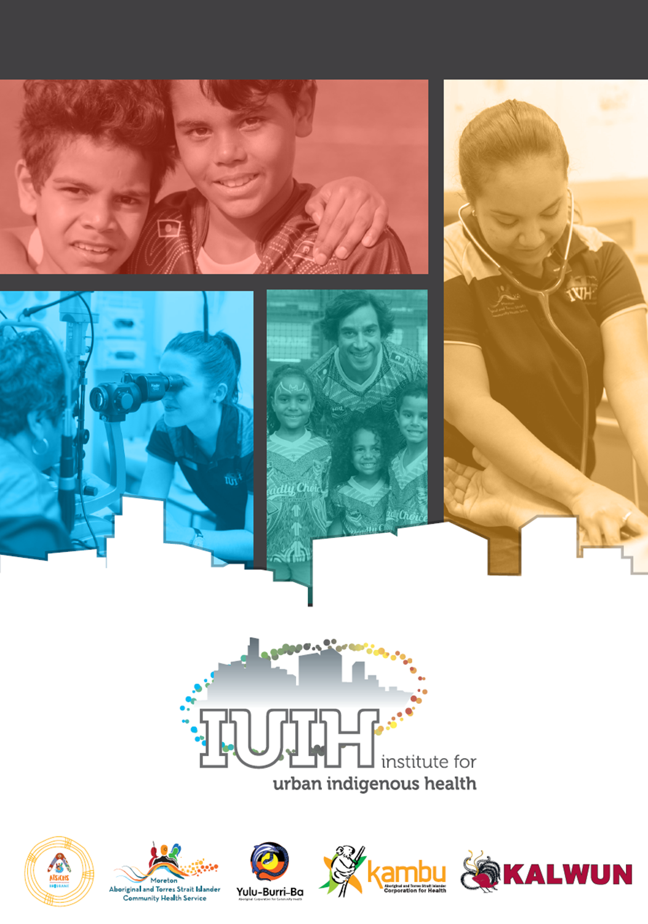
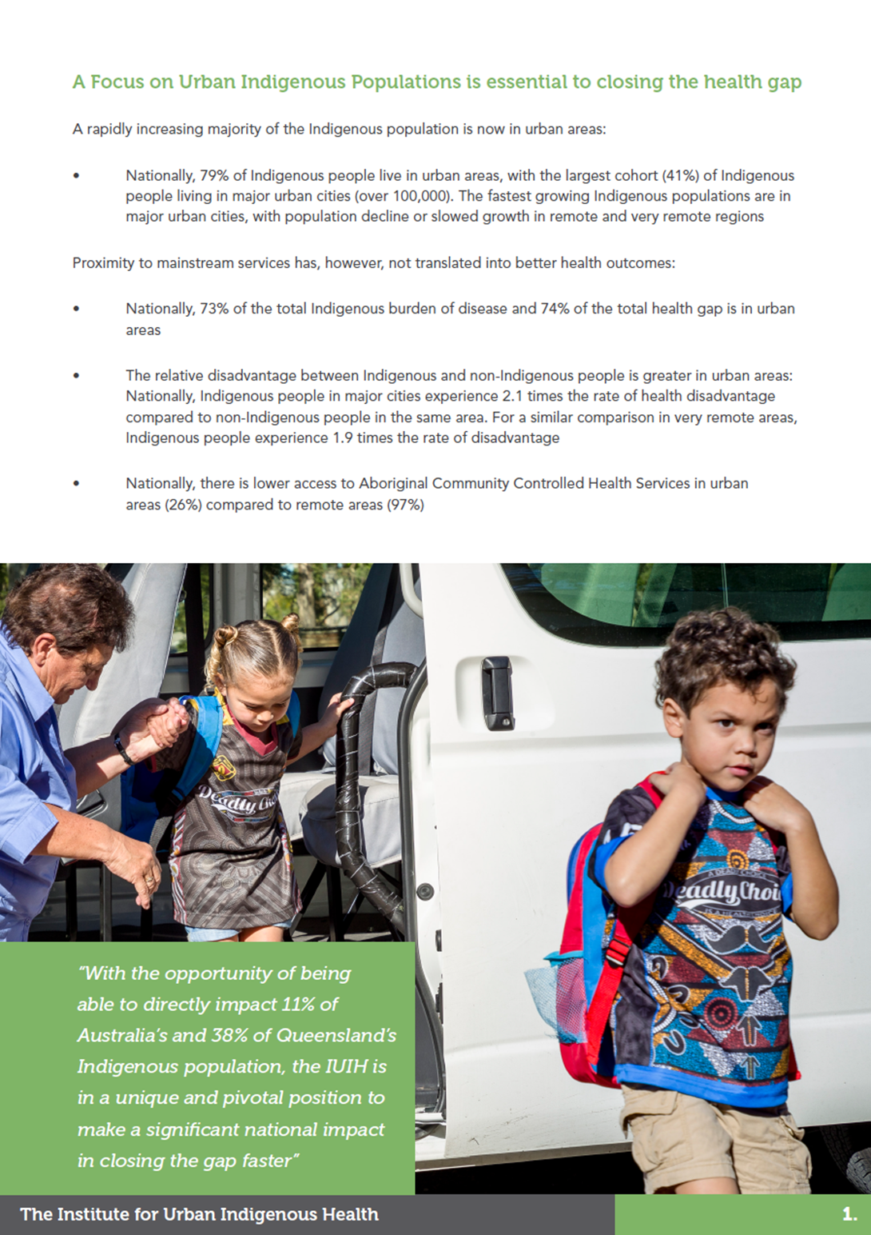
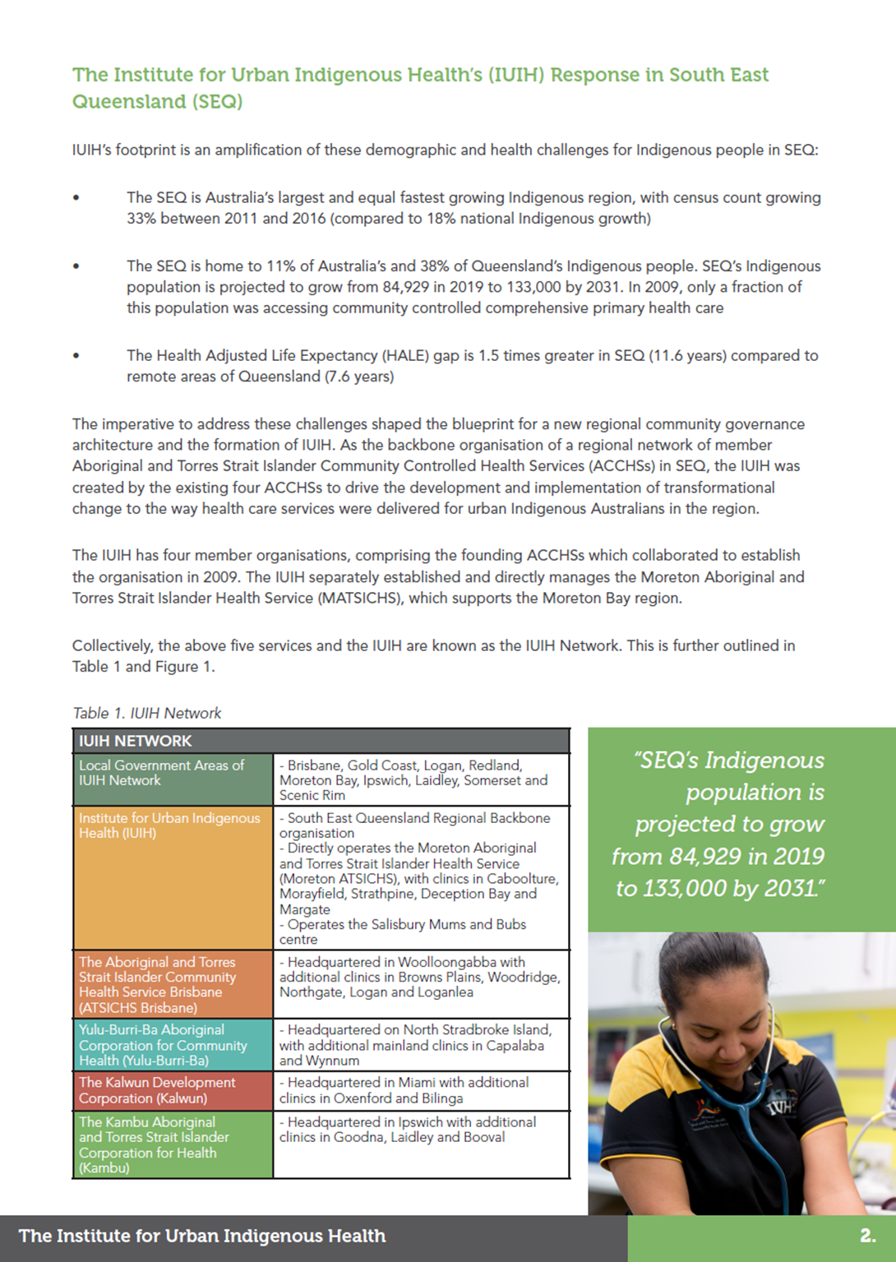
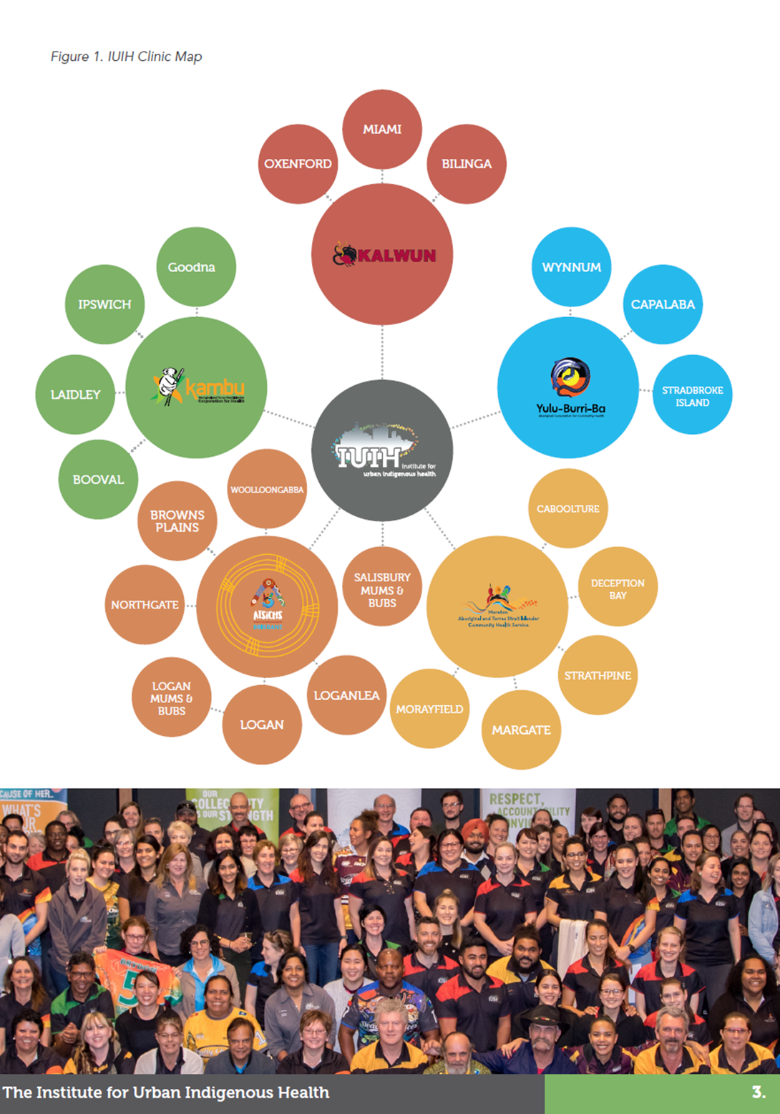
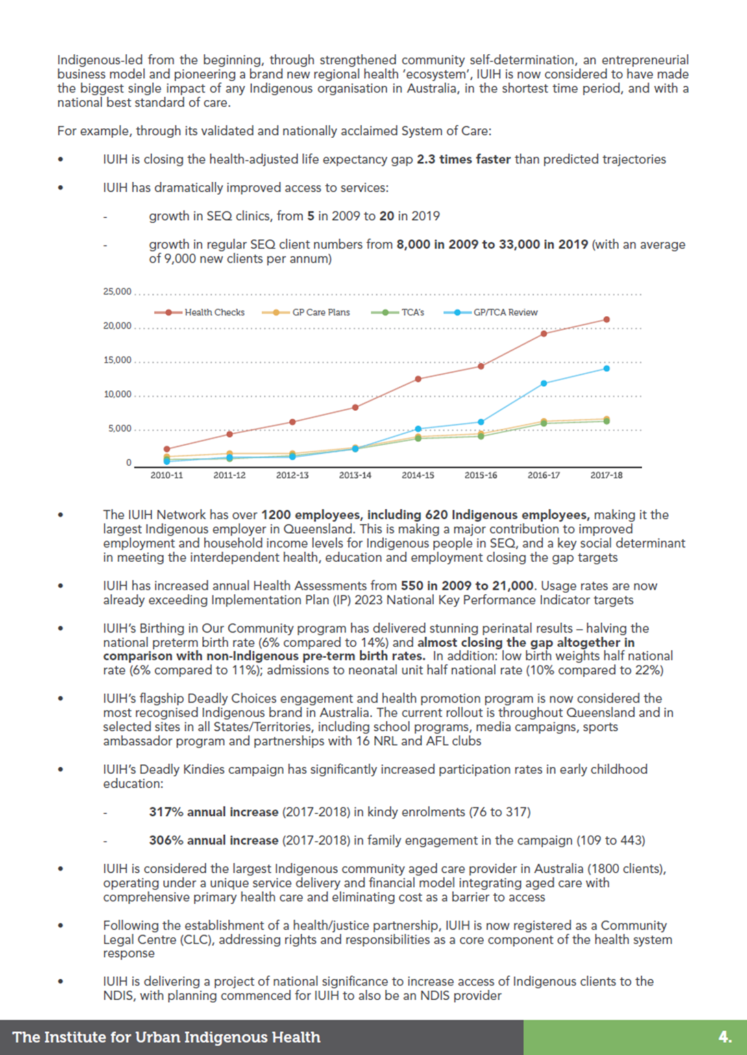
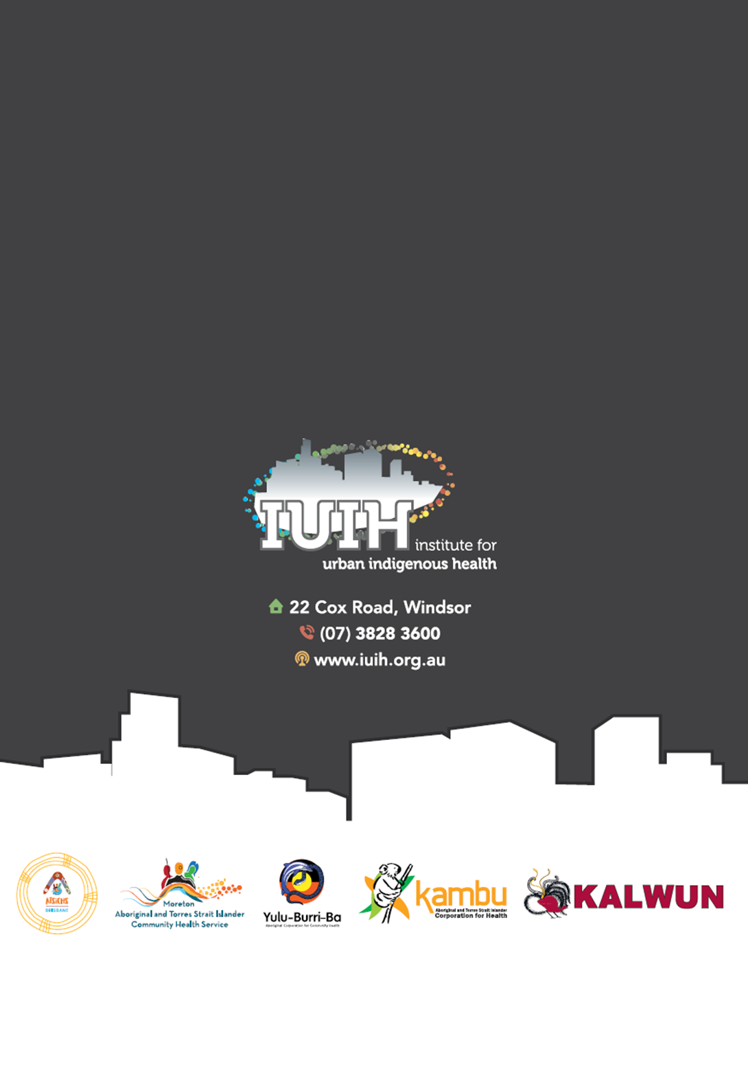

Now incorporated into the ITC program
Note that in SEQ, mental disorders contribute to up to 30% of the Indigenous disease burden
For instance, the state-run Statewide Specialist Aboriginal Mental Health Service (SSAMHS) in Perth is an example of a culturally capable specialist mental health service; this model potentially could be expanded into a community controlled model in partnership with an ACCHS.
National Aboriginal and Torres Strait Islander Health Plan 2013-23.
The AMA, in its 2018 Indigenous Report Card, noted that ACCHSs are better at the critical issue of access, attracting and retaining Aboriginal and Torres Strait islander clients, and result in better health outcomes than mainstream services
Parmenter J et al. Chronic disease self-management programs for Aboriginal and Torres Strait Islander people: Factors influencing participation in an urban setting. Health Promot J Austral. 2019;00:1–8. https ://doi.org/10.1002/hpja.256. Findings from this study (IUIH’s Work it Out chronic disease self-management program) indicate that key features of program design based on a culturally responsive approach influences participation and can contribute significantly to closing the health disparity gap.
Liaw ST et al. 2019. Cultural respect in general practice: a cluster randomised controlled trial. Medical Journal of Australia 210, 263-268
As reported by NACCHO https://nacchocommunique.com/2018/11/14/naccho-aboriginal-health-and-racism-vicvotes-vaccho_org-survey-finds-86-per-cent-of-aboriginal-and-torres-strait-islander-people-living-in-victoria-have-personally-experienced-racism-in-a-mainstrea/
My Life My Lead Consultation Report 2017, Commonwealth Department of Health
Implementation Plan for the National Aboriginal and Torres Strait Islander Health Plan 2013 to 2023
According to an independent study by Latrobe University, IUIH is closing the health-adjusted life expectancy (HALE) gap 2.3 times faster than predicted trajectories
Implementation Plan for the National Aboriginal and Torres Strait Islander Health Plan 2013-23
Since 2009, IUIH Network clinics have increased from 5 to 20; regular Indigenous IUIH clients has increased from 8,000 (16% of the Indigenous population in SEQ) to 33,000 (approximately 45% of the Indigenous population), with an average of 9,000 new clients per annum
Implementation Plan for the National Aboriginal and Torres Strait Islander Health Plan 2013 to 2023
According to an independent study by Latrobe University, IUIH is closing the health-adjusted life expectancy (HALE) gap 2.3 times faster than predicted trajectories
For example, latest AIHW data indicates only 50% of the Indigenous population nationally are accessing ACCHSs. https://www.aihw.gov.au/reports/indigenous-australians/nkpis-indigenous-australians-health-care-2018/contents/nkpi-descriptions
AIHW, 2019 National Key Performance Indicators for Aboriginal and Torres Strait Islander Primary Health Care: Results to June 2018 Cat. no: IHW 211 https://www.aihw.gov.au/reports/indigenous-australians/nkpis-indigenous-australians-health-care-2018/contents/an-overview-of-nkpi-results-to-june-2018
The Paper was prepared with the advice of an expert panel, headed by Chancellor Professor Tom Calma AO, University of Canberra. Paper can be found at: https://www.apsreview.gov.au/sites/default/files/resources/appendix-b-evaluation-aps.pdf

