Lifting productivity at Australia’s container ports: between water, wharf and warehouse

Draft Report

19 October 2022

# Introduction

The National Heavy Vehicle Regulator (NHVR) supports the inquiry into *Lifting productivity at Australia’s container ports: between water, wharf and warehouse*. The inquiry is timely, as it will assist to frame the public and private sector response to the challenges experienced by ports, and Australia more broadly, in relation to supply chain productivity, resilience and international competitiveness.

The NHVR recognises that much of the scope of the inquiry extends beyond the NHVR’s remit (e.g. maritime logistics, labour, private commercial and logistics practices). Our submission will therefore respond only to heavy vehicle road freight productivity, safe load restraint in containers, and opportunities for transporters to inspect loads and ascertain mass.

**Choice of Mode**

The draft Report mentions that “*Rail’s share in container movements at Australia’s ports is low (ranging from below 2 per cent at the Port of Brisbane to about 18 per cent at the Port of Fremantle)*.” The recent *Independent Review of the Ports and Maritime Administration Act 1995 (PAMA Act) and Port Botany Landside Improvement Strategy (PBLIS)* identified that there was an approximate mode split of 85 per cent carried by road, and 15 per cent carried by rail in the 2021 calendar year. These findings are consistent with the Productivity Commission’s previous *Inquiry into Road and Rail Freight Infrastructure Pricing*, which found only 10 to 15 per cent of freight is contestable between modes (i.e. in 85 to 90 per cent of tasks, there is a clear benefit to operators for only one of rail or road).

**Infrastructure improvements**

The heavy vehicle industry servicing ports has played a pivotal role in creating and maintaining the economic prosperity of our cities and regional centres, by transporting goods and services to support domestic and international supply chains, for both import and export markets, throughout the COVID-19 pandemic.

While the NHVR agrees that higher productivity at Australia’s container ports is achievable and would deliver significant benefits, and that maritime logistics systems’ infrastructure needs are being addressed, the NHVR suggests the inquiry and final Report further investigate the road infrastructure needs of modern freight vehicles that support maritime logistics at Ports. Appropriate road infrastructure that meets the needs of the modern road freight fleet has tangible relationships with improved truck and container turnaround times, minimising congestion and related externalities and cost savings.

**PBS (Performance Based Standards) vehicles**

Improving opportunities for Performance Based Standards (PBS) vehicles (mentioned in Figure 3 of the draft Report) forms a large component of the NHVR’s submission. Growing container throughput volumes and container density, and reducing truck volumes and congestion, are key performance indicators to measure success in lifting container productivity at Australian ports. PBS vehicles support delivery against these indicators, and deliver on other critically important measures such as safety and sustainability.

Road infrastructure, and potentially other operational practices and port policies, may have the effect of precluding or deterring use of more productive vehicles that are safer and more sustainable.

**Safe transport of Shipping Containers on Road**

Despite requirements under international marine law that freight inside shipping containers is safely restrained and accurately weighed, a proportion of import containers are overweight and poorly restrained – whether at the point of origin or as a result of the sea voyage. Unless identified, these containers have the potential to create serious risks to public safety during road transport. Separating and actioning non-compliant containers requires time, space, and accurate information. Processes currently in place are ad hoc and inconsistent and disproportionately penalise heavy vehicle transporters through lost time, or regulatory action. Overall, procedures for remedying container issues impacts the productivity of the sector through lost time and increased congestion.

**Recommendations**

**Recommendation 1:** The inquiry into *Lifting productivity at Australia’s container ports: between water, wharf and warehouse* should place greater emphasis on the role of heavy vehicles in port productivity and container logistics. The report has focussed on crane rates to move containers. The NHVR suggests the inquiry would benefit from investigating issues and determining solutions related to road freight task performance (e.g., carrying containers to and from ports). The review could include a review of port, government and stevedore policies relating to methods encouraging mode share shift (distinct from offering operators choice and flexibility between different modes); and an assessment of network design and infrastructure capacity to safely accommodate the longer length and higher mass of PBS and other higher productivity freight vehicles.

**Recommendation 2:** Reasonable efforts should be made by relevant parties (including but not limited to the government, ports, stevedores and other owners and managers of port infrastructure) to encourage use of PBS vehicles and other higher productivity vehicles. Mechanisms to facilitate this outcome could include regulation (such as providing consent to access under notice), strategic and operational policy, and suitable design standards in future infrastructure upgrades.

**Recommendation 3:** Ports, stevedores and other owners and managers of port infrastructure should do more to monitor compliance with Marine Order 42 (Carriage, stowage and securing of cargoes and containers) and should ensure there are facilities at every port to allow unsafe containers to be detected and inspected. Commercial arrangements should support transporters to take action when containers are non-compliant, rather than prohibiting or deterring this.

**Recommendation 4:** Information about the mass of a container should be reliably and seamlessly shared with, or accessible to, road transporters. Information about the customs status of a container should be reliably and seamlessly shared with, or accessible to, road transporters.

For further information, please contact Mr Peter Caprioli, Executive Director Freight & Supply Chain Productivity.

# About the NHVR

The NHVR is Australia’s dedicated statutory regulator for all heavy vehicles over 4.5 tonnes gross vehicle mass or aggregate trailer mass.

We were established in 2013 as a statutory authority pursuant to the Heavy Vehicle National Law.

## Our Purpose

We provide leadership to, and work collaboratively with, industry and partner agencies to drive sustainable improvements to safety, productivity and efficiency outcomes across the Australian heavy vehicle road transport sector.

## Our Vision

Delivering safe, efficient and productive heavy vehicle movements supporting a strong and prosperous Australia.

## Our Mission

Through leadership and advocacy we administer a national statutory system to deliver streamlined regulatory services and administration to the heavy vehicle road transport sector, minimising regulatory burdens while fostering greater safety and productivity.

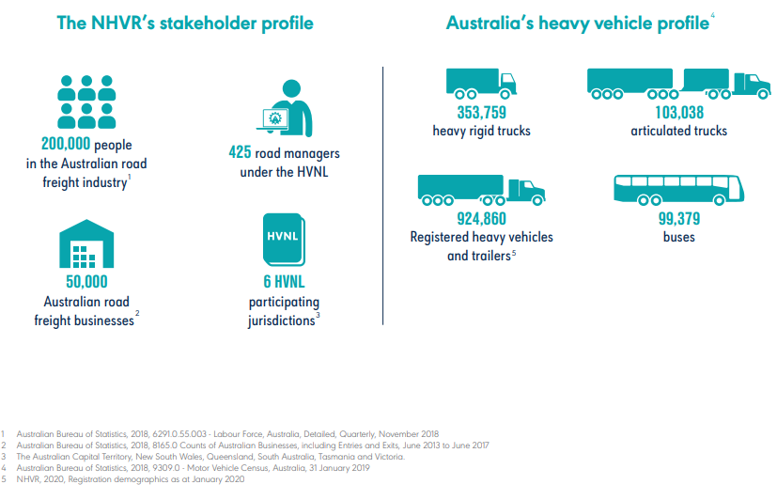

# Submission Response

1. This submission is informed by our knowledge and experience in regulating heavy vehicles, and from our day-to-day engagement with state and territory transport agencies, road managers and the heavy vehicle industry. This provides the NHVR with unique insight into the challenges and opportunities of improving heavy vehicle productivity and safety, with many stakeholders commenting on the importance of incentivising the use of the safest and most productive vehicles that are best for the environment and communities.

### Optimising the safety, productivity, and sustainability of freight operations

1. The draft Report mentions that “*With some exceptions, transporting containers to and from Australian ports by train is more expensive than using trucks, and rail services are inherently limited in where they can deliver or pick up goods*”, and that at some ports, the container freight task is forecast to triple. The challenge for the growing road freight task is to ensure goods are transported in the safest, most sustainable, and most cost-effective manner.
2. If container volumes are a constant (i.e. a freight task exists because supply and demand dictates its existence), variables that should be controlled are the cost and volume of transport performing the task. Lower costs and volumes can be achieved by having fewer trucks on roads. The NHVR believes that the inquiry and final Report would benefit from better recognising the importance of container transport efficiencies within the context of trucks (e.g., in relation to reducing truck congestion, truck turnaround time and queuing).
3. Under the Heavy Vehicle National Law (HVNL), the NHVR has oversight of the PBS Scheme, which is a national scheme designed to offer the heavy vehicle industry the potential to achieve higher productivity and safety through innovative and optimised vehicle design. In simple terms, this means moving more with less vehicle movements in safer vehicles.
4. The draft Report’s reference to PBS vehicles was brief (Figure 3) and did not provide any detail on their utilisation at ports. The NHVR offers the below information to assist the final Report.
5. The NHVR recommends that the final Report provide more information on the benefits of the PBS Scheme to port productivity; for example, within the context of container density per truck relative to truck volume and container throughput volumes. From the Independent Review of PAMA and PBLIS, it was inferred from the data that heavy vehicles are not only still the dominant mode, but increasingly becoming more favoured, given the approximate 250 per cent increase in container throughput volume from 2002 to 2020, with rail mode share decreasing to 15 per cent in 2021 from a high of 20 per cent in 2017. The final Report would benefit from similar analysis, as this has influence on future infrastructure needs to respond to port congestion.

### Freight externalities

1. The draft Report has undertaken analysis to conclude that, within and outside the maritime logistics system, rail brings a range of nonmarket benefits, such as reduced road congestion, carbon emissions and other pollutants, noise, and accidents. While true, making this statement is misleading without also considering the positive impacts of more productive vehicles. Not mentioning more productive heavy vehicles gives the undesired effect of suggesting heavy vehicles are inherently less safe and sustainable. This is particularly important given road freight has and will continue to be fundamental to efficient port operations.
2. The final Report would benefit from information on the reduction in heavy vehicle externalities from using PBS and other more productive vehicles. For example, since 2007, compared to the conventional heavy vehicles that would have otherwise been required to complete the same task, PBS vehicles have:[1]

* reduced CO₂ emissions by over 2.2 billion kilograms
* reduced fuel consumption by over 800 million litres
* removed over 2,700 trucks from the road
* reduced truck distance travelled by over 1.6 billion kilometres.

1. With respect to safety, the NHVR’s recently published [Review of Major Crash Rates for Australian Higher Productivity Vehicles: 2015 - 2019](https://www.nhvr.gov.au/files/202105-1232-cilta-ntarc-review-of-major-crash-rates-hpv-2015-19.pdf) identified that PBS vehicles were:

* involved in 60 per cent fewer major crashes per 100 million kilometres
* involved in 33 per cent fewer major crashes per 100 million gross tonne kilometres
* involved in 30 per cent fewer major crashes per 10,000 vehicles
* forecast to save 143 lives between 2013 and 2033.

1. The success of the PBS scheme is a clear statement of Australia’s heavy vehicle industry’s desire to innovate and be smarter, more productive, safer, and sustainable.
2. More information on the PBS Scheme and PBS vehicles can be found at the NHVR publication ‘[Performance Based Standards – An introduction for road managers’](https://www.nhvr.gov.au/files/201810-0924-pbs-a-guide-for-road-managers.pdf).

### Incentivising the shift to rail freight

1. The NHVR notes the following text from the draft Report: “*forecasts of substantial growth in Australia’s freight task over the coming decades have contributed to most port authorities planning to substantially increase their rail mode share to slow the growth in road congestion. However, mode share targets have been set by state governments and not met in the past*.” The NHVR further understands that similar attempts have been made by other parties to encourage mode share shift, such as the NSW Independent Pricing and Regulatory Tribunal (IPART) recommending options to encourage increased use of rail as a freight mode to enhance efficiency and reduce road congestion.[2]
2. The NHVR recognises the importance of all freight modes, including rail freight. However, a number of factors impact freight mode preferences, including infrastructure, service scheduling, climate, geography, origin and destination, the commodity being transported, and the distances travelled.
3. Road transport is the dominant form of freight for the majority of commodities produced and/or consumed in Australia. Road freight grew by over 75 per cent between 2000-01 and 2015-16, and Australia’s urban freight is forecast to increase by nearly 60 per cent over 20 years to 2040.[3]
4. Collectively, governments have a responsibility to ensure heavy vehicles can partner with rail freight to meet the country’s growing freight task. PBS vehicles deliver on this task, by offering industry productivity improvements of an average of 15 to 30 per cent.[4]
5. The NHVR is aware of different heavy vehicle access entitlements at different ports. In cases such as Port of Brisbane, there is high reliance on PBS vehicles and less on rail freight. In other examples, such as Port Botany, there appear to be policies or practices deterring use of PBS vehicles despite reduction in rail freight performance over time. In the Port Botany case, the road freight task will continue to grow and instead of a smaller volume of PBS vehicles, a larger volume of non-PBS vehicles will be required to transport the same freight task. The outcome will be further congestion and reduced container movement performance as container volumes grow, as well as forgoing of the significant safety, environmental and amenity benefits that PBS vehicles offer over non-PBS vehicles.
6. To best service the Australian economy, and ensure supply chains are resilient, the narrative should be road and rail being complementary and having multiple modal choice options. It is important that encouraging mode share shift to rail should not be achieved by limiting access for productive vehicles, particularly while conventional non-PBS heavy vehicles are still allowed access and rail freight performance continues to not meet targets set by governments and private enterprise.

**Risks associated with freight containers**

1. When the goods inside a shipping container are inadequately restrained or unevenly distributed, the braking and handling of a vehicle carrying the container may be affected. In the worst scenarios, this can cause a vehicle rollover, with fatal results.[5]
2. When the mass of goods inside a container exceeds mass limits for Australian roads, there is potential for damage to road infrastructure including pavement, bridges, and culverts. Overloaded vehicles may also have worse braking and steering performance.

**Who has obligations for shipping containers?**

1. Marine Order 42 incorporates Chapter 6 of the international SOLAS agreement and the Code of Safe Practice for Cargo Stowage and Securing (CSS Code) and therefore obliges shippers of goods to provide a verified gross mass of each container to the shipping line, to secure goods inside containers, and to use containers that comply with an international standard.
2. Under the HVNL each of ten defined parties[6] in the “Chain of Responsibility” (CoR) for a heavy vehicle, has a “primary duty” to ensure, so far as reasonably practicable, the safety of its transport activities in relation to the vehicle. This is a broad duty, with the focus of the duty being safe heavy vehicle transport, and the scope of the duty being limited by a duty holder’s ability to influence or control a matter.
3. Importers of goods into Australia meet the definition of “consignee” or “consignor” for the purposes of the HVNL and therefore have a duty in relation to their imports. One of the ways they should be discharging their primary dutyis to be using contractual arrangements with overseas manufacturers that ensure that goods are safely secured inside a container in a way that would meet the Loading Performance Standards in Schedule 7 of the *Heavy Vehicle (Mass, Dimension & Loading) National Regulation.[7]*

**Challenges to verifying that containers are safe**

1. Though marine law, and importers’ contractual terms may require shippers of containerised goods to load to the declared mass, and to safely pack and restrain goods inside a container, there is substantial variation in the skills, resources, and training of the people packing containers at their points of origin.
2. Even where goods are safely restrained when packed, there are intervening events that can disturb this. For example, foreign customs or port officials may inspect and repack a container. More commonly, the voyage by sea, or forces during loading or unloading, may cause lashings to stretch, slip or snap, cause dunnage to be crushed or compacted, or result in dunnage bags being pierced and deflated.

**Verifying mass**

1. When a container comes off a ship, the only way to confirm that it complies with its declared weight is to weigh it. It appears to be impractical to weigh every container as it is unloaded, without impacting unloading times and affecting productivity; however, weighing equipment incorporated into unloading cranes may be sufficiently accurate to identify grossly overloaded or unbalanced containers for screening.[8] (This would rely on the crane operator having information about the declared weight of each container, for comparison.) Alternatively, stevedores could weigh a random sample of containers for compliance with declared weights.
2. Some container terminals and ports have weighbridges that allow drivers to weigh their loaded vehicle before leaving the port precinct. In some locations, the only option for weighing a load may be a Weigh-in-Motion (WIM) facility that is faster to use, but less accurate than a stationary weighbridge. Some heavy vehicles are also equipped with On Board Mass (OBM) equipment that may provide reasonably accurate mass information, depending on the type of equipment and how it is used.
3. Inconsistency between a declared mass and the actual mass of an import container is a breach of marine law, and therefore a matter for the Australian Maritime Safety Authority (AMSA). At the point when a freight container is consigned for road transport, incorrect mass information also breaches HVNL provisions about complying container weight declarations[9] which apply to a “responsible entity for a freight container” and other parties.[10]
4. When arrangements are made to transport containers based on incorrect mass information, one outcome is that the wrong vehicle is sent to collect a container. Redirecting that vehicle and sending a replacement impacts productivity at the freight terminal, where it contributes to delay and congestion. It also impacts the transport contractor who may not be entitled to any recompense for the costs of sending two vehicles instead of one.
5. Another outcome is that the first vehicle simply accepts the load, despite it exceeding authorised mass limits.

**Verifying load restraint and distribution**

1. Confirming that goods inside the container are safely secured and evenly distributed is more difficult. Opening a container may breach insurance or contractual provisions and presents WHS risks unless the right facilities, equipment, and trained workers are available to open it safely. There are also prohibitions on opening under bond containers without authorisation from Australian Border Force (ABF) employees.
2. One of the indications that the load restraint system inside a container has failed is that the weight inside the container is unevenly distributed.[11] If such a container is placed on a heavy vehicle, the driver of the vehicle may be able to detect the imbalance because of the way that the vehicle handles; however, these indicators may not manifest until the vehicle reaches a certain speed, ascends, or descends a certain gradient, or negotiates a curve of a particular radius. In other words, the problem is unlikely to become apparent until after the vehicle has left a container terminal.

**Obstacles to actioning unsafe containers**

1. When a heavy vehicle driver becomes aware of a problem with a container, there are a number of obstacles to safely dealing with the problem, depending on where the container was loaded. Some cargo terminal operators (CTO) make provision for the return of a container if it is overweight or unsafe, but at some CTOs, once a vehicle leaves the terminal premises, there are limits to the right to re-enter the premises without re-booking a slot.
2. At some ports, the road network itself, and congestion, may prevent or deter a driver from attempting to return an unsafe container to the terminal where they collected it. A lack of port “real estate” means that at many ports, there is no dedicated place for the driver to stop for even a cursory visual inspection of the load.
3. Underbond movements (UBM) present further problems. Under customs law, it is prohibited to divert these containers from their route from the wharf to licenced premises, and it is prohibited to open them. The ABF has developed procedures at some ports for authorising a container to be re-routed and opened for inspection.
4. In early 2020, after collaboration between the ABF, NHVR and industry groups who work at Port Botany, a procedure was developed that would enable the ABF to retrospectively authorise an UBM to be diverted and opened, so long as it went to a nominated Container Freight Station (CFS), and certain entries were made on the Integrated Cargo System (ICS) (see Appendix A).
5. There are some limits to the effectiveness of this arrangement: CFS are not always available. For example, a surge in the number of containers requiring fumigation, or delays in containers being collected on time, may use all of a CFS’ capacity. Some CFS are not open to all comers but are restricted to clients or business partners. Transport companies generally do not have access to the ICS but rely on brokers or freight forwarders to make the necessary entries in the system. Transporters can work 24/7, but the people who have access to the ICS tend only to work during business hours.
6. At the Port of Brisbane, the ABF has implemented a system where they can authorise diversion or inspection of a container via email or text – but not retrospectively. Again, the limits to this system are that ABF officers do not work 24/7 and transporters do not always know whether a container constitutes an UBM, or what process to follow if it does.
7. Whichever way a driver manages to have the load restraint inside a container verified, there are losses in productivity, for the transporter, and in some cases for stevedores, CFS and other parties in the supply chain.
8. When drivers are deterred from acting when they suspect that the contents of a container are safely secured or distributed, or when they are unable to detect problems, the result is an unsafe vehicle on public roads.

**Regulatory Response**

1. In the overwhelming majority of cases, heavy vehicle drivers or their employers are the subject of regulatory action when a freight container is over-mass or not safely secured. This is because the non-compliance is easier to detect on the road. Clearly this is not a fair outcome. The heavy vehicle industry bears the compliance burden because other parties do not do more to deter or detect breaches of marine law, and for the most part, do not facilitate the safe inspection and correction of containers within the port precinct.

**Opportunities for other parties**

1. Ports, CTOs, brokers, and freight forwarders own or control premises within the port precinct and have the ability to allocate space, and time, for containers to be weighed and/or inspected where required. In many instances, those entities exploit their position by charging a range of fees and penalties for the use of their premises which discourage or prohibit an appropriate focus on safety. CTOs also impose conditions of entry that serve the interests of the CTO to the detriment of the driver (for example, a prohibition on taking photos on the premises).
2. Shipping lines, ports and CTOs have greater bargaining power with shippers than do transport and logistics companies who compete with each other for landside business. For instance, they have the opportunity to better monitor non-compliance. Further, through their contracts with shipping lines and shippers, they have the opportunity to report breaches of Marine Order 42 and the Loading Performance Standards to those parties, and to use contractual penalties to deter non-compliance.
3. Reducing the incidence of unsafe and over-mass containers at the point of origin would significantly improve safety and productivity, though there will always be a requirement for some monitoring of containers after unloading.

# Recommendations

The NHVR makes the following recommendations to support the inquiry into *Lifting productivity at Australia’s container ports: between water, wharf and warehouse*.

**Recommendation 1:** The inquiry into *Lifting productivity at Australia’s container ports: between water, wharf and warehouse* should have greater emphasis on the role of heavy vehicles in port productivity and container logistics. The report has focussed on crane rates to move containers. The NHVR suggests the inquiry would benefit from investigating issues and determining solutions related to road freight task performance (e.g. carrying containers to and from ports). This could include a review of port, government and stevedore policies relating to methods encouraging mode share shift (distinct from offering operators choice and flexibility between different modes); and an assessment of network design and infrastructure capacity to safely accommodate the longer length and higher mass of PBS and other higher productivity freight vehicles.

**Recommendation 2:** Reasonable efforts should be made by relevant parties (including but not limited to the government, Ports, stevedores and other owners and managers of port infrastructure) to encourage use of PBS vehicles and other higher productivity vehicles. Mechanisms to facilitate this outcome could include regulation (such as providing consent to access under notice), strategic and operational policy, and suitable design standards in future infrastructure upgrades.

**Recommendation 3:** Ports, stevedores and other owners and managers of port infrastructure should do more to monitor compliance with Marine Order 42 (Carriage, stowage and securing of cargoes and containers) and should ensure there are facilities at every port to allow unsafe containers to be detected and inspected. Commercial arrangements should support transporters to take action when containers are non-compliant, rather than prohibiting or deterring this.

**Recommendation 4:** Information about the mass of a container should be reliably and seamlessly shared with, or accessible to, road transporters. Information about the customs status of a container should be reliably and seamlessly shared with, or accessible to, road transporters.

# Appendix A

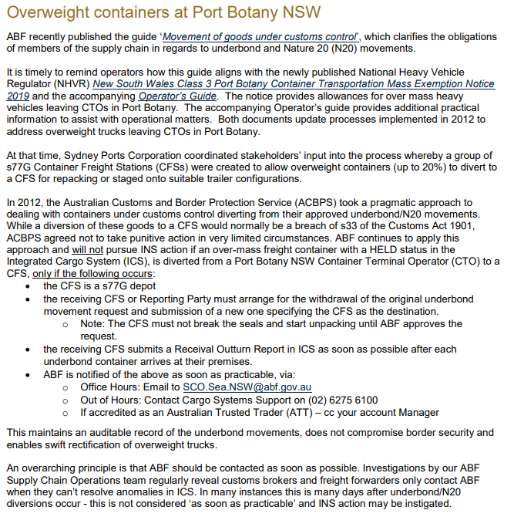

1. NHVR, 2020, Heavy Vehicle Productivity Plan 2020-2025
2. IPART, 2008, Reforming Port Botany’s links with inland transport
3. Department of Infrastructure, Transport, Cities and Regional Development, 2019, [*National Freight and Supply Chain Strategy*](https://www.freightaustralia.gov.au/sites/default/files/documents/national-freight-and-supply-chain-strategy.pdf)
4. NHVR, 2019, Performance Based Standards – An introduction for road managers
5. For example: <https://www.courts.qld.gov.au/__data/assets/pdf_file/0018/131913/cif-young-ja-20080123.pdf>; <https://www.caselaw.nsw.gov.au/decision/5c64b00ee4b02a5a800be8bf>
6. The employer of the driver, a prime contractor for the driver, an operator of the vehicle, a scheduler for the vehicle, a consignor of any goods in the vehicle, a consignee of any goods in the vehicle, a packer of any goods in the vehicle, a loading manager for any goods in the vehicle, a loader of any goods in the vehicle, or an unloader of any goods in the vehicle (s5, HVNL)
7. <https://www.legislation.qld.gov.au/view/pdf/inforce/current/sl-2013-0077>
8. Patricks Stevedores have implemented such a system at their facilities in Port of Brisbane, Port Botany and East Swanson Dock
9. S186, 187, 190, 191, 192, 192A HVNL
10. (a) the person who, in Australia, consigned the container for road transport using a heavy vehicle; or (b) if there is no person as described in paragraph (a)—the person who, in Australia, for a consignor, arranged for the container’s road transport using a heavy vehicle; or (c) if there is no person as described in paragraph (a) or (b)—the person who, in Australia, physically offered the container for road transport using a heavy vehicle (s5, HVNL)
11. Such a load might also be perfectly well secured.