Productivity Commission FDF Interim Report
Response by the Australian Rural leadership Foundation
The ARLF welcomes the opportunity to provide response to the Productivity Commissions interim report of the Future Drought Fund. Drawing on the experience and lessons learnt as a key contributor to the ‘better prepared communities’ stream of the Future Drought Fund, this submission aims to provide information on:
- Better Prepared Communities programs appropriateness
- Aboriginal and Torres Strait Islander engagement
- Social resilience impact and measurement
- Greater economic and environmental benefits and program integration
- Expanding scope to climate change
Our key observation is that the FDF has already made a significant contribution to community resilience through developing capability, building connection and strengthening networks. Across all information requests, it should be noted that with the opportunity and resources to invest in collaboration and relationship building across the investment streams – many of the challenges and opportunities as presented could be achieved. Building resilience requires long term multifaceted investment. The Fund should be commended on its intent and continue to foster collaborative efforts that not only focus on immediate project deliverables but the rather the sustained relationships and networks that will enable and amplify the resilience of communities.
“I found myself networking with people I would have never met, let alone worked with. I learnt a lot from that…… Even if we have ideological differences, there can still be some interesting synergies that come from those interactions.” - “And (participant), who I worked with on the DRLDP project, put us onto another drought resilience grant, and now Latrobe and Allington will be producer demonstration sites using satellite tech and other software to implement regenerative practices and they want to have another field day.”
Participant DRLDP
As we commence work on the new phase of the *program – Helping Regional Communities Prepare for Drought Initiative (HRCPDI) we are confident the more than 3000 connections developed in Phase One across Australian agricultural dependent communities have set a strong foundation for the strengthening of drought resilience and as such preparedness for future drought.
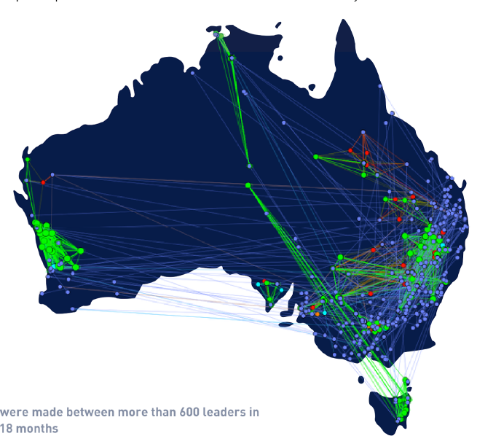
Figure 1 Phase 1 of the DRLP created a network of leaders with over 3,000 connections
- Better Prepared Communities programs appropriateness
There are many successful initiatives focused on building capability supported by state and local governments/networks. To address a system change in our ability to respond to disaster and climate impacts that leave no community behind, a coordinated approach is required in building resilience. As a national actor in a multipronged complex system, aligning on purpose and drawing connections across sectors and regions is recognised as valuable alongside the critical value of place based nuance, response and actions required. Engaging with regional and local partners to deliver effective on ground programs that were connected nationally continues to be a significant undertaking and the outcomes of such activity require ongoing and long term investment. Our current work is contributing to this and will continue to be enhanced/improved.
The Better Prepared Communities are distinct in their:
- Integrated approach
The integrated approach of individual leadership development, networked mentoring support, and funded grant programs. The combined nature of the program provides a similar structure as innovation-focused accelerator programs that invest in the individual entrepreneur, provide mentoring and access to new networks, and funding to develop projects aligned with the participant’s passions. The results from the DRL demonstrate increased impact as a result of engagement across multiple program streams.
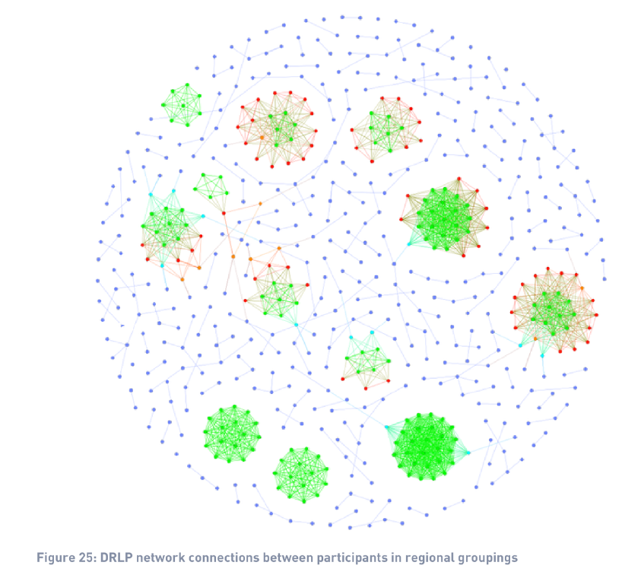
- Progress towards collective impact
Leadership development is more than just a transfer of skills. It is a progress towards personal, professional, career, community, and collective impact.
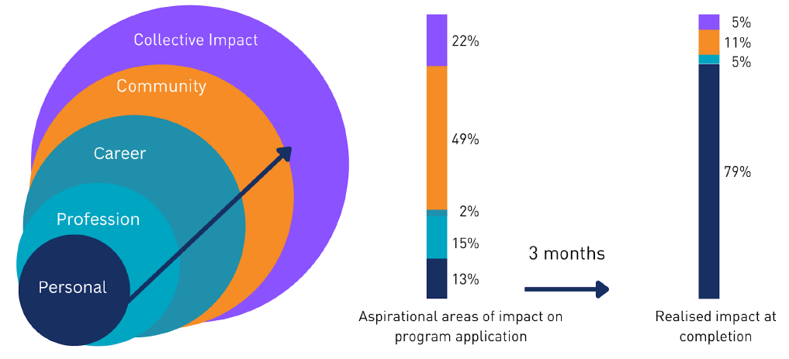
The investment addresses a gap in programs that focus exclusively on individual development functions.
- Programs that only develop leaders.
- Programs that only provide mentoring.
- Programs that only provide funding.
Participants report increased progression towards collective impact when committed across multiple development opportunities.
- National connections – regional partners - locally tailored
A foundation of over 3000 connections has been formed to date with an ongoing program of work that will add 35 regions inter and intra-connected nationally with a mentoring program and community grants program.
Figure 4 (1) Phase 1 of the DRLP created a network of leaders with over 3,000 connections

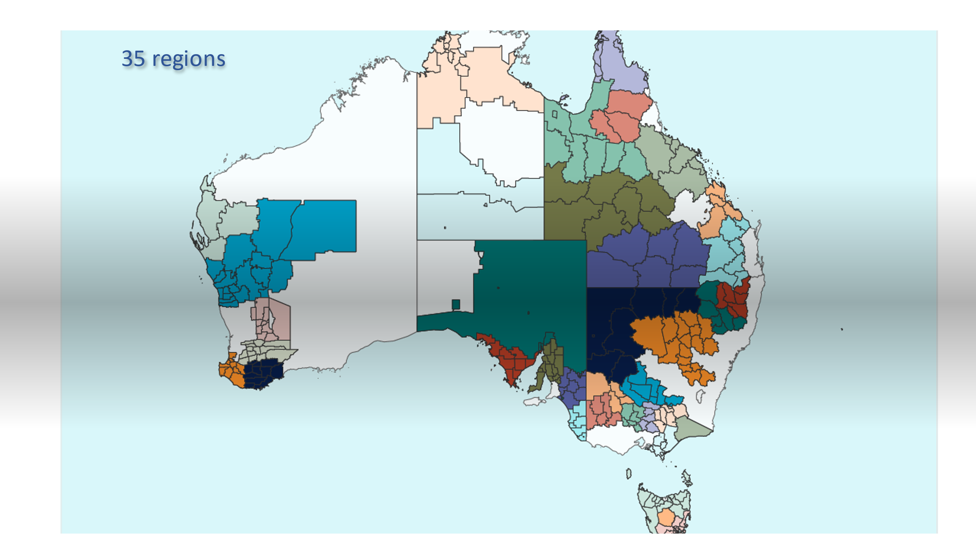
Figure 5 Regions nominated for Phase 2 delivery HRCPRI
We recognise that given that each community circumstances can be highly unique, place-based does not easily lend itself to linear planning and design, nor is it precisely replicable to other locations, therefore our approach is not a ‘cookie cutter’ approach. At its core ARLF is delivering with local people on the ground and tapping into and utilising local knowledge and expertise, and local organisations. We know this is the key to sustaining impact in the regions. Our approach is based on the recognition of the importance of building long-term relationships and trust with communities and with a continued focus in this area alongside parterships such as Foundation of Rural and Regional Renewal – we look forward to strengthened local action that is understood and coordinated nationally.
“The Drought Resilience Leaders Program has given Tasmanian Leaders the opportunity to meet the latent demand for leadership development in a region of Tasmania our organisation has not previously been able to service. The feedback to date has been overwhelmingly positive. Partnering with the ARLF, and fellow consortium members, is a rare opportunity for us to collectively advance our understanding of resilient leadership in an Australian context. It is truly groundbreaking and the benefits for participants and their communities are sure to ripple across Australia in the years to come.”
Ange Driver, CE Tasmanian Leaders
Phase One delivery partner

Aboriginal and Torres Strait Islander people engagement
The ARLF supports the FDF:
- Establishing an Aboriginal and Torres Strait Islander working group to work with the Department to improve design and implementation of the Fund
- Requiring the Consultative Committee to include Aboriginal and/or Torres Strait Islander representation
By way of example, the ARLF has worked with its Aboriginal and Torres Strait Islander alumni over thirty years to learn, share and develop more effective ways of working together. Our organisational governance has two Indigenous board members and one of four of our Patrons is also Indigenous.
Further in seeking to design and deliver programs that are culturally safe, relevant and have meaning for Aboriginal and Torres Strait Islander peoples we work closely with our Indigenous alumni. This commitment and process is an embedded and sustained approach that will continue to evolve with support and engagement of our alumni.

Social resilience impact and measurement
The FDF is to be commended on its intent for investment in long term programs that support transformational change. In its initiation the commencement of multiple activities and the lag in resourcing efforts to foster collaboration was limited. Now in Phase Two, and if given the scope to focus on relationship building (not just immediate project outputs) – better flow on benefits across activity streams will be fostered. This process needs to be actively facilitated through centralised systems that promote information sharing.
The FDF review findings align with the experience in delivering the program.
- Program sequencing and integration: There was confusion about program integration and relationships in the market, between program teams, and within individual program teams. Given the size of the Australian regional and agriculture ecosystems, many stakeholders were involved in multiple FDF initiatives. The burden fell on individual providers and participants to develop tools to communicate the distinction and potential integration between programs. Additional communication material to clearly articulate program relationships would have improved efficiencies and impact.
- Greater and earlier centralised support: Several factors increased complexity of the FDF, including the rapid onboarding, the fact that new actors were being created in established ecosystems, the large number of new initiatives, and differences within initiatives (eg., desire and intention to collaborate vs resources and timing available in early start up phases for this to occur meaningfully). The establishment of greater centralised support and leadership for shared functions such as knowledge sharing and evaluation would have improved early efficiency and effectiveness.
- Lack of long-term confidence and impact: The stated FDF intent of long-term impact is constrained by short-term commitment. The financial and social cost of establishment would not expect to see a return on investment within the allocated two-to-three year period. The lack of long-term commitment creates additional stakeholder uncertainty and reduces the ability to secure and develop capability and capacity. This then creates a self-fulfilling prophesy of a lack of short-term return on investment and lack of evidence of progress towards long-term outcomes.
- A need for standardised collaborative structures: The investment into collaborative and knowledge sharing structured should be in line with the complexity of the program and cater for sorting by region/sector/issue. Greater recognition of the costs incurred by organisations to collaborate without immediate deliverables evident needs accounted for in planning phases.
- Short-term funding for maximum regions is having an impact AND this impact will likely be far greater if the investment in capability, capacity and networks through a leadership approach occurs walking alongside these regions over longer time frames (and coming back to regions after a period of time). The imperative for quick delivery timeframes often clashed with meaningful relationship and collaboration effectiveness in local regions.
Investing in transformational change means investing in social capital and development of people networks not just the project deliverables – it takes time, multi pronged investment in relationships and space to allow emergent opportunities to be acted upon – not only top down expectations

Greater economic and environmental benefits and program integration
The FDF has addressed access and positioned investment in an accessible manner focused firstly on farmers and then the community. It has engaged deeply within the ag sector supported well by broader community and ensured industries were front and centre. The ARLF is supportive of capability investment being made alongside and within existing structures such as the National Landcare Network. An example of this working well includes the collaboration with the National Farmers Federation to deliver the Drought Resilience Mentoring Programs. This has strengthened their offer to members and ensured the program was relevant and added value to the target market. Not limiting the program to one network/program or another, is critical to enable a broad cross section of participation and for those engaged to determine where their energy and contributions are best enacted for long term change in their region/community. Adding value to existing rural and regional initiatives is a design principle in the approach of the ARLF.
Program integration and collaboration requires appropriate resourcing including time to align values, purpose and activity.

- Expanding scope to climate change
The scope of the FDF program is important to mobilisation of collective impact on a specific shared challenge, in this case drought. Expanding the program from drought to climate expands the potential audience while also increases similarities and cross-over with other private and public sector programs in the market. If the scope is to be expanded, a mapping process of broader climate systems and related policies should be undertaken.
Importantly recognising that drought is a ‘system’ that exists within and across other systems – as such a balance of isolating to galvanise purpose and a recognition that the investment will work towards resilience for multiple climate impacts and the social issues and opportunities that stem from such occurrences and sustained crisis.

Drought
Climate
Agriculture
Innovation
Resilience
Region
Figure 2 Drought as system within and across multiple systems
In some of the regions we are active, Drought is either the most prominent climate impact or people feel a shared connection under the umbrella of drought or both. That said, we also recognise that Drought and climate change are just two of the risks faced by these communities – they include other natural disasters as well as interrelated and often interdependent challenges such as access to health education and housing to pandemics. The point is that there is a clear role for governments to walk along side regional communities and invest in building long-term adaptability and resilience such that the call on government funding in crisis may be lessened.
Unique to the FDF investment was implicit understanding in design that all those within an ag dependent community were impacted by drought and climate impacts. The inclusion of the broad community in building the social resilience and the acknowledgement that drought has interdependent environmental and economic impacts beyond one sector was critical to the success brought about by diverse perspectives contributing to the regions resilience.

11 July 2023

