Australian Communications and Media Authority submission
Response to the Productivity Commission’s issues paper—Telecommunications Universal Service Obligation
JULY 2016

Canberra
Red Building
Benjamin Offices
Chan Street
Belconnen ACT
PO Box 78
Belconnen ACT 2616
T +61 2 6219 5555
F +61 2 6219 5353
Melbourne
Level 32
Melbourne Central Tower
360 Elizabeth Street
Melbourne VIC
PO Box 13112
Law Courts
Melbourne VIC 8010
T +61 3 9963 6800
F +61 3 9963 6899
Sydney
Level 5
The Bay Centre
65 Pirrama Road
Pyrmont NSW
PO Box Q500
Queen Victoria Building
NSW 1230
T +61 2 9334 7700 or 1800 226 667
F +61 2 9334 7799
Copyright notice
http://creativecommons.org/licenses/by/3.0/au/
With the exception of coats of arms, logos, emblems, images, other third-party material or devices protected by a trademark, this content is licensed under the Creative Commons Australia Attribution 3.0 Licence.
We request attribution as © Commonwealth of Australia (Australian Communications and Media Authority) 2016.
All other rights are reserved.
The Australian Communications and Media Authority has undertaken reasonable enquiries to identify material owned by third parties and secure permission for its reproduction. Permission may need to be obtained from third parties to re-use their material.
Written enquiries may be sent to:
Manager, Editorial and Design
PO Box 13112
Law Courts
Melbourne VIC 8010
Email: candinfo@acma.gov.au

Introduction 1
Background to the current USO regime 2
The current USO and associated consumer protection regime 2
Today’s communications environment 5
Changing consumer behaviour and expectations 5
Payphones 8
Offline and ‘unconnected’ Australians 8
Overall trends 14
Considerations regarding potential changes to the USO regime 15
Historical context and drivers for Australia’s current universal
services policy 15
Challenges in developing a universal service policy, given the current dynamic communications sector 17
Consumer use and expectations 17
New industry structures and technology 17
One constant is Australia’s geographic landscape 18
Considerations for a way forward 19

Introduction
The Australian Communications and Media Authority (the ACMA) welcomes the opportunity to provide a submission in response to the Productivity Commission’s issues paper on Australia’s Telecommunications Universal Service Obligation (USO).
Universal service is the principle that all citizens should have access to a given standard of communications services. Communications services have the ability to drive economic growth, prosperity and sustainability, and numerous other countries have USO arrangements that are intended to contribute to these goals. Australia’s USO requires the Primary Universal Service Provider (PUSP) to ensure that a standard telephone service (STS) and payphones are reasonably accessible to all people in Australia on an equitable basis.
The challenges associated with assessing the future of the USO share common threads with a number of regulatory challenges in the current communications environment. Regulatory constructs prescribing particular service types and minimum service levels have remained relatively unchanged for decades. However, the communications market, consumer expectations, and the range of communications services have changed significantly in the past decade and continue to evolve.
A challenge for this inquiry is to assess whether the USO is still effective and relevant within this changing environment, taking into account:
- current USO objectives and including an assessment of whether these objectives continue to be relevant in framing a future universal service framework
- the scope of services to be covered in any future universal service framework
- the different needs of different Australian community segments and how to best to meet these needs
- costs and funding arrangements associated with these needs
transitional issues.
In this submission, the ACMA does not address every question posed by the issues paper. However, it seeks to assist the Productivity Commission (PC), drawing on the ACMA’s:
- regulatory role in ensuring that Telstra fulfil its regulatory obligations as the PUSP of the USO—including the ACMA’s role in the collection, review and analysis of Telstra’s performance data related to the USO
- administration and collection responsibilities related to the Telecommunications Industry Levy (TIL), which partially funds the USO
- significant research in the communications sector, including the identification of changes in market structure, consumer trends and usage patterns
broader role in protecting and promoting the interests of consumers and citizens by maintaining effective telecommunications safeguards.

Background to the current USO regime
The concept of universal service has been central to the Australian telecommunications market for a significant period. Initially, telecommunications services were provided by government monopoly, and the concept continued with the introduction of retail competition in the market.
The focus of the USO on voice telephony (or equivalent) services is historical. At the time of the original universal/community service obligation, voice was the most socially important service to the Australian population. This is articulated in the Explanatory Memorandum to the Telecommunications Act 1991, which outlines that the ‘standard telephone service is supplied at performance standards that meet the social, industrial and commercial needs of the Australian community’. Historically, consumers and business largely relied upon fixed-line voice communications over a copper network, with payphones used as a means of communicating when away from home.
With limited exceptions, the fixed-line infrastructure owned by Telstra and its predecessors was designed, optimised and used for the purposes of supplying voice telephony services. Because the supply of a telephony service necessarily involved the provision of the underlying copper network infrastructure, the costs of providing a voice service were inextricably linked to the cost of installing and maintaining that infrastructure.
The introduction of competition in the telecommunications market led to a levy to fund the delivery of the USO. The USO construct allowed a reasonable access to a voice service wherever people lived. The payment of the TIL operated so that providers did not need to enter markets that were unprofitable due to their small size, remoteness or both. This, in turn, allowed non-USO providers to focus on a greater level of flexibility with their market offerings, which also supported competition.

The current USO and associated consumer protection regime
The current USO regime is established under Part 2 of the Telecommunications (Consumer Protection and Service Standards) Act 1999 (TCPSS Act). The TCPSS Act also gives the minister the power to designate a PUSP, and to declare two or more carriers as universal service providers, or regional service providers with appropriately limited responsibilities. In the absence of any such designations, Telstra is by default the PUSP.
In 2012, the USO and the National Relay Service (NRS) levies were replaced with a single levy, the TIL, imposed under the Telecommunications (Industry Levy) Act 2012. The TIL, together with government funding, covers costs associated with the implementation and administration of service contracts or grants to deliver universal service and other public policy telecommunications outcomes. Under the TCPSS Act, the TIL is funded by contributions from participating persons (generally telecommunications carriers with annual eligible revenue in excess of $25 million). Contributions to the TIL are proportional to each participating person’s eligible revenue for the previous financial year, as set out in the Levy Amount Formula Modification Determination 2015 (Levy Determination).
Existing contractual arrangements with Telstra to deliver public interest services (including the STS and payphones USO) commenced on 1 July 2012. Since 1 July 2015, the Department of Communications and the Arts has had responsibility for managing contracts with Telstra for the provision of the STS and payphones USO.
Section 9 of the TCPSS Act states that the object of the USO is to ensure that the STS and payphones are reasonably accessible to all people in Australia on an equitable basis, wherever they reside or carry on business.
Some other public interest services also have strong linkages to the USO. Public safety was a key rationale underpinning the policy to provide reasonable access telecommunications services—allowing Australians either at or away from home to reach police, fire or ambulance in an emergency. The National Relay Service was also established in the late 1990s to assist Australians who are deaf, speech- and/or hearing-impaired to access a standard telephone service. Both these services are now funded through the same arrangements as the USO.
There are no regulations that specifically relate to performance of the USO STS. However, the ACMA uses two related Customer Service Guarantee (CSG) instruments as a ‘proxy’ for assessing Telstra’s compliance.
The Telecommunications (Customer Service Guarantee) Standard 2011 sets minimum service standards for carriage service providers (CSPs), including Telstra, in installing, repairing and meeting appointments for STSs for residential and small business customers. If a CSP fails to meet the minimum performance standards, compensation may be payable to the customer.
The Telecommunications (Customer Service Guarantee – Retail Performance Benchmarks) Instrument (No. 1) 2011 applies to ‘qualifying carriage service providers’ (QCSPs), including Telstra, and sets minimum compliance levels with the CSG Standard timeframes for the following activities:
- installing new connections in urban, major rural, minor rural and remote areas
- installing in-place connections in all areas
- fault rectifications in urban, rural and remote areas
appointment-keeping in all areas.
There are nine annual benchmarks in total for connections, fault repair and appointment-keeping, where QCSPs must meet a minimum 90 per cent benchmark.
The Telecommunications Universal Service Obligation (Payphone Performance Benchmarks) Instrument (No. 1) 2011 (Payphone Benchmarks) was also introduced in 2011 to assist the ACMA in assessing compliance with the payphones USO.
Separately, and contained within Telstra’s Carrier Licence Conditions, is the Network Reliability Framework (NRF). This safeguard complements the CSG in that it requires Telstra to identify and remediate its copper network to ensure reliability of fixed telephone services. The NRF has three levels of operation. The first level examines the general reliability of fixed telephone services in different regions of Australia, while the other two levels are concerned with identifying localised areas and individual services that do not meet minimum levels of reliability.
These safeguards are complemented by other consumer safeguards administered by the ACMA, such as:
- the Telecommunications Consumer Protections (TCP) Code 2015
Priority Assistance (as provided for by Telstra’s Carrier Licence Conditions, Schedule 2 of the Telecommunications Act 1997, and the Priority Assistance for Life Threatening Medical Conditions Industry Code).
The ACMA also works closely with the TIO, the complaints-handling body for telecommunications consumer protection matters. The ACMA does not handle or investigate individual residential or small-business customer complaints unless they generate concerns about systemic compliance. For these various consumer safeguards, the ACMA proactively encourages and monitors compliance through:
- environmental scanning
- submitting enquiries to providers
investigating possible non-compliance.
Figure 1 summarises the variety of consumer safeguards that underpin and closely support the USO.
- USO and related telecommunications safeguards

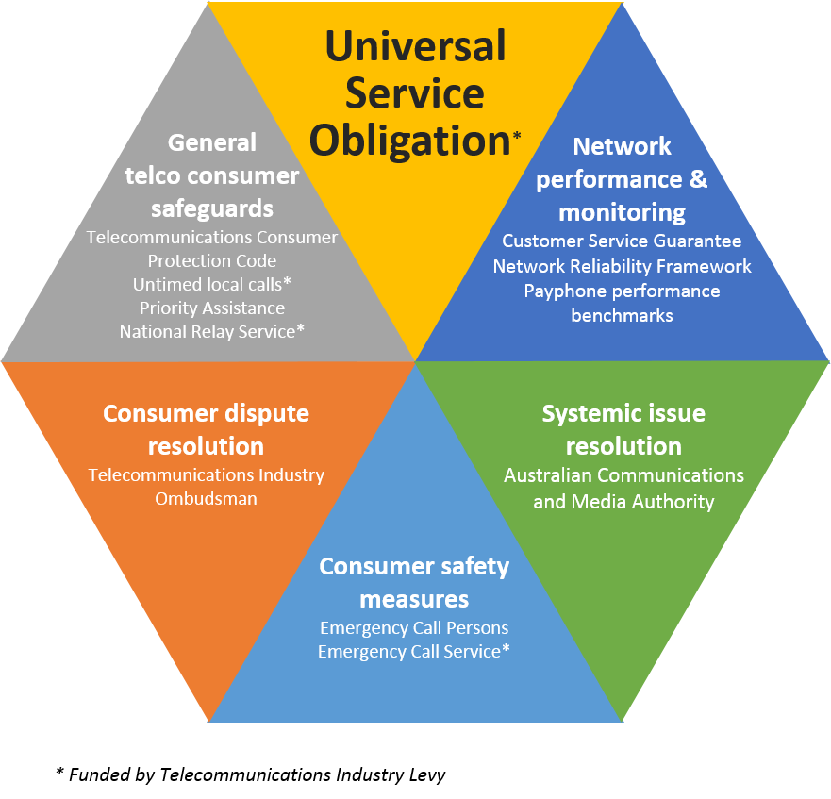

Today’s communications environment
Over the past 10 years, the ACMA has observed significant changes occurring in Australia’s communications and media markets. These include changing citizen and user expectations in the way they interact with digital technologies; and consequential changes in the type and scale of risks and harms being experienced by industry operators, consumers and citizens. The original challenge arising from the digitalisation of content and carriage has been compounded by the emergence of IP-enabled communications and content over the past decade. These changes have been documented by the ACMA’s tracking studies of market and technology developments and longitudinal studies of the Australian community’s changing media and communications practices.
This section of the submission draws upon data and research currently available that the ACMA considers may assist the PC in its deliberations. Throughout the course of the PC’s inquiry, new research and statistical information will become available including the ACMA Communications report 2015–16. The ACMA would welcome the opportunity to provide PC with a briefing on upcoming research that may assist its considerations.

Changing consumer behaviour and expectations
The USO was established so all Australians could have reasonable access to a voice service. However, consumer trend data collected by the ACMA over a number of years has indicated a steady decline in the number of fixed-line services and a gradual increase in mobile voice and data services.
- Services in operation—fixed phone service vs. mobile phone services, number of services (millions)
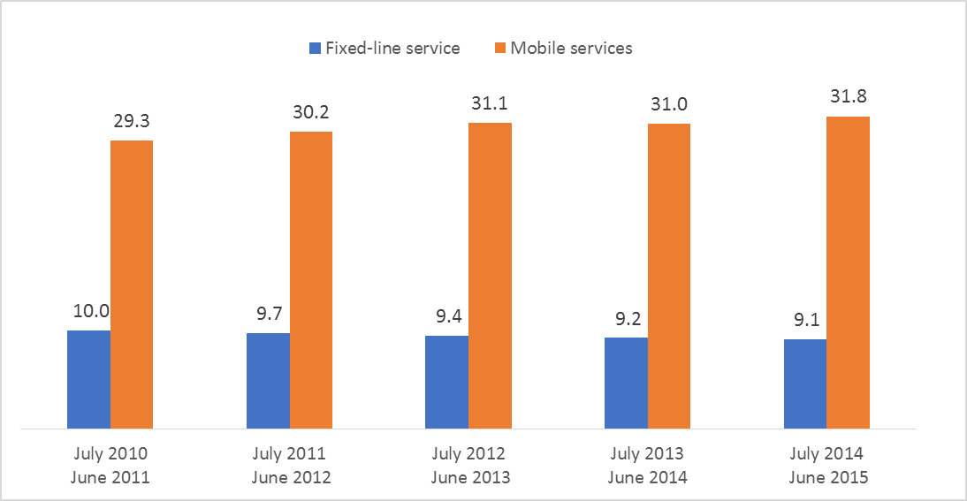
Source: ACMA communications report 2014–15.

More adult Australians have a home internet connection (85 per cent) than have a fixed telephone line at home (70 per cent), indicating that Australians now place greater importance on having access to the internet than on having a fixed home phone line.
It should be noted that home internet connections vary by population density. Adult Australians in the major capital cities are more likely (89 per cent) to have a home internet connection, while those in non-urban areas are less likely (77 per cent) to have a home internet connection, compared to the national average of 85 per cent.
- Home phone vs. home internet connection (%)

Base: Data relates to people aged 18 years and over, in the 12 months to June 2015.
Note: Major capital cities covers Perth, Adelaide, Melbourne, Sydney, Brisbane and Canberra; Major urban covers towns/cities with populations of 100,000 or more (includes Hobart and Darwin); Urban covers towns/cities with populations of 1,000 to 99,999; Non-urban covers areas with populations less than 1,000.
Source: Roy Morgan Single Source.

Almost all adult Australians (95 per cent) own or use a mobile phone and it is becoming more common for Australians to have a mobile phone and no fixed phone service. In the four years since June 2011, the number of adult Australians who have a mobile phone but no fixed home phone has almost doubled, growing from 2.7 million to 5.4 million by June 2015.
- Growth in population with a mobile phone and no fixed telephone (‘000)
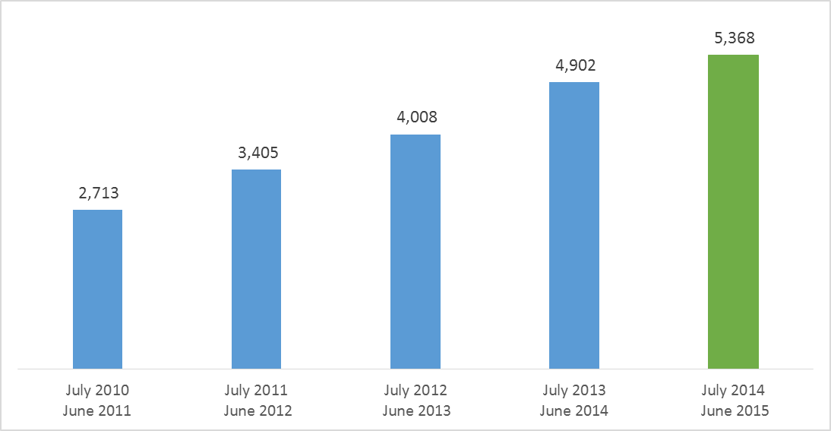
Source: ACMA communications report 2014–15

Mobile phone ownership is very high across the country with only minor geographic differences. On average, 29 per cent of the total adult population has a mobile phone but no fixed-line home phone. For those located in non-urban areas, this figure is 25 per cent, four percentage points lower than the national average. As illustrated in Figure 5, more and more Australians rely on mobile and internet services for communication, at the expense of traditional fixed-line telephone services.
- Number of communications services in Australia and percentage change (millions)

*Change in data source from ACMA annual industry data request in June 2013 to company annual reports from June 2014.
†Sum of mobile phone handset and mobile wireless broadband subscribers.
‡Including mobile phone handset, mobile wireless broadband, fixed-broadband, satellite, fixed-wireless, other broadband and dial-up subscribers.
§Includes PSTN and other fixed-line telephone services. Due to a methodology change in 2014, data reported here differs from data reported in previous communications reports. In 2014, the total resale (retail services directly connected via another network) and retail services in operation are reported. In previous communications reports, wholesale and retail totals were reported.
Source: ACMA Communications report 2014-15.

Payphones
Before the increased ubiquity of mobile networks and devices, payphones were the primary way to make and receive telephone calls while travelling or away from home or place of business. They were designed to provide public access to telecommunications, promoting increased accessibility, and providing an additional mechanism to contact emergency services.
However, as mobile phone take-up has proliferated, there has been a drop in the number of public payphones. Since 2003–04, there has seen an almost 50 per cent decrease in the number of Telstra-operated public payphones.
As the PUSP, Telstra has the responsibility of ensuring that payphones are reasonably accessible to all people in Australia on an equitable basis, wherever they reside or carry on business. However, there are also privately operated payphones (often located in hotels and shops).
While the majority of private payphones continue to be located in urban areas, the USO continues to support the delivery of payphones in regional and remote areas.
- Distribution of Telstra payphones by geographical category, 30 June 2015
 | Urban | Rural | Remote* | RIC
Telstra-operated payphones  % of total | 11,929  68.1 | 4,727  27.0 | 855  4.9 | 579  3.3
Other payphones (provided via Telstra access lines) | 6,667 | 1,345 | 353 | 251
*Including remote Indigenous communities (RIC).
Source: Telstra.

Offline and ‘unconnected’ Australians
As evidenced above, Australians are increasingly embracing fixed-line internet and mobile telephony. However, there is a segment of the community that continue to rely on voice only, fixed-line communications.
While 92 per cent of adult Australians accessed the internet in the six months to May 2015, an estimated 1.1 million (six per cent) had never been online.
For the twelve-month period July 2014 to June 2015:
- around 15 per cent of adult Australians did not have a home internet connection
- around 11 per cent had not accessed the internet in the past three months
less than six per cent had never accessed the internet.
- Comparison: Australian adults who do not have internet connection at home, who did not access in the past three months, and who never accessed the internet (%) (July 2014 to June 2015)
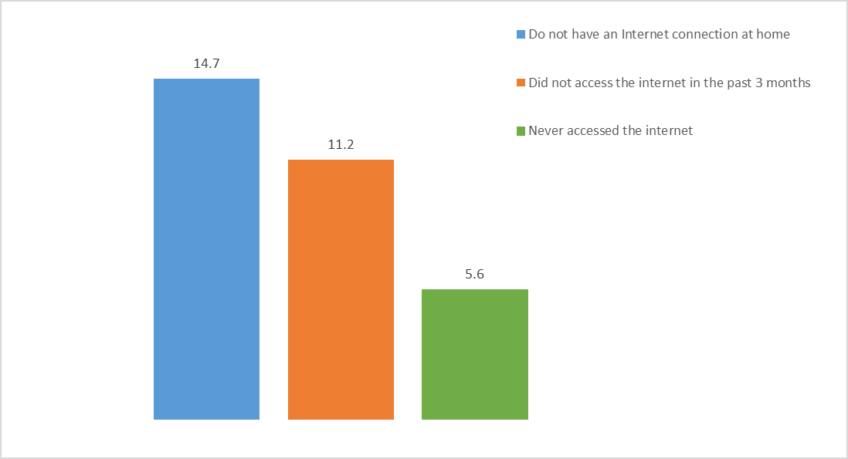Base: Australians aged 18 and over
Source: Roy Morgan Single Source, June 2015.

Figure 7 below shows how the proportion of adult Australians who do not have an internet connection at home has been decreasing more slowly (four percentage points difference over the seven years period) than the proportion of adult Australians who have never accessed the internet (seven percentage points).
- Comparison: Australian adults who don't have internet connection at home and who never accessed the internet over the past seven years (%) (July 2008 to June 2015)
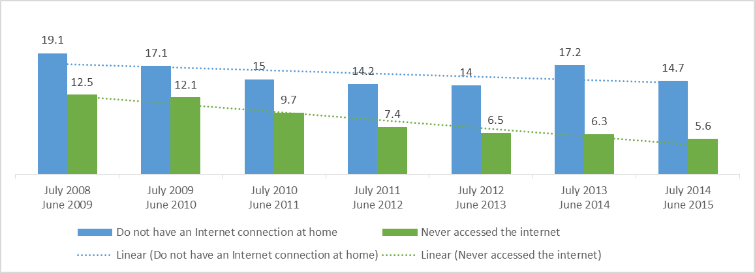 Base: Australians aged 18 and over.
Source: Roy Morgan Single Source, June 2019, June 2010, June 2011, June 2012, June 2013, June 2014, June 2015.
Note: Change of methodology between 2012–13 and 2013–14.

Adult Australians with no internet connection at home represent almost 15 per cent of the adult Australian population. Yet the majority of this sub-group of the Australian population are users of the internet.
Nearly seven in 10 (68 per cent) of adult Australians who did not have a home internet connection are users of the internet, based on latest data available for the period July 2014 to June 2015.
Nevertheless, unconnected adult Australians have different patterns of internet usage. Unconnected adult Australians who used the internet in the past four weeks did not undertake the research and information-related activities to the same extent as all adult Australians. The proportion who accessed the internet to search for a job or employment online is similar (21 per cent), regardless of whether or not there is a home internet connection. However, for other activities, such as reading newspapers or accessing the news online, accessing government information or services, accessing health information, or access to online education, the proportion of unconnected Australians undertaking these activities are below the proportion observed for adult Australians.
- Specific research and information internet activities for adult Australians with no internet connection who had done one or more internet activities online in the last four weeks (July 2014 to June 2015)
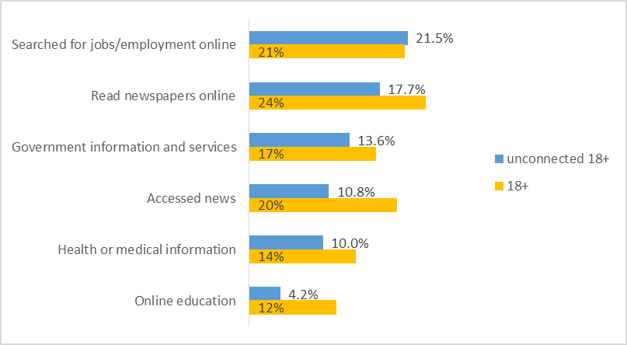
Base: Australians aged 18 and over

The analysis of the demographic profile of adult Australians with no internet connection at home indicates an over-representation of Aboriginal and Torres Strait Islander Australians, older Australians (aged 65 and over), those with lower incomes (under $30,000), those with no tertiary education, living in country areas, and living alone.
The three main factors associated with no home internet connection are being of Aboriginal and Torres Strait Islander descent, living alone and older age:
- 36 per cent of Aboriginal and Torres Strait Islander Australians have no home internet access connection, compared to 15 per cent for adult Australians (represented by the red line in Figure 9).
- 32 per cent for those living alone
27 per cent for older Australians (aged 65 and over).
- Demographic profile of adult Australians with no home internet connection (July 2014 to June 2015)
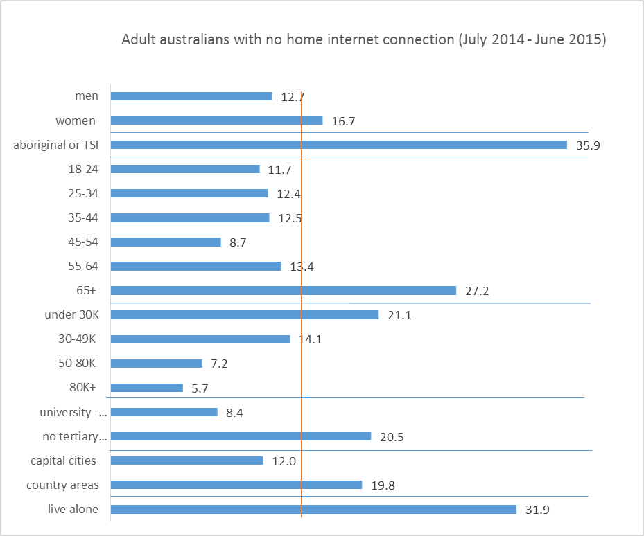
Base: Australians aged 18 and over with no home internet connection
Note: The red vertical line represents the proportion of Australians adults with no home internet connection. It can be used as a benchmark to compare with proportions observed for different demographic segments.
Source: Roy Morgan Single Source, June 2015.

Older age and lower income factors are also evident in the demographic profile of the adult Australians who have never accessed the internet:
- 21 per cent of older Australians (aged 65 and over) never accessed the internet, compared to six per cent for adult Australians (represented by the red line in Figure 10)
17 per cent of those living alone never accessed the internet.
- Demographic profile of adult Australians who never access the internet (July 2014 to June 2015)
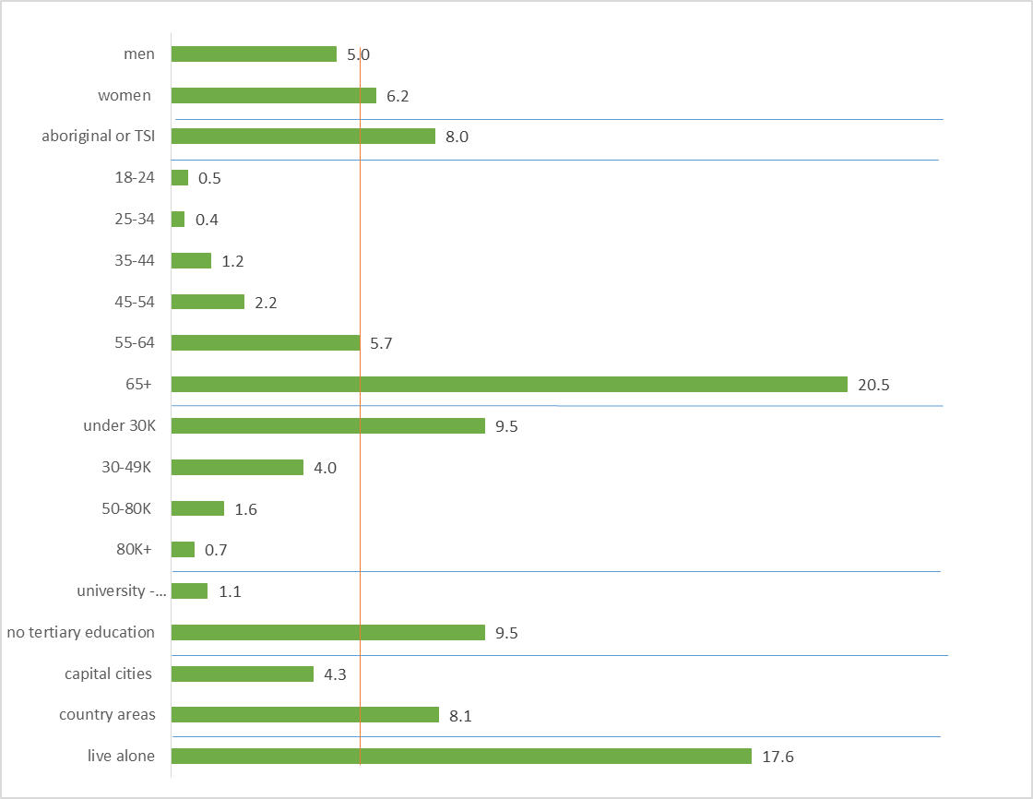
Base: Australians aged 18 and over who responded never accessed the internet.
Note: The red vertical line represents the proportion of Australians adults who never accessed the internet. It can be used as a benchmark to compare with proportions observed for different demographic segments.
Source: Roy Morgan Single Source, June 2015.

Age, income and education are important factors associated with both not having a home internet connection and never having accessed the internet. Table 2 provides a summary of these factors.
- Factors associated with not having a home internet connection and never having accessed the internet compared to total adult population
(July 2014 to June 2015)
% of Australian adults | Aged 65+ | No university degree | Country areas | Income is less than $30k per year | Live alone
in general population aged 18+ | 19% | 54% | 35% | 47% | 10%
Who do not have a home internet connection | 36% | 75% | 47% | 37% | 22%
Who have never connected to the internet | 71% | 91% | 50% | 79% | 32%
Source: Roy Morgan Single Source, June 2015.

The ACMA’s annual consumer survey explores the reasons why Australians choose not to connect to the internet. The main reasons Australians aged 18 and over are not connecting to the internet are outlined in Figure 11.
Overall, the main reason for Australians adults not connecting to the internet is the lack of perceived need (43 per cent of respondents). This reason is even more prevalent for older Australians (aged over 65), those living alone, and those with an income under $50,000 per annum.
- Reasons for not having internet access at home
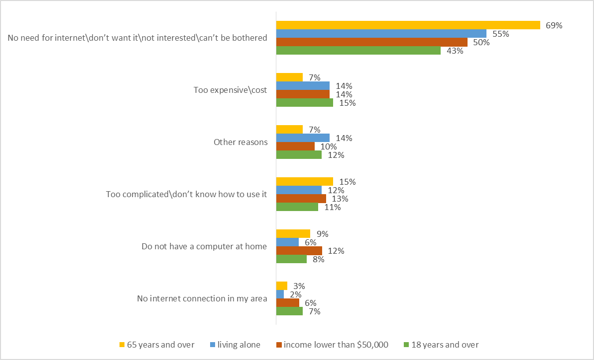
Source: ACMA consumer survey, May 2015.

Overall trends
Unsurprisingly, the ACMA’s research supports PC’s observation that Australia’s telecommunications environment is rapidly evolving.
More Australians now have a fixed internet at home than have a traditional home phone, indicating a greater importance and demand for internet access. A significant and growing number of households have decided not to have a home phone at all, and instead rely on a mobile phone for communications.
Despite this level of take up of internet and mobile services, there remains a percentage of the Australian population who still rely on the traditional telephone service. Research shows that an estimated 1.1 million Australians have not been online or regularly access the internet.
ACMA research also observes variations in the take-up and use of different services across different demographics. Factors such as low income, education level, living outside urban areas, having an Aboriginal or Torres Strait Islander background, and living alone all correlate with a reduced take-up of internet services.

Considerations regarding potential changes to the USO regime

Historical context and drivers for Australia’s current universal services policy
Universal service obligations (and universal service policies generally) across the world have predominately been concerned with achieving outcomes related to accessibility, availability and affordability.
Australia’s existing USO has been one in a suite of interventions that have been used to deliver outcomes against these objectives. A number of other interventions have also been implemented by government to support these outcomes. These interventions have taken a variety of forms, including regulation, contractual obligations and direct subsidies. For example:
- service standards such as the CSG, Priority Assistance, National Reliability Framework support availability outcomes
- interventions on the price of services, such as price controls, untimed local calls, itemised billing and Centrelink telephone allowance support affordability outcomes
National Relay Service, Disability Equipment Program and the Emergency Call Service support accessibility outcomes.
Whilst the focus of Australia’s USO has mostly been on the availability objective, the payphones element of the USO also includes a relatively large focus on meeting accessibility and affordability objectives. Traditionally, payphones provided public access to telecommunications, with price caps supporting affordable calls.
In addition, the objective of an STS being ‘reasonably available’ has also imported some expectations in relation to affordability and accessibility. An example of this can be seen with the requirement that CSPs provide end-user access to 000 and 112, thereby fulfilling an important public safety and accessibility objective.
Table 3 below distinguishes between the key consumer safeguards that all CSPs are required to provide, and those that apply only to Telstra as the PUSP.
- Consumer safeguards provided by CSPs, and safeguards provided by the PUSP (Telstra)
PUSP | CSPs
Standard Telephone Service
- Retail provider of last resort  - Standard telephone handset on request  - Copper continuity obligation (TUSOPA Agreement)  - National Reliability Framework  - Price controls (historical) | - Option to provide standard telephone service  - Untimed local call option  - End-user access to 000 or 112  - Priority Assistance service provided or inform customers of the names of carriage service providers/carriers that do  - Compliance with TCP Code (billing, complaints-handling)  - TIO scheme  - Compliance with CSG benchmarks or customer agreement to wavier
Payphones
- Payphone standards and benchmarks
- Payphones removal obligations (public consultation)

Market reforms to promote an open competitive environment and most recently, the government’s investment in the NBN network also supplement the USO to provide Australians with access to a higher range of services and choice. These have also been supplemented over a number of years by Federal and state/territory funding programs to improve communications infrastructure, such as the Mobile Black Spot Programme.
The ACMA notes that one of the historical characteristics of the telecommunications sector was relative stability. That stability no longer exists but continues to be assumed in the current USO regime. Such stability was evident in:
- consumer expectations—consumers had relatively stable expectations of minimum service levels to be provided by their telecommunications services via a fixed, voice service with certain minimum performance standards
- network structure—Telstra’s legacy copper network (the sole network prior to the advent of telecommunications competition, and still by far the largest fixed network) delivered a relatively stable fixed network structure
industry structure—Telstra and its predecessors were for a long time the sole provider, which was followed in the 1990s by the arrival of a small number of vertically-integrated providers offering a simple range of service offerings.
This inherent historical stability permitted the application of a USO to a single entity, which had the ability to control all aspects of service supply. It also enabled the capacity to achieve related objectives around service standards, affordability and accessibility in response to obligations applied, either to the sector broadly, or targeted to the PUSP.
The ongoing transformation from a relatively stable telecommunications sector to the dynamic characteristics inherent in today’s telecommunications sector poses a challenge to the effectiveness and relevance of a static USO regime.

Challenges in developing a universal service policy, given the current dynamic communications sector
The current communications market is rapidly changing and evolving, due to both demand and supply factors. The key changes are outlined below.

Consumer use and expectations
Research outlined in this submission demonstrates that consumers’ use of services and their expectations of these services have evolved over the last few years. However, there are different changes in different subsets of the consumer market. Consumer expectations are likely to continue to change into the future, particularly with the rollout of the NBN network and enhanced mobile networks.
At the same time as consumers’ expectation of services are changing, the economy as a whole is also increasingly reliant on communications services. As noted in the issues paper, one of the key rationales for the adoption of universal service policies relates to the promotion of broader economic benefits. Reliance on the communications network across most economic and social activities in Australia is increasing, and this trend may be expected to continue.
When the USO was first established, the homogeneity of telecommunications services (primarily fixed voice) led to the fulfilment of the USO by providing all consumers with a ‘standard service’. Many types of communications services that are commonly used are now accessible via multiple technologies.
The ACMA suggests that a key decision point for this inquiry is whether any future universal service framework should ensure the availability of:
- a basic type or level of communications service that meets minimum use requirements; or
a higher standard of communications service(s) that seeks to address common usage needs (recognising that consumers may choose to acquire a lesser service).
This policy choice might be thought of as being between one which seeks to provide a base ‘safety net’ right, and one that seeks to address broader policy objectives, such as overcoming a ‘digital divide’. Importantly, this choice regarding any new universal service framework will have significant implications on the ultimate policy and any potential interventions required.

New industry structures and technology
Today’s communications environment is characterised by a heterogeneity of networks over which a range of substitutable communications services are supplied.
Network and service provision structures are evolving, with an accompanying breakdown of the traditional vertical integration. This is most notable with the NBN offering a wholesale access-only network, but can also be seen via the emergence of many ‘over-the-top’ providers that can offer services substitutable for traditional telecommunication products, usually de-coupled from wholesale access arrangements.
Consequently, the ACMA sees numerous market participants operating at different layers of the supply chain. In its Broken concepts analysis, the ACMA highlighted the shift from vertically-integrated structures to a more horizontal approach. This is displayed in Figure 12.
- Convergence in networks and service layers from vertically integrated structures
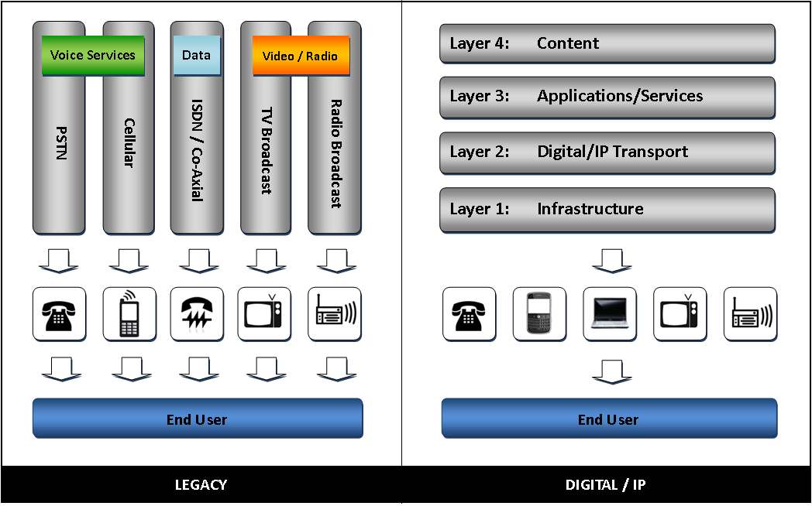

One constant is Australia’s geographic landscape
Traditionally, a key element of the USO has been the accepted concept of cross-subsidisation of services between urban and regional/remote areas, to facilitate the provision of services in areas with very low population densities.
Along with the dynamic supply and demand side changes outlined above, Australia’s vast landmass and associated uneven geographic spread of the population in urban, regional, rural and remote areas poses additional challenges.
This uneven population spread will continue to mean that the provision of commercially viable (and modern) telecommunications services to the more isolated parts of Australia remains an ongoing policy challenge.
Given past and continuing shifts in the communications sector, the existing USO mechanism—and many of the related interventions intended to achieve the objectives of availability, affordability and accessibility—are no longer fit-for-purpose.

Considerations for a way forward
In considering the scope and objectives for any new universal service regime, the ACMA suggests that there are a number of design principles that should guide the way forward in the development of any new universal service framework.

- A new universal service framework should be clear regarding its objectives
Historically, a range of separate obligations has been associated with the USO, which together have been intended to deliver public interest outcomes. Considerations applicable to that whole framework might include:
- the extent to which the elements of the framework and the framework as a whole do or do not seek to deliver outcomes to achieve of the objectives of availability, accessibility and affordability
- whether other objectives should appropriately be pursued, and if so, by what means
whether a universal service should take the form of a basic type or level of communications service, or alternatively a higher standard of communications service(s) that seeks to address common usage needs.
- The role of the market
As a general view, the ACMA considers that, as far as possible, market solutions should be harnessed to deliver universal service objectives through consumer choice. However, should analysis indicate that market failures exist or occur that necessitate the need for government intervention, the following considerations should be taken into account in the development of a universal service framework.
- Appropriate targeting of interventions
Where intervention is required, such interventions should be targeted at market participants that have the best capacity to achieve the objectives of such intervention. Here, the PC may also wish to consider which layer (as outlined early in this chapter) any obligation or intervention should fall within. Targeting the appropriate layer for government intervention requires careful consideration. For example, applying retail-focused service standards at the IP/transport layer may result in unintended consumer outcomes. It may also be difficult to measure the effectiveness of the intervention.
- Delivery mechanisms
Given that a universal service framework exists to deliver consumer outcomes, any interventions that involve targeting providers other than retail service providers should exhibit a clear connection between the intervention and how it will deliver, or contribute to delivering, a particular outcome.
This would enable accountability for the achievement of proposed outcomes, allow individual consumers to have clarity regarding their right to any universal service, and provide transparency to industry if any levy arrangements are used to fund interventions.

- Funding
Any funding mechanisms used to support any universal service regime, and intended to recover the net cost of the universal service framework from industry, should do so in a way that is equitable across all relevant industry participants and minimises as far as possible competitive distortions. In addition, a smooth transition to any new funding arrangement needs to ensure industry certainty is maintained, both during the transitional phase, and thereafter.
- Flexibility
Given the dynamic nature of the communications sector, any new universal service framework should also embed the capacity for an evolution of service standards. This would involve transparent processes for determining if, or when, a change to service requirements are appropriate. In addition, the transition to any new service standards should aim for minimum cost and market distortion. For instance, it seems reasonably likely that a universal service policy regime will need to be re-examined following the full rollout (and potential privatisation) of the NBN.
- Best practice principles
The ACMA also considers that any interventions of a regulatory nature should adhere to regulatory best practice principles, such as:
- any obligations should be placed on those best placed to deliver them, and any risks are placed on those best placed to monitor and mitigate such risks
for regulators to effectively ensure compliance with regulations, such regulations should be clear, measurable and enforceable.

Conclusion
The ACMA suggests the focus of a new universal service framework should be on providing an appropriate outcome for Australian consumers and business in an environment of increased reliance on communications. Given the rapidly evolving nature of the sector and consumers’ expectations of the service, the capacity for change and evolution should be built into the framework for universal service.

As at June 2015 ACMA Communications report 2014–15.
See section 9 of the TCPSS Act.
ACMA, Broken Concepts—The Australian Communications legislative landscape, p. 7.

