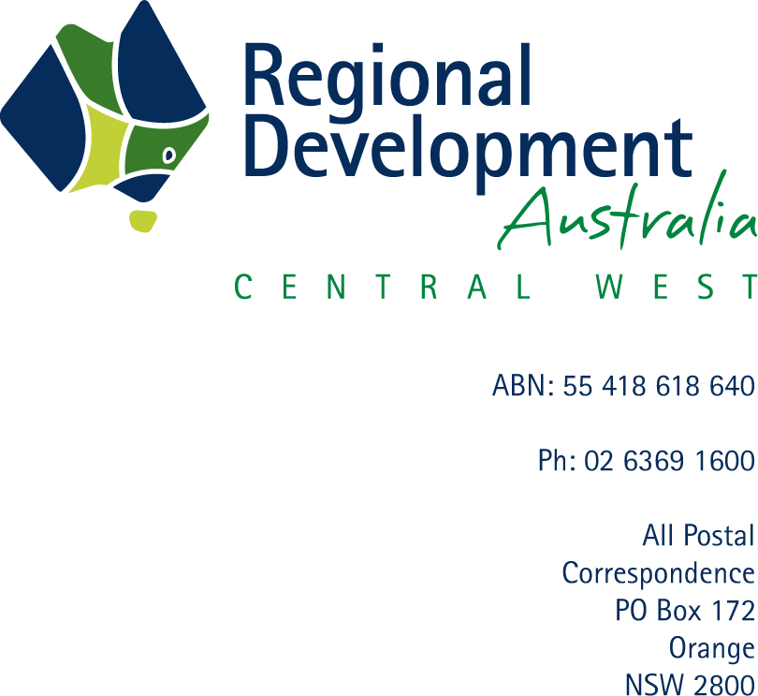

15 February 2017

Transitioning Regional Economies study
Productivity Commission
Locked Bag 2, Collins St East
MELBOURNE VIC 8003

Re: Submission to the Productivity Commission study on Transitioning Regional Economies
Regional Development Australia (RDA) Central West commends the Government in initiating this study into the transition of regional economies following the resources boom, and is pleased to provide the following submission to the Productivity Commission. Ensuring regions can effectively develop and transition to a sustainable economic base is integral to regional development and ultimately national prosperity.
Background
Regional Development Australia Central West (RDA Central West) is a not-for-profit organisation, funded by the Commonwealth and State Governments, bringing together business, community and Local Government to further the economic development and long term sustainability of the NSW Central West region.
Approximately 174,000 people live in the region, which comprises the Local Government Areas of Lithgow, Oberon, Bathurst, Blayney, Orange, Cabonne, Cowra, Parkes, Forbes, Weddin and Lachlan

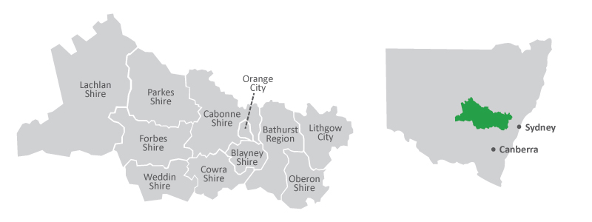
Terms of Reference
The economy of the Central Western region relies somewhat heavily on Mining, in terms of its contribution to Gross Regional Product (GRP). The Mining sector represented 21.9% of total GRP ($2112 million) in 2014. That is approximately three times larger than the next greatest industry contribution to GRP, manufacturing at 7.5%.
However some diversity in the regional economy is evident. The majority of businesses actively trading in Central West NSW are in agriculture. Additionally, the industry with the greatest employment in the region was Healthcare and Social Assistance at 12.5% in 2011.
Challenges
In recent years, local jobs and economies have been adversely affected by downturns in industry employment at Cadia and Lithgow mines, as well as the closure of the Electrolux fridge manufacturers in Orange.
Additionally, the provision of wide reaching and future-proof telecommunications infrastructure, including mobile and broadband internet coverage, remains one of the greatest challenges for the region in terms of bridging the digital divide in health, safety and education, transforming the world of work through automation, and facilitating remote work and service delivery. Telecommunications has the potential to attract and develop new industries, and diversify the economy of the Central West into the future. RDA Central West is currently conducting a Telecommunications project to optimise these outcomes.
Education and skills development has also been identified by RDA Central West as integral to strengthening, diversifying and adding value to the regional economy into the future following the resources boom. Opportunities have been identified in the ‘Agricultural Innovation Skills and Capability Analysis’ (soon to be released).
RDA Central West created the following website with regional profiles as a resource for public and private investment attraction - ‘Invest NSW Central West’ http://www.investnswcentralwest.com.au/.
The ‘NSW Central West Export/Import Contribution Study’ also outlined the key imports and exports for the region, as well as opportunities for import substitution, export growth and future influencing factors. Additional work has also been conducted into infrastructure prioritisation and regional freight capacity.
The Central West NSW has been identified as the sixth largest ‘fast growing’ and ‘high potential regional hub’ in Australia capable of contributing $17.4 billion GRP by 2031. However, as Infrastructure Australia points out, the potential of these fast-growing regions needs to be maximized through coordinated investment across all levels of government and ‘well-informed decisions about demand, scale, timing and funding of projects’.
Capacity Building
One of the greatest barriers to regional economic development in the Central West is the lack of access to appropriate data to inform evidence-based decision making in the region.
RDA Central West is currently working collaboratively with Central NSW Councils (Centroc) and the regional Economic Development Forum (14 Local Councils) to find a solution to the ongoing issues of getting quality reliable data sets that can be accessed via a regional shared data platform.
Making Government and other real-time data more available and accessible would assist a range of regional stakeholders plan for the economic future of the region. This includes making the case for public and private investment attraction, strategic planning, funding submissions and project development.
RDA Central West would welcome further discussions with the Productivity Commission regarding other potential solutions to assist the region to adapt to economic change following the resources boom.
We trust that our feedback will be of assistance to the Commission and would welcome any further opportunities for input to the inquiry or regional engagement in Central West NSW.

Yours faithfully,

Peter McMillan
Executive Officer

RDA Central West, 2014, ‘Invest NSW Central West’, http://www.investnswcentralwest.com.au/opportunities-by-region/invest-nsw-central-west/ ; RDA Central West, 2014, ‘NSW Central West Export/Import Contribution Study’, http://www.rdacentralwest.org.au/wp-content/uploads/2015/01/RDA-Central-West-Export-Import-Study-Nov-2014.pdf
RDA Central West, 2016, ‘Value Adding to Agriculture in Central West NSW’, http://www.rdacentralwest.org.au/wp-content/uploads/2016/09/RDACW-Value-Adding-to-Agricultureweb.pdf, p. 49.
RDA Central West, 2015, ‘Regional Economic Profile’, pp. 21.
RDA Central West, 2016, ‘Telecommunications’, http://www.rdacentralwest.org.au/initiatives/telecommunications/
RDA Central West, 2017, ‘Agricultural Innovation Skills and Capability Analysis’, http://www.rdacentralwest.org.au/initiatives/farming-for-the-future/
RDA Central West, 2014, ‘NSW Central West Export/Import Contribution Study’, http://www.rdacentralwest.org.au/wp-content/uploads/2015/01/RDA-Central-West-Export-Import-Study-Nov-2014.pdf
RDA Central West, 2017, ‘Initiatives’http://www.rdacentralwest.org.au/initiatives/
Infrastructure Australia, 2016, ‘Australian Infrastructure Plan’, pp. 60-61, http://infrastructureaustralia.gov.au/policy-publications/publications/files/Australian_Infrastructure_Plan.pdf
Ibid.

