*Dr Neville F Hills, FRANZCP, MRCPsych.,LLM, PhD.*

*23 January, 2020*

*Dear Commissioners,*

***Re: Productivity Commission 2019, Mental Health, Draft Report, Canberra***

*I am a retired psychiatrist with a special interest in aged care. Unfortunately I have only sighted this discussion paper today so my remarks are brief.*

*May I say that as a Western Australian, I along with many others in this State, have a remote view of our Commonwealth Government, although I have worked in New South Wales and England in my career. As a largely State government employed psychiatrist, I have observed the extent to which our WA government has used the involvement of Commonwealth agencies and funding, to withdraw local services and resources built up over past decades.*

*Increasing Commonwealth interventions in State managed health care is, in my experience, counter-productive. You must appreciate that Perth is as far from the Sydney-Canberra axis as Moscow is from London. Would people in London accept directions and distribution of their taxes from Moscow?*

*This paper so far is a rehash of multiple State and Commonwealth motherhood statements and wish lists. Clinical staff have been well aware for decades what is needed to provide effective services, but instead we have seen restructuring repeatedly destroy good services, while chasing ephemeral and politically driven false concepts. In WA good State services have been dismantled and abandoned in the pursuit of false economies and rationalisations. The pursuit of privatisation at the expense of properly funded and managed State services has proved costly and ineffective. It is time to admit it has not worked in providing mental health care for seriously unwell people.*

*I note that “aged care” has slipped down to the bottom of your chart and is apparently regarded as mere non-health supports. This is consistent with much negative thinking in many mainline mental health reports and strategic planning. Much of the blame for this lies with an early Australian Bureau of Statistics report which purported to show that older persons were not in need of specialist mental health care. The flaws in this were pointed out by Brodaty, Draper and others, but regardless the State government has used it as an excuse to downgrade and fail to develope mental health services for older people.*

*The survey on which the ABS based their findings was small in size, did not consider common mental health conditions in older people and excluded persons in care homes etc. Nevertheless it has been frequently quoted in so many official documents that it now appears to be Holy Writ.*

*The failure of State governments to address aged care in all environments has been a major factor in creating the conditions for the Royal Commission into Aged Care. My personal submission is attached at the end of this submission. I hope it may help illustrate that innovation and quality care can be delivered locally by dedicated and well resourced teams. Unfortunately political impreatives and point scoring deflect from real progress.*

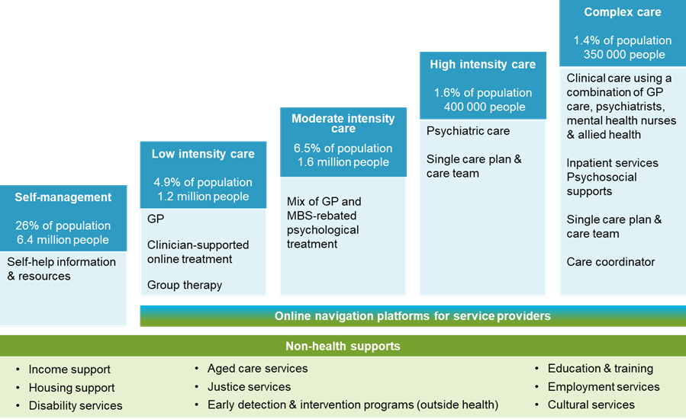

* *Accommodating people in the community rather than in hospitals*

The costs of not adequately addressing the accommodation needs of people with mental illness is evident through increased expenditure on these people in the health sector and in some cases, in the justice system. The proportion of health sector expenditure related to mental health patients rotating through hospital ED departments, and accommodating people with mental illnesses in the most expensive forms of care (hospital acute inpatient facilities) for time periods beyond that required for their effective treatment is difficult to determine. But surveys suggest that around 30% of admitted patients (about 2000 people) in psychiatric wards could be discharged if appropriate housing and community services were available. For each individual retained in an acute hospital bed, who could be treated (at least as well) in a non‑acute bed-based service, the health system is overspending (figure 5).

*The issue is not simply that people should not be needlessly admitted to expensive facilities but that the right assessment, treatment and care must be available at the right time, for the right reasons and as long as clinically necessary. Acute general hospital units previously serviced their own inpatients very satisfactorily for decades. They were never intended to service everyone regardless of need. They should not be seen as the first place of call for mental health care. In my view very long term inpatient care in a general hospital amounts to “cruel and unusual punishment” and must be restricted to very short term voluntary patients.*

*The following chart is simply an unoriginal prejudicial argument against providing best mental health care in the right surroundings. To present this chart superficially suggests like is compared with like when it is not. It gives ammunition to politicians and bureaucrats to attack hospital services.*

| Figure 5 Average daily ongoing cost of accommodation per person |
| --- |

This bar chart shows the average daily ongoing costs of accommodation per person in different settings. The least expensive settings are housing in the community, such as public housing, private rentals or mortgagees. Residential mental health care is relatively more expensive. And specialist forensic health or acute hospital services are relatively more expensive again.

*I support this section. A radical re-design of Commonwealth /State relations is required if we must continue with a federal government system.*

A clearer division of responsibilities between tiers of government is required to avoid these interface problems. In broad terms:

* activities that need local knowledge, expertise and flexibility in order to plan and deliver intended outcomes should be the responsibility of a sub-national level government — follow-up care for people who have been discharged from hospital after a suicide attempt is one such activity;

*This would be my preferred option.*

Option 2 Rebuild model

The rebuild model would have most mental health funding held in regional funding pools controlled by each State and Territory Government and administered by Regional Commissioning Authorities (RCAs). The purpose of RCAs is to create a seamless mental healthcare system that offers continuity of service for people with mental ill-health and fills gaps in service provision. RCAs would overcome unnecessary and inefficient care discontinuities, duplication and gaps that would otherwise persist at the interface between Australian Government and State and Territory Government responsibilities. These new bodies will be responsible for allocating all mental healthcare, psychosocial and carer supports (with the exception of those for people receiving NDIS funding).

To enable this change, the following Australian Government funding should be pooled and transferred directly to the RCAs:

* payments by State and Territory Governments for mental healthcare under the National Health Reform Agreement
* funding for PHN-commissioned mental healthcare (PHNs would no longer commission mental healthcare under the rebuild model)
* the additional payments proposed for psychosocial and carer supports.

|  |
| --- |
|  |

*Entirely agree with the following proposal.*

*In the short term (in the next 2 years)*

The Department of Health should cease directing PHNs to fund headspace centres, including the headspace Youth Early Psychosis Program, and other specific service providers. PHNs should be able to continue funding headspace services or redirect this funding to better meet the needs of their local areas as they see fit.

*In the medium term (over 2–5 years)*

There should be no requirements that commissioning agencies (RCAs or PHNs) have to fund particular service providers.

*Draft Recommendation 25.2*

*This should be reviewed to ensure the surveys are comprehensive and statistically sound from a clinical view as well as an actuarial one.*

| **draft Recommendation 25.2 — routine national surveys of mental health** |
| --- |
| *In the long term (over 5 – 10 years)*  The Australian Government should support the ABS to conduct a National Survey of Mental Health and Wellbeing no less frequently than every 10 years.  The survey design should enable consistent comparisons across time, and aim to routinely collect information on:   * prevalence of mental illness * service use by people with mental illness, and * outcomes of people with mental illness and their carers.   The survey design should ensure that it adequately represents vulnerable population sub-groups who may have diverse needs. Opportunities for linking the survey data with other datasets should be considered. |

**Submission to the Aged Care Royal Commission.**

**Older Adult Mental Health in Western Australia**

**Aged Care Royal Commission Submission**

In my capacity as former psychiatrist superintendent Swanbourne Hospital, Perth WA, I have experience in this matter, and would like to offer some comments. I resigned from the Health Department of WA in 1999 and have worked in long term locum posts in mental health aged care hospitals in England, before and since retirement.

Dr Neville Hills, FRANZCP, MRCPsych., LLM, PhD.

**Royal Commission Terms of reference**

I have two concerns regarding the terms of reference.

1. There appears no clear mention of the State Government’s role in provision of Older Adult Mental Health (OAMH) care, including dementia.
2. There may be a focus only on events arising after admission to aged care, excluding an examination of matters prior to aged care facility admission.

**Background to Older Adult Mental Health Services in WA**

In the late 1970’s in Perth there were two major mental hospitals, Graylands and Swanbourne.

Swanbourne Hospital had responsibility for the intellectually handicapped and elderly since the reorganisation of Claremont Hospital in 1972.

Planning by State Older Adult Mental Health Services (OAMHS) to replace Swanbourne Hospital, commenced in 1981 with a comprehensive range of alternative types of mental health unit proposed for older people.[1] While the planned units were built, subsequently key components did not eventuate, and others were closed or converted to alternative uses.

I published an account of this process in 1996, which I am at present revising and updating where possible.[2] I will forward a copy when it is completed. The essence of our 1981 planning was that patient criteria dictated three types of built facility, and the extension of services into the community. This provided a range of facilities to meet special needs rather than a “one type fits all” approach.

1. Acute care in four Teaching Hospital units, to be approved under the Mental Health Act.[3]
2. New purpose-designed medium to longer stay Psychogeriatric Extended care Units (PECU) comprising
3. Multidisciplinary community assessment team base
4. A Day Hospital and therapy areas
5. Residential wards in 8-bed wings with mainly single room accommodation.[4]

(The term “Extended Care” in use at the time did not refer to length of stay. It was a term devised by the late geriatrician, Dr Richard (Dick) Lefroy to describe extension of hospital services into the community.)

1. Community places in normal housing.[5]

Five modern purpose-built OAMH units (PECU’s), were distributed around the metropolitan area, four of which were placed on general hospital sites, in proximity to community general health care hospitals, carers and families.

Historically, much of the more challenging dementia care was managed in mental asylums and aged care homes. Mental health management to a large extent was based on secure confinement and drug use. A great deal of opprobrium and stigma was attached to mental health services, in many cases deservedly so. However, over recent decades the place of well-trained staff working in positive environments, with multidisciplinary teams of health professionals, has changed the outlook.

A key element of the architectural planning for the new facilities in 1981 was to provide an environmentally familiar setting rather than a “clinical” one. Our goal was to minimise the use of all medication, particularly night sedatives. In this endeavour we were greatly supported by our nursing staff who worked in collaboration with clinical psychologists on all aspects of behaviour management. The clinical psychologists at that time had been trained in behaviour techniques by Prof. Jay Birnbrauer from Murdoch University. This assisted nursing staff in gaining an understanding of alternatives to traditional medications to manage behaviour.

In addition, the presence on staff of psychiatric registrars in training, added fresh clinical insights and ensured judicious use of medication when indicated. Many of these registrars have become senior consultant psychiatrists with a good appreciation of the nature and potential of quality aged care services.

A reaction against specialist mental health care, has driven diversion of many people with dementia, who were previously admitted into mental health care, to general aged care facilities. This has occurred to such an extent that nursing homes and hostels became virtual asylums, in some cases offering no better care than the mental hospitals which they replaced. The problem of excessive reliance on drug use, restraint and detention in locked homes, was transferred from asylums to some, but not all, aged care facilities. The Health Department of Western Australia (HDWA) progressively distanced itself from all aged care, particularly where mental health and dementia are concerned.

**Commonwealth Special Dementia Care Units/Programs**

My principal concern is that, based on experience in WA and other States, I expect that, to the extent the Commonwealth enters service provision, State Governments will withdraw support even further, as has happened in WA. A decision must be made whether specialist dementia care includes, on occasions, a significant mental health component and is a State responsibility or, is entirely one for general aged care and Commonwealth funding. The following excerpt is taken from a 2018 Commonwealth Government discussion paper in relation to the need for specialist dementia care units (SDCU’s).

*There are a number of existing Australian Government and state and territory government-funded supports, and initiatives by individual aged care providers, to support people with BPSD. However, stakeholders have consistently identified a gap in the ability of the aged care and the broader health system to provide appropriate care for the small minority of people (estimated as up to 1 per cent of people with dementia) with very severe BPSD.*

The estimated incidence of dementia in WA published by Alzheimer’s Australia, is based on an Access Economics report.[6]

Number of people with dementia in WA:

2016 - 33,300 people with dementia

2020 - 36,500 people with dementia

2050 - 69,000 people with dementia

1% of this population with very severe BPSD will amount to 365 persons in 2020. It cannot be described as a “small minority”, and the inevitable increase must be addressed. In addition to persons with dementia and severe BPSD, OAMH services are expected to provide care for all other forms of mental illness in the elderly, which can include mood disorders, psychoses, delirium, drug and alcohol addiction, late onset schizophrenia and personality disorders.

In terms of inpatient resources WA has about 140 beds. The shortfall is placed as a burden on the general aged care sector, and even more importantly on family carers. The critical role of family carers was recognised in WA from the outset of planning. Staff at Swanbourne Hospital were involved in supporting the establishment of the first Alzheimer’s support group in Australia (ADARDS). The philosophy of our services was directed to ensuring that patients could remain at home as long as possible and practical. The following statement is the foreword to the Campbell- Miller report on which our services were based.



The *gap* mentioned in the excerpt from the SDCU discussion paper, is a result of decisions made by the HDWA to close beds previously available for Older Adult Mental Health care, to cease providing respite and day hospital care, and to discharge a small number of long term patients with serious BPSD to aged care facilities by providing “top-up” funding for a very limited group. The HDWA has made no progress to match the increasing aged population.

The rationale behind this top-up funding was never satisfactorily explained or thought through. It is my understanding that the failings of the Oakden Hospital in South Australia, and similar ventures in other States, are related to this faulty concept.

A small number of people professionally identified as not yet ready for general aged care facilities were transferred with additional funding to meet their needs. In Perth two aged care units operated by Southern Cross Homes received these people, and I have no reason to doubt they obtained good quality care, although there were some drawbacks. The Southern Cross units were however not able to readily discharge patients; hence admission of new cases was extremely limited, and they were not so conveniently located for some relatives. In effect a very small number of long-term OAMH patients, with expectations of discharge at some time when ready, were placed in two aged care homes, with little or no expectation of discharge or relocation when recovered.

These people were suffering significant mental illness or challenging behaviour, were already in the care of well trained staff with good quality residential arrangements, regularly reviewed by mental health clinicians and the whole multi-disciplinary team, as to whether they were suitable for general aged care. Any OAMH patients assessed as ready for discharge to an aged care facility able to manage their care needs, were normally transferred to aged care facilities with family support, and without breaching any agreements. Funds to improve service delivery by the PECU’s were denied, and any in-house savings obtained were directed elsewhere.

No evaluation of the effect of this State “top-up program” on OAMH unit admissions has been seen, although it was presumably intended to facilitate admissions by creating vacancies. HDWA bureaucrats appeared to believe that a few long- term patients created a bed blockage which they could address. My request for information on the funding provided, was refused on “commercial-in-confidence grounds”.

My view was that the HDWA believed our units were perversely holding people who could be placed in aged care, in contrast to government policy of dispensing with all long term aged care, whether medical or mental health based.[7] Instead of assisting in the process of improving turnover of those patients we admitted, treated and discharged more efficiently, our units were deprived of funds to grow and improve, while a handful of patients who we managed economically and with minimal disruption to aged care homes, were given a subsidy to relocate.

**Legal concerns**

The legal basis on which patients were transferred to Southern Cross Homes was unclear. As they were, or should have been, detained under the *Mental Health Act 1996* (WA), they did not receive any of the legal reviews provided by the Mental Health Review Board. This creates a gap in legal and clinical responsibility, which became a feature of the problems at Oakden Hospital in South Australia. This gap has been discussed by Wendy Lacey, Dean of the University of South Australia Law School.[8]

The unlawful detention of some older people in mental health and aged care facilities has been the theme of my PhD thesis completed in 2016, which is available online.[9] How patients come to be admitted into care with the authorisation of ACAT staff requires further exploration.

Confusion over the mix of Commonwealth and State responsibility for people with dementia and serious mental health management issues, has proved disastrous. It has demoralised staff in mental health, whose efforts to provide quality care, have been down-graded by the view that they were simply holding on to some patients needlessly. It ignored their knowledge of the patients, their families, and their expertise in managing difficult to place patients. At the same time requests for new funds to progress initiatives were stifled and budgets repeatedly cut to meet so-called efficiency savings. Actual savings made by units could not be retained and redirected to new initiatives. The arcane and erratic financial management of the HDWA, ensured proper budgetary management, was impossible.[10]

**BRODATY et AL 7-TIERS**

The 7 Tier model is well established as a basis for service planning and resourcing. However, it is focused on dementia care only, whereas all OAMHS facilities in WA are expected to manage the whole range of mental health disorders, including those arising in dementia. A request I made to the HDWA in 1999 to redirect funds from the sale of Lemnos Hospital, to provide low cost 8-bed cottage style units at the Lodges for patients without dementia, fell on deaf ears.

It should be noted that the 7 tiers are not rigid categories, as is illustrated by the wavy lines in the triangular diagram. Depending on individual circumstances, OAMHS units may need to address tiers 4 to 7, an example being the sudden death of a sole carer for a tier 4 patient, who cannot be left alone at home. Social emergencies of this kind are not rare. Unplanned and unforeseen emergency admissions of persons with dementia can have serious adverse effects and may precipitate behaviour issues. Adequate bed resources can act as a “buffer”, minimising undesirable acute hospital admissions.

**Impact on aged care facility residents without dementia.**

The impact of people with disruptive behaviour, on the care of people in aged care who are not similarly affected, is not given due attention. A major component of service philosophy during my time in the MHS and HDWA, was to ensure smooth operation of the nursing homes and hostels, on which we depended for eventual placement of our patients when recovered. Close and prompt liaison with aged care facilities and general hospitals was an important duty for our doctors, social workers and community nurses. This role was largely ignored by the HDWA.



Why the Health Department of WA, (HDWA) and the WA Mental Health Commission (WAMHC) have paid so little attention to older adult mental health can be traced to several events. One of the most insidious has been repeated quoting of the 1987 ABS Survey, which has been used to justify less attention to older people in mental health care. At the same time the survey results have been quoted consistently to justify additional attention to younger patients. While I have no disagreement with the importance of services for young people, the implication from this fundamentally flawed and misused survey, that older people have fewer needs, is opportunistic and reprehensible.

The following excerpts have been taken from the Oakden Report on South Australian Services for older people, where they are relevant to the matter of Commonwealth and State interactions.[11]

* *During the development of these State plans there has been a significant focus on the planning of specialised OPMHS. It is significant that both NSW and Victoria undertook large scale and detailed OPMHS planning from 2004 onward, in an effort to describe for the first time, at a State level, the full range of services needed (including Commonwealth funded services) to provide comprehensive OPMHS to their population.[12]*
* *Since that time it has been recognised that severe and very severe BPSD has begun to fall between the cracks of the Commonwealth Aged Care system and the State funded Mental Health Care system, with the need for both levels of government to cooperate in the development of programs that cater for this small group of highly disadvantaged people and their families and carers.*
* *In 1998, a decision was made to seek Commonwealth accreditation for Makk and McLeay as nursing home beds. This was a key turning point. From that time, what had been an entirely State funded Specialist OPMHS was now an entirely Commonwealth funded service, for these two units that were attempting to provide the same range of specialist services with a lower level of overall funding. It is unknown what happened to the State recurrent funding of Oakden from that time onward.*
* *In 2001, initial discussions were facilitated between the State Government and Aged Care and Homes (ACH) Group, a not for profit organisation and residential aged care provider. Throughput was slowing and this was mostly attributed to the issue that as nursing home beds, Makk and McLeay represented a permanent placement, unlike the previous State model from the 1990s.[13] However, the Review can find no other description of a mental health reform agenda for OPMHS in SA, other than the National Mental Health Reform (NMHR) agenda. The Review does not believe the NMHR agenda proposes States move toward providing highly specialised hospital type services by NGO aged care providers.*
* *Whilst part of Oakden, has “Nursing Home” status under Commonwealth Aged Care Funding arrangements, it has always been an integral part of the continuum of State-operated Specialist OPMHS. The referral pathway is primarily from SA Health acute OPMHS to a system that is run by SA Health. The service is for those people who have the most severe problems which mean they could not be provided assistance by any other Commonwealth funded Dementia Specific Facility in SA. This interaction between Commonwealth funding and State operation is complex but has been successfully implemented elsewhere in Australia and is considered an important element of how services are provided, in particular for people who have Tier 5 and 6 BPSD.[14]*

*This issue is critically important because without a proper understanding of the interplay between what funding is available under the Commonwealth’s Aged Care Programs (as identified by the Aged Funding Instrument (ACFI)) and what top-up funding is needed from the State to provide quality services there will be, as has occurred, insufficient resourcing.*

*Furthermore, as outlined earlier in this chapter, whilst it is appropriate that the State not remain in the sector providing Aged Care Services that can be provided with great expertise by the Commonwealth RACF sector, it is critical that as in other States it remains the provider of those services that cannot be provided otherwise.*

Dr Steve MacFarlane commenting on the Oakden Report stated;[15]

* *Such models of care have existed in both Victoria and NSW for many years. Victoria has a network of psychogeriatric nursing homes that receive, in addition to the usual aged care funding provided by the Commonwealth, state government top-up funding to enable higher degrees of resourcing into these homes.[16] One of the major failings at Oakden was that although Makk and McLeay were intended to care for a resident group with these high-level needs, they were only funded according to the usual Commonwealth formula that applies to non-specialist facilities. Requests for additional resources fell on deaf ears.[17]*

**Changes in planning and resources in WA since 1980**

The Campbell Miller report of 1981-2 established the basis for the Western Australian Older Adult services and commenced with detailed statistical analysis[18]. It would be unlikely that even more extensive data is not available at present. The issue is that if obtained and presented, will any more regard be held for the significance of this data?

It is possible that providing this dramatic and somewhat threatening information has a “turn-off” effect, particularly for governments of either colour with a foresight range only as far as the next election.

Western Australia has grown in total population number and age since 1981, so any demographic study should examine both the total increase in numbers of persons at risk in the State, and the effects of increasing age on the incidence of the range of mental health problems, not only dementia.

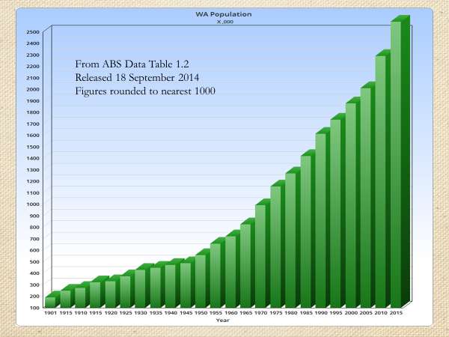

A focus on dementia, for which statistics may be more readily established, risks falling into line with WA Health Department thinking that Older Adult Mental Health is only about dementia, and that dementia care is something to pass off to the Commonwealth for action. It may be helpful to illustrate the reduction in OAMH bed resources that have occurred since 1985.



The table above is the only one I can provide at this time, in view of the generally unhelpful format of HDWA Annual reports. While there may be some new beds since 2005, others have been lost or allocated to working age adult services.

Business plans for the closure of Selby Lodge, opened in 1985, pictured below, are being prepared with no indication how this service will be managed if at all.

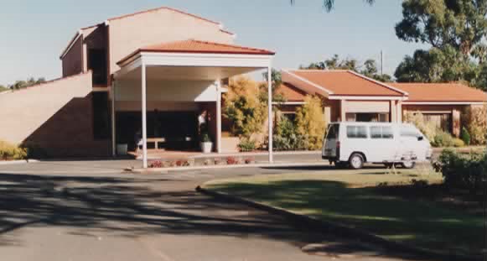

I understand that none of the five Day Hospitals built at the PECU’s now provide care on the model intended in 1981. Various reasons can be advanced, but I am convinced the loss of this form of community- based care is difficult to justify.

**Change in efficiency of service delivery 1975 to 1987**

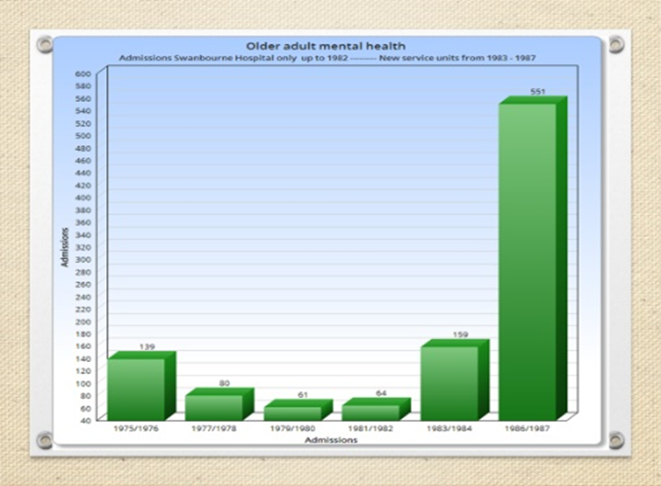

The chart illustrates that in 1975 relatively few patients were admitted to Swanbourne Hospital. One psychiatrist was responsible for over 400 patients, and attempted to give priority for admission to persons living at their own home where possible. Patients who had been admitted elsewhere were placed on a waiting list. When I took over as psychiatrist superintendent in 1980 there were around 50 names on the list. These were persons considered at the time to be unmanageable in aged care homes as they were then operated. With the appointment of a second psychiatrist experienced in older persons mental health in 1982, it became possible to begin to offer effective assessment and treatment, resulting in discharges and more efficient use of resources.

With the closure of Swanbourne and the establishment of a range of new facilities in 1985 -1987 much improved efficiency in assessment and treatment became possible. However this conflicted with the mantra at the time that admission to inpatient units was undesirable. Despite our documented policies of home assessments, day hospital care and least restrictive options, our services were branded as lacking a “community focus”.

Repeated assertions were made by government and the WA MHC that what was needed was less hospital inpatient care, while at the same time opportunities to provide genuine alternatives were stifled by lack of funding and commitment from government. A few initiatives such as the Hospital in the Home service, were funded by closing beds.

That OAMH patients are disadvantaged by ageism, physical illnesses and mental health problems is often conveniently dismissed.

Statistics such as these are not available in the glossy publications of the Health Department or the Mental Health Commission. Efforts to obtain relevant information. in the course of my PhD research were frustrated. Limited documentation had to be obtained by FOI application, or estimated projections based on the Australian Institute of Health and Welfare data.

There are no records kept as to how many persons lacking mental capacity to agree to aged care facility admission, are presently detained and unable to leave. No records exist as to how many aged care facilities also detain persons who retain mental capacity to make their own decisions.

Duplicating State and Commonwealth roles adds to fragmentation, evasion, cost shifting and carer misunderstanding. I urge the Commonwealth to tread carefully, and not to embark on “top up” funding to this problem area, without a binding and verifiable assurance that State funding will not be further reduced consequently.

Any program of added funding should be carefully audited to ensure promised goals are met, does not become another open-ended commitment, and does not provide an excuse for State governments to cut back on their responsibilities.[19]

A repeat of Oakden and other failed programs must be avoided as a priority. However, I hope that the Commission will advance the case for a more enlightened approach by State governments. There is no shortage of information and best practice models in aged care, which have developed over the past forty years and have been incorporated in most of the best-run aged care services.

Expenditure on aged care is cost effective when older people can manage to remain at home as long as possible and assisted to keep out of the highly technical acute hospitals. The role of OAMHS in providing this diversion from acute hospitals is not suitably recognised. I was fortunate to have a joint appointment to Sir Charles Gairdner Extended Care Department and Selby- Lemnos Hospital until 1999. It was possible to influence diversion of referrals daily and offer support to acute inpatient wards. However, this liaison psychiatry role by OAMH psychiatrists is little appreciated, despite heightened relevance for older age patients.

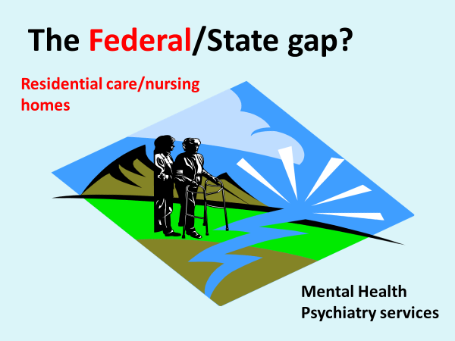

The WA Health Department and the Mental Health Commission did not offer any contributions to the *Australian Senate* *Inquiry into the care and management of younger and older Australians living with dementia and behavioural and psychiatric symptoms of dementia (BPSD), 2014.* Other States and organisations did contribute; hence the final report by omission conveyed an impression that WA was a backwater for innovation and quality services, which was undeserved.

I trust the Commissioners will not allow this neglect to be repeated, and they will actively seek detailed information from authorities in WA in due course.

I would be pleased to discuss my views with any Commission staff if this would assist.

Dr Neville Hills, FRANZCP., MRCPsych., LLM, PhD.

**End**

1. Campbell & Associates, The Campbell Miller plan 1982. Copies at Graylands Hospital Library.
2. NF Hills, Asylum to Mainstream, privately published 1996. Updated 2019. Available on request.
3. Only one was built at Fremantle Hospital which was part-funded by the closure of a community unit and Heathcote Hospital. A new Joint Geriatric/Psychogeriatric Assessment unit at Bentley Hospital was closed.
4. Five PECU units are now designated as acute, and four approved under the Mental Health Act 2015.
5. Eden Hill Cluster Homes, opened in 1982, later closed and not replaced.
6. <https://www.dementia.org.au/wa/research-and-publications/publications/dementia-statistics-wa>
7. A HDWA member of the committee that oversaw the closure of Lemnos Hospital in 1999, told me she thought Lemnos was a Nursing Home. At that time Lemnos admitted and discharged over 100 patients in a year, a result no nursing home of comparable size would achieve.
8. Lacey W, Neglectful to the point of Cruelty, Elder Abuse and the Rights of Older persons in Australia, *Sydney Law Review*, vol. 36 99, 129.
9. <http://research-repository.uwa.edu.au/en/publications/does-mental-health-and-guardianship-legislation-in-western-australia-wa-protect-elderly-persons-from-human-rights-abuse-and-ensure-procedural-and-substantive-justice(883d8fe8-3236-489c-810d-5894032c86a9).html?uwaCustom=thesis>

   Does mental health and guardianship legislation in Western Australia (WA) protect elderly persons from human rights abuse, and ensure procedural and substantive justice? Neville Francis Hills. Law School UWA.
10. Management teams were uninformed about budget details until late in the financial year, when reductions would be made, and savings were redirected elsewhere.
11. Aaron Groves, Chief Psychiatrist SA, Review of the Oakden Older Persons Mental Health Service, 2017.
12. Campbell-Miller Report 1981 for WA overlooked here. WA OAMHS have not received similar Commonwealth funding. A single program run by Dr Boon Loke at RPH and Brightwater Aged Care was Commonwealth funded, but the State refused to continue same and it was closed.
13. OAMHS units in WA have never provided permanent placements.
14. How successful they have been, must be questioned. Dr John Tooth AO made a submission to the 2014 Senate Inquiry on Dementia, which detailed the experience in that State. A highly regarded program at the Hobart Alzheimer Nursing Home, was dismantled because of withdrawal of State support, and acquisition by an NGO aged care organisation. The suicide of a patently very unwell resident in NSW at The Ritz Nursing Home, is another instance where failure to address mental health concerns swiftly and effectively, had a very serious outcome. I have no doubt that there are many similar instances nationally.
15. RANZCP Faculty of Psychiatry of Old Age.
16. That Victoria has a network of Commonwealth funded psychogeriatric nursing homes demonstrates inconsistency of models and funding, as WA does not have a comparable resource. Yet our services are often viewed negatively because of not comparing equivalent service models and funding.
17. <https://www.ranzcp.org/Files/Fellowship/Faculties/FPOA/Oakden-commentary.aspx>
18. Campbell C and Miller W, Health Services and Facilities for the Mentally Ill in Western Australia, 1981. The population of Western Australia was stated to be 2.2 M in 2009, with a further 300,000 persons anticipated by 2015. (2,589,000 reached in 2014).
19. I have learned that the WA MHC declined to proceed with the $2M top-up offer clearly promised in 2016. That this decision was influenced by the Commonwealth discussion paper on SDCU’s would be highly likely. The provision of funding to Brightwater Group in WA was also withdrawn by the State. That service addressed many patients who would otherwise be candidates for State funded mental health care, especially early onset dementia and head injured persons.