P.O. 445 ALBURY NSW 2640
Email: director@alburypreschool.com.au
www.alburypreschool.com.au

Productivity Commission Inquiry into Early Childhood Education and Care
Albury Preschool Submission
About us
Albury Preschool is a not for profit community based preschool and has been part of the Albury community since 1945. Currently 150 families utilise our Preschool each year, with a volunteer Committee of Management elected each year at our Annual General Meeting. Since 2011 when Albury Preschool negotiated its first Enterprise Agreement, we have employed deliberate strategies, to ensure that we are an “employer of choice”, reflecting a high level of respect and regard for the skills and professionalism of early childhood teachers and educators and the value we place on creating a positive workplace culture for all employees. We recognise “Teachers as Teachers” and ensure that our Early Childhood Teachers receive parity with Primary Teachers in their wages and conditions. Our Educators are currently paid approximately 35% above the Modern Award, in recognition of the expectations their role demands. As a result, we continue to be able to recruit, and retain, skilled Early Childhood Teachers and Educators with many staff having been employed at our Preschool for over 20 years.
Access to high quality Early Childhood Education
Attendance at high-quality ECEC services can have long-lasting positive effects on children’s social and emotional, self-regulation and behavioural, problem solving and mathematic, language and literacy, and physical development, and on school readiness (see for example: Kulic et al., 2019; Melhuish et al. 2015; Taggart et al, 2015; Taylor, 2016; Zaslow et al., 2016). High quality early childhood leads to better health, employment and educational outcomes, providing significant return-on-investment for governments.
Studies such as The Australian E4Kids study (Taylor, 2016), have reported that the quality of teacher-child interactions is predicted by the presence of university-qualified teachers and educational leaders. Higher educator qualifications are strongly associated with improved child outcomes, as qualified educators are better able to involve children, stimulate positive interactions, and use a range of strategies to extend and support their learning. The quality of teacher-child interactions predicted children’s pre-academic outcomes at school entry and in Year 3. The quality of interaction and activities directly experienced by each child, is key to supporting the proposed Early Years Strategy vision for children’s learning, wellbeing and development. It is essential, therefore, that the integrity of the National Quality Framework which introduced mandatory minimum qualifications for educators and early childhood teachers to build a highly skilled workforce is maintained to ensure high quality Early Childhood Education.
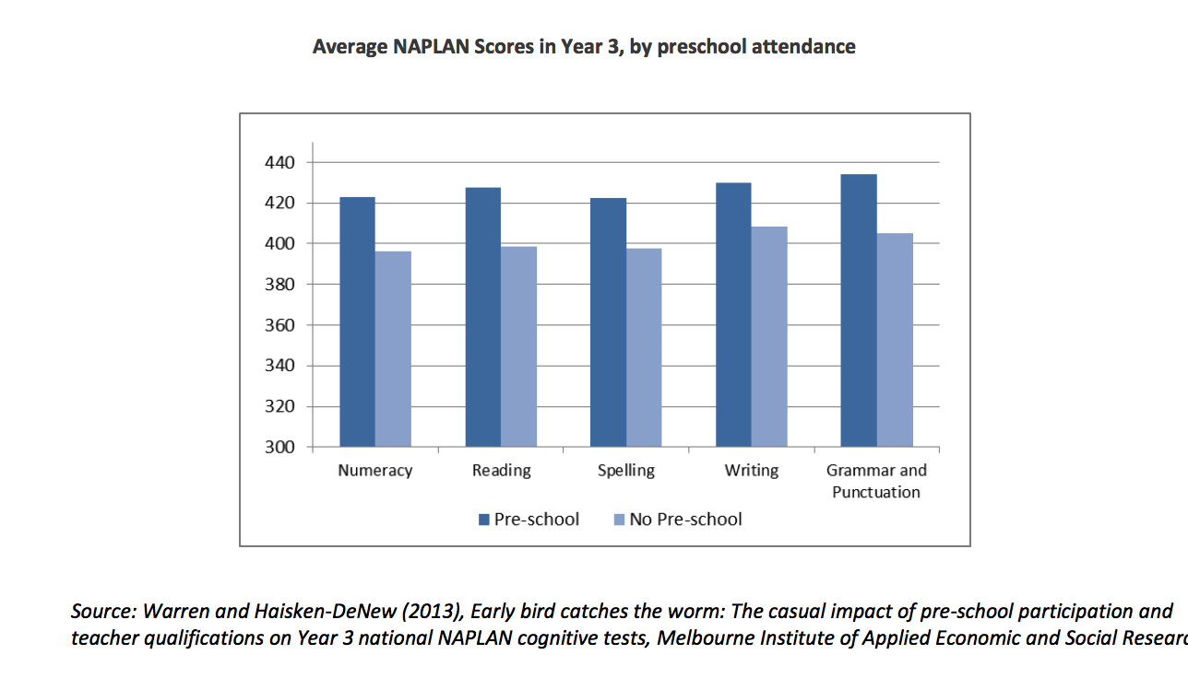

A highly skilled workforce underpins quality
Work in the ECE sector has been undervalued, with dissatisfaction with pay cited as a main reason for leaving the sector (Fenech et al., 2022). Insufficient leave provisions, little work flexibility and poor job security, lack of professional and career development opportunities, high workload and poor administrative and leadership support have also been cited as sources of staff dissatisfaction (CELA et al., 2021; Cumming et al., 2022; Fenech et al., 2022; Thorpe et al., 2018; United Voice, 2017)
Low pay and recognition for educators and teachers has directly resulted in staff shortages, high turnover and reduced quality. Existing research and survey data have identified that ECEC educators’ and teachers’ wages and employment conditions form a significant barrier to efforts to increase and retain a capable and effective ECE workforce. Workplace relations reform and associated financial and workplace supports need to be put in place to address pay and condition inequities.
In relation to working conditions, OECD recommendations include:
• Allocating time for preparation and planning not only of pedagogical but of aspects supporting process quality, such as adequate time for intra-staff communication as well as with parents and other professionals, and ongoing professional learning of different types.
• Ensuring comparible working conditions for those working in schools and ECE sector, as well as between those with the same roles in different parts of the ECE sector
Early childhood teachers study degrees of the same length and complexity and primary and secondary school teachers and should receive equal pay and conditions. They are responsible for children in a critical stage of development and are required to do complex individualised planning and assessment. They are also responsible for leading teams of educators.
The National Children’s Education and Care Workforce Strategy (the Workforce Strategy) 2022-2031 (ACECQA, 2021a) key action is to: “Investigate options for improving professional standing, and workforce pay and conditions, including examining the associated barriers and constraints”
The strategy includes 21 nationally agreed actions to be delivered over the short (by the end of 2024), medium (by the end of 2027) or long term (by the end of 2031), grouped by six inter-related focus areas:
· Professional recognition
· Attraction and retention
· Leadership and capability
· Wellbeing
· Qualifications and career pathways
· Data and evidence
We support the implementation of the Workforce Strategy and ask that the Productivity Commission consider these strategies whilst undertaking their own inquiry and make recommendations that will support affordable, accessible, equitable and high-quality ECEC that reduces barriers to workforce participation and supports children’s learning and development.

Thank you for considering our submission

Kind regards
Jo Barton
Director/Nominated Supervisor

