Estimated Resident Population (ERP)
Rockhampton
Year (ending June 30) | Number | Change in number | Change in percent
2005 | 73,185
2006 | 74,204 | +1,019 | +1.39
2007 | 75,195 | +991 | +1.34
2008 | 76,272 | +1,077 | +1.43
2009 | 77,448 | +1,176 | +1.54
2010 | 78,193 | +745 | +0.96
2011 | 78,939 | +746 | +0.95
2012 | 80,924 | +1,985 | +2.51
2013 | 82,456 | +1,532 | +1.89
2014 | 83,405 | +949 | +1.15
2015 | 83,653 | +248 | +0.30

Source: Australian Bureau of Statistics, Regional Population Growth, Australia (3218.0). Compiled and presented in profile.id by .id , the population experts.

Comment: The population of the Rockhampton Region increased by 248 residents or 0.30 per cent in 2015. The increase in 2015 was noticeably lower than in the previous decade.

Rockhampton Regional Council area - Gross Regional Product measures
Year ending June | Headline GRP $m | % change from previous year | Local industry GRP $m | Local residents GRP $m | Local industry to residents ratio
2,015 | 5,014 | -2.5 | 3,556 | 3,656 | 0.97
2,014 | 5,140 | +3.9 | 3,681 | 3,780 | 0.97
2,013 | 4,946 | +2.8 | 3,753 | 3,827 | 0.98
2,012 | 4,813 | +2.7 | 3,768 | 3,808 | 0.99
2,011 | 4,685 | -0.2 | 3,623 | 3,618 | 1.00
2,010 | 4,696 | -1.1 | 3,426 | 3,399 | 1.01
2,009 | 4,749 | +3.3 | 3,486 | 3,451 | 1.01
2,008 | 4,599 | +4.1 | 3,442 | 3,391 | 1.01
2,007 | 4,419 | +7.6 | 3,198 | 3,111 | 1.03
2,006 | 4,107 | +7.6 | 2,902 | 2,831 | 1.03
2,005 | 3,818 | +7.6 | 2,633 | 2,560 | 1.03
2,004 | 3,548 | +3.8 | 2,354 | 2,289 | 1.03
2,003 | 3,419 | +0.7 | 2,145 | 2,079 | 1.03
2,002 | 3,396 | +2.9 | 2,166 | 2,082 | 1.04
2,001 | 3,301 |  | 2,035 | 1,950 | 1.04

Source: National Institute of Economic and Industry Research (NIEIR) ©2016. Compiled and presented in economy.id by .id , the population experts.
Data is based on 2013-14 constant prices for all years. NIEIR data are inflation adjusted each year to allow direct comparison, and new data releases normally adjust previous years’ figures to a new base year.
Comment: Gross Regional Product of the Rockhampton Region fell by 2.5 per cent in 2015, after rising for the previous three years.

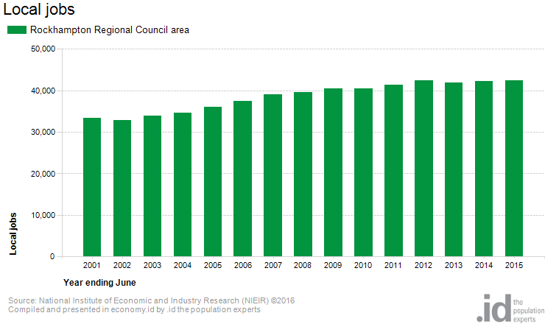

Comment: The number of Rockhampton Regions residents who were employed increased by 1.29 per cent in 2015.

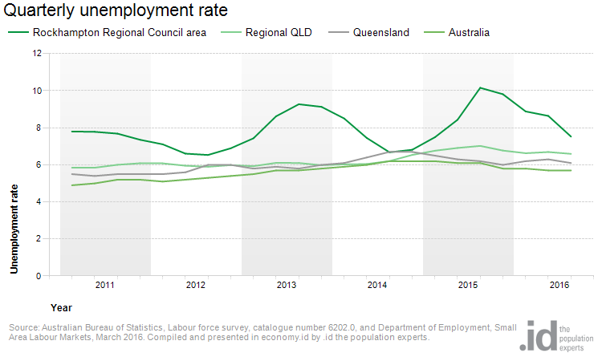

Comment: Rockhampton Region’s unemployment rate is very lumpy rising to 10 per cent in 2015. It also peaked at over 9.5 per cent two years earlier.

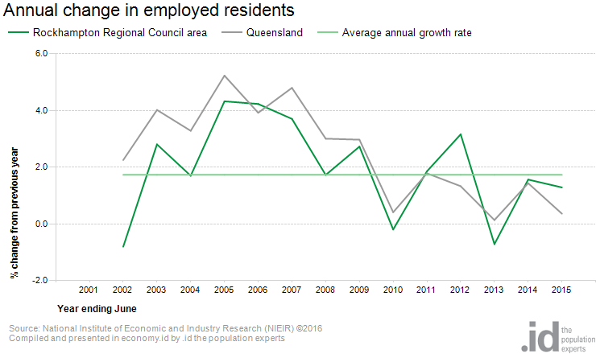

Comment: In 2014 and 2015 the number of employed residents in the Rockhampton Region was below the annual growth rate.

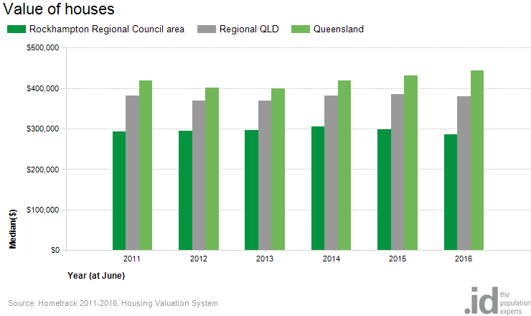

Comment: The value of housing in the Rockhampton Region has fallen each year since 2014.

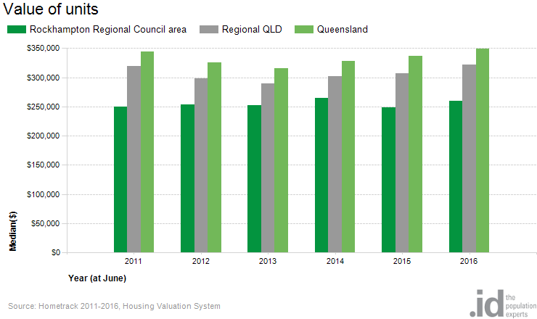

Comment: The value of units in the Rockhampton Region fell in 2015, and partially recovered in 2016

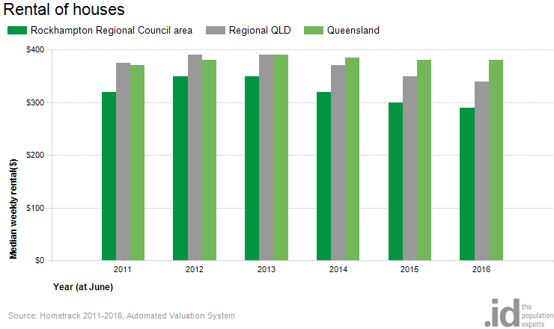

Comment: The amount of house rentals in the Rockhampton Region fell progressively from 2013 to 2016.

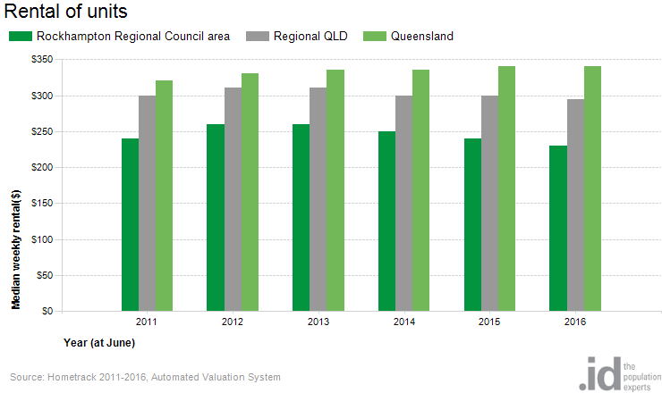

Comment: The amount of unit rentals in the Rockhampton Region also fell from 2013 to 2016.

