Dear PC
I note in Melbourne Water’s prior submission to the PC (2011?) http://www.pc.gov.au/inquiries/completed/urban-water/submissions/subdr156.pdf) the following table:
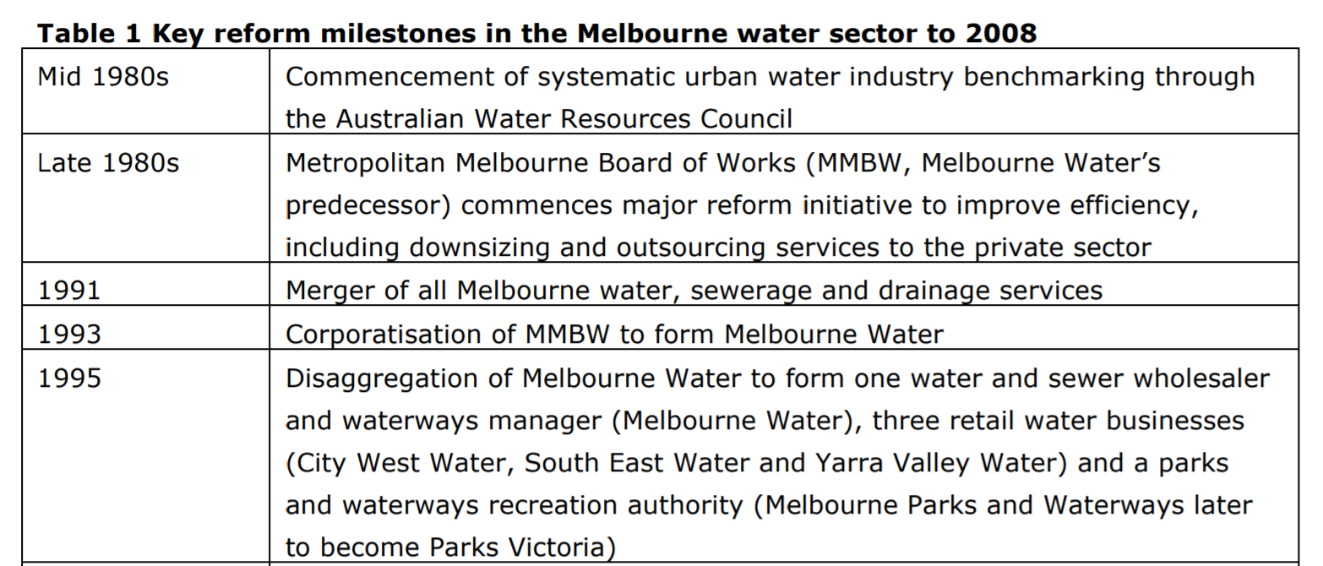

However, note the claims in regard to Melbourne Water becoming a “waterway manager” is incorrect, and Melbourne Parks and Waterways had greater responsibilities than just recreation. In fact, Melbourne Water lost all its conservation and waterway management functions to Melbourne Parks and Waterways in 1994-1996. Melbourne Water became a bulk water and sewerage provider, and also had “main drainage” functions under the MMBW Act. It was not a “waterway manager”
Local Councils are responsible for local drainage, but Melbourne Water was responsible for waterways into which main drains connected ( ie the use of waterways as drains). This function derived from the 1923 Drainage and River Improvement Act. Melbourne Waters “Main Drainage” functions were significantly diminished after all waterway previously vested in Melbourne Water reverted to Crown Land in 1996.
Melbourne Parks and Waterways was vested with management and control of waterways for “conservation, leisure, recreation, tourism and navigation) - see Water Industry Act (1994):
110. Functions and powers
(1) The functions of Melbourne Parks and Waterways are-
(a) within any area or areas specified from time to time by the Governor in Council for the purposes of this paragraph by Order published in the Government Gazette, to own, manage and control open space, parks and waterways for the purposes of conservation, recreation, leisure, tourism and navigation;
(b) within any area or areas specified from time to time by the Governor in Council for the purposes of this paragraph by Order published in the Government Gazette and to the extent provided by that Order- (i) to manage the hydraulic capacity of waterways including the stabilisation of their banks; (ii) to control the quality of water in waterways;
(c) the other functions conferred on it by or under this or any other Act.

(2) Melbourne Parks and Waterways—
(a) may purchase for use as public open space or as a park any land that is zoned by a planning scheme as being for that use and may recommend to the Minister the purchase for that use of any land that is not so zoned;

(b) with the consent of the Treasurer, may provide financial assistance by way of grants, loans or otherwise to any other person or body engaged in activities similar to any of the activities of Melbourne Parks and Waterways;

(c) has power to do all things necessary or convenient to be done for, or in connection with, the achievement of its objectives and the performance of its functions.

In addition, Melbourne parks and Waterways had “Waterway Management” functions under Part 10 of the Water Act (from 1995 onwards to its abolition in 2000): http://www.legislation.vic.gov.au/Domino/Web_Notes/LDMS/LTObject_Store/LTObjSt3.nsf/DDE300B846EED9C7CA257616000A3571/4943D7BF269DAB30CA257761002D58A3/$FILE/89-80a030.pdf

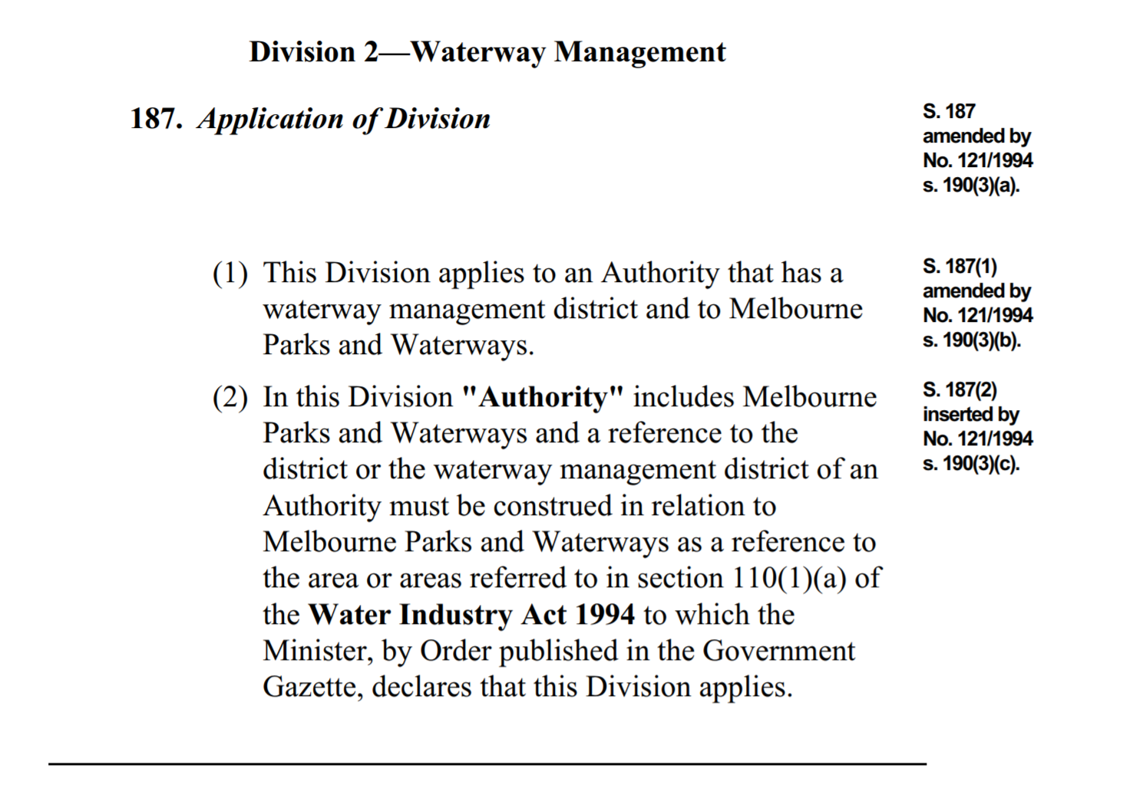
The “Regional Drainage section in Div 3 Part !0 of the Water Act was also applicable to MP&W (subject to an Order under s 110(1)b).
The area of Melbourne Parks and Waterways was specified firstly by and Order published (under s110(1)b of the Water Industry Act) on the 23 December 1994, and then by a subsequent Order on 24 August 1995 here:
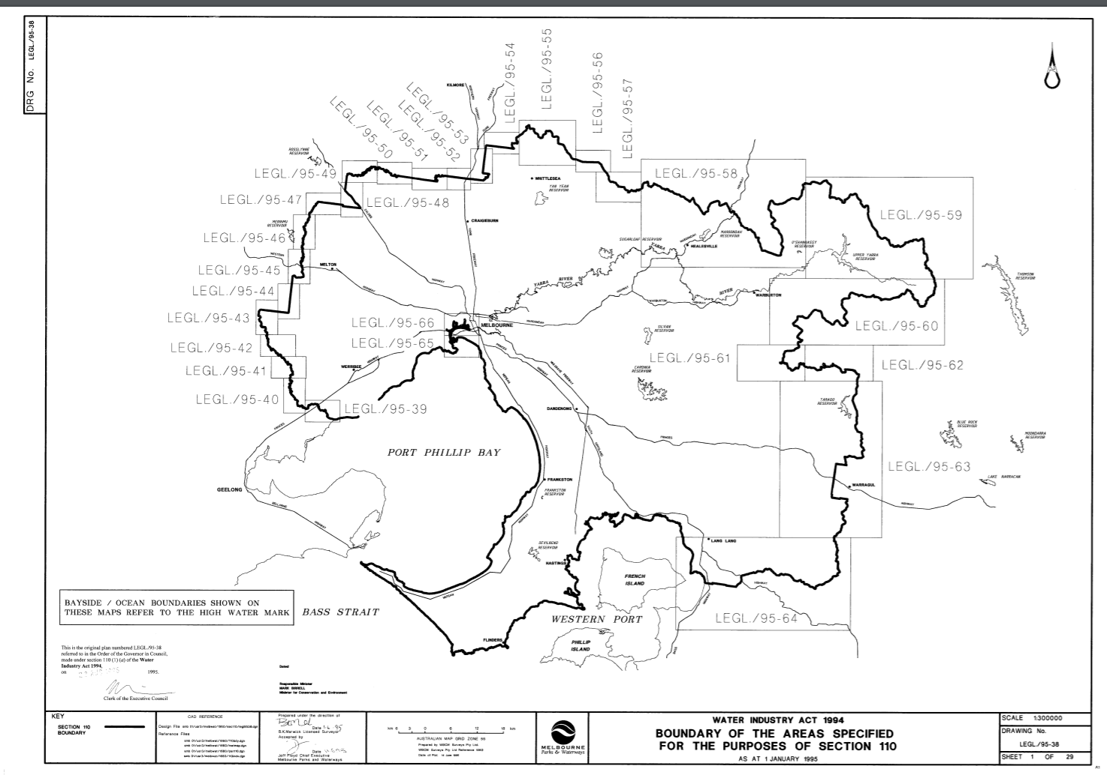
That is MP&W had taken over responsibilities over all of Melbourne Waters operational area.
The following clause in the MMBW indicates that Melbourne Water had lost these waterway management” and conservation functions. Melbourne Water was not an Authority under the Water Act and did not have a Waterway Management District. It therefore did not have regional drainage responsibilities under the Water Act.
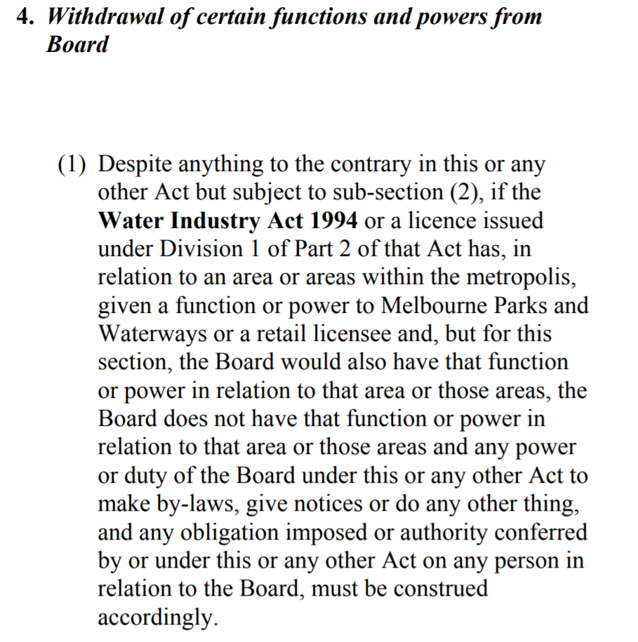
The functions of MP&W were transferred to the State in 2000. Parks Victoria is the Service provider to the State for the former conservation functions of MP&W (ie functions that were removed from Melbourne Water and which Melbourne Water no longer has):

PARKS VICTORIA ACT 1998 - SECT 7
Functions of Parks Victoria
(1) The functions of Parks Victoria are—
(a) to provide services to the State and its agencies for, or with respect to, the management of parks, reserves and other land under the control of the State;
S. 7(1)(ab) inserted by No. 66/2000 s. 42.
(ab) to provide services to the State and its agencies for, or with respect to, the management of waterways land (within the meaning of the Water Industry Act 1994 ) for the purposes of conservation, recreation, leisure, tourism or water transport;
(b) with the approval of the Minister, to provide services to the owner of any other land used for public purposes for, or with respect to, the management of that land;
(c) to carry out such other functions as are conferred on it by or under any Act.

Melbourne Water does not have the conservation or waterway management functions it claims. The area in which it provided these “services” could not have been expanded by the Order in Council under the MMBW Act in 2005, because it did not have these functions, nor did the MMBW Act have the power to declare or expand functions under the Water Act.

http://gazette.slv.vic.gov.au/images/1995/V/general/33.pdf

