Monday 1st April, 2019
SUMMARY STATEMENT

Outback Futures currently provides mobile mental and allied health services to rural and remote Queensland through three flagship programs:

- Mobile multidisciplinary clinics --
- Ongoing regular, remote tele-health therapy – ‘Stay with me’ program
- Critical Incident Response

Outback Futures offers a unique, strategic, intergenerational approach to suicide prevention and mental health in rural and remote communities.

Submitted by:
CEO Outback Futures: Selena Gomersall Toowong. Brisbane. Qld. 4066

OUTBACK FUTURES

Productivity Commission Inquiry into Mental Health

April 2019

There are people worse off than me. Well, we are another day closer to rain... We are not a bunch of whiners you know!

RURAL & REMOTE MENTAL HEALTH SERVICE PROVISION
“
There are many reasons put forward by a deeply entrenched culture in our rural and remote communities to NOT be vulnerable or seek help. Seeking help for emotional or mental health concerns is hard enough in the city, but in a generational bush culture it is not even seen as a last resort option for many.

Despite much being spent on rural and remote mental health, the suicide figures are still on the rise and there is very little improvement in individual and community wellbeing. Short-term and post-vention approaches are crucial to managing the current situation, but do little to shift the long term mental health figures and outcomes in these Outback regions. Change is needed and there needs to be a willingness to invest in the long-term, rather than seeking short-term return on investment. A strategic, inter- generational and community-driven approach needs to be embraced and supported if real change is to occur.

Outback Futures applies a long term, sustainable strategy to renew hope, build resilience and strengthen outback communities. We seek to shift entrenched stigma and empower communities around mental health and wellbeing in rural and remote Australia.
It is our belief that lasting change relies on understanding the importance of genuine community engagement in this process, and a commitment to seeing long-term positive change. City developed service provision models do not work in these cross-cultural arenas. Due respect and collaboration around cultural strengths and considerations are imperative for success.

Why Is There An Issue?
Outback Futures Experience
Currently, much understanding of and decision making around rural and remote mental health is based on ‘better access scheme’ reporting and GP service delivery. In a rural and remote context, the vast majority of people either with issues or at risk, are not accessing their GPs due to:

  - Anonymity / small community dynamics
  - Uncertainties and assumptions about the Mental Health Care Plan and its implications
  - Previous poor experiences with help seeking
  - Cultural stigma
  - Lack of understanding about mental health and service provision

In order to get a more accurate sense of the need and current situation, we have to be accessing those who will not cross a shop front. To access this demographic, there needs to be significant change in the way service provision is delivered in rural and remote communities: better community engagement; increased unrestricted referral pathways and genuine community consultation.

Current Client/Community situation

- Low mental health literacy
- Anti-help seeking culture
- Low expectation around service provision – and therefore reluctance to engage
- Small community dynamics (lack of safety / anonymity)
- Isolation / distance

Current Service provision situation

- Prohibitive referral restrictions (e.g., verified children only; must have a MHCP)
- KPI / clinician driven service (location coverage rather than number of clients seen/engaged)
- No genuine community engagement
- Short-term employment contracts / high staff turnover in mental health industry
- Short-term / post-vention approach
- Fragmented and uncertain funding

Learnings and needs moving forward

- There needs to be a shift towards long-term change. Short-term outcomes are still crucial, but there needs to be intentional emphasis placed on funding and supporting models of service delivery aimed at long-term, community owned transformation and change.
- Rural and remote context and culture means genuine community engagement and client directed service provision is critical. City imposed programs and professionals will not connect with the cross- cultural nature of service provision in rural and remote contexts.
- There needs to be a shift in attitudes to help seeking. This shift has to be accompanied by good quality, accessible and reliable service provision in order to be meaningful.
- Shifts in mental health literacy will not generally occur through city based, gold standard psychoeducation programs (e.g., Mental Health First Aid). There needs to be programs tailored to educational/literacy levels and the reluctance of these clients to commit large amounts of time to mental health and wellbeing issues.

- There needs to be an understanding that in rural and remote contexts, the developmental issues, learning deficits and multidisciplinary concerns that ARE NOT being adequately addressed, are a significant cause of mental health problems experienced by our outback communities in adolescence and adulthood.
- Child and youth mental/allied health needs to be a priority for prevention and long-term strategy.

Outback Futures Community Facilitation Model™
The OUTBACK FUTURES COMMUNITY FACILITATION MODEL™ applies a long-term, strategic approach to renew hope, build resilience and strengthen outback communities. We partner with rural communities to educate and support, with the ultimate goal of equipping people to advocate for their own mental health and wellbeing.

This model is proving to be nimble, replicable and scalable, and is assisting communities to become stronger, better informed and well supported.

The OUTBACK FUTURES COMMUNITY FACILITATION MODELTM has evolved organically over years of working with rural communities and works from a deep commitment to a bush-informed agenda: we tailor city-based resources to ensure they meet the real needs of the communities we serve, and we are supported by a board with equal representation from rural and urban areas.

This model offers three unique components that are critical to successful long term mental health and well- being outcomes.

FIFO – in response to local invitation only!

  - Interventions, and the process of community support and change, are co-designed with the community itself during the Community Engagement phase prior to a clinic.
  - The Outback Futures multi-disciplinary team live for 4-5 days in a community, immersed in community engagement at all levels – leading to trusted relationship and a client-centred approach and offering mental and allied health services. (Multi-disciplinary face to face Clinics).
  - There is longevity and experience in the clinical workforce (due to not requiring staff to live in remote locations) leading to consistency for the client.
  - ‘Flying out’ again, offers safety and anonymity.
  - Consistent and reliable interim tele-health support/therapy is offered between face to face visits (Stay With Me program).

MULTI-DISCIPLINARY (developmental) approach

  - These Clinics offer a ‘One stop shop’ opportunity for service provision.
  - Multi-disciplinary teams (Psychology, counselling, Occupational Therapy, Speech and Language Pathology and Learning and Literacy) offer assessments, family triage and case management plans to be developed during the four or five-day clinic, with interim telehealth support then being available across all disciplines.
  - All disciplines work from a mental health and well-being perspective, and goal setting for therapy is developed accordingly.
  - Addressing these multidisciplinary/developmental and learning issues appropriately acts as a key preventative measure for future mental health and well-being issues.

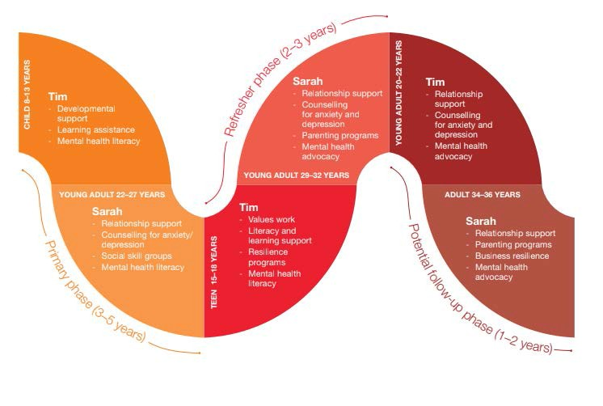
Diagram 1. Illustration of long term, intergenerational and developmental approach to better mental health outcomes

Outback Futures’ experience suggests that the vast majority of adolescents and young adults being treated for depression, anxiety or suicidality in rural and remote communities have unaddressed developmental and/or learning or emotional issues, causing them to have disengaged socially and educationally and to be ‘acting out’ or becoming withdrawn. Shifting these developmental outcomes, building understanding and resilience in the children and a desire in the parents to advocate for change to be involved themselves in the solution, is key to intergenerational, long term change.

BUSH INFORMED AGENDA

  - This OUTBACK FUTURES COMMUNITY FACILITATION MODELTM was developed in the bush through an intentional bush/city collaboration and is constantly directed by a bush-informed agenda
– not translatable to a city context.
  - It is about self-efficacy for bush communities around mental health and well-being, and is based on trusted relationship with a genuinely client-driven process.

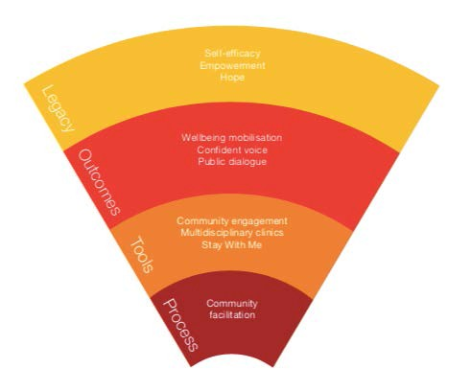

Diagram 2. THE OUTBACK FUTURES COMMUNITY FACILITATION MODELTM

The Outback Futures model is based on a theory of change aimed at developing the three key legacy elements: Self efficacy; hope and empowerment.

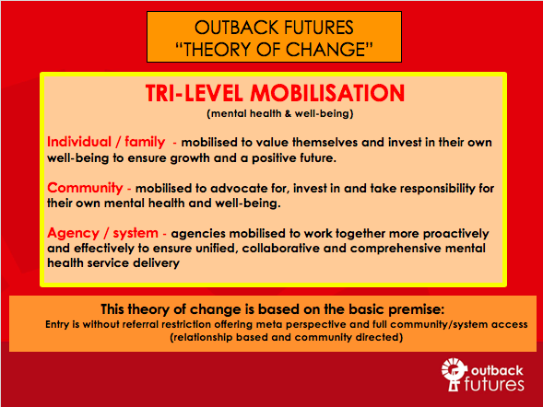

  - The Outback Futures team returning from a multi-disciplinary clinic

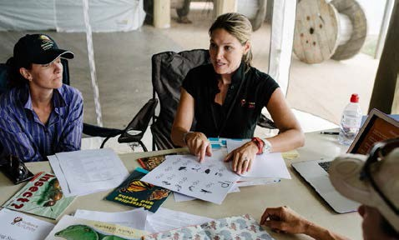
  - “Stay With Me” tele-health therapy session c. Equipping & resourcing parents on a clinic

CASE STUDY: Barcaldine Region

Outback Futures has been building relationship and offering service in the Barcaldine region for around two and a half years, after being initially invited in to respond to a critical incident. This model of genuine engagement; mental health literacy education & positive experience of service provision across all levels of the community, has led the Barcaldine Regional Council to now understand, value and want to advocate for better mental health and well-being outcomes in their region at all levels, from the top down. They have approached Outback Futures to co-design a collaborative, 3-5 year campaign, “HEAD YAKKA: Working Together for Outback Mental Health” to build enough power and efficacy from within the community to ensure they are responsible, proactive and accountable for their mental health and well-being into the future.

Figure 1: The RAPAD regions that Outback Futures is servicing across the next four years

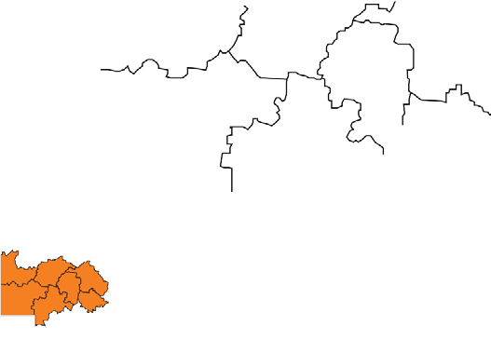
Boulia
Winton
Diamantina
Barcoo
Blackall
Tambo

Summary Statement:
Short-term and post-vention responses to suicide are of critical importance, but genuine reduction in long- term rural and remote suicide statistics in this country demands a total paradigm shift, resulting in deep and lasting change in the way communities, including children and young people, perceive mental health and well-being.

The OUTBACK FUTURES COMMUNITY FACILITATION MODEL™ offers a long-term, strategic solution to renewing hope, building resilience and strengthening outback communities.

As a nimble and replicable model, focused on working closely with communities, offering a quality and consistent experience of service provision, as part of a process of developing self-efficacy and empowerment around mental health and wellbeing across the generations – it offers a cost-effective, genuine, long-term solution for shifting the suicide and mental health outcomes in rural and remote Australia.

APPENDIX A

Twelve-Month Costing of the OUTBACK FUTURES COMMUNITY FACILITATION MODEL
Outback Futures is not a one-off solution, but is about facilitating long term, holistic change and transformation. Outback Futures sits in the gap between people who won’t cross a shop front and the established service providers.

OUTBACK FUTURES COMMUNITY FACILITATION™ CONSISTS OF:

- Engagement – building relationship with community driven agenda around need and service design.
- Resilience Clinics – regular face to face, multi-disciplinary ‘one stop shop’ service delivery.
- Stay With Me – ongoing, consistent, tele-health support across all disciplines
(with the option for additional fee for service projects/events/responses. Fee for service arrangements can be co-designed with Outback Futures and key community stakeholders)

The effectiveness of the Outback Futures intervention is dependent on all three components working together to support, equip and mobilise a community.

COSTINGS:

Expenditure per region | Amount
Community Engagement  - Travel expenses (flights, fuel, accommodation, insurance)  - Clinical contractor fees (Community Engagement Psychologist)  - Resources  - Logistics, coordination and administration | $11,212.50
Multidisciplinary Clinics ($35,000 x 2)  - Travel expenses (flights, fuel, car hire, accommodation, insurance)  - Clinical contractor fees (Psychologist, Counsellor, Occupational Therapist, Speech and Language Pathologist, Learning and Literacy Support, Clinic Coordinator)  - Logistics and coordination  - Reporting and evaluation | $80,500
Remote Telehealth ($24,000 x 2)  - Clinical contractor fees (10 hours per week for 20 weeks post-clinic  - Remote Telehealth Coordinator  - Reporting and evaluation  - Administration | $55,200
Total cost of 12-month Community Facilitation Model per region | $146,912.50

APPENDIX B

Opportunities that Technology Presents for Improved Service Delivery

The process of offering consistency of care to clients, regardless of their remoteness, is a key priority for Outback Futures. The primary mode of delivery for this regular and reliable service provision (with the same clinicians across time) is technology- based therapy.

Outback Futures is in the process of rolling out and supporting a number of new, innovative internet platforms in schools, community organisations, homes and more, with assistance
& personal training from the Outback Futures’ team. A number of specific issues have made this a difficult process, such as, poor bandwidth, agency or Government restrictions and limited technical understanding. This has led Outback Futures to be looking into providing these groups with personal devices set up specifically and solely to support these programs. Outback Futures is committed to overcoming obstacles and offering regular therapy services to individuals, families and groups that would otherwise not receive consistency of care. We believe technology-based therapy is critical to the work of Outback Futures and is a key part of the solution for effective mental health and well-being work in rural and remote communities; but ONLY when offered in conjunction with regular and consistent face to face connection and established and trusted relationship based on genuine community engagement.

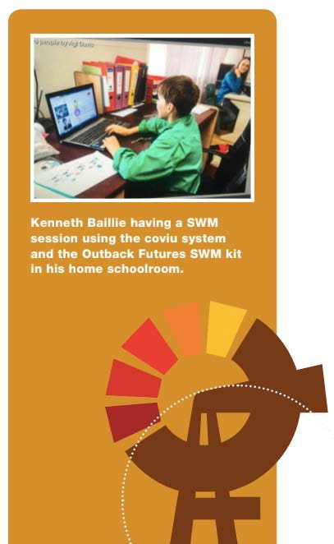

Tele-Health – Stay With Me Kit Costings

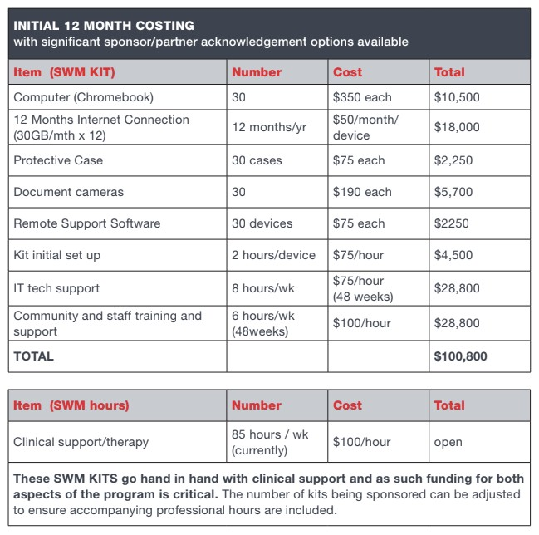

ABN 47 689 178 962
Ph: 07 4651 4162
Fax: 07 4651 4280

