XXXX XXXX
XXXXXXXXXXXX

Mental Health Inquiry
Productivity Commission
GPO Box 1428, Canberra City, ACT 2601

18 March 2019
RE: The Social and Economic Benefits of Improving Mental Health – Submission by XXXXXXXXX and on behalf of the Montelukast (Singulair) Side Effects Support and Discussion Group
Dear Members of the Productivity Commission’s Mental Health Enquiry,

I am a representative of the Montelukast (Singulair) Side Effects Support and Discussion Group. This group has nearly 6300 members from across the globe. I am also the parent of two children who suffered the neuropsychiatric side effects of the widely prescribed asthma medication Montelukast (Singulair).

The severe side effects suffered by my children include –

Child one - Suicide attempt during withdrawal, suicidal ideation during use, severe OCD, severe insomnia, depression, nightmares, anxiety, agitation, headaches, memory impairment, severe stomach pain, leg muscle pain, incontinence which continued for years after discontinuation, vomiting, nausea, nose bleeds, exhaustion, hostility, heart palpitations, non-contagious conjunctivitis, drowsiness, irritability, stutter, trouble with handwriting, short periods of amnesia followed by hand spasm and inability to use legs properly as well as vision flipping, and an intolerance to artificial additives in foods after his adverse reaction to Montelukast (ingesting artificial additives caused auditory and visual hallucinations and low mood including distress).

Child two - Anxiety, agitation, bedwetting, inability to feel sensation of needing to go to the toilet, extreme constipation which lead to anal fissures, nausea, nose bleeds, exhaustion, hostility, heart palpitations, drowsiness, irritability, trouble with handwriting, lack of effort and interaction in activities and play, extreme picky eating, stuck in 45 minute crying loops for no reason, explosive temper, and an intolerance to artificial additives in foods after his adverse reaction to Montelukast.

The financial impact on my family and to the Australian Health Community has been extensive. During our journey with these long-term and debilitating side effects we have visited multiple medical professionals. These include –

Child one – Multiple General Practitioners, two Neurologists, three Psychologists (one being a Psychologist from the Hospital Mental Health Team), one Psychiatrist, three Paediatricians, the Allergy Specialists at the hospital, one Play Therapist, one Developmental Specialist, one Occupational Therapist, and a Naturopath. My son was tested for Autism on three occasions (all came back negative); he was given an MRI, EEG, blood tests and multiple psychological assessments.

Child two – Maternal health nurse, multiple General Practitioners and an ear, nose and throat specialist/surgeon. We managed this child at home using the skills we had learnt from the other specialists that assessed our other son.

I would guess that the financial cost to our family has been in excess of $100,000. I have been unable to return to work in a full-time capacity for the past 10 years, due to the additional stressors and caring responsibilities related to managing the mental health side effects experienced by my children. I have missed the opportunity for advancement in my career and stagnated at the same level from the time my first child became ill in 2007 until mid-2018. My children have missed school and I have accessed carers’ leave at work to manage the impacts of these side effects. The cost to Medicare and my private health fund have also been considerable with us exceeding the safety net for many years. The out of pocket costs for the specialists we have seen, including the paediatricians, the private neurologist, the occupational therapist and the psychologists has resulted in my family being significantly financially disadvantaged. On multiple occasions, my son has exceeded the 10-visit limit for psychological sessions subsidised by the Medicare mental health plan. This doesn’t even begin to account for the extreme emotional hardship this has placed on our family of four.

Since 2008, two Montelukast advocacy groups, Montelukast (Singulair) Side Effects Support and Discussion Group and Parents United for Pharmaceutical Accountability and Safety, have been advocating in Australia, the USA and the UK, for increased warnings and safeguards around the use of Montelukast. Over the years, medical professionals have dismissed the experiences of thousands of affected individuals, including multiple families who have lost loved ones to suicide. I believe more needs to be done to assist those suffering side effects to make the link between the struggles experienced and the medication.

I propose that the Australian Therapeutic Goods Administration create a new and mandated Cautionary Advisory Label (CAL) as part of the Poisons Standard of Australia, for medications that cause severe neuropsychiatric side effects such as suicidal thoughts, actions and depression. Consultation with the State Health Ministers would be required to ensure a national role out of these CALs. Such labels would be of economic benefit to the Australian Government and the community because it would alert users, parents and carers to the dangers and risks of the medications, preventing the need to access a range of medical interventions after damage from long-term side effects.

A list of medications that cause severe neuropsychiatric side effects were listed in the TGA’s recent medical alert (June 2018), they are as follows:

- antidepressants, particularly selective serotonin reuptake inhibitors (SSRIs)
- certain smoking cessation medications, including varenicline and buproprion (marketed as Champix and Zyban respectively)
- certain antiepileptics, including sodium valproate, carbamazepine, levetiracetam, phenytoin, lamotrigine, topiramate, pregabalin and gabapentin
- isotretinoin (marketed as Roaccutane)
- atomoxetine (marketed as Strattera and generic brands)
- montelukast (marketed as Singulair and generic brands)
I believe that all of the medications above should have a mandated CAL in all States of Australia. The CAL should read – ‘See your doctor immediately if you experience mood changes, such as new or worsening feelings of sadness, depression or fear’. This is the wording used for the warning on the Montelukast bottle in the USA.

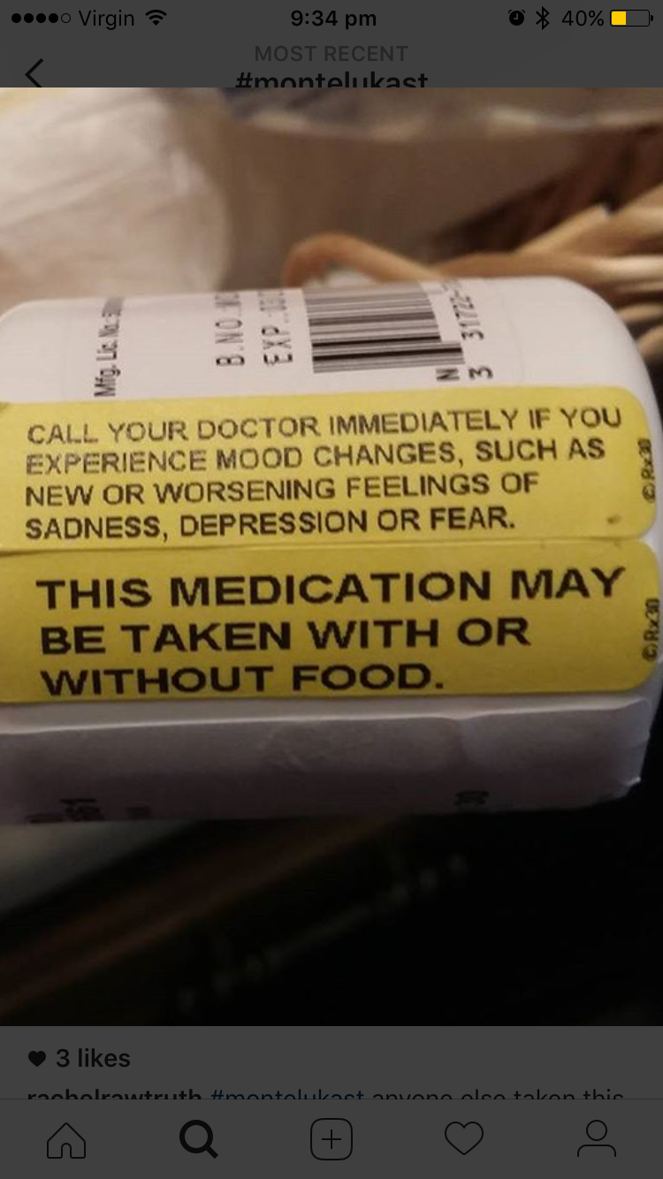

Early intervention is key in reducing the personal and financial impacts caused by these severe and long-term side effects. In the case of Montelukast, members have reported that side effects can present at any time during use, even after years of using the medication safely. For this reason, users are lulled into a false sense of security and making the link between the medication and the side effects can be very difficult. Constant monitoring is required during use and a CAL on the outside of the packaging acts as a prompt, should the side effects present.

Many parents of affected children and affected adults are unable to attend work due to either the additional caring pressures from affected children or because they are suffering the severe neuropsychiatric side effects themselves. Additional pressures are also placed on schools and teachers to manage students that are suffering the life altering and life threatening side effects of Montelukast. With mental health injuries to teachers on the increase, this is certainly a consideration from a work place health and safety and fiscal perspective.

The Honourable Minister for Health Greg Hunt completed an urgent review into Montelukast in 2018 and as a result, drug companies have been asked to place the Consumer Medicines Leaflet inside the packaging of products in Australia that contain Montelukast. I am grateful for this improvement but feel it does not go far enough to reduce the chances of mental health injuries occurring in those who suffer the side effects, and in turn stretching the already scarce financial resources of our mental health care system.

Please help us to reduce the incidence of mental health injuries in Australia. The epidemic of mental health struggles and the increase in suicide requires us to be innovative in our approach. We can no longer accept that mental health injuries are just an accepted part of using medication. Consumers require increased warnings so they can make informed decisions about their health; a proactive and preventative approach will save the Government money in the long term.

The introduction of a CAL that highlights neuropsychiatric side effects will reduce the incidence of mental health injuries in Australia. It is a fiscally and ethically responsible answer to a real and devastating problem.

I speak on behalf of my child and all of the children that have no voice in this debate. We must help parents to monitor for life altering or life threatening side effects.

Please find attached the results of a survey our group conducted that involved 390 representatives of Montelukast affected individuals.
We believe this survey shows evidence that many Montelukast affected individuals suffer long-term side effects and intense withdrawal. We have provided this information to the TGA and they are in the process of investigating these side effects in greater detail. The costs associated with the long-term care of those affected could be greatly reduced if the precaution of a warning label was placed on the outside of the packaging.
Outcomes from our survey that are of interest to the Productivity Commission include:
- More than 60% of respondents (n=241) reported lingering side effects. They answered yes when asked ‘Does the affected individual currently continue to experience any symptoms/problems developed whilst taking Montelukast (Singulair)?’
- The eight most common diagnosis received after an adverse reaction with lingering side effect symptoms:
- Generalized Anxiety Disorder n=62 suspected, n=49 diagnosed
- Acid Reflux n=42 suspected, n=47 diagnosed
- ADHD n=39 suspected, n=25 diagnosed
- OCD n=31 suspected, n=6 diagnosed
- Aspergers n=30 suspected, n=2 diagnosed
- Hypersensitivity Reactions n=28 suspected, n=13 diagnosed
- Migraines n=17 suspected, n=24 diagnosed
- Autism n=16 suspected, n=3 diagnosed

- 87% of all respondents indicated that their Health Care Provider did not discuss possible neuropsychiatric side effects before first prescribing Montelukast.
- 83% of all respondents indicated that their pharmacy did not advise them of the risk of neuropsychiatric side effects.
- 97% of all respondents support a call to governing bodies to enforce compulsory warning labels highlighting the potential neuropsychiatric side effects on the outside of products which contain the active ingredient Montelukast.
- Professionals that were consulted for advice, information, diagnosis or assistance regarding Montelukast side effects were – Pediatricians, General Practitioners, Allergists/Immunologists, Psychologists, Teachers, Pulmonologists/Respiratory Physicians, School counselors, Psychiatrists, Counselors, Asthma nurses, Neurologists, Chiropractor, Naturopaths and Physical/occupational Therapists.
- Diagnostic testing undertaken on Montelukast affected individuals included – Psychological testing, blood tests, ADHS testing, Autism/ ADOS Testing, brain MRI’s, EEG’s and Genetic Testing.
In addition to our survey results, I will also attach a list of research papers that highlight the neuropsychiatric side effects of Montelukast.
It is the right of Australian children to expect that every opportunity to protect them from mental health injury be implemented; it is the right of the community to expect that their government will introduce cost-effective measures to prevent mental health injuries. A small label on the outside of the packaging is not a big ask and the cost could be negligible if it was written into policy that drug companies are to print this warning directly on to the boxes of the applicable medications.

Kind regards,

XXXXXXXXXXXXXXXX

XXXXXXXX of the Montelukast (Singulair) Side Effects Support and Discussion Group and an Advocate for the Awareness of Montelukast Side Effects

Melbourne - Australia

XXXXXXXXXXXXXXX

Annex A. Montelukast (Singulair) Side Effects Survey Results 2017 – Please do not publically publish this document.

Annex B. List of published research papers and case studies regarding Montelukast (Singulair) side effects. – You have permission to publically publish this document.

