Jill B. Bruce B.A., Dip. Ed., J.P.

NARRABEEN. NSW. Australia
www.jillbbruce.com.au

I am strongly opposed to any changes to intellectual property laws as detailed in the Productivity commissions draft Report.

As an Australian children’s non-fiction creator I feel the proposed changes could damage the distinctive voice of the books created in this country and it would adversely affect the livelihood of creators and ultimately the publishing industry as a whole. Note: with one exception, all of my books are now PRINTED IN AUSTRALIA IN FULL COLOUR.

My high quality Australian children's non-fiction literature has a long lifespan and I deserve to be duly compensated for both the quality and longevity of my work. I urge the government to give careful consideration to the correct balance between content creators and end users in intellectual property reform.
The Australian Society of Authors (ASA) is the peak body representing some 3000 Australian writers. They estimate that the average Australian author has an income of around $15,000 a year. Why further discourage creativity?

How do I earn my income from some 74 published books?

I worked as a teacher-librarian and retired aged 66. Some 30 years ago I began writing non-fiction books about Australia to fill a perceived need in education. I earn my income from the sale and public usage of my works:

- I earn royalties from publishers, a 1-off payment.

- Payments from Dept. of Arts, Canberra called Public Lending rights and Education Lending rights for books held and used in libraries.

- The majority of my income comes from the paid use of content through copying and repurposing collected by The Copyright Agency.

If an increased amount of that usage became permissible and free, as the Commission is recommending, the effects on my successful and educationally valuable authorship would be profound and damaging to myself, MY PUBLISHER and other creators.

One area of contention is the end of copyright ownership after 15 years instead of the current 75. Yes 75 is probably too long but 15 is too short. As an example I have a book called Flags and Emblems of Australia first published in 1991. Many libraries still hold the original edition. We have published new editions as emblems have changed. Under the proposed new rules, I would no longer have copyright ownership of the original edition so anyone could do what they wished with it. Why buy or pay copyright to use the new edition that has a few minor changes and updated cover? My books have library and copying longevity!

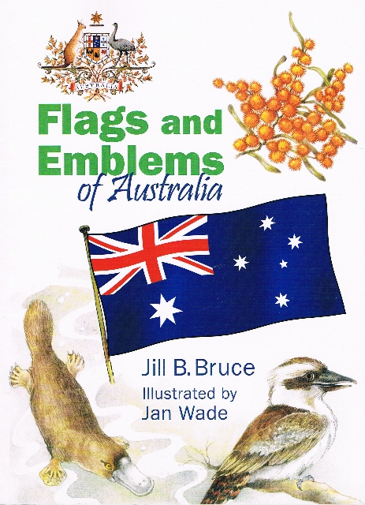

I reject the unjust concept of “fair use” as one that is devastatingly unfair, I support “fair pay” for use of my works so I can continue to create our culture and history.

Please enact sensible, fair reform so that Australian authors, illustrators and publishers are not disadvantaged and disenfranchised. Fair use does not equal “FREE”.

Thank you,

Jill

Ms Jill B Bruce

Jill B Bruce, B.A, Dip. Ed., J.P. Author; Australia Day Ambassador 2010, 2011, 2012, 2013; NSW Judge Children’s Book Council of Australia Children’s Book awards 2012; 2013; Judge for the Women Writers of NSW Children’s Book Awards 2013. 2014 Lady Cutler Award winner for Distinguished service to Children’s literature.

