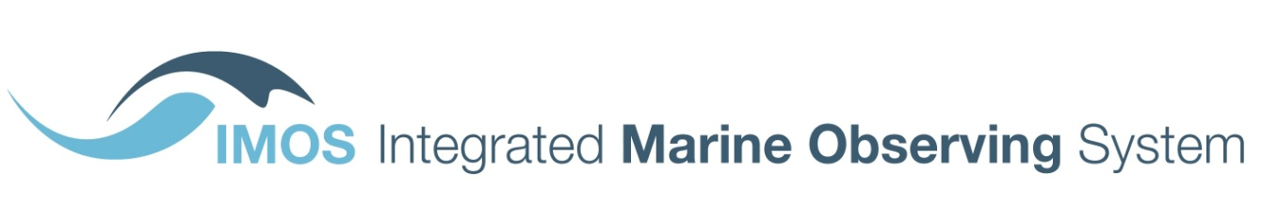
University of Tasmania
Private Bag 110
Hobart TAS 7001
Australia
T +61 3 6226 1977
F +61 3 6226 2997
www.imos.org.au

Productivity Commission Inquiry into Data Availability and Use – IMOS submission

The Integrated Marine Observing System (IMOS) is the largest capability in the National Collaborative Research Infrastructure Strategy (NCRIS) portfolio and welcomes the opportunity to provide a submission to the Productivity Commission on data availability and use.

Since 2006, IMOS has been routinely operating a wide range of observing equipment throughout Australia’s coastal and open oceans, making all of its data accessible to the marine and climate science community, other stakeholders and users, and international collaborators. All IMOS data is open data, freely available to all (non-commercial and commercial) through the Australian Ocean Data Network (AODN, https://portal.aodn.org.au) under a Creative Commons By Attribution (CCBY) licence. The AODN was the vision espoused in 2008 by the six Commonwealth agencies with significant ocean data responsibilities (Australian Antarctic Division, Australian Institute of Marine Science, Bureau of Meteorology, Commonwealth Science and Industrial Research Organisation, Department of Defence (Royal Australian Navy), Geoscience Australia) to make significant holdings of data freely available. AODN became a reality because of the IMOS investment in open data.

By adopting this open data policy IMOS-AODN has had some success in encouraging other research groups in Australia to make their data open access and publically available. It is, however, taking longer than expected to encourage some of the government agencies (Federal and State) to publish their data as open access, so any encouragement from Federal Government would be welcomed.

IMOS also co-founded the Forum for Operational Oceanography (FOO, http://www.foo.org.au/forum/). FOO was established in March 2014 in an attempt to provide a mechanism for clearer and more coherent articulation of user needs and priorities from across diverse sectors and jurisdictions with common interests in operational oceanography, i.e. the provision of real-time and forecast ocean information to advise operational management and planning. One of the main aims of the FOO is to strengthen links with the diverse community of commercial offshore operators, intermediate service providers (metocean consultants, environmental consultants), government agencies and research providers and to agree and achieve international best practice across the sectors. There has been much debate over data access and availability. The ocean is, in general, under-sampled and improving access to all available data is a top priority; commercial operators archive a wealth of observations currently not accessible to the wider community, and which are likely of no further commercial benefit to the company that collected the data. FOO represents a mechanism and opportunity for consolidating Australia’s national coordination of efforts for the benefit of all participating parties. During 2015 FOO received generous support from the Australian Government Department of Industry and Science to foster this national coordination.

Currently, Australian real-time ocean-related observations are funnelled through the Bureau of Meteorology into the World Meteorological Organisation’s Global Telecommunications System (GTS) for the benefit of global players in the WMO, but these observations are not routinely available to Australian researchers outside of the Bureau. Increasingly research groups are developing regional ocean forecast systems which could benefit enormously from access to the GTS-provided data.

IMOS has recently released a draft 5-year plan for 2017-2022 (http://imos.org.au/fileadmin/user_upload/shared/IMOS%20General/documents/IMOS/Plans___Reports/5_year_plan/IMOS_Five_Year_Plan_First_Draft_for_comment_240616a.pdf) for comment in anticipation of the National Research Infrastructure Roadmap. In this document it is re-emphasised that a key element of IMOS is that all observations are turned into data that can be discovered, accessed, downloaded, used and re-used in perpetuity (page 5) and that a properly resourced AODN is needed, enabling open access to marine data beyond the IMOS data collections (page 36). It also indicates that access to research vessels and data from international satellite missions (Australia does not have an operational satellite program), along with engagement of the coastal and ocean modelling communities are the most critical dependencies (page 10). It is re-assuring to know that Australia will have assured access to reliable and operational satellite data from the European Union's Sentinel satellites under the terms of a technical cooperation arrangement signed between the European Space Agency (ESA) and Geoscience Australia on 30 March 2016 (http://www.ga.gov.au/news-events/news/latest-news/Establishment-of-a-satellite-data-hub-to-benefit-Australia-and-international-partners); it will be important that these data are available to the entire marine science community.

Sincerely yours,

Roger Proctor
AODN Director, IMOS, University of Tasmania

Pp Tim Moltmann
IMOS Director, University of Tasmania

IMOS is a national collaborative research infrastructure, supported by Australian Government.
It is led by University of Tasmania in partnership with the Australian marine & climate science community.

