The University of Melbourne’s Indigenous Eye Health (IEH) welcomes the opportunity to respond to requests for information around timely and affordable access to appropriate and cost effective human services. Two key areas impact upon Indigenous eye health - public hospital services and human services in remote Indigenous communities.

Indigenous Australians have a greater burden of eye disease but receive less eye care than non-Indigenous Australians. Poor vision hinders education, employment and independence yet most vision loss and blindness is preventable and easily treatable.

IEH has undertaken formative research to assess the need, barriers and enablers to the delivery of eye health services for Indigenous people. The evidence base gathered has guided the development of a comprehensive and feasible policy framework, the Roadmap to Close the Gap for Vision*[[1]](#footnote-1)* (the *Roadmap*) that is endorsed by the Indigenous and mainstream health sectors and government. IEH is currently actively engaged in providing the necessary advocacy and technical support to Close the Gap for Vision.

The *Roadmap* is a whole-of-system framework with 42 interlocking recommendations to improve Indigenous eye health. The most recent annual update of the Roadmap in November 2016 reports that 11 of the 42 recommendations have been completed. However, 31 recommendations are outstanding and all must be completed to ensure a comprehensive and fully effective health system reform.

Progress in outcomes is being made. The most recent National Eye Health Survey (2016) reported that the prevalence of vision impairment and blindness among Indigenous Australians has declined from six times to three times that of non-Indigenous Australians.

<http://mspgh.unimelb.edu.au/centres-institutes/centre-for-health-equity/research-group/indigenous-eye-health#roadmap-to-close-the-gap-for-vision>

**Response to Requests for Information**

We have grouped our responses to the Requests for Information (RfI) around 2 key areas:

* Information and access
* Coordination and delivery

**Information and access – RfI 11,13,14, 15 and 17**

* Equity of access to public hospital services (RfI 11) is essential for Indigenous community members to close the gap for vision. Data suggests lower rates of cataract surgery and longer waiting times for Indigenous patients in all settings. IEH recommends the use of performance indicators that measure equity of access such as the cataract surgery within 90 days of referral (CS90).
* Public hospital services need to actively participate in the regional planning process advocated in the *Roadmap* and provide relevant performance data as a part of that process (RfI 11 and 15).
* Patient choice (RfI 13) in rural and remote settings is typically limited to the closest regional hospital. Consequently, effective co-ordination is a more important component than choice to realise efficient and cost effective outcomes.
* Patient travel funding is provided by state and territory governments and is often not targeted to align with those objectives, generally adopting a more rigid and mechanistic approach. For example, often an important part of a successful clinical outcome is the support provided by an accompanying person.
* The Rural Hospital Outreach Fund (RHOF) provides funding for Opthalmology services. These services should be bulk billed to reduce cost and minimise cost certainty barriers to access. In addition, funding for outreach VOS and RHOF needs to cover the full cost of a visit, including coordination and case management to deliver efficient outcomes (RfI 36).
* IEH has developed a range of performance indicators (RfI 14 and 15) as a part of Recommendation 6 - Monitoring and Evaluation of the *Roadmap* which aimsto capture and report information about progress and improvement of services and outcomes in Indigenous eye health. (Attachment 2.)
* Effective coordination is essential to deliver the link to secondary and tertiary healthcare (RfI 17) and to facilitate this communication and coordination. (Attachment 3.)

A report by PricewaterhouseCoopers on the value of Indigenous sight clearly demonstrates the economic benefits that flow from the implementation of the Roadmap and a commitment to an integrated approach to closing the gap (RfI 37). <http://www.pwc.com.au/publications/healthcare-indigenous-sight.html>

**Coordination and delivery - RfI 32,33,35, 36 and 37**

* Recommendation 1 of the Roadmap addresses primary eye care as part of comprehensive primary health care to improve the identification and referral for eye care needs. The referral pathway from primary health care to specialist services requires a whole of system approach to be effective and ensure the patient journey is not a “leaky pipe”.

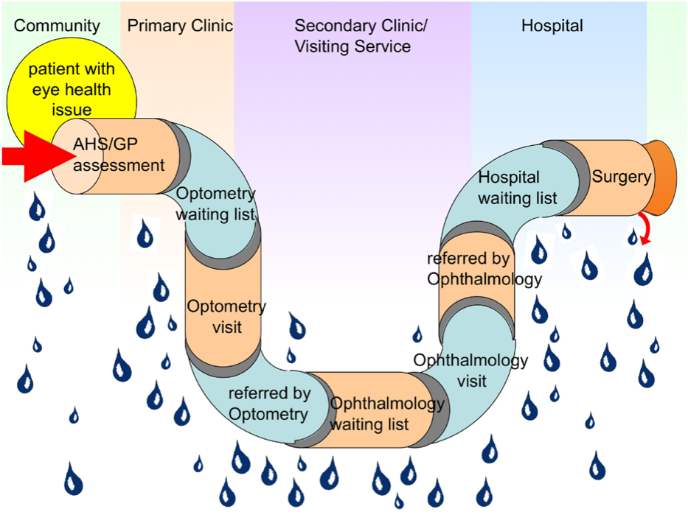

* The importance of culturally safe care is paramount to drive successful patient outcomes and the Aboriginal controlled sector is a key part of delivering appropriate health care (RfI 35).
* The Visiting Optometrists Scheme (VOS) provides funding for Optometrists to visit remote communities and, where required, refer patients for review by an Ophthalmologist. Telehealth (with an associated MBS item) is being effectively used by Optometrists in WA to communicate with the Specialist and the patient to discuss the required procedure and obtain patient consent before coming to the hospital for the actual procedure <http://outbackvision.com.au/telehealth/> (RfI 17 and 32). We would note that this has not translated into effective utilisation of telehealth by GPs and Specialists for clinical purposes.
* The hidden cost burden of relocation for services due to negative impacts of visits to urban centres [[2]](#footnote-2) also reinforces the benefits of a system that emphasises the key role of primary health care and the important role of visiting services and visiting Optometrists and, when required, Specialists. Dedicated coordination is required to minimise the time patients have to spend in the major centres for public hospital services such as cataract surgery or diabetic eye care. The process begins with the MBS item number 715 for mandatory eye checks to be included in the annual health assessment and flows through to other eye health activities that can be delivered in the primary health care setting (Attachment 4).
* The introduction of the new MBS item for non-mydriatic retinal photography screening for Diabetic Retinopathy represents a great opportunity for screening to occur in a primary health care setting and, in some cases, utilise the services of other professionals to support assessment of generated in an alternative location. The cost of the camera and training required for the clinical staff at the health centre is mitigated by the savings in efficient triage and reduced need for specialist visits. <http://mspgh.unimelb.edu.au/centres-institutes/centre-for-health-equity/research-group/indigenous-eye-health/news-and-events/mbs-items-dr-nmrp>
* IEH works at a community level to develop and propagate health awareness and promotion activities around Trachoma (Clean Faces, Strong Eyes) and Diabetes eye care (Check Today, See Tomorrow) (RfI 35).

|  |  |
| --- | --- |
| S:\Katherine materials\artwork for flipchart and trachoma story kit\IMAGES FOR CHART\Goanna_PrimaryLogo.jpg |  |

* The strong focus on community involvement in the development of these resources is key to their successful integration into primary health care setting.
* <http://mspgh.unimelb.edu.au/centres-institutes/centre-for-health-equity/research-group/indigenous-eye-health#diabetes-eye-care>
* <http://mspgh.unimelb.edu.au/centres-institutes/centre-for-health-equity/research-group/indigenous-eye-health#trachoma>
* The Roadmap is working to implement a jurisdictional and regional approach to successful eye health care delivery across Australia (RfI 36). A key element of this approach is the development of services to meet population based need. Excellent examples of this approach occur in Central Australia and the Grampians region of Victoria.
* The Central Australia and Barkly Integrated Eye Health Strategy (CABIEHS) Committee works to ensure “All people in Central Australia and Barkly, particularly Aboriginal people, have access to timely and appropriate eye health and vision care services and supports”[[3]](#footnote-3). This group works to develop a coordinated and integrated approach to eye health care delivery in the region and avoid the fragmentation of service delivery and ensure all parties operating in the space adopt a standard approach and communicate outcomes and follow up clearly.
* The Grampians region formed a committee of key stakeholders that collated the required data to identify the changes needed for the existing eye care system (Attachment 5). They then successfully implemented these changes to generate significant increases for cataract surgery and diabetes eye care.

<https://www.mja.com.au/journal/2015/203/1/equity-vision-australia-sight>

**Contact**

Melbourne Laureate Professor Hugh R Taylor AC

Harold Mitchell Chair of Indigenous Eye Health

Indigenous Health Equity Unit

Melbourne School of Population and Global Health

University of Melbourne

[www.iehu.unimelb.edu.au](http://www.iehu.unimelb.edu.au)

1. The Roadmap to Close the Gap for Vision - Full Report, Professor Hugh R Taylor AC, Mitchell D Anjou, Andrea I Boudville, Robyn J McNeil

   Indigenous Eye Health Unit, Melbourne School of Population Health, The University of Melbourne, January 2012 [↑](#footnote-ref-1)
2. Introducing Competition and Informed User Choice into Human Services: Identifying Sectors for Reform, Productivity Commission, November 2016 (p 137) [↑](#footnote-ref-2)
3. Central Australian Barkly Integrated Eye Health Strategy Committee Terms of Reference [↑](#footnote-ref-3)