ANN M LUCAS
Hindmarsh Island SA 5214

9 October 2018

PRODUCTIVITY COMMISSION INQUIRY: MURRAY-DARLING BASIN PLAN, FIVE YEAR ASSESSMENT – RESPONSE TO DRAFT REPORT
I acknowledge the Aboriginal people who have been present on this land and especially along the River Murray and its estuary, and who traded up and down the rivers in the Murray-Darling Basin.
I thank the Productivity Commission for this opportunity to address issues relating to the area of the lower Murray-Darling Basin.
The Commission notes in the summary of key points in the Draft Report that the current inquiry and consequent recommendations to Government represent ‘an opportunity to make important “stitch in time” changes to ensure an effective Plan’.
It is in that spirit that I offer some observations on the hydrology and ecology of the River Murray and its estuary.
I have lived at various places along the Murray River, spending a lot of my childhood at Barmera and then at Overland Corner, where we had our house flooded in the 1956 flood. We then purchased a shack at Younghusband and eventually purchased a property on Hindmarsh Island in the vicinity of the Murray Mouth, where I still live today.
Sturt the explorer referred to the Murray delta as possibly the richest delta in the world. Since Sturt explored this region there have been marked changes. The impact of European settlement and cultivation on the Murray-Darling Basin is well established. I myself have observed a significant decrease in native animal, bird, reptile and fish species and a decrease in the number of migratory birds in my 25 years on Hindmarsh Island.
A great number of trees were removed to fuel the paddle steamers, the impact of which is still being felt in spite of a significant revegetation program, especially on Hindmarsh Island. This has been further exacerbated by recent property development on Hindmarsh Island. The Island marina has extensive man-made waterways drawing from the freshwater side of the Island above the Goolwa Barrage, further diminishing environmental flows.
The barrages built in the 1930s to maintain fresh water in the lake system have also had a profound impact on the delta.
The health of the delta affects the health of the whole Murray-Darling Basin. I therefore draw to the attention of the Commissioners two features of the delta which should be accounted for in its future management: (1) the subsidence of the delta islands; and (2) the importance of allowing a meeting of the waters of the River and the sea.

- Subsidence
Subsidence of the River Murray delta and its possible causes have been discussed in several scientific journal articles and papers authored by Professor Bob Bourman (formerly of the University of South Australia’s Faculty of Engineering and the Environment) and Professor Colin Murray-Wallace, currently with the School of Earth & Environmental Sciences at the University of Wollongong.
In a summary of one his papers on dynamic landform change in the River Murray estuary which Professor Bourman kindly sent to me he writes:
Dislocation of this last interglacial shoreline across this region attests to ongoing tectonic subsidence, which has implications for the longevity of the barrage system. The barrages, apart from that at Goolwa, have been built along the site of the last interglacial shoreline, which runs parallel to the modern coast. The elevation of the last interglacial shoreline on Hindmarsh Island is approximately 2 m above mean sea level, whereas the equivalent shoreline at Victor Harbor is up to 6 m above present sea level, suggesting tectonic depression of the Murray Lakes area.
A paper published by Professor Bourman and others in 2000 (Marine Geology 170:141-168) records the elevation of the last interglacial shoreline from Victor harbor to Robe as being 6 m at Victor Harbor, 10 m at Chiton Rocks, 0.9 m on Hindmarsh Island, 2 m at Mark Point, 4 m at Bonney Reserve, 5 m at Salt Creek, 8 m at Robe and 18 m near Mount Gambier, indicating ‘downtilting towards the Murray Mouth area from both westerly and south-easterly directions’. Further:
Comparisons with variation in elevation of last interglacial shoreline deposits around the south Australian coastline reveal that the lower Murray Lakes has been subsiding over the past 125,000 yr at a rate of 0.02 mm yr.
Many of the waterways which exist on Hindmarsh Island, and which reveal surface water after substantial rain, are only one metre above sea level, and possibly less. They flag to even the non-specialist that the Island is remarkably low in relation to the sea level. (Attached to this submission is a scan of a diagram showing wetlands of the south and south-east of Hindmarsh Island, indicating their prevalence.)
As well as the waterways that travel across Hindmarsh Island (surface water), there are aquifers beneath its (ground water). These water flows have been altered by the placement of barrages and roads and the creation of man-made waterways.
Septic/waste disposal is a complex issue in an area of submergence, especially where there is tidal influence. A further issue is residential housing development below the 1956 flood level.
It is vital that hydrologists and geomorphologists are consulted to assess the issue of subsidence of Hindmarsh Island, which grows more urgent year by year – particularly before any major engineering works are undertaken, such as increasing the height of the barrages or constructing a new barrage.
- Allowing the waters to meet
The ecological impact of the barrages and the effect of restrictions of water flow on the delta ecosystem as well as the debouching of the Murray are well documented.
It is important for the Commissioners to be aware that until the barrages were constructed the meeting and mixing of fresh and salt waters was a natural occurrence on which the regeneration of native species of fish and fowl were dependent. There is substantial evidence of this in records of the verbal testimony of traditional Aboriginal owners. For example:
- An article published in The Argus, 11 October 2001 notes:
‘The natives called the River Murray “The Rawie”, and the land “The Goolwa” . . . a native explained it to me thus: “The water at Goolwa is sometimes fresh and sometimes salt, or brackish or mixed water called Goolwa, to distinguish it from Coorong, very salt water, and Mooncarie, fresh water, higher up the river.’
- Bailliere’s South Australian Gazetteer and Road Guide 1866 records that Boundary Creek ‘is the name given to the direct N.E. channel from the sea mouth of the Murray to lake Alexandrina, and running between Mundoo island to the W. and Barker’s knoll to the E. It is shallow and much imped with sand-banks and patches of mangrove swamp’. (The existence of the mangroves suggests vegetation had to be tolerant of fresh, salt and brackish water.)
- Manning’s Place Names of South Australia, published 1990, describes Pompoota as ‘an irrigation area 14 km south of Mannum’ with the place name ‘derived from the Aboriginal pompe – “rising” or “swollen” and putte – “end of the tide”. Tidal influence ceases at this point of the river’.
- Attached to this submission is a scan of the 1956 flood map which demonstrates that extreme events, not just regular tidal flows, also served to ‘mix’ the waters.
- The work of Tindale on Aboriginal linguistics, nomenclature and mythology also points to the history, geography and physiology of the delta. Tindale’s work (held by the South Australian Museum under restrictions) is also vital in grasping some of the cultural elements that support a proper understanding of the significance of the delta.
- Other important documents that must be factored into management of the delta include: the Lucas and Draper reports; the Kungan Yarnin Agreement and Letters Patent of 1840, both displayed on an interior wall of the Alexandrina Council Chambers in Goolwa; and the RAMSAR agreement for this area.
The 2002 report of the Murray-Darling Basin Commission, The Murray Mouth: Exploring the implications of closure or restricted flow indicates there are regenerative possibilities if water flow events are managed to allow for the meeting of the waters that is necessary for the health of the delta ecosystem. Flow management must take into account all factors affecting the impact of flow, including wind, tides and sand deposition at the Murray Mouth.
Factors contributing to improved management of the Murray-Darling Basin
I believe that if management of the Murray-Darling Basin can sustain the waterways and land within it, then the riverways will ultimately be able to sustain us.
The Productivity Commission’s Draft Report recommends that the MDBA should be separated into two institutions – the Murray-Darling Basin Corporation and a Basin Plan Regulator. Whichever organisation or organisations ultimately take responsibility for the implementation of the Plan and its regulation, it is important that the actions of all levels of government – federal, state and local governments – fall within their remit. For example, on Hindmarsh Island, management, maintenance and monitoring of the marina waterways are the responsibility of the Alexandrina Council, which is deemed by the South Australian Government to have ‘ownership’ of residential waterways for these purposes.
The impact of major residential developments on the already fragile ecosystem of the Murray delta must be factored into the wider Basin plan. The key role of the delta in the health of the entire Murray River system means it should not be put at risk by local government decisions.
I also recommend that consideration be given to declaring the Murray River – if not the Darling and Murrumbidgee Rivers and other rivers feeding into the Murray-Darling Basin – as having the rights, duties and liabilities of a legal person in the manner of New Zealand’s conferring of legal status on the River Whanganui. In New Zealand’s North Island, the River Whanganui has special significance for the Maori people.
The River Murray and its delta have special significance to Aboriginal people. As Ngarrindjeri elder, Tom Trevorrow, wrote in the 2002 The Murray Mouth report,
The land and waters is a living body.
We the Ngarrindjeri people are a part of its existence.
The land and waters must be healthy for the Ngarrindjeri people to be healthy.
We are hurting for our country.
The Land is dying,
The River is dying,
The Kurangk (Coorong) is dying
And the Murray Mouth is closing.
What does the future hold for us?
It is now 2018 and Tom Trevorrow’s question has not yet been satisfactorily answered. It may be a daunting prospect for the Commissioners to know their recommendations will affect the future wellbeing of many nations within this nation, as well as the continuance of many species of water flora and fauna.
It is my hope that good governance will prevail.
Yours sincerely,
Ann M Lucas

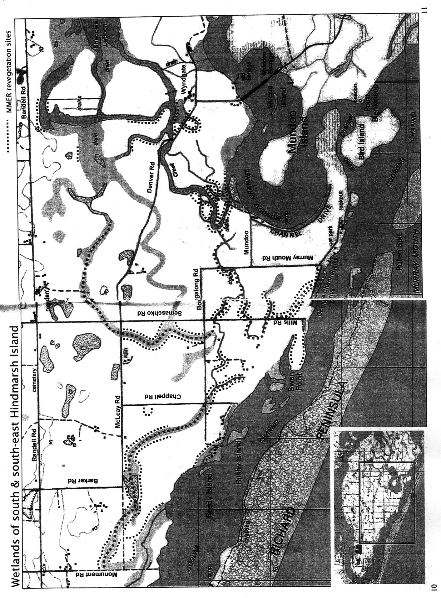

1956 Flood map and 1977 soundings – Lakes Alexandrina and Albert

