Mental Health Inquiry
Productivity Commission
GPO Box 1428, Canberra City, ACT 2601

29 January 2019
RE: The Social and Economic Benefits of Improving Mental Health
Dear Members of the Productivity Commission’s Mental Health Enquiry,

I am a member of the Montelukast (Singulair) Side Effects Support and Discussion Group. This group has over 5850 members from across the globe. I am the parent of an affected child who suffered the neuropsychiatric side effects of the widely prescribed asthma medication Montelukast (Singulair).

The severe side effects suffered by my child include – Cognitive function relapse, Night terrors, ADHD like symptoms, incontinence of both bladder and bowel, death talk, loss of sensitivity to violence or traumatic events in society, wild anger outbursts, allergies, substantial weight gain – mostly in the torso, and hearing difficulty.

The financial impact on my family and to the Australian Health Community has been extensive. During our journey with these long-term and debilitating side effects we have visited multiple medical professionals. These include – General Practitioners, Paediatrician, Allergy Specialist, and Multiple Naturopaths.

Since 2008, two Montelukast advocacy groups, Montelukast (Singulair) Side Effects Support and Discussion Group and Parents United for Pharmaceutical Accountability and Safety, have been advocating in Australia, the USA and the UK, for increased warnings and safeguards around the use of Montelukast. Over the years medical professionals have dismissed the experiences of thousands of affected individuals, including multiple families that have lost loved ones to suicide. I believe more needs to be done to assist those suffering side effects to make the link between the struggles experienced and the medication.

I propose that the Australian Therapeutic Goods Administration create a new and mandated Cautionary Advisory Label (CAL) as part of the Poisons Standard of Australia, for medications that cause severe neuropsychiatric side effects such as suicidal thoughts, actions and depression. Consultation with the State Health Ministers would be required to ensure a national role out of these CALs.

A list of medications that cause severe neuropsychiatric side effects were listed in the TGA’s recent medical alert (June 2018), they are as follows:

- antidepressants, particularly selective serotonin reuptake inhibitors (SSRIs)

- certain smoking cessation medications, including varenicline and buproprion (marketed as Champix and Zyban respectively)
- certain antiepileptics, including sodium valproate, carbamazepine, levetiracetam, phenytoin, lamotrigine, topiramate, pregabalin and gabapentin
- isotretinoin (marketed as Roaccutane)
- atomoxetine (marketed as Strattera and generic brands)
- montelukast (marketed as Singulair and generic brands)
I believe that all of the medications above should have a mandated CAL in all States of Australia. The CAL should read – ‘See your doctor immediately if you experience mood changes, such as new or worsening feelings of sadness, depression or fear’. This is the wording used for the warning on Montelukast in the USA.

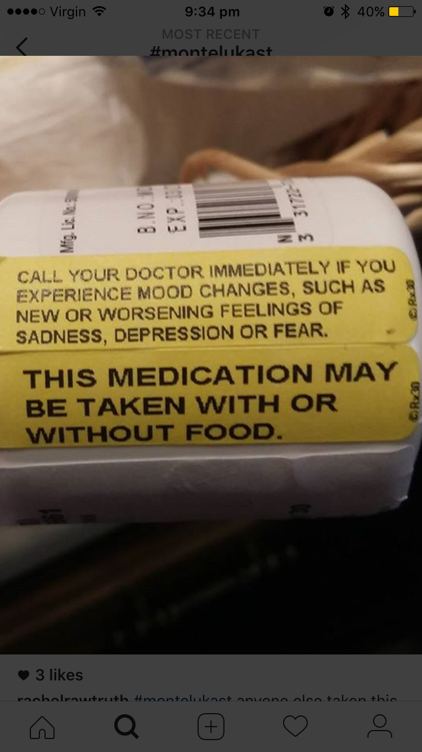

Early intervention is key in reducing the personal and financial impacts caused by these severe and long-term side effects. In the case of Montelukast, members have reported that side effects can present at anytime during use, even after years of using the medication safely. For this reason, users are lulled into a false sense of security and making the link between the medication and the side effects can be very difficult. Constant monitoring is required during use and a CAL on the outside of the packaging acts as a prompt, should the side effects present.

The Honourable Minister for Health Greg Hunt completed an urgent review into Montelukast in 2018 and as a result, drug companies have been asked to place the Consumer Medicines Leaflet inside the packaging of products in Australia that contain Montelukast. I am grateful for this improvement but feel it does not go far enough to reduce the chances of mental health injuries occurring in those who suffer the side effects.
Please help us to reduce the incidence of mental health injuries in Australia. The epidemic of mental health struggles and the increase in suicide requires us to be innovative in our approach. We can no longer accept that mental health injuries are just an accepted part using medication. Consumers require increased warnings so they can make informed decisions about their health.

The introduction of a CAL that highlights neuropsychiatric side effects will reduce the incidence of mental health injuries in Australia. It is a fiscally and ethically responsible answer to a real and devastating problem.

I speak on behalf of my child and all of the children that have no voice in this debate. We must help parents to monitor for life altering or life threatening side effects.

Kind regards,

[Name withheld]

