Submission in response to the Productivity Commission’s Issues Paper on the Social and Economic Benefits of Improving Mental Health

This document is submitted by researchers at the National Centre for Epidemiology and Population (NCEPH), Research School of Population Health (RSPH) at the Australian National University. We are a multi-disciplinary research establishment with expertise in public health, epidemiology, policy analysis, and the social sciences. We teach, conduct research in, and advocate for, a holistic, social determinants of health approach that critically examines the role of social, cultural and economic inequalities in the distribution and drivers of ill-health.

Our research takes a ‘population prevention’ approach to the reduction of the common mental health problems (i.e. anxiety and depression) in the Australian population. A recent 2019 editorial in World Psychiatry highlights that although increasing numbers of people in Western countries are receiving mental health care, epidemiological data do not show a corresponding decrease in the prevalence of depression (Ormel et al. 2019 based on Jorm et al. 2017). The editorial goes on to explain that current prevention approaches do not target strong proximal (and in our view distal) determinants of poor mental health, and this has major consequences for the population-prevalence of mental health problems, and their social and economic consequences. We already know that mental health is shaped over the life-course and is strongly reactive to the social and economic environment. We know that relationships and the quality of care environments are fundamentally important as children grow, and then, in turn, school and community environments emerge as increasingly powerful forces shaping mental health, risk behavior and sense of self-worth. Among adults, poverty, exclusion, work environments, and the demands and supports that characterise our social institutions become key forces on mental health. The high prevalence of common mental health problems in Australia, accompanied by an inability to speedily reverse the trend, exemplifies the need for a whole of population, prevention-focused, multi-sector and politically new response.

This will require a shift in thinking. As well as identifying individuals at the highest risk of developing mental disorders, population health approaches must understand the drivers of distributions of risk and disease (see Figure 1 - adapted from Rose, 2008). High risk individuals are only a small proportion of the overall population and so account for a small burden of disease. It is the people at the center of the distribution, exposed to only a small elevation in risk (i.e. low-level symptoms), who are responsible for the largest burden of disease. Thus, the greatest social and economic benefits will only be realised by shifting the distribution of risk in a positive direction with mass population health strategies (Rose, 2008). This necessarily requires an understanding of how health is shaped by (and subsequently impacts) broader social determinants. Conversely, inattention to broader social drivers, for example, increases in poverty rates or the number of working poor, instability in incomes, job security and living arrangements, will at a population level push the curve backwards. This shifts the large group of people in the ‘middle’ towards greater likelihood (and occurrence) of clinical illness.

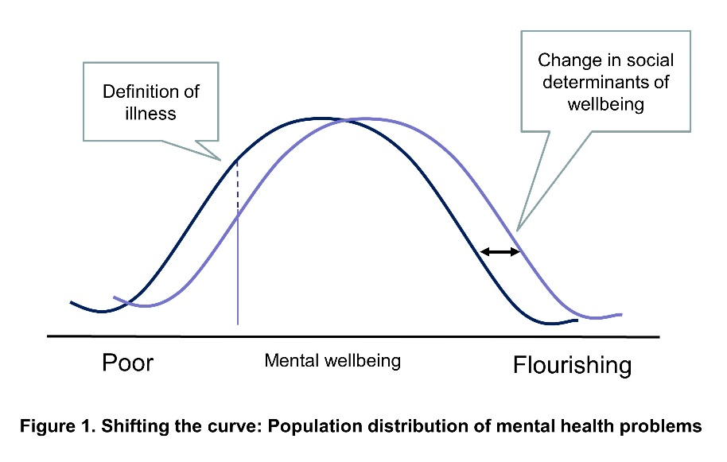

In this submission, we focus on workers’ mental health and ‘poor quality’ work as key social determinants of mental health. The nature of work and the labour-force has changed over recent decades - both in Australia and globally. These changes include increased casual employment (Campbell and Burgess, 2001), more sedentary work (Straker et al, 2016), polarization of overwork and underemployment (Dinh et al., 2017) and more mobility, connectivity and technology in workplaces and workspaces (Colbert et al., 2016). Most of these changes have important implications for mental health (and how it is distributed) at the population-level. We have conducted extensive research identifying the core job characteristics and psychosocial risk factors that adversely affect the mental health of workers and their families. We propose a combination of targeted workplace interventions, employment and social policy, and systemic socio-cultural change to prevent further deterioration of employees’ (and their families) mental health. In this submission, we use our extensive research to address the sub-category titled ‘Mentally healthy workplaces’ in the Issues Paper. We highlight research centered on two main work-related risk factors: a) Psychologically harmful employment conditions, and b) Work-family/care conflict. The recommendations we make speak to interventions and policies at the population-level.

- Psychologically harmful employment conditions

On average, employment is associated with better health, including mental health, than unemployment - as individuals move from unemployment into work, their mental health tends to improve (Dooley et al. 1996; Morrell et al. 1994). The positive health effects of paid work are argued to reflect a range of material and latent benefits, such as higher income and access to resources (e.g. housing, food), having a defined social role and purpose, access to social support and social networks, and time structure. However, jobs and workplaces vary in their physical, psychological, social and economic characteristics and, in contemporary affluent western societies, the psychosocial aspects of work are strongly associated with mental health. A considerable body of research has identified several core psychosocial job characteristics that are harmful for workers’ mental health. These include high job strain (i.e. a combination of high work demands/intensity concurrent with low autonomy at work), inadequate supervisor support, low job security (e.g. precarious work and underemployment), non-standard work schedules, long work hours and workplace bullying (Stansfeld et al. 2006; Harvey et al 2017).

Our collaborative program of work has focused on using Australian, population-level longitudinal data to identify the extent to which psychosocial adversity at work impacts on common mental health problems. Pertinent to this submission, our research has found that:
- Jobs with poor psychosocial attributes (i.e. high job strain and low job security) are no better for mental health than unemployment (Leach et al. 2010; Butterworth et al. 2011).
- Workplace bullying is common in Australia with 7% of employees reporting current bullying and almost 50% reporting that they have been bullied at some point in their working life (Butterworth et al. 2016).
- Workplace bullying is associated with 2-3 fold increases in anxiety and depression (Butterworth et al. 2016) and there is evidence of an association with suicidal ideation (Leach et al. 2017).
- On average, mental health improves for Australians who work up to 39hrs per week, but declines as they work longer than this. This curve is socially patterned – with ‘unencumbered workers’ who have fewer non-work responsibilities able to work longer (i.e. 46hrs) before they incur mental health costs (Dinh et al. 2017).
- Non-standard work schedules (i.e. shift work) are associated with poorer mental health both for workers and their children (Zhao et al. 2019).

Recommendations:
- Increased engagement between work, health and safety regulators and public health practitioners, to develop widely applicable policies, procedures and monitoring systems to reduce psychosocial adversity at work for all employed Australians.
- Increased training for HR practitioners and supervisors to increase awareness and literacy of the potential psychological harms related to poor psychosocial job quality.
- The introduction of universal population-level interventions aimed at cultural change in workplace behaviours and expectations to reduce psychosocial adversity at work (including the impacts of working long hours).

B. Work-family/care conflict

Employees’ mental health is affected by how their work and non-work environments interact. Compelling research has emerged both in Australia and globally, finding that a substantial number of employed parents are finding it practically and psychologically difficult to successfully combine work and family/care commitments - an experience known as work family/care-conflict (WFC). WFC is widespread; experienced by approximately one third of Australian mothers and fathers (Strazdins et al., 2013). For parents, WFC is associated with worse mental health (Odds Ratio=2.40) than unemployment (Odds Ratio=1.71 for mental health) and other established workplace risk factors (e.g. job insecurity, Odds Ratio=1.53; shift-work, Odds Ratio=1.03) (Goh, et al. 2016). WFC affects both mothers and fathers and persists beyond the perinatal period into middle childhood and older. It impacts the family environment via disrupted parenting and family functioning, increased inter-parental conflict, alcohol and drug use, and poorer health behaviours (Amstad et al. 2011). Evidence of the flow-on effects for children’s mental health and development is now emerging from our work (Strazdins et al., 2013; Dinh et al. 2017).

Research considering the introduction of policy and interventions to reduce work-family conflict and promote family-friendly workplaces has centered on flexible work (refs) and parenting leave arrangements (Hewitt et al. 2017). However, there is inequity in who is able to access flexible and leave arrangements (by gender and industry).

Pertinent to this submission, our collaborative research has found that:
- Work-family conflict is common in Australia, with 30% of parents reporting work-family conflict arising from difficulties in combining work with caregiving (Strazdins et al. 2013).
- Poor job quality (i.e. lack of flexibility, low autonomy/control, insecure work) is an independent risk for maternal and paternal postpartum depression and a mechanism for the transmission of mental health inequality to children (Strazdins et al. 2010; Cooklin et al 2011; Cooklin et al. 2015)
- Job insecurity, work intensity plus high caring time outside work hours increase risks of mental health development (Strazdins et al. 2013).
- Work-family conflict negatively influences mothers’ and fathers’ mental health, parent-child interactions, time spent with children and the couple relationship (Cooklin et al. 2011). Having demonstrated cross-sectional associations we are now finding prospective effects on children’s mental health (Dinh et al. 2017).
- Paid maternity leave has benefits for working mothers’ post-partum health and wellbeing (Hewitt et al. 2017).

Recommendations
- Curb the growth of long, unsociable and unpredictable working hours, to safeguard time for family responsibilities, and for sociable and active lives. In doing so, recognise the importance of successful engagement in both work and non-work activities/responsibilities for good mental health (e.g. caring) activities. Such an approach requires a whole of government approach.
- Increase Australian Government policy support and facilitate both existing and new measures allowing greater flexibility for workers to manage family, caring and other responsibilities, creating greater opportunity for family, education and community engagement (as in the Senate Committee report on The Future of Work and Workers, September 2018).
- Facilitate renewed discussion and research about who has access to, and is utilising, flexible work and parenting/carers leave arrangements with the aim or reducing inequity and improving workers mental health.

C. Other related matters – Taking a preventative approach to mental health

Currently preventative policies focus on preventing chronic diseases such as stroke, heart failure, chronic kidney disease, lung disease and type 2 diabetes. These are the so called lifestyle diseases because they reflect how people live, and are strongly shaped by opportunities and supports for, or constraints on, healthy choices. We lack a comparable approach to mental health, even while mental health is also strongly shaped by the conditions, resources, opportunities and constraints within which people live, work, grow and age.

Recommendation
- That the Australian Psychological Society and the Public Health Association of Australia are tasked with developing a National Mental Health Prevention plan that includes action to address the social determinants of mental health in Australia.
- Increased funding opportunities for public health practitioners, epidemiologists, and social scientists to apply multi-disciplinary approaches to develop, identify and implement effective preventative polices for mental health that focus on whole of population strategies and social and economic determinants.

Contacts for this submission:

Dr Liana Leach
Professor Lyndall Strazdins

Additional contributors to this submission:

Ms Jenny Welsh (PhD Candidate)
Ms Yixuan Zhao (PhD Candidate)
Dr Tinh Doan
Dr Christine LaBond

References

Amstad FT, Meier LL, Fasel U, Elfering A, Semmer NK. (2011). A meta-analysis of work-family conflict and various outcomes with a special emphasis on cross-domain versus matching-domain relations. Journal of Occupational Health Psychology. 2011;16(2):151-69.
Butterworth, P., Leach, L., Strazdins, L., Olesen, S., Rodgers, B., & Broom, D. (2011). The psychosocial quality of work determines whether employment has benefits for mental health: Results from a longitudinal national household panel survey. Occupational and Environmental Medicine, 68(11), 806-812.
Butterworth, P, Leach, L.S, Kiely, K.M. (2016). Why it’s important for it to stop: Examining the mental health correlates of bullying and ill-treatment at work in a cohort study. Australian and New Zealand Journal of Psychiatry. 50(11):1085-95.
Campbell I and Burgess J. (2001) Casual employment in Australia and temporary employment in Europe: Developing a cross-national comparison. Work, Employment and Society 15: 171-184.
Colbert A, Yee N and George G. (2016) The digital workforce and the workplace of the future. Academy of Management Briarcliff Manor, NY.
Cooklin AR, Canterford L, Strazdins L, Nicholson JM. (2011). Employment conditions and maternal postpartum mental health: results from the Longitudinal Study of Australian Children. Archive of Women's Mental Health. 2011;14(3):217-25.
Cooklin AR, Giallo R, Strazdins L, Martin A, Leach LS, Nicholson JM. (2015). What matters for working fathers? Job characteristics, work-family conflict and enrichment, and fathers' post-partum mental health in an Australian cohort. Social Science & Medicine. 146:214-22.
Dinh H., Cooklin A.R., Leach L.S, Westrupp E,. Nicholson J.M., & Strazdins L. (2017). Parents' transitions into and out of work-family conflict and children's mental health: Longitudinal influence via family functioning. Social Science & Medicine. 194:42-50.
Dinh, H., Strazdins, L., and Welsh, J. (2017). Work hour thresholds, gendered health inequalities. Social Science & Medicine. 176(2017):42-51.

Dooley D, Fielding J, Levi L. (1996). Health and unemployment. Annual Rev Public Health. 17:449-65.
Goh J, Pfeffer J, Zenios SA. (2016). The Relationship Between Workplace Stressors and Mortality and Health Costs in the United States. Management Science. 62(2):608-28.
Harvey, Samuel B., et al. "Can work make you mentally ill? A systematic meta-review of work-related risk factors for common mental health problems." Occupational and Environmental Medicine. 74.4 (2017): 301-310.
Hewitt, B., Strazdins, L., & Martin, W. (2017). The benefits of paid maternity leave for mothers' post-partum health and wellbeing: Evidence from an Australian evaluation. Social Science and Medicine, 182, 97-105.
Jorm, A. F., Patten, S. B., Brugha, T. S., & Mojtabai, R. (2017). Has increased provision of treatment reduced the prevalence of common mental disorders? Review of the evidence from four countries. World Psychiatry, 16(1), 90-99.
Leach, L.S, Butterworth, P., Strazdins, L., Rodgers, B., Broom, D. H & Olesen, S. (2010). The limitations of employment as a tool for social inclusion. BMC Public Health, 10:621.
Leach, L.S, Poyser, C, Butterworth, P. (2017). Workplace bullying and the association with suicidal ideation/thoughts and behaviour: A systematic review. Occupational and Environmental Medicine. 74:72-79.
Morrell S, Taylor R, Quine S, et al. (1994). A cohort study of unemployment as a cause of psychological disturbance in Australian youth. Social Science & Medicine. 38:1553-64.
Ormel, Johan, et al. (2019). Prevention of depression will only succeed when it is structurally embedded and targets big determinants. World Psychiatry. 18.1: 111.
Rose, G. (2008). Rose’s Strategy of Preventive Medicine”. Oxford University Press: Oxford.
Stansfeld S, Candy B. (2006). Psychosocial work environment and mental health and meta-analytic review. Scandinavian Journal of Work Environment and Health. 32:443-62.
Straker L, Coenen P, Dunstan D, et al.(2016). Sedentary Work – Evidence on an Emergent Work Health and Safety Issue – Final Report. Canberra: Safe Work Australia.
Strazdins L, Shipley M, Clements M, et al. (2010). Job quality and inequality: Parents’ jobs and children’s emotional and behavioural difficulties. Social Science & Medicine. 70:2052-60.
Strazdins L, Obrien LV, Lucas N, Rodgers B. (2013). Combining work and family: Rewards or risks for children's mental health? Social Science & Medicine. 87:99-107.
The Senate. Select Committee on the Future of Work and Workers. (September 2018). Commonwealth of Australia.
Zhao Y, Richardson A, Poyser C, Butterworth P, Strazdins L & Leach L (2019 – under final review). Shift work and mental health: A systematic review and meta-analysis. International Archives of Occupational and Environmental Health.

