We can protect, what we love – it is our choice !!!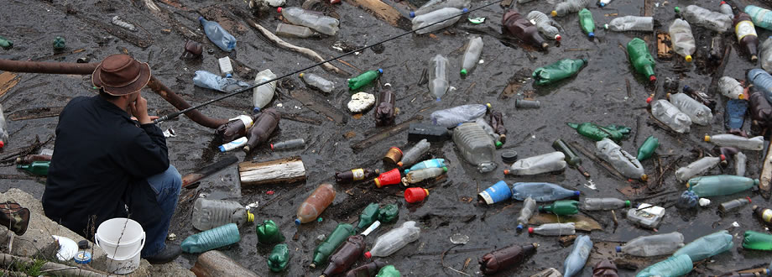

Choose to Refuse!

A moment use & neglect, 100s of years effect.
Take another photo of alternatives ie. re usable bottles, bags etc and display them side by side. It’s your choice to be part of the problem or solution!

I went to every local shop, suggesting to the shopkeepers, that they change their question into "Did you bring a bag?" That still sounds polite, but stops the automatic "Yes, thank you." and if they get the same question in every shop, it might start some shoppers to think and remember next time.
Our coastal waters were the cleanest, now showing that water pollution does not stop at our boundaries. It floats. Even if we keep our own beaches clean and the currents are favourably transporting our plastic waste away to other islands, we will suffer from the same contamination. Other poorer nations don't even have rubbish collection. Avoidance of plastic, in particular single-use plastic is the best solution, Re-use 2nd best. In Germany plastic bottles are marked on the bottom. Only when they have been cleaned and refilled 29 times, they are discarded. The manufacturers need to take responsibility and organise pick up and refill. Recycling is only a band aid solution, using energy again to transform an item into a weaker plastic, which is still ending up in landfill and ultimately in our waterways and food chain at some stage.
"...Biodegradable plastic bags may be major pollutants
studies into the end-of-life fate of biodegradable plastic bags are so diverse in their findings, and so varied in their protocols, that they are of little use for informing policy or regulation. That’s the central finding of a review of published research into the subject, conducted by a team led by Jesse Harrison of the University of Edinburgh in Scotland. Harrison and his team looked at available papers investigating the manufacture and whole-life-cycle of biodegradable plastic bags and found that the available findings were inconsistent and often poorly defined..." https://cosmosmagazine.com/geoscience/biodegradable-plastic-bags-may-be-major-pollutants

22 tips for going plastic free
So you’ve managed to remember your calico bag more than once this week, you’ve swapped out the disposable coffee cup for a KeepCup, and you try to eat-in to avoid plastic-wrapped take-away lunches. Good on you. Every small action makes a difference.
But how do you actually transition and maintain a plastic-free lifestyle?
Well for starters, don’t be too hard on yourself. We live in a plastic world; it’s fairly unavoidable. So if you fall off the wagon and forget to refuse those two straws in your Saturday afternoon green juice, don’t stress. Just learn from your experience, and start again.
Choosing to be plastic-free means you’ll often be choosing the least convenient choice. But over time, these decisions will become a habit. You’ll learn to become more prepared and planned, and you’ll also consume a lot less and save some money.
Since the ABC series War on Waste aired in May, it seems the collective conscience of Australians has increased around our waste. More people are drinking their morning coffee from a reusable cup, And earlier this month, Coles, Woolies and Harris Farm all announced they would phase out the use of single-use plastic bags – a direct result from public pressure.
Plastic is bad for the environment on every level. Not only does it pollute waterways and create excess landfill, but plastic uses a ridiculous amount of resources just in order to be manufactured. In fact, it takes about 12 million barrels of oil to manufacture the 102 billion plastic bags used in the United States alone.
Each year, the average Australian produces 1.5 tonnes of waste a year. Recycling is a fairly standard practice across households in Australia but there are still plastics that cannot be recycled due to their chemical composition. It’s these types of plastics that we should all aim to avoid wherever possible. Generally, the most difficult plastics to recycle are the softest types, the ones that you can easily scrunch in your hand, such as food packaging (think pasta packets or individually wrapped portions of food). Polystyrene is another ubiquitous culprit that never gets recycled in the waste stream.
So let’s take this plastic-free, minimal waste momentum to the next level. Start small, take your time and build on your good habits one-by-one.
1. BYO bag Always take your own shopping bags to the supermarket or shops. These don’t have to be the canvas, environmentally friendly kind if you don’t have any. Even just reusing plastic bags from your own kitchen cupboard can still help to reduce waste.
Bonus Tip: Recycle any soft plastics you do accumulate in the collection kiosks in Coles and/or Woolies.
2. Use a thermos or a KeepCup If you regularly find yourself buying takeaway coffee, take your own clean thermos and avoid adding to the styrofoam and plastic-lined cardboard rubbish pile. Cafe businesses usually appreciate not having to buy their own cups to hand out, and the environment appreciates being cared for. Some cafes will even give you a discount!
3. Avoid individually wrapped products Don’t buy food in pre-portioned packaging, buy in bulk instead! Instead of buying 15 mini packs of biscuits or chips for school lunch, buy a large single packet and portion it into containers. Apply this theory to yoghurt, custards, and anything else that can be bought in a larger size. Every bit counts!
4. Don’t buy fruit and veggies wrapped in plastic! Like buying packaged food in bulk, avoid buying pre-packed or pre-weighed fruits and vegies. You know the kind – cling wrapped bananas on foam trays and the like – unnecessary and wasteful. Instead, choose from the loose section and put them straight in the fruit basket or fridge when you get home. I mean really, why does a banana need any more packaging than what nature has already provided?
5. Swap out the Gladwrap for beeswax wraps or containers Invest in some good, air tight storage containers that are both microwave and freezer safe. It’s a good idea to have multiple containers in a range of sizes to accommodate for all the different types of food you’ll be storing, as well as snack sized containers for lunch boxes and storing liquids, dressings, and so on. As a major health bonus, the phthalates in plastic wrap are really bad for you, so you’ll be doing yourself, your friends, and family a favour too. You can also get reusable wax-lined cloths that work the same way as glad wrap, and look great too – check out Honey Bee Wraps.
6. Buy your meat or cheese from the deli and ask to use your own container. Pre-packaged meat and cheese is usually sold in plastic or styrofoam trays, but if you buy direct from the deli butcher, you can bring your own container to transport your goodies.
7. Have a bottle on hand Plastic water bottles are one of the most common items in the world. Don’t help perpetuate the market for this ridiculously wasteful product; take your own drink bottle when you’re on the go. Water comes out of the tap for free, so why on Earth would you pay for it?!
8. Refuse the straw! Use your lips. They may seem small and harmless, but they accumulate incredibly quickly over the space of a night out drinking. If you have to drink with a straw, try to reuse it over the course of your night. Even better, invest in a reusable straw, like the stainless steel or glass ones from Dharma Straws. We’ve found the stainless steel ones are a bit more durable, as glass isn’t the safest thing to carry around with you.
9. Ditch disposable plates If you’re having a BBQ or party – don’t freak out – but avoid using disposable cups, plates, and cutlery. Use your own glasses and ceramic plates and wash them. If you must use disposable items, opt for biodegradable ones made from corn starch or paper, and compost them afterwards. But if your Aunt Dora is insisting that really do have to use plastic plates, use the more durable kind so you can wash and reuse them.
Bonus Tip: If you write people’s names on their glasses you’ll have less washing up to do. Plus, you get to make up fun names for your guests – hello ‘Sunshine’!
10. Grow your own Fresh herbs and salad leaves almost always come wrapped in plastic at the supermarket. Try growing your own herbs and salad leaves at home to enjoy fresh greens when you want!
11. Get to the farmers’ markets or bulk food store It really is a lovely weekend ritual to get along to your local farmers’ market, where you’ll find farm-fresh produce with no plastic packaging that’s come straight out of the dirt, into the farmer’s van, to you. Another plastic-free grocery store is a bulk food store – to get started, check out if there’s a Scoop Wholefoods or a Naked Foods near you.
12. Buy refills Rather than buying a new product each time, start buying refills for your cleaning supplies. If you use one spray bottle a month then that’s 12 spray heads a year that you don’t need. Reuse your spray head wherever possible! This also applies to laundry detergents and fabric softeners. Always refill rather than chuck it away!
13. Take your own container to the food court instead And refuse the plastic cutlery in favour of your own.
Personal care
14. Swap your plastic toothbrush for a bamboo toothbrush. Never heard of a bamboo toothbrush before? Start by checking out http://boomerangbags.org/shop/ Environmental Toothbrush and Biome.
15. Ladies, a menstrual cup is not as scary as it sounds It might seem daunting, but a cup is a great way to reduce your plastic waste (and save roughly $4000 over a lifetime). Join the tribe of those who swear by the Juju cup.
16. Use an electric shaver The plastic in disposable razors isn’t recyclable and doesn’t biodegrade, so they’re very difficult to dispose of. When you invest in a good electric razor, you’ll actually save money in the long run from not having to buy shaving cream, lotion, and replacement blades quite so often. Otherwise use Razormate sharpener for disposable razors to prolong their life.
17. Try natural scents If you’re a big fan of the air freshener spray can, try out some non-aerosol versions, such as this one from Orange Power. For extra brownie points, you could even make a DIY room freshener spray like this one here. You could also try burning scented candles, incense, or essential oils instead.
18. Step away from the microbeads If you’ve never heard of microbeads before, make sure you have a read about them here. These tiny beads are made from a plastic based substance and contribute to a lot of extra work at water treatment plants.
Everyday life
19. Don’t throw away old toys Recycle old plastic children’s toys. If they’re not broken, don’t throw them away. Consider giving them to a local op shop, daycare, or kindergarten instead. Search for a toy library in your area to borrow from or donate to.
20. Don’t throw away phones Don’t throw away old mobile phones. Most post offices have a special bin for recycling all mobiles and their accessories. If you can’t find one, look carefully in the box of your new phone – there should be a special recycling postage bag included in which you can place your old phone. Check out MobileMuster for more info.
21. Avoid lighters If you really need a lighter, stop buying plastic lighters. Instead, purchase a packet of matches or a refillable lighter that can be reused again and again.
22. Invest in cloth nappies Can you believe that 3.75 million disposable nappies are used each day in Australia and New Zealand? If you have a bub, save the disposable nappies for emergencies and invest in a pair of good cloth ones instead. Up to 4% of landfill in Australia is full of nappies, which aren’t likely to decompose in your child’s lifetime – or even your grandchildren’s lifetimes (about 150 years). Yes, you may have to use extra products for sanitising and washing, but there’s nontoxic laundry powders, that come in a cardboard box, that have less impact on the planet than plastic nappies. Just make sure you actually use the cloth nappies you purchase, as if you just leave them in a drawer somewhere the resources required to make them mean it isn’t worthwhile. The CHOICE website has some of the best information about nappies if you want to learn more.
Bonus: Your initial outlay for cloth nappies might seem expensive, but in the long run you’ll save wads of cash. And if you reuse the nappies for another child, you’ll be saving even more.

1. Bag it: You don’t have to wait for a ban to make the change. Start bringing reusable bags with you on every trip to the store.

2. Take Back the Tap: Plastic water bottles aren’t just a waste, they may also be harmful to your health. Use a reusable water bottle or a glass jar and fill it at the tap.

3. Ditch the Zip: Ditch zip-top bags and plastic wrap for packing up leftovers and use reusable glass containers instead. You can safely reheat them in the microwave too.

4. Pack a Waste-Free Lunch: Go old school…get a retro lunch box and fill it with real food, not a bunch of stuff sealed in plastic.

5. Drift Away from Plastic Packaging: When shopping, buy fewer items packaged in plastic. If an item you want comes in a glass jar or plastic container, choose glass. Instead of buying the plastic wrapped meat or veggies, get the protein from the butcher wrapped in paper…and pack your veggies loose and plastic free in your own reusable bag.

6. Re-Imagine Take-Out: Whether you are ordering take out at a Thai Food restaurant or buying your daily cup of coffee, make sure to leave the house with your own glassware or stainless steel take away containers. Don’t be shy, just present the staff with your reusable gear and ask them to please pack it sustainably.

7. Straws are for Suckers: Do you really need that straw? Bartenders and servers will often give you one by default. When you order, remember to tell them, “No straw, please.” If you really need one, carry your own stainless steel or glass straw.

8. Party Plastic-Free: Treat guests to reusable partyware instead of disposable plates, cups, and cutlery…or try serving finger foods that don’t need utensils. If you throw a BYOB party, have friends BYOC.

9. Clean Up Your Soap Situation: Consider using bar soaps and powders that come with less plastic packaging. If you use liquid, buy in bulk and refill soap containers. Search the ingredients of your toothpaste and facial scrubs and stop using anything with microbeads.

10. Get Active in Legislation & Promote Corporate Responsibility: Join groups like Surfrider, 5Gyres and Upstream and help advocate for extended producer responsibility laws in each and every state. Ask businesses to take responsibility for the products and packaging they are putting out into the world.

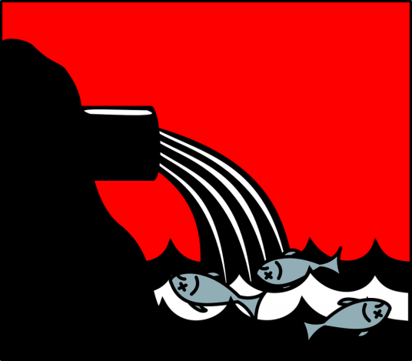
Can’t flush this: 5 things you need to stop flushing
down your toilet right now
Posted on July 14, 2015 by Rashini Suriyaarachchi
When you flush things down the toilet – they don’t just
disappear. Here are 5 things we need to stop flushing down
the toilet right now for our oceans.
In Australia, what we send down our kitchen, laundry, and bathroom drains – and everything we flush down the toilet – ends up in the sewerage system. And it doesn’t end there – once sewage is treated, it’s reused or returned to our creeks, rivers and oceans.
Toilets are for your waste – not your rubbish. Help ensure our waterways are kept junk-free and our treatment process runs smoothly by putting these five items in the bin instead of your toilet.

1. Wet wipes
Flushing wet wipes – even if they’re called ‘flushable’ – is a bad idea for our pipes and wastewater system. According to Sydney Water, 500 tonnes of wet wipes products are removed from Sydney’s sewers each year!
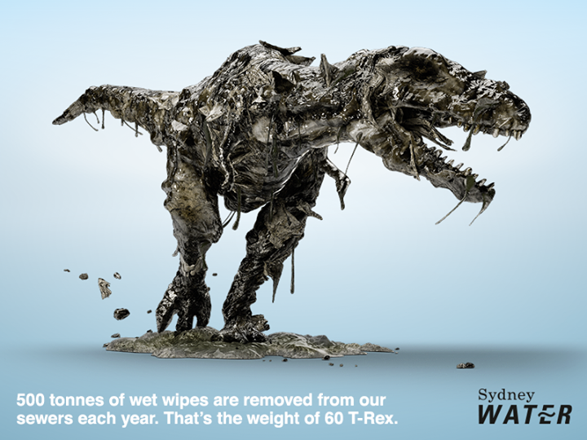
Sydney Water also report that 75% of sewer blockages involve wet wipes. It’s clear that flushing wet wipes is bad news for everyone involved – so try reusable face wipes, or dispose of wet wipes responsibly.
You can find out more about this 500 tonne problem from the Sydney Water website here. And don’t forget: there are reusable alternatives to disposable wipes to lessen your impact on the planet and save yourself wondering how to get rid of your wet wipes.
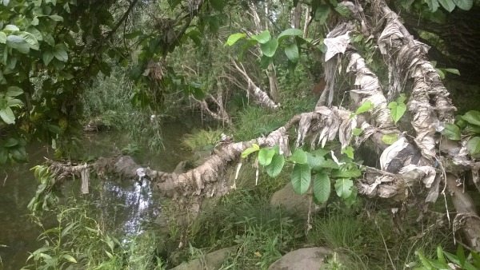
Wet wipes in a Toongabbie creek after an overflow via Sydney Water

2. Cotton buds and pads
You might be able to rip them apart, but even little cotton buds and pads don’t decompose in the sewage system. They can accumulate to clog the pipes on your end, or eventually gather in the bends of pipes to cause bigger blockages.
Just like disposable wipes, you can also find washable pads that can be used more than once.

3. Sanitary products
Made from a combination of ingredients including plastic and cotton, pads and tampons are not designed to be flushed. They can also clog up the pipes in your home or accumulate to block bigger pipes later on.
There are lots of sustainable alternatives to single-use sanitary products – like reusable pads and cups – to stop your pads and tampons being flushed or sent to landfill.

4. Condoms
Condoms are a massive problem for the world’s sewers. In London, one sewage worker told The Guardian: “I’ve been down the sewers in central London and seen what appear to be fish on the surface. They’re actually condoms filled with air, bobbing around. It is pretty grim.”
No one really knows how long it takes for a condom to biodegrade. But one thing is clear – they don’t break down in water so you should not flush them down the toilet.

5. Your pet fish
In June 2015, a province in Canada reported goldfish “the size of dinner plates” swimming, reproducing, and growing in size in storm water ponds. While this was more likely due to residents releasing the fish in nature than flushing them down the toilet – it’s probably a good idea to keep pets out of our sewage system and waterways.

What you can do
These tips might seem obvious to you – but all these items still end up being flushed in toilets in Australia and around the world every year. In Sydney alone, one in four people flush wet wipes, causing 75% of sewer blockages and costing $8 million every year.
Make sure none of your friends and family make these mistakes by sharing this blog using the tools to the left.
Want to do more? Sign up to join 450,000 Greenpeace supporters and get opportunities to create change straight into your inbox!

- Reusable cup: Get your morning brew in a reusable cup instead of the disposable takeaway cups.
- Reusable straw: Say no to plastic straws or bring your own reusable straw (stainless steel or glass are great options
- Reusable cutlery: Pack some cutlery from home or invest in a reusable cutlery pack perfect for the handbag.
- Reusable bottle: Save some money and precious earth resources by bringing your own drink bottle and filling it up with water from the tap.
- Reusable bag: Pack a reusable bag with you each day so you never have to say yes to plastic bags again. You can keep one or two in your car for any unexpected shopping trips.
- Buy Local: You're supporting local economy, you'll be eating seasonally, and you cut down on the food miles you consume.
- Buy bulk: Shop at a bulk food store to avoid plastic packaging and save some time and money.
- Compost or freeze food waste: Composting is a great way to reuse your food waste as nutrition for your garden, you can also freeze your off cuts from fruit and veggies and use them in soups and broths.
- Naked bin: Let your bin go nude (no plastic bag bin liner) or line it with newspaper.
- BYO jar or container: Grabbing lunch on the go? Take a container or jar with you instead of using the plastic takeaway containers.
- Start making your own cleaning products: An awesome way to reduce harmful cleaners in your home and avoid the plastic packaging. Try our DIY dishwashing detergent or laundry detergent.
- Make your own beauty products: Another great way to avoid harmful toxins being absorbed into your body and you can sleep tight knowing you aren't pouring microbeads down the drain. Many of the beauty products I make I store in old glass jars. Check out our recipe for coffee cacao scrub.
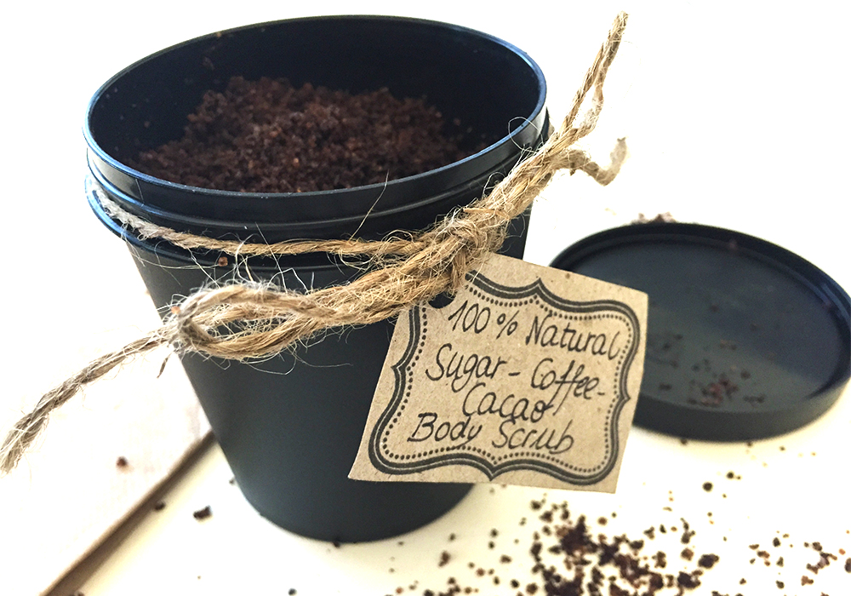
1 Million Women is empowering women and girls around the world to lower their impact on the planet. If you love what we do, please support our work by donating a couple of dollars. For the price of a cuppa, you can help us inspire millions more! (click to donate)
- Use beeswax wraps: Reusable beeswax wraps can be used to replace clingwrap.
- Choose glass over plastic: If you have the choice between plastic packaging or glass, choose glass. You can reuse the glass jar or container over and over and then recycle it at the end of its life. Single-use plastic packaging is designed to be used once and thrown away. Not a good option for our environment.
- Grow your own food: Test out your green thumb and start your own veggie patch. Begin by planting some herbs and build your garden from there.

I was verbally attacked by a foreign gent barking at me about where to put "diapers in?" It would seem people are getting heated up about the inconvenience of having to reduce an environmentally unsustainable neuro-toxic, carcinogenic and hormone disrupting polluting convenience.
11 months to stop single-use plastic bags are 11 months too long for an item that does not biodegrade and is produced and handed out daily in the trillions worldwide, while our planet and oceans are suffocating and the fossil fuel industry is making profit by selling plastic bags. In Canberra it was changed abruptly without warning and only a few customers complained. It took 3 weeks for most to get used to bring their own bag/basket/trolley. That long preparation time caused exactly those outbursts as in the post above. Instead of simply accepting the fact, clients got time to complain.

