12 July 2018

Superannuation,
Productivity Commission,

Submission to the Productivity Commission on the draft report in Superannuation: Assessing Efficiency and Competitiveness

About this submission
This submission addresses some key points in the draft report that relate to both my roles as Head of Retirement Income Research at Challenger and as an adjunct fellow at the Macquarie Applied Finance Centre, where I teach a course in Lifecycle Investments. The views in this submission are my own and do not necessarily reflect the view of either Challenger or the Macquarie Applied Finance Centre or any of their related parties.
The comments deal with Draft finding 4.3 and Information request 4.1 drawing on some of the material in Technical Supplement 6 attached to the report.

Lifecycle theory
There is a difference between lifecycle theory and the products that have been promoted as lifecycle funds in Australia. Bell (2013) provides a clear description of this difference. The course I teach covers lifecycle theory and a practical way to model investments over a lifetime. It touches on lifecycle funds but notes that they are really only one option to managing investments across a lifetime.
The key element of investing across a lifetime is the gradual accumulation of savings and then the depletion of capital as the savings are drawn down to provide income for the retiree. The investment requirements for this lifecycle is different to that faced by an endowment which is preserving capital for multiple generations, with the current generation only using available (or excess) income for spending needs. Including a bequest is possible, but I believe that the role of superannuation, which reflects deferred wages, is to provide income in retirement rather than to establish an endowment for future generations.
The lifecycle challenge is to find the optimal allocation of investments that will maximise income through retirement. This is the key point in Merton (2014) where he calls for the focus in retirement to be on monthly income, not net worth. Another element in this approach is the consideration of a lifecycle through retirement, not to retirement.
An outcome from the analysis in the course is that the optimal allocation to growth assets changes as people age. This is particularly the case when potential earnings are taken into account as human capital. Corrigan et al (2009) discuss the impact of Human capital on investment strategies. Thus, the premise of lifecycle funds in reducing growth exposure is supported. During retirement, the direction of the glide path is less clear. Kingston and Fisher (2014) highlight the need for an increasing exposure to equity through retirement as part of the bequest motive. Kitces and Pfau (2014) find that the same rising path can improve outcomes even in the absence of a bequest motive.

Lifecycle funds
Some of the funds available in Australia have adopted the target date fund approach from the United States and do not provide a desirable glide path. This is especially true when the fund is targeted at the start of retirement and/or focuses on the accumulated value of savings rather than the available income to meet spending needs.

Information request 4.1
In short, properly designed lifecycle funds should be allowed as part of MySuper. The challenge is to ensure that the funds are properly designed and suitable for member’s needs. Any re-design of the product should also consider the varying circumstances through retirement, not just for those members nearing retirement.
Some of the key characteristics are:
- the investment glide path should be managed through the retirement phase
- a focus on income through retirement, rather than balance at retirement
- include human capital and the potential for future contributions
- include any entitlement to the age pension
The third question in Information request 4.1 refers to managing sequencing risk, but there is some mixed terminology here. Sequencing risk generally refers to the impact that the order of returns (despite the same average return) can have on balances or longevity of income payments. Milevsky and Abaimova (2006) provides a clear example of the risks from sequencing when cash flows are present. There is also a timing risk that occurs when there is a large market fall right at the point of retirement. This is the risk referred to in the draft report and is only one form of sequencing risk that needs to be managed. Sequencing risk has a larger impact in the early years of retirement, once cash outflows have started.
A role for more defensive assets is to manage sequence risk in retirement. This has two aspects:
- Defensive assets provide stable income (although dividends from Australian share have been relatively stable historically)
- They have lower short-term market volatility
These two elements reduce the impact of sequencing risk in retirement. Effectively if the market is down, fewer capital units will need to be sold down to fund spending.

Lifecycle fund design and comparison to balanced funds.
In broad terms, a lifecycle approach recognises that a young investor with years of income and contributions ahead does not need any defensive assets. Later in life, when balances are large, a risk-averse investor is likely to want some defensive assets. A lifecycle approach should start high and reduce growth exposure leading into the retirement phase. In-between there is a smooth path.
Long run returns will (in expectation) depend on exposure to the equity risk premium (ERP) or other growth risk premia. Comparing two strategies with different average growth exposures only compares the growth allocation, not the underlying strategy. This is why the examples in the draft report, including the Trueck (2016) reference find life-cycle funds underperforming by so much. The key metric as described by Chant et al (2014) is the money-weighted average growth allocation. For a comparison to be truly valid the money-weighted average allocation should be the same as the fixed allocation in the balanced fund. Only then can the lifecycle strategy be compared to a balanced fund approach.

Alternative Lifecycle comparison
To provide a comparison, I have constructed an alternative lifecycle portfolio. Using only a growth/defensive split, the weights of the lifecycle portfolio are:
Age | Growth allocation | Defensive allocation
<45 | 100% | 0%
45 - <50 | 80% | 20%
50 - <55 | 70% | 30%
55 - <60 | 60% | 40%
60+ | 50% | 50%

The weights and age bands were selected so that the money-weighted average allocation was 65% to match the balanced portfolio. This has been calibrated to retirement at age 67 and, replicating the analysis in the draft report, no consideration has been given to the retirement phase in this submission.
Simulations were run using a stationary bootstrap similar to the approach of Politis and Romano (1994). The sampled returns from Vanguard (2017) were combined slightly differently to methodology described in the draft report. The asset classes were first combined into two portfolios of growth and defensive assets. These were constructed so that the 65% growth / 35% defensive portfolio matched the balanced portfolio noted in Technical Supplement 6 to the draft report. For clarity, these are the weights used:

Asset Class | Growth % | Defensive % | Balanced %
Australian equities | 42.3% | - | 27.5%
Global equities | 26.9% | - | 17.5%
Global equities (hedged) | 11.5% | - | 7.5%
US equities | 3.8% | - | 2.5%
Australian bonds | - | 42.9% | 15.0%
Global bonds (hedged) | - | 14.3% | 5.0%
Cash | - | 42.9% | 15.0%
Australian property | 11.5% | - | 7.5%
Global property | 3.8% | - | 2.5%
 | 100% | 100% | 100%

The growth and defensive portfolios can be combined to replicate either the balanced portfolio in the draft report or the equivalent lifecycle portfolio described above. A total of 2000 simulations were run using the stationary bootstrap approach, with the parameters provided for Case A in the draft report. The final balance at the point of retirement was computed for each simulation in order to produce charts equivalent to Figures 6.3 and 6.4 from the technical supplement.
The conclusions from using an equivalent lifecycle portfolio will be quite different than those reached in Technical Supplement 6. Figure 1 is the reproduction of Figure 6.3 from the technical supplement. The lifecycle portfolio provided a slightly higher average return, and better results in the higher percentiles. For the lower percentiles, the differences were small between the two portfolios.
The more striking result can be seen in Figure 2. In contrast to the results in the technical supplement (which are driven by the lower exposure to growth assets), the relative losses in a lifecycle portfolio are smaller when compared to the balanced portfolio outcome for the same market scenario. This is also true in percentage terms, as can be seen in Figure 3.
Care should also be taken to report the difference as a loss. Comparing any sensible investment to a pure gamble, such as a coin toss could produce a large ‘relative loss’ in a scenario when the gamble resulted in double money (or 16x at the 5th percentile for four consecutive tosses). Not receiving a large potential upside is not the same as losing a large amount of capital.

Figure 1 Distribution of retirement balances for lifecycle and balanced portfolios
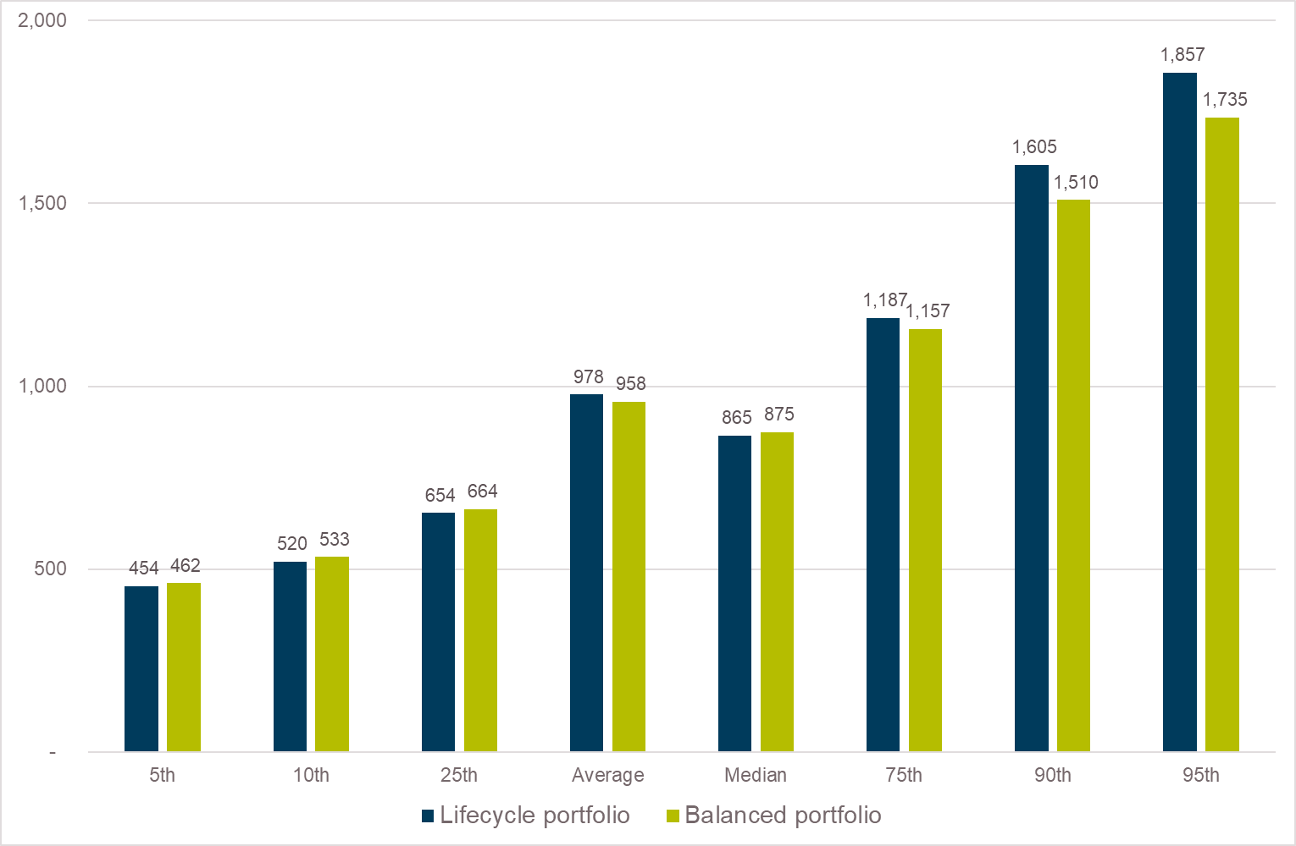

The improved outcome for the lifecycle approach does not mean that it is always the optimal choice for someone saving for retirement. What this analysis is showing is that in the absence of the ability to change exposure across time, a pre-planned reduction in risk as asset balances grow is more likely to produce a better result for the member than taking the same risk exposure constantly through time. Changing risk exposure with market conditions can improve the outcome further.
Figure 2 Relative losses are smaller with a lifecycle portfolio
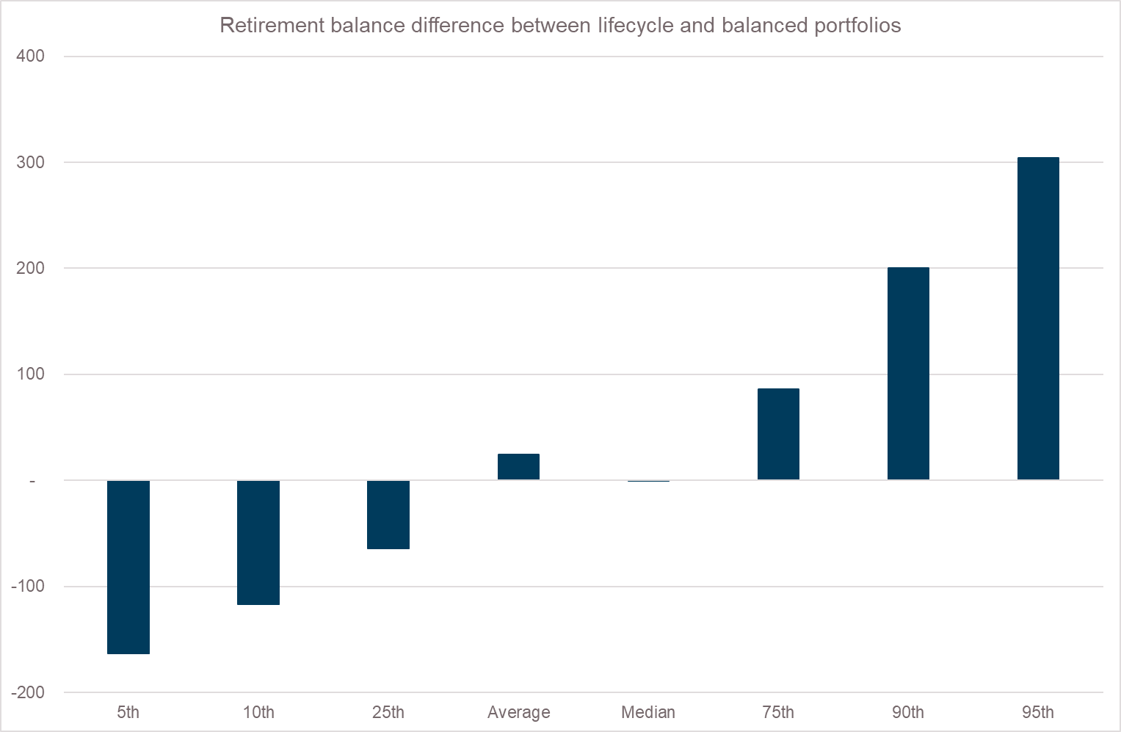

Figure 3 Percentage differences also favour a well-designed lifecycle portfolio
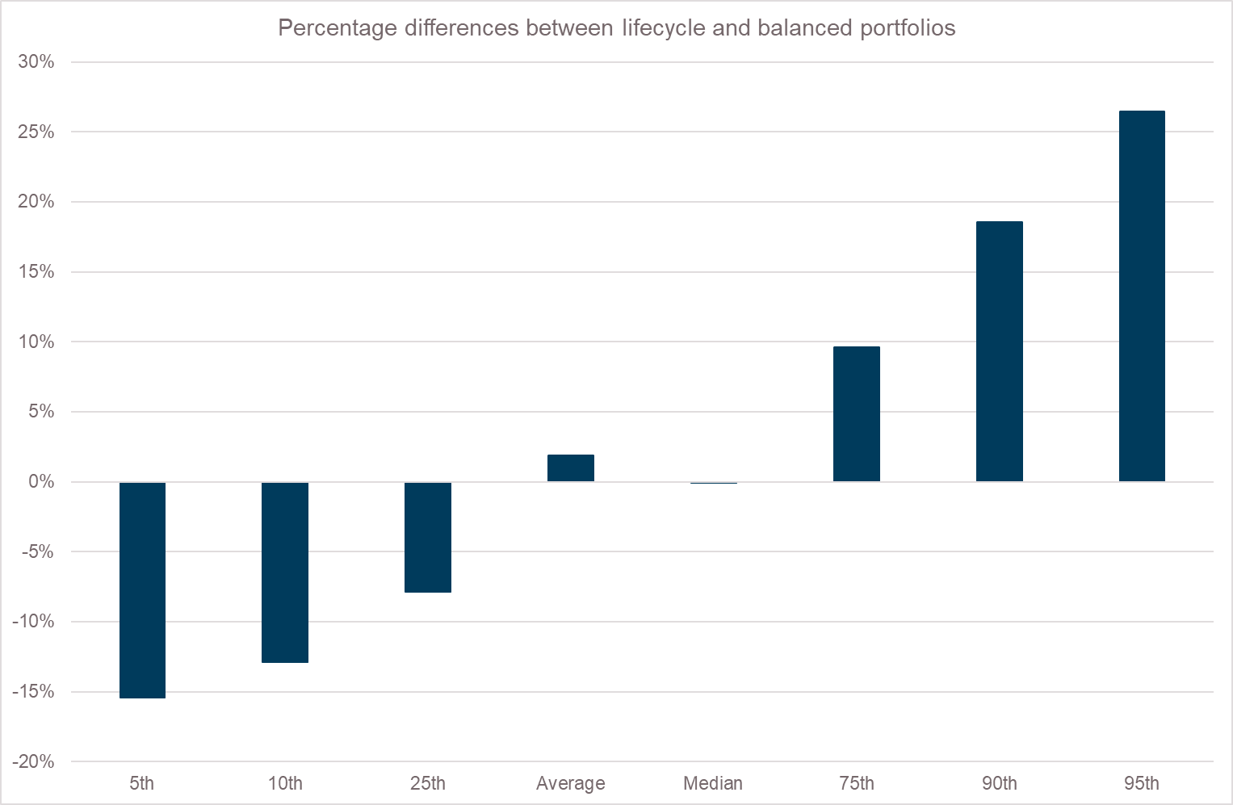

Real wages and Case A
The draft report and technical supplements have assumed that real wages grow by 1.5% pa. This is higher than has been achieved historically in Australia. High real wage growth occurred in the first decade of this century, but as the shaded sections in Figure 4 indicate, this real wage growth has not been sustained historically. This assumption has a significant impact on the results of the modelling. Specifically, there is a high contribution to the final balance coming from wages growth and a relatively smaller impact from investment performance. I think this is potentially misleading.
The Case A example of a 21-year-old starting with $50,000 will have a final salary of $135,000 representing 46 years of 1.5% real growth and an experience factor that adds almost 37% to their wage. Their retirement balance is $833,383 from which they will draw a $41,669 a year in today’s terms. This represents a replacement ratio on only 30% based on final salary and would entail a significant adjustment to lifestyle. The accumulated savings would exclude any age pension payments under current means testing arrangements, so the cameo will be in for a severe shock in retirement.
Many would view such a sharp adjustment as a failure of super to provide for adequate retirement income. If this is a realistic scenario, then a contribution rate in excess of 15% of salary will be necessary to limit the dislocation at retirement. My own expectation is that real wages growth will be more modest (in line with historical averages) and that the experience factor after age 40 adds little to real wages.

Figure 4 Australian wages and inflation, 5 year rolling growth (%pa)
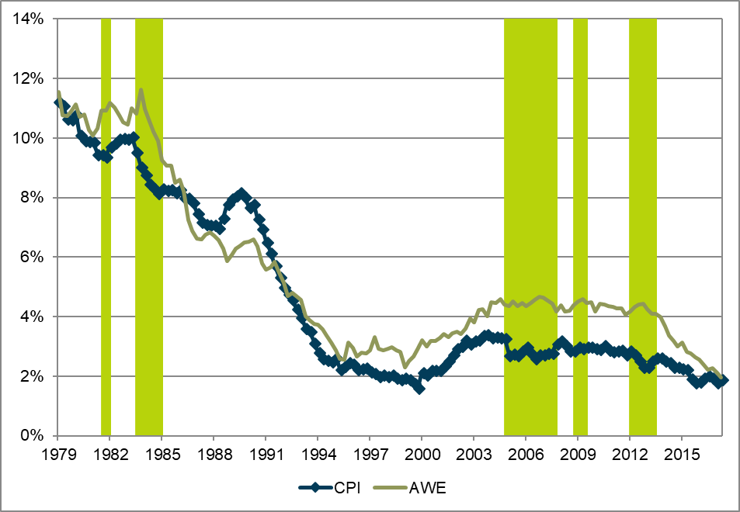
Source: 5 year rolling growth calculated from data by ABS and RBA

Another modelling option would be to draw greater than the minimum drawdown rate in retirement. With appropriate risk management, this can generate higher, sustainable, retirement income. An indication of the availability here is the chart in Box 1.6 of the draft report noting that approximately $500,000 will be left to the estate at death. However, any drawdown more 43% of final salary under Case A assumptions would exhaust the capital before age 88 and would still be inadequate.

Concluding remarks
It is a reasonable observation that some lifecycle funds are not necessarily providing the best outcomes for members and changes should be implemented to improve the retirement outcomes for these members. However, this does not extend as far as Draft Finding 4.3 implies. The finding is drawing on erroneous modelling of lifecycle strategies. In this submission, I have highlighted an approach more aligned to lifecycle theory to demonstrate the value of an appropriate lifecycle strategy.
Most people are best served by making a full allocation to risky, growth assets early in their accumulation years. In most cases, this will not be suitable in retirement. Having a strategy that adjusts the risk levels as necessary should be a better default option for the member than an option that only takes the average desired risk at all times.

References
Bell, D. 2013, Are lifecycle funds appropriate for MySuper products?, Cuffelinks,
http://cuffelinks.com.au/are-lifecycle-funds-appropriate-for-mysuper-products/
(accessed 27 June 2018).
Chant, W., Mohankumar, M. and Warren, G. 2014, MySuper: A New Landscape for Default
Superannuation Funds, CIFR Paper 020/2014, Centre for International Finance and
Regulation, Sydney.
Corrigan, J. Nandi, S. and Matterson, W. (2009) “A holistic framework for life cycle financial planning”. Milliman Research Report.
http://au.milliman.com/insight/research/insurance/A-holistic-framework-for-life-cycle-financial-planning (accessed 27 June 2018).

Kingston, G. and Fisher, L., 2014. Down the retirement risk zone with gun and camera. Economic Papers: A journal of applied economics and policy, 33(2), pp.153-162.

Kitces, Michael E. and Pfau, Wade D., 2014., Retirement Risk, Rising Equity Glidepaths, and Valuation-Based Asset Allocation. Available at SSRN: https://ssrn.com/abstract=2497053 or
http://dx.doi.org/10.2139/ssrn.2497053

Merton, R. 2014, ‘The crisis in retirement planning’, Harvard Business Review.

Milevsky, M.A. and Abaimova, A. (2006) ‘Retirement Ruin and the Sequencing of Returns’, available at https://www.mdpreferredservices.com/documents/Milvesky%20-%20Sequecing%20of%20Returns.pdf
Politis, D.N. and Romano, J.P. 1994, ‘The Stationary Bootstrap’, Journal of the American Statistical Association, vol. 89, no. 428, pp. 1303–1313.

Trueck, S. 2016, Lifecycle Investment Strategies – Myths and Facts, 18 March, Centre for
Financial Risk, Macquarie University, Sydney.
Vanguard 2017, The Power of Perspective: Vanguard 2017 Index Chart.

Resource constraints limited the bootstrap replication to 2000 simulations. This could be extended for greater refinement, but the results will be robust, even at the 5th percentile estimate.
The distribution of the balanced portfolio outcomes is similar to that in Technical Supplement 6, with an average outcome 1% lower. This is possibly due to slight differences in the calibration. My results have slightly wider dispersion, which is likely to relate to the smaller sample size
The experience factor is problematic to model. Older ABS data, no longer published, had an earlier plateau than the approach used in the draft report. A recent Grattan Institute presentation at UNSW referred to modelling wages by age based on the 2% file from ATO returns and this could improve the projection

